Muhammad Roychan Meliaz
FSDO001ONL021

OCBC – Hacktiv8 Bootcamp
Final Project
CRUD PaymentDetail running lokal

GET API
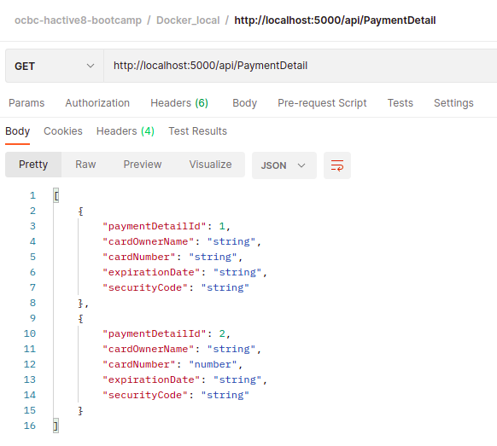
POST API
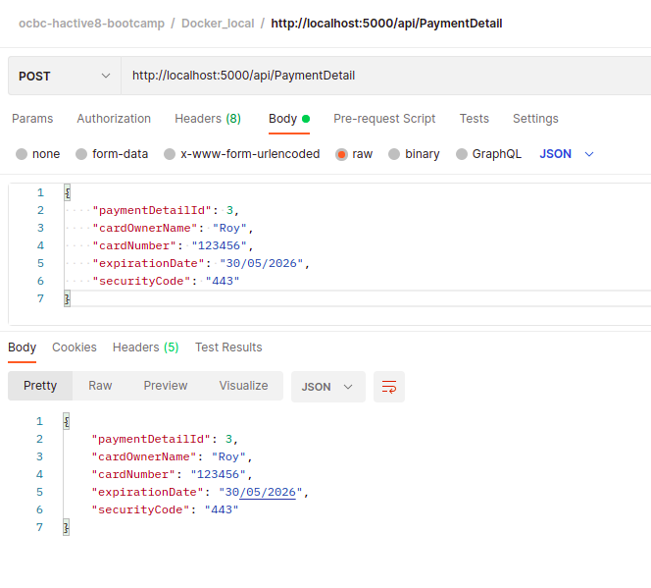

POST API Result
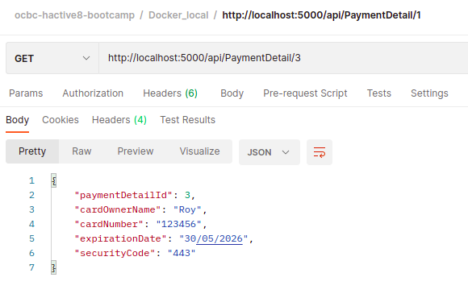
PUT API
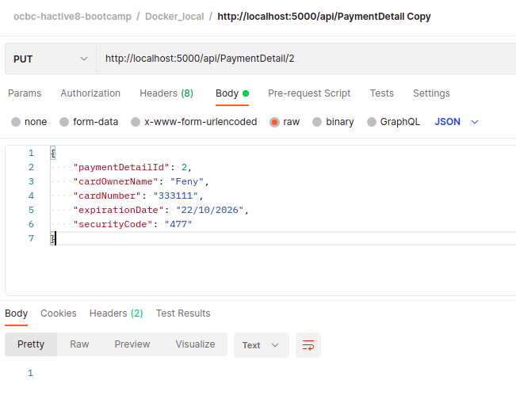

PUT API Result
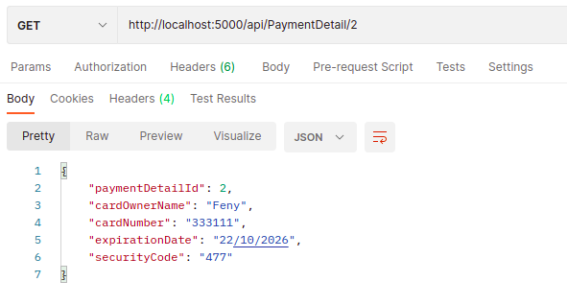

DELETE API
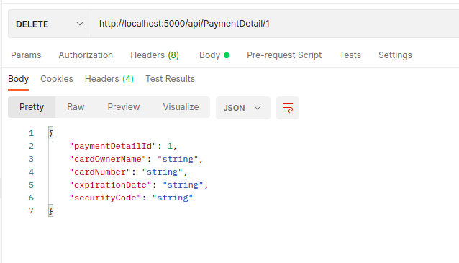

DELETE API RESULT
