DATA ANALYSIS PROJECT REPORT
Final Term Project — CSC 4262 Programming in Python
Project Title | NYC Airbnb 2019: Price Pattern Analysis Using Pandas, NumPy, and Matplotlib
Student Name | Durjoy Roy
Student ID | 23-50576-1
Course / Section | CSC 4262 Programming in Python — Section A
Instructor | MD. Tanzeem Rahat
Date of Submission | May 2,2025

1. Executive Summary
This project examines Airbnb listing prices in New York City using the AB_NYC_2019 dataset, which contains 48,895 listings across five boroughs with 16 variables covering price, location, room type, host activity, and review history. The goal was to identify what drives price variation in the NYC short-term rental market by answering three specific research questions: how prices differ by borough and room type, whether review count has any relationship with price, and where price outliers are concentrated in the dataset. Using Pandas for data wrangling and aggregation, NumPy for statistical computations including z-scores, percentiles, and log transformation, and Matplotlib for visualization, the analysis found that borough and room type together account for most of the price variation observed. Manhattan entire-home listings carry median prices more than twice those in the Bronx. Review count shows almost no relationship with price. Price outliers are rare overall but heavily concentrated in Manhattan. These findings give both hosts and guests a clearer picture of how the NYC short-term rental market is structured.

2. Introduction and Project Objectives
The short-term rental market in New York City is one of the busiest in the world. For a host trying to set a competitive nightly rate or a traveller trying to plan a trip budget, understanding which factors actually drive price is a practical question. This project treats that as a data problem: given a snapshot of all active NYC listings from 2019, what do the numbers reveal about how price behaves across different segments of the market?

Item | Content
Dataset name | AB_NYC_2019.csv — New York City Airbnb Open Data
Dataset source | Kaggle — https://www.kaggle.com/datasets/dgomonov/new-york-city-airbnb-open-data
Main project goal | To identify the key drivers of Airbnb listing prices in New York City using subgroup comparisons, relationship analysis, and outlier detection.
Research Question 1 | How does listing price vary across NYC boroughs and room types, and which borough-room type combination has the highest median price?
Research Question 2 | Is there a meaningful relationship between a listing's price and its number of reviews, and does this hold across different room types?
Research Question 3 | Where are price outliers concentrated in the dataset, and which boroughs and room types have disproportionately high outlier rates?

RQ1 matters because borough and room type are the two most visible and actionable variables for anyone participating in this market. RQ2 matters because it tests a common assumption that popular, frequently reviewed listings charge more, directly against real data. RQ3 matters because outliers distort average-based comparisons and identifying where they cluster helps separate genuine luxury segments from noise.

3. Dataset Description
The AB_NYC_2019 dataset is a snapshot of all active Airbnb listings in New York City as of 2019. Each row represents one individual listing and includes information about the host, the listing's location across all five NYC boroughs, the type of room offered, the nightly price, review activity, and availability. The three room types present are Entire home/apartment, Private room, and Shared room.

3.1 Basic Dataset Information
Property | Value
Number of rows | 48,895 listings
Number of columns | 16 columns
Data types present | Numerical (int64, float64), categorical (object), date-time (last_review), text (name, host_name)
Key variable | price — nightly listing rate in USD, the primary variable throughout this analysis
Potential issues observed | Missing values in last_review and reviews_per_month (both ~20.6%); a small number of listings with price = 0; heavy right skew in the price column; minor missing entries in host_name and name

3.2 Initial Observations
The most noticeable feature of the dataset is the heavy right skew in price: the mean (~$153) is substantially higher than the median (~$106), which tells us that a small number of very expensive listings pull the average upward. The last_review and reviews_per_month columns share the same missing rate of about 20.6%, which is expected since both are absent for listings that have never received a review. The neighbourhood_group and room_type columns are clean categoricals with no missing values, making them reliable for groupby operations. A small number of listings have price set to 0, which is almost certainly a data entry error.

4. Data Cleaning and Preparation
All cleaning was done on a copy of the original dataframe to keep the raw data intact. Each step was driven by a specific quality issue rather than applied as a routine checklist.

Issue Found | Action Taken | Reason / Justification | Code Reference
last_review stored as string, not a proper date type | Converted to datetime using pd.to_datetime() with errors='coerce' so invalid entries become NaT | Correct dtype is required before extracting last_review_year via .dt.year — without this, year extraction fails entirely | Cleaning Step 1 — Cell 15
reviews_per_month missing for ~20.6% of listings (10,052 rows) | Filled with 0 using fillna(0) | These listings have zero reviews, so a monthly review rate of 0 is the correct representation. Dropping 20% of rows would be an unjustifiable loss of valid listing data | Cleaning Step 2 — Cell 15
host_name and name have a small number of missing entries (<0.1%) | Filled with the string 'Unknown' | These fields are not used in any quantitative analysis. Filling with a placeholder avoids NaN propagation in output tables while keeping the rows | Cleaning Step 3 — Cell 15
11 listings with price = 0 or price < 0 | Removed using df_clean[df_clean['price'] > 0] | A nightly price of zero is not a valid listing price on Airbnb. These are data entry errors. Keeping them would suppress minimum values and distort price distribution analysis | Cleaning Step 4 — Cell 15

After all cleaning steps, the dataset retained 48,884 rows (11 zero-price listings removed). Duplicate check via .duplicated().sum() returned 0, so no rows were removed for duplication. The before-and-after missing value comparison confirmed that reviews_per_month and host_name/name missing counts dropped to zero, while last_review retained its NaT entries since those listings genuinely have no review history.

5. Feature Engineering
Three new features were created from existing columns. Each was designed to support one or more of the research questions rather than added as generic preprocessing.

New Feature | How It Was Created | Why It Is Useful
last_review_year | Extracted integer year from the cleaned last_review datetime column using .dt.year. NaN-safe: listings with no review date produce NaT, which .dt.year returns as NaN | Enables year-level groupby summaries of median price. Used to check whether listings with more recent review activity show different price levels compared to older or unreviewed listings
price_log | Computed as np.log1p(price), which applies log(1 + price) to every row. log1p is used instead of log to handle zero values safely | Raw price is heavily right-skewed. Log transformation compresses extreme values and produces a distribution closer to normal, making scatter plots more interpretable and correlation values more meaningful for RQ2
is_high_price_p95 | Binary flag (1 or 0) created using NumPy: p95 = np.percentile(price, 95); is_high_price_p95 = (price >= p95).astype(int). The computed P95 threshold was $355 | Enables direct analysis of the top 5% of listings by price. Used to compare which boroughs have the highest share of high-price listings, directly supporting RQ3 on outlier and extreme-price concentration

6. Analysis Methodology
The analysis was organised around the three research questions. Each library played a specific role that could not be swapped out for another.

Pandas was used for loading the dataset from a public GitHub URL, inspecting structure and data types, performing all cleaning transformations, running groupby aggregation tables at the borough level, room type level, and as a two-way pivot, computing Spearman and Pearson correlations, and building year-level trend summaries.

NumPy was used for three distinct computations: log1p transformation of the price column to reduce skew, 95th percentile threshold calculation using np.percentile to identify high-price listings, and z-score computation on price_log for outlier detection by computing (x - x.mean()) / x.std(ddof=0) on the raw array.

Matplotlib was used to produce four charts, each directly tied to a research question: a bar chart for borough-level median prices (RQ1), a log-scale boxplot for room type price distributions (RQ1), a scatter plot for the price-review relationship (RQ2), and a bar chart of outlier rates by borough (RQ3).

7. Analysis and Visualizations

7.1 Research Question 1: Price Variation by Borough and Room Type
How does listing price vary across NYC boroughs and room types, and which borough-room type combination has the highest median price?

To answer this, two separate groupby operations were run. First, price was aggregated by neighbourhood_group (borough), computing count, mean, median, and 75th percentile for each. Second, the same aggregation was applied by room_type. A two-way pivot table then crossed borough against room type to produce median price for every combination. Additionally, the is_high_price_p95 flag was grouped by borough to show what share of each borough's listings fall in the top 5% price tier.
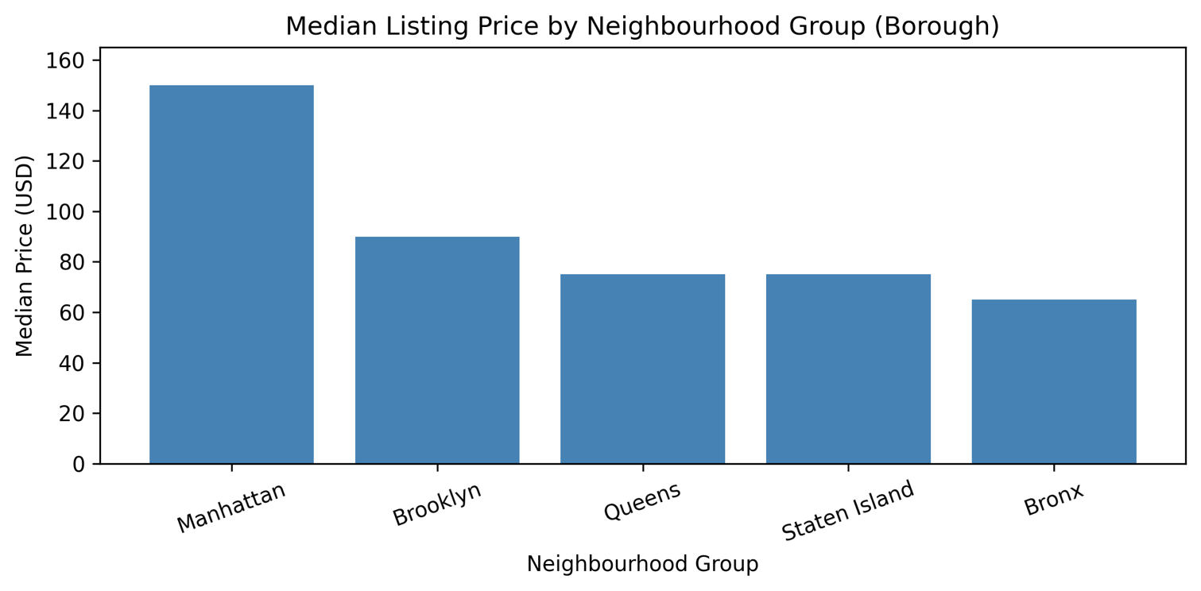
Figure 1. Median nightly listing price by NYC borough, sorted highest to lowest.

Manhattan has the highest median listing price at approximately $150 per night, followed by Brooklyn (~$90), Queens (~$75), Staten Island (~$75), and the Bronx (~$65). The gap between Manhattan and the Bronx is more than 2x, confirming that borough is a strong price separator. The two-way pivot table shows that the highest-price segment across the entire dataset is Entire home/apartment listings in Manhattan, with a median price of approximately $191 — well above all other borough-room type combinations. Even shared rooms in Manhattan sit above the median for entire-home listings in the Bronx, showing how strongly location dominates the price hierarchy.
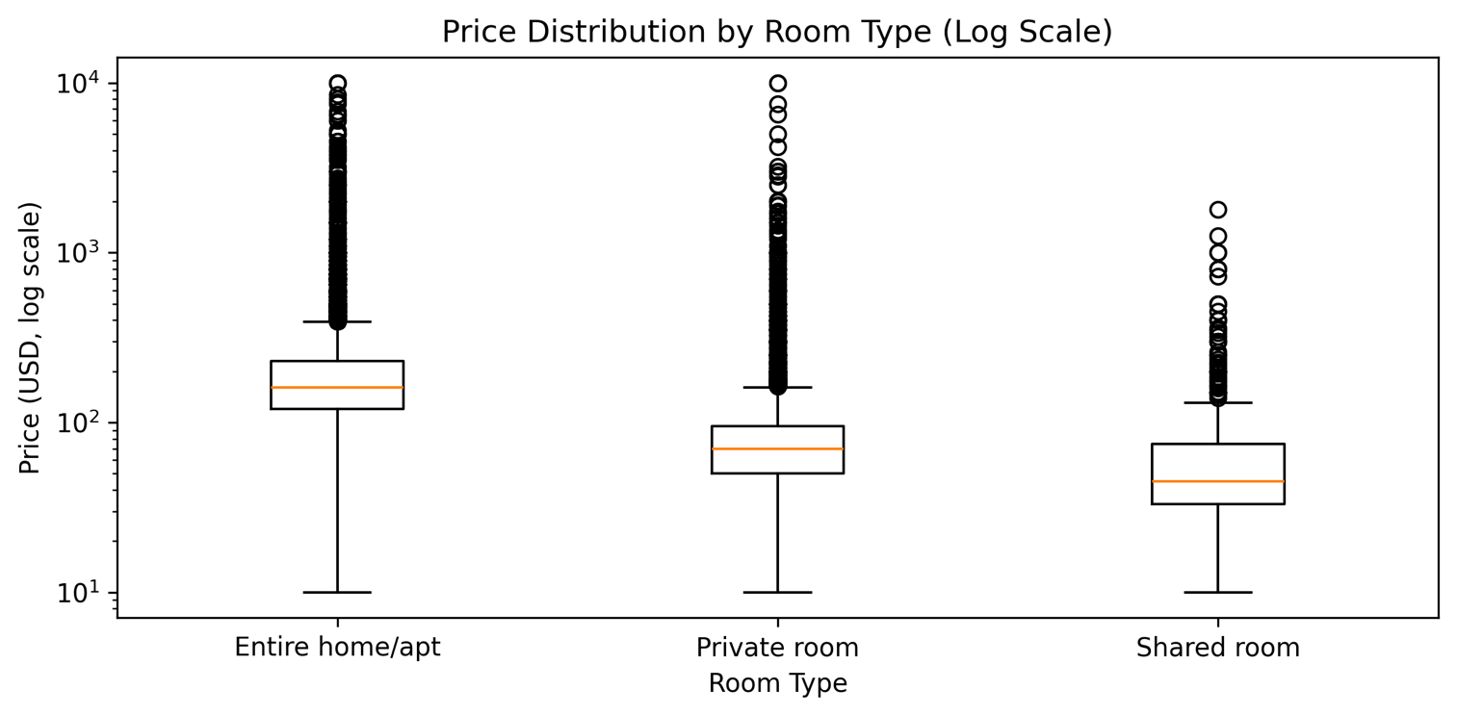
Figure 2. Boxplot of nightly price by room type on a log scale.

Entire home/apartment listings have both the highest median price and the widest spread, with a long upper tail visible even on the log scale. Private rooms are priced significantly lower, and shared rooms lower still. The log scale is necessary here because without it, the extreme high-price listings compress the boxes into near-invisibility. The chart confirms that room type creates a stable and meaningful price hierarchy across the dataset, independent of location.

7.2 Research Question 2: Relationship Between Price and Review Count
Is there a meaningful relationship between a listing's price and its number of reviews, and does this relationship hold across different room types?

Both Spearman and Pearson correlations were computed between price_log and number_of_reviews across the full dataset. Spearman was chosen as the primary metric because it does not assume a linear relationship and is robust to non-normal distributions. The correlation was also computed separately for each room type to test whether a stronger signal exists in any specific segment.
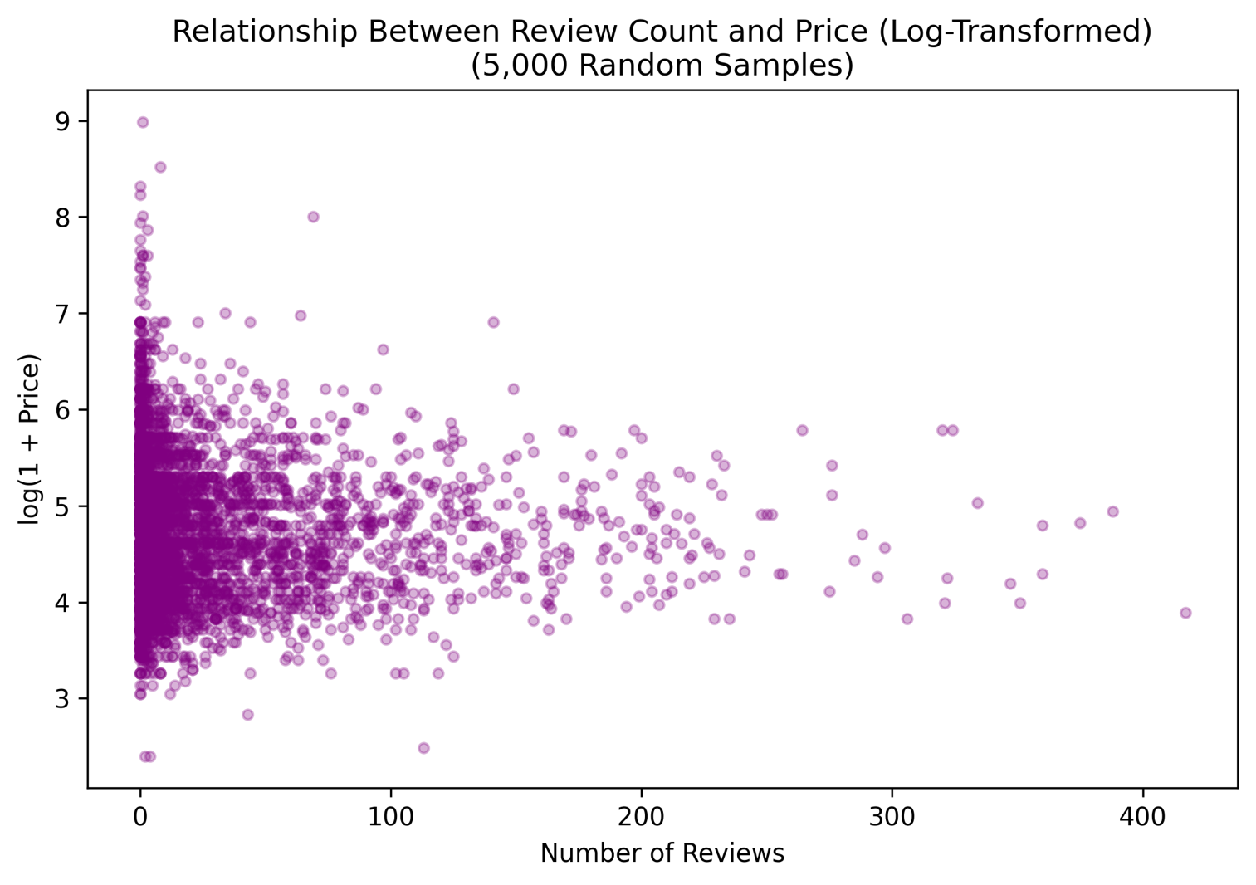
Figure 3. Scatter plot of number of reviews versus log-transformed price.

The Spearman correlation between log-price and number of reviews is approximately -0.0549. A formal statistical test yields a p-value of < 0.0001, indicating that this relationship is statistically significant due to the large sample size (n=48,884). However, the magnitude of the correlation is negligible (|r| < 0.1), meaning it is practically meaningless. Review count is not a useful predictor of price. (Note: To avoid extreme overplotting and maintain visual clarity, Figure 3 displays a random sample of 5,000 listings rather than the full dataset.)

7.3 Research Question 3: Outlier Concentration by Borough and Room Type
Where are price outliers concentrated in the dataset, and which boroughs and room types have disproportionately high outlier rates?

Outliers were identified using a z-score approach applied to price_log rather than raw price. Applying z-scores directly to raw prices would flag a disproportionate number of moderately expensive listings due to the heavy right skew. Computing z-scores on the log-transformed values gives a more conservative threshold. Any listing with |z| ≥ 3 was flagged as an outlier. The is_high_price_p95 flag was also grouped by borough to show the distribution of the top 5% price tier across locations.
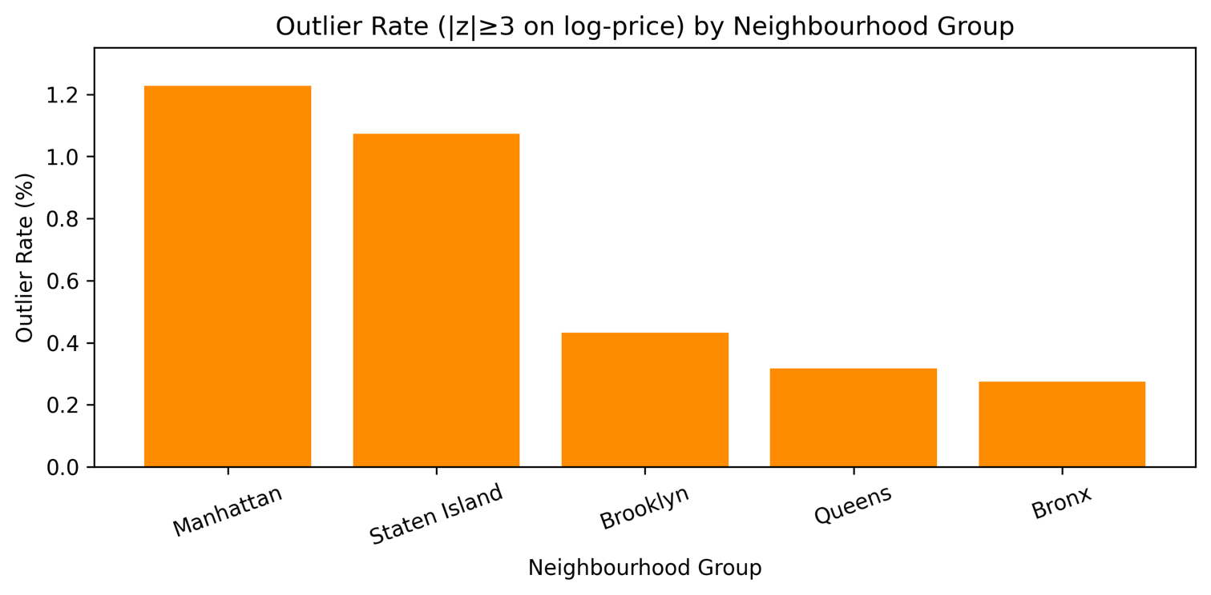
Figure 4. Percentage of listings classified as price outliers (|z| >= 3 on log-price) by NYC borough.

Across the full dataset, only 378 listings (0.77%) qualify as z-score outliers on log-price, extreme prices are genuinely rare. Manhattan has the highest outlier rate among the five boroughs at 1.23%, confirming that luxury and ultra-high-price listings cluster geographically. The room-type breakdown shows that Entire home/apartment listings account for the majority of outlier instances at 1.14%, consistent with the wide price spread observed in RQ1. Staten Island, despite having a mid-range median price, shows a lower outlier rate than Manhattan or Brooklyn, indicating that its pricing is more tightly clustered without extreme high-end listings pulling the tail.

8. NumPy-Based Custom Computation
NumPy was used for three distinct computational tasks in this project, each going beyond simple array conversion or element-wise arithmetic.

Component | Description
Computation 1: Log transformation | np.log1p(price) applied element-wise to create price_log. log1p is preferred over log because it handles zero values safely, log(1+0) = 0 rather than undefined. Used throughout RQ2 and RQ3 to reduce skew.
Computation 2: 95th percentile threshold | p95 = np.percentile(price, 95) computed the dollar threshold ($355) above which listings are classified as high-price. Used to create the is_high_price_p95 binary flag, which covers 2,451 listings (5.01% of the cleaned dataset).
Computation 3: Z-score outlier detection | z = (x - x.mean()) / x.std(ddof=0) computed manually on the price_log array using NumPy operations. Listings with |z| >= 3 are flagged as outliers. Applied on log-price rather than raw price to account for the heavy right skew in the original distribution.
Result / key takeaway | The P95 threshold of $355 correctly isolates the top 5% of listings. The z-score analysis identified 378 listings (0.77%) as outliers, far fewer than a raw-price z-score approach would have returned, which confirms the value of working on the log-transformed variable.

9. Key Findings
The following five findings are each supported by specific numerical evidence from the analysis.

Borough is the single strongest driver of price variation.
Manhattan's median nightly price (~$150) is more than twice that of the Bronx (~$65), with Brooklyn, Queens, and Staten Island sitting in between. This 2x gap holds across all room types, meaning location dominates even when the type of listing is held constant.

Room type creates a consistent and significant secondary price tier.
Entire home/apartment listings have a median price roughly 2.5 to 3 times higher than private rooms, and shared rooms are priced lowest in every single borough without exception. The log-scale boxplot confirms this hierarchy is stable and not driven by outliers.

The highest-price market segment is Entire home/apartment listings in Manhattan.
The two-way pivot table shows this combination carries the highest median price (~$191) of any borough-room type pairing in the dataset. The is_high_price_p95 flag grouped by borough also shows Manhattan with the highest concentration of top-5% listings.

Review count has no meaningful relationship with price.
The Spearman correlation between log-price and number of reviews is -0.0549 overall, effectively zero. Breaking the result down by room type shows no subgroup exceeds a correlation of 0.10 in absolute value, with Entire home/apt showing the strongest value at around -0.131. The common assumption that heavily reviewed listings charge more does not hold in this dataset.

Price outliers are rare overall but geographically and categorically concentrated.
Listings at or above the P95 threshold of $355 cover 2,451 listings (5.01%). Z-score outliers on log-price number just 378 (0.77%). Manhattan has the highest borough-level outlier rate at 1.23%, and Entire home/apartment has the highest room-type outlier rate at 1.14%. Extreme pricing is a specific market phenomenon, not noise spread evenly across the dataset.

A sensitivity analysis was conducted to measure the impact of extreme price values. Removing the 378 z-score outliers (0.77% of listings) reduces the overall mean price from $152.76 to $139.39, which is approximately an 8.8% decrease. This confirms that extreme luxury pricing pulls the average upward, but the effect is modest given the small number of outliers.

10. Limitations
Single-year snapshot.
The dataset covers 2019 only. The NYC short-term rental market changed substantially after 2020 due to pandemic-related travel disruption, regulatory changes, and demand shifts. Results from this dataset may not reflect current conditions and should not be generalised beyond the 2019 period.

Missing last_review data limits time-based interpretation.
About 20.6% of listings have no last_review date, meaning last_review_year is only available for listings that have at least one review. Any year-based groupby summary should be understood as applying only to reviewed listings, not all listings.

Price is listed, not transacted.
The price column reflects the nightly rate set by the host, not the rate at which the listing was actually booked. A listing priced at $500 may be booked infrequently or never at that rate. The dataset has no occupancy or revenue data, so a high listed price does not mean high earnings.

Unmeasured variables affect price.
Important price determinants such as photos, amenities, host response rate, proximity to subway stations, and interior quality are absent from this dataset. The analysis can identify correlates of price (borough, room type) but cannot build a causal model of what drives price at the individual listing level.

Correlation does not imply causation.
The near-zero correlation between review count and price shows these two variables are not linearly associated in this dataset. This does not prove that reviews have no effect on booking rates or that pricing decisions have no effect on review volume. Both are likely shaped by a third set of factors, listing quality, location, and demand, that this dataset does not capture.

11. Conclusion
This project set out to investigate what drives Airbnb listing prices in New York City using the 2019 open dataset of 48,895 listings. Three clear answers emerged from the analysis. First, price is primarily explained by two variables; borough and room type. Manhattan commands the highest prices, the Bronx the lowest, and the gap at the median exceeds 2x. Entire home/apartment listings are consistently the most expensive room type in every borough. Second, review count does not predict price. The Spearman correlation is near zero at the overall level and in every room-type subgroup, which directly challenges the common assumption that popular listings charge more. Third, price outliers are rare in absolute terms but concentrated in Manhattan and in the entire home/apartment segment, meaning extreme pricing is a specific market feature rather than noise spread evenly across listings.

Future analysis could incorporate occupancy data, amenity listings, or host performance metrics to build a more complete picture of what drives both pricing decisions and actual booking success. A multi-year dataset would also allow trend analysis across time rather than a single cross-sectional snapshot like this one.

12. References / Dataset Source
Dgomonov. (2019). New York City Airbnb Open Data [Dataset]. Kaggle. https://www.kaggle.com/datasets/dgomonov/new-york-city-airbnb-open-data

The dataset is also loaded in the project notebook via the following public GitHub raw URL to ensure full reproducibility when rerun :
https://raw.githubusercontent.com/roydurjoy412/Programming_In_Python_FinalTerm/main/data/AB_NYC_2019.csv

13. Appendix
The following summary tables from the notebook are included here for reference. All four figures appear in-line in Section 7.

A. Borough-Level Price Summary
Borough | Count | Mean Price | Median Price | P75 Price
Manhattan | 21,660 | $197 | $150 | $220
Brooklyn | 20,095 | $124 | $90 | $150
Queens | 5,666 | $100 | $75 | $110
Staten Island | 373 | $115 | $75 | $110
Bronx | 1,090 | $88 | $65 | $99

B. Submission Checklist
- I included my GitHub repository link or Google Colab notebook link in the Google Sheet provided by the instructor.
- I attached the project report as a separate file.
- My report includes dataset source, project objective, cleaning steps, feature engineering, analysis, visualizations, findings, limitations, and conclusion.
- My code uses Pandas, NumPy, and Matplotlib meaningfully.
- All placeholder text has been replaced with project-specific content.

