Scalable Fine-Grained eBPF Isolation through Hybrid Policy Verification

Abstract: Multi-tenant cloud hosts run eBPF programs for networking, observability, and security on a shared Linux kernel. However, kernel-verifier acceptance does not guarantee tenant-specific policy compliance. This paper presents a selective-analysis design using a conservative three-valued abstract analyzer (SAFE, VIOLATION, UNKNOWN), with unresolved cases forwarded to a frozen KRAKENGUARD symbolic verifier. Two baselines were measured on one host: E1, comprising eight programs and 72 runs, and E2, covering 1–64 feasible symbolic paths across 63 runs. In E1, median verification time ranged from 672 to 708 ms as instruction count increased from 2 to 20. In E2, median time rose from 746 to 1,231 ms (65%), with an estimated 7.7 ms per additional path above roughly 730 ms of fixed overhead. Although the analyzer, 24-program corpus, and E3–E5 protocol were implemented, raw artifacts were unavailable for final verification. Therefore, reported discharge and savings figures remain unverified. This study contributes a conservative design, baseline measurements, and a transparent account of outstanding evidence.
Keywords eBPF, multi-tenant cloud security, eBPF isolation, symbolic execution, abstract analysis, policy verification, KRAKENGUARD

1. Introduction

1.1 Background of the Study
Cloud infrastructure increasingly consolidates workloads on shared Linux hosts. Extended Berkeley Packet Filter (eBPF) supports networking, tracing, observability, and security [1], but allows programs from different tenants to run within the same kernel. Security mechanisms must distinguish each tenant’s authorized actions. Although the Linux verifier provides a fundamental safety check, verifier acceptance does not guarantee tenant-specific policy compliance: a program may pass verification yet violate policies governing helper calls, maps, memory, return values, or interactions with other programs.

1.2 Research Problem
Fine-grained symbolic policy analysis, as used in KRAKENGUARD [2], can precisely evaluate policy compliance but incurs the full verification cost for every program. Its scalability is limited by growing symbolic paths and expressions. Running symbolic verification on every program is unnecessary when compiled structure makes the decision clear. This study therefore seeks to reduce redundant symbolic verification without treating uncertainty as safe.
1.3 Significance of the Study
A fail-closed selective front-end preserves the symbolic verifier as the authority while avoiding its cost when a cheap proof is available. Baseline measurements identify whether program size, path count, or fixed overhead drives verification time. The study also distinguishes measured findings from planned or unrecoverable results, supporting more transparent systems-security evaluations.

1.4 Research Gap
Existing research addresses verifier precision [3], runtime enforcement [4], verifier testing [5], virtualization [6], scheduling [7], delegation [8], and confinement [14], [15]. However, limited work examines whether a conservative three-valued abstract stage can safely reduce symbolic policy-verification calls while reporting audited cost measurements across program features and feasible paths. This study addresses that gap while distinguishing reproducible findings from results that remain unverified.

1.5 Objectives and Research Questions
The objective is to design a conservative hybrid policy-verification workflow, measure the baseline cost behavior of the symbolic verifier, and state exactly what evidence supports each claim. The study addresses four research questions:
- RQ1: Does compiled instruction count explain end-to-end symbolic verification cost (E1)?
- RQ2: How does cost grow with the number of feasible symbolic paths (E2)?
- RQ3: Can a conservative three-valued analyzer discharge a useful subset of programs without false SAFE or false VIOLATION decisions (E3)?
- RQ4: Under what conditions does the hybrid workflow reduce end-to-end cost, and how does fallback behave as path complexity increases (E4, E5)?

1.6 Scope of the Study
The study evaluates synthetic XDP programs compiled with Clang for BPF, using one fixed policy, KRAKENGUARD revision, and host. It neither replaces the Linux verifier or KRAKENGUARD nor claims end-to-end tenant isolation. Its contributions are:
- A characterization of KRAKENGUARD through controlled program-feature (E1) and symbolic-path (E2) experiments.
- A conservative abstract policy analyzer with SAFE, VIOLATION, and UNKNOWN outcomes and fail-closed fallback.
- A cost model and break-even analysis of selective verification.
- An evidence audit distinguishing measured baselines from unreproducible Phase 5 results.

2. Review of Literature

2.1 eBPF in Multi-Tenant Infrastructure
eBPF allows user-supplied programs to run at selected kernel hooks; XDP, for example, enables fast packet processing near the receive path. The kernel documents instruction behavior, helpers, maps, and verifier concepts [10], while RFC 9669 standardizes the BPF instruction set [11]. Runtime surveys describe how in-kernel execution, helpers, and verification interact [1]. This programmability also creates an isolation requirement: each tenant’s program must remain within its authorized scope.

2.2 Abstract and Symbolic Analysis
Abstract interpretation summarizes program behavior in a tractable domain, conservatively sacrificing precision when needed [12]. Symbolic execution explores path conditions and solves constraints; KLEE is a well-known engine for LLVM programs [13]. KRAKENGUARD lifts eBPF bytecode into an intermediate representation, resolves helpers and symbols, builds a verification harness, and uses KLEE to examine policy-relevant behavior [2]. Because symbolic execution may explore many feasible paths, its cost depends on workload characteristics—a relationship this paper measures rather than assumes.

2.3 Related eBPF Isolation and Verification Systems
Table I summarizes related work. These systems motivate the multi-tenant context but are not interchangeable baselines; this study compares a hybrid strategy with a frozen KRAKENGUARD configuration.
Table I: Summary of related eBPF isolation and verification work
Work | Focus | Main technique
KRAKENGUARD [2] | Policy verification | KLEE-based fine-grained isolation policies
BCF [3] | Verifier precision | Proof-guided abstraction refinement
AEE [4] | Runtime enforcement | Approximation-enforced execution of untrusted extensions
Veritas [5] | Verifier testing | Specification-based oracle for misbehavior
vBPF [6] | Virtualization | Tenant and state isolation with late binding
PeeR [7] | Scheduling | Isolation for latency-critical eBPF applications
BPF Token [8] | Delegation | Namespace-bound BPF filesystems
SeaBee [9] | Infra. protection | Defense against privileged tampering
bpfbox [14] | Confinement | Process confinement with eBPF policy
BPFContain [15] | Containers | eBPF-based container confinement
This study | Selective verification | Three-valued abstract front-end with symbolic fallback

2.4 Confinement and Isolation Risks
bpfbox demonstrates precise process confinement through eBPF-based policy enforcement [14], while BPFContain examines container confinement [15]. Research on cross-container attacks shows how overly permissive eBPF capabilities threaten isolation in shared-kernel clouds [16]. These studies inform policy design and threat modeling but do not provide performance baselines for policy verification.

2.5 Need for the Present Study
Generic multi-tenant isolation is already addressed by several systems and is not this study’s novelty. The narrower, falsifiable question is whether a conservative front-end can reduce symbolic invocations without changing final decisions, and how symbolic verification costs scale with program size and path count. This study provides baseline measurements and an evidence-bounded design.

3. Research Methodology

3.1 Research Design and Approach
The study uses a five-phase design-and-evaluate approach: literature taxonomy, gap verification, baseline measurement, controlled experiments (E1 and E2), and hybrid prototyping with an E3–E5 protocol. Analysis is descriptive. Tables are intended to be reproducible from raw run records; results that cannot be regenerated are labeled unverified.

3.2 System Architecture
Figure 1 shows the hybrid workflow. Analysis uses the compiled eBPF object and control-flow graph, not C source, because compilation may fold predicates or remove branches [10], [11].
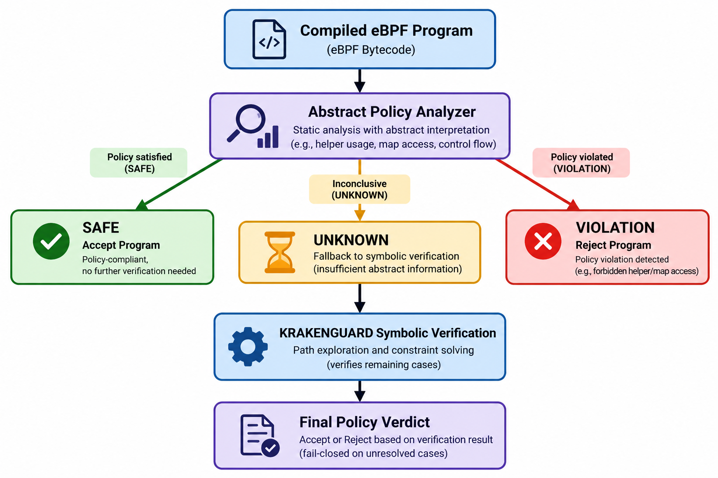
Figure 1. Hybrid fine-grained eBPF policy-verification pipeline. The abstract analyzer accepts or rejects only on a conclusive result; unresolved cases go to KRAKENGUARD, and errors or timeouts never imply acceptance.
1) Input and compilation. Programs are compiled with Clang for BPF (-mcpu=v1, -O2 -g, XDP hook). Source and object hashes, policy hash, and compiler settings are recorded to identify each tested binary.
2) Abstract policy analysis. The abstract state tracks reachability, integer facts, policy predicates, helper and map identities, access modes, memory facts, return values, and analysis status. Facts propagate through the control-flow graph; branches are pruned only when predicates are proven, and conflicting facts are weakened at joins. Unsupported eBPF semantics are never assumed compliant.
3) Three-valued routing. The analyzer returns one outcome: SAFE when all reachable abstract states are proven compliant, VIOLATION when a forbidden action is proven reachable, or UNKNOWN when neither is established. A forbidden operation’s syntactic presence alone does not establish VIOLATION; reachability must be proven. With A the abstract analyzer and V_{sym} the authoritative symbolic verifier, the hybrid decision is:
H(P,Π) = ACCEPT, if A(P,Π) = SAFE (1)
H(P,Π) = REJECT, if A(P,Π) = VIOLATION
H(P,Π) = V_{sym}(P,Π), if A(P,Π) = UNKNOWN
The design is one-sided: analysis failure reduces precision, never authority; UNKNOWN never implies SAFE. Table II summarizes the required actions.
Table II: Hybrid decision semantics and required action
Abstract result | Evidence available | Required action
SAFE | Compliance proved | Accept
VIOLATION | Violation proved | Reject
UNKNOWN | Neither proof | Symbolic fallback
Analysis error | No trusted result | Fail closed
Timeout | No completed proof | Do not accept

4) Symbolic fallback. Unresolved programs enter the frozen KRAKENGUARD pipeline, which lifts bytecode, builds a harness, and runs KLEE [2], [13]. Only the authoritative conditional-policy result determines the verdict; transport success, a top-level response flag, or process exit without a valid policy artifact is insufficient.
5) Verdict and provenance. Violations are rejected, while timeouts, malformed responses, missing verdicts, and analysis errors remain distinct and never count as success. Each run records the abstract decision, uncertainty reason, fallback status and verdict, per-stage timing, and artifact identifiers.
3.3 Study Area and Context :
All experiments ran on one host with a frozen KRAKENGUARD revision (e7bd840…) and a fixed policy (SHA-256 270403…), packaged in a Docker artifact with a pinned image digest (Table III).
Table III: Experimental environment
Item | Value
Operating system | Linux 7.2.3-arch1-2, x86_64
CPU / memory | AMD Ryzen 5 5600H, 12 logical cores; about 7.1 GiB RAM
Toolchain | Clang/LLVM 22.1.8; -target bpf -mcpu=v1 -O2 -g
Hook type | XDP
Baseline | Frozen KRAKENGUARD, Docker image (immutable digest)

3.4 Population, Sample and Sampling Technique
The target population is policy-specific eBPF programs on shared hosts. Since production corpora were unavailable, synthetic programs were purposively constructed. E1 uses eight XDP micro-programs (2–20 instructions), while E2 tests 1, 2, 4, 8, 16, 32, and 64 feasible KLEE paths. The Phase 5 corpus contains 24 programs across four equal categories (Table IV), distinguishing easy cases from those requiring fallback.
Table IV: Validation corpus (24 programs)
Cat. | Description | Programs
A | Abstractly provable compliant | 6
B | Abstractly uncertain, symbolically compliant | 6
C | Abstractly provable violation | 6
D | Abstractly uncertain, symbolically violating | 6

3.5 Data Sources, Collection Methods and Research Instruments
The primary endpoint is end-to-end wall time. Each program or level has two warmups and seven measured repetitions: E1 includes 72 executions and E2 63 (49 measured). Planned protocols specify 216 E3 and 432 E4 executions, with conditions interleaved using seed 42. E5 targets 1–32 paths; eligible programs did not reach 64. Phase 5 hypotheses concern agreement with the symbolic reference (H5-C), measurable discharge (H5-COV), lower hybrid time (H5-P), and path-dependent fallback cost (H5-S). These are planned counts, not observed runs.
3.6 Data Analysis Techniques
Medians and means are reported per program or level; outliers are retained unless a predeclared rule invalidates them. For path scaling, a least-squares line is fitted to the medians and described as an empirical model, not a complexity result. For the hybrid workflow let A_{i}, S_{i} and F_{i} be abstract time, symbolic-only time and incremental fallback time for program i, and let I_{i} = 1 if the result is UNKNOWN and 0 otherwise:
H_{i} = A_{i} + I_{i}F_{i}, Δ_{i} = H_{i} − S_{i} (2)
A negative Δ_{i} favors the hybrid. With discharge fraction d and mean costs, the expected hybrid cost and the break-even condition are:
E[H] = Ā + (1 − d)F̄ (3)
Ā + (1 − d)F̄ < S̄ (4)
For E4 the unit of comparison is the program: with Hē_{i} and Sē_{i} the per-program medians, d_{i} = Hē_{i} − Sē_{i} and r_{i} = Hē_{i} / Sē_{i}. A ratio of aggregate medians is not the median of per-program ratios, so the denominator and aggregation order must be stated.

3.7 Ethical Considerations
The study involved no human participants or personal data. All programs were synthetic, and open-source tools were used under their respective licenses. The findings represent a research evaluation, not a production security guarantee. Results that could not be independently verified are labeled unverified rather than reconstructed from summaries.

4. Results

4.1 E1: Program Features and Verification Cost
The E1 audit confirmed 72 rows, unique run IDs, consistent policy and baseline IDs, and exact agreement between CSV measurements and JSON aggregates, with qualifications. Table V and Figure 3 show median times of 672.4–707.6 ms (a 35.2 ms, or 5.2%, spread) despite a tenfold increase in compiled instructions. The correlation between instruction count and median time was (r=0.41) across eight programs, driven by P7, the only two-path program; among the seven single-path programs, (r\approx-0.05). P4’s genuine timing spike was retained.

Table V: E1 median end-to-end verification time
Program | Instructions | Paths | Median (ms)
P0 | 2 | 1 | 681.82
P1 | 5 | 1 | 679.87
P2 | 4 | 1 | 677.55
P3 | 18 | 1 | 672.43
P4 | 6 | 1 | 688.57
P5 | 11 | 1 | 692.90
P6 | 17 | 1 | 686.70
P7 | 20 | 2 | 707.61

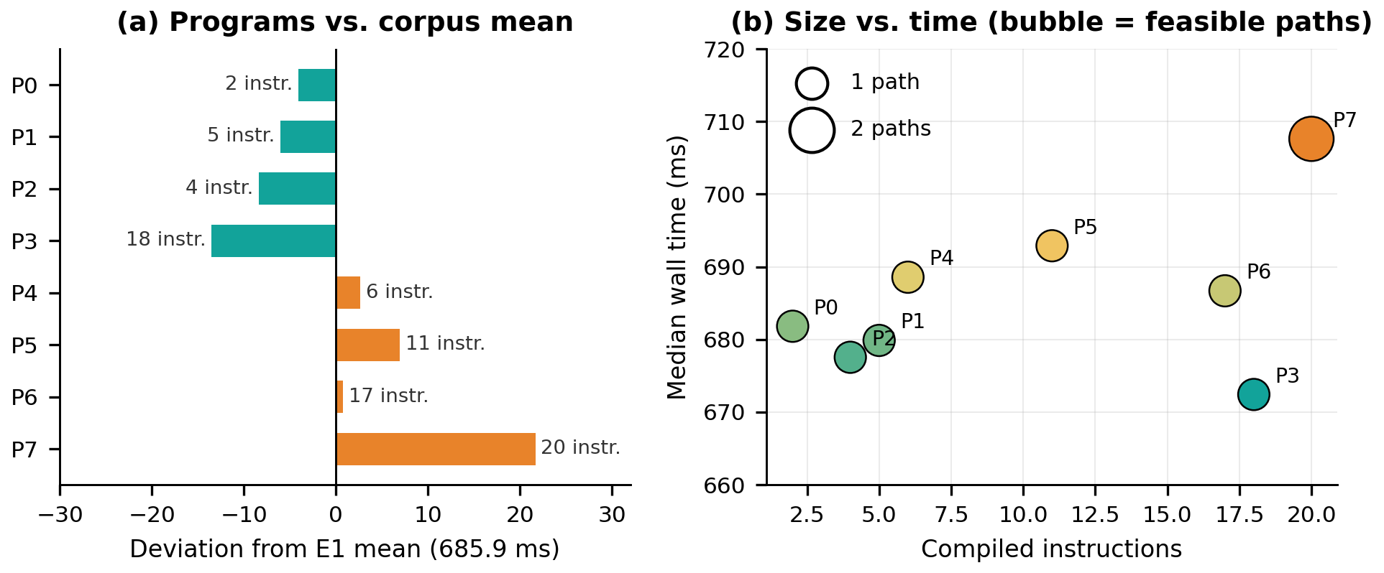
Figure 2. E1 results. (a) Deviation of each program’s median from the E1 mean, annotated with its instruction count. (b) Compiled instructions against median time; bubble size shows the number of feasible paths.
The audit also found that one source-level branch (in P2) was optimized away by Clang, that the basic-block count was a heuristic, and that the field named verifier_states held KLEE’s explored-path statistic. These qualifications limit how strongly the table can be read.

4.2 E2: Controlled Symbolic Path Growth
Table VI shows that cost increases steadily with the number of feasible symbolic paths. The median rises from 746.14 ms at one path to 1,231.16 ms at 64 paths, an increase of 65.0%. The project record reports T(P) ≈ 740 + 7.6P ms with R² > 0.999; refitting the tabulated medians gives 732 + 7.7P ms (R² = 0.9993). The residuals are within ±6.4 ms at every level, so the line is a good description of the tested family; it is not a complexity result.
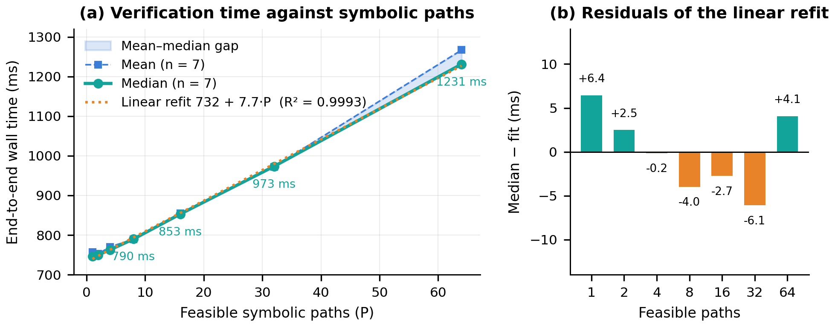
Figure 3. E2 verification cost. (a) Median and mean wall time against feasible symbolic paths, with the least-squares refit of the medians. (b) Residuals of the refit at each path count.
Table VI: E2 verification cost against feasible paths
Paths | Median (ms) | Mean (ms) | Increase (%)
1 | 746.14 | 757.28 | 0.0
2 | 749.93 | 752.64 | 0.5
4 | 762.77 | 770.22 | 2.2
8 | 789.88 | 789.19 | 5.9
16 | 853.02 | 854.79 | 14.3
32 | 973.44 | 972.45 | 30.5
64 | 1231.16 | 1266.86 | 65.0

Growth is sub-proportional: 64 paths cost 1.65 times the one-path median. Marginal cost is 3.8 ms for the first added path and 6.4–8.1 ms per path thereafter. At 64 paths, the mean exceeds the median by 35.7 ms, versus less than 12 ms at other levels, indicating that a few slow repetitions inflate the largest-level mean.

4.3 Fixed Overhead and Path-Dependent Cost
The refit attributes about 732 ms to fixed pipeline overhead (startup, lifting, and harness construction) and 7.7 ms × P to path-dependent cost. This component represents 8% of total cost at 8 paths, 25% at 32, and 40% at 64, adding 495 ms at 64 paths. Even one path costs about 0.75 s. This split is model-derived, not separately measured.

4.4 Phase 5 Prototype and Evidence Status
The repository contains the abstract analyzer, the 24-program corpus, correction and fallback validation records, a frozen execution specification and the E3–E5 protocol. However, the final independent results audit did not accept E3–E5 as completed experiments: the claimed execution commit and the raw result sets were unavailable for recomputation. Figure 7 summarizes what each experiment has and lacks. Older summaries report a 12/24 discharge rate, 45.53% E4 savings and zero correctness mismatches; none of these is presented as an established result. A real-world Katran attempt ended with a failure status before a valid verdict and is not a successful evaluation.

4.5 Break-Even Analysis (Model-Based)
No abstract-analysis time A was available, so the break-even model uses assumed costs (25, 100, and 250 ms), the E2 one-path median as S, and worst-case fallback F = S. The break-even discharge rate d* = A/S is about 3%, 13%, and 33%, respectively. For 24 programs, symbolic-only cost is 17.9 s; at A = 100 ms, hybrid cost ranges from 20.3 s with no discharge to 2.4 s with full discharge. At A = 100 ms, modeled savings per discharged program rise from 640 ms at one path to 1,127 ms at 64 paths. These are model illustrations, not prototype measurements.
5. Discussion
RQ1 (program features). In this micro-corpus, instruction count does not explain end-to-end cost: a ten-fold range in instructions moved median time by only 5%. This supports treating fixed pipeline overhead and feature-dependent symbolic behavior as separate dimensions. It does not show that size is irrelevant in general, and the compiler and instrumentation qualifications apply.
RQ2 (path scaling). Cost rises monotonically and almost linearly with feasible paths, from 746 ms to 1,231 ms, at roughly 7.7 ms per path. Because about 730 ms is fixed, relative growth is small at low path counts and large only beyond 16 paths. This motivates selective analysis within the tested range, but it does not show that every workload behaves this way.
RQ3 (selective discharge). The three-valued design and its fail-closed rules are implemented, but whether it discharges a useful subset without false SAFE or false VIOLATION results is not established, because the E3 raw evidence was not recoverable. The 12/24 and 45.53% values stay testable claims until the execution tree is recovered or the approved matrix is rerun with full provenance.
RQ4 (when the hybrid pays off). The break-even condition shows that a high discharge rate is not enough if the abstract stage is expensive, and a cheap stage does not help when nearly every case falls back. The path-scaling baseline suggests the gain per discharge is largest for path-heavy programs, but discharge rate, abstract cost and fallback cost must be reported together. The Katran attempt shows that a valid baseline verdict must exist before timing a production program.
Compared with work on verifier precision, testing, virtualization, and scheduling [3]–[7], this study isolates fine-grained policy-verification cost. In the tested regime, fixed overhead and path-dependent cost dominate, suggesting that avoiding unnecessary invocations may matter more than speeding up each invocation.
6. Conclusion
This paper presented a conservative hybrid design for fine-grained eBPF policy verification, with a three-valued abstract analyzer in front of a symbolic verifier. Baseline measurements show that instruction count alone does not explain verification cost (E1), while cost grows about 65% from one to 64 feasible symbolic paths on a fixed overhead of roughly 730 ms (E2). The analyzer, corpus and protocol exist, but the raw E3–E5 artifacts were not available to the final audit, so the 50% discharge and 45.53% savings figures are excluded from the findings. Recovering the immutable execution tree, or rerunning the matrix under the frozen protocol, is the prerequisite for any end-to-end performance claim.
7. Recommendations and Implications
- Practical: analyze the compiled object, not the source; record hashes, compiler flags and policy identity; keep UNKNOWN routed to the symbolic verifier.
- Security and policy: a positive result in the modeled program-policy setting is not a proof of tenant isolation; keep the kernel verifier, permissions, namespaces and cgroups in place.
- Managerial: a verification gateway needs versioned policy semantics, fallback resource limits, timeout handling and authenticated provenance before production use.
- Academic: report discharge rate, abstract cost and fallback cost together, publish raw rows with aggregation scripts, and label planned or unrecoverable results as such.
- Future research: complete the Phase 5 evidence audit; measure abstract-stage cost; extend beyond synthetic XDP programs to other hooks and policy forms; obtain a valid Katran baseline; replicate across hosts and toolchains; study UNKNOWN refinement.
8. Limitations of the Study
The corpus contains 24 synthetic, policy-directed XDP programs and may not represent production workloads with large parsers, loops, tail calls, or maps. Correctness is relative to a frozen KRAKENGUARD configuration, not absolute. Measurements use one host, kernel, compiler, hook, policy, and verifier revision. E2 covers 1–64 paths and E5 only 1–32. Wall time is the primary endpoint; memory and solver time were unavailable. Cost decomposition and break-even results are model-based. E3–E5 remain unverified, and the Katran attempt produced no valid result.
Acknowledgment. The author thanks the maintainers and authors of the open-source eBPF analysis infrastructure used as experimental baselines.

References
[1] B. Gbadamosi, L. Leonardi, T. Pulls, T. Høiland-Jørgensen, S. Ferlin-Reiter, S. Sorce, and A. Brunström, “The eBPF runtime in the Linux kernel,” arXiv preprint arXiv:2410.00026, 2024.
[2] J. Patel, L. G. Buhl-Nielsen, A. Ghosn, and M. Kogias, “KRAKENGUARD: Towards fine-grained eBPF isolation,” in Proc. 23rd USENIX Symp. Networked Syst. Design Implement. (NSDI), 2026.
[3] H. Sun and Z. Su, “Prove it to the kernel: Precise extension analysis via proof-guided abstraction refinement,” in Proc. 31st ACM Symp. Oper. Syst. Princ. (SOSP), 2025, doi: 10.1145/3731569.3764796.
[4] H. Sun and Z. Su, “Approximation enforced execution of untrusted Linux kernel extensions,” in Proc. USENIX Security Symp., 2025.
[5] T. Lyu, K. K. Dwivedi, T. Bourgeat, M. Payer, M. Xu, and S. Kashyap, “eBPF misbehavior detection: Fuzzing with a specification-based oracle,” in Proc. 31st ACM Symp. Oper. Syst. Princ. (SOSP), 2025, doi: 10.1145/3731569.3764797.
[6] J. Zhang, X. Song, D. Du, Y. Xia, B. Zang, and H. Chen, “Virtualizing eBPF with late-binding,” in Proc. 20th USENIX Symp. Oper. Syst. Design Implement. (OSDI), 2026.
[7] J. Carin, B. Holmes, W. Wang, A. Bhardwaj, and M. Ghobadi, “PeeR: First-class scheduling for latency-critical eBPF applications,” in Proc. 20th USENIX Symp. Oper. Syst. Design Implement. (OSDI), 2026.
[8] Linux Kernel Maintainers, “BPF system call documentation,” Linux Kernel Documentation, 2024–2026. [Online]. Available: https://docs.kernel.org/userspace-api/ebpf/syscall.html
[9] National Security Agency, “SeaBee: Security enhanced architecture for eBPF,” open-source project, 2025–2026. [Online]. Available: https://github.com/NationalSecurityAgency/seabee
[10] Linux Kernel Documentation, “BPF documentation,” 2026. [Online]. Available: https://docs.kernel.org/bpf/
[11] D. Thaler, “BPF instruction set architecture (ISA),” RFC 9669, 2024. [Online]. Available: https://www.rfc-editor.org/rfc/rfc9669.html
[12] P. Cousot and R. Cousot, “Abstract interpretation: A unified lattice model for static analysis of programs by construction or approximation of fixpoints,” in Proc. 4th ACM SIGACT-SIGPLAN Symp. Princ. Program. Lang. (POPL), 1977, pp. 238–252.
[13] C. Cadar, D. Dunbar, and D. Engler, “KLEE: Unassisted and automatic generation of high-coverage tests for complex systems programs,” in Proc. 8th USENIX Symp. Oper. Syst. Design Implement. (OSDI), 2008.
[14] W. Findlay, A. Somayaji, and D. Barrera, “bpfbox: Simple precise process confinement with eBPF,” in Proc. Cloud Comput. Secur. Workshop (CCSW), 2020, pp. 107–120.
[15] W. Findlay, D. Barrera, and A. Somayaji, “BPFContain: Fixing the soft underbelly of container security,” arXiv preprint arXiv:2102.06972, 2021.
[16] Y. He, R. Guo, Y. Xing, X. Che, K. Sun, Z. Liu, K. Xu, and Q. Li, “Cross container attacks: The bewildered eBPF on clouds,” in Proc. 32nd USENIX Security Symp., 2023, pp. 5971–5988.

