Lacrosse Demonstration of JAGS Analysis

Roy Emanuel, Ph.D.

# Problem

I have not yet demonstrated any of the “Bayesian” flavor of analysis, and this is intended to be my first go at it.

The following code builds up the data used in the different models.

## [1] "Hello World"

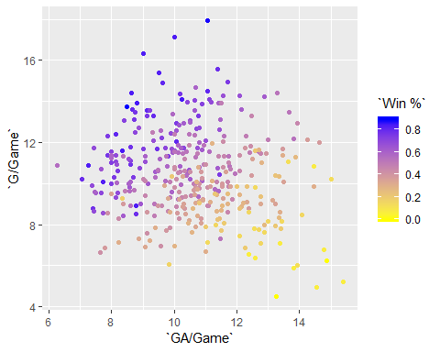

The first model is a linear regression using GoalsFor and GoalsAgainst as the independent variables and winning percentage as the