System Architecture
How the system is built

LLM-Based Autonomous SOC Agent for IoT Cyberattack Detection and Response
EL HAYEK Roy
MSc 2 Artificial Intelligence
September 2026
This document goes with the thesis proposal. It uses simple words and many pictures. Difficult words are explained in Appendix A.

Contents
Contents 2
1. What the system does 3
1.1 Why this rule matters 3
2. The problem today 3
3. The three sources 4
4. The whole system 4
4.1 The seven parts 6
5. How the data moves 6
6. What is a bundle 7
6.1 Why I cut the time before the AI, not after 7
6.2 Two problems I must handle 7
7. Inside the AI agent 8
7.1 Why a fixed path 8
8. The safety rules 9
8.1 A problem I found in my own method 9
9. How I will test it 10
9.1 The four research questions 10
10. The technology I chose 11
11. Where everything runs 11
12. The plan 12
12.1 What I start this week 12
13. Questions I would like to discuss 12
Appendix A. Words used in this document 14

1. What the system does
The system watches a network of small connected devices. It reads the alerts those devices produce. Then it explains what is happening and suggests what to do.
It suggests only. It never acts by itself. A human always decides.

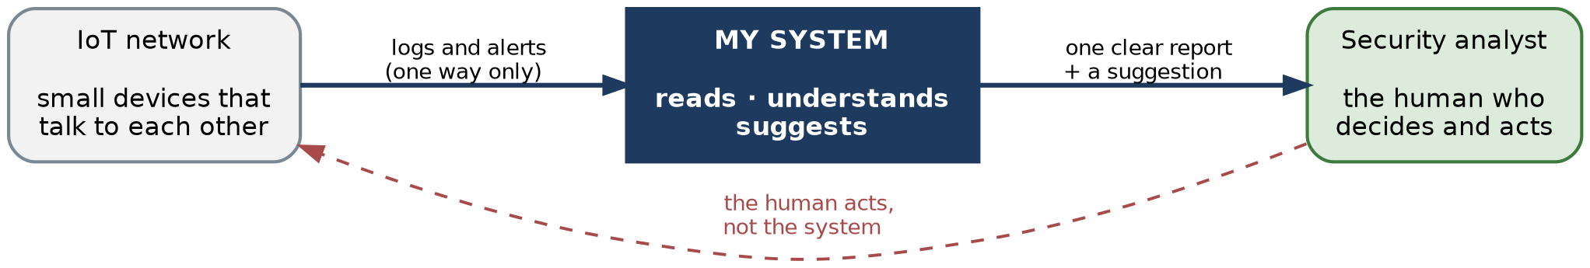
Figure 1. The system sits between the network and the human. Information goes one way.
This is the most important rule in the whole design. The system can read, but it can never change anything on the network. A human does that.

1.1 Why this rule matters
The system uses an AI language model. These models are useful, but they are not always right. Sometimes they make mistakes.
In security, a wrong automatic action is dangerous. For example, the system could stop a hospital machine because of a false alarm. The damage would be worse than the attack.
So the system stays a helper. It prepares the work. The human keeps the power.

2. The problem today
A security team uses several tools. Each tool watches one thing. Each one sends its own alerts.
Nobody connects these alerts. The analyst must read all of them, understand them, and decide alone. There are too many alerts and not enough time.
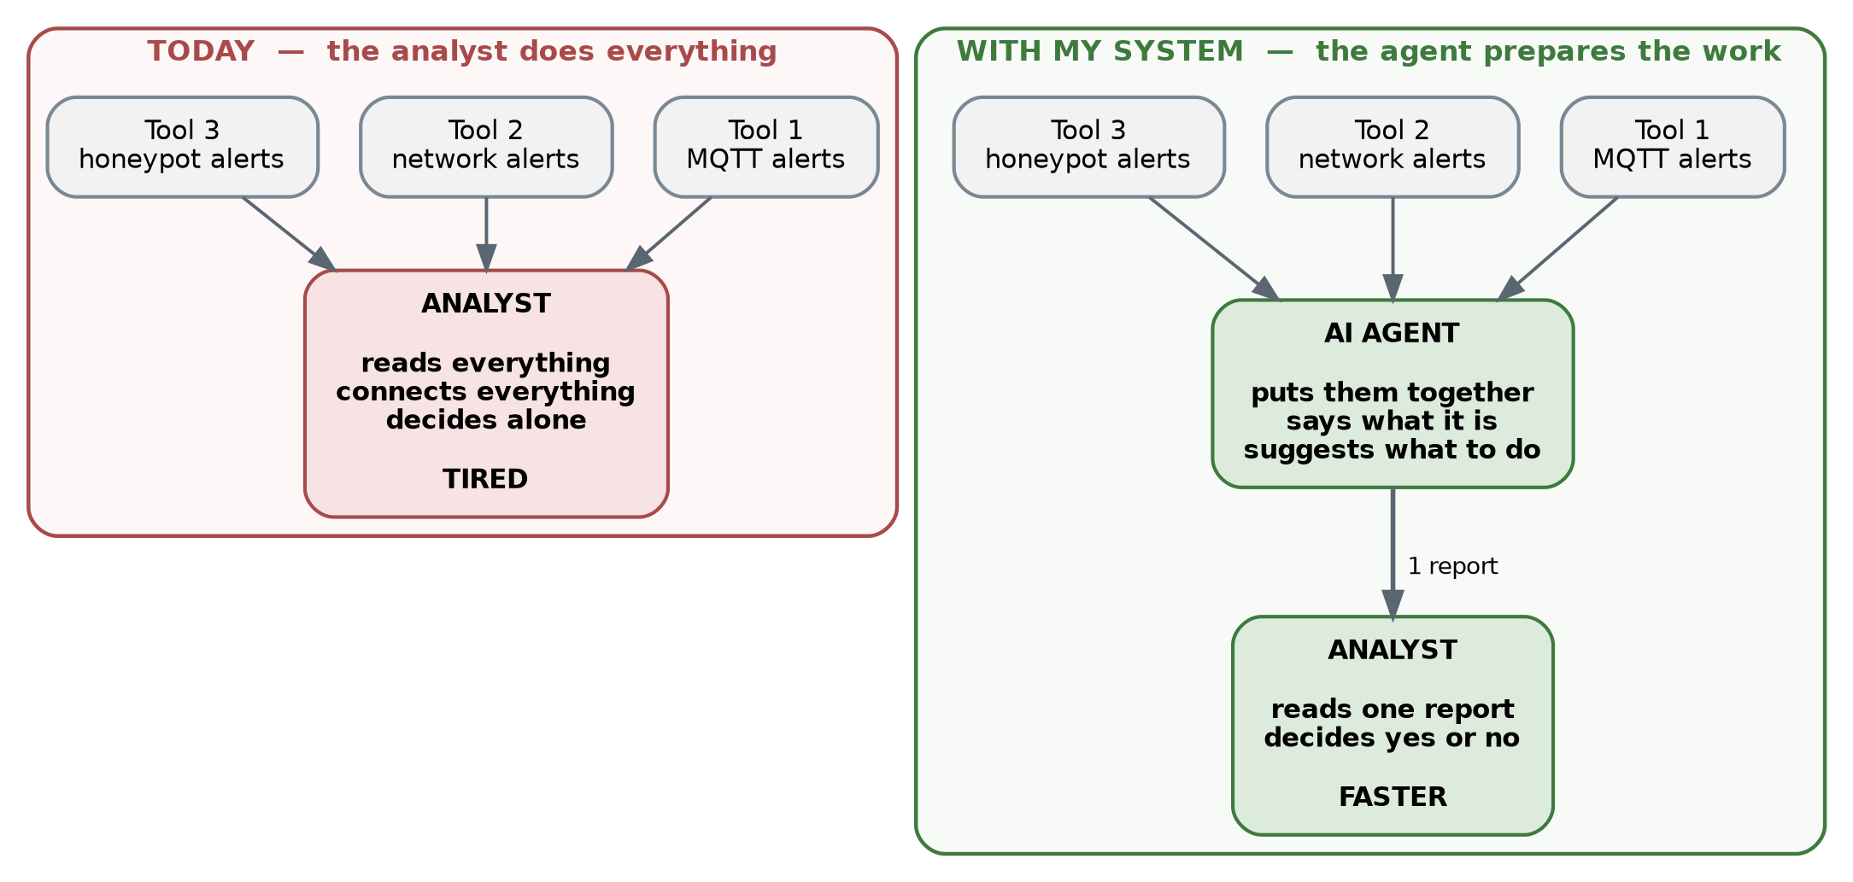
Figure 2. Today the analyst does all the work. With the system, the agent prepares one clear report first.
My system does the first part of that work. It reads the alerts, puts them together, and writes one short report with a suggestion. The analyst reads one page instead of fifty alerts.

3. The three sources
The system reads three kinds of information at the same time.
Source | What it is | What it can see
MQTT | MQTT is the language small devices use to talk to each other. A central server passes the messages. | Strange messages, too many messages, wrong passwords
Network flows | A short summary of each connection: who talked to who, for how long, how much data. Not the content. | Scans, floods, traffic going to a bad server
Honeypot | A fake computer that looks real but has no real job. Nobody should touch it. | Password guessing, and the commands the attacker types

Each source sees only a part of the attack. No source sees everything. This is the reason for using all three.
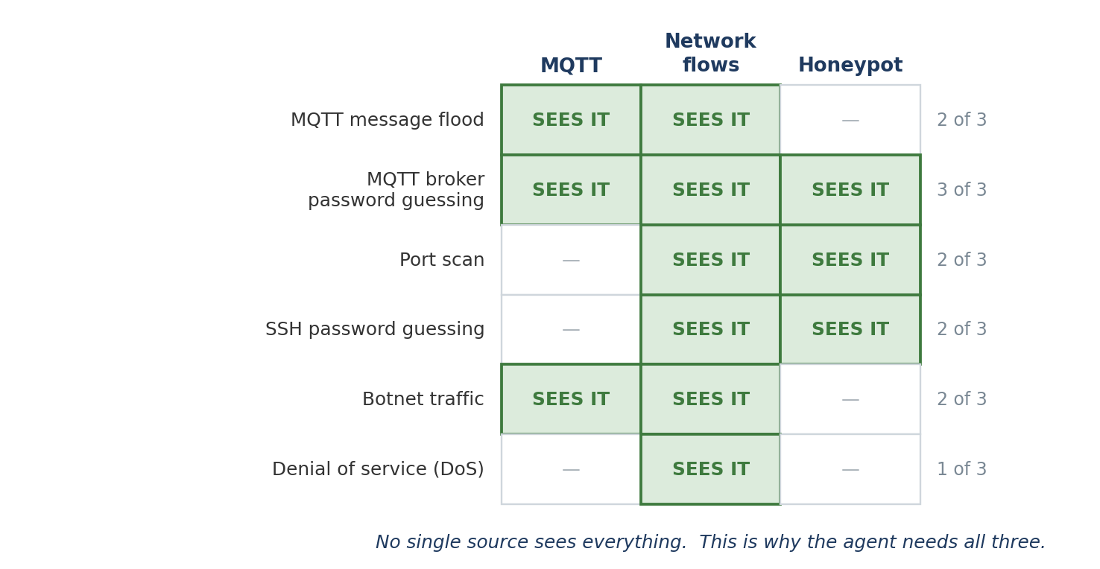
Figure 3. Which source can see which attack. Some attacks are visible in three sources, some in only one.
This picture is also my first research question (H1). I want to measure it: does using three sources give a better answer than using one source?

4. The whole system
The picture below shows all seven parts and how the information moves between them. The dashed arrows are not the main flow. They show control or comparison.
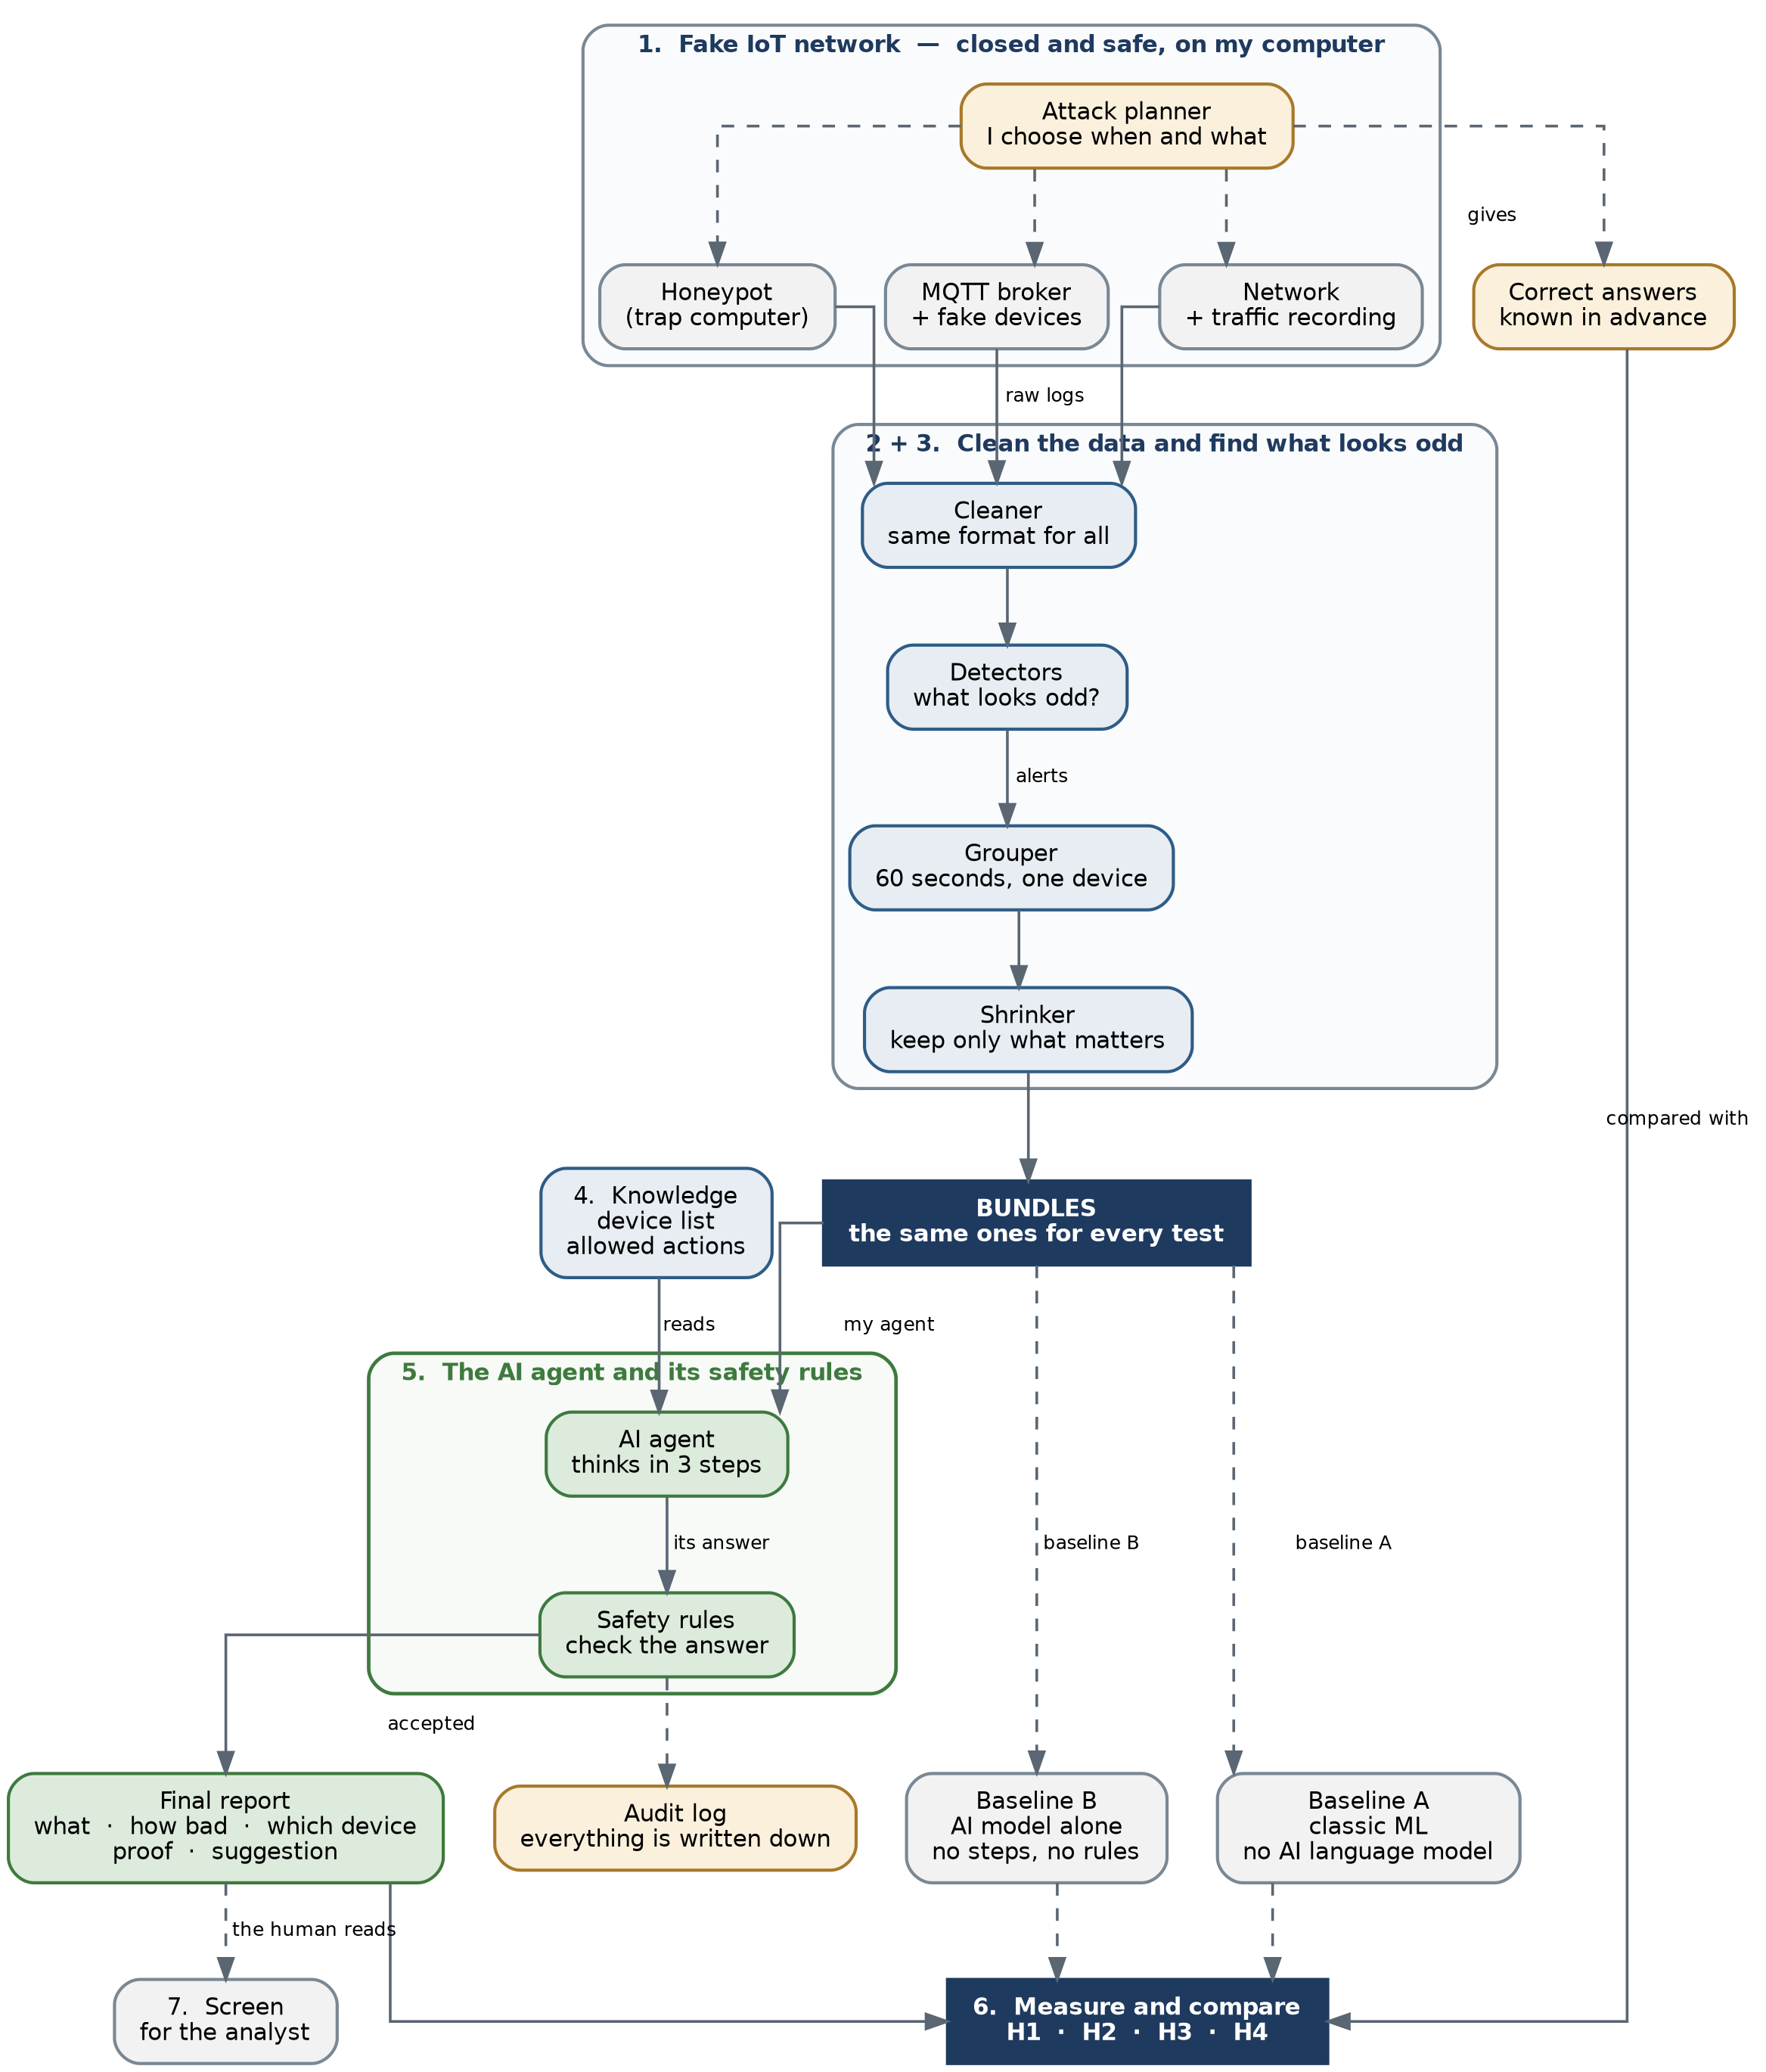
Figure 4. The complete system. The numbers are the seven parts, explained in the table below.

4.1 The seven parts
# | Part | What it does
1 | Fake IoT network | Produces the data. I attack it myself, so I always know the correct answer.
2 | Cleaning and grouping | Puts all the data in the same format, then cuts it into small pieces.
3 | Detectors | Simple programs that say "this looks odd". Not AI.
4 | Knowledge | A small library: the list of devices, and the list of allowed actions.
5 | AI agent + safety rules | The AI part. It reads, thinks, and suggests. The rules check its answer.
6 | Measurement | Compares the agent with two simpler methods, against the correct answers.
7 | Screen | Shows the result to the human. For the demonstration only.

Parts 5 and 6 are the scientific work. Parts 1 to 4 exist only to prepare data for them. Part 7 shows the result but produces no research data.

5. How the data moves
The same eight steps happen for every piece of data, always in the same order.
Figure 5. The eight steps, from raw logs to a report for the human.
Step | What happens
1. Raw logs | The three sources write what they see.
2. Clean | Everything is rewritten in one single format. After this, the rest of the system does not need to know where a line came from.
3. Detect | Simple detectors mark what looks odd.
4. Group | The timeline is cut every 60 seconds, for each device. Each piece is called a bundle.
5. Shrink | A bundle can be very big. We keep a summary plus a few examples, so the AI can read it.
6. AI agent | The agent reads one bundle and decides what it is.
7. Safety check | Normal code checks the answer. Is it allowed? Is the proof real?
8. Report | The human receives one clear report with a suggestion.

Steps 1 to 5 and step 7 are normal code. Only step 6 uses AI. This is on purpose: the more normal code, the more the results can be repeated exactly.

6. What is a bundle
A bundle is the unit I work with. Everything I measure is based on bundles.
A bundle is simple: all the alerts about one device, during one period of 60 seconds.
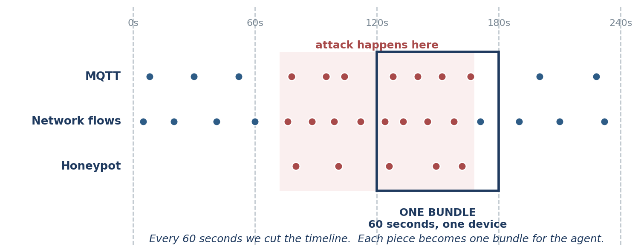
Figure 6. Alerts arrive at different moments. Every 60 seconds we cut. Each piece becomes one bundle.

6.1 Why I cut the time before the AI, not after
I could let the AI decide where an incident starts and stops. I chose not to.
The reason is the comparison. I test the agent against two simpler methods. If each method cuts the time differently, they do not answer the same questions. Then I cannot compare them fairly.
So I cut the time first, with normal code. Every method receives exactly the same bundles. Now the comparison is fair.
There is a cost. I cannot say that my agent discovers where an incident begins. It receives a bundle and explains it. I write this clearly in the thesis. It is a choice, not a mistake.

6.2 Two problems I must handle
A bundle can be too big. In 60 seconds a busy network can produce hundreds of lines. The AI cannot read all of them. So step 5 keeps a summary plus a few examples. Very important: I use exactly the same summary for the agent and for the two simpler methods. If not, the comparison is not fair.
One attack makes several bundles. A slow attack of four minutes produces four bundles. These four are not independent. My statistics must consider this, and I explain how in the thesis.

7. Inside the AI agent
The agent is not a free conversation with the AI. It is a fixed path with three steps, always the same.
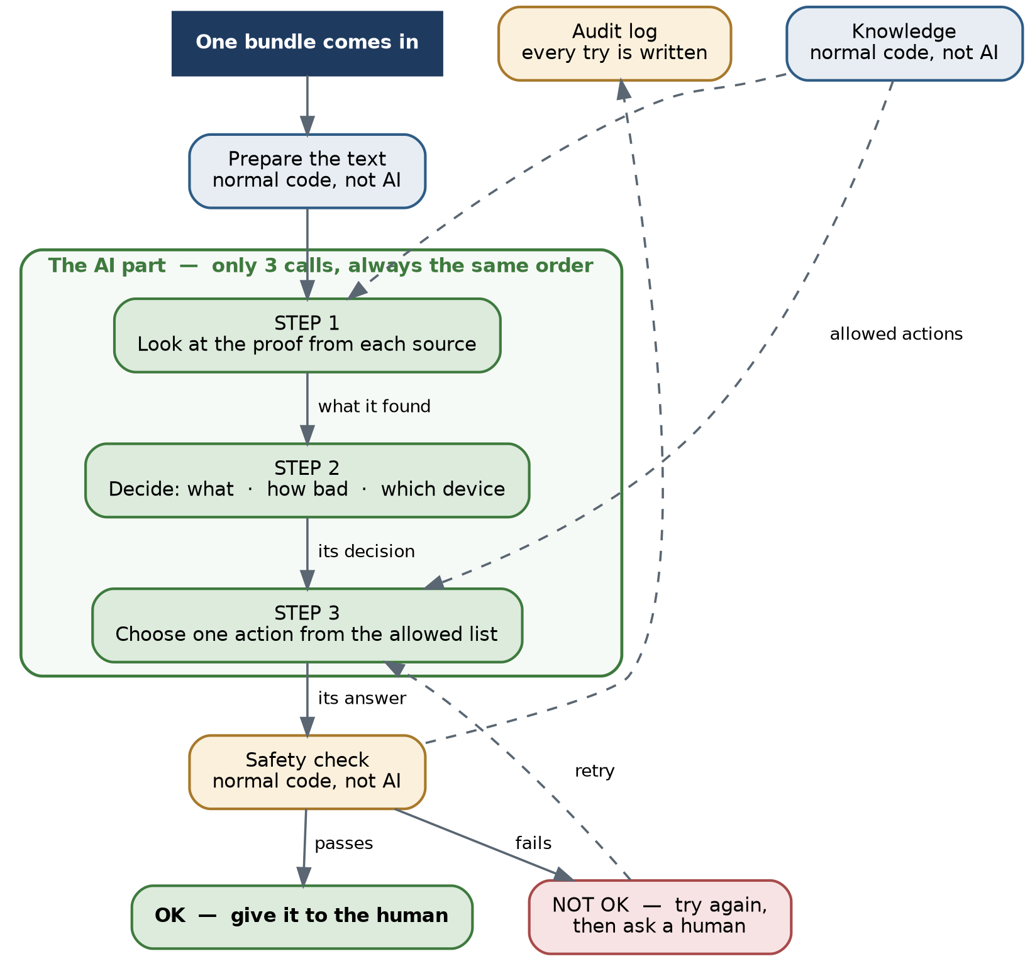
Figure 7. Inside the agent. Green boxes use the AI. Blue and orange boxes are normal code.
Step | What the AI receives | What the AI gives back
1. Look at the proof | The bundle, plus information about the device | What it found in each source, and what connects them
2. Decide | What step 1 found | The type of attack, how serious, which device
3. Suggest | The decision from step 2, plus the list of allowed actions | One action from the list, with the proof

7.1 Why a fixed path
A free AI loop is possible. But it has three problems: the answer changes every time, the cost is not predictable, and I cannot repeat my own experiments exactly.
A fixed path still gives step-by-step thinking, tool use, and reading of knowledge. That is exactly what my research question H2 tests. And every run can be repeated.

8. The safety rules
The AI writes an answer. Before any human sees it, normal code checks it three times.
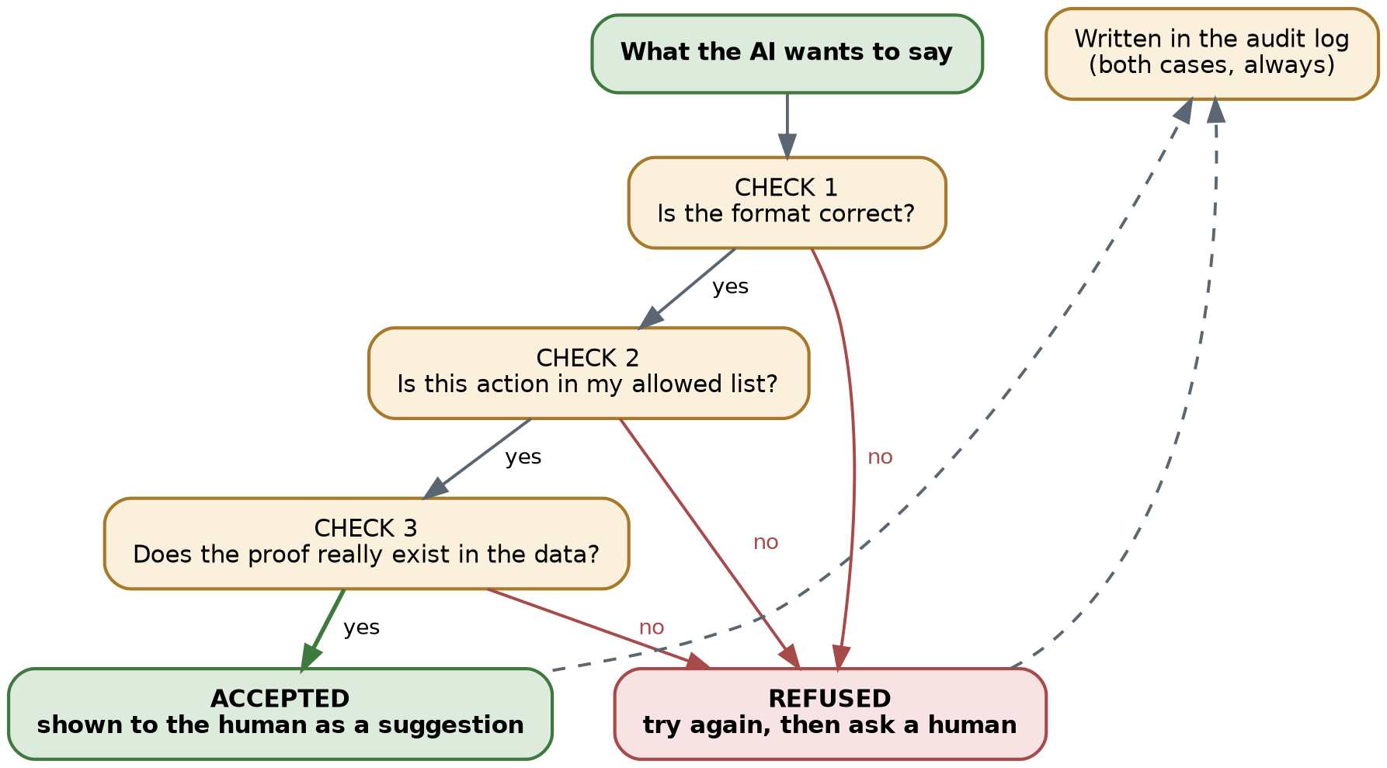
Figure 8. Three checks. If one check fails, the answer is refused. Everything is written in the audit log.
Rule | What it means
Short list of actions | The agent can only choose from a list I wrote in advance. The list comes from published security guides, not from my own opinion.
Fixed format | The answer must always have the same shape: type, seriousness, device, proof, suggested action.
Checking | Normal code refuses an answer that has a wrong shape, or an action outside the list, or proof that does not exist in the data.
Audit log | Every attempt is written down, good or bad, with the exact question and the exact answer.
The honeypot records what the attacker types. That text goes into the AI. An attacker could try to write instructions there, to control my agent. So this text is kept separate, cut short, and the checks are always applied after it.

8.1 A problem I found in my own method
My safety code removes forbidden actions automatically. So if I only count forbidden actions, the score is always perfect. That proves nothing.
So I measure three different things instead:
- Is the shape of the answer correct?
- Is the action in the allowed list? (This is the part that proves nothing by itself, and I say so.)
- Is the action correct for this situation? For example, stopping an important machine because of one small scan is allowed, but it is a bad idea.
The third one is the real result. I need it for my research question H3.

9. How I will test it
I compare three methods on exactly the same data.
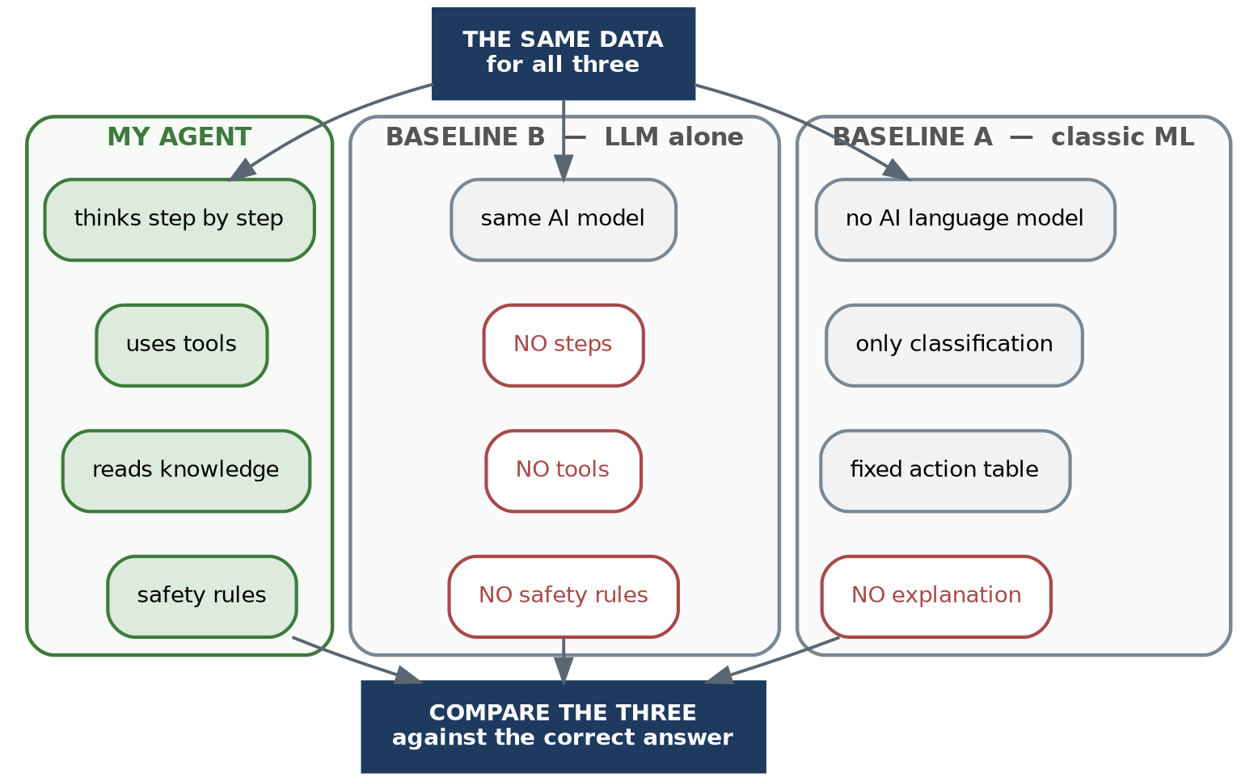
Figure 9. The same data goes to three methods. Then all three are compared with the correct answers.
Method | What it has | Question it answers
My agent | Thinks in steps, uses tools, reads knowledge, has safety rules | —
Baseline B | The same AI model, but nothing else | Is the architecture useful, or is it only a good AI model?
Baseline A | Classic machine learning, no AI language model | Do we really need an AI language model at all?

A weak comparison proves nothing. If I build a bad Baseline A, my agent wins easily and the result has no value. So I will build both baselines carefully. If my agent still wins, the result is real.

9.1 The four research questions
 | Question | What I change
H1 | Is three sources better than one source? | Each source alone, then all three together
H2 | Is the agent better than the AI model alone? | My agent vs Baseline B, same AI model
H3 | Do the safety rules help, without making the answer useless? | Safety rules ON vs OFF
H4 | Is my agent better than both simpler methods? | My agent vs Baseline A vs Baseline B

10. The technology I chose
I chose each tool for a reason, not because it is popular.
Part | Choice | Why
Backend | Python with FastAPI | It handles many requests at the same time. And it checks the shape of the data automatically, which is exactly what my safety rules need.
Screen | React | It is the technology I know. I keep it very small.
AI agent | I write it myself. No big AI framework. | Three steps is about 200 lines of code. A framework would hide what I send to the AI, and I need to know that exactly.
Knowledge search | A simple list in memory | I only have 50 to 200 documents. A big database would add complexity for nothing.
AI model | An open model with a fixed version | Anyone can download the same model and repeat my experiments. With a closed model this is not possible.
Detectors | Standard machine learning tools | These are not my contribution. I use what already works.
Fake network | Docker, all simulated | No hardware to buy. I can delete everything and start again in one command.

The cost of all the experiments is about 100 euros. I also record the cost for each incident, because no similar published work gives this number.

11. Where everything runs
I develop on my own computer. I only use the internet for the final experiments.
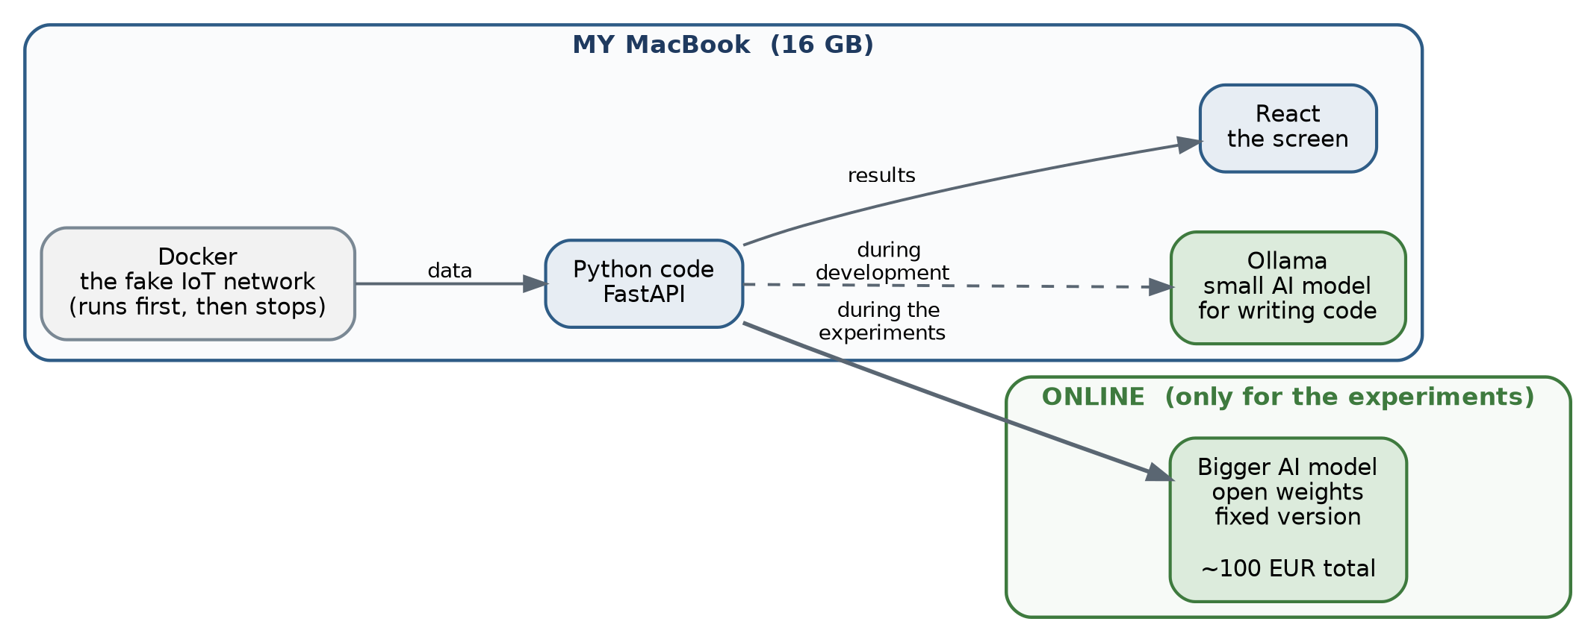
Figure 10. The small AI model runs on my MacBook while I write code. The bigger model runs online for the experiments.
The reason is time. On my computer, all the experiments would take about three days of continuous work. Online, the same work takes about two hours and costs very little.
The code is the same in both cases. Only one line of configuration changes.

12. The plan
The work has four phases and twelve epics.
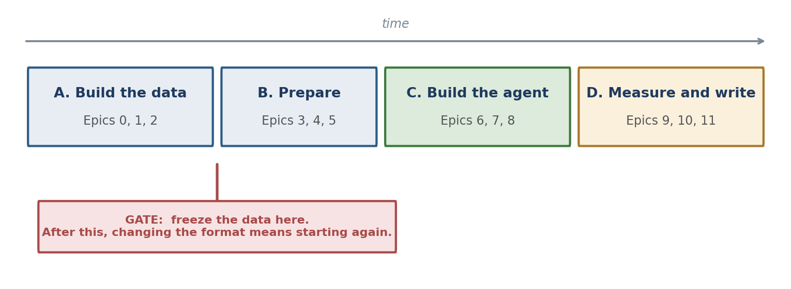
Figure 11. The four phases. The red mark shows the most dangerous moment of the project.
The red mark is important. When the data is created, I must freeze it. If I change the format after that, I have to create all the data again, and I lose weeks. So I want to be very careful before that point.

12.1 What I start this week
A small test, five days maximum. One file, about 150 lines.
I write false alerts by hand. I send them to the AI. Then I check if the answer is correct. This is repeated twenty times. I count how many answers are correct and how many are the same.
I do this first because it answers the most important question early: can the AI do this task at all? If the answer is no, I prefer to know now and not in five months.

13. Questions I would like to discuss
These are not mistakes. They are choices I made alone and I am not sure about.
Question | Why it is important
Is 60 seconds the right period? | A slow attack covers several bundles. This choice changes every number I measure later.
How many test situations do I need? | All my hypotheses say "significantly better". I need a number before I create and freeze the data.
How do I measure a dangerous suggestion fairly? | My safety code removes forbidden actions automatically, so the simple score is always perfect. Section 8.1 proposes a solution. I would like your opinion.
What happens when the safety check refuses? | Try again? Ask a human? Stop? Each choice gives a different result.
Are two comparison methods enough? | Maybe you expect a third one.
Which six attacks should I choose? | Some must be visible in several sources and some in only one. If not, H1 is true for the wrong reason.

Appendix A. Words used in this document
Word | Simple explanation
Agent | A program that uses an AI model, thinks in several steps, and can use tools.
LLM | Large Language Model. An AI that reads and writes text.
IoT | Internet of Things. Small connected objects: cameras, sensors, smart lights.
SOC | Security Operations Center. The team that watches a company network.
MQTT | A simple language that small devices use to send short messages.
Network flow | A summary of one connection: who, to whom, how long, how much data.
Honeypot | A fake computer used as a trap. Anyone who touches it is an attacker.
Bundle | All the alerts about one device during 60 seconds. My unit of work.
Baseline | A simpler method used for comparison, to prove my agent is really better.
Ground truth | The correct answer, known in advance because I launched the attack myself.
Hypothesis (H1 to H4) | A sentence I want to prove or disprove with numbers.
Docker | A tool that runs a small isolated computer inside my computer.
FastAPI | A Python tool to build the server part of an application.
React | A tool to build the screen the user sees.
Audit log | A file where every decision is written down and never erased.
Open model | An AI model anyone can download. The opposite of a closed commercial model.

