Meeting Minutes Brantano 2.8: 1st session

# 02/10/2020, 09:30h

# Subject: Project Plan

# Participants:

**Alexander Van Gils**

**Arne Verhaert**

**Robbe Caes**

**Stijn Van de Cauter**

**Pieter Van der Auwera**

**Roy Kunnen**

**Dries Geysens**

# Discussed:

**Integrated Security & Data Lab**

**Scope:**

Front End

1. Pages:
   1. Home
   2. Contact
   3. Shop
   4. Profile
   5. Support
   6. Privacyverklaring
   7. Orderform
   8. FAQ(return, terms and conditions, disclaimers , privacy declarement, etc.), domain name
2. Items to sell
3. Reviews
4. Filters (much work)
5. Dutch, French & English
6. Recommendation

Back end

* With C#, linked to cloud
* jquery

Cloud

* Item info
* Orders
* Payments
* Suppliers info
* Stock management
* Customers info
* Administrator + root account
* Delivery service

Security:

* HTTPS
* Firewall / Netwerkplan uitwerken
* DNS SSL
* Load Balancer
* Certificates
* Databasebeveiliging
* GDPR gewijs interne audit
* MFA (optioneel, indien voldoende budget)

**Budget:**

25K - not enough to realise all your wishes. Either more budget or less advanced site.

**Timing:**

In the given weeks, not all can be realised except when there is more budget and more people can be hired/paid for that work.

**Chosen technologies and components:**

Standard HTML, CSS, JS to get the site up and running. Maybe some PHP might be involved.

C# will be used to write back-end.

Site will be hosted on Azure

**Who is doing what:**

**Alexander: Technical Lead**

**Arne:** Supporting coder (security specialist)

**Robbe:** Supporting Coder (security specialist)

**Stijn:** Supporting Coder (security specialist)

**Pieter: Project Manager (security specialist/ overview)**

**Roy:** Supporting Coder, Cloud beheerder (setup en management)

**Alex:** Data specialist

**Dries:** Data specialist

**Timeframe:**

*(high-level design, low level and finished product ALSO what is possible? + instructions on how to operate our new web shop)*

A first low level design can be finished in 2-3 weeks, the high level design will take some more time and with the finished product, instructions will be given on what you have to do to keep the site operational.

Could you communicate the details of your company to us, please? Name (perhaps logo), contacts (PM, TL), the shared work space you are using…

* Name: For Crying Out Cloud - FCOC
* Logo:   
  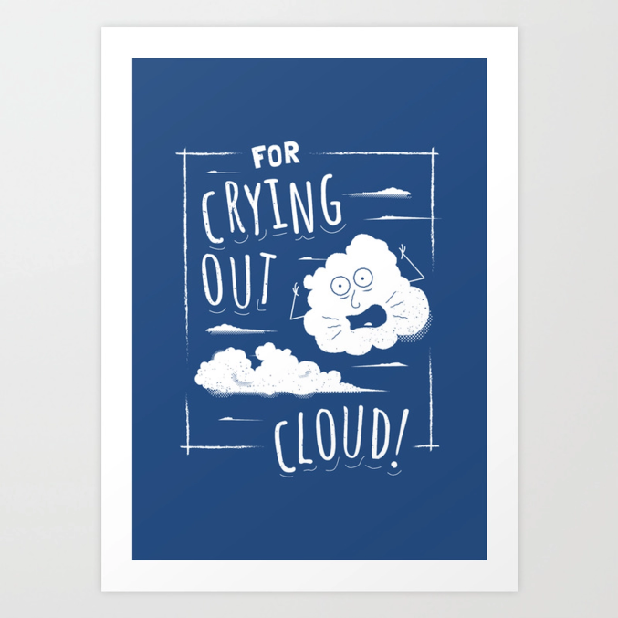
* PM: Pieter, r0666180@student.thomasmore.be
* TL: Alexander, r0759691@student.thomasmore.be
* Shared space:
  + Internal communication via Discord
  + Documentation on GitHub: <https://github.com/roykunnen/For-Crying-Out-Cloud---FCOC>

# Decisions & Feedback:

Project Plan is not finished. We need to add a lot more detail in our plan, and have a schedule.

We need to distribute our work efficiently, so we can work on different parts of the project simultaneously.

Tasks will be broken down into smaller pieces and assigned to team members.

Research costs to make a detailed budget plan, so we know where the expensive parts are situated.

Create the high and low level design.

Make sure every part of the plan is understandable and/ can be explained immediately.

Research what we do not know (yet).

Focus on the priorities first, and create it layer by layer.

Designing the filter will be discussed with the data experts.

Stock management is accounted for, but must be researched further/in detail.

Do not be afraid to ask help.

Planning will be made and sent by 09/10/2020