Meeting Minutes Brantano 2.8: 2nd session

# 09/10/2020, 10:00h

# Subject: Project Plan

# Participants:

**Alexander Van Gils**

**Arne Verhaert**

**Robbe Caes**

**Stijn Van de Cauter**

**Pieter Van der Auwera**

**Roy Kunnen**

**Dries Geysens**

**Alex Willemen**

# Discussed:

**Integrated Security & Data Lab**

**Scope:**

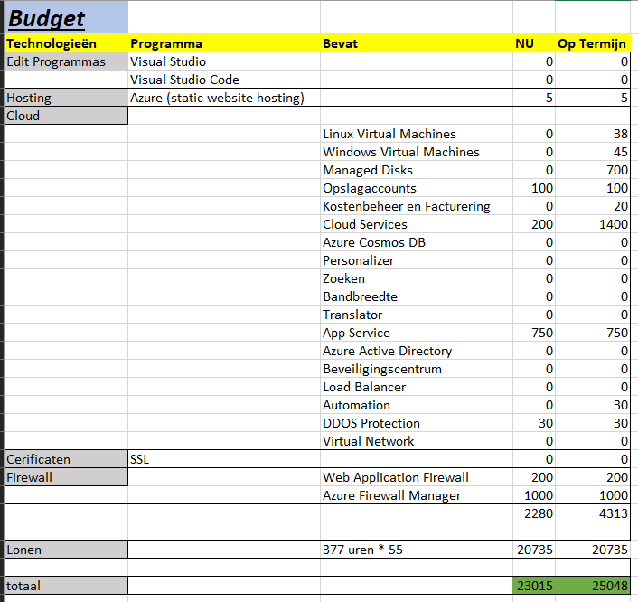

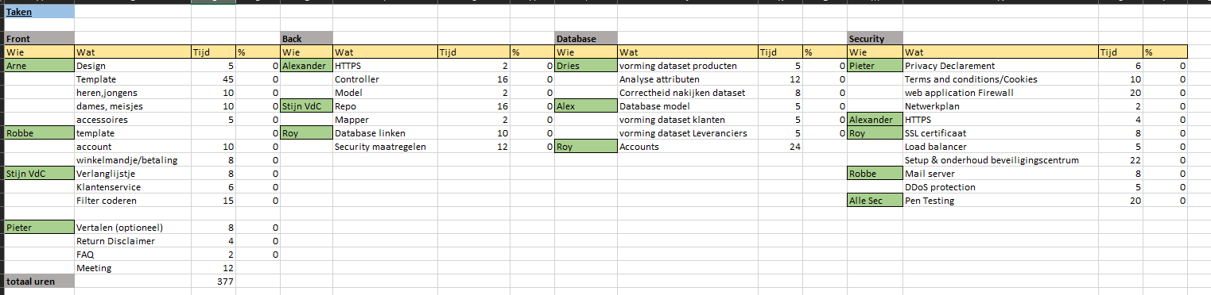

Low Lvl design site

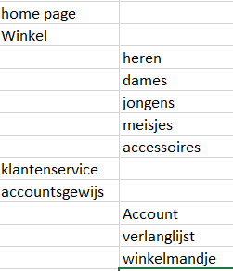

1st draft network topology

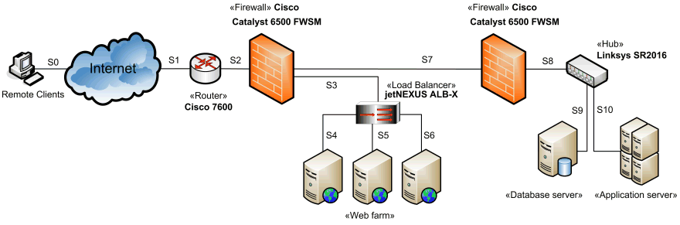

# Decisions & Feedback:

By next week, we will have a high level design ready for the website, as well as a high level design and finished version of the network topology.

We will work out a budget plan for 1, 3 and 5 years.

See what has more benefit: brantano hosts this themselves, or we host it for them.

Make sure every part of the plan is understandable and/ can be explained immediately.

Research what we do not know (yet).

Do not be afraid to ask help.

Next update will be made and sent by 16/10/2020.