Ling 572 HW2

Michael Roylance, Olga Whelan

**Q1** (a) mallet import-svmlight --input examples/train.vectors.txt --output train.vectors

mallet import-file --input examples/test.vectors.txt --output test.vectors --use-pipe-from train.vectors

vectors2classify --training-file train.vectors --testing-file test.vectors --trainer DecisionTree > dt.stdout 2>dt.stderr

(b) train accuracy mean = 0.6377777777777778

test accuracy mean = 0.5233333333333333

**Q2** It looks like Mallet DT learner treats the features as binary. After running the commands below, we get the same accuracy results as in Q1.

./binarize.sh train.vectors.txt train.vectors.bin.txt

./binarize.sh test.vectors.txt test.vectors.bin.txt

mallet import-svmlight --input train.vectors.bin.txt --output train.vectors.bin

mallet import-svmlight --input test.vectors.bin.txt --output test.vectors.bin --use-pipe-from train.vectors.bin

vectors2classify --training-file train.vectors.bin --testing-file test.vectors.bin --trainer DecisionTree > dt.stdout.bin 2>dt.stderr.bin

diff dt.stdout dt.stdout.bin

**Q3** (a)

|  |  |  |
| --- | --- | --- |
| Depth | Training accuracy | Test accuracy |
| 1 | 0.45296296296296296 | 0.4166666666666667 |
| 2 | 0.5207407407407407 | 0.5266666666666666 |
| 4 | 0.6377777777777778 | 0.5233333333333333 |
| 10 | 0.7514814814814815 | 0.6 |
| 20 | 0.8555555555555555 | 0.6833333333333333 |
| 50 | 0.9681481481481482 | 0.7 |
| 100 | 0.9685185185185186 | 0.7 |
| 1000 | 0.9685185185185186 | 0.7 |

(b) We can see that growing the depth of decision tree improves the training accuracy up until 100 nodes deep. The improvement at 100 nodes over 50 nodes is negligible, and there is no improvement at depth of 1000.

But creating a very deep tree overfits the training data and does not generalize it well, i.e. does not improve test accuracy a lot. It can be seen that changing the depth from 20 to 50 nodes brings a more than 10% improvement in training accuracy, but less than 2% improvement in testing.

**Q5**

min_gain = 0

|  |  |  |  |
| --- | --- | --- | --- |
| Depth | Training accuracy | Test accuracy | Wall clock time (in minutes) |
| 1 | 0.452962962963 | 0.416666666667 | 2:46 |
| 2 | 0.520740740741 | 0.53 | 5:39 |
| 4 | 0.637777777778 | 0.526666666667 | 11:32 |
| 10 | 0.751481481481 | 0.6 | 28:00 |
| 20 | 0.855555555556 | 0.67 | 43:21 |
| 50 | 0.968518518519 | 0.683333333333 | 57:31 |

min_gain = 0.1

|  |  |  |  |
| --- | --- | --- | --- |
| Depth | Training accuracy | Test accuracy | Wall clock time (in minutes) |
| 1 | 0.452962962963 | 0.416666666667 | 2:52 |
| 2 | 0.52 | 0.53 | 5:46 |
| 4 | 0.601481481481 | 0.54 | 10:49 |
| 10 | 0.601481481481 | 0.54 | 10:42 |
| 20 | 0.601481481481 | 0.54 | 10:36 |
| 50 | 0.601481481481 | 0.54 | 10:40 |

**Note:** build_dt.cmd has to be run from the directory where build_dt.sh is located.

**Q6** Here f1 is x, f2 is y.

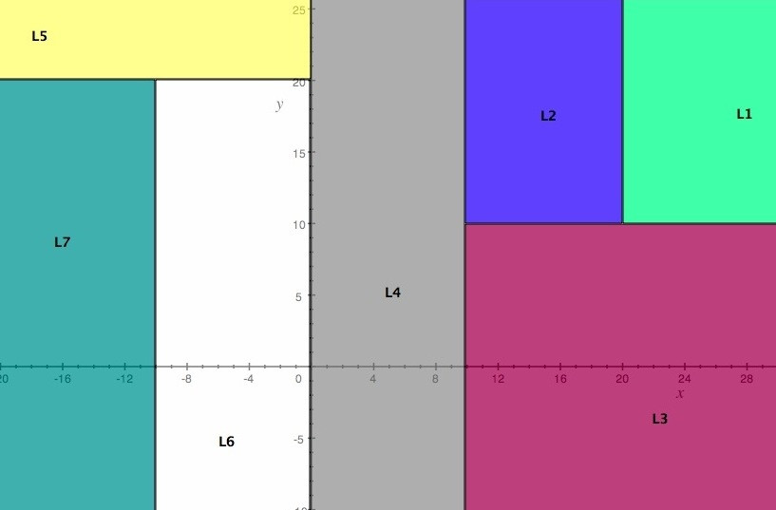

Note: picture is cut off on the top and on the right. It is supposed to extend to x=30 and y=30.