**Duloxetine Versus Escitalopram in Generalized Anxiety Disorder**

**(DEGAD)**

**Ruoxi Li**

**rl3401**

Table of Contents

1 Introduction and Background 1

2 Objectives 3

2.1 Primary 3

2.2 Secondary 3

2.2.1 Improvement in Quality of Life 4

2.2.2 Overall Clinical Improvement 4

2.2.3 Change in Global Functional Impairment 5

2.3 Safety 5

2.3.1 Liver Damage 5

2.3.2 Blood Pressure Alterations 5

2.3.3 Incidence of Serotonin Syndrome 6

3 Trial Design 6

3.1 RCT Features 6

3.2 Blinding 7

3.3 Randomization 8

3.4 Inclusion and Exclusion Criteria 8

3.5 Enrolling Centers 9

3.6 Data Coordination and Trial Management 10

4 Data Collection and Patient Follow-up 10

4.1 Outcome Details 10

4.1.1 Primary Outcome 10

4.1.2 Secondary Outcome 11

4.2 Data Collection Mechanism 12

4.3 Schedule of Visits 12

4.4 Trial Timeline 13

5 Statistical Considerations 14

5.1 Type of Outcome 14

5.2 Power Calculation: 14

5.3 Sample Size 15

5.4 Sensitivity Analysis 16

5.5 Interim Analysis Plan 16

6 Safety Considerations 17

6.1 Liver Damage[6] 18

6.2 Blood Pressure Alterations 18

6.3 Incidence of Serotonin Syndrome 18

6.4 Other Safety Outcomes 18

7 Limitations and late-breaking problems 19

8 References 20

**1 *Introduction and Background:***

Generalized anxiety disorder (GAD) is characterized by excessive anxiety and worry about a variety of events or activities that occurs more days than not, for at least 6 months. People with generalized anxiety disorder find it difficult to control their worry, which may cause impairment in social, occupational, or other areas of functioning. Based on diagnostic interview data from National Comorbidity Survey Adolescent Supplement (NCS-A), an estimated 2.2% of adolescents had generalized anxiety disorder, and an estimated 0.9% had severe impairment[1].

First-line treatments for GAD include psychotherapy or pharmacotherapy, with the latter being the primary choice due to resource efficiency[3,4]. Benzodiazepines were the initial go-to drugs but had issues like addiction potential and were less acceptable to patients[4]. With fluoxetine's introduction, SSRIs and SNRIs became the preferred first-line pharmacotherapy for their improved tolerability and safety[5]. Current first-line drugs include Duloxetine and Escitalopram. However, there is a notable absence of randomized clinical trials directly comparing their efficacy.

In response, I propose a randomized phase 3 trial to assess among males and females aged 18 to 80, of all races, diagnosed with GAD based on the DSM-5-TR criteria, whether Duloxetine (administered as 60 to 120 mg capsules taken orally once daily)[6,7] is more effective than the Standard of Care (SOC), Escitalopram (administered as 10 to 20 mg tablets orally once daily)[3,8,9], in reducing anxiety symptoms, over a 8-week period encompassing both treatment administration and individual follow-up. During this period, the intervention group will be administered Duloxetine, given as 60 to 120 mg capsules taken orally once daily and the control group will receive the Standard of Care (SOC), which is Escitalopram, administered as 10 to 20 mg tablets taken orally once daily. This two parallel group superiority design trial will be conducted across various states in the United States to ensure a diverse and representative sample.

The purpose of this trial is to fill this evidence gap by providing a direct comparison of the efficacy of Duloxetine and Escitalopram in treating GAD, thereby aiding clinicians in making more informed decisions and potentially improving treatment outcomes for GAD patients.

**2 *Objectives***

2.1 Primary

The primary outcome of this trial is the reduction in anxiety symptoms. It is a patient important outcome, as it could reflect how a patient feels or functions, or how long the patient survives.

Null hypothesis is H0: There is no difference in the mean reduction in Hamilton Anxiety Rating Scale (HAM-A)[10,11] scores between the Duloxetine and Escitalopram in males and females aged 18 to 80 diagnosed with GAD based on the DSM-5-TR criteria over 8 weeks .

Two alternate hypotheses are H11: Duloxetine results in a greater mean reduction in HAM-A scores than Escitalopram in males and females aged 18 to 80 diagnosed with GAD based on the DSM-5-TR criteria over 8 weeks. H12: Escitalopram results in a greater mean reduction in HAM-A scores than Duloxetine in males and females aged 18 to 80 diagnosed with GAD based on the DSM-5-TR criteria over 8 weeks.

The primary null hypothesis will be tested using a two-sided test at an alpha level of 0.05. This choice is made to allow for the detection of any significant difference in efficacy between the two drugs, regardless of which drug is more effective. The direction of clinical interest is towards demonstrating the superiority of Duloxetine over Escitalopram, which is H11.

2.2 Secondary

These secondary outcomes will be tested with nominal alpha level = 0.05 two-sided. With multiple tests or comparisons, the p-values achieved, if unadjusted, are thus “nominal”. They cannot be interpreted as significant or not by using the 0.05 or less criterion.

2.2.1 Improvement in Quality of Life

Null hypothesis:

H0: There is no difference in the mean improvement in Quality of Life Enjoyment and Satisfaction Questionnaire Short Form (Q-LES-Q-SF)[12] scores between the Duloxetine and Escitalopram in males and females aged 18 to 80 diagnosed with GAD based on the DSM-5 criteria over 8 weeks .

Two alternate hypotheses:

H11: Duloxetine results in a greater mean improvement in Q-LES-Q-SF scores than Escitalopram in males and females aged 18 to 80 diagnosed with GAD based on the DSM-5-TR criteria over 8 weeks.

(H12): Escitalopram results in a greater mean improvement in Q-LES-Q-SF scores than Duloxetine in males and females aged 18 to 80 diagnosed with GAD based on the DSM-5-TR criteria over 8 weeks.

2.2.2 Overall Clinical Improvement

Null hypothesis is H0: There is no difference in the mean reduction in the Clinical Global Impressions of Improvement scale (CGI-I) [13] scores between the Duloxetine and Escitalopram in males and females aged 18 to 80 diagnosed with GAD based on the DSM-5 criteria over 8 weeks .

Two alternate hypotheses are H11: Duloxetine results in a greater mean reduction in CGI-I scores than Escitalopram in males and females aged 18 to 80 diagnosed with GAD based on the DSM-5-TR criteria over 8 weeks. H12: Escitalopram results in a greater mean reduction in CGI-I scores than Duloxetine in males and females aged 18 to 80 diagnosed with GAD based on the DSM-5-TR criteria over 8 weeks.

2.2.3 Change in Global Functional Impairment

Null hypothesis is H0: There is no difference in the mean reduction in Sheehan Disability Scale (SDS) Global Functional Impairment[14-17] scores between the Duloxetine and Escitalopram in males and females aged 18 to 80 diagnosed with GAD based on the DSM-5 criteria over 8 weeks.

Two alternate hypotheses are H11: Duloxetine results in a greater mean reduction in SDS Global Functional Impairment scores than Escitalopram in males and females aged 18 to 80 diagnosed with GAD based on the DSM-5-TR criteria over 8 weeks. H12: Escitalopram results in a greater mean reduction in SDS Global Functional Impairment scores than Duloxetine in males and females aged 18 to 80 diagnosed with GAD based on the DSM-5-TR criteria over 8 weeks.

2.3 Safety

2.3.1 Liver Damage[6]

Instrument used for measurement will be Liver function tests, which yield continuous data and will be measured at baseline, biweekly thereafter, and upon the emergence of related symptoms.

2.3.2 Blood Pressure Alterations[6]

Instrument used for measurement will be blood pressure monitor, which yield continuous data and will be measured at baseline, biweekly thereafter, and upon the emergence of related symptoms.

2.3.3 Incidence of Serotonin Syndrome[6,7]

Instrument used for measurement will be assessment and diagnostic exclusion by clinicians, which yield categorical data and will be measured at baseline, biweekly thereafter, and upon the emergence of related symptoms.

**3 *Trial Design***

3.1 RCT Features

This study is a Phase 3, randomized, multi-center clinical trial with a two parallel group superiority design. It aims to compare the efficacy of Duloxetine and Escitalopram in treating GAD in adults over a 8-week period, encompassing both treatment administration and individual follow-up.

1. Prospective: This trial uses a prospective design, assessing the association between intervention and clinical outcomes by sampling an intervention group and a control group and following them for a 8-week period, which encompasses both the administration of treatment and individual follow-up.
2. Intervention: During the 8-week study period, the intervention group will be administered Duloxetine, given as 60 to 120 mg capsules taken orally once daily.
3. Control group: During the 8-week study period, the control group will receive the Standard of Care (SOC), which is Escitalopram, administered as 10 to 20 mg tablets taken orally once daily.
4. Randomization: The study will use randomly permuted blocks and randomization will be stratified by site.
5. Double-Blinding: In this study, neither the participants nor the clinicians will be informed about the specific medication being administered. Additionally, the study will incorporate a double-dummy design, ensuring that both the experimental and control groups receive treatments that are indistinguishable in appearance and administration.
6. Intent-To-Treat (ITT) primary analysis: We will include all randomized patients in the analysis according to their initial group assignment.

7.complete follow-up: We will obtain final outcome status on all randomized patients by ensuring complete follow-up by scheduling regular visits, using automated reminders, assigning a dedicated follow-up team, updating contact information, and providing incentives.

3.2 Blinding

This trial will be a double-blinded trial, which means both the participants and the clinicians administering the treatments will be blinded. The advantage is that clinicians or patients cannot consciously or unconsciously favor one intervention over the other. Besides, blinding preserves the benefits of randomization by protecting against bias after trial start and over the course of the trial.

Here’s an explanation of the steps taken to ensure blinding and the advantages of this approach:

Firstly, in this study, neither the patients nor the clinicians will be informed about the specific medication being administered.

Secondly, the study will use a double-dummy design, ensuring that treatments for both the experimental and control groups are indistinguishable in appearance and administration. For the intervention group, participants will be receiving two sets of medication bottles as follows: the bottle of Duloxetine contains Active Duloxetine and the bottle of Escitalopram contains Placebo Escitalopram. For the control group, participants will be receiving two sets of medication bottles as follows: the bottle of Duloxetine contains Placebo Duloxetine and the bottle of Escitalopram contains Active Escitalopram.

3.3 Randomization

This study will first stratify participants by site and then employ a randomly permuted block design for randomization.We will use sites as the stratification variable as sites vary greatly in terms of risk factors of their patients, and therefore in event rates for primary outcomes in RCTs. Besides, if one site leaves, balance in rest of trial others is not affected. Additionally, each site in effect conducts a small replication of the trial. Its result can be compared to the overall trial result. We do not need to stratify by other factors, as we have overall randomization, which we expect to provide balance on all other factors, adjusted and unadjusted.

After stratifying participants by site, treatment assignment will follow a randomly permuted blocks scheme. Each participant within a block is assigned one of the two treatment arms in a predetermined, random order to ensure balanced group sizes within each block. Participants will be assigned to blocks with varying sizes: 2, 4, and 6, in predetermined proportions of 50%, 30%, and 20%, respectively. The selection of the next block's size is entirely random and unpredictable from these available options. Within each block, randomization is conducted to determine the treatment assignments.

3.4 Inclusion and Exclusion Criteria

Main Inclusion Criteria:

1. Patients with a confirmed diagnosis of GAD based on the DSM-5-TR criteria.
2. Patients aged 18 to 80 years.It is to ensure that participants are able to make independent decisions to participate in clinical trials.
3. Both male and female. As it can increase the external effectiveness of the study.
4. Inclusive of all races to ensure a diverse representation.
5. Patients from designated regions where the multi-center trial is being conducted.
6. Participants must be able to understand and provide written informed consent.

Main Exclusion Criteria:

1. Females who are pregnant, nursing, or have recently given birth. Because SSRI use, particularly later in pregnancy, may increase the risk for persistent pulmonary hypertension and symptoms of poor adaptation in the neonate[8].
2. Individuals with a documented hypersensitivity to either Duloxetine or Escitalopram.
3. Participants with a history of suicide attempts within the past year or those currently deemed at risk of suicide by the investigator. An increased risk of suicidal thoughts and behavior in young adult patients taking Escitalopram is reported[8].
4. Participant with any DSM-5-TR Axis I diagnosis besides GAD, specifically: diagnosis of major depressive disorder within the past 6 months; diagnosis of panic disorder or post-traumatic stress disorder within the past year; lifetime diagnosis of disorders such as obsessive-compulsive disorder, bipolar affective disorder or somatoform disorders[2]. As it may reduce the internal validity of the HAM-A in responding to the anxiety symptoms.
5. Participant with any DSM-5-TR Axis II disorder or historical antisocial behavior patterns deemed by the investigator as potentially disruptive to study protocol adherence[2]. It is to ensure that participants can comply with the research protocol and provide reliable data.

3.5 Enrolling Centers

The trial will include major medical centers, university hospitals, and mental health clinics as enrolling centers across the United States.

3.6 Data Coordination and Trial Management

There will be Data Coordinating Center (DCC) and Clinical Trial Management (CTM) resources for this proposed trial. DCC plays a role in coordinating and implementing large multi-center randomized controlled trials by bringing expertise in planning, conduct, monitoring, analysis and reporting and in data management, quality control and quality assurance, and information technology support for trial monitoring and communication[18].The CTM is responsible for overseeing all facets of one or more clinical trials, from the initial start-up phase right through to the database lock, encompassing milestone tracking, budget management, and ensuring strict adherence to regulations[19].

**4 *Data Collection and Patient Follow-up***

4.1 Outcome Details

4.1.1 Primary Outcome

The primary outcome is the reduction in anxiety symptoms and it is a patient important outcome.

The instrument used for the outcome is HAM-A. HAM-A is a questionnaire administered by clinicians to measure the severity of perceived anxiety symptoms. This 14-item questionnaire delves deep into the nuances of anxiety. Scores on the HAM-A range from 0 to 56. A notable decline in score during treatment typically signifies a patient's improvement in managing anxiety[10,11]. The reliability and the concurrent validity of the HAM-A are proved to be sufficient[20].

HAM-A measurements will be taken at the start of treatment and the end of the treatment period and will be administered by trained clinical personnel at the enrolling center. After each assessment, DCC will record each patient's total score on the HAM-A, which is continuous.

4.1.2 Secondary Outcome

The second outcomes include improvement in Quality of Life, which is a patient important outcome. The instrument used for this outcome is the Q-LES-Q-SF. It is a self-administered instrument that consists of 16 items designed to assess a patient's satisfaction and enjoyment across various domains of daily life. Only the first 14 items contribute to the total score, which ranges from 14 to 70, where a higher score reflects a greater degree of life satisfaction and` enjoyment[12]. According to studies, the English version of the Q-LES-Q-SF is a valid, reliable self-report instrument for assessing Quality of Life[21].

Measurements for Q-LES-Q-SF will be taken at the start of treatment and every four weeks until the end of the treatment period and will be self-administered at the enrolling center. After each assessment, DCC will record each patient's score on the Q-LES-Q-SF, which is continuous.

The second outcomes also include overall clinical improvement, which is a patient important outcome. The instrument used for this outcome is CGI-I. Each time the patient is seen after medication has been initiated, the clinician compares the patient's overall clinical condition to the one week period just prior to the initiation of medication use. The score is rated on a seven-point scale: Compared to the patient's condition at admission to the project, this patient's condition is: 1=very much improved since the initiation of treatment; 2=much improved; 3=minimally improved; 4=no change from baseline (the initiation of treatment); 5=minimally worse; 6= much worse; 7=very much worse since the initiation of treatment. The CGI is proven to be valid clinical outcome measure suitable for routine use[22].

CGI-I measurements will be taken one week before starting medication and then every four weeks during treatment until the end of the treatment period and will be administered by clinicians at the enrolling center. After each assessment, DCC will record each patient's score on the CGI-I, which is continuous.

The second outcomes include change in functional impairment as well, which is also a patient important outcome. The instrument used for this outcome is SDS. SDS is a short, simple, and cost-effective measure of disability and functional impairment that can be quickly administered and scored without disrupting the flow of routine care. The SDS is a composite of three self-rated items designed to measure the extent to which three major domains in the patient’s life are functionally impaired by psychiatric or medical symptoms. The SDS assesses functional impairment in three major life domains: work, social life/leisure activities, and family life/home responsibilities. Its validity and reliability has been investigated in several studies[14-17].

Measurements for SDS will be taken at the start of treatment and every four weeks until the end of the treatment period and will be self-administered at the enrolling center. After each assessment, DCC will record each patient's SDS Global Functional Impairment score, which is continuous.

4.2 Data Collection Mechanism

We will a web-based data management system with Electronic Case Report Forms (eCRFs).

4.3 Schedule of Visits

|  |  |  |  |  |  |  |  |
| --- | --- | --- | --- | --- | --- | --- | --- |
|  | Screening Period | | Double-Blind Treatment Period | | | | |
| **Milestones** |  |  |  |  |  |  | EOT/EOS* |
| **Visit Number** | V1 | V2 | V3 | V4 | V5 | V6 | V7 |
| **Day** | d-14 | d-7 | d1 | d15 | d29 | d43 | d57 |
| **Week** | Wk-2 | Wk-1 | Wk0 | Wk2 | Wk4 | Wk6 | Wk8 |
| **Screening/Baseline:** |  |  |  |  |  |  |  |
| Trial Informed Consent | X |  |  |  |  |  |  |
| Inclusion/exclusion | X |  |  |  |  |  |  |
| Medical history | X |  |  |  |  |  |  |
| Medication history | X |  |  |  |  |  |  |
| Demographics | X |  |  |  |  |  |  |
| Randomization |  | X |  |  |  |  |  |
| IVRS/IWRS contact |  | X |  |  |  |  |  |
| **Treatment:** |  |  |  |  |  |  |  |
| Administration Training | X |  |  |  |  |  |  |
| Administer Study Drug |  | X |  |  |  |  |  |
| Study Drug Dispensation |  |  | X |  | X |  |  |
| Kit Return |  |  |  |  | X |  | X |
| Concomitant Medications |  |  | X |  | X |  |  |
| **Safety Assessments:** |  |  |  |  |  |  |  |
| Blood Pressure |  |  | X | X | X | X | X |
| Serotonin Syndrome Check |  |  | X | X | X | X | X |
| **Lab Testing:** |  |  |  |  |  |  |  |
| Liver function tests |  |  | X | X | X | X | X |
| **Primary outcome assessment:** |  |  |  |  |  |  |  |
| HAM-A |  |  | X |  |  |  | X |
| **Secondary outcome assessment:** |  |  |  |  |  |  |  |
| Q-LES-Q-SF |  |  | X |  | X |  | X |
| CGI-I |  | X |  |  | X |  | X |
| SDS |  |  | X |  | X |  | X |

Table 1. Schedule of Visits

X: Required Measurements

*EOT = End of Treatment, EOS = End of Study

4.4 Trial Timeline

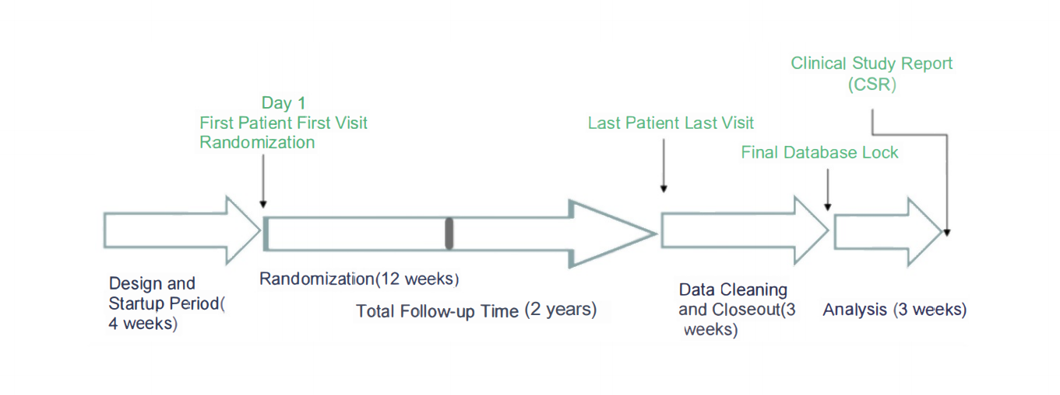

Figure 1. Estimated Trial Timeline

**5 *Statistical Considerations***

5.1 Type of Outcome

Primary outcome data type is continuous. Statistical test for the null and alternative hypotheses will be Analysis of Covariance (ANCOVA). Statistical design is superiority, experiment wide type I error rate is 0.05, test is two-sided.

5.2 Power Calculation:

Based on the literature, we identified an unadjusted effect size of 10.1 for the control group, representing the average reduction in anxiety symptoms measured by the HAM-A over an 8-week period. Consequently, we have set the least clinically meaningful effect size at 12.1, which is 20% greater than that of the control group[23].

For intervention group, we assume:

%CrossoversI: 5%; %NoncompliersI: 10%; %FullcompliersI: 85%

For control group, we assume:

%CrossoversC: 5%; %NoncompliersC: 10%; %FullcompliersC: 85%

For Crossovers, we use the unadjusted effect size from the other arm. For noncompliers, we use the average of the unadjusted effect size from two groups.

For Intervention group, Adjusted Effect Size is:

(5%*10.1)+(10%*11.1)+(85%*12.1)=11.9

For Control group, Adjusted Effect Size is:

(5%*12.1)+(10%*11.1)+(85%*10.1)=10.3

The Adjusted Effect Sizes account for potential bias introduced by noncompliance or crossover effects, making the sample size calculation more robust and reflective of the actual expected outcomes in the study.

5.3 Sample Size

A Sample Size of 696 is needed for my trial for my desired level of power, which is 0.8, with the standard error controlled at 7.44 based on previous publications[23].

The adjusted effect sizes for the intervention and control groups were calculated using the assumptions of 5% crossovers, 10% noncompliers, and 85% full compliers for both groups, along with specific unadjusted effect sizes for each category, and the average of unadjusted effect sizes of both groups for noncompliers.

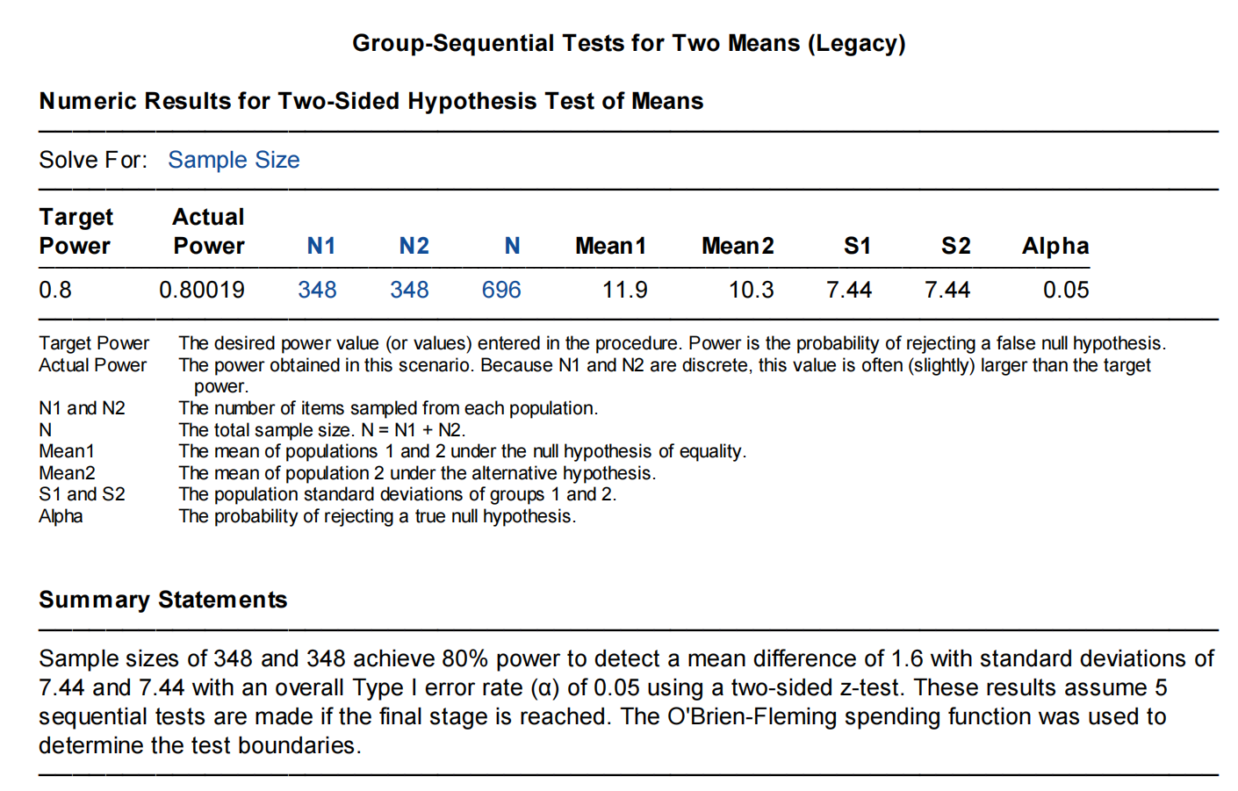

Figure 2. Report for Adjusted Sample Size

5.4 Sensitivity Analysis

Table 2. Sensitivity Analysis

|  |  |  |  |
| --- | --- | --- | --- |
| Total Sample Size with Power = 0.8 | | | |
|  | δ =1.7 | δ = 1.6 | δ =1.5 |
| σ =7.0 | 546 | 616 | 702 |
| σ =7.44 | 618 | 696 | 792 |
| σ =8.0 | 714 | 806 | 916 |

We can see that the total sample size with the fixed power tends to grow as the σ increases or the δ decreases. That is because as the data variability grows, identifying a genuine effect becomes more challenging, requiring an increased sampling to attain the same assurance. Similarly, to discriminate smaller effects from the noise caused by data variability, we must increase the sample size as the effect size's magnitude decreases.

As for this trial, the table underlines the importance of accurate estimates for both the standard deviation and the effect size when planning. For cost-effective research, efforts should be made to reduce variability within the data and to have a clear rationale for the expected effect size to ensure that the study is not underpowered or overpowered.

5.5 Interim Analysis Plan

Our Interim Analysis Plan for the clinical trial involves five equally spaced interim analyses, including the final analysis, which are conducted at 20%, 40%, 60%, 80%, and 100% of information, respectively. The interim analysis plan for this clinical trial, utilizing the O'Brien-Fleming method, provides a structured approach to controlling the Type I error rate at an overall alpha of 0.05 while allowing for potential early stopping based on efficacy or futility. Stopping boundaries are symmetric, as we use an active control.

The terminal criteria for stopping the trial are based on the stopping boundaries. If z-score that crosses the upper boundary would indicate a significant positive result, suggesting that the trial could be stopped early due to efficacy. Conversely, crossing the lower boundary could suggest futility or harm, prompting early termination.

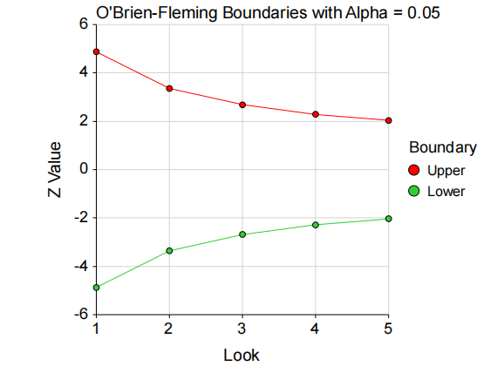

Figure 3. Sequential Monitoring of Clinical Trial: The Interim Analysis

The graph presents the O'Brien-Fleming stopping boundaries for interim analyses in our trial, The x-axis represents interim analysis points, the y-axis denotes the Z-value. The red line shows the upper boundary, the green line represents the lower boundary. The points mark the critical values at which a trial could be stopped for efficacy or safety.

In our trial proposal, these boundaries will serve as critical checkpoints for decision-making regarding the continuation of the trial. Each interim look will be taken as per the predetermined schedule, with the potential to stop the trial early if the observed Z-value crosses either the upper or lower boundary.

**6 *Safety Considerations***

Since Duloxetine and Escitalopram are FDA-approved medications, referring to their label information reveals that liver damage and blood pressure alterations are among the most common potential side effects in individuals taking Duloxetine, while serotonin syndrome is a common potential effect in individuals taking either Duloxetine or Escitalopram.

6.1 Liver Damage[6]

Instrument used for measurement will be Liver function tests, which include alanine transaminase (ALT) and aspartate transaminase (AST), alkaline phosphatase (ALP), gamma-glutamyl transferase (GGT), serum bilirubin, prothrombin time (PT), the international normalized ratio (INR), total protein and albumin. These tests can help determine an area of the liver where damage may be taking place and, depending on the pattern of elevation, can help organize a differential diagnosis[25]. Tests yield continuous data and will be measured at baseline, biweekly thereafter, and upon the emergence of related symptoms.

6.2 Blood Pressure Alterations[6]

Instrument used for measurement will be blood pressure monitor. It yield continuous data and will be measured at baseline, biweekly thereafter, and upon the emergence of related symptoms.

6.3 Incidence of Serotonin Syndrome[6,7]

Instrument used for measurement will be assessment and diagnostic exclusion by clinicians. Serotonin syndrome requires a thorough review of medications and a careful physical exam. The Hunter test is accepted as the most accurate criteria for diagnosis and is designed specifically for patients with SSRI overdose[25]. It yield categorical data and will be measured at baseline, biweekly thereafter, and upon the emergence of related symptoms.

6.4 Other Safety Outcomes

Other more general safety outcomes my trial will monitor include weight and appetite changes, discontinuation syndrome and death.

**7 *Limitations and late-breaking problems***

The internal validity of the HAM-A was deemed insufficient as its ability to distinctly identify anxiolytic and antidepressant effects being unclear[20]. However, by applying exclusion criteria that removed participants with any DSM-5-TR Axis I diagnosis other than GAD, we aimed to mitigate this issue. Additionally, our trial focused only on short-term efficacy differences (8 weeks) and cannot assess the long-term efficacy differences between the two treatments.

**8 *References***

[1] National Institute of Mental Health [Internet]. Generalized Anxiety Disorder [cited 2023 Nov 3]. Available from: <https://www.nimh.nih.gov/health/statistics/generalized-anxiety-disorder>.

[2] American Psychiatric Association. Diagnostic and Statistical Manual of Mental Disorders. 5th ed., text rev. Arlington, VA: American Psychiatric Association, 2022.

[3] adaa.org [Internet]. Clinical Practice Review for GAD; c2023 [cited 2023 Nov 3]. Available from: <https://adaa.org/resources-professionals/practice-guidelines-gad>

[4] Slee A, Bondaronek P, Liu Y, Cheng Z, Freemantle N. Pharmacological treatments for generalised anxiety disorder: a systematic review and network meta-analysis. Lencet. 2019;393(10173), 768-77.

[5] Bui E, King F, Melaragno A. Pharmacotherapy of anxiety disorders in the 21st century: A call for novel approaches. Gen Psychiatr. 2019;32(6):e100136.

[6] U.S. Food and Drug Administration [Internet]. Label for CYMBALTA [cited 2023 Nov 3]. Available from: <https://www.accessdata.fda.gov/drugsatfda_docs/label/2023/021427s055s057lbl.pdf>

[7] U.S. Food and Drug Administration [Internet]. 021427s009, 20021427s011, 20021427s013ltr.pdf [cited 2023 Nov 3]. Available from: <https://www.accessdata.fda.gov/drugsatfda_docs/appletter/2007/021427s009,%20021427s011,%20021427s013ltr.pdf>

[8] U.S. Food and Drug Administration [Internet]. Label for Lexapro [cited 2023 Nov 3]. Available from: <https://www.accessdata.fda.gov/drugsatfda_docs/label/2023/021323s057,021365s040lbl.pdf>

[9] U.S. Food and Drug Administration [Internet]. [cited 2023 Nov 3]. Available from: <https://www.accessdata.fda.gov/drugsatfda_docs/nda/2003/021323_S003&021365_S004_LEXAPRO_TABS.pdf>

[10] Thompson E. Hamilton Rating Scale for Anxiety (HAM-A). Occup Med. 2015;65(7):601.

[11] Hamilton M.The assessment of anxiety states by rating. Br J Med Psychol. 1959;32:50-5.

[12] Endicott J, Nee J, Harrison W, Blumenthal R. Quality of Life Enjoyment and Satisfaction Questionnaire: a new measure. Psychopharmacol Bull. 1993, 29(2):321-6.

[13] Busner J, Targum SD. The clinical global impressions scale: applying a research tool in clinical practice. Psychiatry (Edgmont). 2007;4(7):28-37.

[14] Sheehan KH; Sheehan DV. Assessing treatment effects in clinical trials with the discan metric of the Sheehan Disability Scale. International Clinical Psychopharmacology 2008;23(2):70-83.

[15] Leon AC, Shear MK, Portera L, Klerman GL. Assessing impairment in patients with panic disorder: the Sheehan Disability Scale. Soc Psychiatry Psychiatr Epidemiol. 1992;27:78–82.

[16] Leon AC, Olfson M, Portera L, Farber L, Sheehan DV. Assessing impairment in primary care: a psychometric analysis of the Sheehan Disability Scale. Int J Psychiatry Med. 1997;27:93–105.

[17] Olfson M, Kathol RG, Weissman MM, Sheehan DV, Leon AC, Hoven C. Mental Disorders and Disability in a Primary Care Group Practice. American Journal of Psychiatry. 1997; 154: 1734-1740.

[18] University of Wisconsin-Madison [Internet]. Data Coordinating Center; c2023 [cited 2023 Dec 11]. Available from: <https://biostat.wiscweb.wisc.edu/research/clinical-trials/data-coordinating-center/>

[19] Precision Medicine Group, LLC [Internet]. Inside a CRO: The Pivotal Role of Clinical Trial Manager in Clinical Research; c2023 [cited 2023 Dec 11]. Available from: <https://www.precisionformedicine.com/blogs/inside-a-cro-the-pivotal-role-of-clinical-trial-manager-in-clinical-research/>

[20] Maier W, Buller R, Philipp M, Heuser I. The Hamilton Anxiety Scale: reliability, validity and sensitivity to change in anxiety and depressive disorders. J Affect Disord. 1988;14(1):61-8.

[21] Riendeau RP, Sullivan JL, Meterko M, Stolzmann K, Williamson AK, Miller CJ, et al. Factor structure of the Q-LES-Q short form in an enrolled mental health clinic population. Qual Life Res. 2018;27(11):2953-64.

[22] Berk M, Ng F, Dodd S, Callaly T, Campbell S, Bernardo M, et al. The validity of the CGI severity and improvement scales as measures of clinical effectiveness suitable for routine clinical use. J Eval Clin Pract. 2008;14(6):979-83.

[23]Goodman WK, Bose A, Wang Q.Treatment of generalized anxiety disorder with escitalopram: Pooled results from double-blind, placebo-controlled trials. J Affect Disord. 2005;87(2-3):161-167.

[24] Wright A, Vandenberg C. Duloxetine in the treatment of generalized anxiety disorder. Int J Gen Med. 2009;2:153-62.

[25] Simon LV, Keenaghan M. Serotonin Syndrome. [Updated 2023 Jul 17]. In: StatPearls [Internet]. Treasure Island (FL): StatPearls Publishing; 2023 Jan-. Available from: <https://www.ncbi.nlm.nih.gov/books/NBK482377/>