**Logical Proof Tool – User Manual**

**Table of Contents:**

1. **General information 2**
2. **Interface use** **3-5**
3. **Rules** **6-31**
   1. Assumption 6
   2. Data 7
   3. Copy 8
   4. And Introduction (“∧i“ ) 9
   5. And Elimination (“∧e1”, “∧e2”) 10
   6. Or Introduction (“∨i1”, “∨i2”) 11
   7. Or Elimination (“∨e”) 12
   8. Law of Excluded Middle (“LEM”) 13
   9. Arrow Introduction (“→i”) 14
   10. Modus Ponens (“MP”) 15
   11. Modus Tollens (“MT”) 16
   12. Negation Introduction (“¬i”) 17
   13. Negation Elimination (“¬e”) 18
   14. Double Negative Introduction (“¬¬i") 19
   15. Double Negative Elimination (“¬¬e”) 20
   16. Contradiction Elimination (“⊥e”) 21
   17. Proof by Contradiction (“PBC”) 22
   18. Proven i 23
   19. Proven e 24

**Predicates**

* 1. Variable Introduction (“X0/Y0 i”) 25
  2. Equal Introduction (“=i”) 26
  3. Equal Elimination (“=e”) 27
  4. All Introduction (“∀x i”, “∀y i”) 28
  5. All Elimination (“∀x e”, “∀y e”) 29
  6. Exist Introduction (“∃x i”, “∃y i”) 30
  7. Exist Elimination (“∃x e”,” ∃y e”) 31

1. **General information:**

**About the tool:**

This is a tool that was made in order to help people to write logical proofs. It **does not** solve logical expressions.

This tool consists of two parts: Logical Proof, and Text Editor. Many usage examples are present in the example folder. The tool also allows you to, save and load to/from word documents.

**Text Editor Usage:**

The Text Editor is designed mainly in order for writing logical statements. The tool’s keyboard has Greek letters and logical symbols that can help writing proofs more easily than any other text editor.

Saving from text editor will copy all the textbox content that has been written into it, to a word document.

The Text Editor is more suited for **English** use.

**Logical Proof Usage:**

Using the Logical Proof requires entering a valid logical expression at the text box at the top of the page, which will be referred as the main logical expression. It must contain exactly one ⊢ symbol between two valid logical expressions, the one to the right is the expression you want to prove. Some examples for a valid main expression:

p^q ⊢ q

P(t), ∀x(P(x)→¬Q(x)) ⊢ ¬Q(t)

⊢ (q→r) → ((¬q→¬p) → (p→r))

Then you can add a statement and pick a rule. After choosing a rule up to 3 segments can show up, in them you write the reasoning for the statement. Instead of commas you just write them in the different segments. For example

Note that the dash symbol (' – ') does not mean a new segment is needed, only if it were to be a comma.

Those symbols are equal:

> →

~ ¬

^ ∧

v ∨

1. **Interface use**

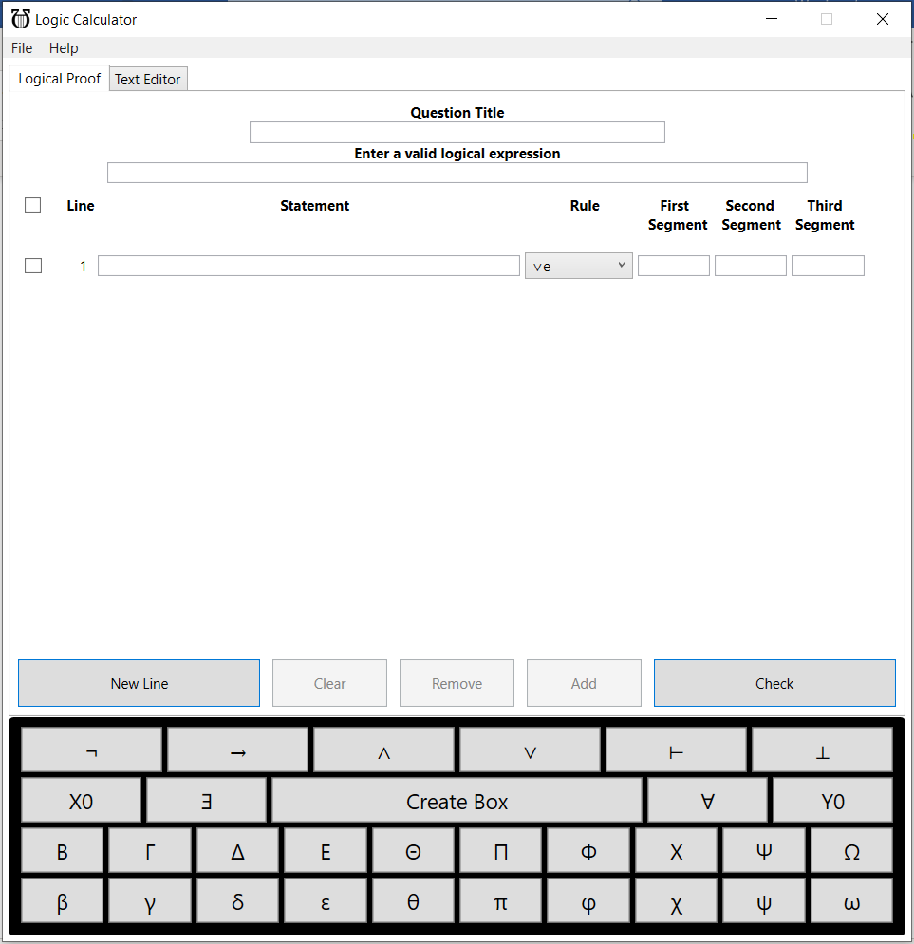

*Note: Ctrl + Click on every hyper link over picture will jump to correct page.

* **Keyboard**

Clicking any button but the "Create Box" button will put the clicked symbol wherever the cursor is currently placed, in both the Text Editor and the Logical Proofs.

* **Create Box** – available **only** in the Logical proofs tab, requires checking 2 lines around the area that you want the box to surround. The upper closer of the box will be placed **above the upper** checked line, and the bottom closer will be placed **under the lower** checked line. A box must contain at least one line.
* **New Line**

Adds new line at bottom of the table.

* **Clear**

Remove all text inputs in the selected lines, must check at least one line.

* **Remove**

Delete all selected lines, must check at least one line. When removing a box opener/closer, you must also remove the respective closer/opener.

* **Add**

Add **one** new line **above** each selected line, need to check at least one line.

* **Check**

Checks if the proof is valid, and if the thing that was needed to be proven has been achieved.

User will get notification if something is wrong in his proof and the tool will point to the place the problem takes place and the reason.

* **Master Checkbox**

Check/Uncheck all lines in proof, if checked, tool will open buttons for “check mode” - “Clear”, “Remove” and “Add”, if unchecked tool will go back to “insert mode”.

* **Checkbox**

Check specific line, when used, tool will open buttons for “check mode” - “Clear”, “Remove” and “Add”

* **Rule Picker**

Drop down all available rules.

* **Main expression**

The logical proof expression should be written inside that text box, must be filled in order to use the Logic Proofs tool. Must be valid logical expression.

* **Question Title**

Will be the written as title in the word file when the proof is saved, **optional.**

* **Tab Picker**

Switch tabs between “Logical Proof” and “Text Editor” by clicking on the corresponding tab. When saving, the currently picked tab's content will be saved.

* **Menu bar**
  + **File:**
    - **New**

Clear all current input in both tabs.

* + - **Open**

Loads the content of a word document to the tool. If the file a Logical Proof made by this tool it will load to “Logical Proof”. Otherwise, it will load to the “Text Editor”.

* + - **Save**

Opens the save to word document dialog.

* + - **Exit**

Closes the software (same as clicking the X in the top right of the screen).

* + **Help:**
    - **User Manual**

Opens the user manual (which you are reading).

* + - **About**

Show copyrights.

* **Minimize**

Minimize program (no data will be lost).

1. **Rules**

**Assumption**

* **General info:**

Assumption can be any logical expression or variable.

* **Limitation:**

Assumption must start have a box opener or variable introduction (X0/Y0i) above it.

* **Tool Example:**

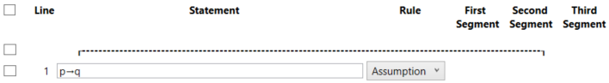

**Data**

* **General info:**

Use for data that was declared in the main expression.

* **Limitation:**

Data declaration is valid only if the expression is written in main expression as data.

* **Tool Example:**

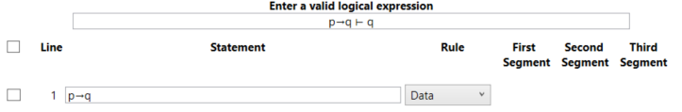

**Copy**

* General info:

Copy statement to current line.

* Segments use:

One segment for line number of the statement that is supposed to be copied.

* Limitation:

Can copy only from the current box or boxes that contain it.

* Presentation example:

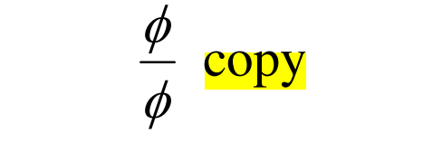

* 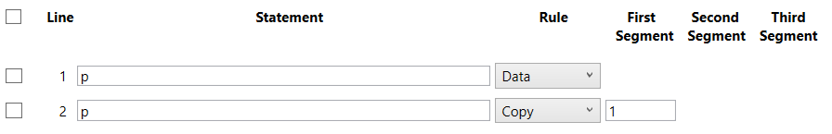Tool Example:

**And Introduction (“∧i“)**

* **General info:**

Combine two already known variables.

* **Segments use:**

One segment for line number of first variable and another segment for the line number of second variable.

* **Limitation:**

None

* **Presentation example:**

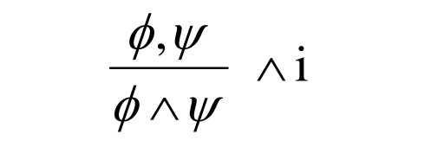

* **Tool example:**

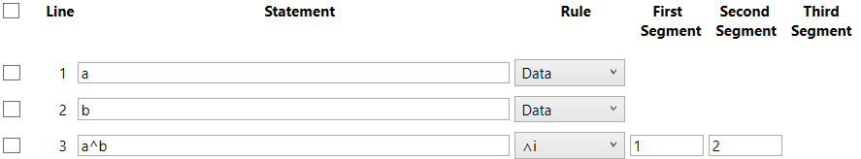

**And Elimination (“∧e1”, “∧e2”)**

* **General info:**

Used to extract one variable from two variables connected with “∧”.

'∧e1' gets the left variable. '∧e2' gets the right variable.

* **Segments use:**

One segment for the line number of the statement that contains “∧” between two variables or expressions.

* **Limitation:**

None

* **Presentation example:**

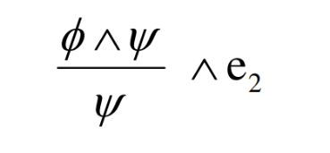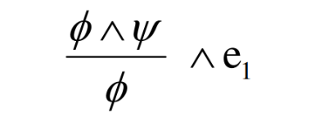

* 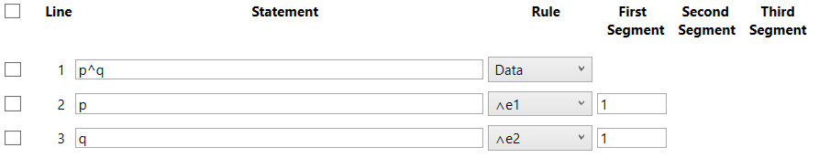**Tool Example:**

**Or Introduction (“∨i1”, “∨i2”)**

* **General info:**

If 'x' is true, then it's always true that 'x or something' is true.

'∨e1' adds to the right of the variable. '∨e2' adds to the left of the variable

* **Segments use:**

One segment for the expression that you wanted to add to.

* **Presentation example:**

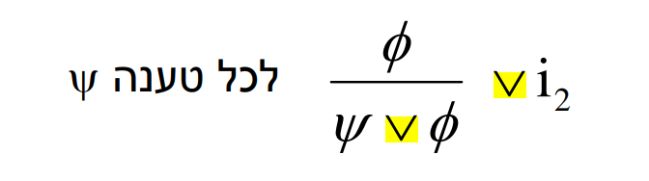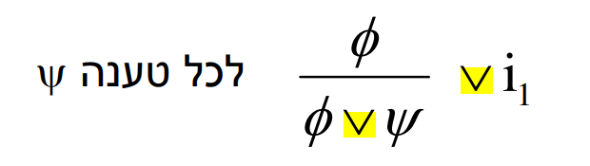

* 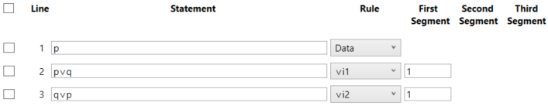**Tool Example:**

**Or Elimination (“∨e”)**

* **General info:**

Assuming you have a∨b and you show that a→c and b→c then you can always get to c, which means that c is a fact.

* **Segments use:**

The first segment marks the original 'or' expression. The other two segments refer to the boxes that show both sides of the mentioned expression reaching to the same conclusion.

* **Presentation example:**

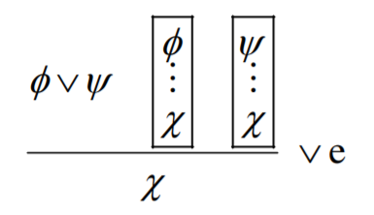

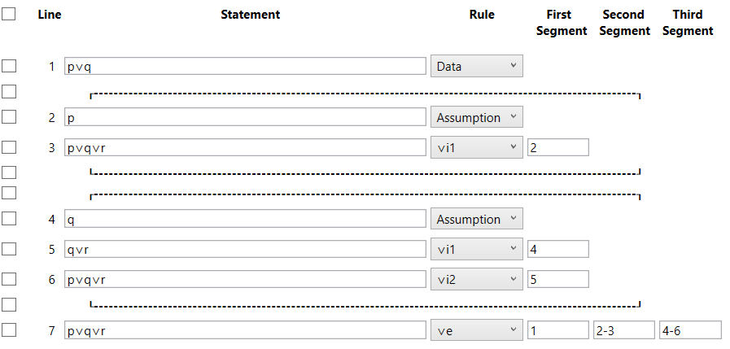

**Law of Excluded Middle (“LEM”)**

* **General info:**

Argument must be true or false, there is no third option.

* **Limitation:**

None

* **Presentation example:**

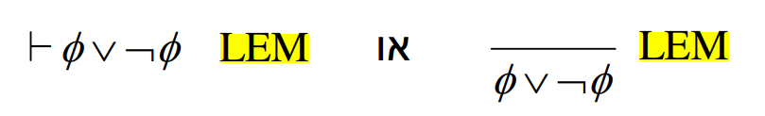

* 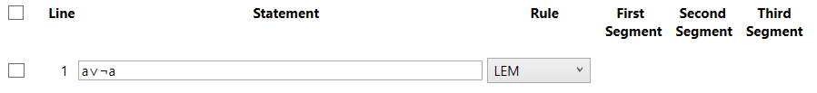**Tool Example:**

**→ introduction (“→i”)**

* **General info:**

Used to conclude a box.

* **Segments use:**

One segment for the line numbers of the box.

* **Presentation example:**

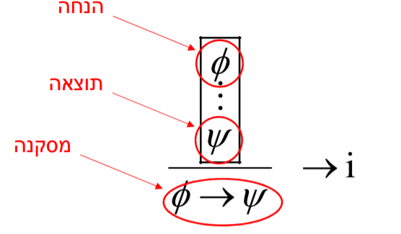

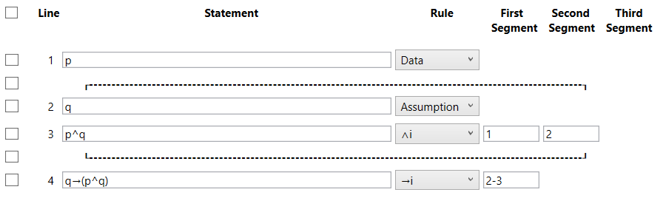

**Modus Ponens (“MP”)**

* **General info:**

If we know “φ→ψ” and we have “φ” we can conclude “ψ”

* **Segments use:**

One segment for the line number of “φ” and another segment for the line number of “φ→ψ”

* **Limitation:**

None

* Presentation example:

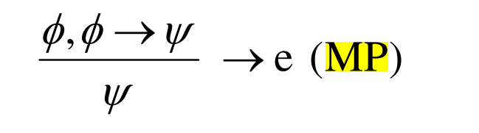

* 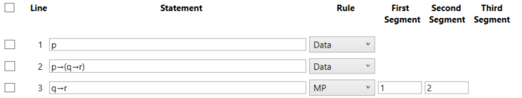**Tool Example:**

**Modus Tollens (“MT”)**

* **General info:**

If we know “φ→ψ” and we don’t have “ψ” we can conclude we don’t have “φ”

* **Segments use:**

One segment for the line number of “φ→ψ”, and another segment – line number of “¬ ψ”

* **Limitation:**

None

* **Presentation example:**

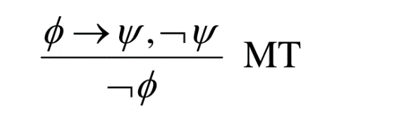

* 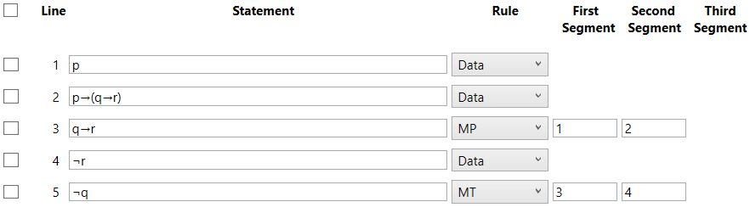**Tool Example:**

**Negation Introduction (“¬i”)**

* **General info:**

After assuming 'x' and getting a contradiction, it is possible to infer '¬x'.

* **Segments use:**

One segment for the line numbers of the box containing the contradiction.

* **Presentation example:**

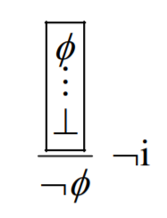

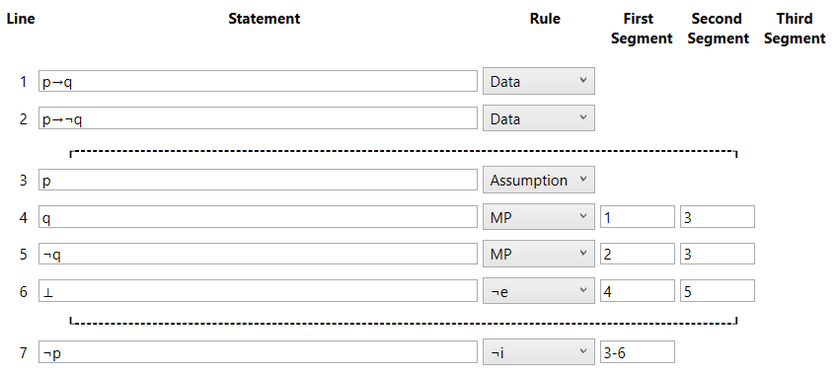

**Negation Elimination (“¬e”)**

* **General info:**

Used for indicating that a contradiction has been reached.

* **Segments use:**

One segment for each of the contradicting lines numbers.

* **Presentation example:**

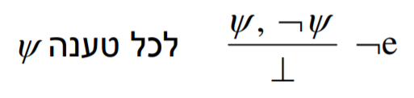



**Double Negative Introduction (“¬¬i")**

* **General info:**

Any 'ψ' equals '¬¬ψ'.

* **Segments use:**

One segment for the line number of the expression that you want the ¬¬ to be added to.

* **Presentation example:**

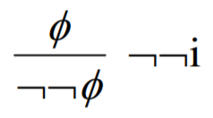

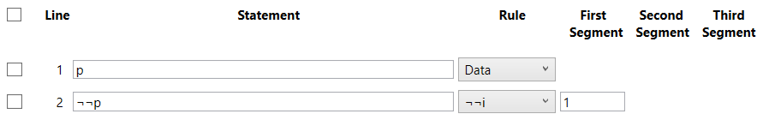

**Double Negative Elimination (“¬¬e”)**

* **General info:**

Any 'ψ' equals '¬¬ψ'.

* **Segments use:**

One segment for the line number of the expression that you want the ¬¬ to be removed from.

* **Presentation example:**

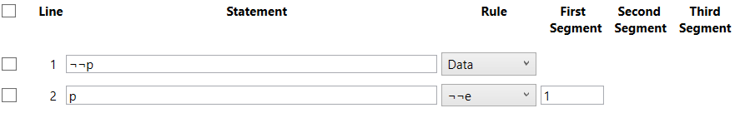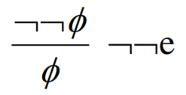

**Contradiction Elimination (“⊥e”)**

* **General info:**

After getting a contradiction anything is possible.

* **Segments use:**

One segment for the line number of the contradiction '⊥'.

* **Presentation example:**
* 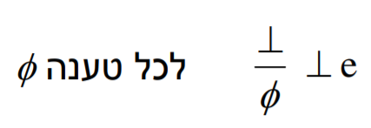

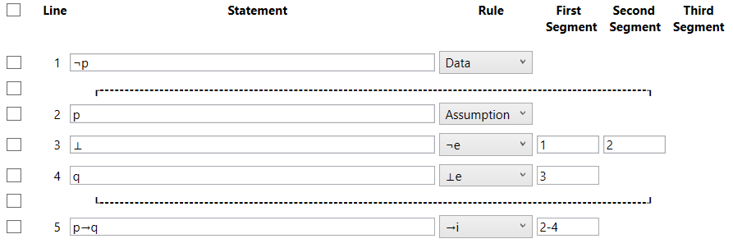

**Proof by Contradiction (“PBC”)**

* **General info:**

Used after making a negative Assumption and getting contradiction.

After getting contradiction from negative assumption, it means the non-negative is true.

* **Segments use:**

One segment that contains the entire box, from the (negative) assumption line number (3) until contradiction line ('⊥') separate with **“-”**

* **Limitation**:

The first row in the given box be an “Assumption”.

The statement in the given last row must be “⊥”.

* **Presentation example:**

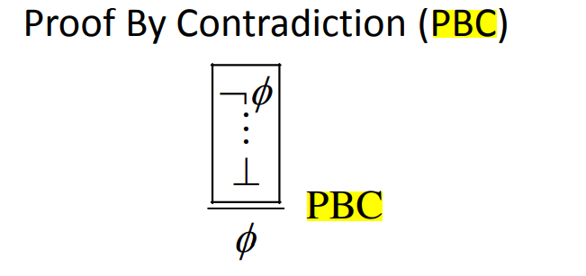

* 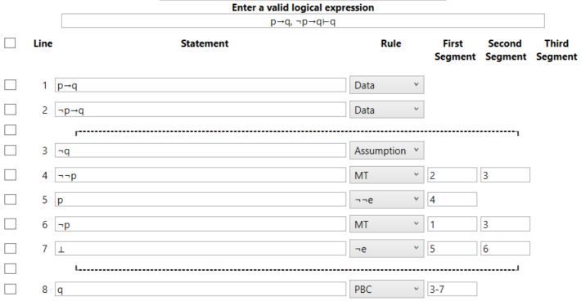**Tool Example:**

**Proven i**

* **General info:**

Use to declare a fact that already have been proven before. The given statement will be checked as a generic rule when using the rule 'Proven e' later in the proof (see 'Proven e' below for more details).

Proof Tool will **only verify the syntax** of the input in the statement, but not the logical validity, and will refer to it as known fact. Note that the order of the 'Proven i' statement will determine the use later with 'Proven e'.

* **Limitation:**

Same syntax verified like in a main expression, so must be valid logical expression.

This rule is **not supported for any predicate proofs/rules.**

* 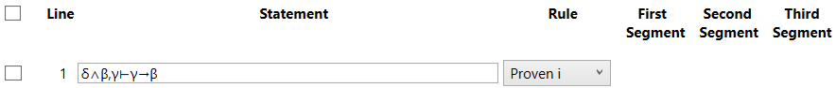**Tool Example:**

**Proven e**

* **General info:**

Used when all the data needed in “Proven i” rule achieved during proof progress,

This rule is generic which means the data letters used in “Proven i” can be different than letters used in Proof.

**Example** (see photo below):

In this case “Proven i” had 2 data expressions: “δ∧β”, “γ” and we already proved that if we have this data we can get to “γ→β”.

In our current Proof we have “r”, “(p∨r)∧q”.

In careful look we can see we have the same data as in “Proven i”,

“(p∨r)∧q” == “δ∧β” 🡺 “p∨r” == “δ”, “q” == “β”;

“r” == “γ”

And we already know from “Proven i” that mean we have “γ→β” in our case:

“r→q”, we get it by using “Proven e”.

* **Segments use:**

First segment – “Proven i” line number.

Second segment – lines contain the needed data declared in “Proven i” line **separated by “,”**

Order of referred lines in second segment **must match the same order** as the respective “Proven i” data.

In this example line 3 🡺 (p∨r)∧q == δ∧β

And then line 2 🡺 r == γ.

* **Limitation:**

**Not supported in predicates.**

* **Tool Example:**

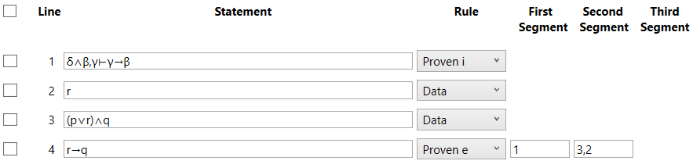

**Predicates**

**Variable Introduction (“X0/Y0 i”)**

* **General info:**

Used when you want a to represent a general variable.

* **Segments use:**

None.

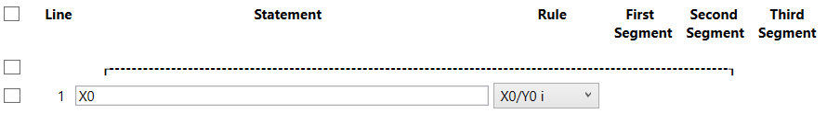

**Equal Introduction (“=i”)**

* **General info:**

Every expression is equal to itself.

* **Segments use:**

None.

* **Presentation example:**

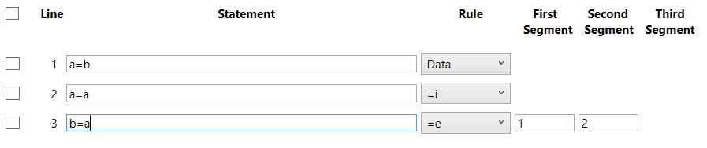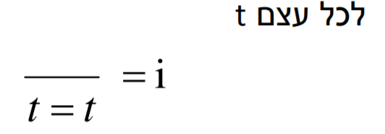

**Equal Elimination (“=e”)**

* **General info:**

Used for transitivity.

* **Segments use:**

One segment for each of the base line numbers.

* **Presentation example:**

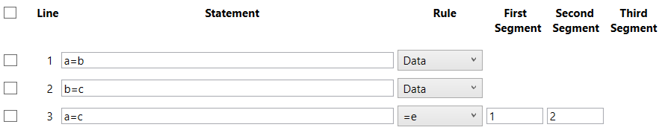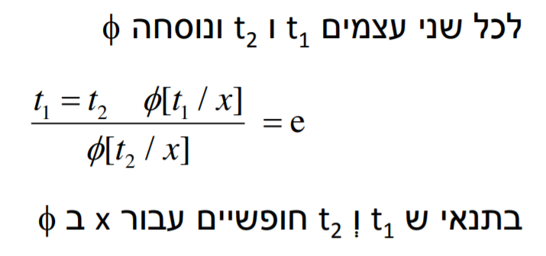

**All Introduction (“∀x i”, “∀y i”)**

* **General info:**

If something can be applied to a general variable, it can be applied to all variables of the same category.

* **Segments use:**

One segment for the box that shows taking a general variable and applying something to it.

* **Presentation example:**

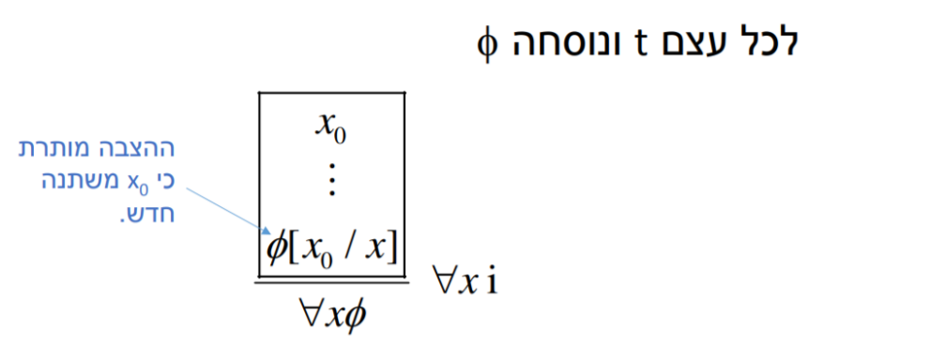

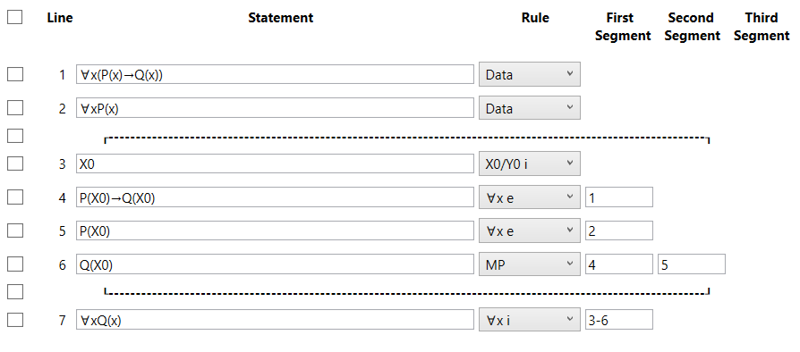

**All Elimination (“∀x e”, “∀y e”)**

* **General info:**

Used for extracting a specific variable from a general "All" expression.

* **Segments use:**

One segment for the line that contains the general expression.

* **Presentation example:**

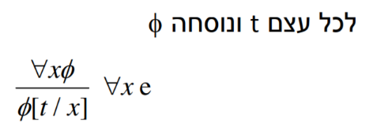

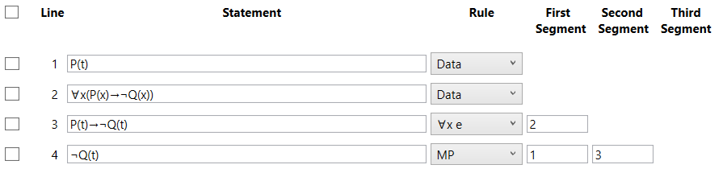

**Exist Introduction (“∃x i”, “∃y i”)**

* **General info:**

Used for indicating that it has been shown that there is a variable that the rule is applied to.

* **Segments use:**

One segment for referring the line in which the the variable is.

* **Presentation example:**

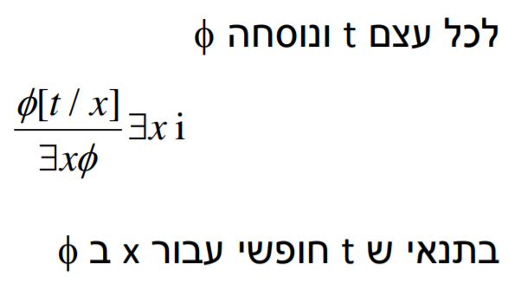

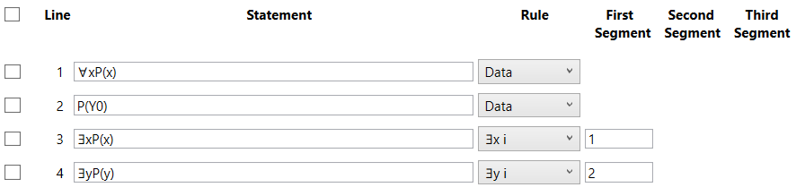

**Exist** **Elimination (“∃x e”,” ∃y e”)**

* **General info:**

Used after reaching “∃x i”/ “∃y i”.

* **Segments use:**
* **Presentation example:**

