## Installations Procedures for Mosquitto

Mosquitto is highly portable and available for a wide range of platforms.

I will use ****Windows 10**** (Windows 10 Home Single Language — Version 10.0.18362 Compilation 18362). In an upcoming post, I will implement it in [RPi](https://www.raspberrypi.org/products/raspberry-pi-4-model-b/) :)

Please refer to [**mosquitto official page**](https://mosquitto.org/)first:)

1° ****Step**** — Go to <https://mosquitto.org/download/> and for Windows get this file:

[mosquitto-1.6.8-install-windows-x64.exe](https://mosquitto.org/files/binary/win64/mosquitto-1.6.8-install-windows-x64.exe)

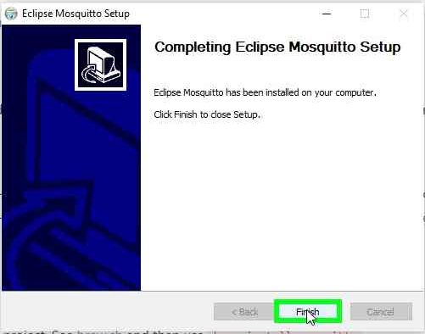

2° ****Step**** —****Adding Dependencies**** files (.dll)

As you complete the Mosquitto installation, please copy/paste these dependencies files into the Mosquitto ****root directory**** (you can download these .dlls directly from my google drive below):

Edited:

nowadays, Dez 2020, there is no need to load these libs;

skip this step :)

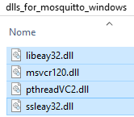

Administrator credentials might be asked as you are dealing with systems files;)

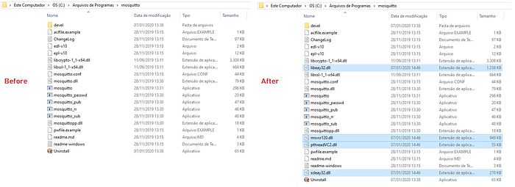

****mosquitto broker server**** in my ****windows 10 platform****; these extras .ddl files are related to ****licenses policies**** :/

3° ****Step**** — Go to ****Windows Explorer**** > ****MyComputer****, left mouse click go to ****Properties**** > ****Advanced Systems Configurations****

hint: Ctrl+R, type:

***sysdm.cpl***(System Properties)

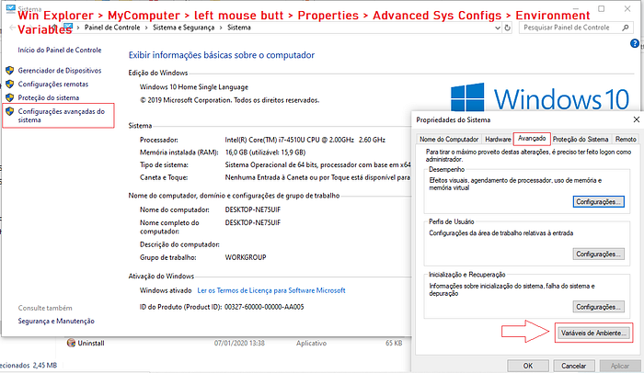

4° ****Step**** — Click ****Environment Variables**** (1), ****Path**** (2), ****New**** (3) and paste ***C:\>Program Files\mosquitto*** directory (4), ****pointing to**** mosquitto’s .****dll**** & ****.exe**** files location. Click ok.

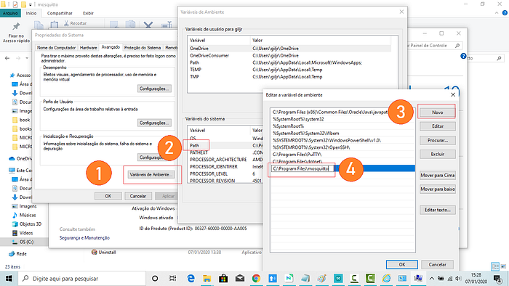

****Setting Environment pat****h: Now when you type at the console, mosquitos commands will be recognized;

5° ****Step**** — Open ****Cmd Prompter****, go to ****C:\>**** and ****type:****

****C:\>mosquitto -v****

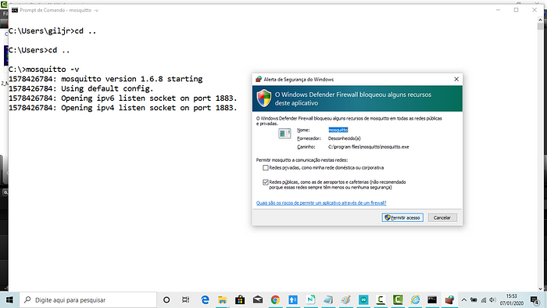

****MQTT**** server runs at ****PORT 1883****; If secure communication (****SLL/TLS****), it will run at ****PORT 8883;****

6° ****Step**** —Set mosquitto service as ****Manual****;

Go to Services > Properties > Initializations > and set it as ****Manual****

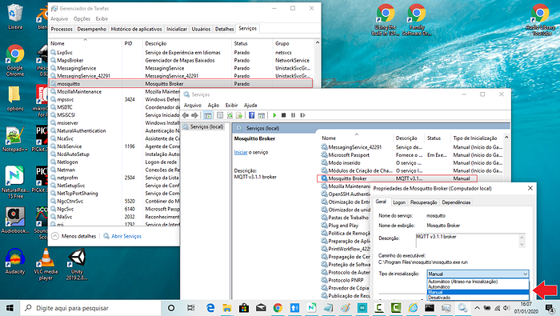

****Manual**** Now we want to have control over ****mosquitto broker**** initialization. Click ok and save it all.

7° ****Step**** — Testing the installations; at the console, type:

****C:\mosquitto - -help****

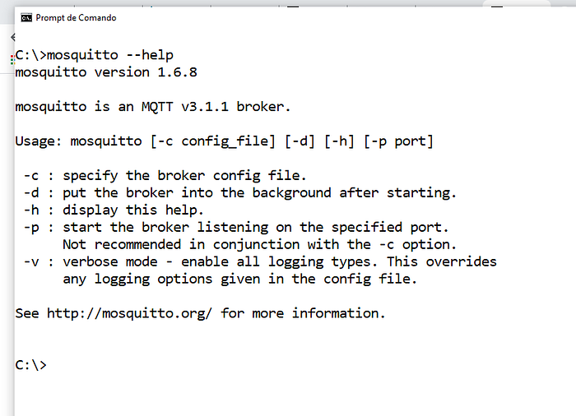

8° ****Step**** — As the broker’s clients can be ****server****, ****publisher****, ****subscriber****, and ****password services,**** mosquitto API brings us these ****four**** executables ****programs****.

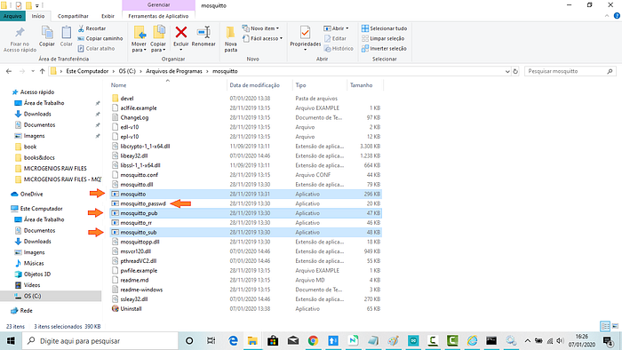

****Mosquitto API**** is composed of these ****four**** programs: ****Broker****, ****Publisher****, ****Subscriber,**** and ****Password**** Service.

9Step — ****Communications test;****

The ****mosquitto.conf**** is the configuration file for mosquitto. In this first configuration, a similar internal file will be loaded by mosquito broker automatically, and its default configuration authorizes anonymous access:/

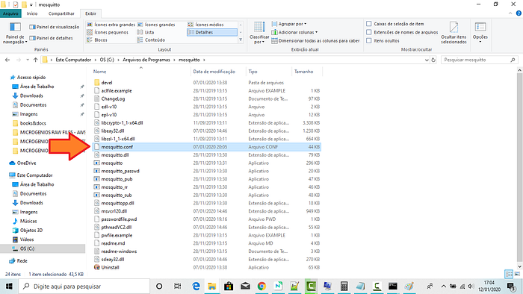

****C:\Program Files\mosquitto****

In ****anonymous**** access, we will ****now up the default broker configuration****, remember, without modification of mosquitto.conf :)

Here are the steps:

0° Step — ****Install mosquitto broker**** in your machine & ****reconfigure**** its service in ****Win10**** so we can start & stop it ****manually****;

Consider following [this](https://medium.com/jungletronics/mosquitto-intro-to-mqtt-ea4f7ea589ba) post:)

## Preparing 3 Prompters Terminals

Open ****Three Terminals****; type these commands in each one:

****cd.. (2x)**** // go to c:/> directory

****cd C:\Program Files\mosquitto**** // change to mosquitto directory

****cls**** // clear the screen;)

First, anonymous access:

## Anonymous Acess

1° Step —Let’s run the ****server:****

On ****Term1****, in ****C:\Program Files\mosquitto\**** directory, ****type****:

****mosquitto -v****

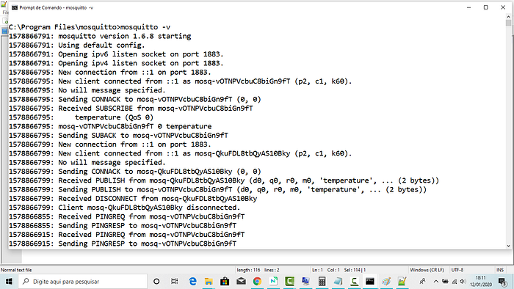

****-v (verbose)**** all event will be dump to the terminal

2Step — At others two terminals in sequence for ****sub & pub clients****, type:

****Term_2****, For ****_sub****, in ****C:\Program Files\mosquitto\**** directory, ****type****:

****mosquitto_sub -h localhost -p 1883 -t temperature****

****Term_3****, For ****_pub,**** in ****C:\Program Files\mosquitto\**** directory, ****type****:

****mosquitto_pub -h localhost -p 1883 -t temperature -m 45****

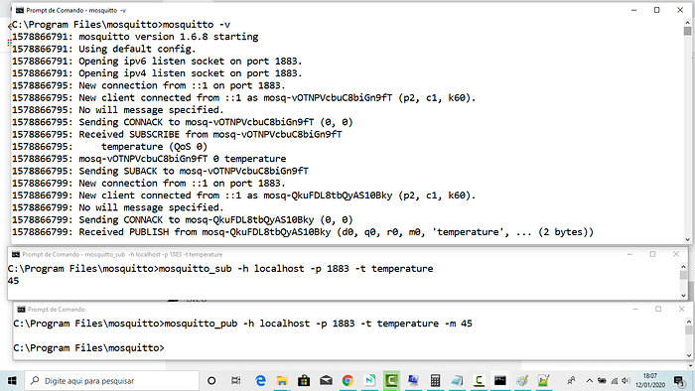

See the dump file in the admin broker terminal above. See that the clients are ****anonymous**** —this is very dangerous on the internet****:/****

1578781497: New client connected from ::1 as mosq-5eKhup3oVmPBaNaZnW ****(p2, c1, k60).****

# Simple Authentication Access

Now let’s fix anonymous access by setting a ****login/passwd**** connection.

Anonymous clients will be refused to connect.

For this, we will have to edit, ****as administrator credentials****, the ****mosquitto.conf**** file. Here is the structure of it:

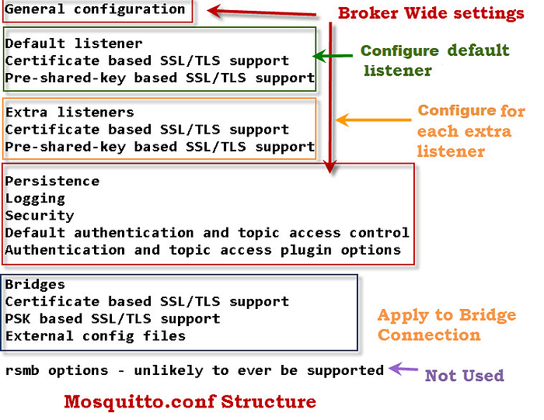

[Quick Guide to The Mosquitto.conf File With Examples](http://www.steves-internet-guide.com/mossquitto-conf-file/))

As you know, this file is located ****at system file****, so we need to open this file in [**notepad++**](https://notepad-plus-plus.org/downloads/) editor like administrator:

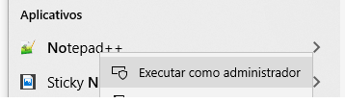

[notepad ++](https://notepad-plus-plus.org/downloads/) for mosquitto.conf editting — Note: You can configure a broker to listen on a port and ****require SSL**** and also to listen on another port and ****not use SSL****.

To ****create a password file**** you need to use the ****mosquitto_passwd**** utility that comes with the ****client tools**** when installing the mosquitto broker.

To initialize the configuration of authenticated access, at ****Term_01****, we will need to ****stop the server**** (ctrl + C) and use the command below to create ****passwordfile.pwd**** file that will be located at ****C:\Program Files\mosquitto**** directory; our administrator will be ****admin**** user and our ****password**** will be ****123****;

1º Step —On Term 1, on ****C:\Program Files\mosquitto\**** directory, ****type****:

[**mosquitto_passwd**](https://mosquitto.org/man/mosquitto_passwd-1.html) ****-c "C:\Program Files\mosquitto\passwordfile.pwd" admin****

and hit ****<enter>**** and enter ****2 x**** the chosen ****password (123)****;

This command creates ****passwordfile.pwd**** file and set as our administrator ****admin**** user, password ****123****;)

Your file for user configuration is ready at C:\ProgramFiles\mosquitto\ directory!

****Admin**** is the name of our first and our main ****user****;

2° Step — Go to ****C:\Program Files\mosquitto**** directory and see the file created there:

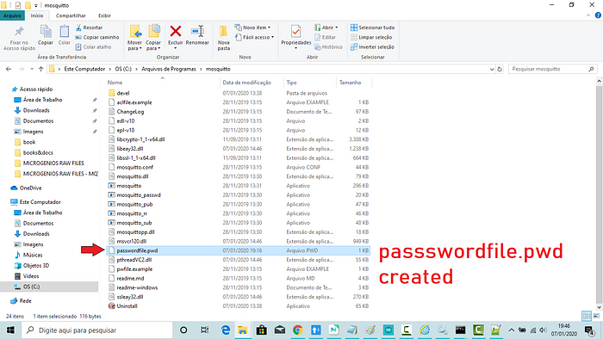

****C:\Program Files\mosquitto\ directory****

If we open this new file as text, ****passwordfile.pwd,**** we will see the ****admin user**** credentials:

****admin:$6$sEorGWHKkOfEI8qJ$nxEMynuvKuguXqbYq7TWBsSAxEDon/MuK0pFo4Cm0yOK29m/I0yi6y3zFzuJeFXRT9DgyVVLDS/wO72CADlIaw==****

3°Step — Now open C:\Program Files\mosquitto\****mosquitto.conf.****

At ****line 651****, ****uncomment**** it and ****set**** it to ****false,**** like this:

****allow_anonymous false****

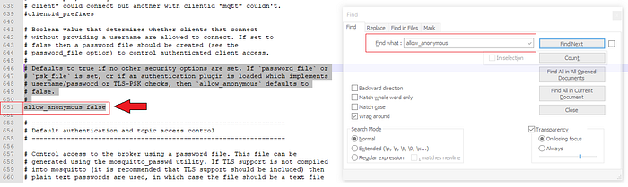

****allow_anonymous false****

4°Step — Scrolling down enough until ****line 669****, ****uncomment it**** and set it to the directory ****location**** of ****password file config****, like this:

****password_file "C:\Program Files\mosquitto\passwordfile.pwd"****

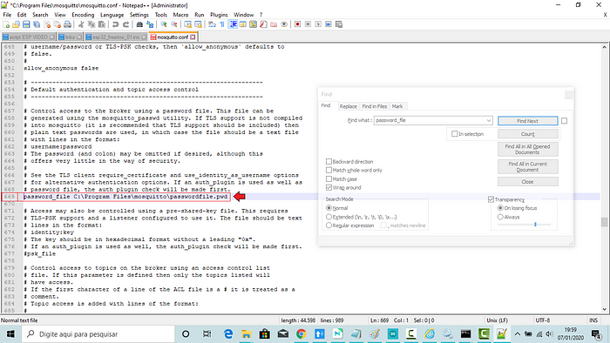

Save the file and now start the server again.

5°Step — At ****Terminal 1****, ****type**** (run as Administrator, please):

<Ctrl + C> // To stop the server

****mosquitto -c mosquitto.conf -v**** // to run it with loaded file

This will ****break the connection of the anonymous client:****

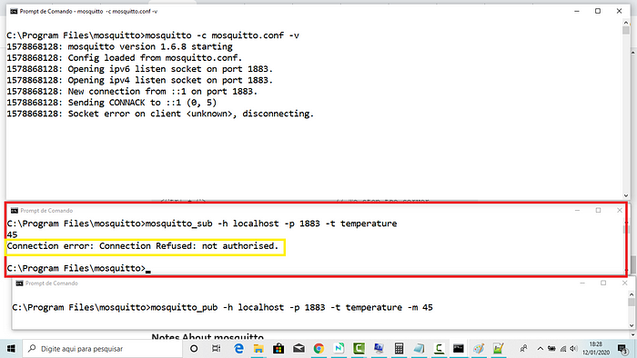

****Connection error: Connection Refused: not authorised.**** (sic)

6°Step — Now let’s test if the admin user can ****subscribe**** topic:

At ****Terminal 2****, ****type****:

mosquitto****_sub**** -h localhost -p 1883 ****-u admin -P 123**** -t temperature

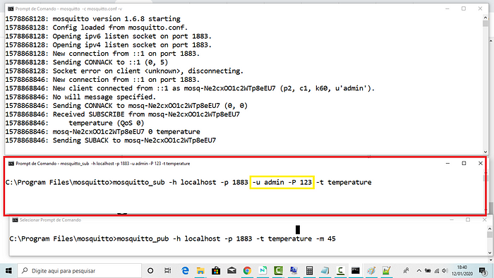

****subscribing**** at the second terminal

7°Step — Now let’s test if the admin user can ****publish**** to the same topic.

At ****Terminal 3****, ****type**** (run as Administrator, please):

mosquitto****_pub**** -h localhost -p 1883 ****-u admin -P 123**** -t temperature -m 45

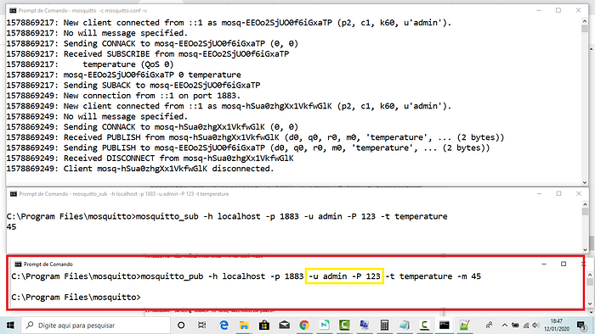

****publishing**** at the third terminal

And there you have it! ****no more anonymous user!****

#Step — On Windows, open three *prompt Terminals* (one as administrator) and type on Terminal #01 (I assumed you follow this MQTT series:)

mosquito - c mosquitto.conf -v

At Terminal #02:

mosquitto_sub -h localhost -p 1883 -u user1 - P 321 -t temperature -q 2

And Finally at Terminal #03:

mosquitto_pub -h localhost -p 1883 -u user1 - P 321 -t temperature -m 45 -q 2

See everything working below:

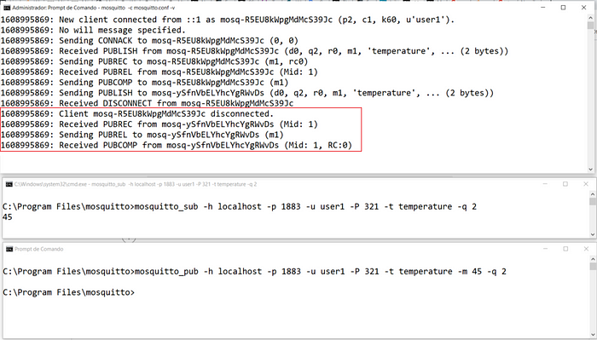

****PUBREC**** = message received acknowledgement; ****PUBREL**** = message release ; ****PUBCOMP**** = the process is complete (the message can be deleted from the queue)

Now let’s set the level of QoS to 1:

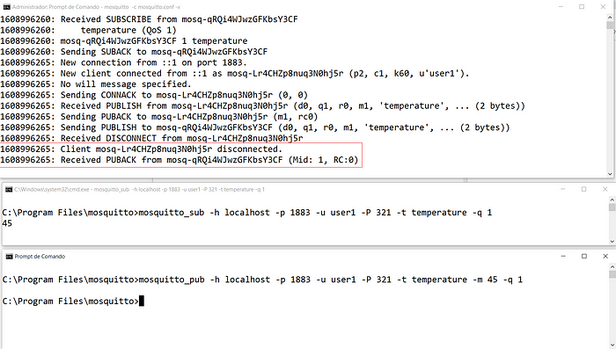

****PUBACK**** = message acknowledgement

Now the lowest possible level, QoS 0:

