Setting up Arduino IDE

### **Installing Arduino IDE**

To run Arduino IDE, you need JAVA installed on your computer. If you don’t, go to the following website to download and install the latest version: <http://java.com/download>.

#### **Downloading Arduino IDE**

To download the Arduino IDE, visit the following URL:

* <https://www.arduino.cc/en/Main/Software>

Scroll down until you find the legacy version section.

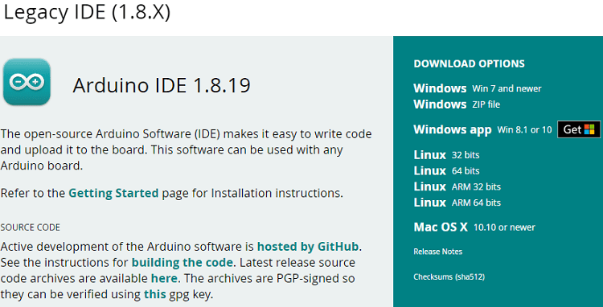

Select your operating system and download the software. For Windows, it is recommended downloading the “**Windows ZIP file**“.

### 

### **Running Arduino IDE**

Grab the folder you’ve just downloaded and unzip it. Run the executable file called *arduino.exe* (highlighted below).

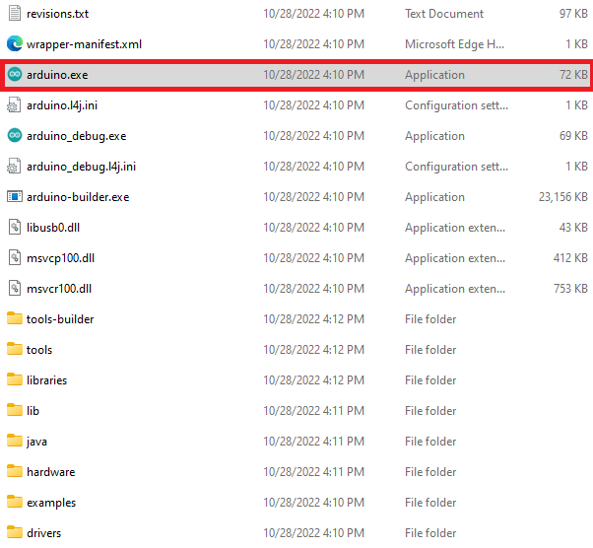

The Arduino IDE window should open.

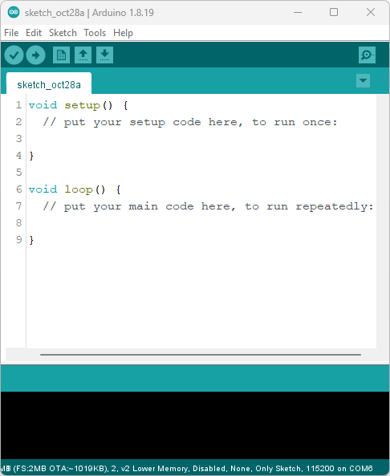

## **Installing the ESP8266 NodeMCU in Arduino IDE**

To be able to program the ESP8266 NodeMCU using Arduino IDE, you need to add support for the ESP8266 boards. Follow the next steps:

1. Go to **File** > **Preferences**.

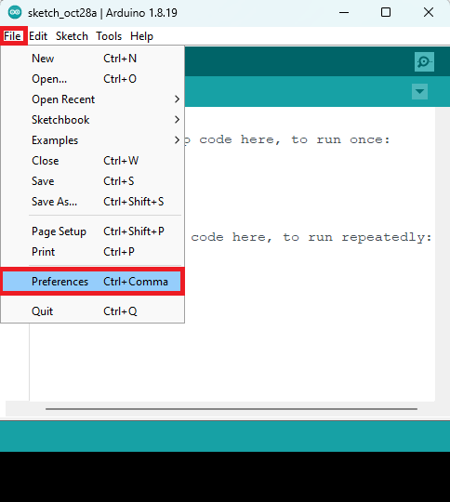

1. Enter the following into the “*Additional Board Manager URLs*” field.

https://arduino.esp8266.com/stable/package_esp8266com_index.json

See the figure below. Then, click the “**OK**” button.

Arduino IDE ESP8266 additional boards manager

Note: if you already have the ESP32 boards URL, you can separate the URLs with a comma as follows:

https://dl.espressif.com/dl/package_esp32_index.json,

http://arduino.esp8266.com/stable/package_esp8266com_index.json

1. Open the **Boards Manager**. Go to **Tools** > **Board** >**Boards Manager…**
2. Search for **ESP8266** and install the “**ESP8266 by ESP8266 Community**“.

That’s it. It will be installed after a few seconds.

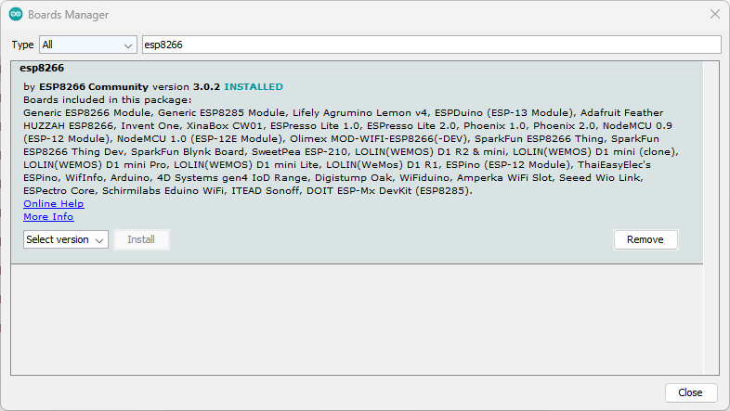

After this, restart your Arduino IDE.

Then, go to **Tools** > **Board** and check that you have ESP8266 boards available.

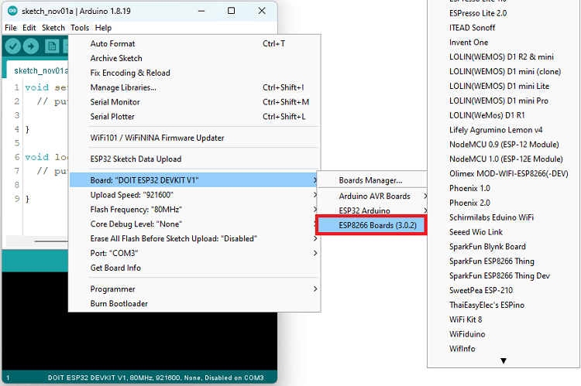

Now, you’re ready to start programming your ESP8266 using Arduino IDE.

### **ESP8266 Examples**

In the Arduino IDE, you can find multiple examples for the ESP8266 board. First, make sure you have an ESP8266 board selected in **Tools** > **Board**. Then, simply go to **File** > **Examples** and check out the examples under the ESP8266 section.

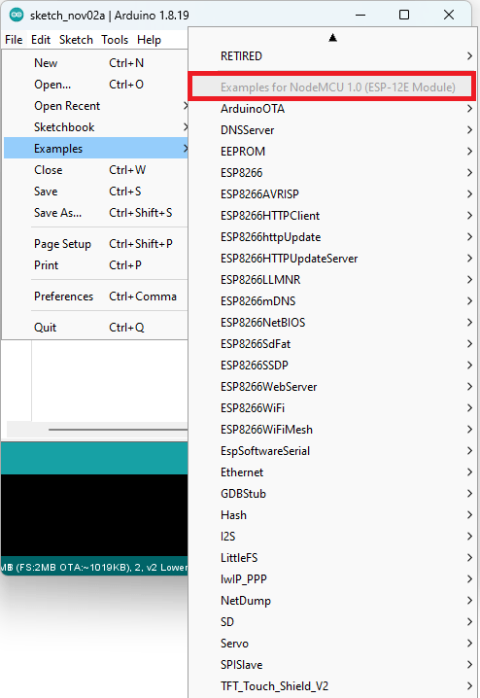

### **Update the ESP8266 Core in Arduino IDE**

Once in a while, it’s a good idea to check if you have the latest version of the ESP8266 boards add-on installed.

You just need to go to **Tools** > **Board** **> Boards Manager**, search for **ESP8266**, and check the version that you have installed. If there is a more recent version available, select that version to install it.

## **Upload Code to the ESP8266 NodeMCU using Arduino IDE**

To show you how to upload code to your ESP8266 board, we’ll try a simple example available in the Arduino IDE examples for the ESP8266.

First, make sure you have an ESP8266 selected in **Tools** > **Board**. If you’re using the ESP8266-12E NodeMCU Kit as shown in previous pictures, select the **NodeMCU 1.0 (ESP-12E Module)** option. If you don’t know what your board is, you can always select the **Generic ESP8266 Module**.

Then, go to **File** > **Examples** > **ESP8266WiFi** > **WiFiScan**.

This will load a sketch that scans Wi-Fi networks within the range of your ESP8266 board.

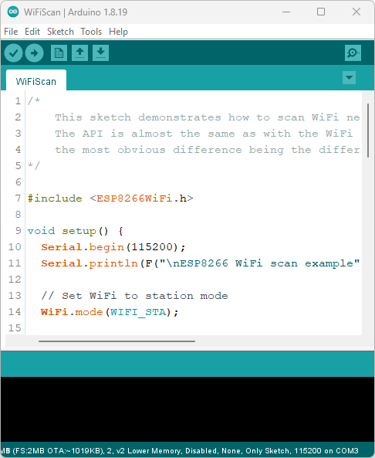

Connect your ESP8266 development board to your computer using a USB cable.

**Warning:** you must use a USB cable with data wires. Some USB cables from chargers or power banks are power only and they don’t transfer data—these won’t work.

Now, follow the next steps to upload the code.

**1)** Go to **Tools** > **Board**, scroll down to the ESP8266 section and select your ESP8266 board. If you don’t know what your board is, the **Generic ESP8266 Module** usually works fine for most boards.

**2)** Go to **Tools** > **Port** and select a COM port available. If the COM port is grayed out, this means you don’t have the required USB drivers. Check the section **Installing USB Drivers** before proceeding.

### Installing the ESP8266 NodeMCU USB Drivers

After connecting the ESP8266 board to your computer, if the COM port in Arduino IDE is grayed out, it means you don’t have the required USB drivers installed on your computer.

Most ESP8266 boards either use the CP2101 or CH340 drivers. Check the USB to UART converter on your board, and install the corresponding drivers.

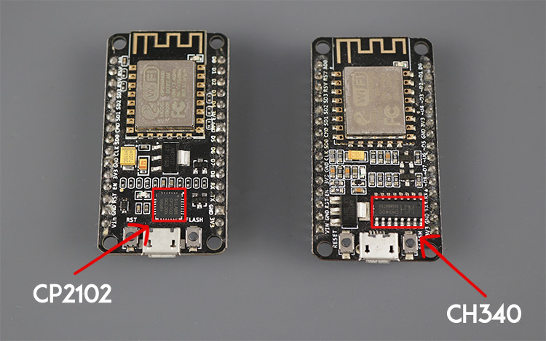

You’ll easily find instructions with a quick google search. For example “install CP2101 drivers Windows”.

On Ubuntu if you get an error, like

*could not open port /dev/ttyUSB0: [Errno 13] Permission denied: '/dev/ttyUSB*'*

Use the below command to fix it

**sudo chmod a+rw /dev/ttyUSB\***

**3)** Press the upload button.

Arduino 2.0 Upload Button

The code should be successfully uploaded to the board after a few seconds.

