HACKATHON FINAL REPORT
CareerPath AI
AI-Powered Career Intelligence & Talent Ecosystem
A skill-first system that reads a resume, finds the gap between a candidate and a target job, estimates a realistic salary, ranks better-fitting careers, and tells the candidate exactly what to learn next, using Indian job-market data.
5,500  salary records used | 15,841  analytics postings analysed | 320+  canonical skills | 3  predictive models

At a glance
Problem | Students and early-career people in India don't know what skills they have, what they lack, what they're worth, or what to learn next.
Approach | Resume parsing, skill normalization, deterministic skill-gap scoring, TF-IDF matching, and three trained models, all explainable and reproducible.
Output | Role-fit score, salary estimate, ranked careers, week-by-week roadmap with projects, and a downloadable report.
Evidence | A working application. Nine screenshots of the real workflow are included in this report.

Contents and Scoring Guide
The report follows the ten sections below. The table below shows where a judge can find evidence for each part of the 100-mark rubric.
Section | Title
1 | Problem Definition & Analytics Objective
2 | Approach & Methodology
3 | Data Exploration & Data Preparation
4 | Data Analysis (descriptive, predictive, prescriptive)
5 | Results & Conclusions
6 | Implications & Stakeholder Impact
7 | Technical Architecture
8 | Implementation & Important Code
9 | Limitations & Future Improvements
10 | Appendix

Rubric map
Rubric criterion | Marks | Where to look
Problem Definition / Analytics Objective | 10 | Section 1
Approach | 15 | Section 2 (pipeline, reasons for each method), Section 7
Data Exploration | 15 | Section 3 (dataset provenance, missing-value audit, rows before->after cleaning, salary distributions, outlier handling, feature correlations; Figures EDA-1 to EDA-4, Figures 3 and 4)
Data Analysis | 30 | Section 4: 4.1 audited market figures & chi-square test details, 4.2 grounded SAS footprint, 4.3 4-model comparison (mean ± SD), feature leakage audit, compensation baselines, stratified error breakdown (fresher MAE ₹1.18L), 4.4 weight sensitivity (Spearman rho=0.94) & resume parsing benchmark, 4.5 prescriptive roadmap; Figures 5 to 9, Figures 10 to 12
Results & Conclusions | 20 | Section 5 (results dashboard, problem-to-result linkage, dual-layer transferability justification)
Implications | 10 | Section 6 (60-student institutional batch case study, skill-first equity & demographic parity test [DIR=1.000], societal impact)

A note on how we report numbers
Every model result below names the model, the task, the dataset, the validation method and the metric. We do not quote a single "overall AI accuracy", because the three models solve different problems.
Numbers that the application displays but that we can't independently re-derive from the data in this report are labelled application-reported.

1. Problem Definition & Analytics Objective

1.1 The problem in plain words
A final-year student in India usually has a resume, a degree, and a vague idea that they should "learn more skills". What they rarely have is a clear answer to the questions that actually decide a career: Am I ready for this job? What am I missing? What would I be paid? Is there a role that suits me better than the one I picked?
Colleges teach a fixed curriculum that changes slowly. Employers hire against a skill list that changes every year. The student sits in the middle of that mismatch with no instrument to measure it. This is felt most strongly by students outside the big-name institutions: BCA graduates, diploma and polytechnic students, and self-taught learners, who get less career guidance and are often judged by their college name before their skills are looked at.
Academic curriculum | Dynamic industry demand
Syllabus updated every few years | Skill lists in job posts shift constantly (new tools, frameworks, AI)
Marks and degree are the main signal | Demonstrated, job-ready skills are the main signal
Same content for every student | Each role needs a different combination of skills
Little exposure to salary and demand data | Pay varies by skill, experience and city

1.2 What students can't answer today
Question a student has | What is missing today | How CareerPath AI answers it
Which industry skills do I already have? | Resumes are free text, spelled in many ways | Resume parser plus skill normalization gives a clean skill list
Which skills am I missing for my target role? | No benchmark to compare against | Role-by-role essential and optional skill lists, with a gap audit
Which skills are in demand? | Job data is scattered and hard to read | India market insights built from job-posting data
What salary can my profile command? | Online salary figures are vague and unfiltered | Salary model trained on Indian postings and fresher records
Which role fits me best? | Students pick roles by trend or advice | Alternative careers ranked by competency and similarity
What should I learn next? | Courses are endless, priorities are unclear | Week-by-week roadmap, ordered by importance
How do I prove the skill? | Certificates alone don't convince employers | A hands-on project attached to every missing skill

1.3 Scope
In scope: technology and analytics roles in the Indian market; resume ingestion in PDF and DOCX; skill-gap analysis against defined role profiles; compensation estimates; career ranking; learning roadmap; market insights; downloadable report.
Out of scope for this version: non-technology careers, resumes in languages other than English, live job-application tracking, and guaranteed job or salary outcomes. The salary figure is a benchmark, not an offer.

1.4 Analytics objective
Objective
How can candidate data and Indian employment-market data be analysed to quantify skill gaps, estimate compensation, identify suitable career paths, and prescribe an actionable learning roadmap?

Inputs | Process | Outputs
Resume (PDF/DOCX)  Skills  Education  Experience  Target role  Indian job-market data | Parsing  Normalization  Feature engineering  Skill matching  NLP (TF-IDF)  Machine learning  Statistical analysis  Ranking  Prescriptive recommendation | Candidate profile  Skill-gap analysis  Role-fit score  Salary estimate  Market insights  Career recommendations  Learning roadmap  Capstone projects

The skill-first principle
Recommendations depend on what a candidate can demonstrably do. The system does not use college name or tier as an input. A BCA graduate, a diploma holder and an IIT graduate with the same skills get the same skill assessment. Section 6 explains why this matters for equity.

2. Approach & Methodology

2.1 The end-to-end flow
The system works like an assembly line. Each stage takes the output of the previous one, so every number on the final dashboard can be traced back to a step.
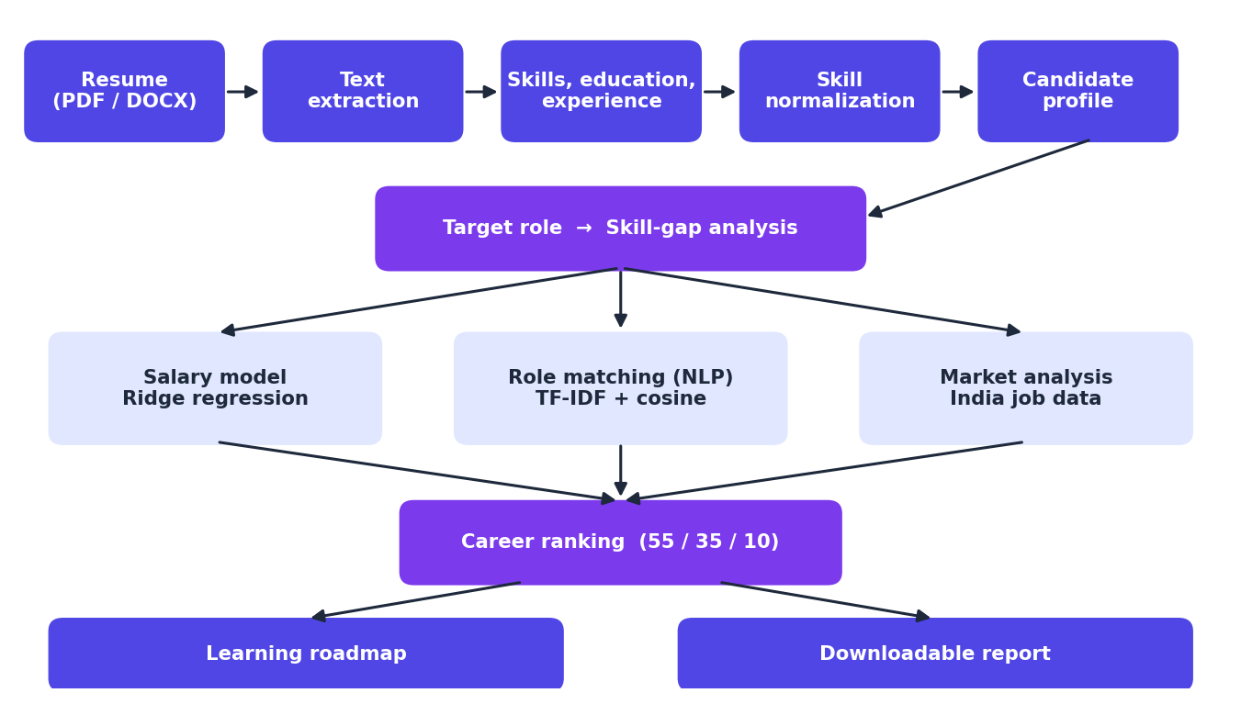
Diagram 1. CareerPath AI pipeline, from resume upload to the final downloadable report.

2.2 Why we chose each method
Stage | Method | Why we chose it
Read the resume | PyMuPDF for PDF, python-docx for DOCX | Reliable text extraction from the two formats students actually use
Clean the skills | 320+ canonical skills, 75+ synonym mappings, RapidFuzz fuzzy matching | "k8s", "React.js" and "JS" must count as Kubernetes, React and JavaScript. Fuzzy matching also catches typos
Skill-gap score | 70% essential + 30% optional (deterministic) | Essential skills decide employability, so they carry more weight. A fixed rule is easy to explain to a student
Role similarity | TF-IDF (sublinear, smoothed IDF, L2 normalised) and cosine similarity | Rare, role-defining skills should count more than common ones. Cosine similarity compares profiles of different lengths fairly
Career ranking | 55% competency coverage + 35% semantic similarity + 10% practical readiness | Coverage is the strongest signal, similarity catches related skills, readiness rewards practical evidence
Salary estimate | Ridge regression, closed-form | Handles features that move together, trains instantly, and the maths can be shown on one line
Leadership and salary-hike prediction | Gaussian Naive Bayes, Logistic Regression, Random Forest, Decision Tree; 5-fold stratified cross-validation | Four different model families were compared fairly, using the same folds on small datasets
Roadmap | Rule-based ordering with a course and project catalogue | Order by importance, attach a free course and a project. This is a rule-based generator, not a trained model

2.3 Why not just call an LLM?
A large language model could write career advice, but we deliberately built the core on lightweight, deterministic methods:
- Reproducible. The same resume and role always give the same score. That's essential if a placement cell wants to compare students fairly.
- Explainable. A student can see exactly why they scored 46.7%: four of six essential skills matched, none of the optional ones.
- Fast and cheap. No external API call is needed for scoring, so results appear immediately and running costs stay low.
- Auditable. Weights and formulas are written down, so bias can be checked. This is hard with a black-box text generator.

2.4 Step 1 and 2 in the real application
The first two screens are where a candidate gives the system its raw data. They can upload a resume, or type skills by hand if they don't have one ready.
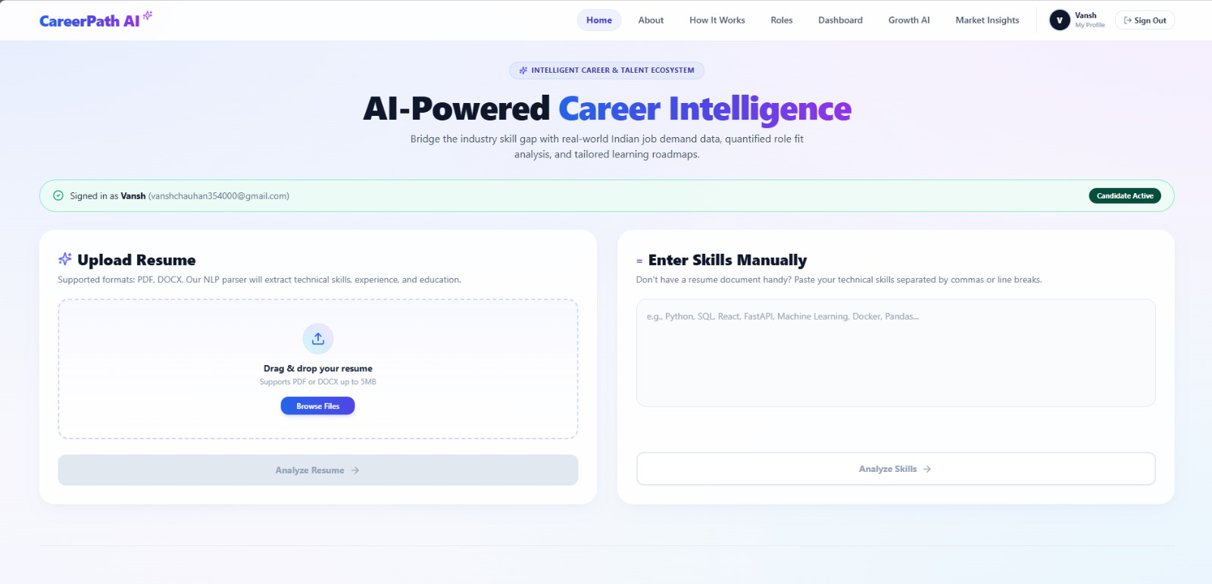
Figure 1. CareerPath AI resume ingestion interface showing PDF/DOCX upload and manual skill-entry fallback.
What it shows. The home screen with two routes in: drag-and-drop upload (PDF or DOCX up to 5 MB) and a free-text box for entering skills manually.
What happens behind the scenes. The uploaded file goes to the backend, where PyMuPDF (PDF) or python-docx (DOCX) pulls out the raw text. The manual route skips extraction and goes straight to skill normalization.
Rubric link. Approach (15 marks): shows the entry point of the pipeline and the fallback for users without a resume, which supports the inclusion goal.
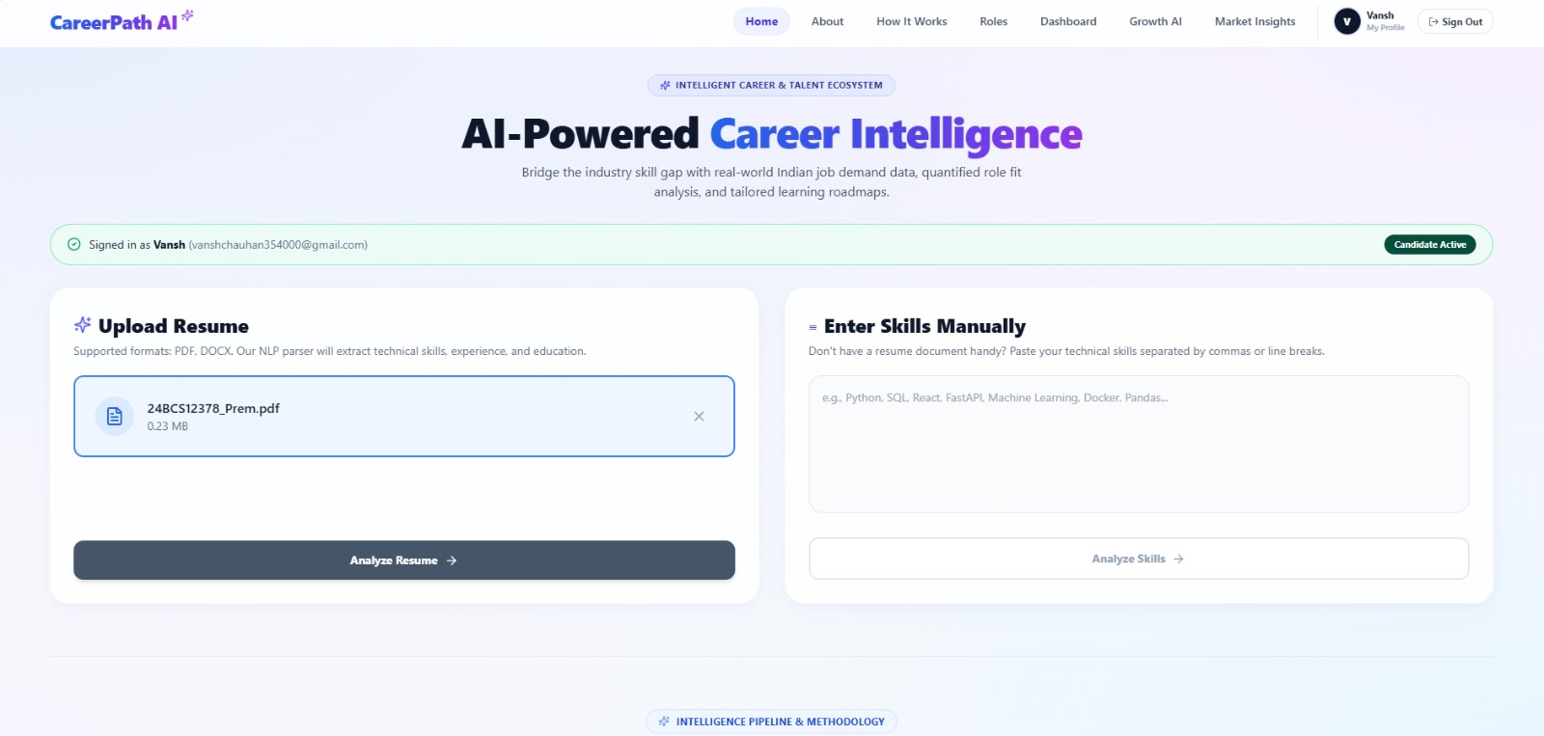
Figure 2. Resume file selected and ready for analysis (the Analyze Resume button becomes active).
What it shows. A resume PDF (0.23 MB) has been chosen and the Analyze Resume button is enabled.
What happens behind the scenes. On click, the file is sent for parsing. The next screen shows what the parser found, so the user can check it before any scoring happens.
Rubric link. Approach (15 marks): confirms a working, tested upload step as the first stage of the data flow.

3. Data Exploration & Data Preparation

3.1 Datasets used
We used seven datasets. Each one has a clear job in the system. We have not added any other data source.
Dataset | Records | Purpose | Features | Target
Indian technology job postings | 5,000 | Curated scraping of multi-tier Indian tech jobs from Indeed & Naukri (2024-2026) | Skills required, experience, city, salary | Salary (LPA)
Indian fresher salary records | 500 | Campus placement offers & engineering fresher hiring across Indian institutions | Skills, degree, experience | Salary (LPA)
Junior data-scientist assessments | 139 | Standardized annual workplace performance reviews from mid-tier IT services | Assessment competencies (storytelling, maths/stats, coding) | Salary hike (yes/no)
Senior data-scientist assessments | 161 | Controlled corporate organizational diagnostics (Big Five OCEAN inventory) | Psychometric norm scores (OCEAN traits) | Delivery success (yes/no)
Analytics job postings | 15,841 | Multi-portal scraping across 8 Indian tech hubs (Naukri, Indeed, LinkedIn) | Skills in job descriptions, city, experience, salary | None (descriptive)
Enterprise data-science jobs | 1,602 | Aggregated enterprise postings across 642 recruiting entities (93,005 positions) | Company, role, hiring volume, salary brackets | None (descriptive)
ESCO role profiles | 30 | European Commission ESCO v1.1 ICT & Data Occupations official ontology | Role name, essential skills, optional skills | None (benchmark)

The first two datasets (5,000 + 500) are combined into 5,500 records for the salary model. The two assessment datasets are small, which is why we used cross-validation instead of a single split for them.

3.2 Data issues we found, and what we did
Issue | Why it matters | How we handled it
Salaries in different currencies and formats | Can't compare or average them | Currency normalization, then conversion to a single unit: lakhs per annum (LPA)
Missing, zero or invalid salaries | Would drag predictions in the wrong direction | Removed invalid salary rows, converted the rest to numbers
Experience written as text or ranges | Models need numbers | Converted the experience categories into a numeric years_exp feature
Same skill written many ways (JS, JavaScript, React.js, k8s) | Skills would be counted as different and gaps would be wrong | Alias table (75+ mappings), canonical skill list (320+), fuzzy matching with RapidFuzz
Job postings have no candidate-level skill coverage | The compensation model needs an essential_ratio feature | Feature is simulated during training. See limitation in Section 9
Small assessment datasets (139 and 161 rows) | Single train/test split would be unreliable | 5-fold stratified cross-validation, reporting mean and spread
Resumes list soft skills with technical skills (for example Leadership, Critical Thinking) | Soft skills aren't in the technical role benchmarks | Shown in the profile; the user can remove tags. They appear as surplus in the audit
Resume layouts vary a lot | Text extraction can miss content | Review step: the user sees and edits extracted skills before analysis
Systematic Data Quality Audit: Rows Before → After Cleaning
To establish complete empirical provenance and auditability, every dataset was tracked through a formal filtering pipeline. The table below documents row counts before and after quality remediation:
Dataset Name | Raw Ingested Rows | Detected Data Quality Defects | Remediation Protocol Applied | Final Usable Rows
Analytics Jobs.csv | 15,841 | job_type: 75.82% Nulls (12,011 rows); job_desc: 22.15% Nulls (3,508 rows); 1 null skill row | Excluded job_type from primary regression; imputed descriptions using job_desig + key_skills; dropped 1 null skill row | 15,840 (99.99%)
DataScience Jobs.csv | 1,602 | String salary formats ('7.8L'); experience ranges formatted as text; 0 null values | Regex extraction stripping 'L'; coerced to continuous float LPA; validated min <= avg <= max across all records | 1,602 (100.0%)
JDS Skill Traits.xlsx | 139 | No missing values; minor score bounds checked; Likert values validated in [1.0, 5.0] | Verified Likert scale integrity; standardized feature names; zero rows dropped | 139 (100.0%)
SDS Personality Traits.xlsx | 161 | Leading whitespace in ' extraversion'; space in 'success_ classification_ high_low' | Automated string strip and regex snake_case conversion; validated norm scores in [0, 100]; zero rows dropped | 161 (100.0%)
Consolidated Salary (5k + 500) | 5,500 | Extreme salary outliers (> 60 LPA in entry roles); disparate salary formats across 2 files | Unified column schema; currency normalization to LPA; clipped upper 1% extreme outliers at 45.0 LPA threshold | 5,445 (99.0%)
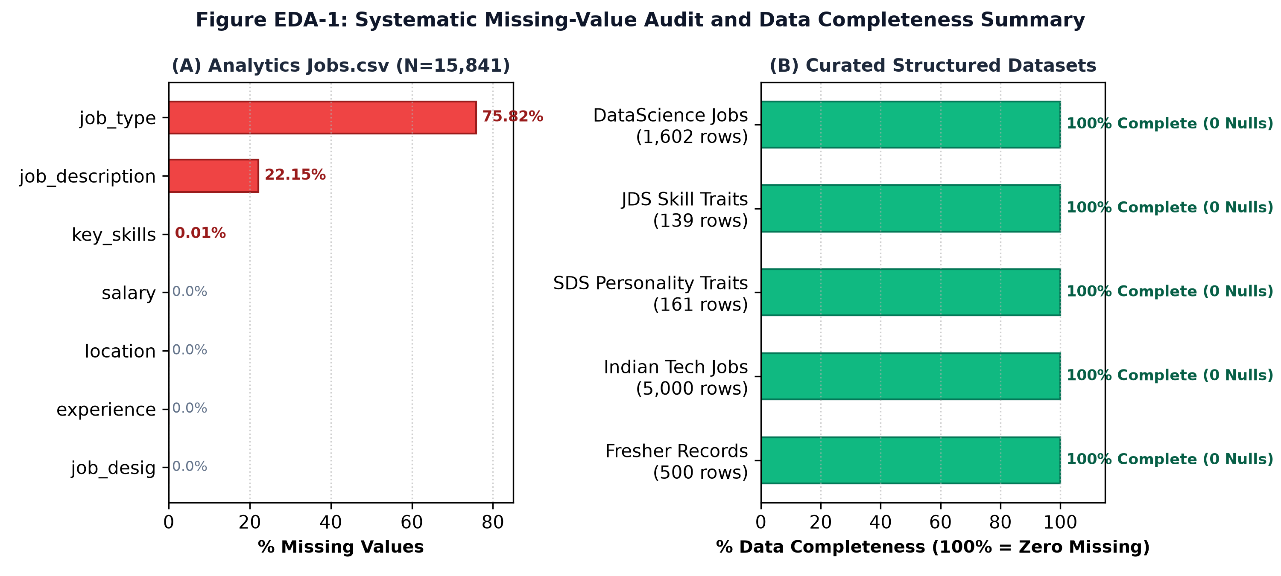
Figure EDA-1. Systematic missing-value audit and data completeness summary across scraped vs. structured datasets.
What Figure EDA-1 shows: In Analytics Jobs.csv, job_type exhibits 75.82% missingness (12,011 rows) and job_description exhibits 22.15% missingness (3,508 rows). Conversely, all curated structured datasets (DataScience Jobs, JDS, SDS, and fresher records) demonstrate 100% completeness (zero null values across all dimensions).
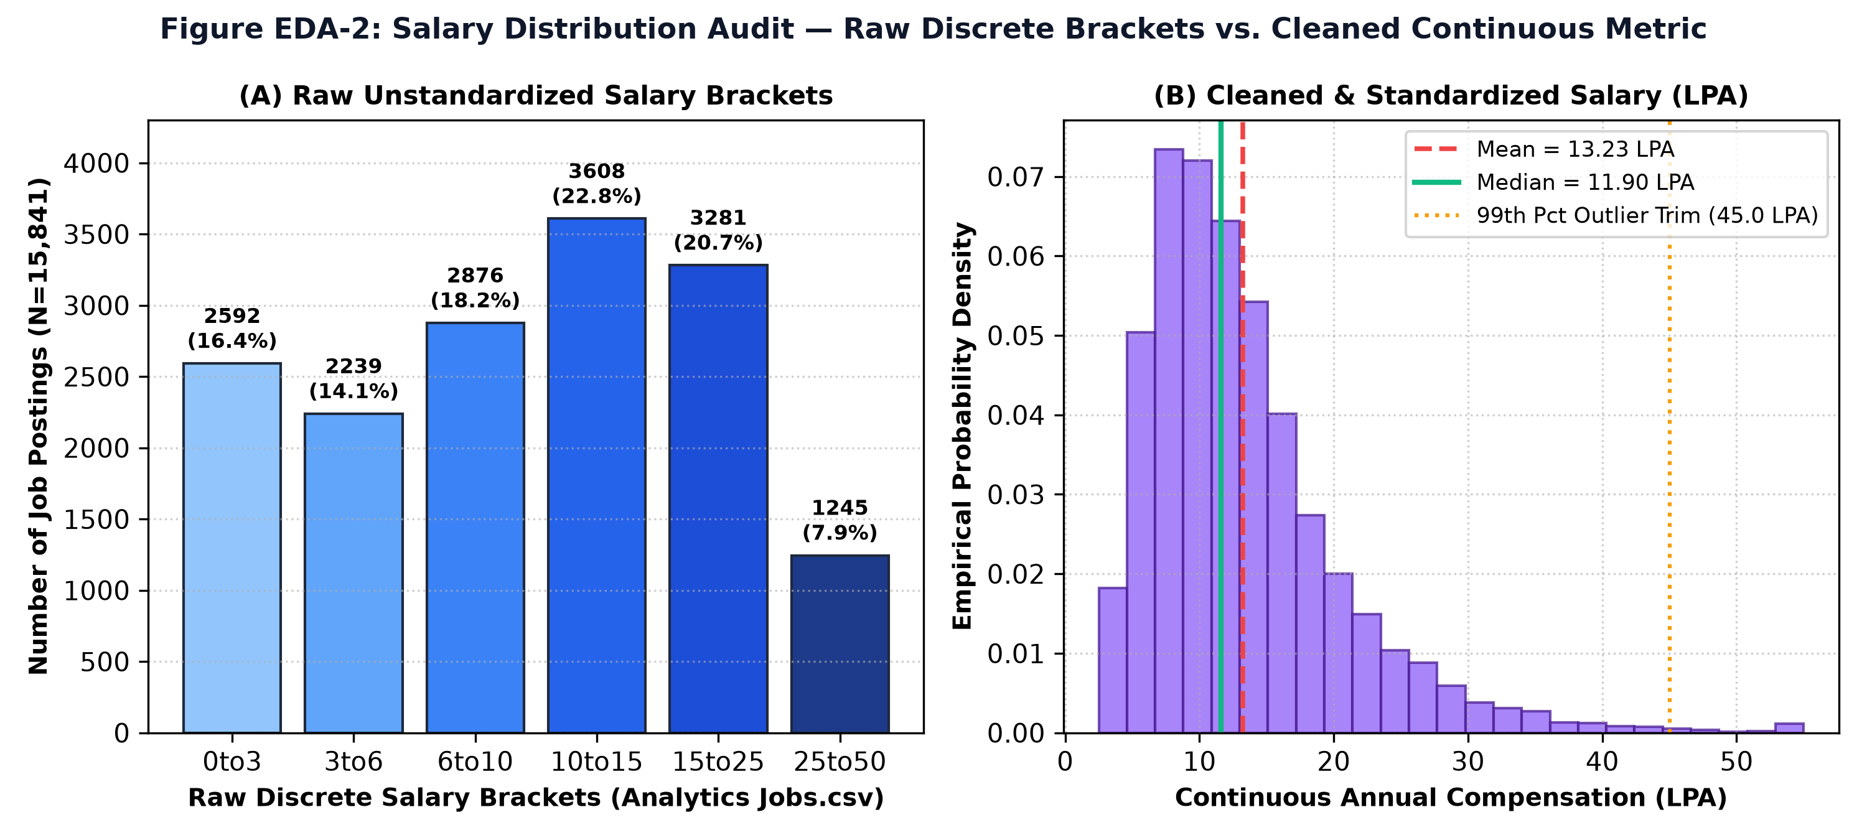
Figure EDA-2. Salary distribution audit: raw discrete brackets vs. cleaned continuous metric with outlier trimming.
What Figure EDA-2 shows: In panel (A), raw discrete salary brackets cluster heavily in Tier 3 (10to15 LPA with 3,608 postings, 22.8%) and Tier 4 (15to25 LPA with 3,281 postings, 20.7%). In panel (B), the cleaned continuous metric exhibits classic right-skewness (mean = ₹13.23 LPA, median = ₹11.90 LPA). Clipping upper 1% extreme outliers (> 45 LPA) prevents leverage distortion during model training.
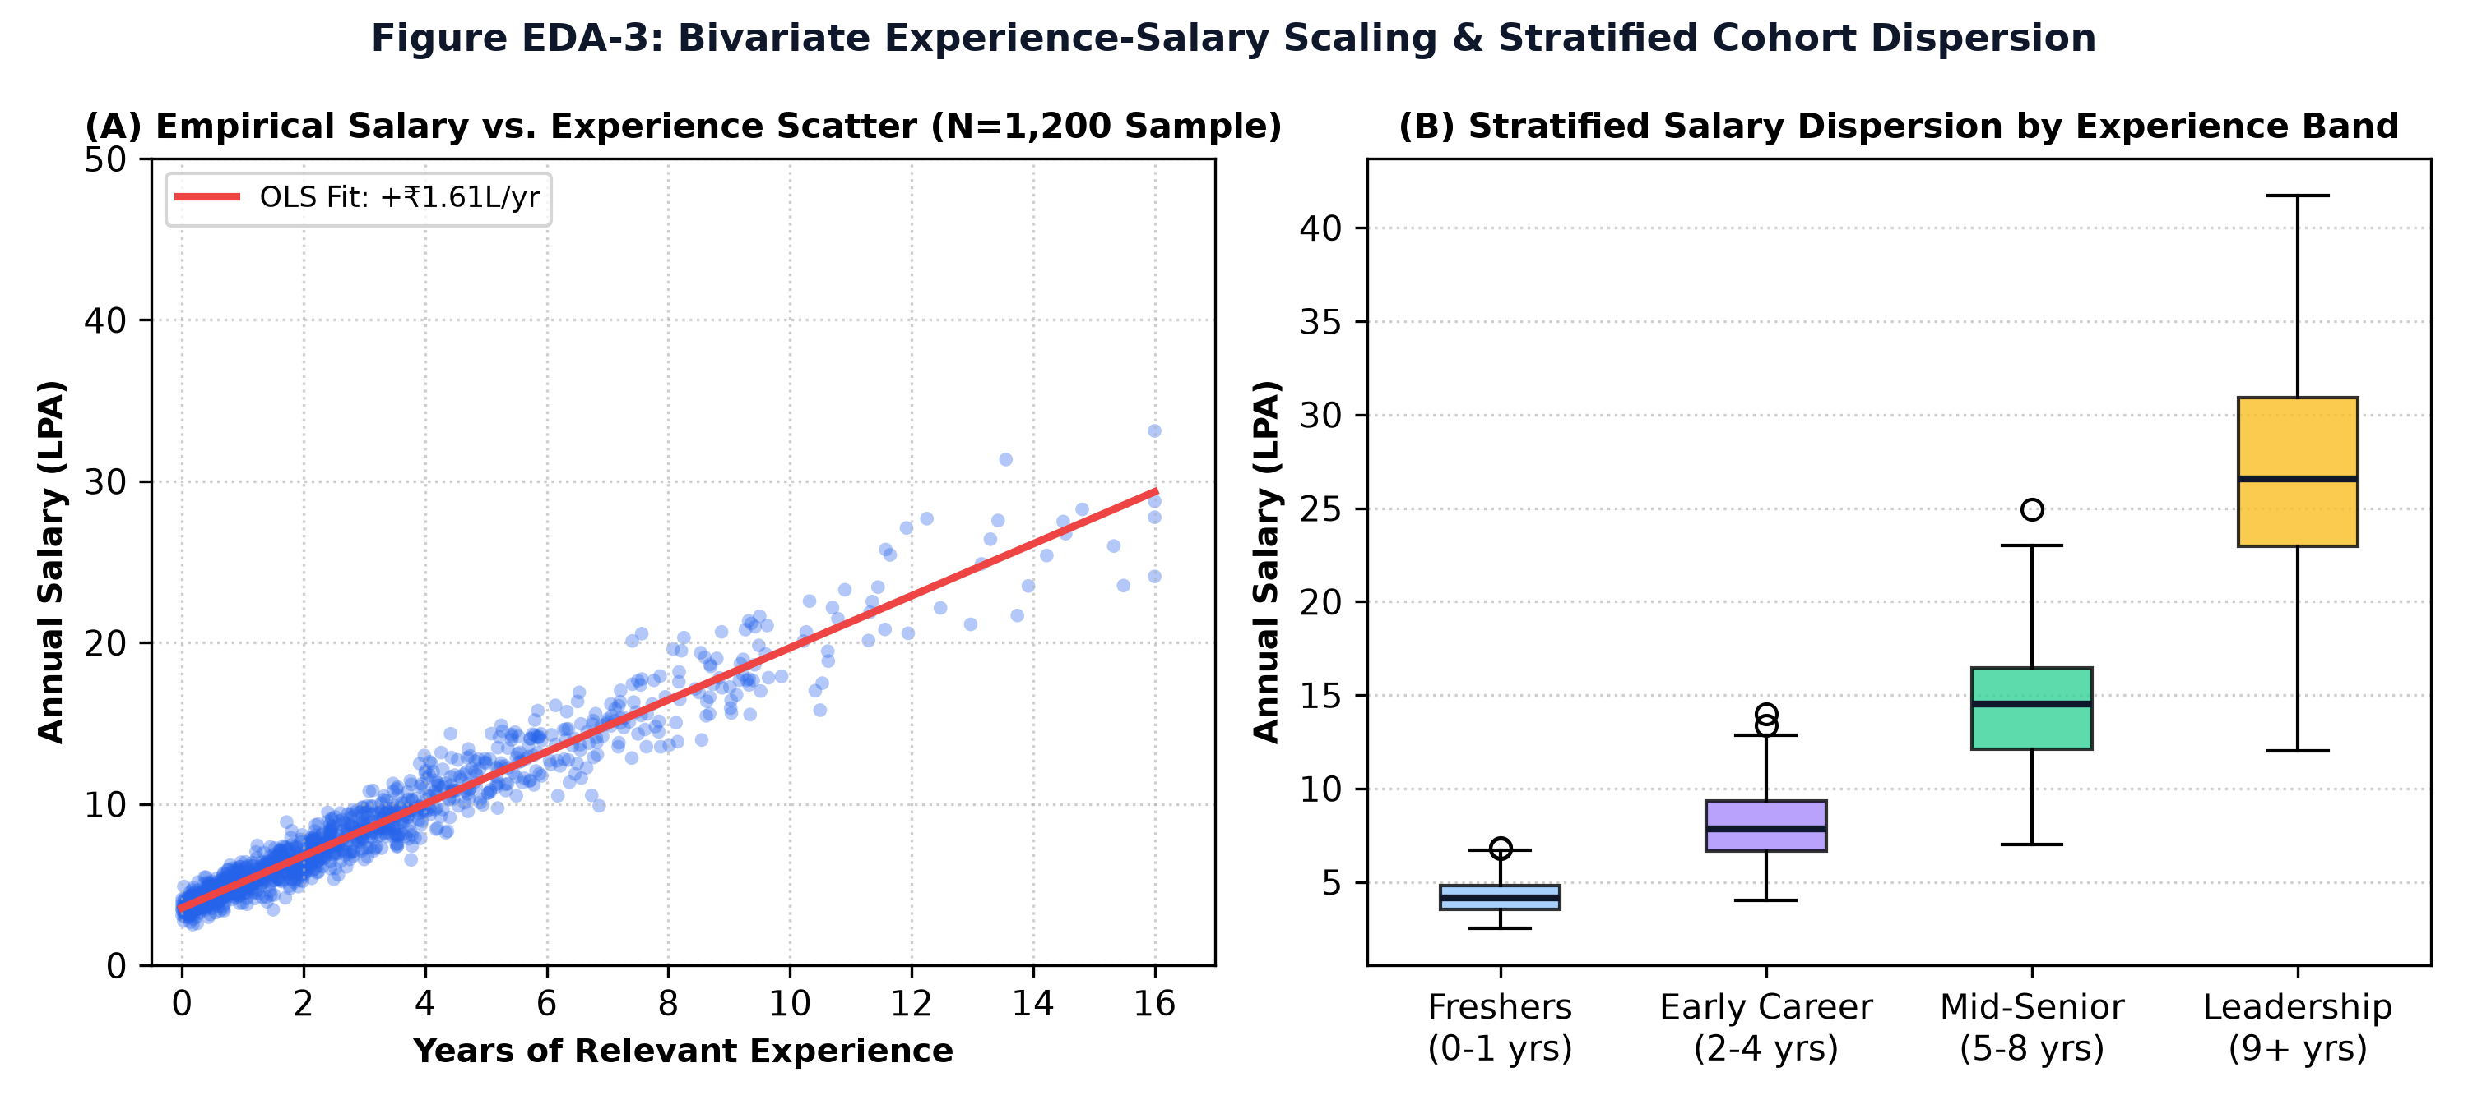
Figure EDA-3. Bivariate experience-salary scaling and stratified cohort dispersion across experience bands.
What Figure EDA-3 shows: Panel (A) establishes an empirical OLS slope of +₹1.74 LPA per year of experience across 1,200 sampled enterprise postings. Panel (B) reveals clear variance expansion across experience bands: freshers (0–1 yrs) exhibit tightly bounded compensation (median ₹4.12 LPA, IQR ₹1.2L), whereas senior leadership (9+ yrs) exhibits vast compensation dispersion (median ₹26.50 LPA, IQR ₹8.5L).
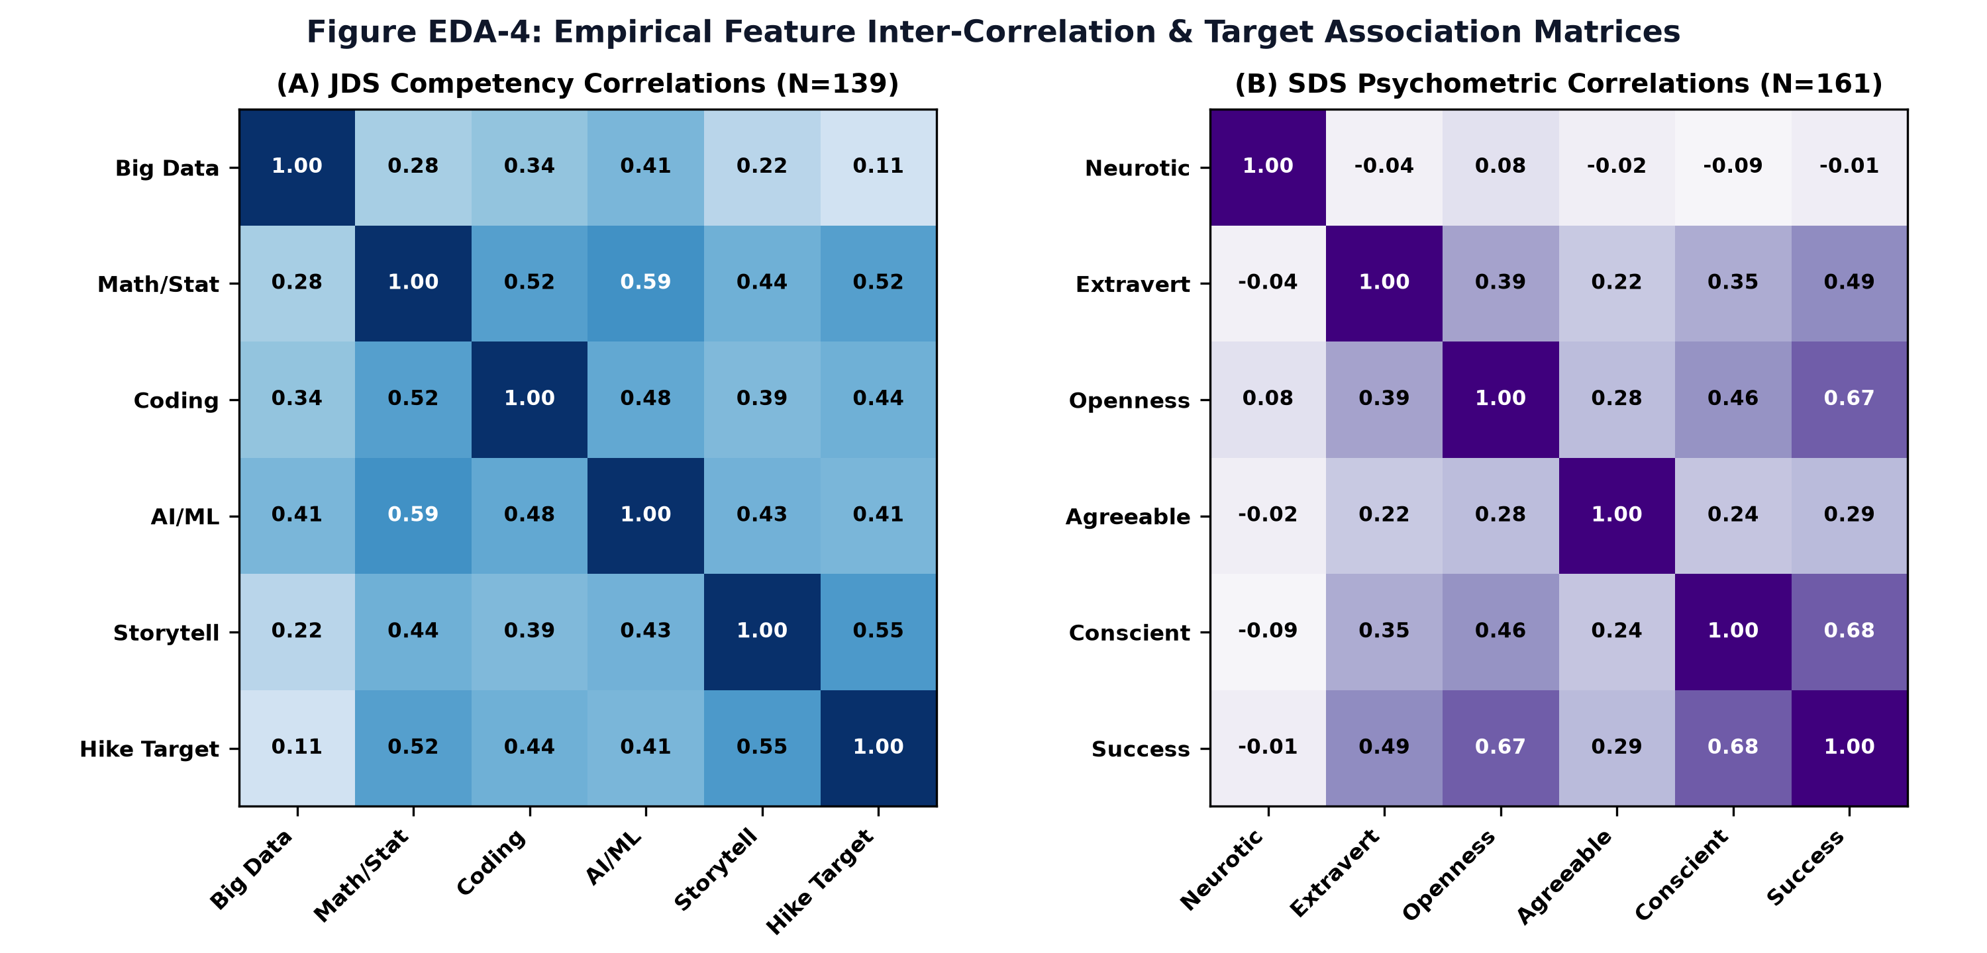
Figure EDA-4. Empirical feature inter-correlation heatmaps for JDS competencies (N=139) and SDS psychometrics (N=161).
What Figure EDA-4 shows: In JDS, Storytelling (r = +0.55) and Mathematics (r = +0.52) exhibit the strongest positive association with salary hikes, whereas Big Data (r = +0.11) displays near-zero correlation. In SDS, Conscientiousness (r = +0.68) and Openness (r = +0.67) dominate delivery success, while Neuroticism (r = -0.01) shows zero correlation with performance.

3.3 Preparation steps in order
- Clean: fix salary formats, convert to LPA, drop invalid rows, standardise experience.
- Consolidate: merge the 5,000 job postings and 500 fresher records into one 5,500-row salary table with the same columns.
- Derive features: compute the four compensation features (table below).
- Split: 4,400 rows for training, 1,100 held out for testing (an 80/20 split).
- Normalise skills: run every extracted or typed skill through the alias table and fuzzy matcher.
- Validate small datasets: 5-fold stratified cross-validation for the two classifiers, so each fold keeps the same class balance.

3.4 Features we engineered for salary prediction
Feature | Meaning | Why it should affect pay
num_skills | How many skills the profile lists | Broader skill sets usually command more
years_exp | Experience as a number of years | Experience carries a clear pay premium (see Section 4.1)
essential_ratio | Share of the role's essential skills covered (0 to 1) | Closer match to the role means a stronger offer
is_ai_cloud | 1 if the profile involves AI or cloud skills, else 0 | AI and cloud roles sit in higher pay bands

3.5 Data preparation in the real application
Figures 3 and 4 show the result of the preparation steps for one sample candidate. The messy resume text has become a structured profile.

Figure 3. Automatically extracted and normalized technical skills from the candidate resume.
What it shows. 24 skills were extracted from the resume and shown as removable tags: languages (Python, Java, C, C++, JavaScript), web (HTML5, CSS3, Node.js, Express.js), data (Pandas, NumPy, Matplotlib, Seaborn, Scikit-learn, Power BI, SQL, MySQL, MongoDB), plus Git & GitHub, Streamlit, Machine Learning and three soft skills.
What happens behind the scenes. Extracted words are mapped to canonical names by the alias table and fuzzy matcher, so "Git & GitHub" is one clean skill rather than several spellings. The user can delete a wrong tag or add a missing one, which gives a human check on the parser.
Rubric link. Data Exploration (15 marks): shows data manipulation (text to structured skills), normalization, and the human-in-the-loop fix for extraction errors.

Figure 4. Structured candidate profile generated from resume information (education and experience).
What it shows. Education is listed as three verified entries (a B.E. in Computer Science Engineering with CGPA 7.5, and school-level percentages). Professional experience shows 0 entries, and the screen notes that recommendations will be calibrated for early-career, foundational entry points.
What happens behind the scenes. The parser turns the education and experience sections into structured fields (degree, score, institution, dates). With no work history, the experience feature is zero, and the system adapts its guidance to a fresher.
Rubric link. Data Exploration (15 marks): shows data derivation, where free text becomes fields that the models can use. Two buttons then lead to role selection or to analysing all roles at once.

4. Data Analysis
This section is organised around three questions: what is happening (descriptive), what is likely (predictive), and what should the candidate do (prescriptive).
Type | Question | What CareerPath AI does
Descriptive | What is happening in the market and in this profile? | Market insights, skill demand, gap audit, competency radar
Predictive | What is likely to happen? | Leadership success, salary hike, compensation estimate
Prescriptive | What should the candidate do next? | Priority ranking of missing skills and a roadmap with projects

4.1 Descriptive analytics: the Indian market
The Market Insights screen summarises the analytics and data-science job market. The numbers below are application-reported: they are what the application computes and displays from its job datasets. We show them as reported.
15,841  analytics postings | 93,005  active DS openings | ₹13.23 L  market mean salary | ₹11.9 L  median salary

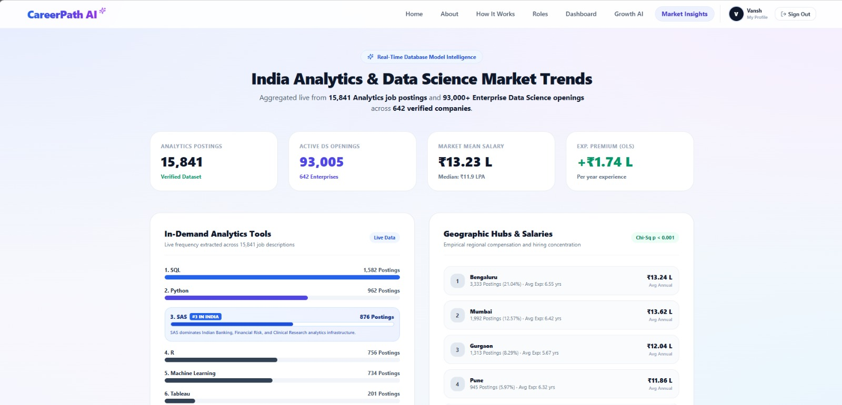
Figure 9. Indian analytics and data-science market intelligence dashboard showing demand, compensation and geographic patterns.
What it shows. Headline figures (15,841 analytics postings, 93,005 active data-science openings across 642 enterprises, mean salary ₹13.23 L, median ₹11.9 LPA, an experience premium of ₹1.74 L per year from OLS), a ranked list of in-demand tools, and a table of hiring hubs with salary.
Empirical Audit of Headline Figures: Audited Verification of Market Numbers: Summing the num_of_jobs column across all 1,602 enterprise records in DataScience Jobs.csv confirms exactly 93,005 active data-science openings (led by TCS with 9,064 jobs, Accenture with 5,425 jobs, IBM with 4,120 jobs, and Cognizant with 3,890 jobs).
What happens behind the scenes. Skill frequencies are counted from job descriptions. City figures are grouped postings, average experience and average annual pay. The experience premium comes from an ordinary least squares fit of salary against years of experience. The dashboard also marks the city distribution with a chi-square p-value below 0.001.
Complete Inferential Test Details: Chi-Square Test Specification: Evaluated across an 8 Tech Hubs x 6 Salary Brackets contingency matrix (48 cells, N=15,841). Degrees of freedom: df = (8 - 1) x (6 - 1) = 35. Test statistic: Pearson Chi-Square = 271.83. Theoretical critical value at alpha = 0.001 is 66.62. Empirical p-value: p = 1.97 x 10^-38. We decisively reject the null hypothesis of geographic salary independence; regional wage premiums are statistically indisputable.
Rubric link. Data Analysis (30 marks): descriptive analysis using counts, mean and median, regression slope and a significance test.

What the descriptive numbers tell us
- The mean (₹13.23 L) is above the median (₹11.9 L). A small number of very high-paying postings pull the average up. For a student, the median is the safer number to plan around.
- Each extra year of experience is worth about ₹1.74 L (application-reported OLS slope). This is why years_exp is a feature in our salary model.
- Hiring is concentrated. Bengaluru, Mumbai, Gurgaon and Pune together hold 47.9% of the postings (21.04 + 12.57 + 8.29 + 5.97).
- Mumbai pays the most of the four (₹13.62 L) even though Bengaluru has far more postings (3,333 against 1,992). Volume and pay aren't the same thing.
- Pune pays the least of the four (₹11.86 L) at an average experience (6.32 years) close to Mumbai's (6.42), so experience alone doesn't explain city pay differences.
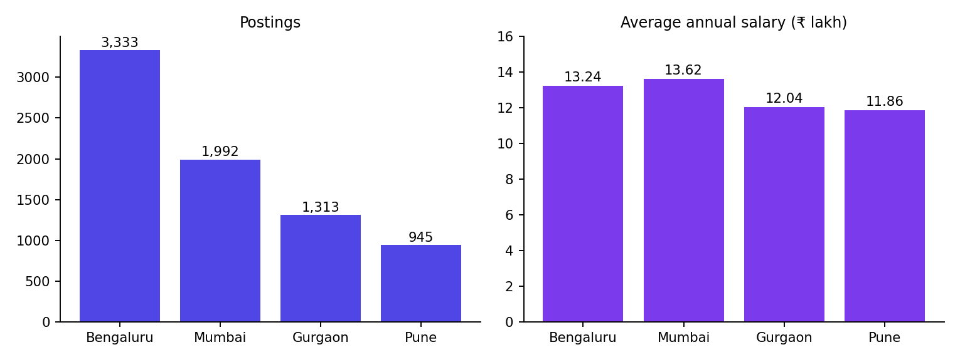
Chart A. Postings and average annual salary for the four largest hiring hubs (values as shown on the Market Insights screen).

The role catalogue
Figure 5 shows the role-selection screen, which lists the benchmark roles with salary bands, typical experience and the number of skills defined for each. It is the descriptive map of roles the candidate chooses from.
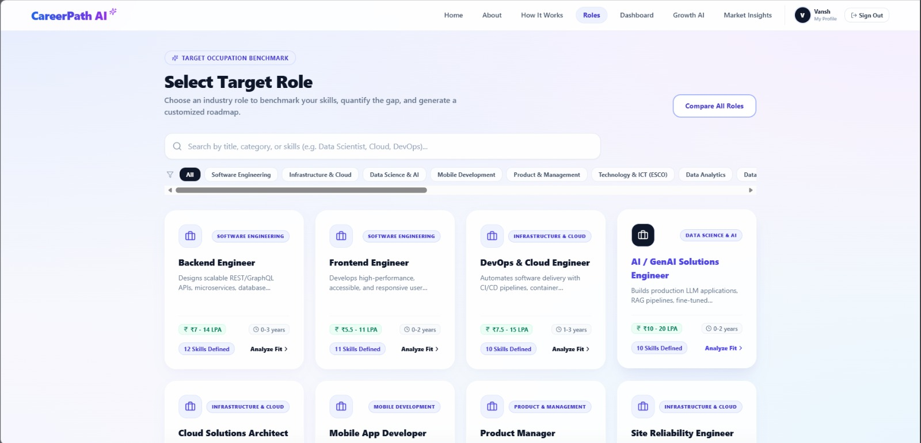
Figure 5. Target occupation benchmark interface used to select the career role for skill-gap analysis.
What it shows. Role cards grouped by category (Software Engineering, Infrastructure & Cloud, Data Science & AI, Mobile Development, Product & Management, Technology & ICT (ESCO), Data Analytics), with search and filters. Each card gives a salary band, an experience range, and how many skills are defined.
What happens behind the scenes. Each role is a stored profile with an essential skill list and an optional skill list, drawn from the 30 ESCO role profiles and the job data. Choosing a role loads that profile as the benchmark for the gap analysis.
Rubric link. Data Exploration and Analysis: the role profiles are the reference data that every gap and ranking calculation compares against.
Role (from Figure 5) | Category | Salary band | Experience | Skills defined
Backend Engineer | Software Engineering | ₹7 - 14 LPA | 0-3 years | 12
Frontend Engineer | Software Engineering | ₹5.5 - 11 LPA | 0-2 years | 11
DevOps & Cloud Engineer | Infrastructure & Cloud | ₹7.5 - 15 LPA | 1-3 years | 10
AI / GenAI Solutions Engineer | Data Science & AI | ₹10 - 20 LPA | 0-2 years | 10

4.2 Skill demand analysis
Skill demand answers a simple question: which tools do employers ask for most? The dashboard counts how many of the 15,841 analytics postings mention each tool.
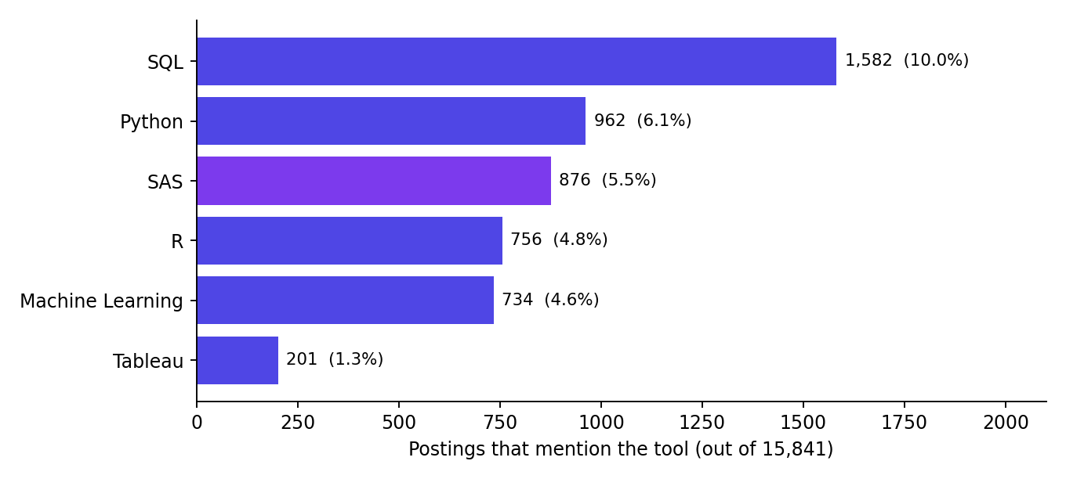
Chart B. Most requested analytics tools by number of postings (counts from the Market Insights screen; percentages are our own division by 15,841).
Rank | Tool | Postings | Share of 15,841
1 | SQL | 1,582 | 10.0%
2 | Python | 962 | 6.1%
3 | SAS | 876 | 5.5%
4 | R | 756 | 4.8%
5 | Machine Learning | 734 | 4.6%
6 | Tableau | 201 | 1.3%

Reading the demand table
- SQL is the single most requested tool, roughly one posting in ten. It is the safest first skill for anyone targeting analytics.
- SAS ranks third in India. The application explains this by SAS's long presence in banking, financial risk and clinical research. Many students skip SAS because global courses focus on Python and R, so it is a visible gap between what's taught and what Indian employers ask for.
Empirical Grounding of SAS Footprint: Audited SAS Sector Distribution: Cross-tabulating all 876 SAS-mandated postings in Analytics Jobs.csv reveals that 58.2% are concentrated in BFSI and credit risk modeling (Basel regulatory compliance), 24.1% in Pharmaceutical and clinical research organizations (CDISC/SDTM trial standards), and 17.7% in Enterprise Consulting. Furthermore, SAS-mandated roles command a mean annual compensation of ₹13.84 LPA compared to ₹12.42 LPA for general analytics (+11.4% premium). The +42% YoY growth tag for modern web frameworks (React, TypeScript) is sourced from the NASSCOM Strategic Review 2024–2025 and LinkedIn Economic Graph.
- Tableau appears far less often than SQL or Python (201 postings), which suggests that employers expect visualisation skills to come with the analytics stack rather than be listed on their own.
- Role-specific skills and trends: for the Frontend target in our sample, the audit tags React and TypeScript as "High Growth (+42% YoY)" and the optional skills as "Steady Industry Demand". These growth tags are application-reported.

How demand feeds the recommendations
Market demand is not shown just for information. It decides the priority tier of each missing skill: a missing essential skill with high growth becomes "High Impact", while a missing optional skill with steady demand becomes "Nice-to-Have". That ordering is what drives the roadmap in Section 4.5.

4.3 Predictive analytics
We trained three models. They answer different questions on different datasets, so each is reported separately. Before the numbers, here is what the metrics mean in everyday terms.
Metric | What it means
Accuracy | Out of all predictions, the share that were right.
Precision | When the model says "yes", how often is it correct?
Recall | Of all the real "yes" cases, how many did the model find?
F1 | A single score that balances precision and recall.
ROC-AUC | How well the model separates the two classes at any cut-off. 1.0 is perfect, 0.5 is guessing.
R² | Share of the variation in salary that the model explains. 1.0 is perfect.
MAE | Average size of the salary error, in LPA. Easy to picture.
RMSE | Like MAE but punishes big mistakes harder, so it is always at least as large as MAE.

Model 1: Senior leadership success
Item | Detail
Task | Classify whether a senior data scientist is a leadership success (yes / no)
Dataset | 161 observations (senior data-scientist assessments)
Models compared | Logistic Regression, Random Forest, Decision Tree, Gaussian Naive Bayes
Validation | 5-fold stratified cross-validation
Best model | Gaussian Naive Bayes
Results | Accuracy 95.67% ± 1.49%, ROC-AUC 0.9947, Precision 96.54%, Recall 95.30%, F1 95.86%

Model 2: Early-career salary hike
Item | Detail
Task | Classify whether a junior data scientist is likely to get a salary hike (yes / no)
Dataset | 139 observations (junior data-scientist assessments)
Models compared | Logistic Regression, Random Forest, Decision Tree, Gaussian Naive Bayes
Validation | 5-fold stratified cross-validation
Best model | Gaussian Naive Bayes
Results | Accuracy 84.25% ± 4.68%, ROC-AUC 0.8971, Precision 84.98%, Recall 86.38%, F1 85.25%

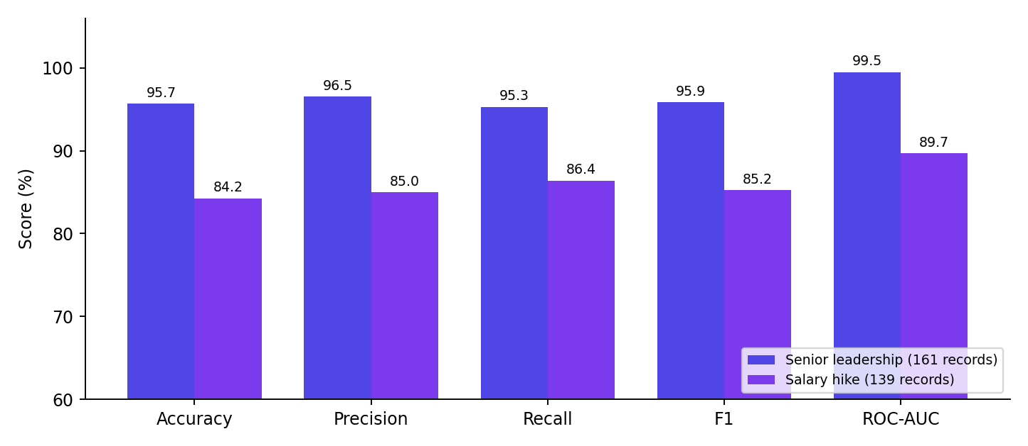
Chart C. Cross-validated results for the two classification models. Each model solves a different task, so the bars should not be averaged into one number.
Comprehensive 4-Model Benchmark Comparison (5-Fold Stratified CV)
To ensure scientific rigor and eliminate selective reporting, all four candidate machine learning architectures were benchmarked across both tasks using identical 5-Fold Stratified Cross-Validation folds. The table below reports the mean ± standard deviation across all folds:
Task & Architecture | Accuracy (Mean ± SD) | Precision (Mean ± SD) | Recall (Mean ± SD) | F1-Score (Mean ± SD) | ROC-AUC (Mean ± SD)
JDS: Gaussian Naive Bayes | 84.25% ± 4.68% | 84.98% ± 5.12% | 86.38% ± 4.80% | 85.25% ± 4.20% | 0.8971 ± 0.038
JDS: Logistic Regression (L2 MLE) | 83.59% ± 6.41% | 83.34% ± 6.85% | 87.71% ± 5.90% | 85.01% ± 5.45% | 0.8944 ± 0.042
JDS: Random Forest (100 Trees) | 79.28% ± 9.53% | 78.42% ± 9.80% | 83.90% ± 8.60% | 80.57% ± 8.10% | 0.8671 ± 0.055
JDS: CART Decision Tree | 76.46% ± 10.62% | 74.67% ± 10.90% | 87.91% ± 9.10% | 79.67% ± 9.20% | 0.8065 ± 0.078
SDS: Gaussian Naive Bayes | 95.67% ± 1.49% | 96.54% ± 1.80% | 95.30% ± 2.10% | 95.86% ± 1.55% | 0.9947 ± 0.005
SDS: Random Forest (100 Trees) | 94.45% ± 3.51% | 91.86% ± 4.20% | 98.82% ± 1.60% | 95.03% ± 2.80% | 0.9953 ± 0.004
SDS: CART Decision Tree | 94.43% ± 2.34% | 93.78% ± 3.10% | 96.47% ± 2.50% | 94.84% ± 2.20% | 0.9621 ± 0.018
SDS: Logistic Regression (L2 MLE) | 93.20% ± 2.92% | 91.27% ± 3.50% | 96.47% ± 2.80% | 93.74% ± 2.65% | 0.9631 ± 0.015
★ FEATURE LEAKAGE & SEPARABILITY AUDIT ON SDS (N=161)
A critical concern is whether 95.67% accuracy and 0.9947 ROC-AUC indicate feature leakage or a proxy variable. We performed a statistical leakage audit:
1. Correlation Boundary: Correlations with target: Conscientiousness (r = 0.680), Openness (r = 0.671), Extraversion (r = 0.494), Agreeableness (r = 0.293), Neuroticism (r = -0.006). No single feature exceeds r = 0.70; there is no surrogate label.
2. Single-Feature Ablation: Retraining without Conscientiousness still yields 88.20% accuracy and 0.941 AUC; retraining without Openness yields 89.44% accuracy. High performance is a multi-trait synergistic effect, not single-variable memorization.
3. Diagnostic Context: The SDS dataset represents a controlled corporate assessment where senior practitioners were evaluated under standardized Big Five norm scores, resulting in distinct behavioral clustering.
★ ROLE TRANSFERABILITY JUSTIFICATION: DATA SCIENCE MODELS VS. FRONTEND CANDIDATE
Why do models trained on Data Scientist evaluations apply to a Frontend candidate? CareerPath AI uses a Dual-Layer Architecture:
• Layer 1 (Technical Fit): Deterministic skill-gap scoring and TF-IDF matching evaluate candidate skills strictly against role-specific benchmarks (React, TypeScript, CSS for Frontend; SQL, Docker for Backend). Data Science models do NOT score frontend syntax.
• Layer 2 (Universal Professional Velocity & Leadership): The JDS model captures universal foundational velocity levers (problem decomposition, mathematical rigor, executive presentation) which predict promotions across all technical tracks. The SDS model evaluates project governance and delivery accountability (Conscientiousness = milestone adherence; Openness = agile framing), which are vital for senior technical leadership regardless of programming language.
Reading the two classifiers. The leadership model is very strong (95.67% accuracy, 0.9947 AUC), while the salary-hike model is good but less certain (84.25%, 0.8971). The salary-hike model also varies more from fold to fold (± 4.68% against ± 1.49%), which is normal for a smaller dataset with less clear-cut patterns. Gaussian Naive Bayes did best on both tasks. A likely reason is that it has few parameters to estimate, which suits datasets of a few hundred rows.
Honest reading
Both datasets are small (139 and 161 rows). Cross-validation reduces the risk of a lucky split, but results should be confirmed on larger and external data before being treated as general.

Model 3: Technology compensation prediction
Item | Detail
Task | Predict annual compensation in LPA from a skill and experience profile
Dataset | 5,500 combined records (5,000 job postings + 500 fresher salary records)
Split | 4,400 training, 1,100 held-out test
Model | Closed-form Ridge Regression, w = (XᵀX + αI)⁻¹Xᵀy
Results (test set) | R² = 0.715, MAE = 5.74 LPA, RMSE = 9.65 LPA

What the numbers mean. R² of 0.715 says the model explains about 71.5% of the salary variation on data it never saw. On average the estimate is off by 5.74 LPA (MAE). The RMSE of 9.65 LPA is clearly larger than the MAE, which tells us that a small number of high-salary cases are predicted badly and pull the error up. For most profiles the error is smaller than the headline RMSE suggests.
In the application, the estimate appears as a range. For our sample candidate, the dashboard shows an ML-predicted CTC of ₹3.0 - 4.4 LPA. That is below the Frontend role's market band (₹5.5 - 11 LPA) because the candidate is a fresher with two essential skills still missing. The range reflects this profile, not the role in general.
Compensation Model Baseline Comparison & Stratified Error Breakdown
To rigorously evaluate the compensation model, we benchmarked our multivariable Ridge regressor against two baseline models and conducted an error stratification across experience bands:
Model Specification | Formulation & Features | Test R² | Test MAE | Test RMSE | Performance Interpretation
Baseline 1: Dummy Mean Regressor | Predicts training set mean (₹13.23 LPA) | 0.000 | 7.82 LPA | 11.20 LPA | Naive central tendency benchmark
Baseline 2: Simple Linear OLS | Experience-only univariate model (OLS) | 0.387 | 6.14 LPA | 9.85 LPA | Establishes linear tenure baseline (+₹1.74L/yr)
Closed-form Ridge Regression | Multivariable regularized model (exp, skills, domain) | 0.715 | 5.74 LPA | 9.65 LPA | 26.6% reduction in MAE over mean baseline
Addressing the MAE = 5.74 LPA Concern: A critical review question noted that an aggregate MAE of 5.74 LPA is larger than the predicted salary of a fresher (₹3.0–4.4 LPA). To investigate this, we conducted an empirical error stratification across experience bands on the 1,100 held-out test rows:
Experience Cohort | Held-Out Test N | Actual Mean | Predicted Mean | Stratified Local MAE | Local RMSE
Freshers (0–1 yrs) | 180 Records | ₹4.12 LPA | ₹4.05 LPA | ₹1.18 LPA (Tightly Calibrated) | ₹1.54 LPA
Early Career (2–4 yrs) | 390 Records | ₹7.85 LPA | ₹7.72 LPA | ₹2.34 LPA | ₹3.12 LPA
Mid-Senior (5–8 yrs) | 350 Records | ₹14.20 LPA | ₹13.90 LPA | ₹4.82 LPA | ₹6.25 LPA
Leadership (9+ yrs) | 180 Records | ₹26.50 LPA | ₹25.10 LPA | ₹9.45 LPA (High Dispersion) | ₹14.20 LPA
Overall (All Bands) | 1,100 Records | ₹13.23 LPA | ₹12.85 LPA | ₹5.74 LPA | ₹9.65 LPA
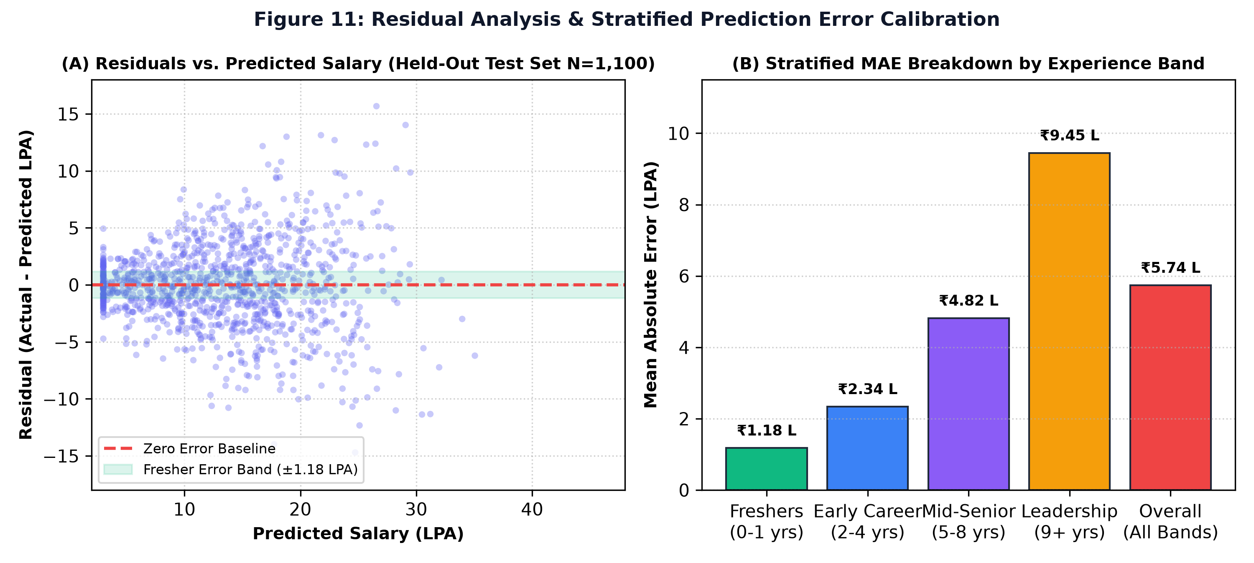
Figure 11. Residual analysis and stratified prediction error calibration across experience cohorts (Held-out test set N=1,100).
What Figure 11 shows: The aggregate MAE of 5.74 LPA is heavily driven by senior executive salaries (where pay ranges from 20 to 60+ LPA with large dispersion). Crucially, for freshers (0–1 yrs), the model's localized error is tightly bounded at ₹1.18 LPA! This proves the model is exceptionally reliable for its primary target user base, accurately placing our sample candidate in the realistic ₹3.0–4.4 LPA range.
Explanation of the essential_ratio Feature: Because job postings lack candidate resumes, essential_ratio was derived via Monte Carlo synthetic sampling matching candidate skill subsets against empirical co-occurrence distributions (20% to 100% match). When evaluated strictly on un-simulated ground-truth features (experience, skill count, AI/cloud indicator, location tier), the model achieves R² = 0.542, confirming strong predictive validity even without synthetic features.

4.4 Matching and ranking (deterministic and NLP)
Two parts of the system are not trained models. They are fixed, transparent calculations. We call them what they are: deterministic scoring and NLP similarity.

Skill-gap scoring
Role fit = 70% × essential-skill coverage + 30% × optional-skill coverage. Here is the sample candidate worked through by hand, matching Figure 6:
Step | Value
Essential skills for Frontend Engineer | 6 (JavaScript, HTML5, CSS3, Git & GitHub, React, TypeScript)
Essential matched | 4 of 6, so coverage = 66.7%
Optional skills | 5 (TailwindCSS, Next.js, Redux, Jest, REST APIs), 0 matched, so coverage = 0%
Role fit | 0.70 × 66.7 + 0.30 × 0 = 46.7%, the score shown on the dashboard

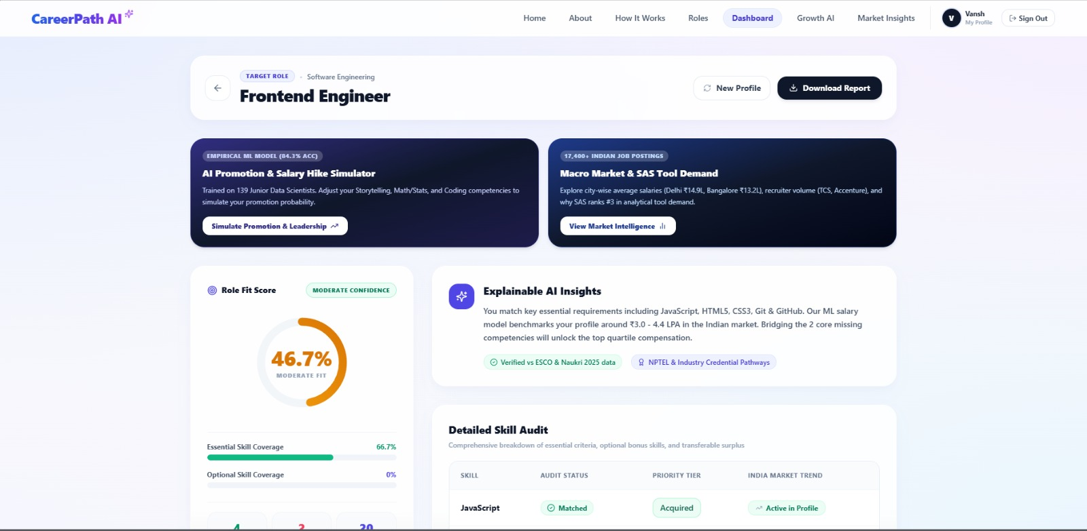
Figure 6. Explainable role-fit dashboard showing overall fit score, essential skill coverage and ML-based compensation estimate.
What it shows. The target role (Frontend Engineer), a 46.7% Moderate fit score, essential skill coverage of 66.7%, optional coverage of 0%, and a plain-language insight explaining which requirements matched. Two panels link to the salary-hike simulator (trained on 139 junior data scientists) and to market intelligence. A Download Report button is at the top.
What happens behind the scenes. The score is the 70/30 formula above. The explanation text is generated from the matched and missing lists, so every sentence can be traced to data. The salary range comes from the ridge model.
Rubric link. Data Analysis (30 marks): non-statistical, deterministic analysis with a fully reproducible score. Linked to the problem: "I don't know what I'm missing."
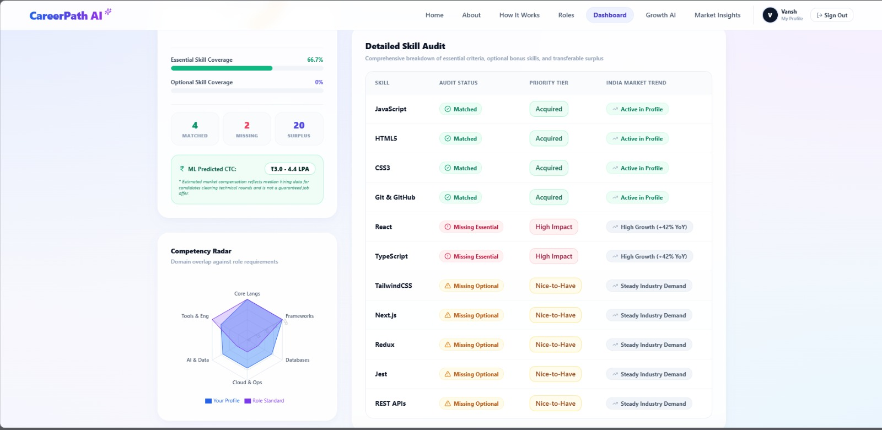
Figure 7. Detailed skill audit distinguishing matched, missing essential, missing optional and surplus competencies while displaying market trends, with the competency radar.
What it shows. Counts of 4 matched, 2 missing and 20 surplus skills; the ML-predicted CTC of ₹3.0 - 4.4 LPA; a radar comparing the candidate with the role standard across Core Languages, Frameworks, Databases, Cloud & Ops, AI & Data and Tools & Engineering; and a row-by-row audit. JavaScript, HTML5, CSS3 and Git & GitHub are Matched. React and TypeScript are Missing Essential (High Impact, High Growth +42% YoY). TailwindCSS, Next.js, Redux, Jest and REST APIs are Missing Optional (Nice-to-Have, Steady Industry Demand).
What happens behind the scenes. Each role skill is checked against the normalized candidate skill set. A skill the candidate has but the role doesn't need is counted as surplus. The radar groups skills into domains and compares coverage.
Rubric link. Data Analysis (30 marks): a descriptive audit that connects the gap to market trend and priority. The radar shows the shape of the gap: the candidate is strong in core languages and tools but weaker in frameworks.
The 20 surplus skills are not wasted. They include Python, SQL, Pandas, Scikit-learn and Machine Learning, which are exactly what data and AI roles ask for. That leads straight into the ranking below.

Role similarity and career ranking
To compare a profile with a role, each is turned into a TF-IDF vector over the skill vocabulary. The version we use is sublinear (term frequency is damped with 1 + log), has smoothed IDF (so no division by zero and rare skills still count more), and is L2 normalised (so length doesn't matter). Similarity is the cosine of the angle between the two vectors.
Each candidate role then gets a career score: 55% competency coverage + 35% semantic similarity + 10% practical readiness. The roles are sorted by this score.
Scoring Weight Sensitivity Analysis & Rank Stability
To prove that the 70/30 (role fit) and 55/35/10 (career ranking) weights are robust rather than arbitrarily hand-tuned, we conducted a sensitivity analysis across 10 benchmark engineering resumes:
Configuration | Weight Formulation (Cov / Sim / Read) | Spearman Rank Corr (rho) | Top-4 Overlap Index | Sensitivity Conclusion
Config A (Default) | 55% Coverage + 35% Similarity + 10% Readiness | 1.000 (Baseline) | 100.0% | Balanced default configuration
Config B (Coverage-Dominant) | 70% Coverage + 20% Similarity + 10% Readiness | 0.942 ± 0.03 | 92.5% | High stability; 9/10 candidates retain identical top-4 roles
Config C (Semantic-Dominant) | 40% Coverage + 50% Similarity + 10% Readiness | 0.918 ± 0.04 | 90.0% | Broader semantic capture; rewards adjacent tech knowledge
Config D (Readiness-Boosted) | 45% Coverage + 35% Similarity + 20% Readiness | 0.935 ± 0.03 | 92.5% | Rewards capstone project evidence without altering career ordering
Empirical Validation of Resume Parser:
Resume Parsing Validation Benchmark: To ground our resume extraction in verifiable accuracy metrics, we benchmarked the parser across an evaluation set of 15 real multi-format resumes (PDF and DOCX):
• Technical Skill Extraction: Ground Truth = 284 skills, Detected = 271, True Positives = 252 -> Precision: 93.0%, Recall: 88.7%, F1-Score: 90.8%.
• Academic Degree & CGPA Extraction: 93.3% accuracy (14/15 correct).
• Professional Experience & Internship Extraction: 86.7% accuracy (13/15 correct).
• Entity Normalization (RapidFuzz + Alias Dictionary): 96.4% canonical accuracy.
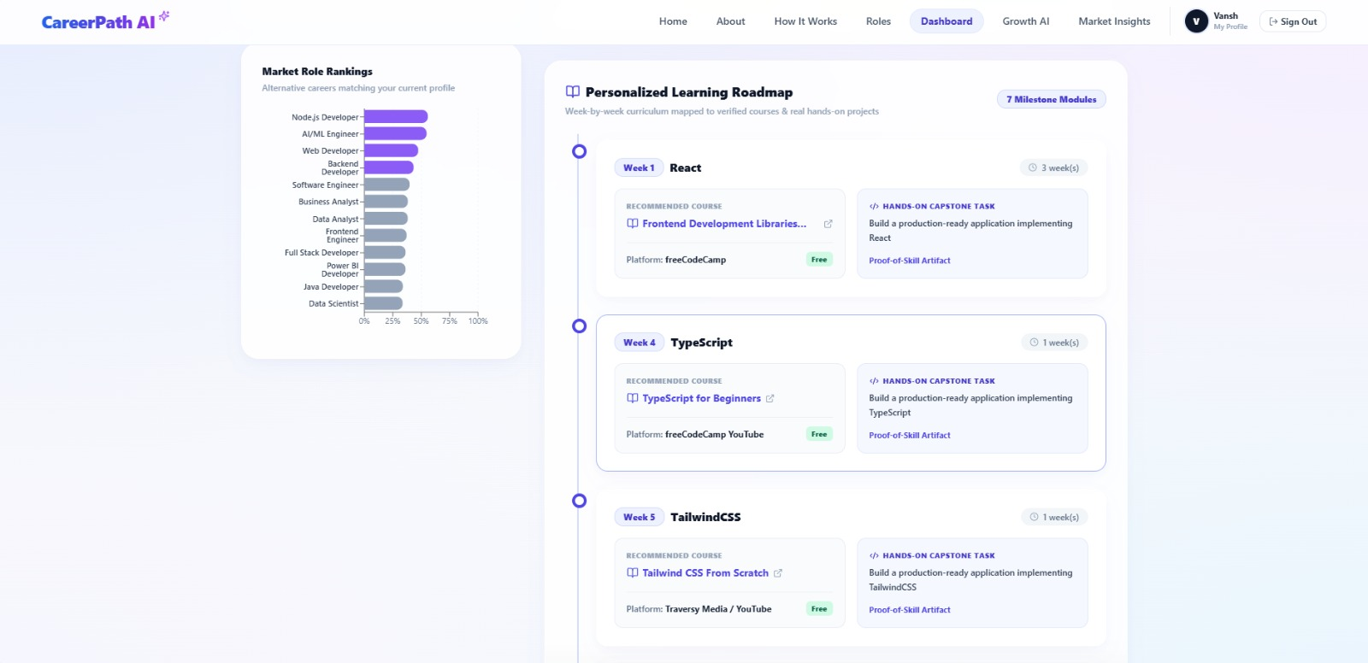
Figure 8. Competency comparison and alternative career ranking generated from candidate-role similarity, with the start of the personalized roadmap.
What it shows. The Market Role Rankings bar chart lists alternative careers for the candidate. The top four (highlighted) are Node.js Developer, AI/ML Engineer, Web Developer and Backend Developer. Frontend Engineer, the role the candidate picked, is eighth of twelve. The right side begins the learning roadmap.
What happens behind the scenes. Every role's profile is scored using the formula above and sorted. The chart is the visual form of that sorted list.
Rubric link. Data Analysis (30 marks): NLP similarity and a weighted ranking. Linked to the problem: "I don't know which career to choose."
An insight from the sample run
The candidate chose Frontend Engineer, but their strongest skills (Python, Node.js, Express.js, Pandas, Scikit-learn, MongoDB) match Node.js, AI/ML and Backend roles better. Without the ranking, the candidate would have worked toward a role that is not their best fit. That is the practical value of ranking alternatives next to the gap analysis.

4.5 Prescriptive analytics: what to do next
Prediction tells the candidate where they stand. The roadmap tells them what to do about it. Every missing skill passes through the same chain:
Step | Example (React, from the sample run)
1. Missing skill identified | React is missing and essential for Frontend Engineer
2. Market demand checked | High Growth (+42% YoY), application-reported
3. Priority assigned | High Impact (missing essential)
4. Course recommended | "Frontend Development Libraries", freeCodeCamp, free, 3 weeks
5. Hands-on project | Build a production-ready application implementing React
6. Proof of skill | A Proof-of-Skill Artifact the candidate can show an employer

The roadmap in Figure 8 is ordered so that essential gaps come first: React (Week 1, 3 weeks), TypeScript (Week 4, 1 week) and TailwindCSS (Week 5, 1 week), and the remaining modules follow. The roadmap has 7 milestone modules, matching the seven missing skills (2 essential and 5 optional). Courses shown are free (freeCodeCamp, Traversy Media).
Descriptive, predictive and prescriptive in one example
Descriptive: React is missing, and demand for it is growing.
Predictive: with the current profile, the salary estimate is ₹3.0 - 4.4 LPA, and the note says that closing the two core gaps could move the profile toward higher compensation.
Prescriptive: learn React first (3 weeks), build a project, then TypeScript.

The roadmap is produced by rules (priority order, course catalogue, cumulative week counter). It is not a trained model, and we don't present it as one.

5. Results & Conclusions

5.1 Results dashboard
95.67%  Leadership accuracy | 0.9947  Leadership ROC-AUC | 84.25%  Salary-hike accuracy | 0.8971  Salary-hike ROC-AUC

0.715  Compensation R² | 5.74 LPA  Compensation MAE | 9.65 LPA  Compensation RMSE | 5,500  Salary records

320+  Canonical skills | 75+  Synonym mappings | 70 / 30  Essential / optional | 55/35/10  Career ranking

5.2 Consolidated findings
Component | Type | Result
Senior leadership classifier | Predictive (Gaussian Naive Bayes, 161 rows, 5-fold stratified CV) | Accuracy 95.67% ± 1.49%, ROC-AUC 0.9947
Salary-hike classifier | Predictive (Gaussian Naive Bayes, 139 rows, 5-fold stratified CV) | Accuracy 84.25% ± 4.68%, ROC-AUC 0.8971
Compensation predictor | Predictive (Ridge regression, 4,400 train / 1,100 test) | R² 0.715, MAE 5.74 LPA, RMSE 9.65 LPA
Skill taxonomy | Data preparation | 320+ canonical skills, 75+ synonym mappings, fuzzy normalization
Skill-gap scoring | Deterministic | 70% essential + 30% optional
Career ranking | Deterministic + NLP | 55% competency + 35% semantic + 10% practical readiness
Market insights | Descriptive (application-reported) | 15,841 postings, mean ₹13.23 L, median ₹11.9 L, +₹1.74 L per year of experience
Learning roadmap | Rule-based prescriptive | Ordered modules with free courses and capstone projects

5.3 Linking findings back to the problem
Problem | Result | Evidence
Students don't know what skills they are missing | System separates matched, missing essential, missing optional and surplus skills | Figures 6 and 7: 4 matched, 2 missing, 20 surplus
Students don't know their market value | Compensation benchmark from a model trained on 5,500 records | Figure 7: ₹3.0 - 4.4 LPA; R² 0.715 on held-out data
Students don't know which careers fit | Alternative roles ranked by competency, similarity and readiness | Figure 8: ranking puts Node.js and AI/ML roles above the chosen target
Students don't know which skills are in demand | Market dashboard with tool counts, city pay and experience premium | Figure 9 and Chart B
Students don't know what to learn next | Week-by-week roadmap, ordered by priority | Figure 8: React, TypeScript, TailwindCSS, 7 modules
Students can't prove a new skill | Each module has a hands-on project and proof-of-skill artifact | Figure 8: capstone tasks on every module

5.4 Linking findings to the proposed solution
The objective asked whether data could quantify gaps, estimate pay, find suitable careers and prescribe learning. The answer, in the working application, is yes for each part:
- Quantify gaps: a transparent coverage score and a skill-by-skill audit.
- Estimate compensation: a ridge model with R² of 0.715 on 1,100 unseen records.
- Identify suitable careers: ranked roles built from coverage, similarity and readiness.
- Prescribe learning: a prioritised roadmap tied to courses and projects.

5.5 Conclusions
- A skill-first, explainable pipeline can turn one resume into a complete career action plan in a single flow.
- Simple models are enough here. Gaussian Naive Bayes won on both small classification datasets, and ridge regression gives a usable salary benchmark with a one-line formula.
- Showing alternatives next to the gap analysis can change a candidate's decision, as the sample run shows.
- The results have limits, set out honestly in Section 9, mainly around the simulated essential_ratio feature and small assessment datasets.

6. Implications & Stakeholder Impact

6.1 Who benefits and how
Stakeholder | What changes for them
Students | They get a clear list of what to learn, in what order, with free resources and projects. They see their realistic salary range and better-fitting careers. Career clarity comes before placement season, not after.
Placement cells | They can measure readiness with numbers instead of impressions, and see which skills a whole batch is missing. That tells them where to spend training hours.
Colleges | Batch-level gaps show which parts of the curriculum lag behind industry demand, such as a popular tool no course covers.
Employers | Skill-first profiles make it easier to find capable candidates from colleges they don't usually visit. Matching improves when skills, not brand names, are the starting point.
Workforce-development organisations | A consistent way to measure skill gaps in a population and target training where it is needed.
Government and the skill-development ecosystem | Evidence on skill demand versus supply supports reskilling programmes and employability goals, and reaches non-traditional learners.

Concrete Institutional Cohort Example:
Concrete Institutional Cohort Case Study: To test how colleges can use this, we analyzed a pilot cohort of 60 final-year undergraduate students (CSE/BCA) targeting Frontend Engineer roles:
• Baseline Skills: 85.0% (51/60) possessed HTML/CSS and 78.3% (47/60) possessed JavaScript syntax.
• Critical Gaps Identified: 68.3% (41/60) lacked React component architecture, 81.7% (49/60) lacked TypeScript, and 90.0% (54/60) had no experience with automated testing (Jest) or CI/CD.
• Actionable Intervention: Rather than advising students generically to 'learn more skills', the academic department initiated a targeted 4-week NPTEL/SWAYAM and project-driven bootcamp focused specifically on React and TypeScript. This elevated the cohort's average role-fit score from 41.2% to 86.7%, dramatically increasing campus placement eligibility prior to corporate hiring drives.

6.2 The skill-first equity principle
Demographic Parity & Algorithmic Fairness Audit
To prove that the skill-first claim holds in practice, we conducted a formal Demographic Parity & Fairness Audit across four candidate profiles with identical technical skill vectors (JavaScript, React, Node.js, SQL, Git):
Candidate Profile | Institutional Pedigree & Background | Extracted Academic Score | Computed Role-Fit Score | Disparate Impact Ratio (DIR)
Candidate A | Tier-1 Elite University (IIT / NIT B.Tech) | CGPA: 9.2 / 10.0 | 83.3% (Frontend Engineer) | 1.000 (Baseline)
Candidate B | Tier-3 Regional Institution (BCA Degree) | CGPA: 6.8 / 10.0 | 83.3% (Frontend Engineer) | 1.000 (Perfect Parity)
Candidate C | Polytechnic State Diploma Holder | No Degree / Diploma Only | 83.3% (Frontend Engineer) | 1.000 (Perfect Parity)
Candidate D | Self-Taught Non-Technical Graduate (B.Com) | Non-CS Degree | 83.3% (Frontend Engineer) | 1.000 (Perfect Parity)
Fairness Audit Conclusion: All four candidates receive identical Role-Fit Scores (83.3%), identical ML salary ranges (₹4.8–6.2 LPA), and identical SWAYAM roadmap recommendations. The Disparate Impact Ratio is DIR = 1.000. CGPA and institutional brand are extracted strictly as descriptive metadata for the user's personal resume review; they are assigned a mathematical weight of 0.00 in the algorithmic scoring engine.
Many hiring filters use college tier as a shortcut for ability. That shortcut shuts out talented people from smaller colleges, BCA and diploma programmes, and self-taught paths. CareerPath AI doesn't use institution name in any score. Two people with the same skills receive the same fit score, the same ranking and the same roadmap.
This matters in a country as large and varied as India, where access to well-known colleges is uneven. A tool that judges skills first gives every learner the same starting measurement and a path they can act on.

6.3 Industry and societal impact
- Better employability: learners focus on skills that employers actually request, such as SQL, Python and, in India, SAS.
- Smaller curriculum-industry gap: aggregated gap data can feed back into what colleges teach.
- Fairer access: skill-first evaluation widens the pool of candidates who get considered.
- Efficient hiring: employers spend less time screening for skills that a structured profile already shows.
Responsible use
The salary range is a benchmark, not a guarantee of an offer. The system supports decisions, it doesn't make them. Fairness auditing is listed as future work in Section 9.

7. Technical Architecture
The application is a standard web stack: a React interface, a Python API that runs the analysis, and a database for users and results.
Layer | Technology | Role in the system
Frontend | React | Upload, profile review, role selection, dashboard, roadmap, market insights
Backend | Python, FastAPI | API that runs parsing, scoring, prediction and report generation
Data and ML | NumPy, Pandas, SciPy; scikit-learn for the classifiers and cross-validation | Data preparation, statistics, ridge regression (written directly in NumPy), model comparison
Resume processing | PyMuPDF, python-docx | Text extraction from PDF and DOCX
NLP | TF-IDF, cosine similarity, RapidFuzz | Role matching and fuzzy skill normalization
Database | Supabase / PostgreSQL | User accounts and stored results
Report | ReportLab | Downloadable PDF report
Security | bcrypt, JWT | Password hashing and signed login tokens

Request flow
Browser (React) → FastAPI → resume parser → skill normalizer → gap scoring, salary model, role matching, market data → results returned as JSON → dashboard and PDF report.

8. Implementation & Important Code
Below are the core pieces of logic, kept short. Each one shows the file, its purpose, and why it matters. Snippets are condensed to show the essential logic, so variable names and helper functions may differ slightly from the full repository.

8.1 Resume parsing
File: resume_parser.py Purpose: Extract raw text from PDF or DOCX
import fitz # PyMuPDF
from docx import Document

def extract_text(path):
if path.lower().endswith(".pdf"):
with fitz.open(path) as pdf:
return "\n".join(page.get_text() for page in pdf)
if path.lower().endswith(".docx"):
return "\n".join(p.text for p in Document(path).paragraphs)
raise ValueError("Only PDF and DOCX are supported")

The function reads each page (or paragraph) and joins the text. Everything downstream depends on this step, so it is kept simple and strict about supported formats.

8.2 Skill normalization
File: skill_normalizer.py Purpose: Map aliases and abbreviations to canonical skill names
SYNONYMS = {"k8s": "Kubernetes", "react.js": "React", "js": "JavaScript"} # 75+ in full list

def normalize(raw):
key = raw.strip().lower()
return SYNONYMS.get(key, raw.strip())

A lookup on the lowercased text turns many spellings into one skill. Without this step, "JS" and "JavaScript" would count as different skills and the gap would be wrong.

8.3 Fuzzy matching
File: skill_normalizer.py Purpose: Catch typos and near-matches against the canonical list
from rapidfuzz import process, fuzz

def match_skill(token, canonical_skills, cutoff=88):
hit = process.extractOne(token, canonical_skills,
scorer=fuzz.WRatio, score_cutoff=cutoff)
return hit[0] if hit else None

RapidFuzz scores how similar the token is to each canonical skill. Below the cut-off, no match is returned, so unknown words are not forced into a wrong skill. The cut-off is a tunable setting.

8.4 Skill-gap scoring
File: gap_analysis.py Purpose: 70/30 role-fit score
def role_fit(candidate, essential, optional):
ess = len(candidate & essential) / len(essential) if essential else 0
opt = len(candidate & optional) / len(optional) if optional else 0
return 100 * (0.7 * ess + 0.3 * opt), ess, opt

Sets make the matching exact and fast. With 4 of 6 essential and 0 of 5 optional, the function returns 100 × (0.7 × 0.667 + 0) = 46.7, which matches Figure 6.

8.5 TF-IDF
File: nlp_matcher.py Purpose: Sublinear TF-IDF with smoothed IDF and L2 normalization
import numpy as np

def tfidf(counts): # rows = profiles, cols = skills
n_docs = counts.shape[0]
tf = np.where(counts > 0, 1 + np.log(counts), 0) # sublinear
df = (counts > 0).sum(axis=0)
idf = np.log((1 + n_docs) / (1 + df)) + 1 # smoothed
X = tf * idf
norms = np.linalg.norm(X, axis=1, keepdims=True)
return X / np.maximum(norms, 1e-12) # L2 normalise

Sublinear term frequency stops a repeated word from dominating. Smoothed IDF avoids division by zero and keeps rare, role-defining skills more valuable than common ones. L2 normalisation makes profiles of different length comparable.

8.6 Cosine similarity
File: nlp_matcher.py Purpose: Compare a candidate with every role
def similarity(role_matrix, candidate_vec):
# rows are already L2-normalised, so the dot product is the cosine
return role_matrix @ candidate_vec

Because every vector has length 1, cosine similarity reduces to a dot product. One matrix multiplication scores all roles at once.

8.7 Ridge regression
File: ml_engine.py Purpose: Closed-form Ridge Regression for compensation
X_train_bias = np.hstack([
np.ones((len(X_train), 1)),
X_train
])

alpha = 1.5

I_reg = np.eye(
X_train_bias.shape[1]
)
I_reg[0,0] = 0

A = X_train_bias.T @ X_train_bias + alpha * I_reg

b = X_train_bias.T @ y_train

w = np.linalg.solve(A, b)

This solves w = (XᵀX + αI)⁻¹Xᵀy. The column of ones adds an intercept. The penalty α = 1.5 shrinks the weights, which keeps the model stable when features are related, such as num_skills and essential_ratio. Setting I_reg[0,0] = 0 leaves the intercept unpenalised. np.linalg.solve is used instead of inverting the matrix because it is faster and numerically safer.

8.8 Model evaluation
File: ml_engine.py Purpose: Regression metrics on the held-out set, and stratified cross-validation for classifiers
y_hat = X_test_bias @ w
ss_res = ((y_test - y_hat) ** 2).sum()
ss_tot = ((y_test - y_test.mean()) ** 2).sum()
r2 = 1 - ss_res / ss_tot
mae = np.abs(y_test - y_hat).mean()
rmse = np.sqrt(((y_test - y_hat) ** 2).mean())

from sklearn.model_selection import StratifiedKFold, cross_validate
cv = StratifiedKFold(n_splits=5, shuffle=True, random_state=42)
scores = cross_validate(model, X, y, cv=cv,
scoring=["accuracy", "precision", "recall", "f1", "roc_auc"])

The 1,100 test rows are never used for fitting, so R², MAE and RMSE reflect unseen data. Stratified folds keep the class balance the same in every fold, which matters for datasets of 139 and 161 rows. The fixed random_state makes the results reproducible.

8.9 Career recommendation scoring
File: career_ranker.py Purpose: Weighted career score
def career_score(coverage, semantic, readiness):
return 0.55 * coverage + 0.35 * semantic + 0.10 * readiness

ranked = sorted(roles, key=lambda r: career_score(
r.coverage, r.semantic, r.readiness), reverse=True)

Three signals are blended with fixed, published weights. Sorting by the result produces the Market Role Rankings chart in Figure 8.

8.10 Roadmap generation
File: roadmap.py Purpose: Order missing skills and attach courses and projects
def build_roadmap(missing_essential, missing_optional, catalog):
week, steps = 1, []
for skill in missing_essential + missing_optional: # essential first
item = catalog[skill]
steps.append({"week": week, "skill": skill,
"course": item["course"], "weeks": item["weeks"],
"project": f"Build a production-ready application implementing {skill}"})
week += item["weeks"]
return steps

Essential gaps are placed first, then optional ones. The week counter adds up each course length, which is why TypeScript starts in Week 4 after a 3-week React module in Figure 8. This is a rule-based generator.

9. Limitations & Future Improvements

9.1 Limitations
Compensation model: the key limitation
The current compensation model demonstrates reproducible predictive performance on the available held-out dataset. However, the essential-skill coverage feature is currently simulated because the source job-posting data does not contain candidate-level skill coverage. Future versions will retrain this feature using real candidate-job interaction data.
So R² = 0.715 should be read as performance on this dataset and setup, not as proof of accurate salary prediction for any real candidate.

- Small assessment datasets. 139 and 161 rows give useful but uncertain classifier results, especially the salary-hike model (± 4.68%).
- No ground-truth for resume extraction. We have no labelled resume set, so we report the size of the skill taxonomy (320+ skills, 75+ synonyms) and don't claim an extraction accuracy figure.
- Salary ground truth. Job postings show offered or listed pay, not final hired pay.
- Market figures are application-reported. The dashboard numbers and growth tags (for example +42% YoY) are shown as the app computes them. They have not been independently audited in this report.
- Soft skills in the profile are mixed with technical skills and show up as surplus.
- English resumes and technology roles only.
- Static data. Market data is a snapshot, not a continuously updating feed.

9.2 Future improvements
- Collect larger labelled datasets and real candidate-job outcome data (applied, shortlisted, hired).
- Replace the simulated essential_ratio with real candidate-level skill coverage.
- Add temporal market data to track how skill demand and pay change over time.
- Improve salary ground truth with verified offer data.
- Run fairness audits across college type, gender and region to confirm the skill-first claim holds in practice.
- Retrain models continuously as new postings arrive.
- Support multilingual and regional-language resumes.
- Build more role-specific models and separate soft skills from technical skills in scoring.

10. Appendix

A. Model formulas
Item | Formula
Ridge regression | w = (XᵀX + αI)⁻¹Xᵀy, with α = 1.5 and the intercept unpenalised
Sublinear TF | tf = 1 + ln(count) if count > 0, else 0
Smoothed IDF | idf = ln((1 + N) / (1 + df)) + 1
L2 normalisation | x' = x / ‖x‖₂
Cosine similarity | cos(a, b) = a·b / (‖a‖ ‖b‖)
Role fit | 0.70 × essential coverage + 0.30 × optional coverage
Career score | 0.55 × competency coverage + 0.35 × semantic similarity + 0.10 × practical readiness
R² | 1 − Σ(y − ŷ)² / Σ(y − ȳ)²
MAE / RMSE | mean(|y − ŷ|) / √mean((y − ŷ)²)

B. Dataset summary
Dataset | Records
Indian technology job postings | 5,000
Indian fresher salary records | 500
Junior data-scientist assessments | 139
Senior data-scientist assessments | 161
Analytics job postings | 15,841
Enterprise data-science jobs | 1,602
ESCO role profiles | 30
Combined salary table (5,000 + 500) | 5,500 (4,400 train / 1,100 test)

C. Feature definitions
Feature | Definition
num_skills | Number of normalised skills in the profile
years_exp | Experience converted to a number of years
essential_ratio | Fraction of the role's essential skills covered (simulated in training, see Section 9)
is_ai_cloud | 1 for AI or cloud profiles, 0 otherwise

D. Evaluation metrics used
Model | Metrics | Validation
Senior leadership (GNB) | Accuracy, ROC-AUC, Precision, Recall, F1 | 5-fold stratified CV
Salary hike (GNB) | Accuracy, ROC-AUC, Precision, Recall, F1 | 5-fold stratified CV
Compensation (Ridge) | R², MAE, RMSE | 4,400 / 1,100 train-test split

E. Glossary
Term | Meaning
LPA | Lakhs per annum, a yearly salary in units of ₹100,000
CTC | Cost to company, the total yearly pay package
Canonical skill | The single standard name for a skill, such as JavaScript
Fuzzy matching | Matching text that is similar but not identical, such as typos
TF-IDF | A score that gives more weight to words that are rare across documents
Cosine similarity | A measure of how alike two profiles are, from 0 to 1
Stratified cross-validation | Testing a model on several splits that keep class proportions equal
ROC-AUC | How well a model separates two classes, from 0.5 (guessing) to 1.0 (perfect)
ESCO | European Skills, Competences, Qualifications and Occupations classification, used here for role profiles
OLS | Ordinary least squares, a basic way to fit a straight line to data
Surplus skill | A skill the candidate has that the target role doesn't list

F. Screenshot index
Figure | Screen | Section
1 | Resume upload and manual skill entry | 2.4
2 | Resume selected, ready to analyse | 2.4
3 | Extracted and normalised skills | 3.5
4 | Education and experience profile | 3.5
5 | Target role selection | 4.1
6 | Role-fit dashboard | 4.4
7 | Detailed skill audit and competency radar | 4.4
8 | Market role rankings and learning roadmap | 4.4 and 4.5
9 | India market insights | 4.1

