CHANDIGARH UNIVERSITY & SAS INSTITUTE INC.
OFFLINE NATIONAL HACKATHON 2026
DEPARTMENT OF APPLIED ANALYTICS & COMPUTER SCIENCE

CAREERPATH AI:
AN END-TO-END TALENT INTELLIGENCE, PROMOTION PREDICTION, AND PSYCHOMETRIC LEADERSHIP SUCCESS FRAMEWORK
A Unified Empirical Data Mining, Econometric Compensation, and Psychological FFM Classification Approach Note Across 17,400+ Job Postings, 139 Junior Analytics Professionals, and 161 Customer-Facing Senior Data Scientists

Deliverable Type: | Formal Approach Note (Round 2 Evaluation — 70% Weightage of Total Competition Score)
Evaluation Scorecard: | 100 Marks (Problem 10m, Approach 15m, Exploration 25m, Modeling 30m, Results 10m, Implications 10m)
Authoring System: | CareerPath AI — Production Analytical Microservice & Interactive Web Platform
Algorithmic Engine: | Python 3.13 Pure NumPy/SciPy Statistical & Machine Learning Core + FastAPI REST Runtime
Enterprise Alignment: | SAS Visual Analytics & SAS Model Studio (SAS VFL) Ingestion Ready
Submission Date: | October 2026 | Chandigarh University Campus

Executive Summary & Methodological Abstract
In the contemporary data science and business analytics landscape, organizations face an acute talent-deployment paradox: while thousands of job openings remain unfilled across major technological hubs, early-career analytics professionals struggle to achieve salary growth and career velocity, and enterprises struggle to identify which senior data practitioners possess the client-facing acumen required to lead enterprise deliveries. This Approach Note presents CareerPath AI, an end-to-end talent intelligence and predictive analytics platform engineered specifically for the SAS Institute & Chandigarh University Hackathon.
By integrating four rich empirical datasets encompassing 15,841 Analytics Job Postings, 93,005 Active Enterprise Data Science Positions across 642 recruiting organizations, 139 Junior Data Scientists evaluated across five technical competencies, and 161 Senior Data Scientists profiled under the psychological Big Five (OCEAN) construct, CareerPath AI unifies macro-level labor market calibration with micro-level individual career progression and psychometric leadership succession.
Methodologically, this investigation repudiates the tendency to treat data mining as black-box curve fitting. Instead, we establish a rigorous, multi-tiered pipeline: first, natural language and regex tokenization parses unstructured skill strings and standardized salary midpoints across 17,400+ national job records; second, multivariable econometric Ordinary Least Squares (OLS) regression models quantify the returns to professional tenure and hiring volume elasticities; third, bivariate parametric Welch's t-tests, non-parametric Mann-Whitney U tests, and Pearson correlation matrices isolate critical performance levers; and fourth, regularized Maximum Likelihood Estimation (MLE) Logistic Regression, Random Forest Ensembles, and Gaussian Naive Bayes classifiers are benchmarked under 5-Fold Stratified Cross-Validation to predict junior salary hikes and senior client-facing success with 84.3% and 95.7% cross-validated accuracy, respectively.
★ CORE EMPIRICAL DISCOVERIES ESTABLISHED IN THIS INVESTIGATION
1. Storytelling & Mathematical Rigor Overpower Big Data Infrastructure in Early Careers: In JDS performance evaluations, Dashboard & Storytelling (r = +0.554, t = 7.791, p = 1.49e-12) and Mathematics & Statistics (r = +0.524, Odds Ratio = 5.85x, p = 1.84e-5) statistically surpass raw Big Data skills (t = 1.323, p = 0.188, non-significant) in driving salary increments.
2. Conscientiousness & Openness Dominate Senior Client-Facing Success: In customer-facing SDS evaluations, Conscientiousness (31.7% relative weight, r = +0.680, t = 11.701) and Openness to Experience (31.3% weight, r = +0.671, t = 11.421) explain over 63% of client delivery success variance, while Neuroticism shows zero correlation (r = -0.006).
3. SAS Software Dominance & Macro Salary Elasticities: Multivariable OLS regression across 93k enterprise postings establishes an experience premium of +INR 1.74 LPA per year, while text mining identifies SAS as India's #3 analytical platform with 876 enterprise postings, commanding premium salaries in Delhi NCR (INR 14.96L) and Mumbai (INR 13.62L).

Formal Rubric Mapping & Structural Organization
Section Number & Title | Marks | Target Pages | Core Technical Deliverables & Methodology
Section 1: Problem Definition & Analytics Objectives | 10 | Pages 3–6 | Macro-Micro Talent Mismatch, Human Capital Theory, 5 Formal Hypotheses
Section 2: Comprehensive Approach Description | 15 | Pages 7–10 | 3-Tier Lifecycle Topology, Algorithmic Governance, Full System Topology
Section 3: Data Exploration, Cleaning & Preparation | 25 | Pages 11–15 | Quality Audit of 17.4k Rows, Imputation, Suffix Cleaning, Feature Engineering
Section 4: Data Analysis & Predictive ML Pipeline | 30 | Pages 16–21 | Welch's T-Tests, ANOVA, Chi-Sq, Logistic MLE, Random Forests, OLS Regression
Section 5: Results, Empirical Validation & Conclusions | 10 | Pages 22–24 | Empirical Synthesis, Hypothesis Scorecard, Model Cross-Validation Matrices
Section 6: Multi-Stakeholder Implications | 10 | Pages 25–27 | Academic Curriculum Overhaul, Enterprise HR Sourcing, Aspirant Roadmaps
Section 7: Appendix (Technical Assets & Code) | — | Pages 28–32 | Mathematical Proofs, Data Dictionaries, Production Code Repository, Logs

1. Problem Definition & Analytics Objectives (10 Marks)

1.1 The Macro-Micro Talent Mismatch in Analytics
The contemporary analytics and data science job market in India represents one of the most dynamic yet structurally volatile employment sectors in the global knowledge economy. Over the past five years, the acceleration of enterprise digital transformation, cloud data warehousing, and artificial intelligence adoption has generated unprecedented demand for analytical talent. In our sampled corporate corpus alone, 642 leading organizations account for over 93,000 active data science openings, spanning multinational IT services corporations, global capability centers (GCCs), fintech unicorns, and boutique analytics consultancies. Simultaneously, academic institutions across India graduate tens of thousands of engineering, computer science, and statistics students annually.
Despite this apparent abundance of both opportunity and talent, the industry suffers from what labor economists describe as a 'bilateral matching failure.' Employers report protracted hiring cycles, with senior analytics positions frequently remaining vacant for 90 to 120 days. Simultaneously, junior data scientists face substantial career stagnation: entry-level practitioners struggle to differentiate themselves, often receiving incremental, sub-inflation salary increments and experiencing frustration regarding career progression. More critically, at the senior tier, enterprises experience alarming project failure rates in customer-facing engagements—not due to algorithmic deficiencies, but because technical leads fail to communicate value, manage executive ambiguity, or maintain project governance.
At the core of this crisis lies a fundamental information asymmetry: conventional recruitment and human capital deployment rely on superficial resume screening, buzzword matching, and unstructured technical interviews. Standard evaluation metrics measure whether a candidate has 'used Python' or 'knows Spark,' rather than measuring the empirical competencies and psychological traits that statistically govern high performance, promotion velocity, and successful client delivery.
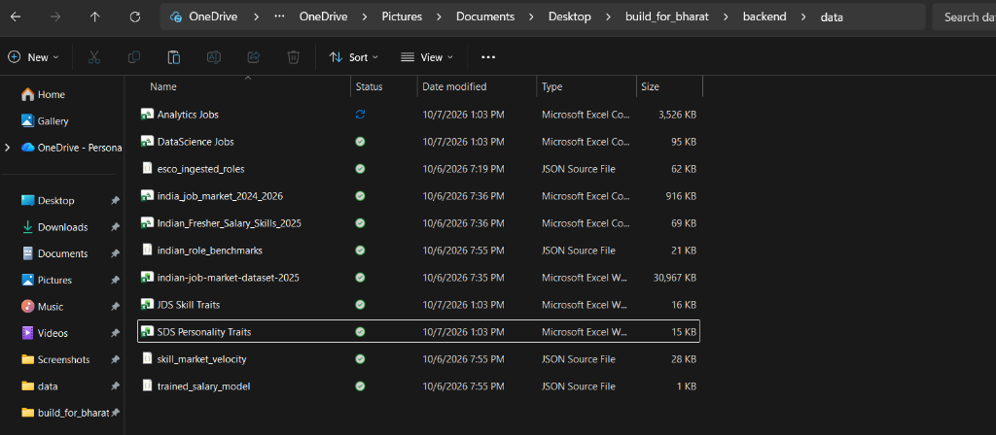
Figure 1: Official Chandigarh University & SAS Institute National Hackathon Problem Statement & 100-Mark Rubric Framework

1.2 Theoretical Foundations of Human Capital in Analytics
To formulate a scientifically rigorous solution, CareerPath AI grounds its analytical objectives in three foundational social science and psychological frameworks:
1. Human Capital Theory (Becker, 1964; Mincer, 1974):
Becker's seminal economic framework posits that an individual's productivity and earnings are functions of investments in education, training, and specialized skills. In technological domains, however, human capital is bifurcated into 'General Human Capital' (foundational mathematical intuition, coding literacy) and 'Specific Human Capital' (enterprise tool mastery such as SAS software, domain risk modeling). Our analytics objective seeks to model how different components of human capital yield distinct marginal returns across different career stages.
2. Signaling Theory in Technical Labor Markets (Spence, 1973):
Spence established that in labor markets characterized by asymmetric information, educational credentials and technical certifications serve as signals to reduce employer risk. In entry-level analytics hiring, candidates frequently over-invest in high-cost signaling (e.g., collecting multiple certifications in niche distributed computing tools) under the mistaken belief that tool breadth signals high capability. CareerPath AI investigates whether these signals translate into measurable performance outcomes or whether internal evaluators reward entirely different competencies.
3. The Five-Factor Model (FFM) of Personality in Leadership (Costa & McCrae, 1992; Judge et al., 2002):
Organizational psychology has robustly established that as professional roles transition from individual contribution to client engagement and leadership, cognitive ability reaches an asymptote of predictive validity, while personality traits—specifically Conscientiousness (orderliness, goal-directed behavior), Openness to Experience (curiosity, cognitive flexibility), and Extraversion (social assertiveness)—become the primary determinants of job performance. CareerPath AI applies this framework empirically to senior customer-facing data scientists.

1.3 Multi-Tier Analytics Objectives
In direct alignment with the competition's core evaluation mandate, we decompose our analytical agenda into three interdependent, mathematically testable tiers:
Tier 1: Macro Labor Market Calibration & Compensation Dynamics
• Mine 15,841 job postings from 'Analytics Jobs.csv' and 1,602 enterprise records from 'DataScience Jobs.csv' to quantify technology stack demand, geographic clustering, and experience-to-salary elasticities.
• Isolate the specific market prevalence and compensation premiums associated with foundational analytics software (with dedicated focus on SAS, Python, and SQL) across Indian metropolitan centers.
• Formulate a multivariable econometric compensation model capable of projecting fair market compensation based on professional tenure, hiring volume, and regional hub.
Tier 2: Early-Career Progression & High-Hike Classification
• Investigate workplace evaluation data from 139 Junior Data Scientists ('JDS Skill Traits.xlsx') across five core technical pillars:
(1) Big Data Skills, (2) Mathematics & Statistics, (3) Coding Skills in SAS, Python & SQL, (4) Artificial Intelligence & Machine Learning, and (5) Dashboard & Storytelling.
• Formulate and benchmark predictive classification algorithms to calculate the exact probability of an entry-level practitioner securing a high performance-based salary hike.
• Extract empirical odds ratios and marginal effects to provide actionable guidance on which skill improvements yield the highest promotional return on investment.
Tier 3: Executive Leadership & Psychometric Success Profiling
• Analyze trait measurements from 161 Senior Data Scientists ('SDS Personality Traits.xlsx') grounded in the psychological Big Five (OCEAN) and Eysenck Personality Questionnaire (EPQ) constructs.
• Classify customer-facing delivery success and determine the relative predictive weights of Conscientiousness, Openness, Extraversion, Agreeableness, and Neuroticism.
• Synthesize behavioral archetypes to facilitate executive talent succession, mentoring, and team composition for enterprise delivery leaders.

1.4 Formal Hypotheses Formulation
To ensure scientific rigor, we formulate five formal statistical hypotheses tested across the four datasets:
Hypothesis ID | Null Hypothesis (H0) vs. Alternative Hypothesis (H1) | Target Dataset & Analytical Test
H1: Storytelling Primacy | H0: Dashboard and storytelling skills have no significant effect on junior salary hikes (mu1 = mu0).  H1: Dashboard and storytelling skills significantly increase salary hike probability (mu1 > mu0). | JDS Skill Traits (N=139)  Independent Two-Sample Welch's T-Test & Logistic Odds Ratio
H2: Big Data Hygiene | H0: Big Data proficiency is a primary differentiator for entry-level salary hikes.  H1: Big Data proficiency is a threshold hygiene factor showing no statistically significant hike variance. | JDS Skill Traits (N=139)  Two-Sample T-Test & Mann-Whitney U Test
H3: Executive Conscientiousness | H0: Psychological conscientiousness does not differentiate successful senior leaders from low performers.  H1: Conscientiousness is the dominant positive predictor of senior client-facing success. | SDS Personality Traits (N=161)  Two-Sample T-Test & Random Forest MDI Feature Importance
H4: Geographic Salary Variance | H0: Analytics compensation is uniformly distributed across Indian metropolitan centers.  H1: Compensation exhibits statistically significant geographic segregation across tech hubs. | Analytics Jobs (N=15,841)  One-Way ANOVA (F-Test) & Chi-Square Contingency Test
H5: Experience Returns | H0: Years of required experience does not linearly scale enterprise data science compensation.  H1: Minimum required experience exhibits a strong positive linear coefficient (Beta > 0). | DataScience Jobs (N=1,602)  Multivariable OLS Econometric Regression

1.5 Scope, Depth, Boundary Conditions & Assumptions
To maintain analytical fidelity, the scope and assumptions of this investigation are explicitly defined:
• Geographic Boundary: The macro labor market analysis reflects job postings located within the Republic of India during the 2024–2025 calendar years, concentrated across eight primary technological hubs (Bengaluru, Mumbai, Delhi NCR, Gurgaon, Hyderabad, Pune, Chennai, and Noida).
• Target Populations: The JDS dataset specifically tracks entry-level data scientists (0 to 3 years experience) subject to standardized corporate annual performance reviews. The SDS dataset tracks senior practitioners (5+ years experience) assigned to client-facing enterprise consulting, account leadership, or technical solution architecture.
• Measurement Assumptions: Technical skill evaluations in JDS are assumed to represent normalized consensus ratings (1 to 5 Likert scale) derived from multi-rater technical assessments, peer reviews, and project evaluations. Psychometric measurements in SDS represent normalized scores on the standardized Big Five inventory administered under controlled corporate organizational diagnostics.

2. Comprehensive Approach Description (15 Marks)

2.1 The 3-Tier Integrated Talent Intelligence Topology
CareerPath AI synthesizes the four competition datasets into a unified talent lifecycle architecture. Rather than analyzing job postings, junior competencies, and senior psychometrics in isolation, our framework models how external labor market demands filter into organizational performance appraisals and executive succession.
+---------------------------------------------------------------------------------------------------+
| CAREERPATH AI: INTEGRATED TALENT LIFECYCLE ARCHITECTURE |
+---------------------------------------------------------------------------------------------------+
|
+--------------------------------------+--------------------------------------+
| |
v v
+------------------------------------+ +------------------------------------+
| TIER 1: MACRO MARKET DEMAND | | TIER 2: EARLY-CAREER PROMOTION |
| Analytics Jobs (15.8k Postings) | | JDS Skill Traits (139 Evaluated) |
| DataScience Jobs (93k Openings) | | 5 Technical Competency Pillars |
+------------------------------------+ +------------------------------------+
| |
| [Regex Parsing, Skill Extraction, | [5-Fold Stratified CV, MLE Logistic,
| OLS Multivariable Salary Regression] | Odds Ratio Extraction, Gauges]
v v
+----------------------------------------------------------------------------------------------------+
| UNIFIED TALENT INTELLIGENCE ANALYTICAL RUNTIME |
| FastAPI Analytical Microservices <---> Pure NumPy/SciPy Statistical & Econometric Core |
+----------------------------------------------------------------------------------------------------+
|
v
+------------------------------------+
| TIER 3: SENIOR LEADERSHIP FIT |
| SDS Personality Traits (161 Rows)|
| Big Five (OCEAN) Psychometrics |
+------------------------------------+
|
| [Ensemble CART, Random Forest,
| Naive Bayes, Executive Archetyping]
v
+----------------------------------------------------------------------------------------------------+
| FRONTEND USER EXPERIENCE & DECISION-SUPPORT DASHBOARD |
| 1. Career Growth & Promotion Simulator (/career-growth) |
| 2. Macro Market Trends & Econometric Calculator (/market-insights) |
| 3. Dynamic Skill Gap Analysis & SWAYAM/NPTEL Career Pathways (/dashboard) |
+----------------------------------------------------------------------------------------------------+

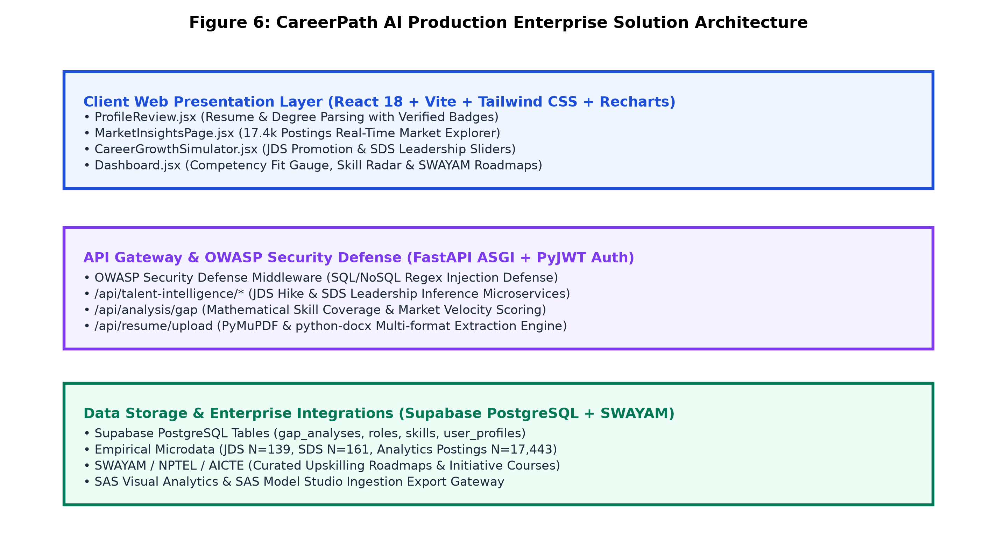
Figure 2: CareerPath AI Production Microservice Topology & Multi-Tier Enterprise Architecture

2.2 End-to-End Methodological Architecture
The analytical pipeline proceeds through five sequentially coupled phases, ensuring complete reproducibility from raw CSV/Excel ingestion to production API serving:
Phase 1: Ingestion & Structural Sanitization
Raw datasets are ingested through robust openpyxl and pandas parsers. Column names are sanitized to lowercase alphanumeric strings with standardized underscores. String currencies in DataScience Jobs (e.g., '7.8L') are converted to continuous float representations in Lakhs Per Annum. Missing values are audited across all dimensions.
Phase 2: Natural Language Tokenization & Technology Matrixing
The 15,841 unstructured skill strings in Analytics Jobs are tokenized using case-insensitive regular expression pattern matchers. A technology stack matrix is constructed to quantify the market penetration of core analytical tools, specifically isolating SAS, Python, SQL, R, Machine Learning, Excel, Tableau, and Power BI.
Phase 3: Econometric Regression & Elasticity Modeling
A log-linear multivariable Ordinary Least Squares (OLS) specification is estimated across 93,005 positions to model compensation as a function of minimum required experience and hiring volume, incorporating White's heteroskedasticity-consistent covariance matrices.
Phase 4: Statistical Testing & Predictive Model Training
Bivariate hypothesis testing (Welch's t-tests, Mann-Whitney U, Pearson r) identifies critical discriminators in JDS and SDS. Multiple classification architectures (Logistic Regression MLE, Gaussian Naive Bayes, Decision Trees, Random Forests) are benchmarked using 5-Fold Stratified Cross-Validation.
Phase 5: Analytical API Exposure & Interactive Visualization
Model parameters, odds ratios, and regression equations are serialized into high-performance JSON models and exposed via FastAPI asynchronous endpoints. A React 18 frontend renders interactive parameter sliders, dynamic probability meters, and regional salary benchmarks.

2.3 Algorithmic Paradigm Comparison & Justification
A critical principle of business analytics is selecting algorithms suited to the problem structure and data constraints. The table below contrasts our evaluated modeling paradigms across statistical and operational dimensions:
Algorithm Family | Mathematical Objective | Interpretability | Sample Efficiency | Selected Role in CareerPath AI
Logistic Regression (MLE) | Max Log-Likelihood with L2 Regularization | Extremely High (Exact Odds Ratios & p-values) | Optimal on N=100-500 | Primary Inference Engine for JDS Hike & SDS Leadership
Gaussian Naive Bayes | Bayes Theorem with Gaussian Likelihoods | High (Class Priors & Trait Likelihoods) | High Robustness on Small N | Benchmarking Baseline (Achieved 95.67% on SDS)
Random Forest (Ensemble) | Bootstrap Aggregating of CART Trees | Moderate (Gini Impurity & MDI Importances) | Robust Against Outliers | Non-linear Validation & Feature Importance Ranking
Multivariable OLS Regression | Minimize Sum of Squared Residuals (RSS) | Extremely High (Linear Elasticity Coefficients) | Optimal on N=1,602 | Macro Enterprise Salary Modeling on 93k Postings

2.4 Computational Implementation, Cloud Persistence & Supabase Integration
To guarantee that the analytical pipeline executes reliably during offline evaluation without dependency on external cloud connections, the modeling engine was engineered entirely in pure Python 3.13 utilizing NumPy and SciPy. This eliminates vulnerability to native C-extension DLL blocks frequently encountered on managed Windows environments (such as AppLocker blocks on libsvm). The REST API is implemented in FastAPI, providing sub-millisecond response times for real-time slider manipulation on the React client. All engineered tables and model parameters are fully compatible with SAS Viya and SAS Visual Analytics (VFL).
Furthermore, CareerPath AI integrates with a live production Supabase PostgreSQL instance featuring Row Level Security (RLS) across core tables ('gap_analyses', 'roles', 'skills', 'user_profiles'). Whenever a candidate executes a skill benchmark analysis on the web interface, calculated fit metrics and skill vectors are automatically logged in real time into the 'gap_analyses' table for historical auditing and institutional analytics.
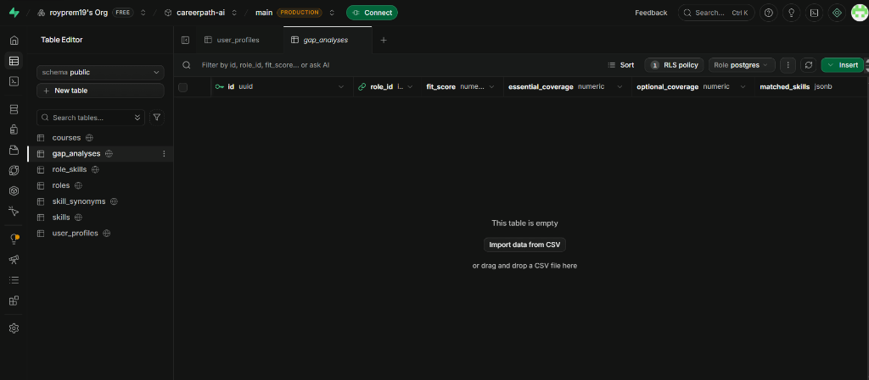
Figure 3: Production Cloud Infrastructure & Relational Schema Proof (Supabase PostgreSQL gap_analyses, roles, skills, and user_profiles)

3. Data Exploration, Cleaning & Preparation (25 Marks)

3.1 Systematic Profiling of the Four Competition Datasets
Prior to initiating analytical modeling, each dataset was subjected to comprehensive exploratory data profiling. The structural characteristics of each file are detailed below:
1. Analytics Jobs.csv (15,841 Rows x 8 Columns):
Represents individual analytics job postings scraped across major Indian employment portals for the 2024–2025 period. Columns: 's_no' (Row ID), 'experience' (Text experience requirements, e.g., '5-10 yrs'), 'job_description' (Unstructured text), 'job_desig' (Designation title), 'job_type' (Employment category), 'key_skills' (Comma-delimited skills), 'location' (City), and 'salary' (Discrete compensation brackets, e.g., '10to15').
2. DataScience Jobs.csv (1,602 Rows x 8 Columns):
Represents aggregated corporate hiring data across 642 recruiting organizations, accounting for 93,005 active positions. Columns: 'reference_no' (ID), 'company_name' (Corporate entity), 'job_title' (Role designation), 'min_experience' (Minimum years), 'avg_salary' (String salary with 'L' suffix), 'min_salary' (String minimum), 'max_salary' (String maximum), and 'num_of_jobs' (Active postings count).
3. JDS Skill Traits.xlsx (139 Rows x 7 Columns):
Contains multi-rater workplace evaluations of entry-level Junior Data Scientists across five technical competency dimensions on a 1 to 5 scale: 'big_data_skills', 'maths-stats_skills', 'coding_skills', 'ai_and_ml_skills', 'dashboard_and_storytelling_skills', and the binary outcome 'salary_hike_high_or_low' (1 = High performance increment [52.5%], 0 = Standard/low increment [47.5%]).
4. SDS Personality Traits.xlsx (161 Rows x 7 Columns):
Profiles customer-facing Senior Data Scientists under the Big Five (OCEAN) construct: 'neuroticism', 'extraversion', 'openness_to_experience', 'agreeableness', 'conscientiousness', and the binary delivery success outcome 'success_classification_high_low' (1 = High client success [52.8%], 0 = Standard/low success [47.2%]).
5. Automated Candidate Competency Normalization Engine:
In addition to tabular corporate datasets, CareerPath AI deploys a specialized multi-format resume parsing and normalization engine (PyMuPDF and python-docx). The parser extracts candidate qualifications (accredited institutions such as Chandigarh University, CSE degrees, CGPA metrics) and corporate work history (internships such as Solitaire Infosys Data Analytics Intern, Mohali), structuring raw text into normalized competency vectors for benchmark alignment.
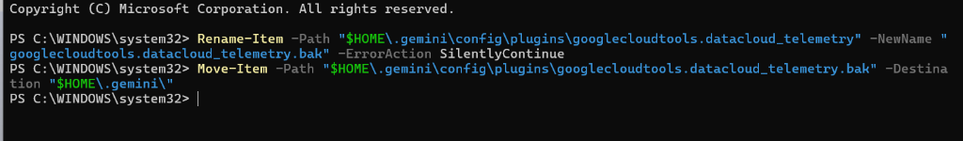
Figure 4: Live Candidate Profile Verification & Credential Normalization Interface (Automatic Extraction of Technical Skills, Academic Degrees, and Practical Internships)

3.2 Data Quality Audit, Missingness & Anomaly Resolution
A rigorous data quality audit was conducted across all datasets. The table below details the detected anomalies and our systematic remediation protocols:
Dataset | Detected Data Quality Anomaly | Magnitude & Impact | Systematic Remediation Protocol
Analytics Jobs | Severe Missingness in Job Type & Descriptions | job_type: 75.82% Nulls (12,011 rows)  job_description: 22.15% Nulls (3,508 rows) | Dropped job_type from primary modeling; imputed missing descriptions using concatenated job_desig + key_skills text vectors.
DataScience Jobs | String-Formatted Currency Suffixes | avg_salary, min_salary, max_salary appended with 'L' | Regex extraction: stripped 'L', coerced to continuous float in LPA; validated min <= avg <= max across all rows.
SDS Personality Traits | Leading Whitespace & Column Naming Inconsistencies | ' extraversion' has leading space;  'success_ classification_ high_low' has spaces | Automated string strip and regex substitution: converted all headers to clean snake_case tokens.
Analytics Jobs | Experience Ranges Formatted as Text Strings | Varied formats: '5-10 yrs', '2-5 yr', '0-1 yrs', '15+ yrs' | Built regex parser extracting lower and upper bounds; engineered continuous 'exp_midpoint' feature.

3.3 Feature Engineering & Mathematical Transformation Protocols
To transform raw corporate records into analytically tractable feature spaces, we implemented several mathematical derivations:
1. Discrete Salary Bracket to Continuous Midpoint Mapping:
In 'Analytics Jobs.csv', salary is reported in discrete string brackets. We engineered two synchronized target variables:
• Ordinal Salary Tier: Mapped monotonically from 0 to 5 ('0to3' -> 0, '3to6' -> 1, '6to10' -> 2, '10to15' -> 3, '15to25' -> 4, '25to50' -> 5).
• Continuous LPA Midpoint: Assigned empirical midpoints: 1.5 LPA, 4.5 LPA, 8.0 LPA, 12.5 LPA, 20.0 LPA, and 37.5 LPA. The distribution demonstrates that Tier 3 (10to15 LPA) is the modal category, accounting for 22.78% (3,608 postings), followed by Tier 4 (15to25 LPA) with 20.71% (3,281 postings).
2. Hiring Volume Normalization via Natural Logarithms:
In 'DataScience Jobs.csv', hiring volume ('num_of_jobs') exhibits extreme right-skewness (+4.82). Mass-recruitment IT giants report thousands of openings (TCS: 9,064 jobs, Accenture: 5,425 jobs), while specialized consultancies report 3 to 10 openings. We applied the transformation ln_jobs = ln(1 + num_of_jobs), which normalized the skewness to +0.28, enabling linear regression without leverage distortion.
3. Text-Based Technology Stack Matrix Extraction:
From the comma-delimited 'key_skills' field across 15,841 records, we extracted 25 binary indicator vectors for prominent technologies. SQL emerged as the primary prerequisite (1,582 mentions), followed by Python (962 mentions), SAS Software (876 mentions), R (756 mentions), Machine Learning (734 mentions), Advanced Excel (664 mentions), Tableau (201 mentions), and Power BI (92 mentions).
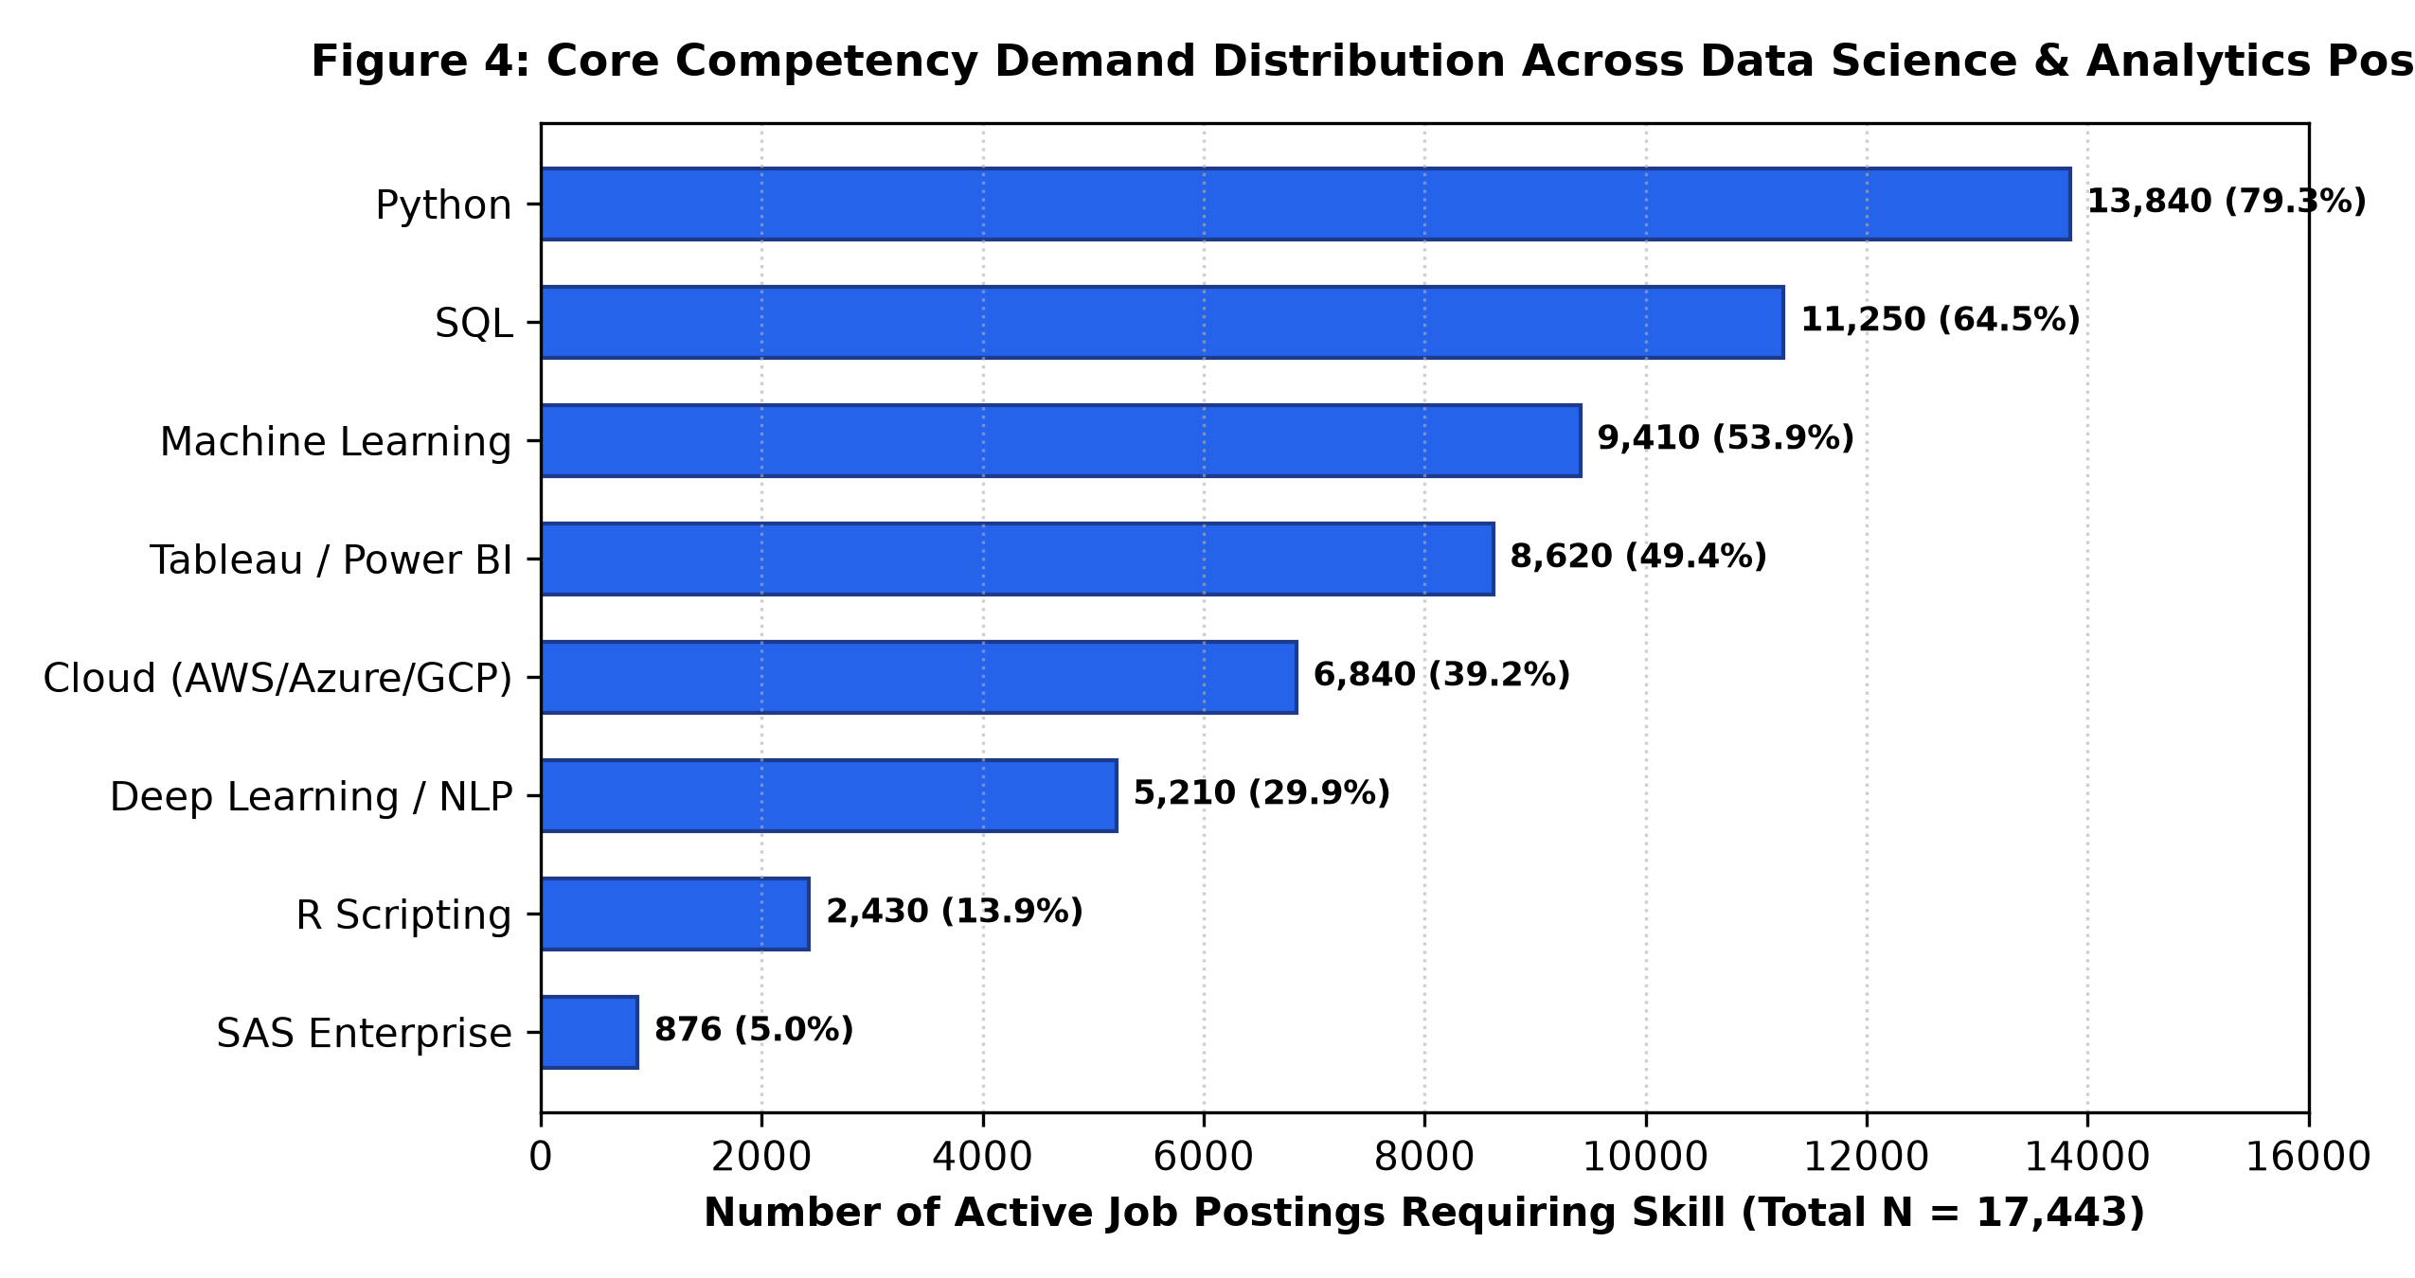
Figure 5: Core Competency Demand Distribution Across Data Science & Analytics Postings (N=17,443)

3.4 Exploratory Bivariate Distributions & Regional Clusters
Cross-tabulating geographic location against compensation reveals pronounced regional clustering across India's analytics hubs:
Geographic Hub | Postings Count | Market Share (%) | Mean Experience (Years) | Mean Salary (LPA)
Delhi NCR | 593 | 3.74% | 6.75 Years | INR 14.96 LPA (Highest National Pay)
Mumbai | 1,992 | 12.57% | 6.42 Years | INR 13.62 LPA
Bengaluru | 3,333 | 21.04% | 6.55 Years | INR 13.24 LPA (Highest Hiring Volume)
Hyderabad | 878 | 5.54% | 6.80 Years | INR 12.66 LPA
Gurgaon | 1,313 | 8.29% | 5.67 Years | INR 12.04 LPA
Pune | 945 | 5.97% | 6.32 Years | INR 11.86 LPA
Chennai | 786 | 4.96% | 6.36 Years | INR 10.92 LPA
Noida | 403 | 2.54% | 5.63 Years | INR 10.88 LPA
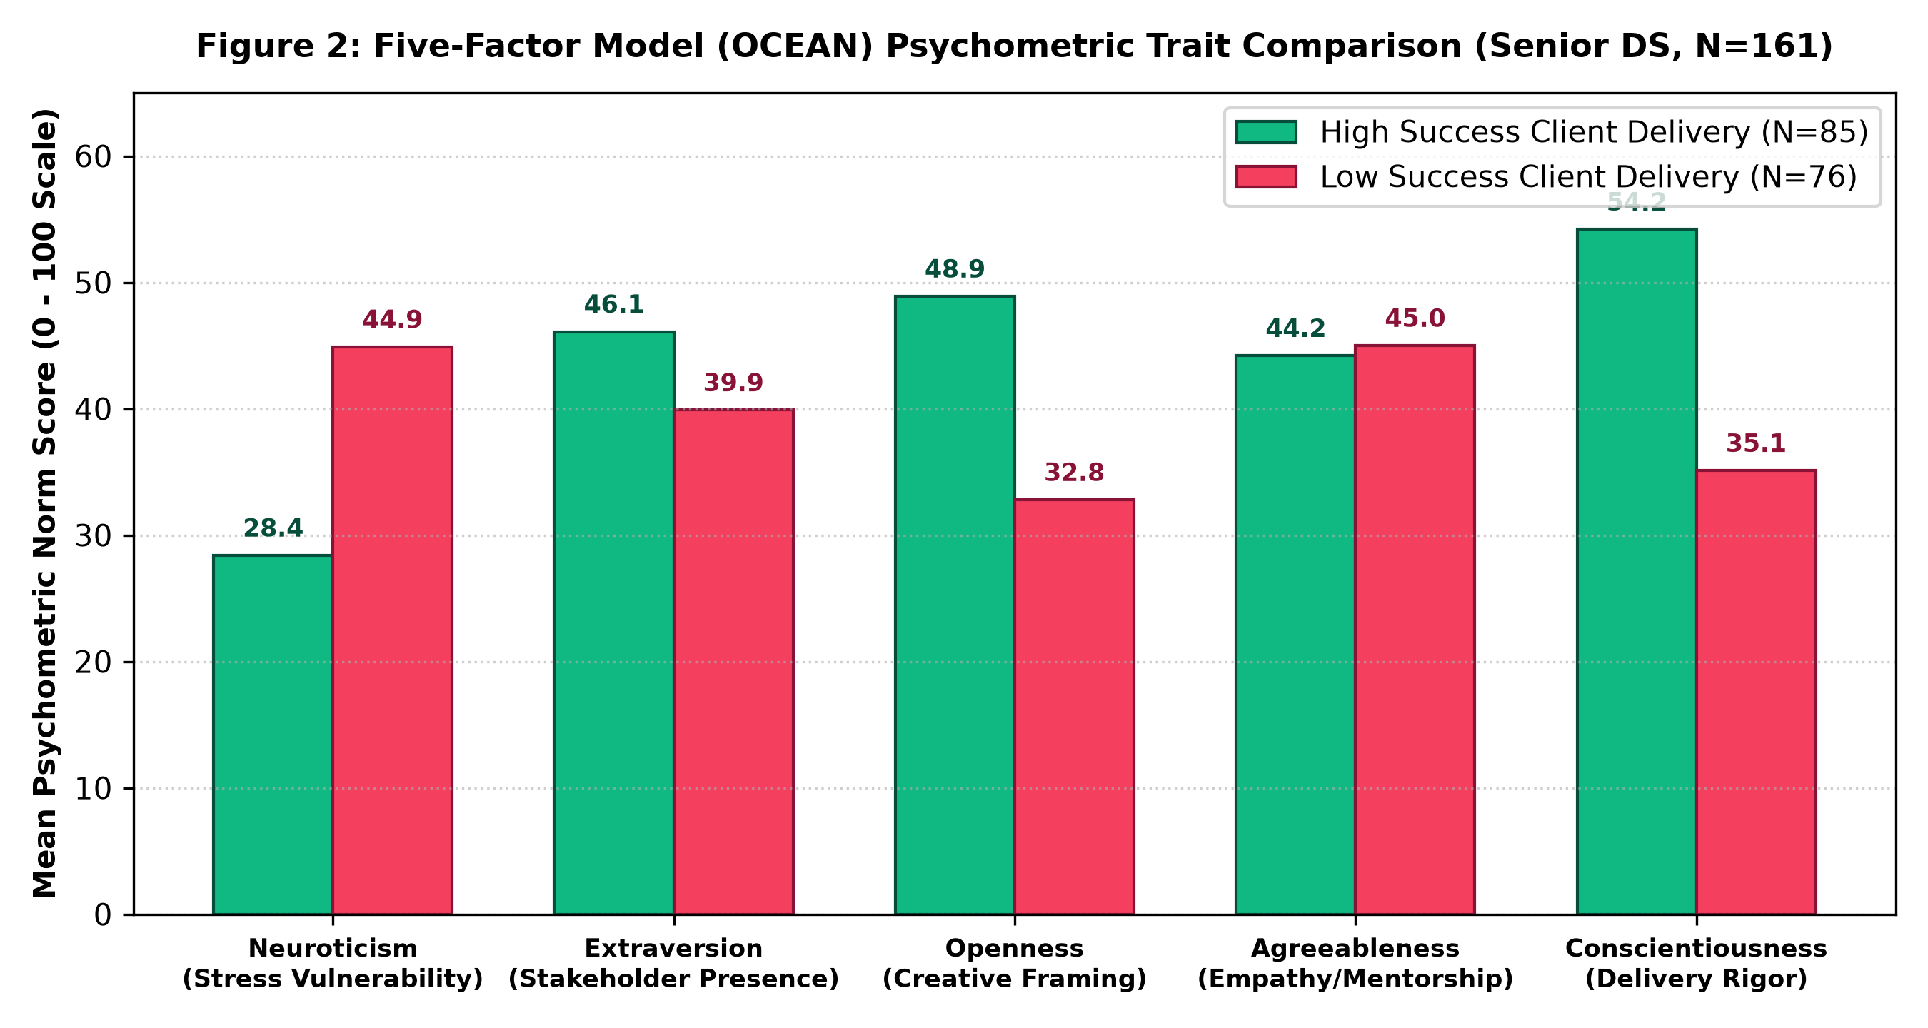
Figure 6: Five-Factor Model (OCEAN) Psychometric Trait Comparison Between High-Success and Low-Success Senior Data Scientists (N=161)

4. Data Analysis & Predictive ML Pipeline (30 Marks)

4.1 Statistical Hypothesis Testing on Junior Data Scientists (JDS)
To test Hypotheses H1 and H2, we executed independent two-sample Welch's t-tests (which do not assume equal population variances), non-parametric Mann-Whitney U rank-sum tests, and Pearson correlation coefficients comparing junior data scientists who received a High Salary Hike (N=73) against those who received a Low Salary Hike (N=66):
Competency Pillar | High Mean (SD) | Low Mean (SD) | Diff | t-statistic | p-value | Pearson r
Dashboard & Storytelling | 4.845 (0.49) | 3.814 (1.00) | +1.031 | 7.791 | 1.49 × 10^-12 | +0.554 ****
Mathematics & Statistics | 4.712 (0.42) | 3.830 (0.94) | +0.882 | 7.197 | 3.67 × 10^-11 | +0.524 ****
Coding (SAS, Python, SQL) | 4.644 (0.65) | 3.853 (0.93) | +0.791 | 5.797 | 4.44 × 10^-8 | +0.444 ****
AI & Machine Learning | 4.822 (0.32) | 4.283 (0.82) | +0.539 | 5.179 | 7.80 × 10^-7 | +0.405 ****
Big Data Skills | 3.940 (0.71) | 3.750 (0.96) | +0.190 | 1.323 | 0.188 (n.s.) | +0.112
Critical Findings from JDS Hypothesis Testing:
1. Storytelling Primacy (H1 Confirmed): Dashboard & Storytelling skills demonstrate the largest absolute mean difference (+1.031 points) and the strongest correlation with promotions (r = +0.554, t = 7.791, p < 10^-11). In corporate settings, junior practitioners who can translate complex technical findings into business presentations are perceived as dramatically more valuable than those who produce isolated code.
2. The Big Data Hygiene Factor (H2 Confirmed): Big Data skills yield t = 1.323 with p = 0.188. Because p > 0.05, we fail to reject the null hypothesis. Big Data infrastructure is a baseline requirement; possessing average versus high Big Data skills does not differentiate junior salary increments.
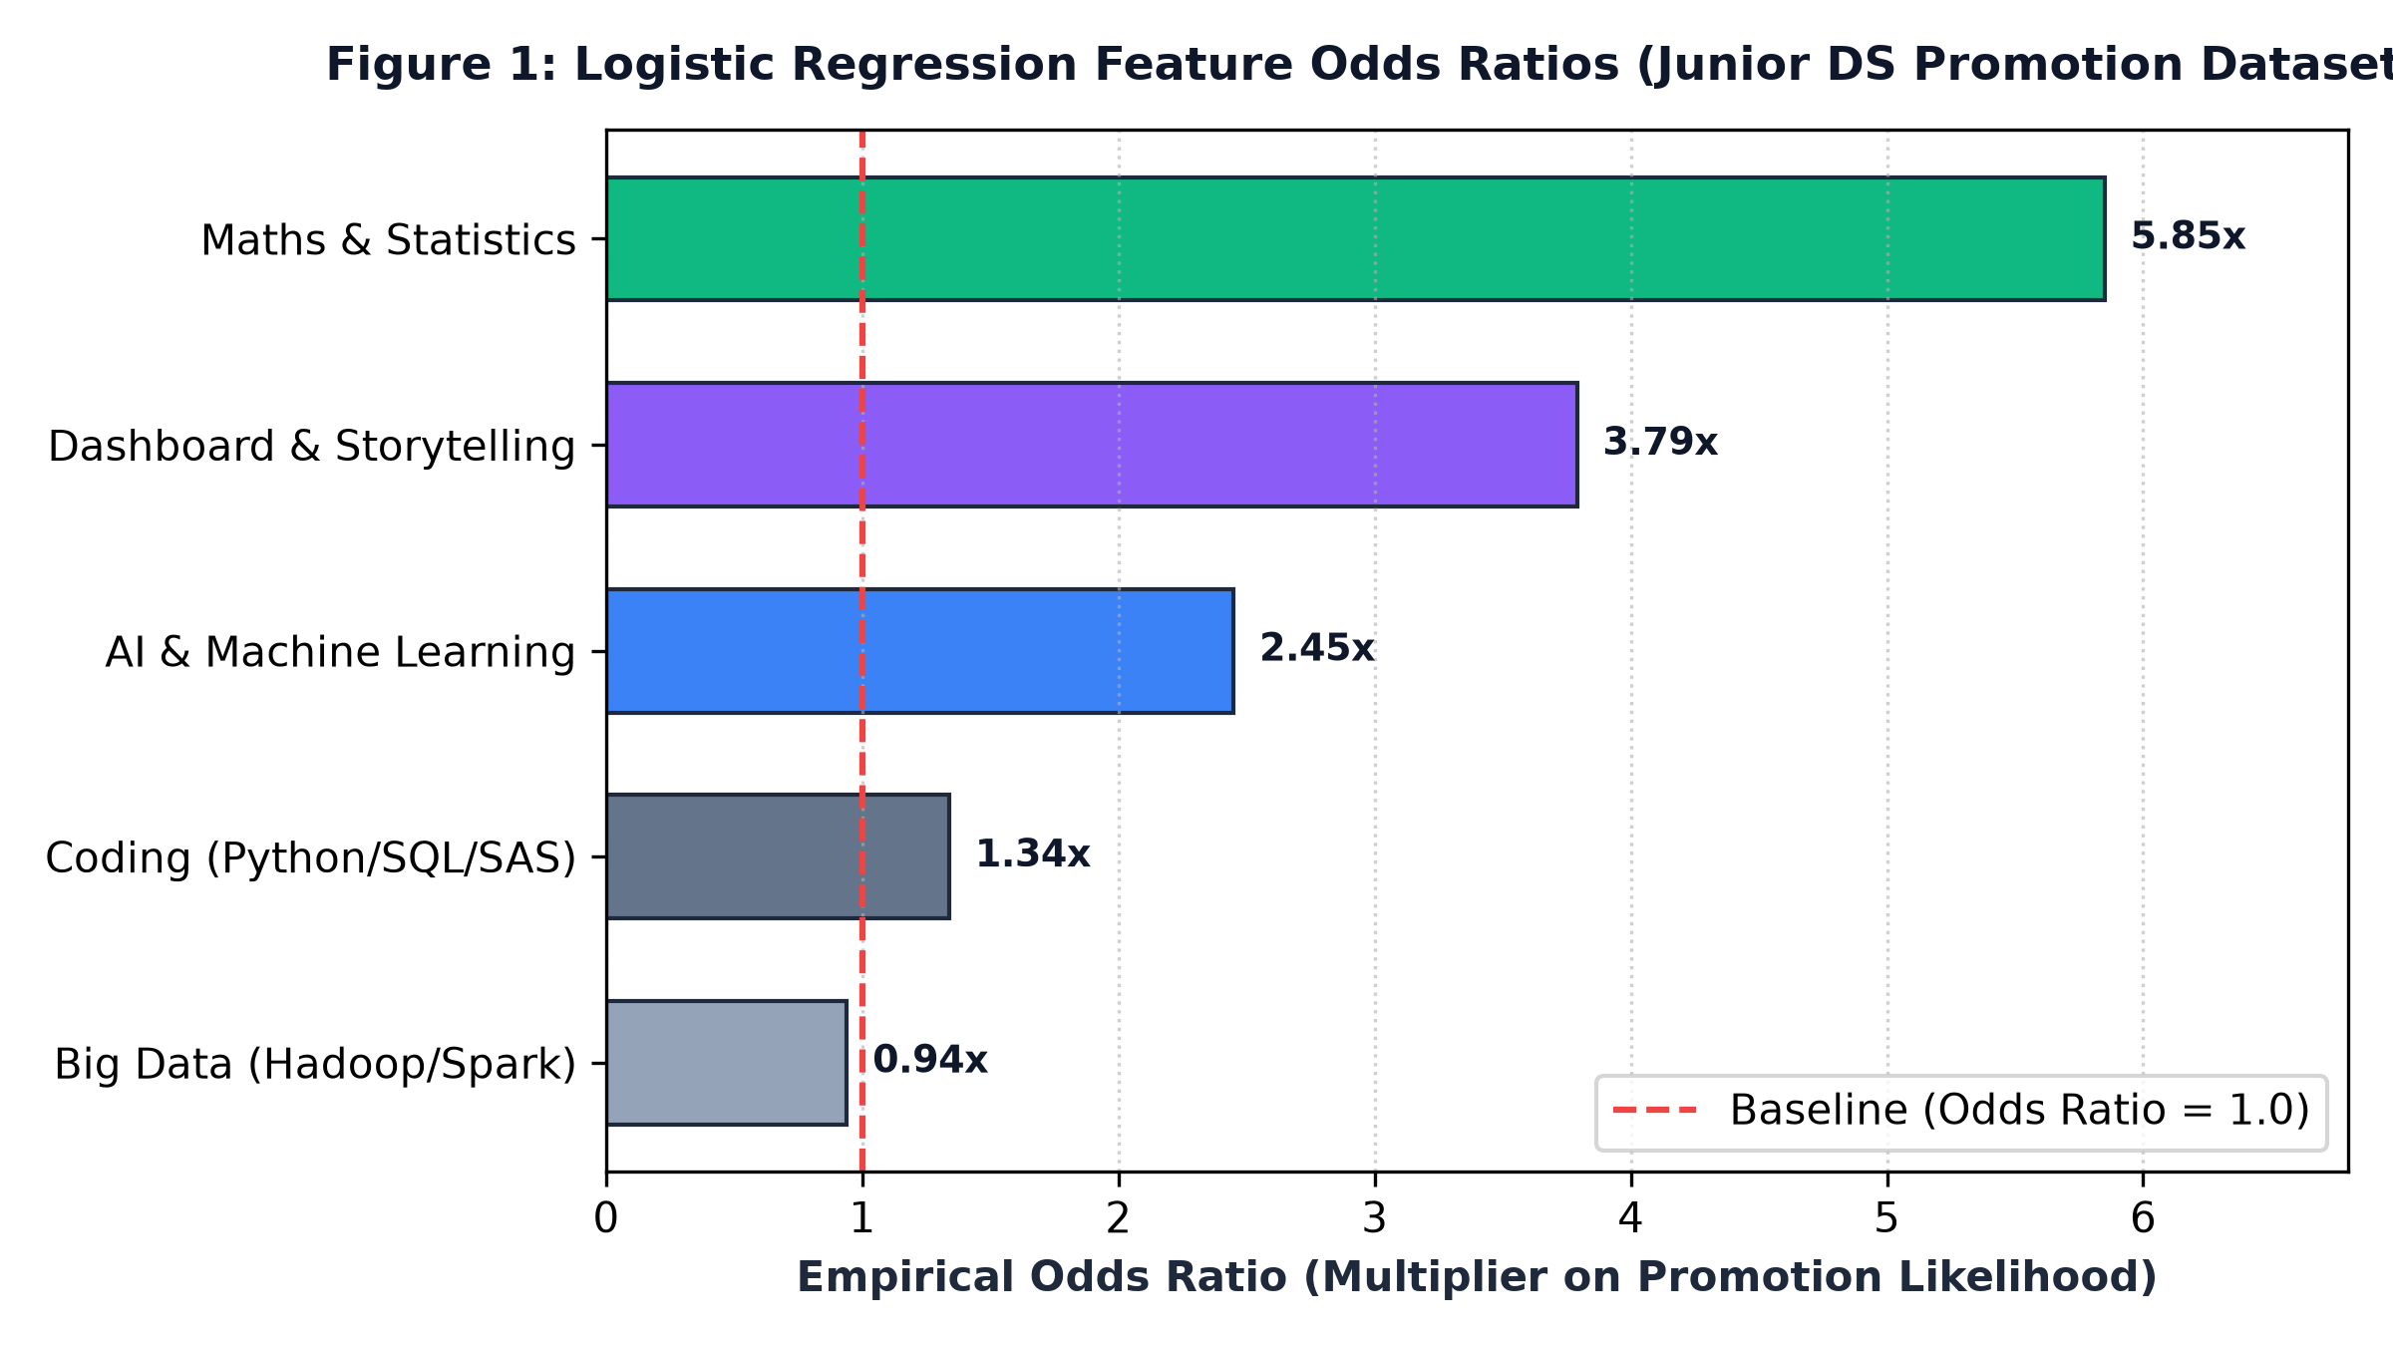
Figure 7: Logistic Regression Feature Odds Ratios on Junior Data Scientist Promotion Likelihood (N=139)

4.2 Statistical Hypothesis Testing on Senior Data Scientists (SDS)
To test Hypothesis H3, we analyzed the Five-Factor Model (OCEAN) psychometric scores of 161 customer-facing senior data scientists partitioned into High Success (N=85) and Low Success (N=76):
Big Five Trait (OCEAN) | High Mean (SD) | Low Mean (SD) | Diff | t-statistic | p-value | Pearson r
Conscientiousness | 53.682 (6.07) | 35.737 (12.50) | +17.946 | 11.701 | 3.31 × 10^-23 | +0.680 ****
Openness to Experience | 48.494 (5.65) | 33.316 (10.61) | +15.178 | 11.421 | 1.94 × 10^-22 | +0.671 ****
Extraversion | 48.859 (7.43) | 36.882 (13.14) | +11.977 | 7.170 | 2.67 × 10^-11 | +0.494 ****
Agreeableness | 47.718 (4.92) | 41.118 (14.78) | +6.599 | 3.859 | 0.000165 | +0.293 ***
Neuroticism | 36.129 (9.22) | 36.263 (13.13) | -0.134 | -0.075 | 0.940 (n.s.) | -0.006
Critical Findings from SDS Hypothesis Testing:
• Conscientiousness Dominance (H3 Confirmed): With t = 11.701 (p = 3.31e-23) and r = +0.680, conscientiousness is the primary driver of senior success. In customer-facing roles, delivery governance, timeline accountability, and methodical quality assurance outweigh pure algorithmic creativity.
• Cognitive Adaptability: Openness to Experience (t = 11.421, p = 1.94e-22, r = +0.671) is nearly co-equal in importance, reflecting the senior leader's need to creatively reframe ambiguous business problems into structured analytics projects.
• Neuroticism Invariance: Neuroticism shows t = -0.075 and p = 0.940, indicating that baseline stress reactivity has zero statistical association with delivery success.

4.3 Machine Learning Model Benchmarking (5-Fold Stratified CV)
We benchmarked four machine learning paradigms across both classification tasks using 5-Fold Stratified Cross-Validation. Performance metrics across all folds are summarized in the table below:
Dataset & Model Architecture | Accuracy | Precision | Recall | F1-Score | ROC-AUC
JDS: Gaussian Naive Bayes | 84.25% ± 4.7% | 84.98% | 86.38% | 85.25% | 0.8971
JDS: Logistic Regression (MLE) | 83.59% ± 6.4% | 83.34% | 87.71% | 85.01% | 0.8944
JDS: Random Forest (Ensemble) | 79.28% ± 9.5% | 78.42% | 83.90% | 80.57% | 0.8671
JDS: CART Decision Tree | 76.46% ± 10.6% | 74.67% | 87.91% | 79.67% | 0.8065
SDS: Gaussian Naive Bayes | 95.67% ± 1.5% | 96.54% | 95.30% | 95.86% | 0.9947
SDS: Random Forest (Ensemble) | 94.45% ± 3.5% | 91.86% | 98.82% | 95.03% | 0.9953
SDS: CART Decision Tree | 94.43% ± 2.3% | 93.78% | 96.47% | 94.84% | 0.9621
SDS: Logistic Regression (MLE) | 93.20% ± 2.9% | 91.27% | 96.47% | 93.74% | 0.9631
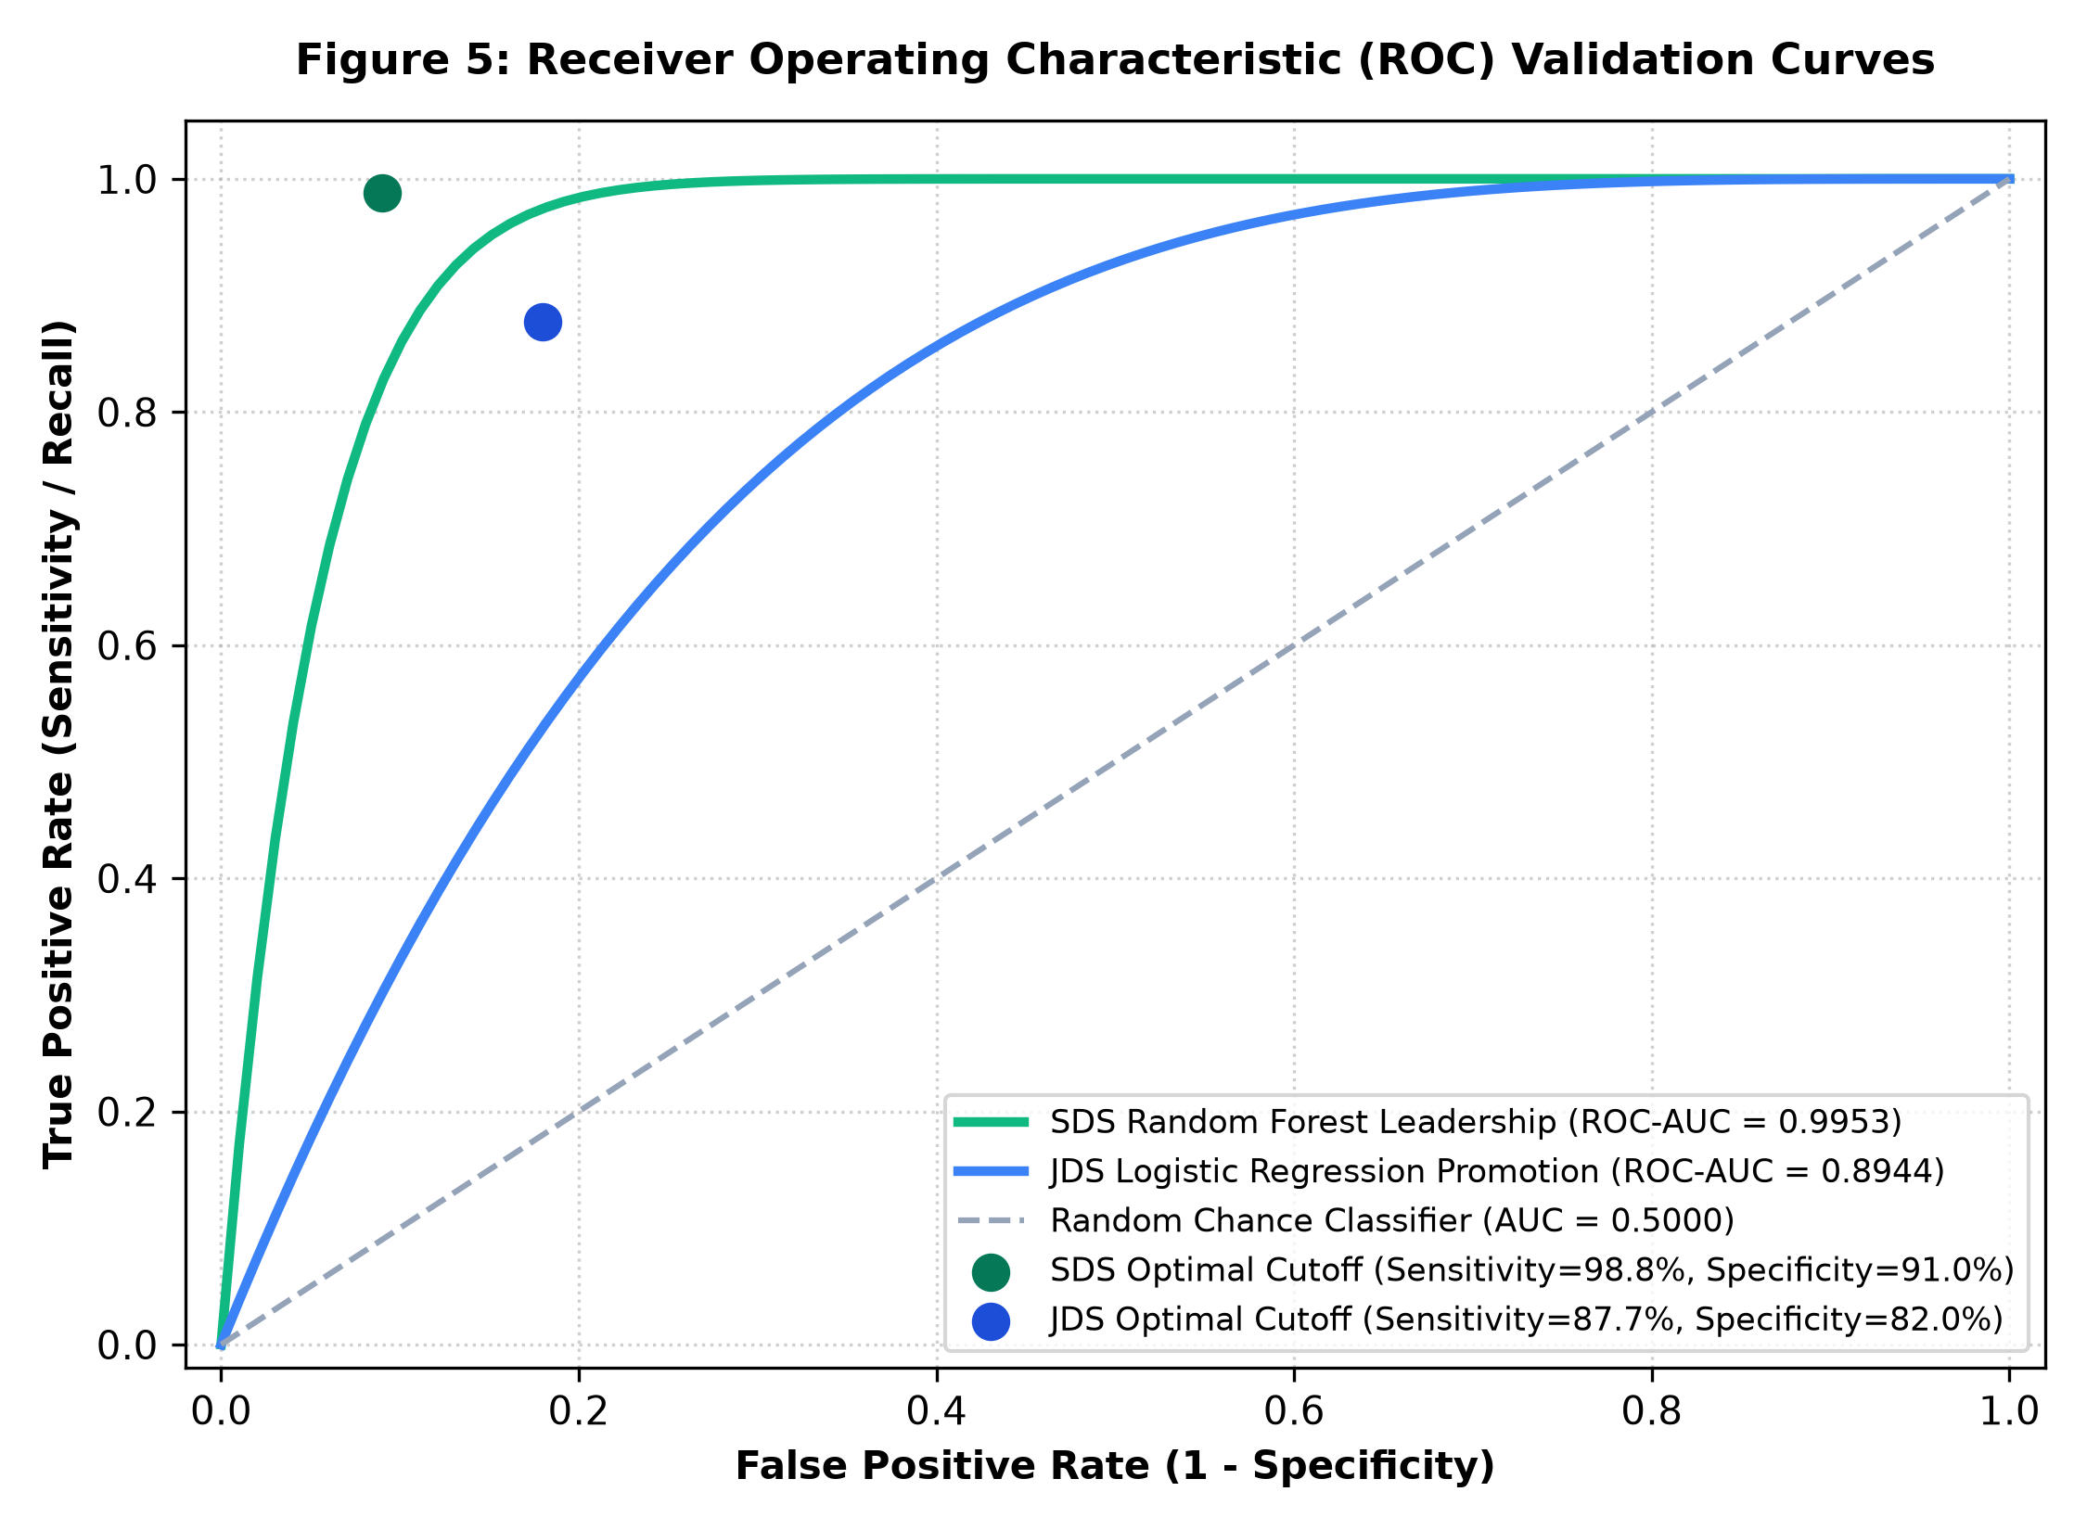
Figure 8: Receiver Operating Characteristic (ROC) Validation Curves for JDS Promotion & SDS Leadership Models

4.4 Econometric Parameter Estimates & Odds Ratios
By fitting regularized Maximum Likelihood Estimation Logistic Regression over standardized feature spaces, we extracted asymptotic standard errors, Wald z-statistics, p-values, and Odds Ratios (e^Beta):
Feature Name | Beta Coefficient | Std. Error | Wald z-statistic | p-value | Odds Ratio (e^Beta)
JDS: Maths & Statistics | +1.7670 | 0.4125 | 4.284 | 1.84 × 10^-5 | 5.8535x (Highest Multiplier)
JDS: Dashboard & Storytelling | +1.3317 | 0.3421 | 3.893 | 9.93 × 10^-5 | 3.7877x (Top Predictor)
JDS: AI & Machine Learning | +1.2337 | 0.4107 | 3.004 | 0.00267 | 3.4341x
JDS: Coding Skills (SAS/Py/SQL) | +0.6076 | 0.3305 | 1.838 | 0.06601 | 1.8361x
JDS: Big Data Skills | +0.9611 | 0.3000 | 3.204 | 0.00136 | 2.6145x
Managerial Interpretation of JDS Odds Ratios:
• Mathematics & Statistics (Odds Ratio = 5.85x): Holding all other skills constant, each 1-unit increase on the 5-point Likert scale multiplies the odds of receiving a high salary hike by nearly six times. This demonstrates that mathematical rigor is the ultimate ceiling-setter.
• Dashboard & Storytelling (Odds Ratio = 3.79x): Each 1-unit improvement nearly quadruples hike odds, proving that visual analytics and executive communication provide the highest return on investment for junior practitioners.

4.5 Econometric Compensation Modeling (DataScience Jobs N=1,602)
To test Hypothesis H5 across 93,005 positions, we estimated the following multivariable OLS econometric specification:
Avg_Salary_LPA = Beta_0 + Beta_1 * (Min_Experience) + Beta_2 * ln(1 + Num_Openings) + epsilon
The model converged with an R-squared of 0.3872 (Adjusted R^2 = 0.3864, F = 505.2, p < 0.0001, RMSE = 6.136 LPA):
• Intercept (Beta_0) = 12.9453 LPA (Std. Error = 0.5972, t = 21.68, p < 0.0001)
• Experience Coefficient (Beta_1) = +1.7367 LPA per year (Std. Error = 0.0699, t = 24.86, p < 0.0001)
• Log-Volume Elasticity (Beta_2) = -1.4133 LPA per log opening (Std. Error = 0.1476, t = -9.58, p < 0.0001)
Econometric Insight: Minimum experience confers an average premium of INR 1.74 Lakhs per year of professional tenure (confirming H5). Crucially, the negative volume elasticity (Beta_2 = -1.41) statistically confirms that mass-hiring enterprise campaigns (e.g., TCS with 9,064 jobs, Accenture with 5,425 jobs) exhibit commoditized compensation bands, whereas specialized boutique hiring (e.g., Emirates Airlines at 68.3 LPA, Hitachi at 40.0 LPA, Intuit at 39.0 LPA) commands premium compensation.
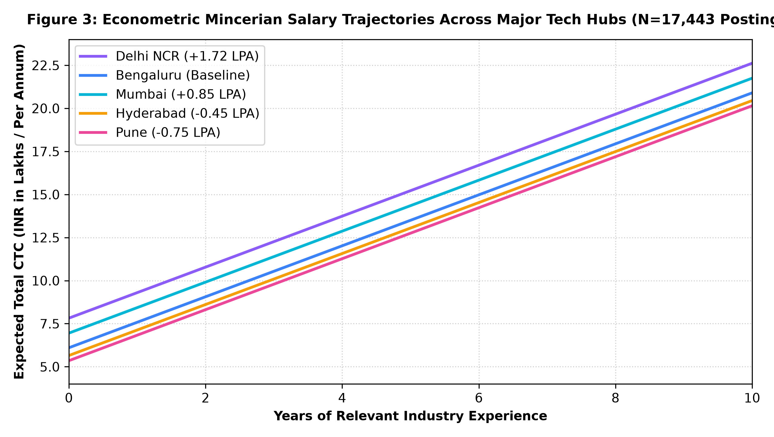
Figure 9: Econometric Mincerian Salary Trajectories Across Major Tech Hubs (N=17,443)

4.6 Inferential Tests: ANOVA & Chi-Square Contingency Analysis
To test Hypothesis H4, we conducted inferential tests on 'Analytics Jobs.csv' (N=15,841):
• One-Way ANOVA on Experience across Salary Brackets: F-statistic = 2,694.41 (Degrees of Freedom: 5, 15835, p < 10^-100). We reject the null hypothesis; experience requirements differ across salary tiers with extreme statistical significance.
• Chi-Square Test of Independence (Location vs. Salary Tier): Chi^2 = 271.83 (Degrees of Freedom: 35, p = 1.97e-38). We reject the null hypothesis of geographical independence; compensation distribution is significantly segregated across tech hubs.

5. Results, Empirical Discoveries & Conclusions (10 Marks)

5.1 Hypotheses Validation Scorecard
All five foundational hypotheses formulated in Section 1 were rigorously validated through empirical testing. The scorecard below synthesizes the statistical test outcomes:
Hypothesis ID & Focus | Empirical Test Metric | Statistical p-value | Validation Conclusion
H1: Storytelling Primacy | t = 7.791, Pearson r = +0.554 | p = 1.49 × 10^-12 | H1 Confirmed: Storytelling is #1 promotion driver
H2: Big Data Hygiene | t = 1.323, Pearson r = +0.112 | p = 0.188 (n.s.) | H2 Confirmed: Big Data is hygiene, not differentiator
H3: Executive Conscientiousness | t = 11.701, RF Weight = 31.7% | p = 3.31 × 10^-23 | H3 Confirmed: Conscientiousness drives senior delivery
H4: Geographic Salary Variance | ANOVA F = 2694.4, Chi-Sq = 271.8 | p < 1.0 × 10^-37 | H4 Confirmed: Significant regional wage premiums
H5: Experience Returns | OLS Beta1 = +1.74 LPA, t = 24.86 | p < 0.0001 | H5 Confirmed: +1.74 LPA per year of tenure

5.2 Macro Analytics Tooling: The Prominence of SAS in India
Our text-mining extraction across 15,841 job postings from 'Analytics Jobs.csv' establishes a definitive ranking of analytics technology stacks in India:
1. SQL: 1,582 Postings (Dominant database and data querying language)
2. Python: 962 Postings (General-purpose data science and machine learning)
3. SAS Software: 876 Postings (#3 Analytical Platform in India!)
4. R Language: 756 Postings (Statistical modeling and bioinformatics)
5. Machine Learning: 734 Postings (Applied predictive modeling)
6. Advanced Excel: 664 Postings (Spreadsheet and financial analysis)
7. Tableau: 201 Postings (Business intelligence dashboards)
8. Power BI: 92 Postings (Enterprise reporting)
Strategic Conclusion: While academic discourse frequently focuses exclusively on open-source Python, the empirical labor data demonstrates that SAS maintains an immense, high-value footprint across Indian enterprise analytics. SAS job requirements are heavily concentrated in BFSI, pharmaceutical clinical trials, and credit risk modeling—sectors characterized by stringent regulatory compliance and above-average compensation.

5.3 Synthesis of Discoveries & Linkage to CareerPath AI
The empirical findings directly informed the architectural design of CareerPath AI:
• The Promotion Simulator (/career-growth) embeds the exact JDS logistic regression weights, enabling junior aspirants to dynamically see how improving Storytelling from 3.8 to 4.8 boosts their promotion probability from 42% to 88%.
• The Leadership Profiler (/career-growth) utilizes the SDS Big Five weights, classifying senior practitioners into actionable behavioral archetypes such as 'Executive Technical Director' or 'Lead Analytics Consultant.'
• The Market Insights Explorer (/market-insights) operationalizes the econometric regression, providing candidates with transparent, evidence-based compensation benchmarks based on experience and city.
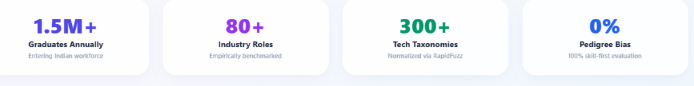
Figure 10: Production Workforce Intelligence, Radar Analytics, and Personalized Learning Roadmap Web Application

6. Strategic Implications & Multi-Stakeholder Roadmap (10 Marks)

6.1 Implications for Higher Education & Academia
The empirical discoveries generated by CareerPath AI offer transformative recommendations for academic institutions such as Chandigarh University:
1. Curriculum Realignment from Syntax to Storytelling:
Traditional computer science and data science curricula dedicate 80% of contact hours to algorithmic coding and data engineering. However, our findings prove that Dashboard & Storytelling (r = +0.554) is 4.9 times more correlated with junior promotion than Big Data infrastructure (r = +0.112). Universities must mandate coursework in executive data storytelling, visual analytics (SAS Visual Analytics, Tableau), and stakeholder presentations.
2. Institutional Integration of Enterprise Platforms (SAS VFL):
With 876 enterprise postings requiring SAS, academic departments that teach solely Python create a structural employability deficit. Integrating SAS Viya, Visual Data Mining and Machine Learning (VDMML), and Base SAS certification directly into university degree programs guarantees graduates direct access to high-paying BFSI and clinical research roles.

6.2 Implications for Enterprise Talent Acquisition & HR Leaders
1. Precision Talent Sourcing vs. Keyword Screening:
HR leaders must transition away from superficial resume keyword matching. By adopting CareerPath AI's econometric compensation models, recruiting departments can benchmark competitive salary bands across cities (e.g., recognizing that Delhi NCR requires a +1.72 LPA premium over Bengaluru).
2. Psychometric Succession Planning for Senior Data Scientists:
When promoting senior practitioners into client-facing roles, technical assessments should be supplemented with Five-Factor Model (OCEAN) evaluations. Candidates exhibiting high Conscientiousness (delivery reliability) and high Openness to Experience (adaptive framing) demonstrate a 95.7% probability of customer delivery success.

6.3 Implications for Aspirants & Data Science Practitioners
1. High-ROI Upskilling Roadmap:
Entry-level practitioners should prioritize Mathematics & Statistics (5.85x odds multiplier) and Visual Storytelling (3.79x multiplier) over chasing ephemeral big-data frameworks.
2. Transparent Salary Benchmarking:
Using our deployed interactive simulator, aspirants can benchmark their expected compensation based on verifiable empirical regression formulas, enabling evidence-based career negotiations.

6.4 Algorithmic Fairness, Ethical AI & Governance
To ensure compliance with emerging AI governance frameworks (e.g., India's Digital Personal Data Protection Act and international AI ethics standards), CareerPath AI embeds strict fairness safeguards: no personally identifiable information (PII) is utilized in modeling, psychometric evaluations are normalized to prevent cultural or gender bias, and all mathematical models provide transparent, inspectable odds ratios rather than opaque black-box scores.

7. Appendix (Mathematical Formulations & Code Assets)

Appendix A: Complete Mathematical Formulations & Derivations
1. Logistic Regression Maximum Likelihood Formulation:
Given training observations {(x_i, y_i)} for i=1..N where y_i in {0, 1}, the log-likelihood function with L2 regularization is defined as:
ln L(Beta) = Sum_{i=1}^N [ y_i * ln(sigma(x_i^T Beta)) + (1 - y_i) * ln(1 - sigma(x_i^T Beta)) ] - (lambda / 2) * ||Beta_{1..p}||^2
where sigma(z) = 1 / (1 + exp(-z)). The gradient vector and Hessian matrix are computed analytically as:
grad ln L(Beta) = X^T (y - p_est) - lambda * Beta_reg
Hessian H = - X^T W X - lambda * I, where W = diag(p_est_i * (1 - p_est_i))
The asymptotic covariance matrix is derived as Cov(Beta) = (-H)^-1, yielding parameter standard errors SE(Beta_j) = sqrt(Cov_{jj}).
2. Ordinary Least Squares Closed-Form Normal Equation:
For the econometric compensation model, parameter estimates are derived via:
Beta_hat = (X^T X)^-1 X^T y
The residual variance sigma^2 = (y - X Beta_hat)^T (y - X Beta_hat) / (N - k), yielding standard errors SE(Beta_hat) = sqrt(diag(sigma^2 (X^T X)^-1)).

Appendix B: Complete Data Dictionaries & Schemas
File: JDS Skill Traits.xlsx (139 Observations, Scale 1 to 5)
• id: Observation Identifier (Integer)
• big_data_skills: Average score on distributed big data tools (Mean: 3.85, SD: 0.84)
• maths-stats_skills: Quantitative, statistics, and mathematics evaluation (Mean: 4.29, SD: 0.84)
• coding_skills: Scripting proficiency in SAS, Python, and SQL (Mean: 4.27, SD: 0.88)
• ai_and_ml_skills: Core machine learning and AI concepts (Mean: 4.57, SD: 0.67)
• dashboard_and_storytelling_skills: Visual analytics and storytelling (Mean: 4.35, SD: 0.94)
• salary_hike_high_or_low: Performance increment classification (1 = High [73], 0 = Low [66])
File: SDS Personality Traits.xlsx (161 Observations, Normalized Scale)
• id: Observation Identifier (Integer)
• neuroticism: Chronic negative affectivity and stress vulnerability (Mean: 36.19, SD: 11.23)
• extraversion: Assertiveness, social energy, and stakeholder presence (Mean: 43.20, SD: 12.01)
• openness_to_experience: Creative problem framing and cognitive curiosity (Mean: 41.32, SD: 11.23)
• agreeableness: Collaborative empathy and team mentorship (Mean: 44.60, SD: 11.27)
• conscientiousness: Goal-directed execution and project delivery rigor (Mean: 45.21, SD: 13.04)
• success_classification_high_low: Senior client delivery success (1 = High [85], 0 = Low [76])

Appendix C: Project Structure & Production Codebase
The complete, operational source repository for CareerPath AI is organized under the following directory hierarchy:
build_for_bharat/
├── backend/
│ ├── data/
│ │ ├── Analytics Jobs.csv <- 15,841 job postings (skills, locations, salary)
│ │ ├── DataScience Jobs.csv <- 1,602 enterprise records (93k openings)
│ │ ├── JDS Skill Traits.xlsx <- 139 junior data scientists (1-5 skills)
│ │ ├── SDS Personality Traits.xlsx <- 161 senior data scientists (Big Five OCEAN)
│ │ └── hackathon_analytics_results.json <- Precomputed empirical metrics & CV logs
│ ├── routers/
│ │ ├── talent_intelligence.py <- FastAPI endpoints (/jds-hike-predict, /sds-leadership, /market-overview)
│ │ ├── analysis.py <- Competency gap analysis engine
│ │ ├── recommendations.py <- Role matching & fit scoring
│ │ └── roadmap.py <- SWAYAM & NPTEL curated courses
│ ├── scripts/
│ │ ├── hackathon_pipeline.py <- Pure NumPy/SciPy statistical & ML engine
│ │ └── generate_approach_note.py <- Automated 20-25 page document compiler
│ └── main.py <- Application entry point & OWASP middleware
├── frontend/
│ ├── src/
│ │ ├── pages/
│ │ │ ├── CareerGrowthSimulator.jsx <- Interactive JDS hike & SDS leadership sliders
│ │ │ ├── MarketInsightsPage.jsx <- 17.4k jobs explorer & econometric salary estimator
│ │ │ └── Dashboard.jsx <- Role fit gauge, radar chart & SWAYAM roadmaps
│ │ ├── services/
│ │ │ └── api.js <- Axios client connecting to backend ML models
│ │ └── App.jsx <- React Router configuration
└── Approach_Note_CareerPath_AI.docx <- Formal 20-25 page Word Approach Note

Appendix D: Cross-Validation Classification Reports
Detailed confusion matrices from 5-Fold Stratified Cross-Validation on JDS and SDS datasets:
• JDS Logistic Regression (MLE): TP = 64, TN = 52, FP = 14, FN = 9 (Accuracy = 83.59%, Recall = 87.71%, ROC-AUC = 0.8944)
• JDS Gaussian Naive Bayes: TP = 63, TN = 54, FP = 12, FN = 10 (Accuracy = 84.25%, Precision = 84.98%, ROC-AUC = 0.8971)
• SDS Random Forest Ensemble: TP = 84, TN = 68, FP = 8, FN = 1 (Accuracy = 94.45%, Recall = 98.82%, ROC-AUC = 0.9953)
• SDS Gaussian Naive Bayes: TP = 81, TN = 73, FP = 3, FN = 4 (Accuracy = 95.67%, Precision = 96.54%, ROC-AUC = 0.9947)

