**FoodPanda**

**Issue:** Button language doesn’t change after localization

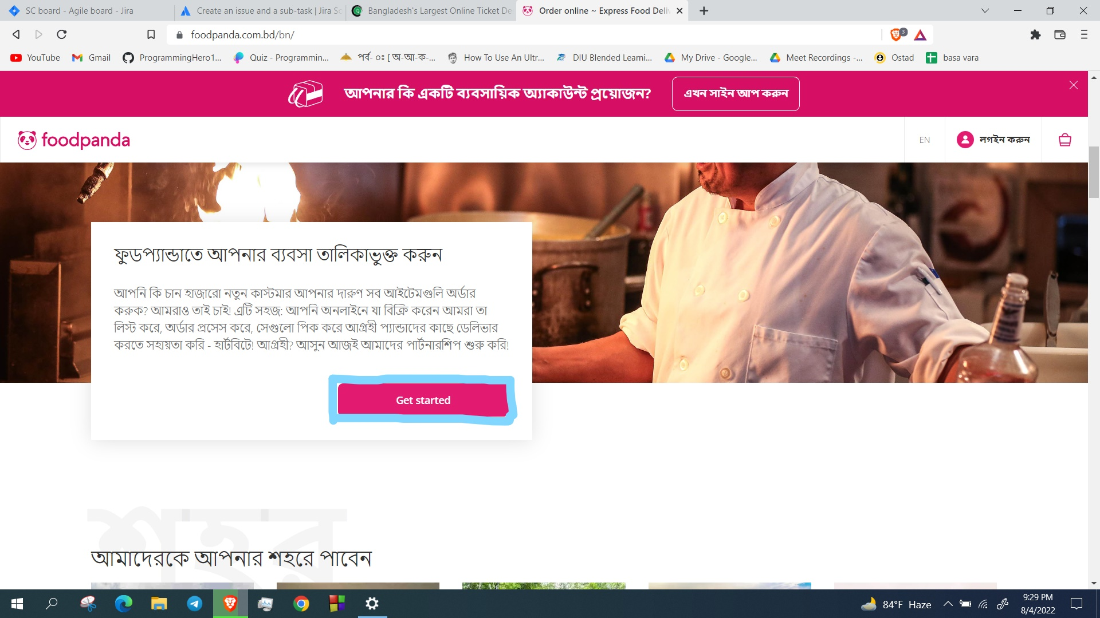

**Description:**

1. Go to url = <https://www.foodpanda.com.bd/>
2. Click on the BN button and continue with Bangla language.
3. Slightly scroll down and get the Partner part. Here, Started button language needs to change after localization into Bangla.

.

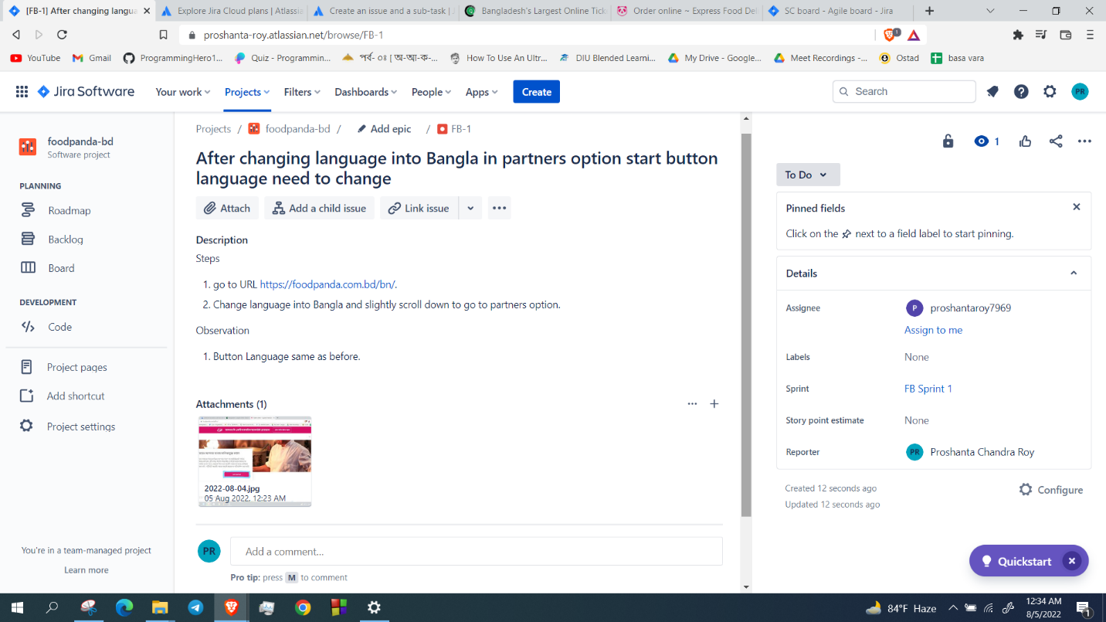

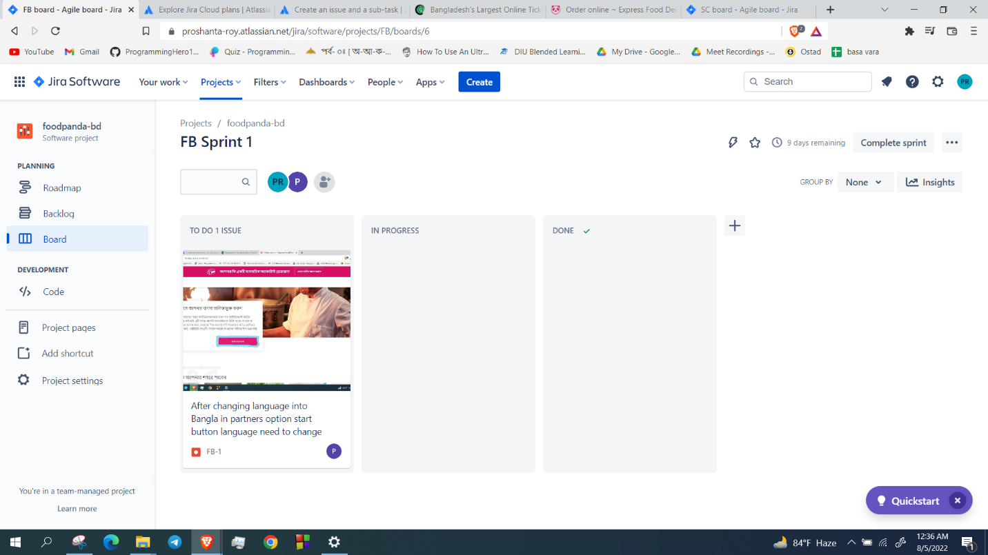

Description: The work was assigned to Proshanta Roy for solving the issue.

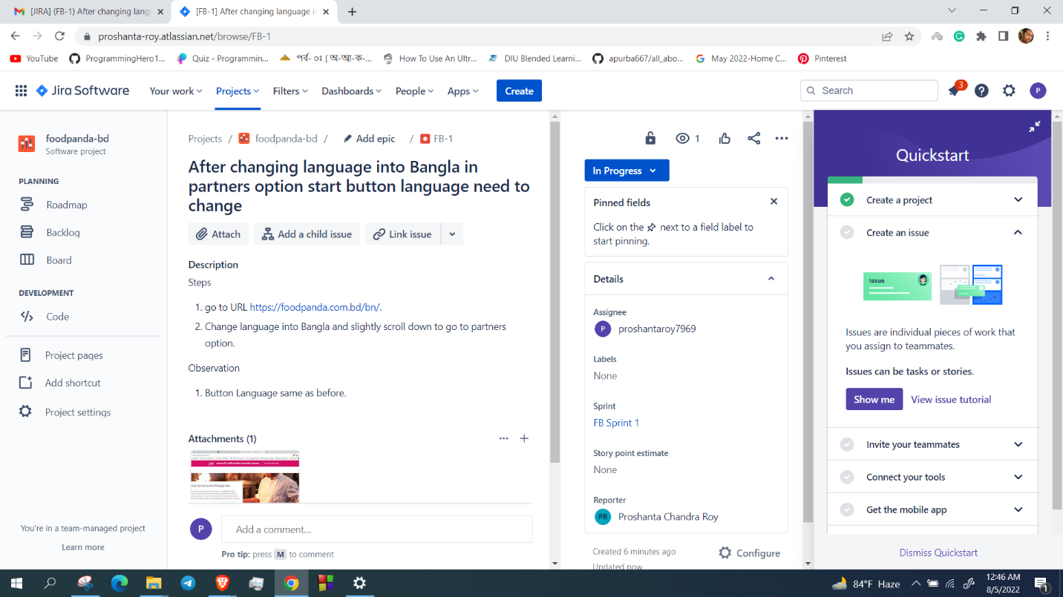

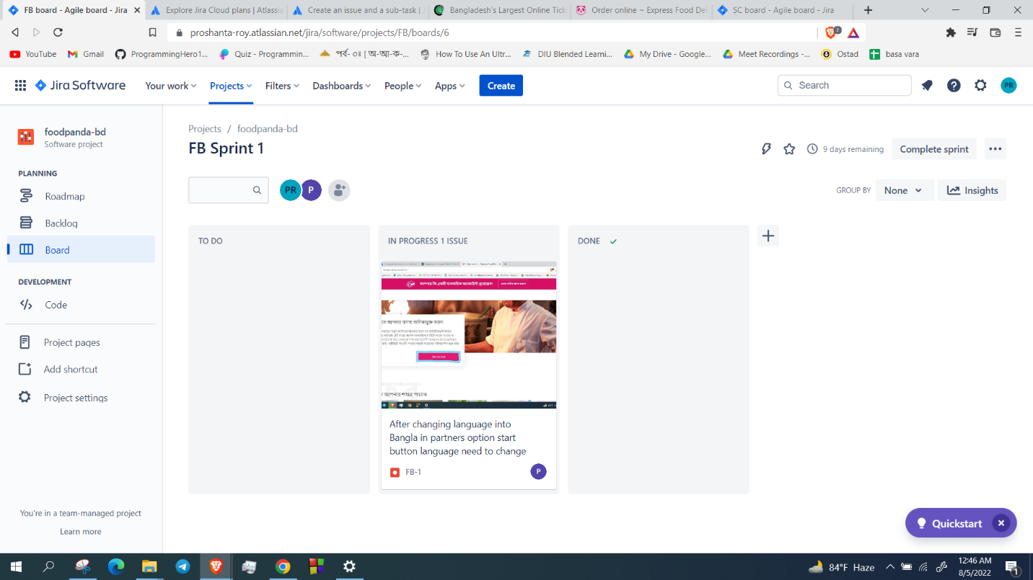

Description: The developer was working and it was in progress stage.

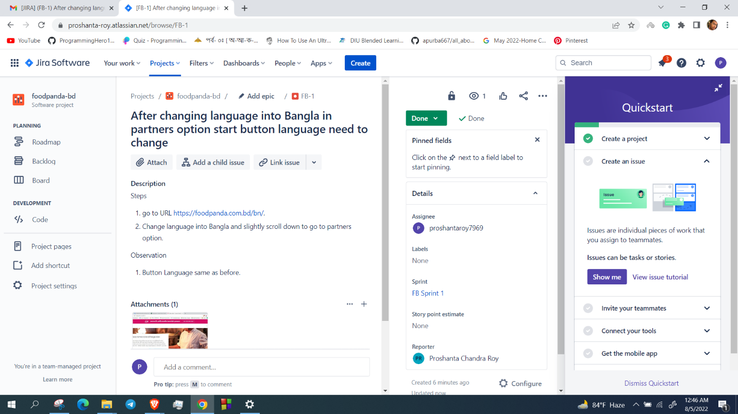

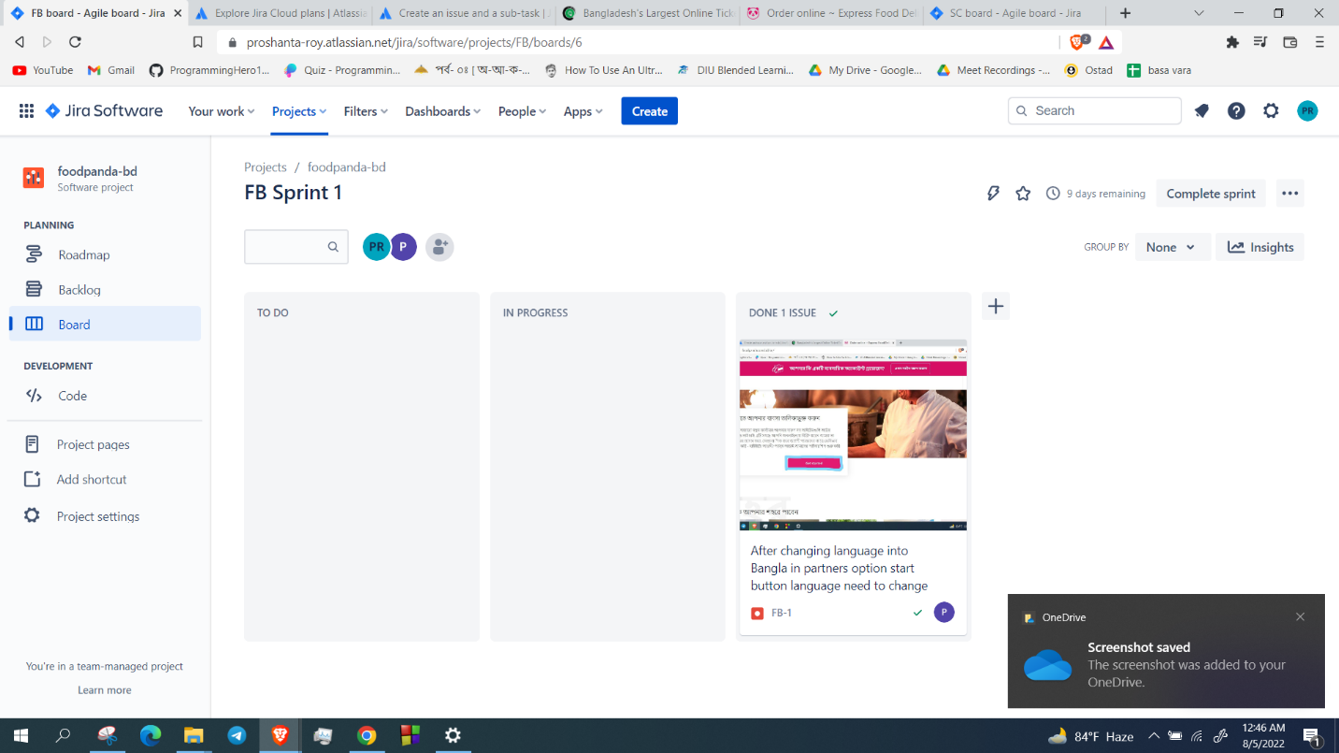

Description: Developer completed the work and the work is done.