# Task Schedular

* Registration Page -It’s a step before login to get the information in Database and save the work of user. Register to task schedular .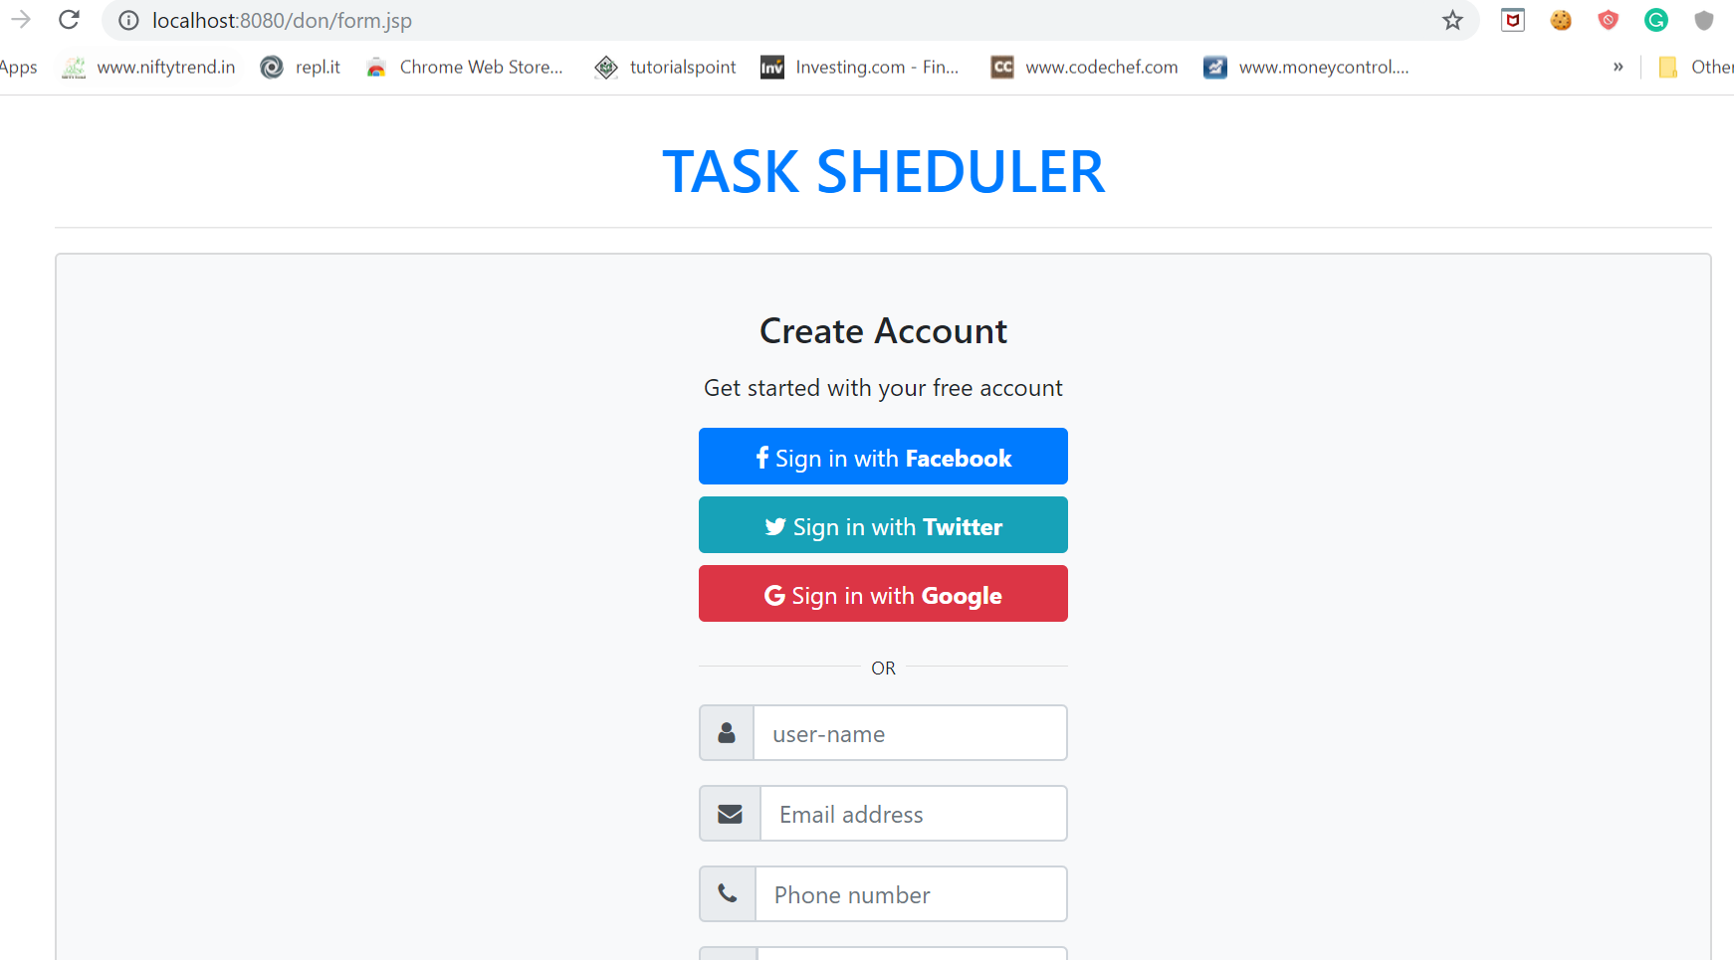
* DB view
* 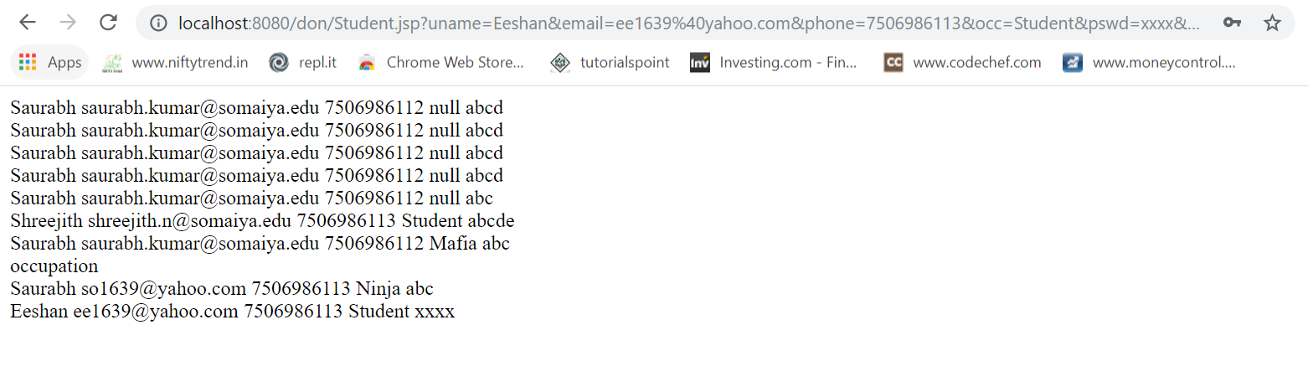
* Login Page 🡪 Required valid Username & Password .
* 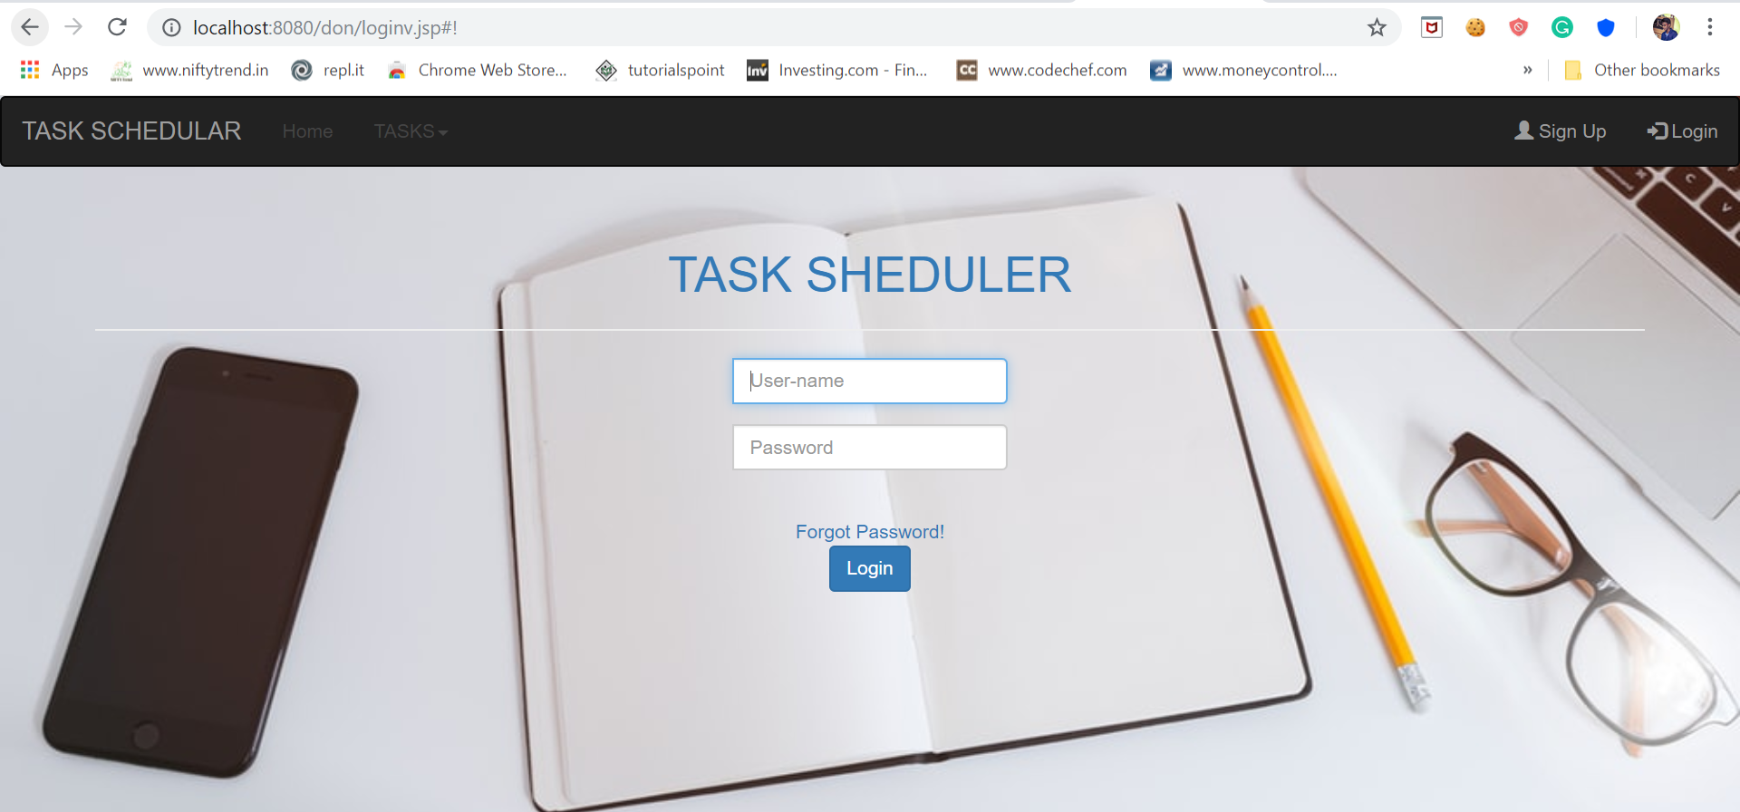
* If the user had forgot the password. The following form needed to fill for new password.

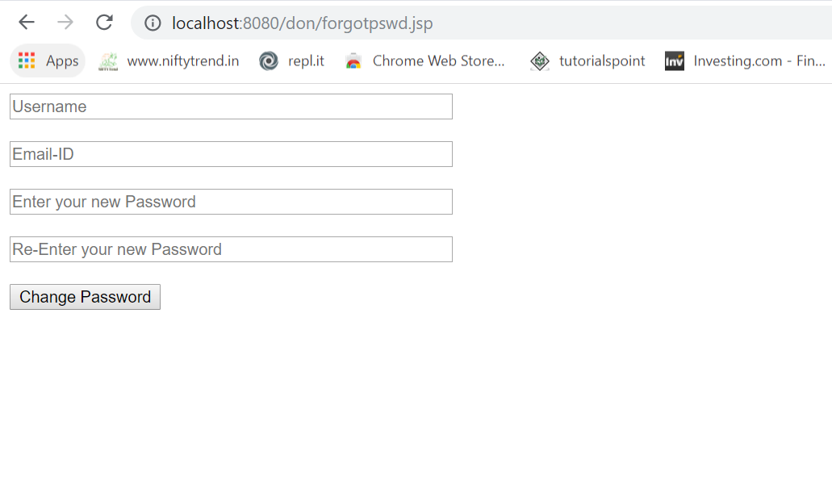

* Home Page!! 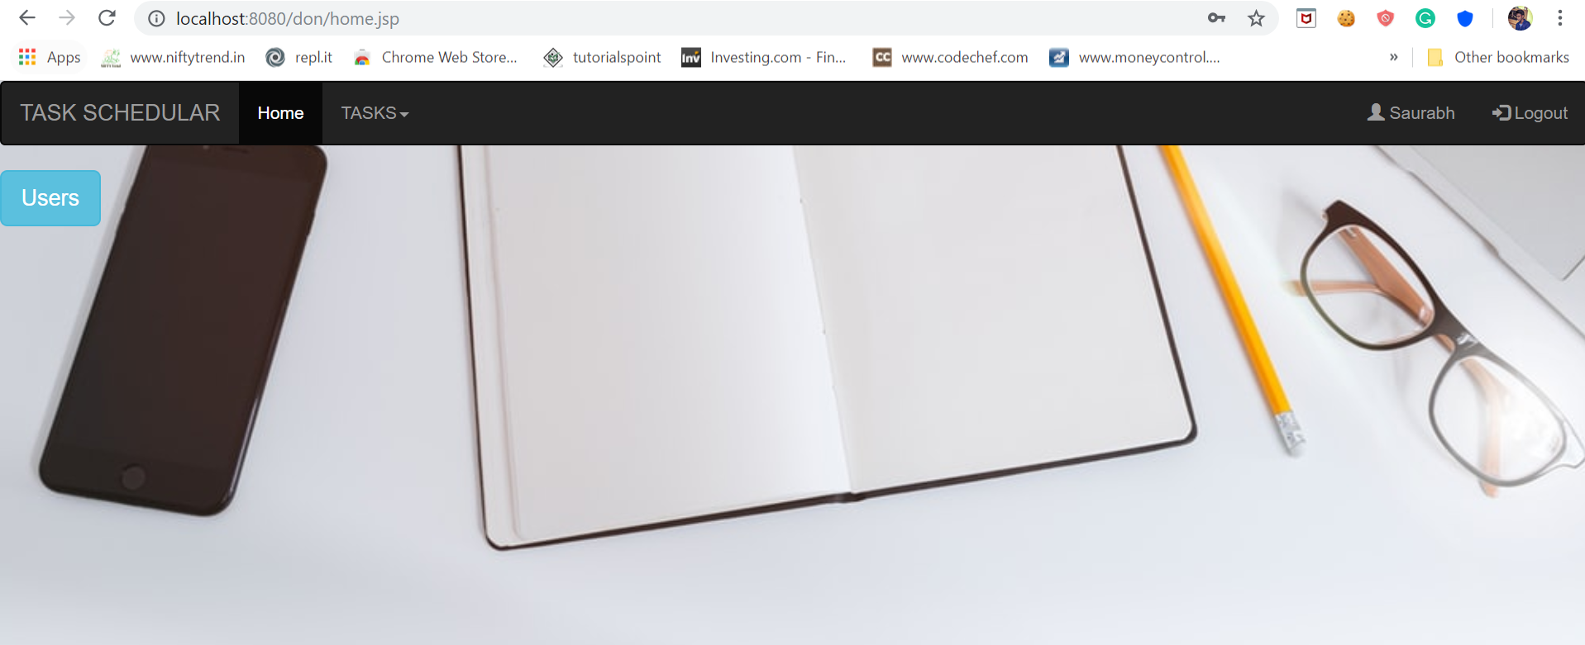
* 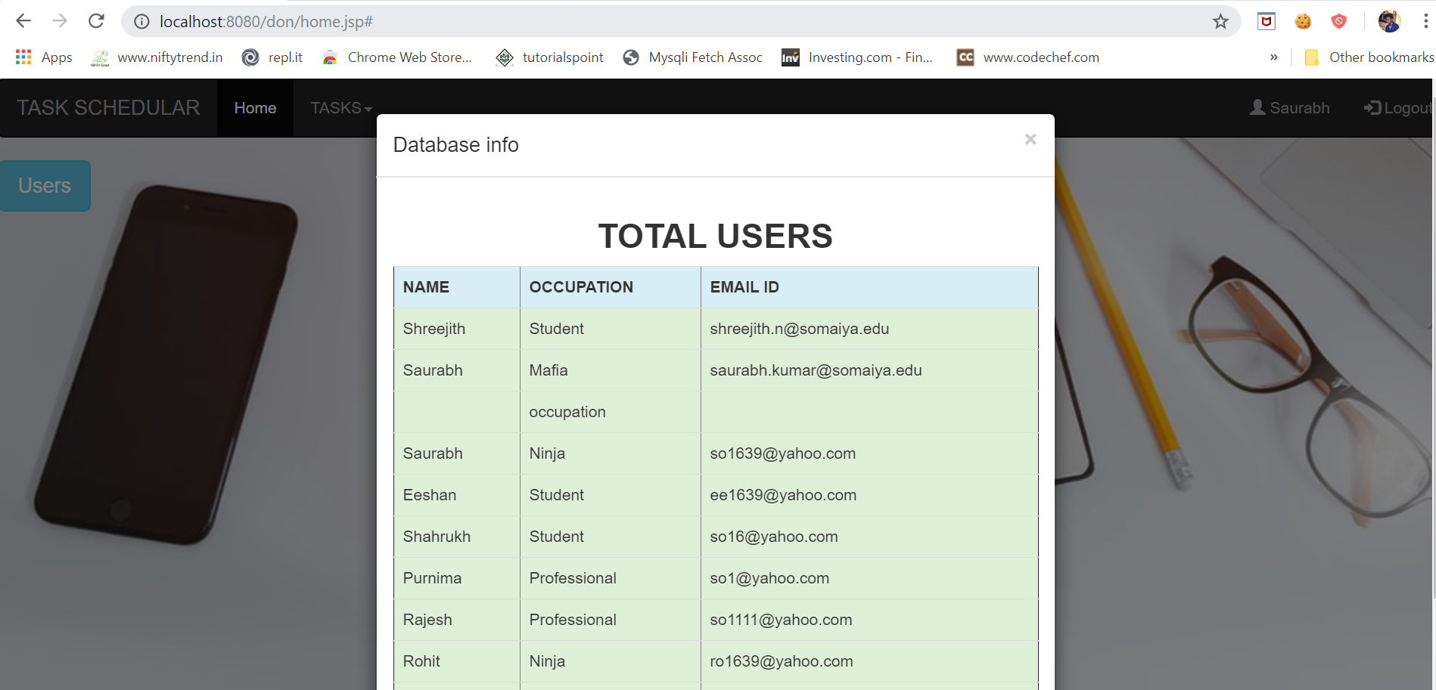
* You can ADD task with name, type &estimated time to complete. You can see all task on clicking all tasks to be done.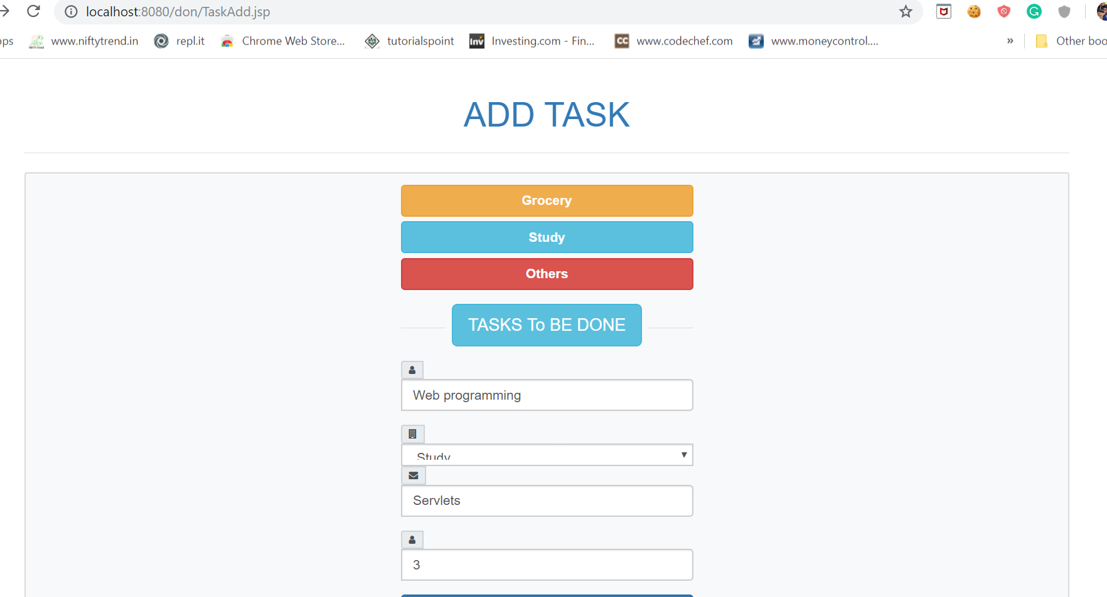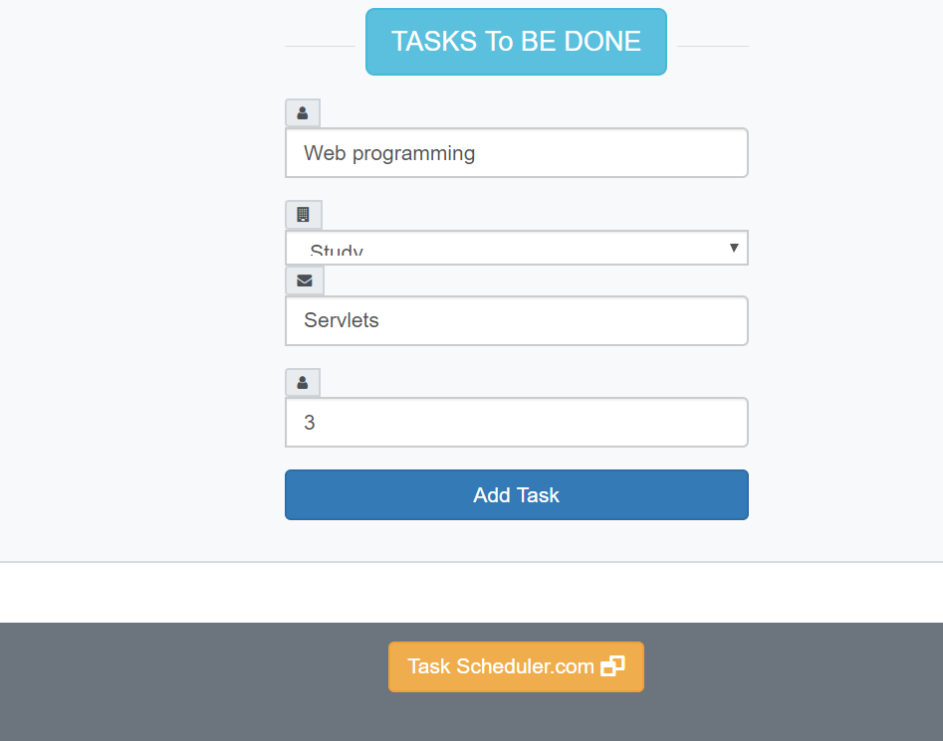
* All Tasks can be view ordered by type and can be deleted for particular user. 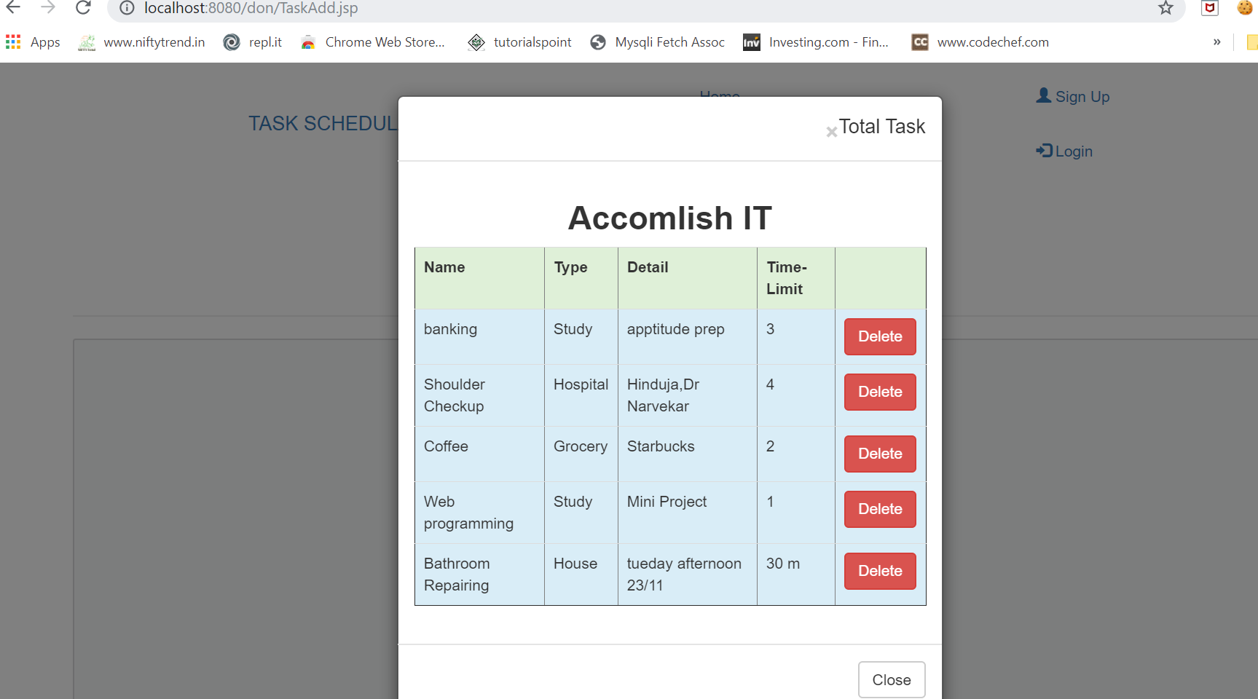

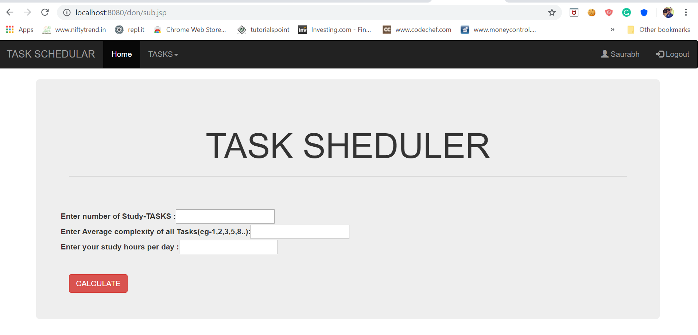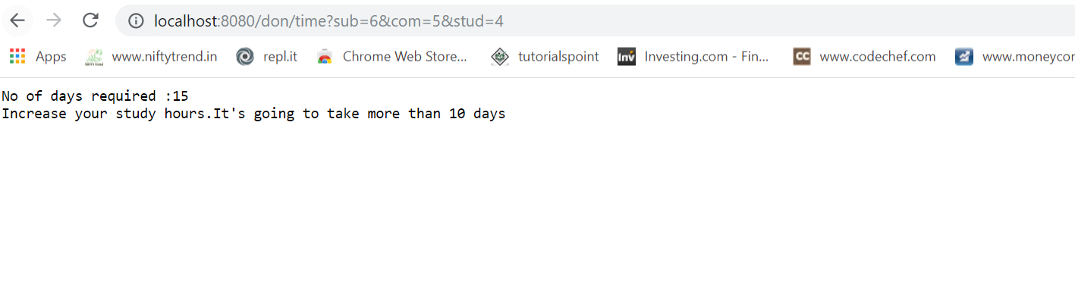

* Logout-Back Button is prevented after logout to avoid leakage of secure page.
* 
 