Central processing unit architecture - final project
Submitted by:
Yanai Mason – 206701591
Roy Shani – 315995852
MIPS based MCU Architecture

Overall system description
In this project, we want to build an MCU (Microcontroller Unit) processor based on a 5-stage MIPS Single-Cycle architecture: IF, ID, EX, MEM, WB. We have been asked to add additional hardware components (Basic Timer, FIR, GPIO, Interrupt Controller) that will work together as needed. The communication between the different hardware components will be via 3 bus lines that will transfer relevant information between the producers and consumers. Below is a block diagram:
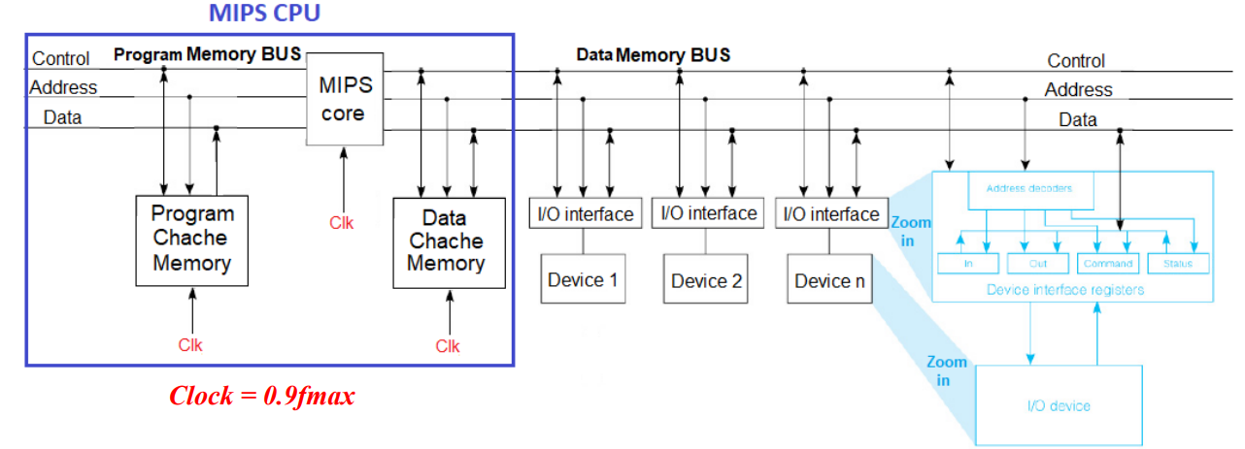
The RTL diagram of the MCU is below: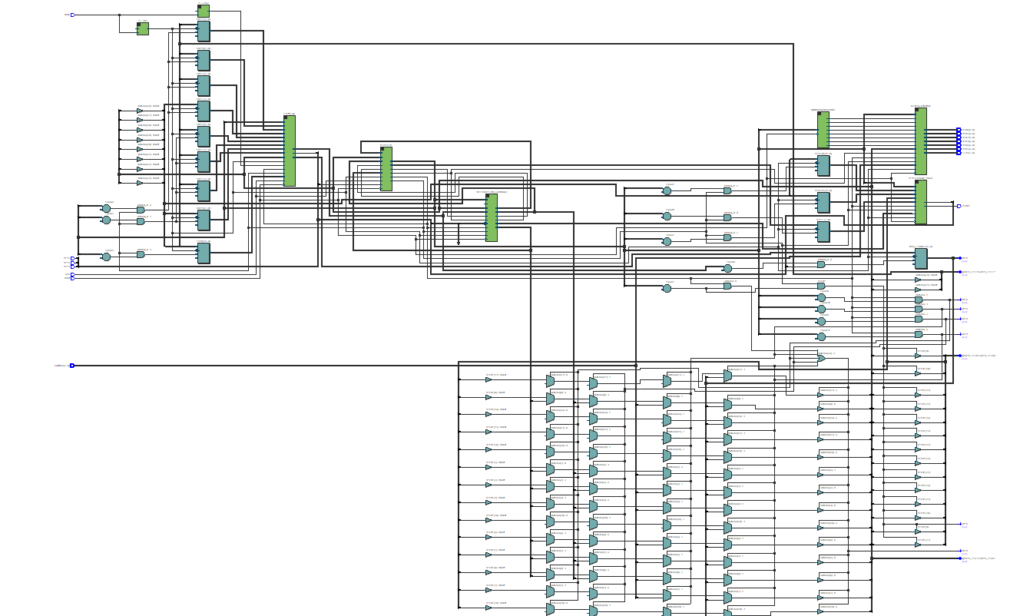

The logic usage for each block is given by:
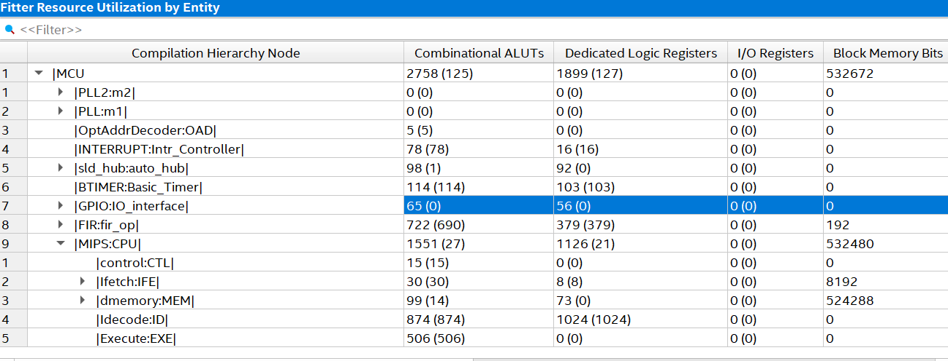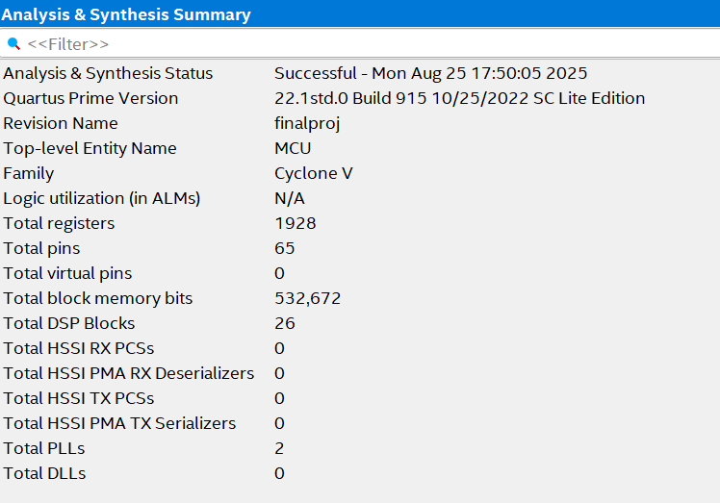
The port table is given by:
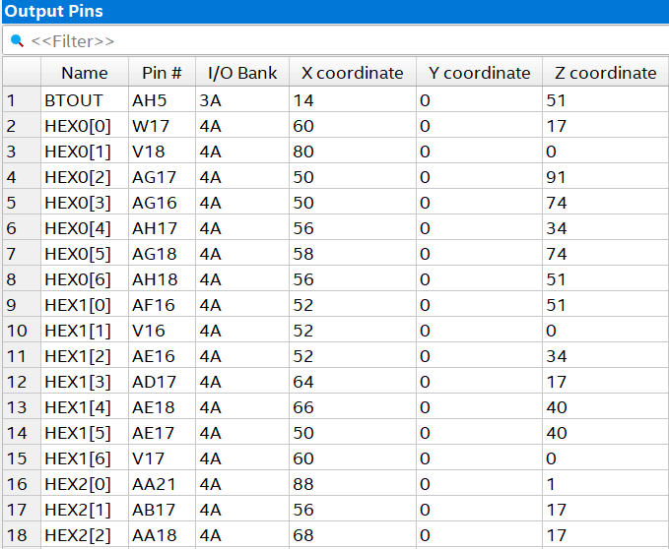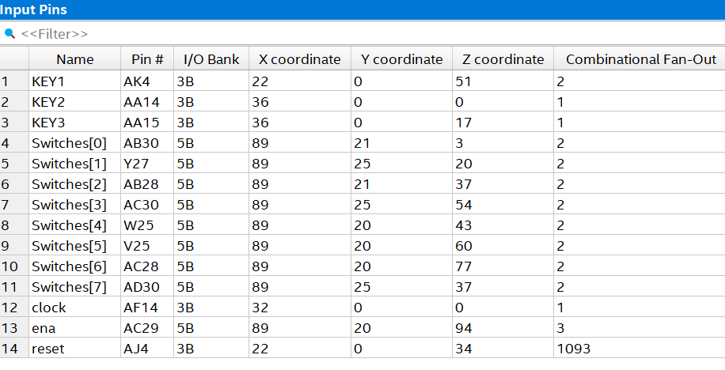

MIPS
This component is the CPU of the MCU. It is a Single-Cycle architecture and supports the instructions provided in the exercise. It can execute any program that uses only these instructions. Below is the processor with the port names:
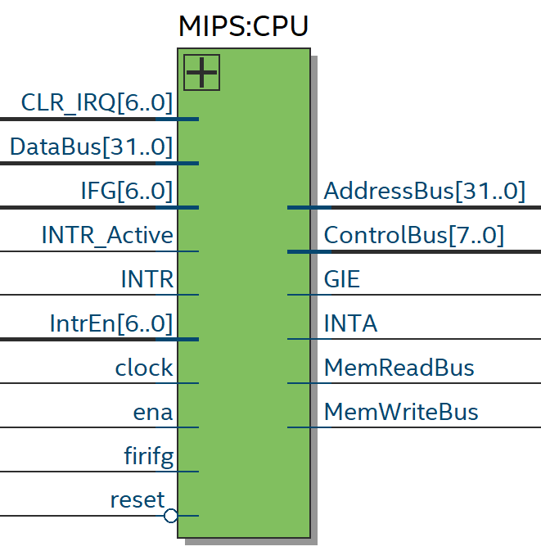
Below is the RTL of the MIPS processor:
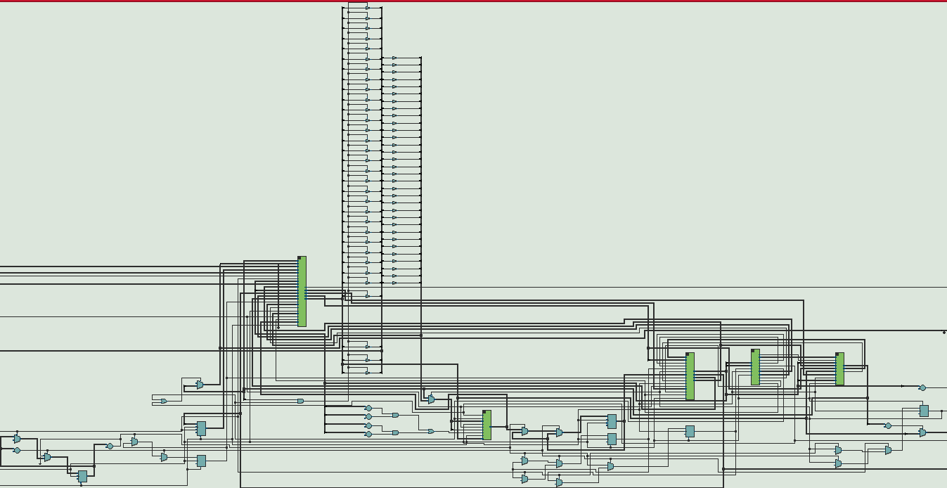

Instruction fetch
The Instruction Fetch (Ifetch) module is the core component of a single-cycle MIPS processor responsible for providing the Program Counter (PC) and fetching instructions from memory. It contains a PC register that is updated on each clock cycle based on a multiplexer's output, which selects the next address from four possible sources: a sequential increment (PC_plus_4), a conditional branch address, a jump target address, or an interrupt service routine address. The module utilizes an internal ROM, instantiated with an altsyncram component, to store the program's instructions. he Ifetch module also includes logic for branch and jump instructions, using control signals like Branch, Zero, and jump to determine the correct next PC, ensuring proper program flow. Additionally, it provides outputs for the current PC and the PC+4 address, which are used by other modules in the processor. Below is its diagram:
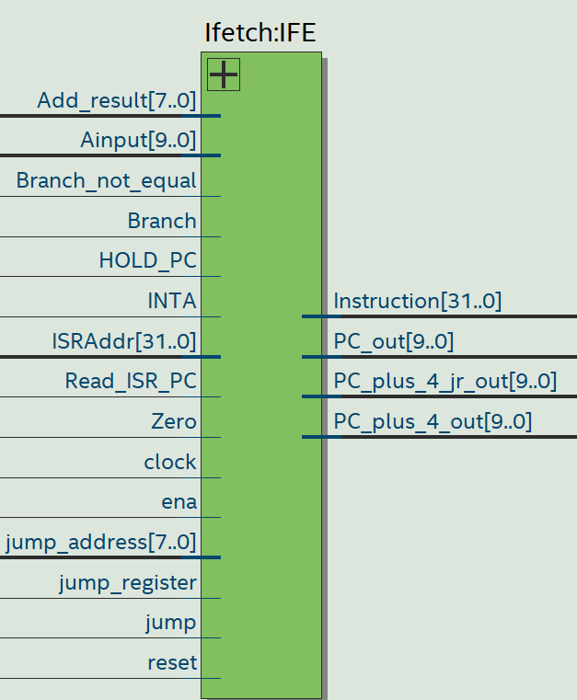

Instruction Decode
The Instruction Decode (Idecode) module serves as the processor's decode and register file stage, primarily responsible for reading instruction fields, accessing the register file for operand values, and preparing data for subsequent pipeline stages. This module contains an array of 32 general-purpose registers that act as the processor's register file. It takes a 32-bit instruction as input and extracts the source and destination register addresses, using these to read two operands from the register file. A key function of the module is to handle the sign extension of 16-bit immediate values from instructions to 32 bits. The module also includes a multiplexer to select the correct data to write back to the register file (from the ALU, memory, or a special value for a Jump-and-Link instruction), as well as specific logic to manage special-purpose registers for interrupt handling and to calculate jump addresses for control flow instructions. The commonly seen write back module is implemented within this component. Below is idecode diagram:
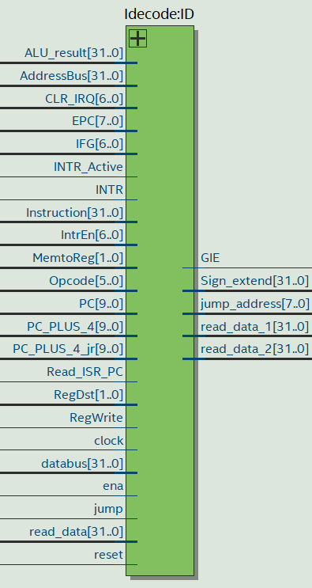

Execute
The Execute module is the stage of the MIPS processor responsible for performing arithmetic and logic operations, as well as calculating branch addresses. It includes a core Arithmetic Logic Unit that takes two 32-bit operands (Ainput and Binput) and a 3-bit control signal (ALU_ctl) to perform various operations, including addition, subtraction, AND, OR, XOR, and set-less-than. The module's internal logic uses a multiplexer to select the second operand (Binput) for the ALU, which can either be a value from the register file or a sign-extended immediate value. Additionally, the module calculates branch addresses by adding the sign-extended immediate value to the current Program Counter (PC) and generates a Zero flag that indicates if the ALU result is all zeros, which is essential for conditional branch instructions. The module also contains specific logic to handle instructions like shifts and multiplication. Below is its diagram: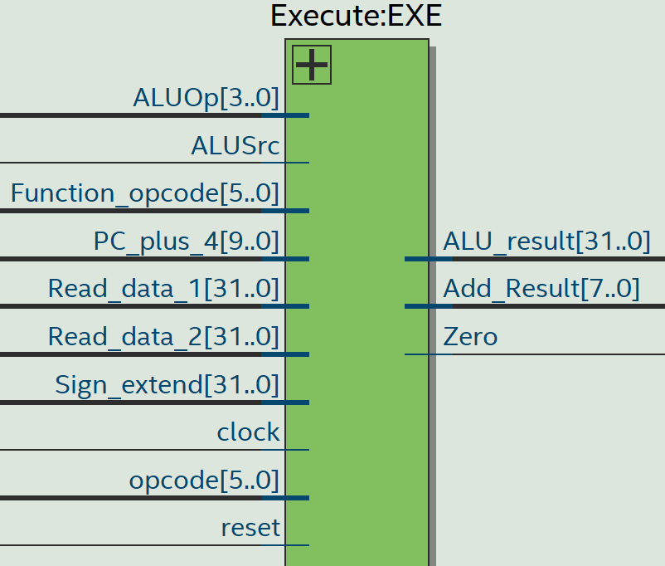

Data Memory
The dmemory module implements the main data storage for the MIPS processor, functioning as a single-port RAM for reading and writing 32-bit data. It primarily uses an altsyncram component, which is configured to allow both read and write operations, utilizing the clock for synchronization. The module calculates the memory address (dMemAddr) based on the input address from the ALU, with specific logic to adapt the address width for either ModelSim simulation or FPGA hardware implementation. Write operations are controlled by the Memwrite and ena signals, asserting wren_a to enable data storage, while read data is continuously available on the read_data output based on the provided address. This module is crucial for load and store instructions, allowing the processor to interact with its main data storage. Below is its diagram:
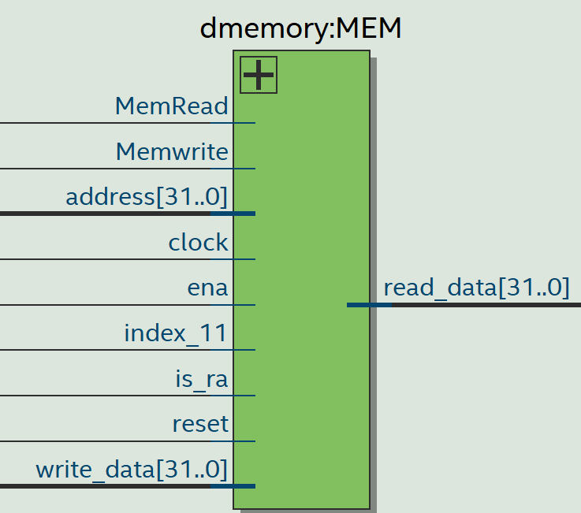

Basic Timer
The Basic Timer (BTIMER) module is a versatile hardware component that provides timing functionality, interrupt generation, and Pulse-Width Modulation (PWM) capabilities. The module's behavior is controlled by several dedicated registers, including BTCTL (Control Register), BTCCR0 and BTCCR1 (Compare Registers), and a counter register BTCNT. It features a configurable clock divider that generates an internal clock (CLK) from the master clock (MCLK) based on the BTSSEL field in BTCTL. The BTCNT counter increments on each divided clock cycle, and its value can be cleared by a strobe (BTCLR) or held (BTHOLD). When BTCNT matches either BTCCR0 or BTCCR1, an event can be triggered. For PWM, the BTOUT signal is toggled when the counter reaches a compare value, allowing for duty cycle control. It also generates an interrupt flag (BTIFG) based on a selected bit from the counter or when the counter matches BTCCR0, allowing the processor to handle time-based events. The BTCNT value can be read or written to through a dedicated address on the bus, allowing the processor to interact with the timer's state. Below is its diagram:

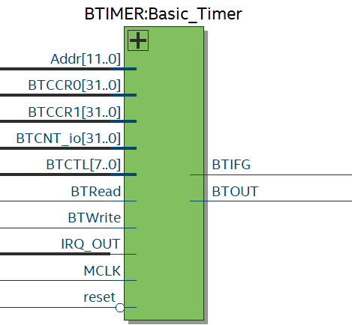
And the basic timer’s RTL:
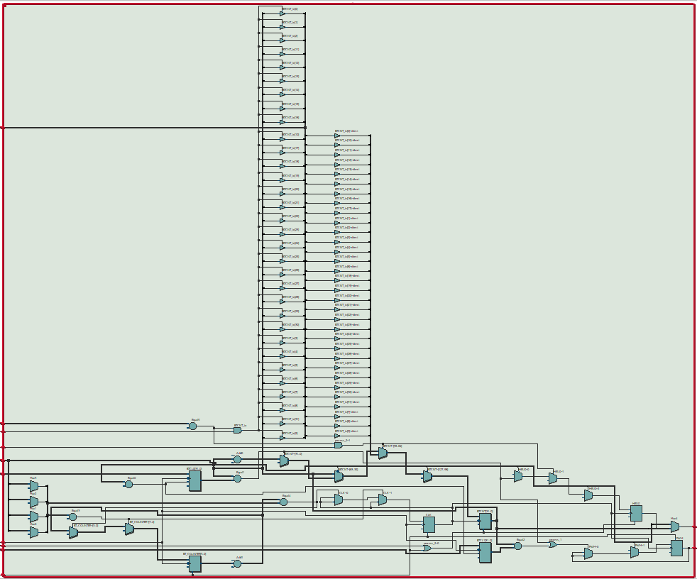

Interrupt controller
The interrupt module acts as the central orchestrator for all interrupt requests in the MIPS system, managing multiple interrupt sources, prioritizing them, and generating the main interrupt signal to the CPU. It features an Interrupt Flag Register (IFG) that stores the status of all active interrupt requests and an Interrupt Enable Register (IntrEn) that allows software to enable or disable individual interrupt sources. The module continuously monitors various external IntrSrc inputs (like timers and key presses) and, when an enabled interrupt becomes active, asserts the main INTR signal to the CPU (provided the Global Interrupt Enable GIE is also active). Upon receiving an interrupt acknowledge signal (INTA) from the CPU, the module clears the corresponding interrupt flag and provides an IRQ_OUT vector to indicate which interrupt source is currently active. Furthermore, it determines an TypeReg (Interrupt Vector Address) value based on the highest-priority active interrupt, which the CPU uses to jump to the correct Interrupt Service Routine. The module also allows the CPU to read and write to its internal registers (like IFG and IntrEn) via the data and address buses, enabling dynamic control over interrupt behavior. Below is its diagram:
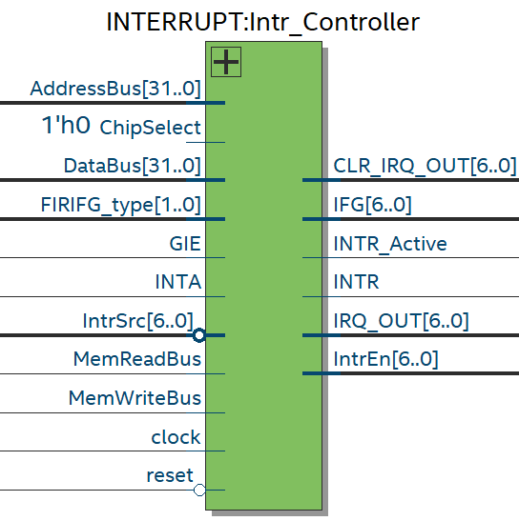
And its RTL:
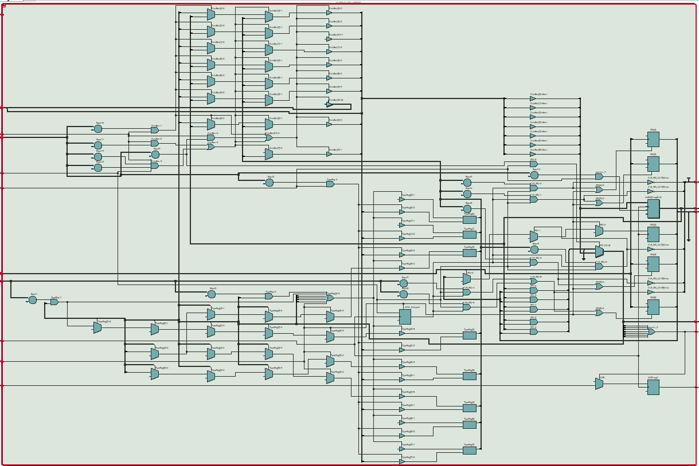

GPIO
The GPIO module serves as a bridge between the processor's bus and a set of external peripherals, allowing the CPU to read from switches and write to LEDs and seven-segment displays. The module is primarily a structural design, instantiating several instances of two sub-modules: OutputPeripheral for the LEDs and seven-segment displays and InputPeripheral for the switches. Each peripheral is individually controlled by a dedicated chip select signal (CS_LEDR, CS_SW, etc.), ensuring that data transfers on the DataBus are directed to the correct component. When the processor performs a write operation with a valid chip select, the OutputPeripheral modules capture the data from the DataBus and drive the corresponding external output pins. Conversely, when the processor performs a read operation, the InputPeripheral module places the current state of the switches onto the DataBus, allowing the CPU to read the input values. Below is its module:
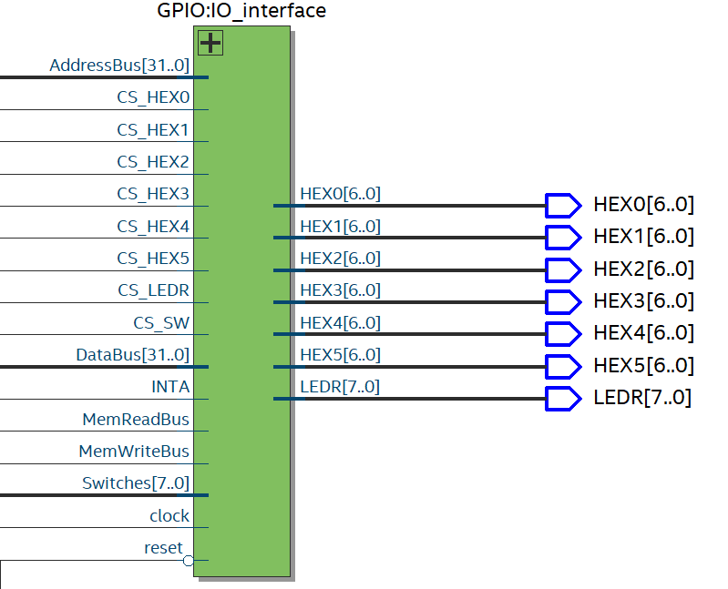
The RTL of this component is below:
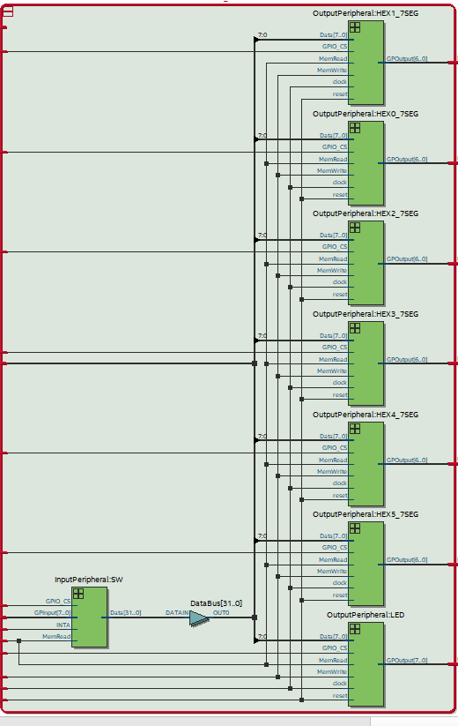

Critical path
The critical path is the longest path of logic propagation within the digital circuit we built. It represents the slowest path in the system, and as such, we need to use it to determine the maximum achievable clock frequency for the MCU's design. The critical path in this project is:
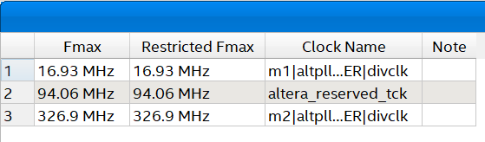
The critical path in tech view is:
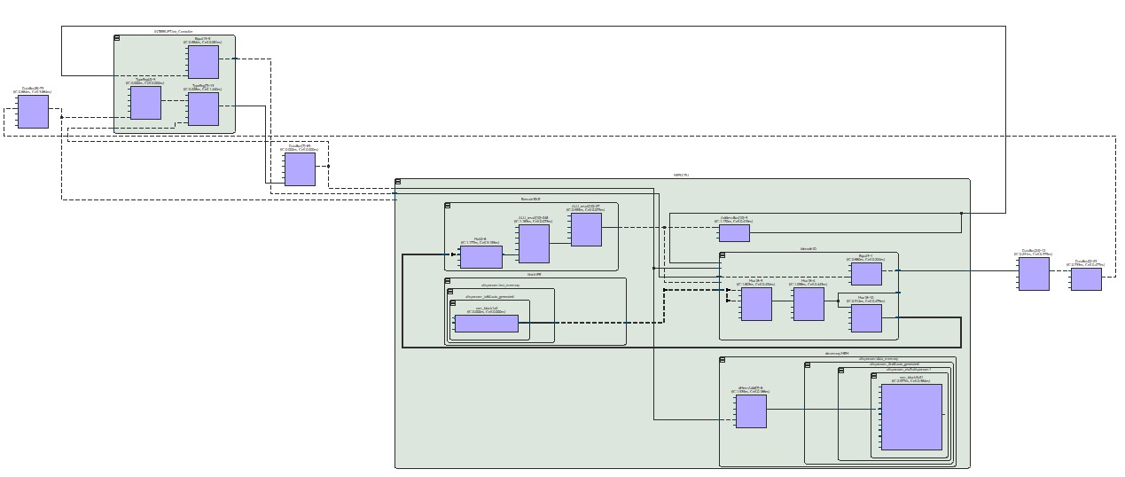
The critical path in chip planner is:
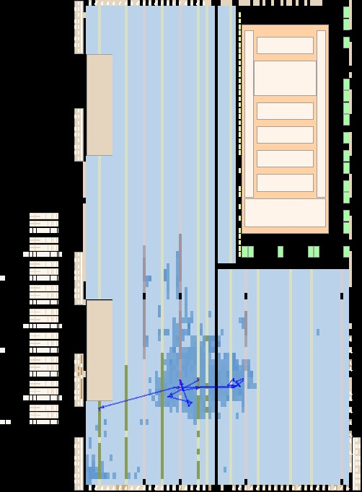
The critical path is:
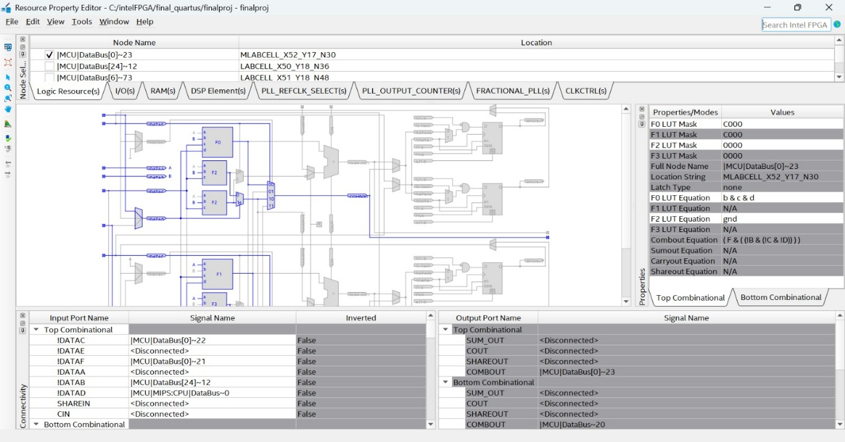
Minimum path is:
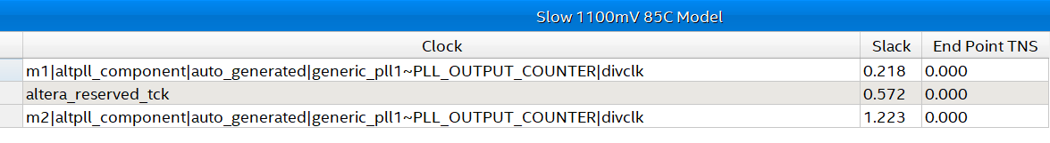

Data analysis
This section of the report will discuss obtained results in terms of timing analysis, simulation, wave diagrams and signal tap.
ModelSim Wave diagram analysis:

