

Ben-Gurion University of the Negev

Faculty of Engineering Science

Dept. of Electrical and Computer Engineering

Fourth Year Engineering Project

Preliminary Design

Accelerating MRI acquisition using deep learning

|  |  |  |
| --- | --- | --- |
|  | **s-2018-105/ p-2018-026** | **Project number:** |
|  | **Roy Shaul 203011085**  **Itamar David 301494746** | **Student**  **(name & ID):** |
|  | [**Dr. Riklin Raviv Tammy**](mailto:rrtammy@ee.bgu.ac.il) | **Supervisors:** |
|  | **-** | **Sponsors:** |
|  | **19.11.2017** | **Submitting date:** |

האצת סריקת תמונות MRI באמצעות למידה חכמה :

סטודנטים: שאול רועי, דוד איתמר.

אימייל[*royshau@post.bgu.ac.il*](mailto:royshau@post.bgu.ac.il)[*davidit@post.bgu.ac.il*](mailto:davidit@post.bgu.ac.il) :

מנחה: ד"ר ריקלין רביב תמי.

רקע: דימות תהודה מגנטית (MRI) הוא סריקה לא פולשנית של איברים פנימיים בגוף למטרות אבחון רפואי. הבסיס הפיזיקלי של הסריקה מתבסס על שדה מגנטי חזק ופולסים של שדה אלקטרומגנטי בתדרי רדיו (RF) ליצירת תמונה של האיברים הפנימיים. דגימות הסריקה מוצגות במישור התדר המרחבי, הנקרא K-space, ולאחר התמרת פורייה הפוכה מתקבלת תמונת משמעותית של האיבר הרצוי.

צורך: משך סריקת הMRI משפיע על נוחות הנבדק ומחיר התהליך, מעבר לכך כל תזוזה במהלך הסריקה גורמת ליצירת רעש בתמונה. כיום הסריקה לוקחת זמן רב דבר הפוגע בזמינות הסריקה ובאיכות התמונה המתקבלת בעקבות תזוזה בלתי נמנעת של הנבדק.

מטרות: מטרת הפרויקט היא קיצור משמעותי בזמן הסריקה באמצעות כלי תוכנה בלבד וללא שימוש בחומרה נוספת (לדוגמת סריקה מקבילית), באמצעות הפחתה של מספר דגימות הסריקה ומבלי לגרוע באיכות התמונה. הפרויקט יתמקד בסריקות מוח.

החידוש: הגישה המובילה היום להאצת הסריקה על ידי שימוש בדגימה חלקית היא Compressed Sensing. כדי לממש את השיטה יש צורך לדגום בצורה רנדומלית את הסריקה מה שמהווה חסרון מכיוון שלשם כך יש צורך בשיטת סריקה שונה מהמקובל במכשירי MRI. בנוסף אין שימוש במידע שהתמונה המשוחזרת היא תמונת MRI. החידוש בגישה שלנו הוא שימוש בסט דגימות אשר מתאים למכשירי MRI קיימים ושיחזור הדגימות החסרות באמצעות למידה של התפלגות ייצוג הK-space של התמונה.

השיטה המוצעת: השיטה המוצעת היא השלמת תמונת K-space שנדגמה בצורה חלקית על ידי שימוש בGenerative adversarial networks (GANs)) וכך ללמוד את הפילוג הטבעי של התמונה. בשיטה זו מאמנים שתי רשתות: "רשת יוצרת" שתפקידה ללמוד להשלים את התמונה החסרה בצורה הטובה ביותר, ולהצליח לרמות את ה"רשת הבוחנת" שתפקידה לזהות האם התמונה שנכנסה אליה אמתית או שיוצרה על ידי ה"רשת היוצרת". כך מאמנים רשת שמסוגלת לשחזר תמונה בצורה טבעית, לפי פילוג של תמונות אמתיות. נפעיל רשת זו על תמונות הK-space החסרות של סריקות המוח שלנו.

מילות מפתח:

דימות תהודה מגנטית (MRI), למידת מכונה, למידת עמוקה, רשת יוצרת מתחרה (GAN), שחזור תמונה, תמונות רפואיות, עיבוד תמונות רפואיות,K-space, Compressed sensing (CS) , Peak noise to ratio (PSNR) .

**Accelerating MRI acquisition using deep learning**

Students Names: Shaul Roy, David Itamar

[*royshau@post.bgu.ac.il*](mailto:royshau@post.bgu.ac.il)[*davidit@post.bgu.ac.il*](mailto:davidit@post.bgu.ac.il)

Advisers’ name: Dr. Riklin Raviv Tammy

Background: Medical resonance imaging (MRI) is a non-invasive scan of internal organs in the body for medical diagnostics purposes. The physics of the scan is based on using strong magnetic fields and radio waves pulses to generate image of the organs. The samples of the scan are acquired in a spatial frequency plane, called K-space, and an inverse Fourier transform is used to create a meaningful organ image.

Purpose: The MRI scan duration affects the patient comfort and the procedure’s cost, additionally every movement during the scan creates artifacts in the generated image. Currently the scans take a long time which reduces the availability of the scan and lowers the generated image quality due to the inevitable movement of the patient.

Objectives: The objective of the project is to considerably reduce the scan time using only software tools with no additional hardware (e.g. Parallel Imaging), by under-sampling the image and without a visible quality loss. The project will be focused on brain scans.

The innovation: The current leading approach in scan acceleration using under-sampling is “Compressed sensing”. To implement this method a random sample of the scan is needed, which requires a different scan method than the standard in MRI scanners, furthermore there is no use in the data that the reconstructed image is an MRI image. The innovation in our approach is using a under-sample set that is compatible with current MRI scanners and reconstruct the missing samples by learning the distribution of the image K-space representation.

Proposed method: The proposed method is reconstructing the under-sampled K-space image by using Generative adversarial networks (GANs) to learn the natural distribution of the image and use it to reconstruct the missing samples. In this method two networks are trained: a generator network which purpose is to fill in the image and fool the discriminator network, which purpose is to identify if the image is real or synthetic. This way, the generator network learns to generate a photorealistic K-space image, that can fill in the under-sampled image.

Key words: Magnetic resonance imaging(MRI), K-space, Compressed sensing(CS), Deep learning, Machine learning, Generative adversarial networks (GANs), Image Reconstruction, Biomedical imaging, Medical image processing, Peak noise to signal ratio(PSNR)

### Research purpose

The main objective of this research is to develop a software based solution to accelerate MRI scans significantly, without a visible quality loss. To achieve this goal, we will accelerate the scan by taking significantly fewer measurements and obtain an under-sampled K-space image. we will then train a Generative Adversarial Network (GAN), a type of neural network that can generate data based on given examples, which purpose is to reconstruct the under-sampled K-space image.

We plan on trying to implement a solution that will bring into consideration other or all the slices of the scan in order to recover each of the other slices, as data from one slice can help in another slice reconstruction.

The quality of the reconstructed image will be measured in Peak signal-to-noise ratio (PSNR), which is commonly used to measure the quality of compressed images. We aim to achieve over 35dB with a 50% under-sampling mask, like today’s state-of-the-art method.

**Accelerating MRI acquisition using deep learning**

**Research Proposal**

the main objective of this research is to significantly accelerate MRI scans, using only software solution that can be implemented on today’s MRI machines with a minimal loss of image quality. Our research will focus on MRI brain scans.

The technology we intend to improve is the MRI scanner.

The scanner is based on using strong magnetic fields and radio waves pulses to generate image of the organs. The scanner samples are acquired in a spatial frequency plane, called K-space, that is generated from the relaxation properties of the hydrogen atoms within the organs.

to generate each row of the K-space image one RF pulse is used, the number of rows multiplied by the number of slices (z-axis) determines the total scan time. The current duration of a standard single MRI acquisition is approximately 5 minutes. A patient usually needs several of those acquisitions, which can make the duration of a single scan very long.

In order to shorten the scan time, we plan to under-sample the rows of each K-space image. by under-sampling the rows, we can have a linear time reduction, as every row scan takes a constant time.

The under-sampled rows must be filled in by the right values to avoid aliasing effect and noise to generate a high-quality image.

In our research, we plan to use Generative Adversarial Network (GAN) to fill in the missing data.

The GAN network learns the image natural distribution from given samples the following way: Two networks are trained, a generative network and a discriminative network. the generative network object is used to create the most natural looking image to “fool” the discriminating network, which sees both real and generated samples and is trained to distinguish between them. by using this zero-sum game contest framework, a natural looking image can be created by the generative network, and those pictures will be used as our reconstructed images.

We also plan on using the spatial information from other slices to reconstruct each of the slices, as opposed to current reconstruction methods that reconstruct each slice as a separate image. This might be done by using a Long Short-Term Memory (LSTM) architecture, a neural network architecture that has a memory unit and can use temporal information (as in information from other slices) to determine the output result.

This solution can be used in today’s MRI machine with only a minor change in the machine software and no additional hardware and can generate the reconstructed image on the spot.

This research will be conducted according to the following plan:

We will begin by implementing Compressed sensing MRI (CS-MRI) algorithm to learn the currently leading method in software based under-sampled MRI reconstruction and have an evaluation comparison to our method. We will then collect a large enough MRI brain dataset to train and test our networks. We will design and train different neural network generative architectures to learn the K-space distribution using our collected dataset, and use masks on the ground truth images to generate synthetic under-sampled images. We will test our system against CS-MRI to try and achieve a similar or better PSNR and tweak our architecture according to the results.

**Flow Chart**

For the system training phase, we will be using the following scheme:

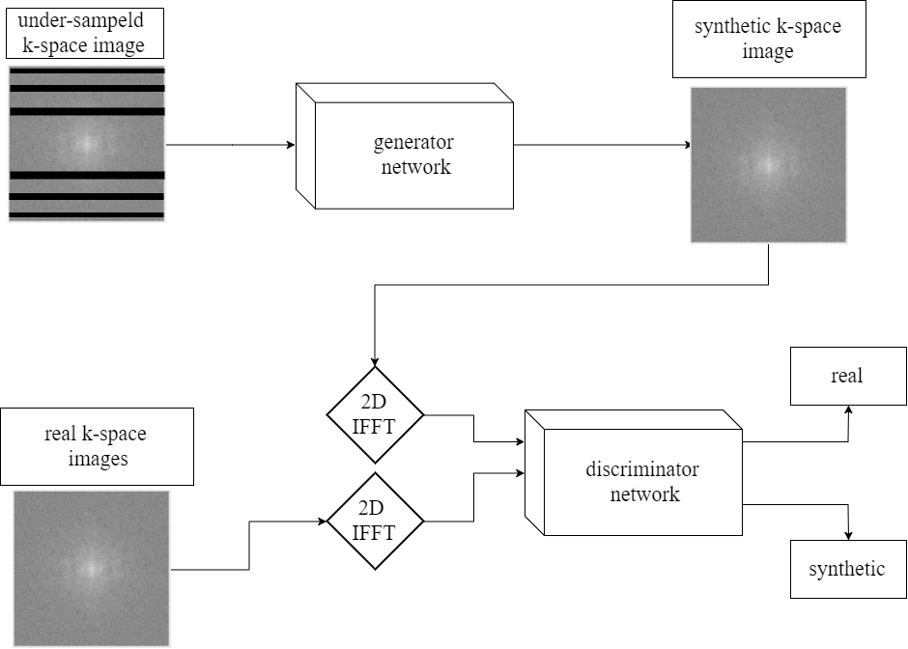

After the network is trained, the discriminative network is no longer needed, as its objective is solely to train the generator to provide the best reconstructed images. The final image reconstruction system will be the following:

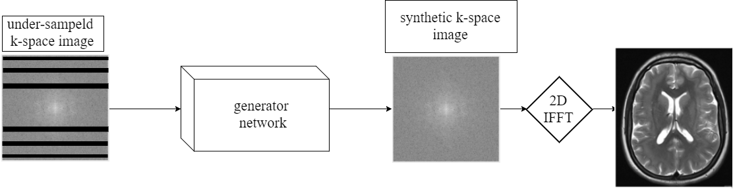

**Literature Review**

**Deep learning terms**

Convolutional Neural Network (CNN)

A convolutional neural network (CNN, or ConvNet) [1] is a type of artificial neural network. it uses learned weighted filters perform different operations, such as image classification [2], segmentation and generation.it is currently the leading technique for these applications.

A CNN uses learned kernels to apply filters on the input at each layer to make a deep pipeline to extract features. it’s advantage on other neural network architectures is that it uses much less parameters than fully-connected neural networks and keeps spatial information of the image. The reduction in the number of parameters can be achieved due to the prior knowledge of spatial information in the input.

Generative Adversarial Network (GAN)

A generative adversarial networks (GAN) [1, 3] consist of a generator network G and a discriminator network D. The goal of the generator G is to map latent variable z to the distribution of the given true data in order to fool a discriminator D, while the discriminator aims to distinguish the true data x from the synthesized fake data G (z). During the training process, G is optimized to maximize the D’s probability of error. Simultaneously, D is getting better and provides more accurate predictions.

GAN networks are today’s state-of-the-art method in producing photorealistic images.

Recurrent Neural Network (RNN)

A recurrent neural network (RNN) [1] is a type of artificial neural network in which connection between the network units form a directed cycle. This network formation makes the network aware of temporal behavior, which make it applicable to tasks such as speech recognition and video recognition.  
A noticeable RNN architecture is Long Short-Term Memory (LSTM) [4]. Each LSTM block is responsible for "remembering" values over arbitrary time intervals. LSTM along with GAN was used to successfully inpaint 3D objects [5], and maybe can be used to inpaint 3D brain K-space images.

**Compressed sensing**

Compressed sensing [6] is a signal processing algorithm for reconstruction of under-sampled signal. The algorithm is based on the principle that a sparsity of a signal can be exploited to recover it from much fewer samples than the required by the Shannon-Nyquist sampling theorem. to successfully recover the signal two conditions need to be met. The first one is that the signal needs to be sparse, in some domain. The second one is incoherent random sampling of the signal. the signal is being reconstructed by using non-linear iterative reconstruction.

each iteration attempts to minimize the following equation:

$|| Ax – y || + λ || W x ||$ (1)

The first term refers to the least squares difference (L2 norm, ||⋅||) between the estimated signal and the acquired data, to keep the data consistent. The second term regulates the L1 norm of the signal under the transform, to ensure sparsity. λ is chosen empirically, according to the application, to balance data consistency and sparsity.

Compressed sensing is used in many different applications in signal processing, one of which is compressed sensing for MRI acceleration (CS-MRI) [7]. The CS-MRI technique exploits the fact that under certain transformations (e.g Wavelet transformation) the MRI image is sparse. The K-space needs to be randomly sampled to reconstruct the image.

This method is completely software based, like our solution for the problem. However, an incoherent sample mask is required for this technique to work best, which is not possible in today’s commercial MRI machines. Also, the K-space reconstruction is based only on the signal sparsity, and does not take into consideration the distribution of the MRI K-space data or the spatial information available in other slices.  
This is the technique we want to compare our solution to, as it currently the leading under-sampled MRI reconstruction method in use.

**Image inpainting**

Inpainting is the process of reconstructing lost or deteriorated parts of images and videos. In the digital world, inpainting refers to the application of sophisticated [algorithms](https://en.wikipedia.org/wiki/Algorithm) to replace lost or corrupted parts of the image data. Image inpainting using CNN has given impressive results [8]. In these applications, GAN architecture is usually being used to generate photorealistic images, as opposed to L2 loss that generates blurry results. This technique was also used to inpaint 3D objects [5]. the proposed solution used GAN and RNN architecture to inpaint partially built 3D objects. MRI scans are also 3D objects and missing samples might be reconstructed better using the whole scan information, and not just the slice information, as current methods use.

**Design Proposal**

Our aim is to develop an algorithm that will reconstruct under-sampled brain images.

The algorithm will be implemented in Python environment by using Tensorflow, an open source software library for machine intelligence. We will collect a large brain images dataset to use for training and testing.

Our algorithm will use GAN network architecture to learn the distribution of K-space images, as explained in the “Research Proposal” section. We also plan to experiment with other techniques to make use of our 3D spatial data, such as the LSTM architecture.

**project constraints and risks:**

* The dataset we collect needs to be large and unique enough so that our model can generalize best.
* The computation time to train such a network can be as long as days.
* The performance and computation time can be affected by many parameters which we need to gently tune to achieve the best results.

**Project assumptions:**

* We assume that most of the needed data is not lost because of the under-sampling and can be recovered by using the remaining signal.

**Project capacity**

We plan on designing an algorithm that will reconstruct under-sampled k-space brain images and find the best under-sampling mask.

The Images will be the input to our algorithm and they are to be produced by an MRI scanner according to a given sampling mask that we will design. The mask we aim to find is the one that gives the best trade-off between the sampling time and reconstructed image quality.

The algorithm output will be a reconstructed MRI image.

**Proposal for final testing**

We will split our acquired dataset to training set, to train the model, and test set, to test our results. the test set will be only shown to the model after the training session is over to ensure that it is tested on first seen images.

Our measurement will be the Peak signal to noise (PSNR) measurement of images we reconstruct from the test set. we will calculate each of our reconstructed images to the ground-truth images and compare the results to images reconstructed using the CS-MRI algorithm.

PSNR is an engineering term for the ratio between the maximum possible power of a signal and the power of corrupting noise that affects the fidelity of its representation. it is most commonly used to measure the quality of images reconstructed after lossy compression. it is measured in dB and the higher the measurement the higher quality the image reconstruction is.

$PSNR =10log \frac{maxI^{2}}{MSE}$ (2)

**Estimated budget**

|  |  |
| --- | --- |
| **manpower budget** | **computer + GPU budget** |
| 2 students. | 350 hours |
| 30 working days, 9 hours per day. | 2.5 shekels per hour (google cloud) |
| 80 shekels per hour. |  |
| 30 X 9 X 2 X 80 =43,200 shekels. | 350 X 2.5=875 shekels |
| **total:44,075** | |

**Schedule**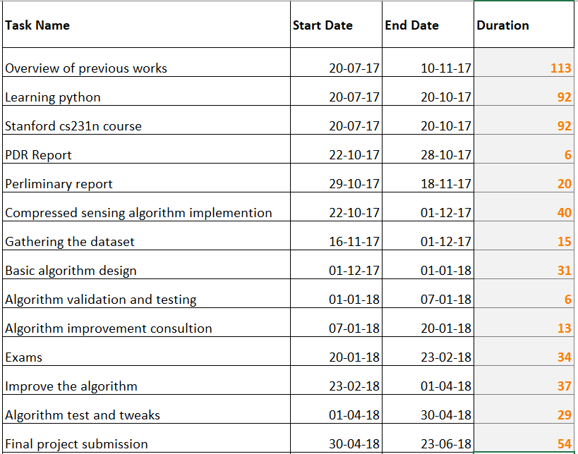

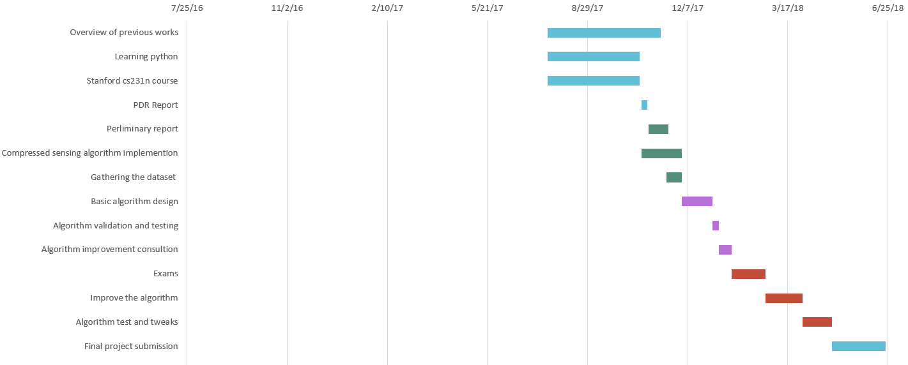

**References**

[1] I. Goodfellow, Y. Bengio, and A. Courville, *Deep learning*. The MIT Press, 2017.

[2] A. Krizhevsky, I. Sutskever, and G. E. Hinton, “ImageNet classification with deep convolutional neural networks,” *Communications of the ACM*, vol. 60, no. 6, pp. 84–90, 2017.

[3] I. Goodfellow, J. Pouget-Abadie, M. Mirza, B. Xu, D. Warde-Farley, S. Ozair, A. Courville and Y. Bengio : Generative adversarial nets. In Advances in neural information processing systems,2014, pp. 2672–2680

[4] F. Gers, “Learning to forget: continual prediction with LSTM,” *9th International Conference on Artificial Neural Networks: ICANN '99*, 1999.

[5] W. Wang, Q. Huang, S. You, C. Yang, and U. Neumann, 2017. Shape Inpainting using 3D Generative Adversarial Network and Recurrent Convolutional Networks. In Proceedings of the IEEE Conference on Computer Vision and Pattern Recognition ,2017, pp. 2298-2306.

[6] D. L. Donoho, *Compressed sensing*. Department of Statistics, Stanford University, 2004.

[7] M. Lustig, D. Donoho, and J. M. Pauly, “Sparse MRI: The application of compressed sensing for rapid MR imaging,” *Magnetic Resonance in Medicine*, vol. 58, no. 6, pp. 1182–1195, 2007.

[8] D. Pathak, P. Krahenbuhl, J. Donahue, T. Darrell, and A. A. Efros, “Context Encoders: Feature Learning by Inpainting,” *2016 IEEE Conference on Computer Vision and Pattern Recognition (CVPR)*, 2016.

[9] A. Arinaldi and M. I. Fanany, “Generating Single Subject Activity Videos as a Sequence of Actions Using 3D Convolutional Generative Adversarial Networks,” *Artificial General Intelligence Lecture Notes in Computer Science*, pp. 133–142, 2017.

[10] S. Wang, Z. Su, L. Ying, X. Peng, S. Zhu, F. Liang, D. Feng, and D. Liang, “Accelerating magnetic resonance imaging via deep learning,” *2016 IEEE 13th International Symposium on Biomedical Imaging (ISBI)*, 2016.

**טופס כיבוד זכויות יוצרים וסודיות**

אני מצהיר שלא אעשה שימוש בפרויקט ההנדסי שלי בכל חומר בעל זכויות יוצרים כגון:

טקסט,

תמונה,

אודיו,

וידיאו ,

מוזיקה,

סרט,

אנימציה,

תוכנה

חומרה

תיכנון מעגל

ללא קבלת אישור מראש מבעל הזכויות

אני מצהיר שאשלב בפרויקט ההנדסי שלי בדוחות, סרטונים, והרצאות אינפורמציה שאינה נחלת הכלל

רק בתנאי שאושרה מראש ע"י בעל הזכויות.

הרישום לפרויקט ההנדסי משמש ההתחייבות שלי לקיים ולכבד זכויות יוצרים וסודיות

חתימות: רועי שאול

איתמר דוד

תאריך: 19/11/17