R. Gladden Jan. 20, 2012

WebWiz Version 5 Implementation Guide

Environment Information:
IBM has built a separate WebWiz network and application infrastructure which will run in parallel with that of the current version of WebWiz. The new environment uses unique URLs which route users to new Application servers which run the updated WebWiz software. These servers then connect to the current Communication servers which host the user’s vtams. Therefore, you can only be logged into the current or new WebWiz environment at one time – you cannot be working in both simultaneously.

Going from current to new version or from new to current version:
The two versions require different WebToHost Manager versions and different display (*.zmd) and printer (*.zmp) configurations. The former will detect what software is needed on your pc and will download it; the latter configuration files contain the ip addresses of your primary and backup application servers, which are different for the two versions.

In order to get the correct version of WebToHost Manager and display and printer configs, it’s necessary to run eZClear with two options checked:
‘Delete internet cached files’ (for WebToHost Manager version) and
‘Delete user files…’ or ‘Delete Bluezone‘ (for display and printer configs).

The ‘Delete user files/Bluezone’ option will also delete saved scripts or other settings that are stored on your pc. If this is a problem for you, you have two choices:

1) Backup config files:
Your config files are probably stored in a folder/subfolder called Bluezone/Config. Create a subfolder called Backup under Bluezone/Config and copy the contents of the Bluezone/Config into the Backup folder. After you’ve loaded the new version of software, you can restore any saved scripts or other settings into the Bluezone/Config directory, being careful to leave the new *.zmd and *.zmp files.

2) Manually delete display and printer files:
In the directory where your config files are stored, manually delete the *.zmd, *.zmp files, leaving other files there. Then run eZClear but choose only the ‘Delete internet cached files’ option.

Bluezone Desktop:
If you also use Bluezone desktop, and it shares a directory with your WebWiz Bluezone software, be careful when running the eZClear ‘Delete user files’ option as that will delete your desktop config (*.zmd, *.zmp) also. Again, you can save the desktop config in a backup directory.

Version 5 Differences:

1) Old and new URLs:
webwiz.avis.com is being replaced by webwiz5.avis.com
webwiz.drivebudget.com is being replaced by webwiz5.drivebudget.com
webwiz4.drivebudget.com is being replaced by webwiz5.budget.com
aewebwiz.avisweb.com is being replaced by aewebwiz5.avisweb.com

2) Desktop Shortcut:
The new version will put a shortcut to the URL browser page. It will look like the picture shown below but the name will be that of your group which defines the display and printer sessions used. If you click on this shortcut, the URL browser page will come up with a ‘login failed’ message. You can just click on the ‘login again’ button to get a fresh screen on which you can enter your user id and password. You can also ignore the shortcut and add the new URL to your browser’s ‘favorites’ tab.

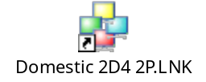

3) Password storage:
The new version does not store passwords, so they will have to be typed in each time you log in. Use the same user id and password as now. In the near future, WebWiz passwords will be set to expire after some period, and you will be required to change them via screen input. We’ll pass more instructions shortly, but please keep this in mind.

4) Launch Screen:
The new version has a different screen which allows you to start individual sessions or all at one time. You’ll see a screenshot in the detailed instructions later in this guide.

5) Bluezone version:
The new WebWiz version includes Bluezone version 5. If you have a separate Bluezone desktop software version there is no conflict between running them despite having different versions.

6) Display and printer configurations’ ip addresses:
The *.zmd and *.zmp files which define the display and printer configurations contain the ip addresses of the primary and backup servers. For the current environment, those addresses are 170.225.12.200,201,202, or .203. For the new environment, they are 170.225.12.171, .172, .173, or .174. Please note that logging in to the new environment does not ensure that your bluezone sessions are running on the new application servers. It’s possible to run with the old *.zmd and *.zmp files so you’re connecting through the old application servers, despite having logged in through the new URLs.

7) Power keys:
Bluezone version 5 replaced power keys with power pads, but we have re-enabled power keys for AvisBudget, so they should work the same as in the current version.

8) eZClear:
The new version of eZClear requires you to close the browser to run the eZClear software. So click on eZClear, close the browser, and continue running eZClear from the box which will remain on your screen.

Reporting Problems:
Do not contact the Help Desk if you have problems in the new environment. Instead,
please report any problems to me at the email address shown below. Include as much detail as possible: User id (not password), URL, and a screen shot would be most helpful. Then return to the current environment.

Please note that if you get a connection ‘timeout’ failure, try starting that individual session again by clicking on the Session tab, then the Connect option.

Please contact me at any time if you have questions or run into problems. I can be reached as follows:
Rosemary.Gladden@avisbudget.com.
Office phone 973-496-2159 (9-5 ET Mon-Fri)
Cell phone 516-508-6950

A secondary contact is Mark.Zaremba@avisbudget.com, 973-496-2151.

Returning to Current Environment if necessary:
See the detailed instructions below. If you have any problems getting back to the current environment, please reach out to me immediately, using my cell phone if outside my business hours, and contact the Help Desk.

Note on Internet Explorer Version 8 (or Higher)

Please note that IE 8 and higher versions require the new URLs to be added to the Users Trusted Sites in IE properties.

Implementation Instructions

1 – Run eZClear from the current WebWiz environment.
In order to get the correct version of WebToHost Manager and display and printer configs, it’s necessary to run eZClear with two options checked:
‘Delete internet cached files’ (for WebToHost Manager version) and
‘Delete Bluezone…’ (for display and printer configs).
Be careful to back up any special profiles or scripts before running eZClear with the ‘delete user file’ option.
2 - Log out of current WebWiz environment.
3 - Open a new browser.
4 - Access the new WebWiz environment using the new URL replacing your current one as shown below:
https://webwiz.avis.com https://webwiz5.avis.com
https://webwiz.drivebudget.com https://webwiz5.drivebudget.com
https://aewebwiz.avisweb.com https://aewebwiz5.avisweb.com
https://webwiz4.drivebudget.com https://webwiz5.budget.com

5 – You will see the following screen:

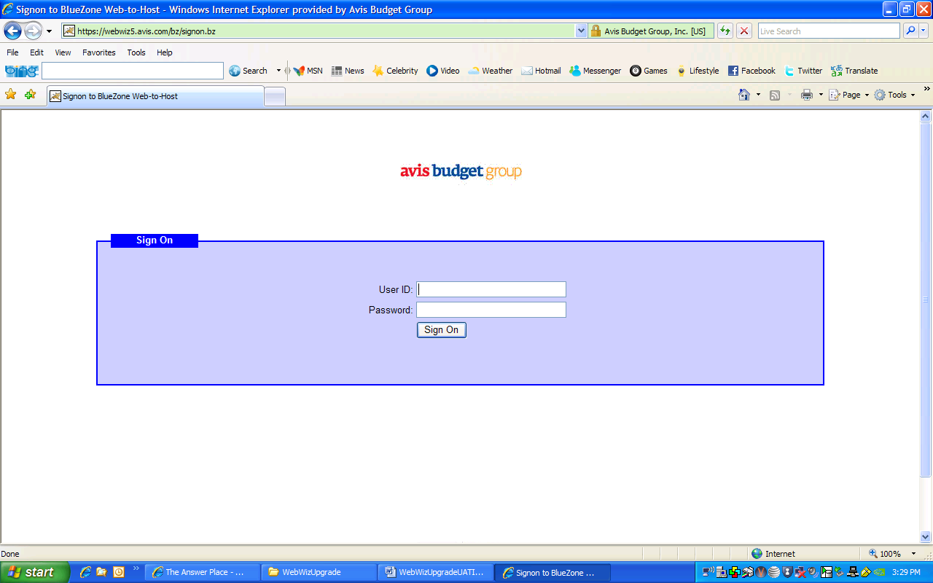

6 – Enter your user id and password and click the ‘sign on‘ button.

7 - This will bring you to the next screen, similar to this one. You may see a prompt above the AvisBudgetGroup logo saying ”This website wants to install the following add-on: ‘BlueZone Web-to-Host Control Module v5’ from Rocket Software, Inc. If you trust the website and the add-on and want to install it, click here..” Click to install the software which is Active-X.

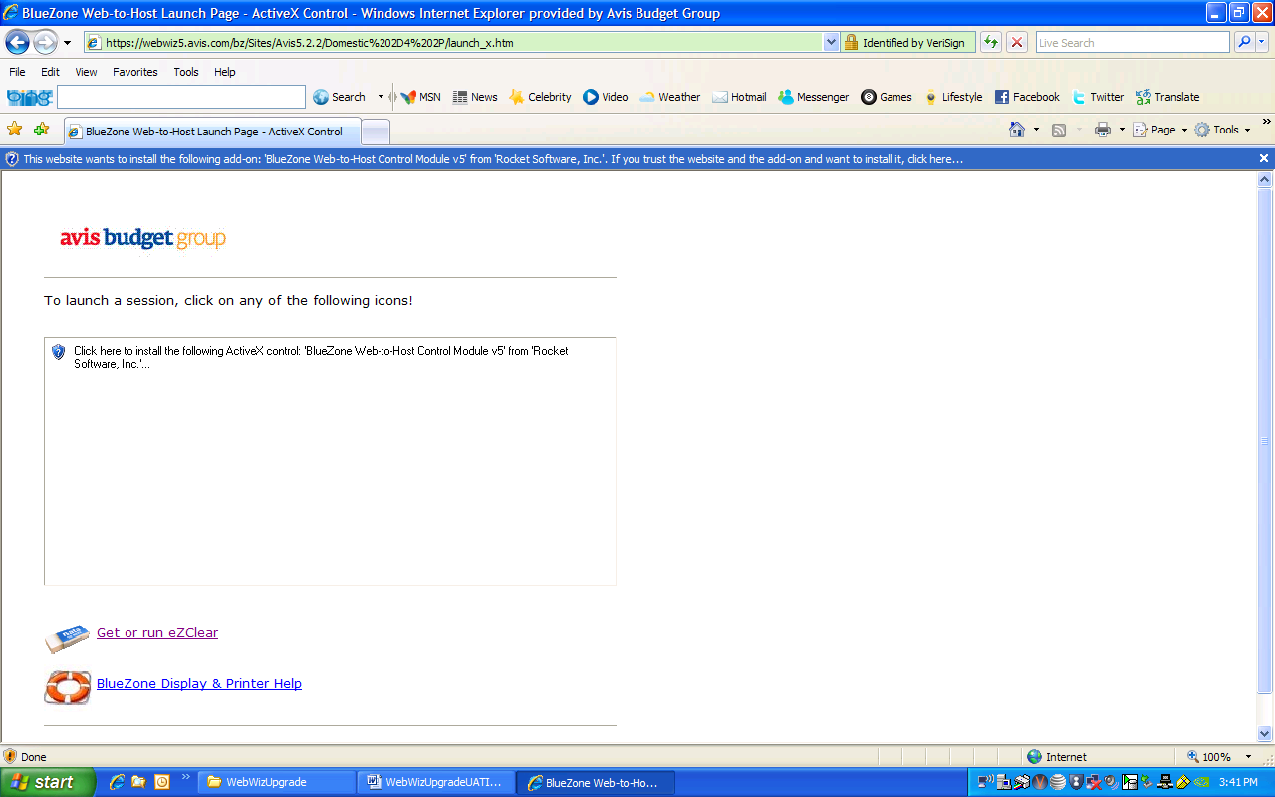

8 - You’ll see another popup box as in the screen below asking if you want to install this software. Click on Install. .

–
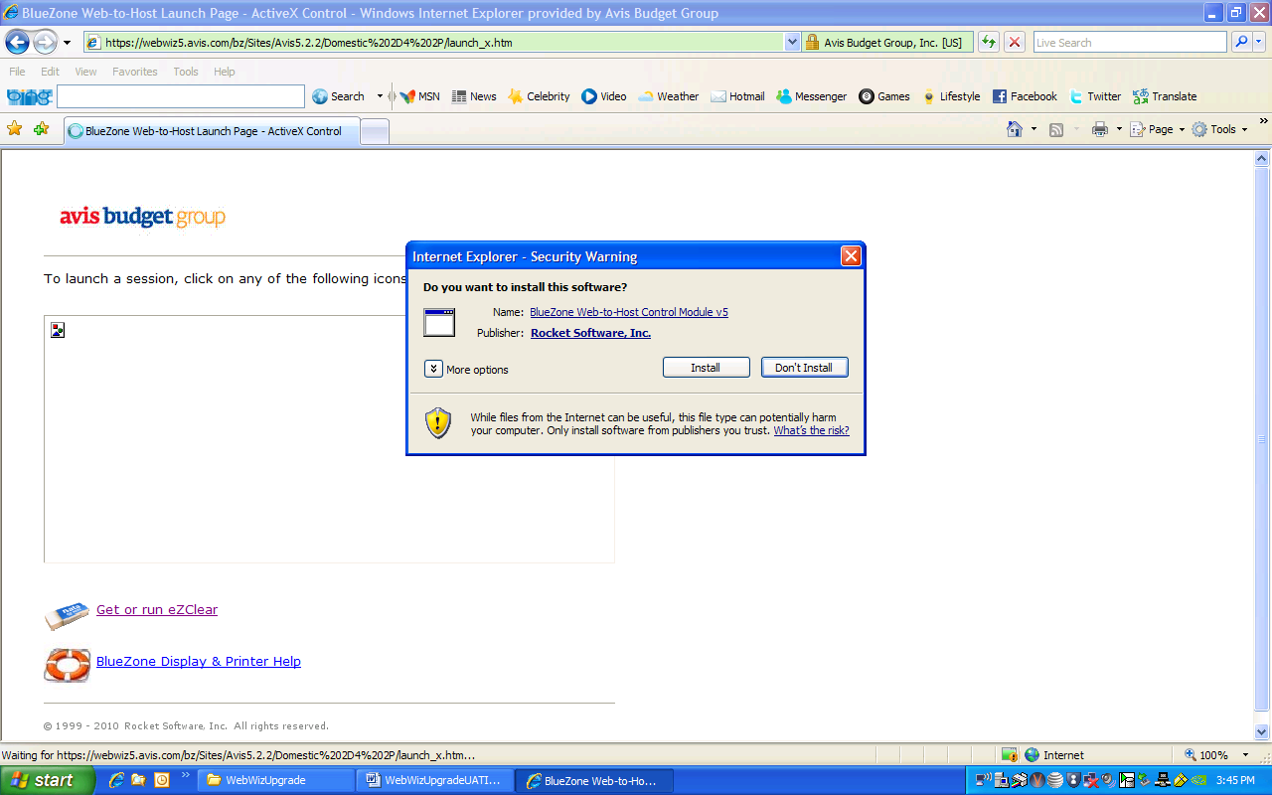

9 – You will see software being downloaded:

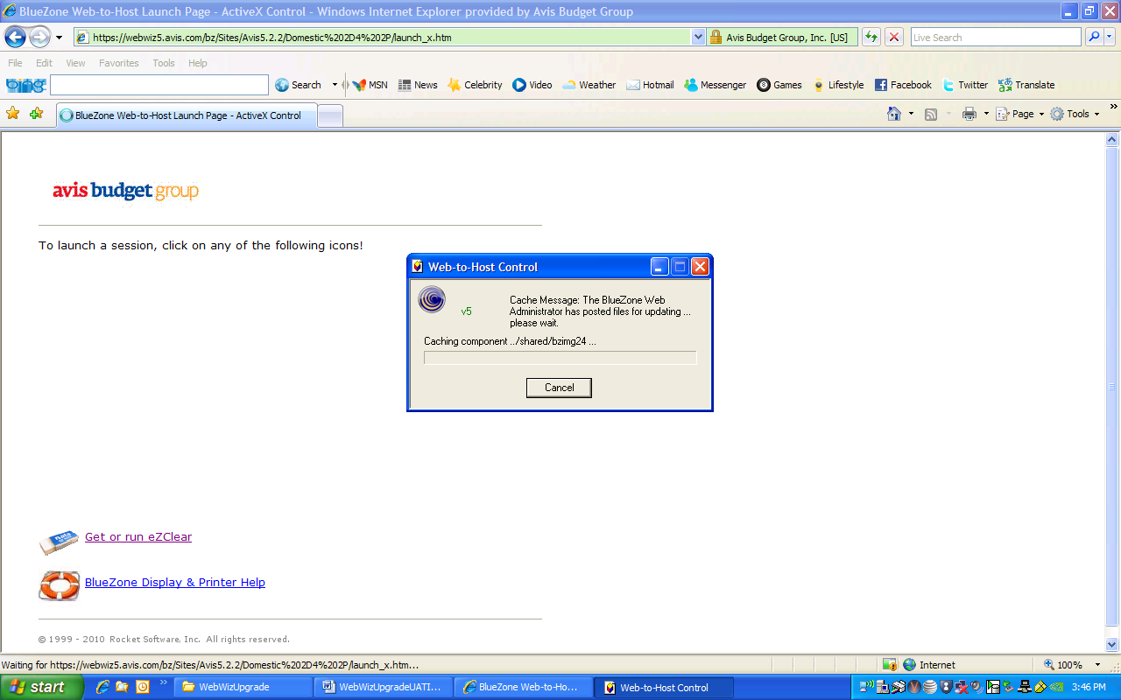

10 – When the download is complete, you’ll see the launch screen:

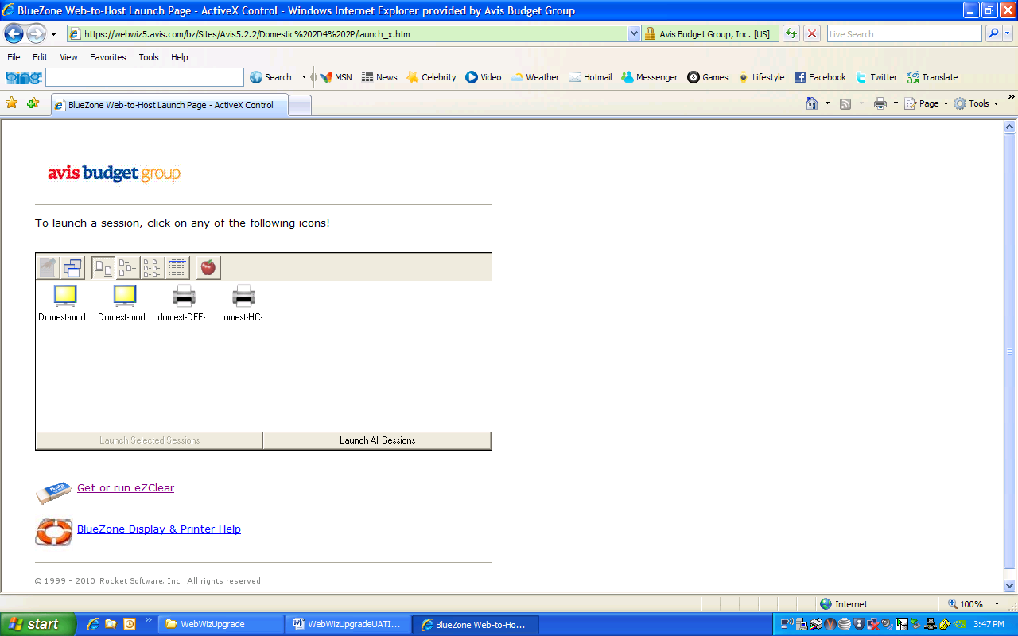

11 – You can launch your sessions individually or in pairs or all together by putting your cursor on the one(s) you want with the CTRL key held down, and then clicking on the words ‘launch selected sessions’. You can also launch all of them at once by clicking on the words ‘launch all sessions’ – for this option, it’s not necessary to put your cursor on any sessions. Please note that printer sessions will not come up unless their associated display sessions are up, so printer sessions should never be started alone or before the display sessions.

12 – The first time you’re launching your sessions you’ll get a popup box asking if you want to “run this software” for your display session(s). Click on the Run button.

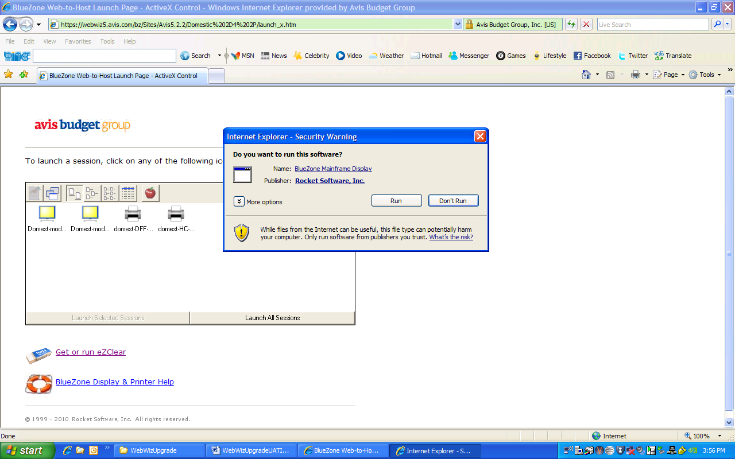

13 – This will cause your display session(s) to open. You’ll see another popup box asking if you want to run software for your printer sessions, as shown below. Click on the Run button.

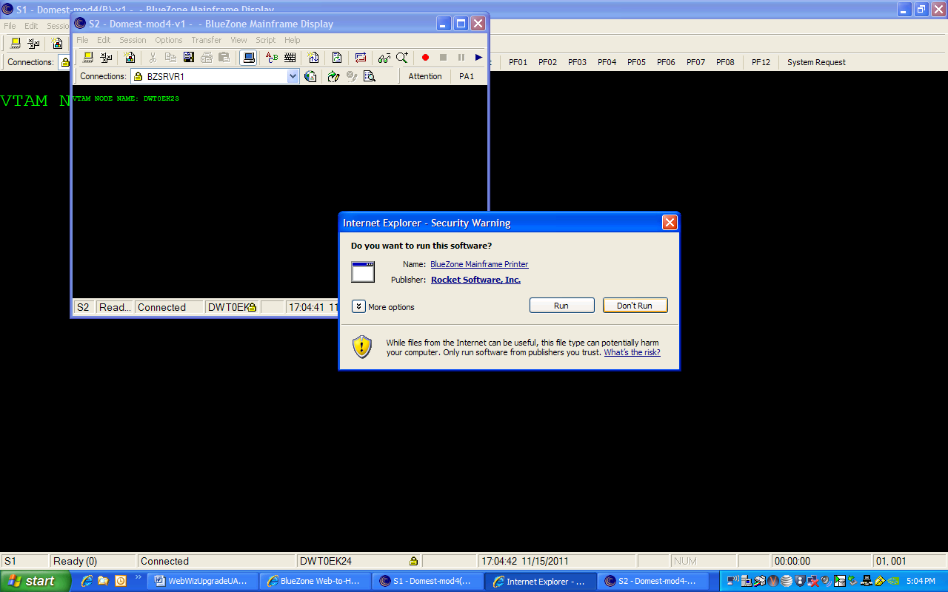

14 – Now you should have all your display and printer sessions open looking the same as in the current WebWiz environment. You can log in and do transactions as usual.

Validating the Environment

15 - The *.zmd and *.zmp display and printer configuration files contain the ip addresses of the WebWiz Application servers in the data center. It’s possible to log in to the new WebWiz server but get your Bluezone sessions through the old WebWiz server. In order to be sure you’re in the new environment, check the host ip address in each of your bluezone sessions as follows:

- Click on Session on the Display session toolbar.
- Click on Configure.
- In the popup box, click Configure. Verify the host ip address has a last octet ending in .171, .172, .173, or .174 which are the new Application servers. If you see the last octet as .200, .201, .202, or .203, you’re still going to the old Application server. Below is an example:

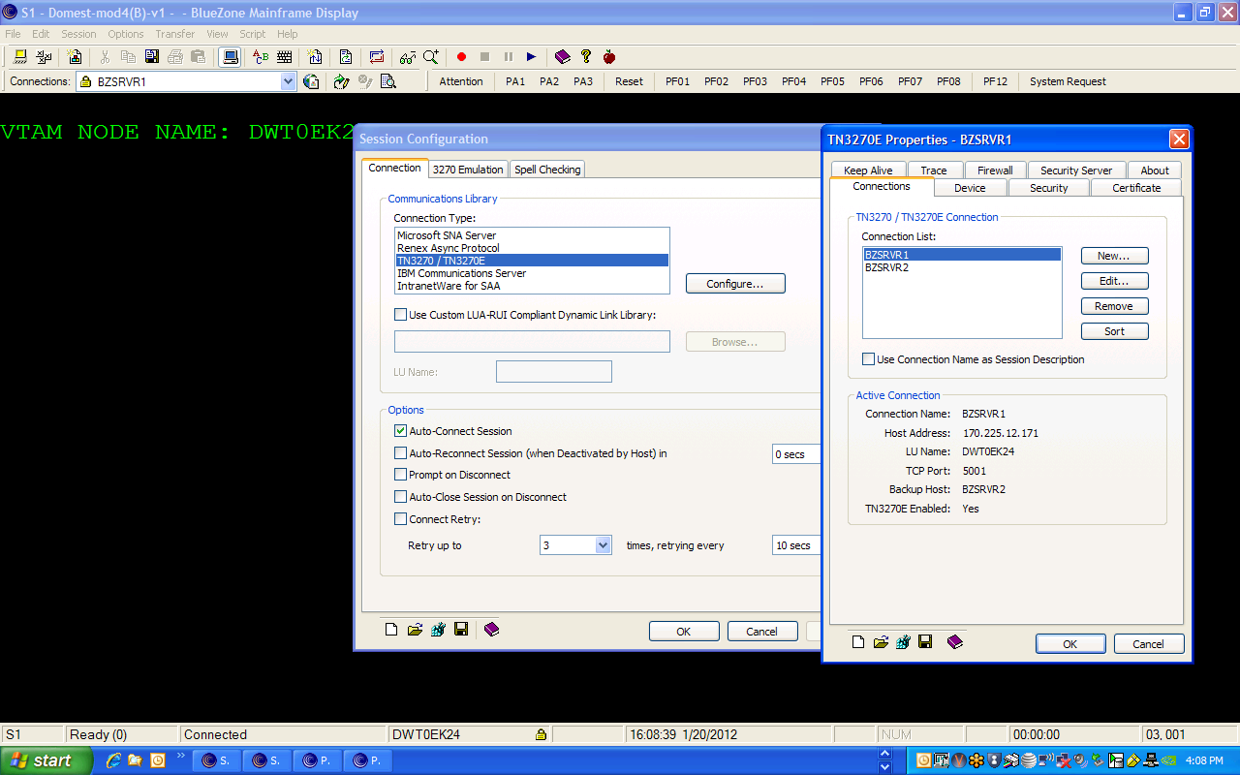

Troubleshooting Common Problem

- - We’ve had reports of users’ first display session coming up okay but the second fails with an error ‘lu name not known to server’ or ‘lu name already in use’. There is an easy fix for this.

- Click on the Session tab in the failing Bluezone session toolbar.
- Click on Configure.
- Click on Configure in the Popup box that opens. Check the Lu Name field. Shown below is the case in which the lu name appears as %s8%. This means the valid name did not get downloaded properly.
- Click the edit tab.
- In the next popup window, enter the vtam name for this session in the lu name field.
- Click ok on the edit connection box.
- Click ok on the properties box.
- Click ok on the session configuration box.
- Click on the File tab on the tool bar.
- Click Save.
- Click on the Session tab.
- Click connect. The session should open correctly now (and in future).

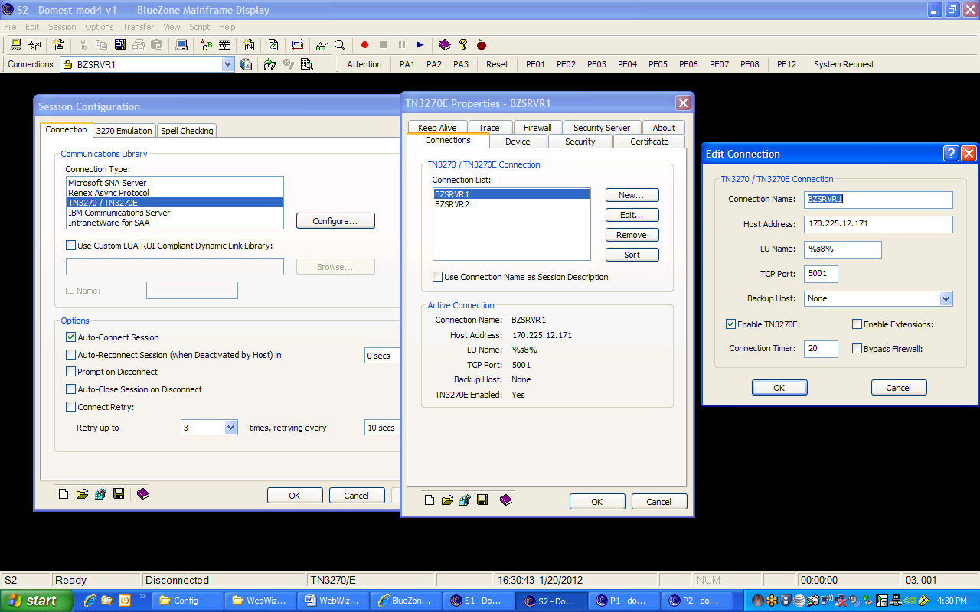

Returning to the Current WebWiz Environment if Necessary

17 – Run eZClear from the new environment. Click on the words “Get or run eZClear” on the launch screen. You’ll see a popup box as shown below.

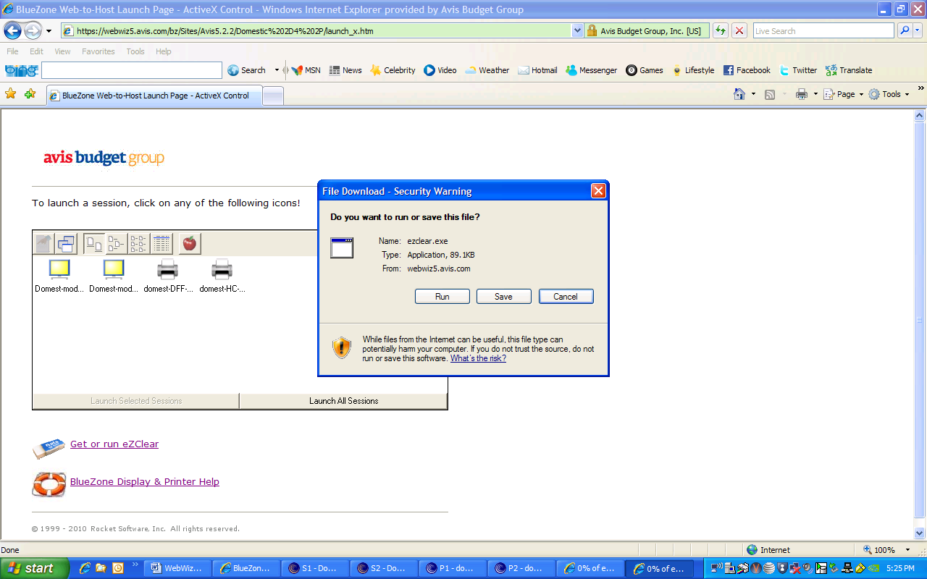

IMPORTANT!
18 - Close your browser – eZClear in the new environment requires it. The popup box will remain on-screen or will be minimized; if the latter case, restore it to full size and click on the Run button. You’ll see another popup box as shown below.

Note: As mentioned on page one above, if you check the ‘Delete all user files’ option you’ll delete the .zmd, .zmp files, but you’ll also delete any scripts you may have stored. You do want to delete the .zmd and .zmp files, but you can always delete them manually (or rename them) in their stored directory in order to get the correct ones from the current environment. However, if you have no stored scripts to worry about, you can delete them by checking the ‘Delete user files’ option.

When you’ve checked the appropriate boxes, click on ‘Yes’ to run eZClear.

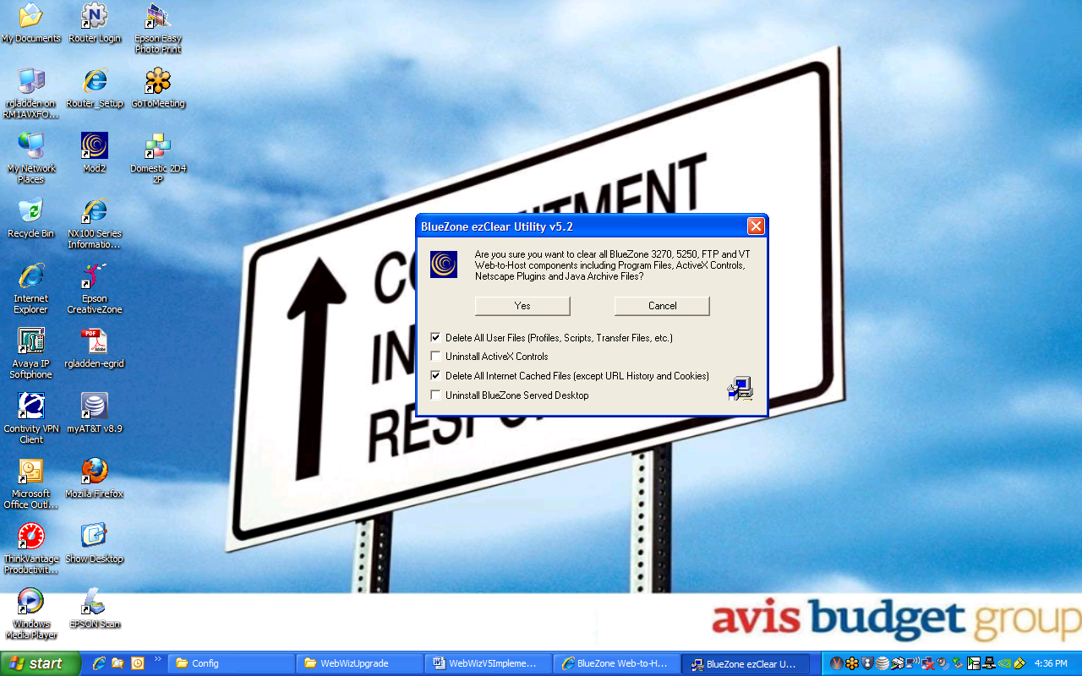

19 – You’ll get a popup box asking if you’re sure. Click on the Yes button.

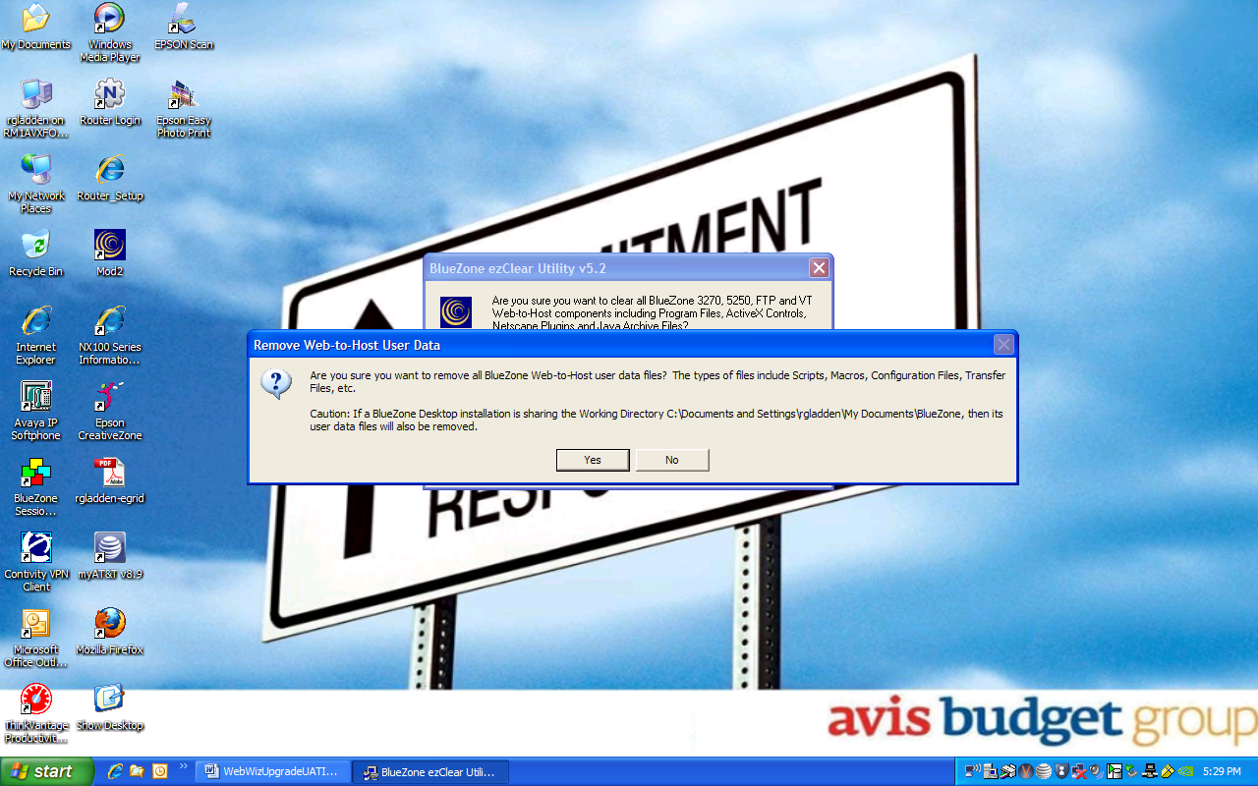

20 - Then return to the current environment by opening a new browser using the current URL. New software will automatically be downloaded; answer ‘yes’ or ‘run’ when asked to permit the download. You may need to modify and save your printer configurations again.

\

