
BUDGET WIZARD System Access
via BLUE ZONE Internet portal
Inventory Closeout procedures

Please find herein the information required for you to affect inventory availability changes to the Wizard System (Close outs)).

Getting into Wizard via your PC.

You Wizard session is accessed through a internet based program called BLUEZONE

Click on the following link to access the BlueZone Web site

https://webwiz.drivebudget.com

Once connected you will get the Wizard (Cendant) Blue Zone sign on screen.

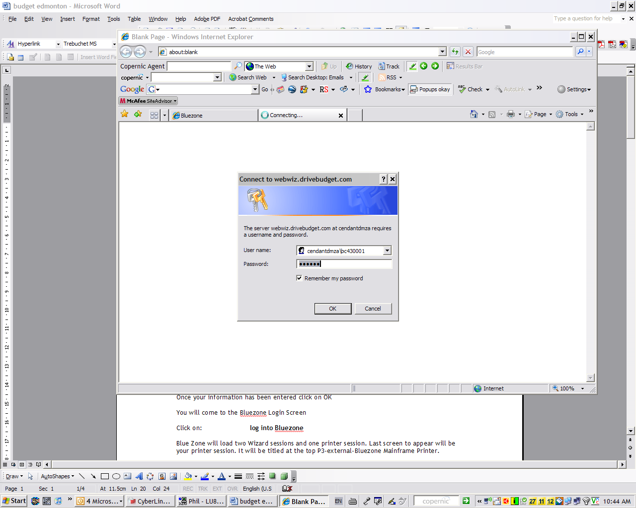

At User Name type in: Your Blue Zone user name
Password: Your Blue Zone Password

Every entry is in lower case. If you type an incorrect entry 3 times your account will be locked out and you must call the Helpdesk (1-800-822-2847) identify yourself and request that the Bluezone account be unlocked.

Once your information has been entered click on OK

You will come to the Bluezone Login Screen

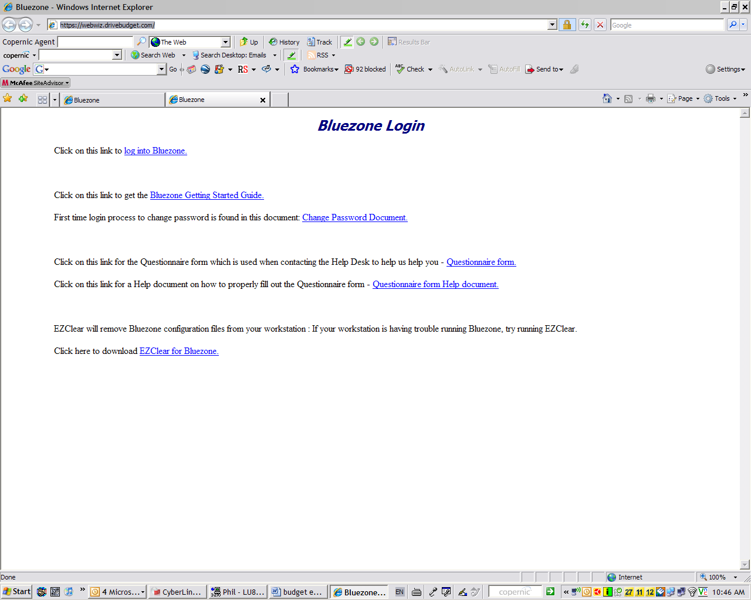

Click on: log into Bluezone

Blue Zone will load two Wizard sessions and one printer session. Last screen to appear will be your printer session. It will be titled at the top P3-external-Bluezone Mainframe Printer.

On the bottom bar you should see (from left to right) P3 - connected – Vtam – online.

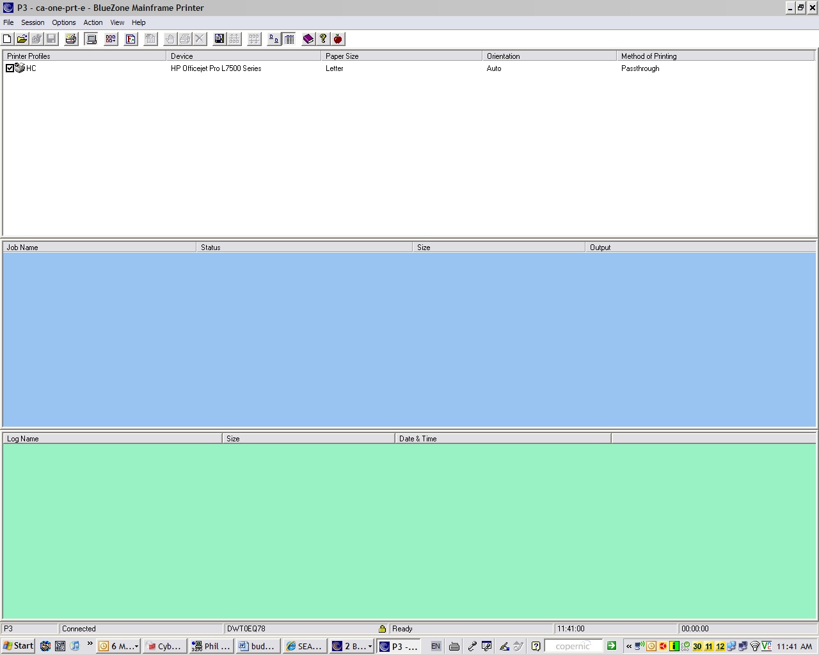

To access Wizard either click on S1 (session 1) or S2 (session2).

Type in bims – press enter (either right control or numeric keypad enter)

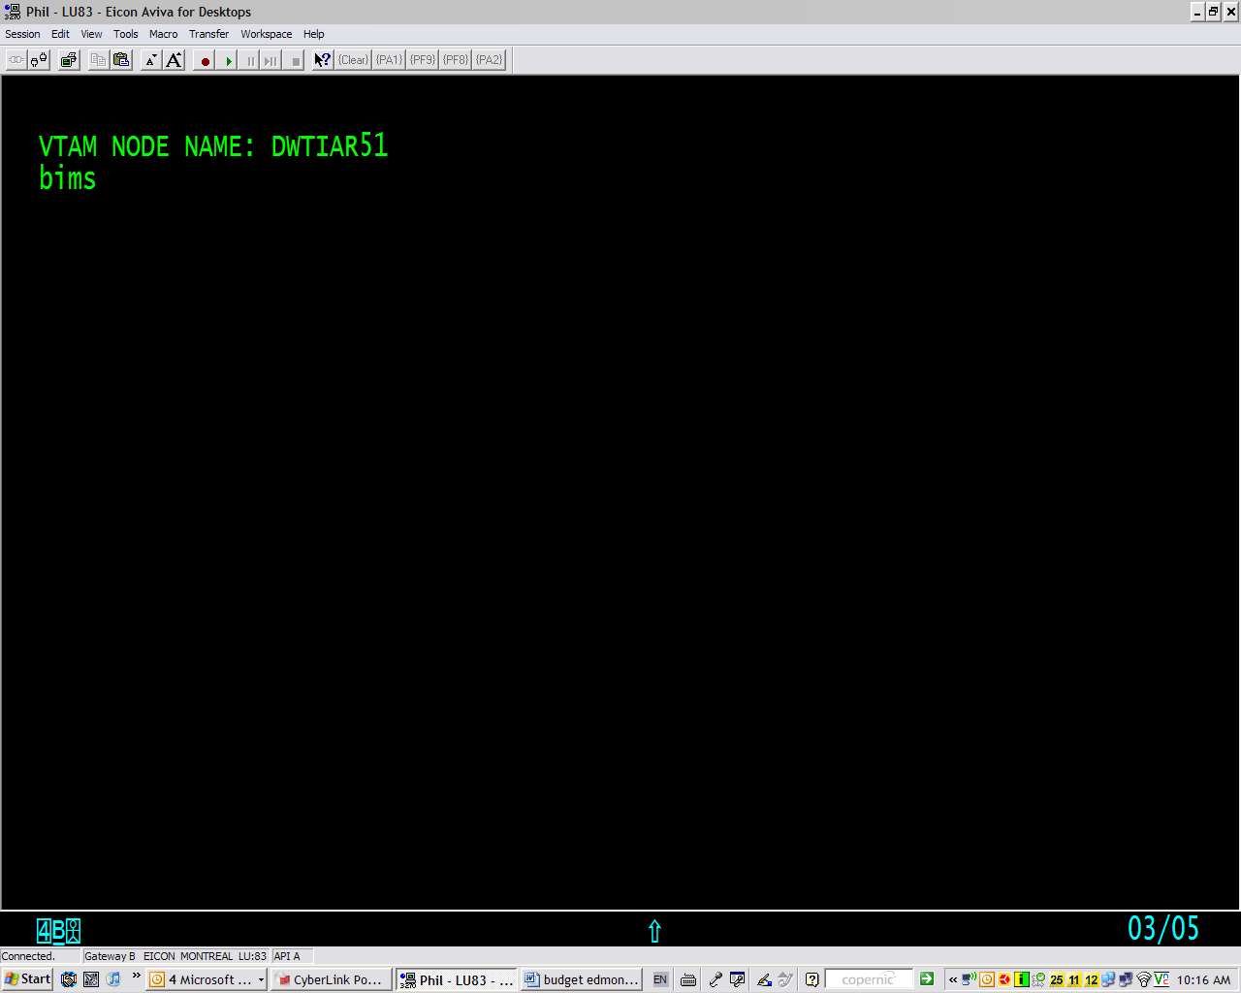

The following screen will appear

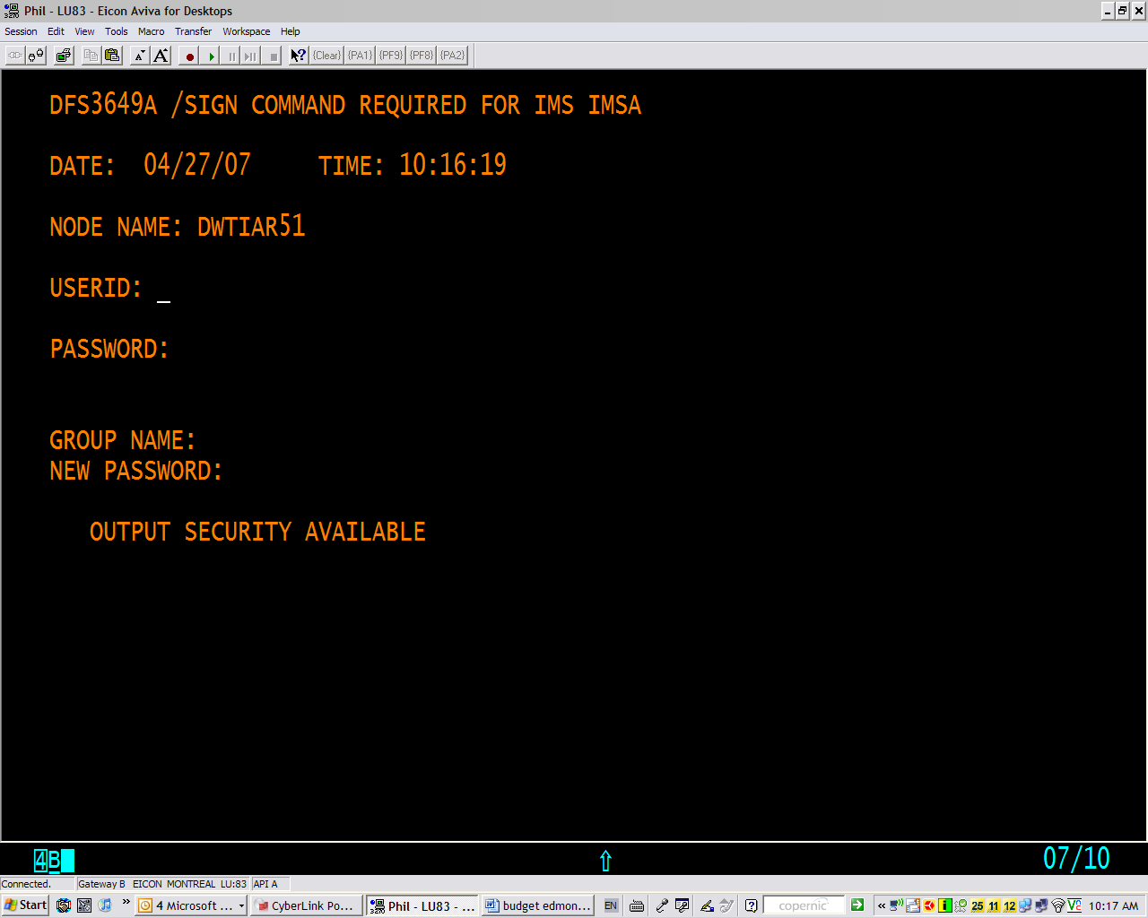

Your Wizard USERID 06yvr15a
Your Wizard Password is lic378

At the following screen, type in /for b601. (a “dot” must be typed at the end of B601

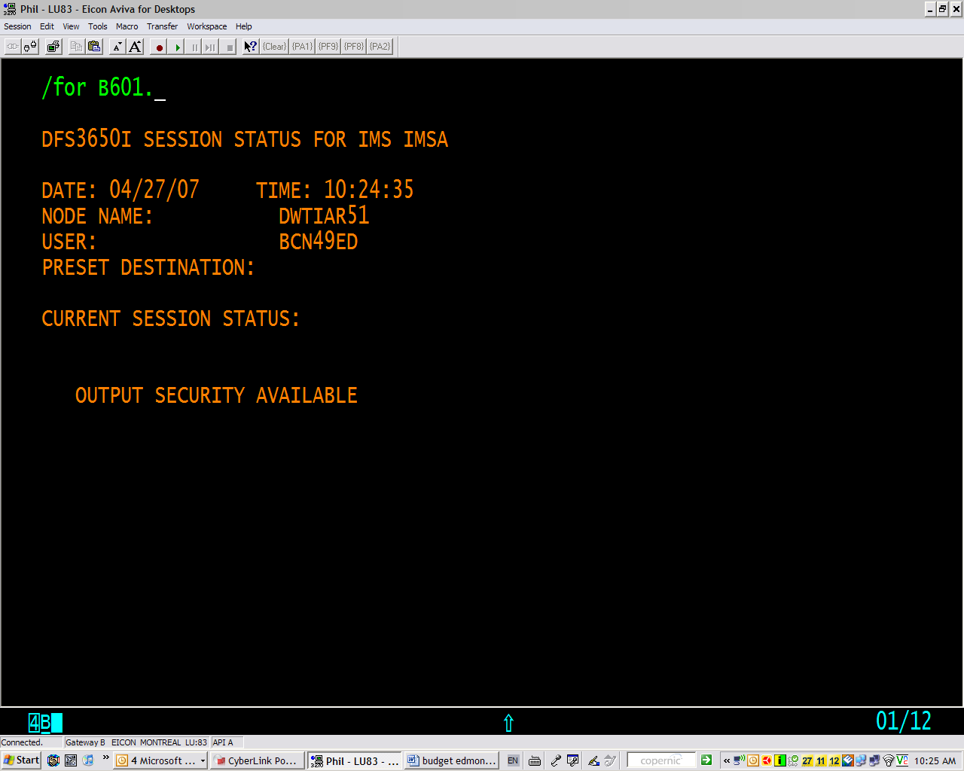

The following screen will then appear, please enter NA under action and then your fleet owner number under station. This will allow you to access affect changes to all the locations under that fleet owner number. If your locations are under more than one fleet owner number, the above procedure will need to be repeated with the respective fleet owner number to access your other locations

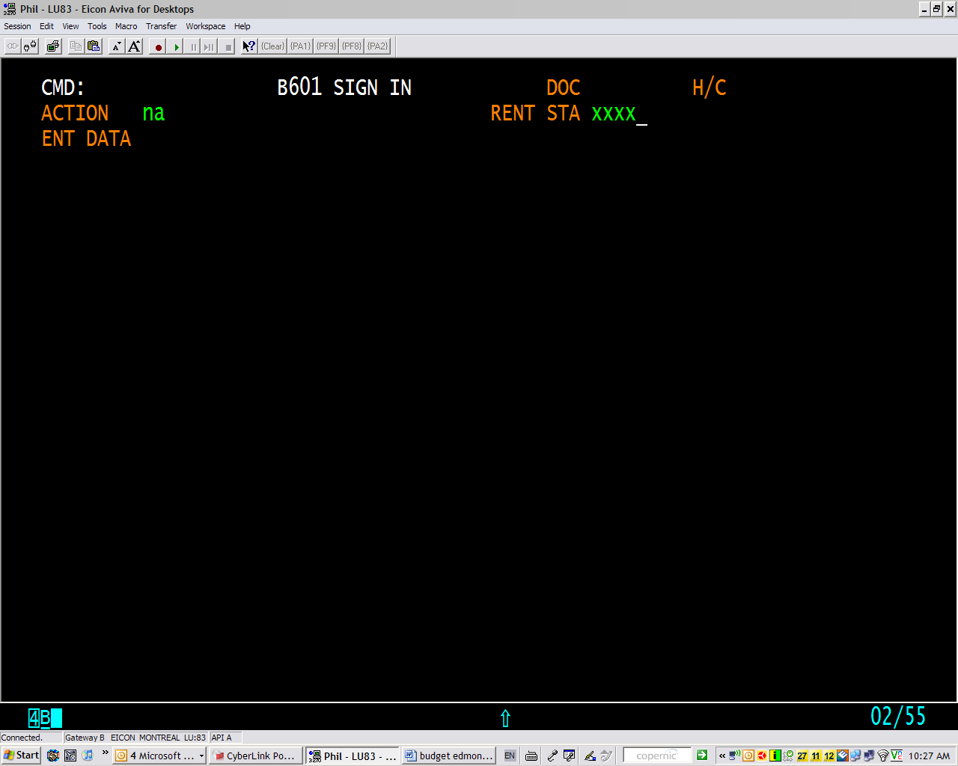

You may access the Budget Standard availability screen by entering /for STDBAVL (in the CMD prompt)

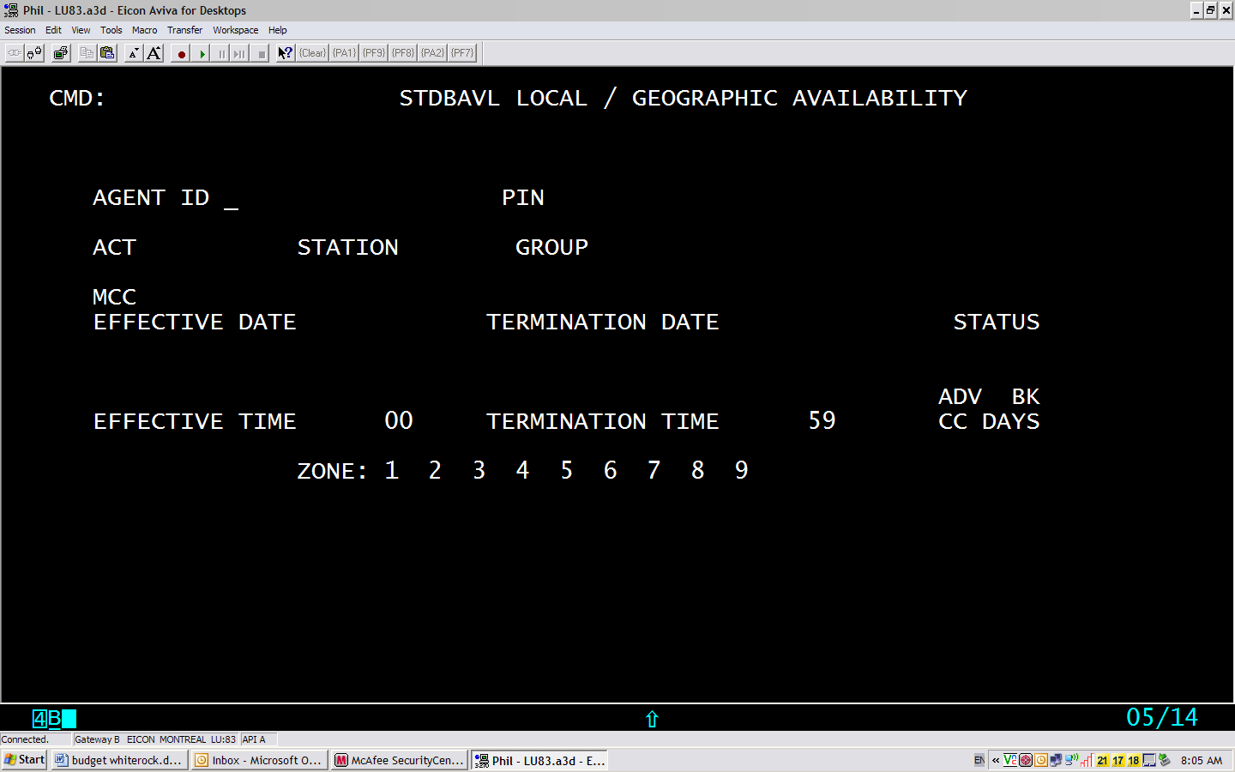

PROMPT | Entry  (Use the “TAB” key to move from one field to another)
Agent ID | Not Required
PIN | Not Required
ACT | STD
Station | Individual Station number (if only one location needs to be modified)  If more than one location is to be affected, you must repeat the process for each location by changing the location code and pressing “enter” if all of the parameters are the same  Fleet Owner Number (If all locations under the fleet owner need to be modified)
Group | Car group or groups to be affected  Ex:  If A and B car groups are to be affected, A B are to be typed in. You may enter up to 16 individual car groups into this filed  If the close out affects ALL car groups you only need to enter “Y” in the group field
MCC | Only used if “Cool Cars’ are part of your inventory
Effective Date * | Enter Start date ex: 01MAR08
Term Date * | Enter End date ex: 03MAR08
Effective Time* | Enter Time (24 hour clock format)
Termination Time* | Enter Time (24 hour clock format)
ADV BK CC DAYS | Not Used in North America
Status | S = Sold out  A= Available  R= Request  N= Not in Fleet
ZONE | Used to status one way rentals  One way rentals must be processed as a separate transaction  If closing out one-ways do not indicate anything at the STATUS prompt.  Indicate one of the following under each zone number  S= Sold out – A= Available – R= Request – N= Not in Fleet
Press “enter” to complete your transaction | The following prompt will appear:  “Transaction Accepted and Completed”

If a closeout involves partial days (Ex from August 1st at 12:00 till August 5Th at 16:00)
You must process the closeout as 3 separate transactions:

Effective date | Effective time | Term. Date | Term. time
01AUG08 | 12:00 | 01AUG08 | 23:59
02AUG08 | 00:00 | 04AUG08 | 23:59
05AUG08 | 00:00 | 05AUG08 | 16:00

If you do no proceed in this manner and indicate from 01AUG08 12:00 Till 05AUG08 16:00 instead, the system will interpret your request as a sellout from 12:00 till 16:00 for each of the days indicated therefore allowing reservations to be taken before noon and after 16:00 on each day.

Very Important

When finished for the day or for any reason to close down Wizard.

Always, Always Always type in /rcl (in the CMD prompt) to close out your Wizard sessions.

It is only when both sessions are back to Vtam Node Name is it safe to shut down your Wizard connection.

When you have done this simply go to file and click on exit for both Wizard sessions and your printer session.

You will come to the Cendant screen which identifies your location. Simply click on the X in the top right hand corner and close your browser.

Repeat to connect to Wizard.

* If the Help Desk requires your PIN # for this Bluezone ID it is 7328

