

Department of Computer Science & Engineering

Course Title :Artificial Intelligence and Expert Systems Lab

Course Code :CSE 404

Lab Report :01

Submission Date :21.02.25

Submitted To: Submitted By:

Noor Mairukh Khan Arnob Susmita Roy

Lecturer, Reg: 21201199

Department of CSE, UAP Sec: B2

Problem Title:

Developing a Knowledge Base for Industry, Company, Role, and Supervision

Relationships Using Prolog.

Problem Description:

Organizations are structured hierarchically, where employees work in different

industries, companies, and roles while maintaining supervision relationships. The

goal of this project is to represent this hierarchical information in Prolog and

develop rules to facilitate queries such as:

· Determining the industry a person works in.

· Identifying people with the same role or company.

· Finding supervisors and their subordinates (both direct and indirect).

· Retrieving all employees in a specific role.

This Prolog-based system will allow efficient querying and reasoning over the

structured knowledge base, incorporating recursion where necessary.

Tools and Languages Used:

· Programming Language:Prolog (SWI-Prolog)

· Tools:SWI-Prolog environment for execution and debugging

· Operating System:Windows

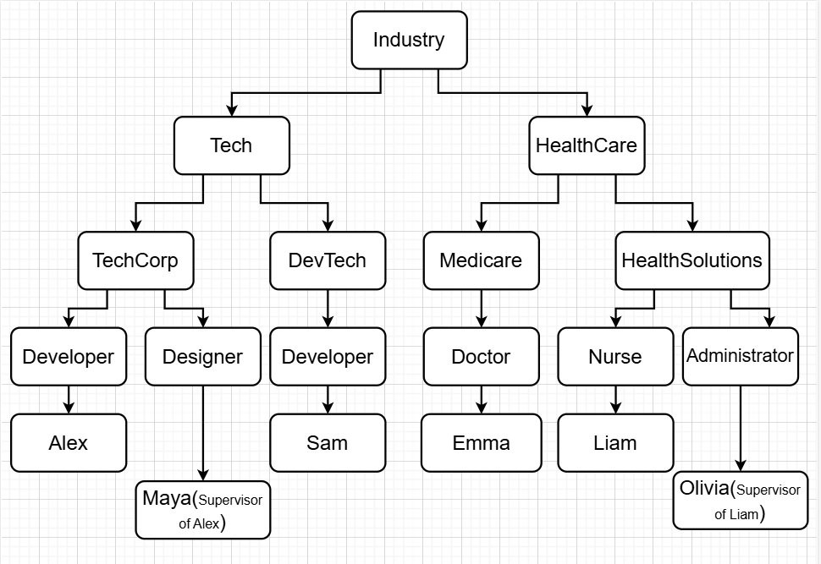

Diagram:

Profession Classification Tree

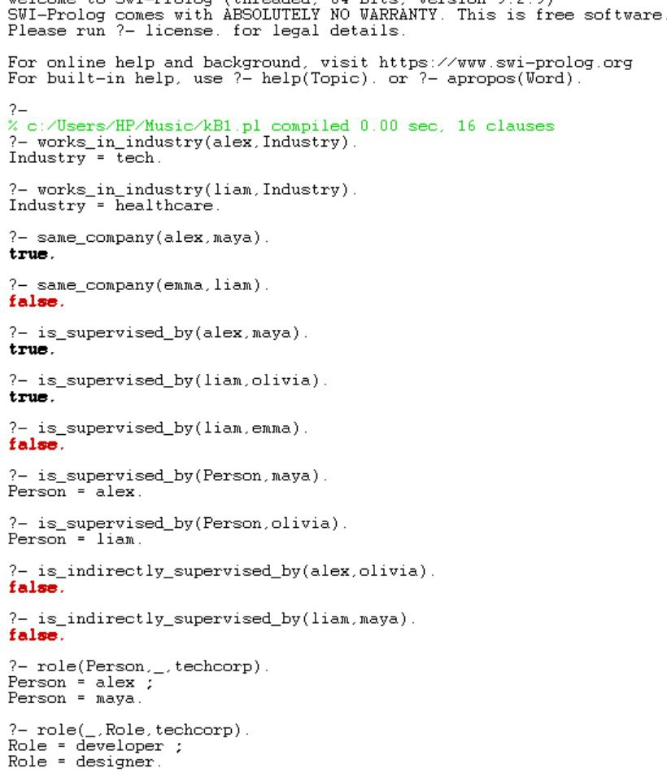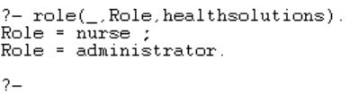

Sample Input/Output:

Conclusion:

This Prolog-based system effectively models industry, company, role, and

supervision relationships, enabling powerful queries to extract insights about

employees and their hierarchical structure. The use of recursion allows for

indirect relationships to be captured, improving the system's reasoning

capabilities.

Challenges Faced:

1. Handling Cyclic Dependencies:Ensuring the supervisor-subordinate

structure does not result in infinite loops.

2. Scalability Issues:When applied to larger data-sets, query efficiency may

be impacted.

3. Debugging Recursive Rules:Ensuring recursion properly terminates while

maintaining correct relationships.