Take-Home_Ex01 part 1

Teo Wee Siang Roy

2025-05-01

## Editorial Brief – Visualising Singapore’s Resident Population (2024)

As the graphical editor of a media company, I have been tasked to design up to **three impactful data visualisations** to support an article on Singapore’s resident population as of **June 2024**.

The aim is to help readers quickly understand demographic trends using clear and accessible visuals based on official statistics.

### Data Source

[Department of Statistics Singapore (DOS)](https://www.singstat.gov.sg/find-data/search-by-theme/population/geographic-distribution/latest-data): Planning Area and Subzone, Single Year of Age (0–100+), Sex (Male, Female, Total), Resident Population counts (as of June 2024)

### Visualisation Objectives

* **Relevance**: Support editorial narratives (e.g. ageing population, regional differences)
* **Clarity**: Easy for general readers to understand
* **Compactness**: Limited to a maximum of three charts

## Data Preparation Summary

* Cleaned and filtered for relevant fields (Age, Sex, Planning Area)
* Converted columns to numeric where needed (e.g. Age, Population)
* Aggregated by region and demographic groups for visual storytelling

### Data Cleaning Summary

To prepare the dataset for visualisation, the following data cleaning steps were applied:

* **Skipped Metadata Rows**  
  The original Excel file contained header and metadata rows. We used skiprows = 2 to access only the actual data records.
* **Dropped Incomplete Rows**  
  Removed rows where any key fields were missing:
  + Subzone
  + Age
  + Sex
  + Population (2024)  
    This ensures only valid, complete records are included in the analysis.
* **Renamed Columns for Clarity**  
  Replaced generic or auto-generated column names (e.g., Unnamed: x, 2024) with:
  + Planning Area, Subzone, Age, Sex, Population
* **Converted to Numeric Types**  
  Converted the Age and Population columns to numeric using coercion.  
  Non-numeric values were turned into NA and filtered out.
* **Removed Rows with Missing Age or Population**  
  Any rows with missing (NA) values in Age or Population were dropped after conversion.

## Data Parameters and Description

| **Field Name** | **Field Description** |
| --- | --- |
| Planning Area | Administrative regions in Singapore (e.g. Bedok, Ang Mo Kio, Tampines, etc.) |
| Subzone | Subdivisions within each Planning Area |
| Age | Age of residents in single years (0 to 100+) |
| Sex | Gender category: Male, Female, or Total |
| Population | Number of residents for the given demographic group in June 2024 |

## Load packages

We begin by loading all required R packages using the pacman::p_load() function. These packages support data wrangling, visualisation, animation, and layout composition for this take-home exercise.

* **tidyverse**: Core set of packages for data manipulation, transformation, and visualisation using ggplot2.
* **readxl**: To import Excel files (.xlsx), such as the population dataset used in this exercise.
* **haven**: Enables importing datasets from software like SPSS, SAS, and Stata.
* **ggrepel**: Prevents overlapping text labels in ggplot2 plots, improving readability.
* **ggthemes**: Provides additional ggplot2 themes for publication-quality charts.
* **patchwork**: Combines multiple ggplot2 plots into a single composite layout.
* **ggridges**: Creates ridgeline plots to visualise distributions across categories.
* **ggdist**: Supports visualisations of distributions and uncertainty (e.g. dot + interval plots).
* **scales**: Useful for formatting axis labels (e.g. commas, percentages, date breaks).
* **plotly**: Adds interactivity to static plots made with ggplot2, enabling zoom, hover, etc.
* **gganimate**: Enables animation of ggplot2 plots across time or other variables.
* **gifski**: Required by gganimate to render animations into GIF format.
* **gapminder**: A sample dataset often used for animated population plots and trend visualisation.

pacman::p_load(tidyverse, readxl, haven, ggrepel,   
ggthemes, patchwork, ggridges, ggdist, scales, plotly,   
gganimate, gifski, gapminder)

## Import Data

pop_data <- read_csv("TH01/data/cleaned_population_2024.csv")

# EDA 1: Population Pyramid (Age-Sex Distribution)

pyramid_data <- pop_data %>%  
 filter(Sex %in% c("Males", "Females")) %>%  
 mutate(Population = ifelse(Sex == "Males", -Population, Population))  
  
ggplot(pyramid_data, aes(x = Age, y = Population, fill = Sex)) +  
 geom_bar(stat = "identity", width = 0.9) +  
 coord_flip() + scale_x_continuous(limits = c(0, 100)) +  
 scale_y_continuous(labels = function(x) comma(abs(x))) +  
 scale_fill_manual(  
 values = c("Males" = "#00bfc4", "Females" = "#f8766d"),  
 breaks = c("Males", "Females"),   
 labels = c("Males", "Females")  
 ) +  
 labs(  
 title = "Population Pyramid of Singapore (2024)",  
 subtitle = "Male population is shown on the left, female on the right",  
 x = "Age",  
 y = "Population (count)",  
 fill = "Gender Distribution"  
 ) +  
 theme_minimal(base_family = "Helvetica") +  
 theme(  
 plot.title = element_text(size = 16, face = "bold", hjust = 0.5),  
 plot.subtitle = element_text(size = 12, hjust = 0.5,color = "grey40"),  
 axis.text = element_text(size = 10),  
 axis.title = element_text(size = 11),  
 legend.position = "top",  
 legend.title = element_text(size = 10, face = "bold"),  
 legend.text = element_text(size = 9),  
 plot.margin = margin(10, 10, 10, 10)  
 )

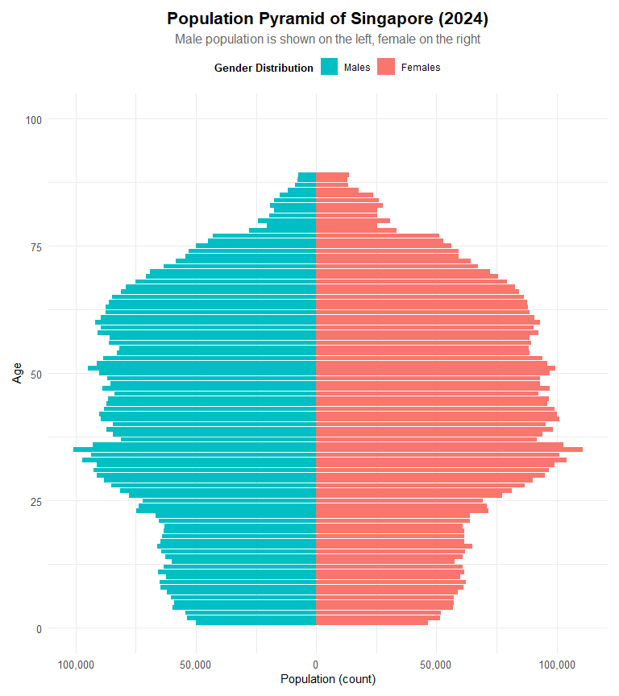

pyramid_data <- pop_data %>%  
 filter(Sex %in% c("Males", "Females")) %>%  
 mutate(  
 Population = ifelse(Sex == "Males", -Population, Population),  
 Age_Group = case_when(  
 Age >= 0 & Age <= 12 ~ "Children (0–12)",  
 Age >= 13 & Age <= 19 ~ "Teenagers (13–19)",  
 Age >= 20 & Age <= 39 ~ "Young Adults (20–39)",  
 Age >= 40 & Age <= 64 ~ "Middle-aged Adults (40–64)",  
 Age >= 65 ~ "Elderly (65+)"  
 ),  
 Age_Group = factor(  
 Age_Group,  
 levels = c(  
 "Children (0–12)",  
 "Teenagers (13–19)",  
 "Young Adults (20–39)",  
 "Middle-aged Adults (40–64)",  
 "Elderly (65+)"  
 )  
 )  
)  
  
ggplot(pyramid_data, aes(x = Age_Group, y = Population, fill = Sex)) +  
 geom_bar(stat = "identity", position = "stack", width = 0.8) +  
 coord_flip() +  
 scale_y_continuous(labels = function(x) comma(abs(x))) +  
 scale_fill_manual(  
 values = c("Males" = "#00bfc4", "Females" = "#f8766d"),  
 breaks = c("Males", "Females"),  
 labels = c("Males", "Females")  
 ) +  
 labs(  
 title = "Segmented Population Pyramid of Singapore (2024)",  
 subtitle = "Grouped by key life stages. Male population on the left, female on the right.",  
 x = "Age Group",  
 y = "Population (count)",  
 fill = "Gender Distribution"  
 ) +  
 theme_minimal(base_family = "Helvetica") +  
 theme(  
 plot.title = element_text(size = 16, face = "bold", hjust = 0.5),  
 plot.subtitle = element_text(size = 12, hjust = 0.5,color = "grey40"),  
 axis.text = element_text(size = 10),  
 axis.title = element_text(size = 11),  
 legend.position = "top",  
 legend.title = element_text(size = 10, face = "bold"),  
 legend.text = element_text(size = 9),  
 plot.margin = margin(10, 10, 10, 10)  
 )

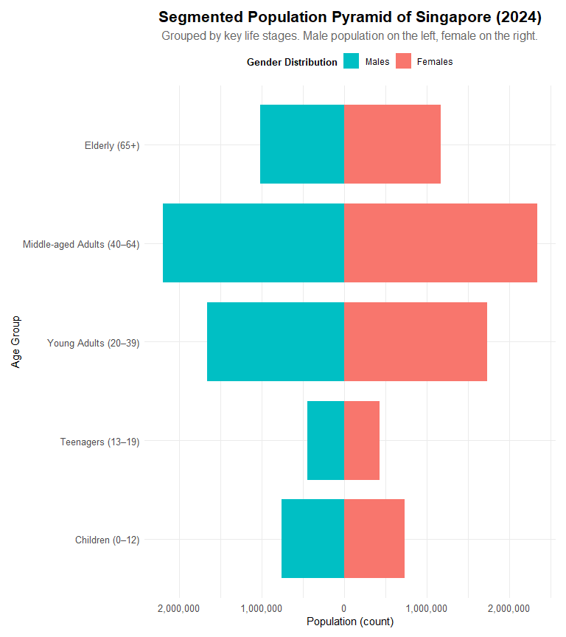

## EDA 1 Insights

The following insights were derived from two visualizations:  
1. A population pyramid by **individual age**  
2. A segmented pyramid grouped by **age stages**

**Balanced Gender Counts in Ages 0–19**  
- Both the individual and grouped charts show that male and female populations are nearly equal from age 0 to 19  
- This includes the “Children (0–12)” and “Teenagers (13–19)” segments  
- The bars are symmetrical for both sexes, indicating no gender disparity in the younger cohorts

**Largest Population in Middle-aged Adults (40–64)**  
- The “Middle-aged Adults (40–64)” age group is the most populous, with the widest stacked bar  
- This observation holds true in both visualizations

**Greater Female Presence in Elderly (65+)**  
- In the individual age plot, females outnumber males starting around age 70  
- The difference becomes increasingly prominent in the 80 to 100+ range  
- This is reinforced in the grouped pyramid where the “Elderly (65+)” bar is longer for females

**Smaller Cohorts in Youth (Ages 0–19)**  
- The “Children (0–12)” and “Teenagers (13–19)” groups have the shortest bars  
- This reflects a shrinking young population, as seen in the narrow base of the age-specific pyramid

# EDA 2: Top 10 Planning Areas by Total Population and Elderly Population (Age 65+)

top_total <- pop_data %>%  
 filter(Sex == "Total") %>%  
 group_by(`Planning Area`) %>%  
 summarise(TotalPopulation = sum(Population, na.rm = TRUE)) %>%  
 arrange(desc(TotalPopulation)) %>%  
 slice_max(TotalPopulation, n = 10)  
  
plot_total <- ggplot(top_total, aes(x = reorder(`Planning Area`, TotalPopulation), y = TotalPopulation)) +  
 geom_col(fill = "#2b8cbe") +  
 geom_text(aes(label = scales::comma(TotalPopulation)), hjust = -0.1, size = 3) +  
 coord_flip() +  
 scale_y_continuous(labels = label_comma(), expand = expansion(mult = c(0, 0.1))) +  
 labs(title = "Top 10 Planning Areas by Total Population") +  
 theme_minimal(base_family = "Helvetica") +  
 theme(  
 plot.title = element_text(face = "bold", size = 14),  
 axis.title = element_blank(),  
 panel.grid.major.y = element_blank()  
 )  
  
# Top 10 by Elderly (Age 65+)  
top_elderly <- pop_data %>%  
 filter(Sex == "Total", Age >= 65) %>%  
 group_by(`Planning Area`) %>%  
 summarise(ElderlyPopulation = sum(Population, na.rm = TRUE)) %>%  
 arrange(desc(ElderlyPopulation)) %>%  
 slice_max(ElderlyPopulation, n = 10)  
  
plot_elderly <- ggplot(top_elderly, aes(x = reorder(`Planning Area`, ElderlyPopulation), y = ElderlyPopulation)) +  
 geom_col(fill = "#e34a33") +  
 geom_text(aes(label = scales::comma(ElderlyPopulation)), hjust = -0.1, size = 3) +  
 coord_flip() +  
 scale_y_continuous(labels = label_comma(), expand = expansion(mult = c(0, 0.1))) +  
 labs(title = "Top 10 Planning Areas by Elderly Population (65+)") +  
 theme_minimal(base_family = "Helvetica") +  
 theme(  
 plot.title = element_text(face = "bold", size = 14),  
 axis.title = element_blank(),  
 panel.grid.major.y = element_blank()  
 )  
  
plot_total / plot_elderly +   
 plot_annotation(title = "Comparison of Population Distribution by Planning Area (2024)",  
 theme = theme(plot.title = element_text(size = 16, face = "bold", hjust = 0.5)))

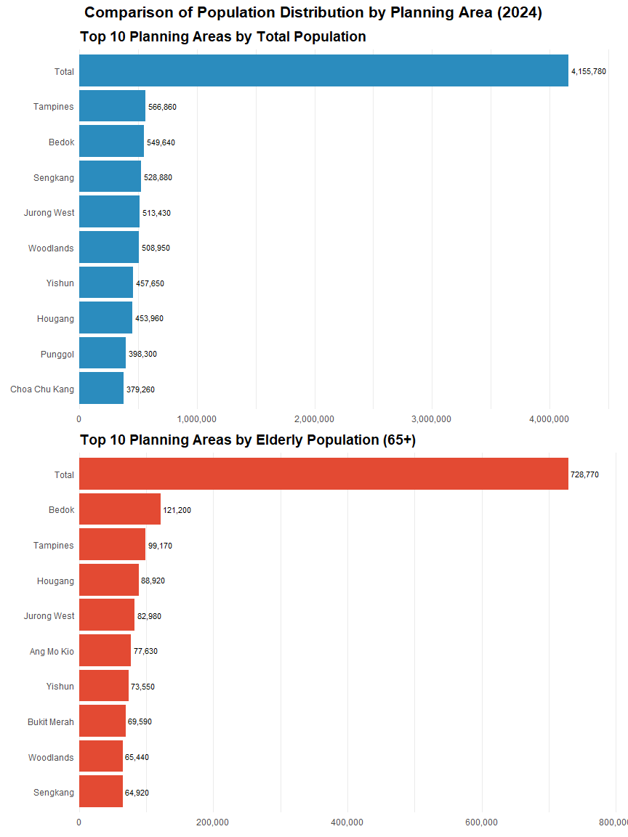

## EDA 2 Insights

* **Bedok, Tampines, and Jurong West Appear in Both Rankings**  
  These three planning areas rank in the **top 10 for both total population and elderly population (65+)**, indicating they are high-density towns with large absolute numbers of seniors.
* **Central Area Ranks High in Total Population but Not in Elderly Count**  
  While the Central Area appears in the total population chart, it is **absent from the elderly chart**, suggesting a **lower proportion of elderly residents** — possibly due to its mixed commercial-residential nature.
* **Ang Mo Kio and Bukit Merah Appear Only in the Elderly Ranking**  
  These areas do **not rank among the top 10 in total population** but have **high elderly counts**, implying a relatively **older resident base** compared to newer towns.
* **Woodlands and Sengkang Rank High in Total but Not Elderly Population**  
  These towns appear in the **total population top 10** but are **absent in the elderly top 10**, indicating a **younger demographic composition**.
* **Elderly Population Distribution is More Uniform**  
  Compared to the total population, the **elderly population values are closer in range**, suggesting a **more even spread of seniors** across the top-ranked areas.

# EDA 3 : Age Group Composition by Planning Area

age_levels <- c("Elderly (65+)", "Middle-aged Adults (40–64)",  
 "Young Adults (20–39)", "Teenagers (13–19)",  
 "Children (0–12)")  
  
age_colors <- c(  
 "Elderly (65+)" = "#a6d854",  
 "Middle-aged Adults (40–64)" = "#e78ac3",  
 "Young Adults (20–39)" = "#8da0cb",  
 "Teenagers (13–19)" = "#fc8d62",  
 "Children (0–12)" = "#66c2a5"  
)  
  
pop_grouped <- pop_data %>%  
 filter(Sex == "Total") %>%  
 mutate(  
 Age_Group = case_when(  
 Age >= 0 & Age <= 12 ~ "Children (0–12)",  
 Age >= 13 & Age <= 19 ~ "Teenagers (13–19)",  
 Age >= 20 & Age <= 39 ~ "Young Adults (20–39)",  
 Age >= 40 & Age <= 64 ~ "Middle-aged Adults (40–64)",  
 Age >= 65 ~ "Elderly (65+)"  
 )  
 ) %>%  
 filter(!is.na(Age_Group)) %>%   
 group_by(`Planning Area`, Age_Group) %>%  
 summarise(Population = sum(Population), .groups = "drop")  
  
  
pop_percent <- pop_grouped %>%  
 mutate(`Planning Area` = trimws(`Planning Area`)) %>%  
 filter(  
 !is.na(`Planning Area`),  
 `Planning Area` != "",  
 `Planning Area` != "NA",   
 `Planning Area` != "Total"  
 ) %>%  
 group_by(`Planning Area`) %>%  
 mutate(  
 Total = sum(Population),  
 Share = Population / Total  
 ) %>%  
 ungroup()  
  
  
if("NA" %in% pop_percent$`Planning Area`) {  
 print("Warning: 'NA' string still found in Planning Area")  
}  
  
  
ordering <- pop_percent %>%  
 filter(Age_Group == "Elderly (65+)") %>%  
 arrange(desc(Share)) %>%  
 pull(`Planning Area`)  
  
ordering <- ordering[!is.na(ordering) & ordering != "NA"]  
  
pop_percent$`Planning Area` <- factor(pop_percent$`Planning Area`, levels = ordering)  
pop_percent$Age_Group <- factor(pop_percent$Age_Group, levels = rev(age_levels))  
  
pop_percent <- pop_percent %>%  
 filter(`Planning Area` != "NA" & !is.na(`Planning Area`))  
  
ggplot(pop_percent, aes(x = `Planning Area`, y = Share, fill = Age_Group)) +  
 geom_col(width = 0.8) +  
 geom_text(  
 aes(label = percent(Share, accuracy = 1)),  
 position = position_stack(vjust = 0.5),  
 size = 5,  
 color = "white"  
 ) +  
 scale_y_continuous(labels = percent_format(accuracy = 1)) +  
 scale_fill_manual(values = age_colors, breaks = age_levels) +  
 coord_flip() +  
 labs(  
 title = "Age Group Composition by Planning Area (2024)",  
 subtitle = "Bars and legend start from Elderly (65+)",  
 x = "Planning Area",  
 y = "Proportion of Total Population",  
 fill = "Age Group"  
 ) +  
 theme_minimal(base_family = "Helvetica") +  
 theme(  
 plot.title = element_text(face = "bold", size = 16, hjust = 0.5),  
 plot.subtitle = element_text(size = 12, hjust = 0.5, color = "grey40"),  
 legend.position = "bottom",  
 legend.title = element_text(size = 10, face = "bold"),  
 legend.text = element_text(size = 9),  
 axis.text = element_text(size = 9)  
 )

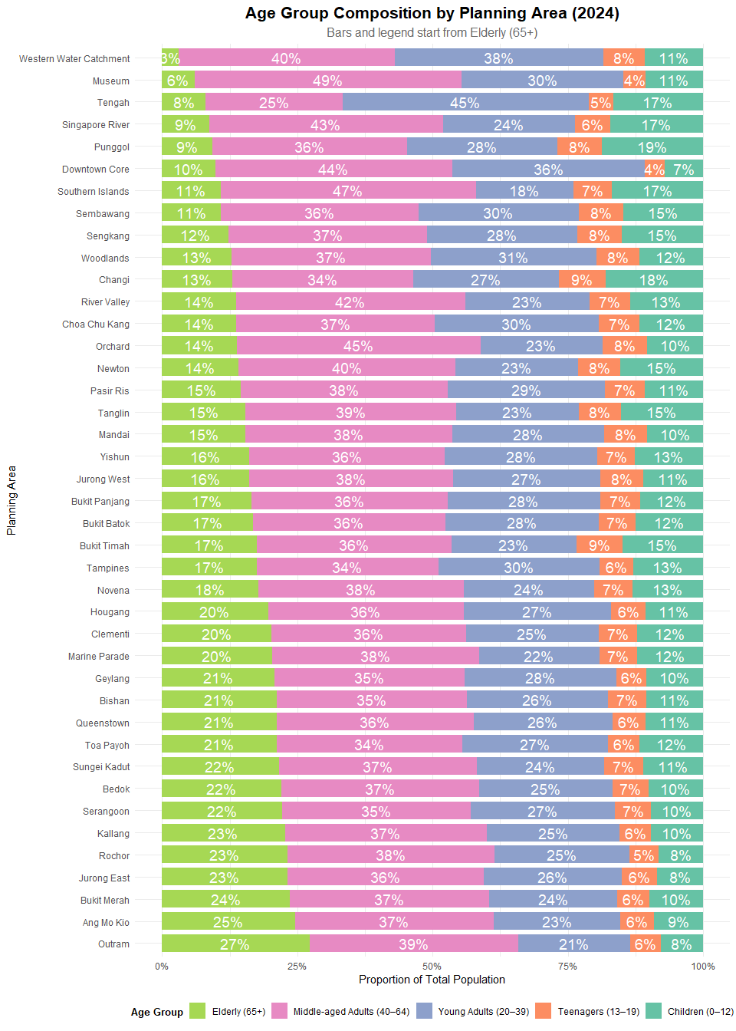

## EDA 3 Insights

* **Higher Elderly Proportions**  
  Planning areas such as **Outram**, **Bukit Merah**, and **Ang Mo Kio** have visibly higher proportions of residents aged **65 and above**.
* **Younger Population Profiles**  
  Areas like **Punggol**, **Sembawang**, and **Tengah** show larger proportions of **Children (0–12)** and **Young Adults (20–39)**, with smaller Elderly segments.
* **Middle-aged Adults Dominate Most Areas**  
  The **40–64** age group forms the largest proportion in most planning areas, indicating a dominant working-age population.
* **“Total” Row Reflects National Age Structure**  
  The bar labeled **“Total”** reflects the overall distribution of age groups across all planning areas and serves as a baseline for comparison.
* **Smaller Young Dependent Segments**  
  In most planning areas, **Children** and **Teenagers** together constitute less than **25%** of the population.
* **Balanced Age Distribution in Selected Areas**  
  Some areas such as **Jurong West** and **Woodlands** display relatively balanced proportions across all five age groups.