Analysis and Optimization of Routing Protocols in IEEE 802.15.4

Debarshi Kumar Sanyal, Sudeepta Ray and Uttam Kumar Roy
Information Technology, Jadavpur University,
Block-LB, Plot-8, Sector-III, Kolkata-700 098, India
u_roy@it.jusl.ac.in, sray_ju@yahoo.co.in

Abstract
IEEE 802.15.4 is a new global standard uniquely designed for low power-consumption, low cost, and Low data-Rate, Wireless Personal Area Networks (LR-WPANs). It specifies only PHYsical (PHY) and Medium Access Control (MAC) layers. ZigBee adds a flexible and secure network layer that supports a variety of architectures to provide highly reliable wireless communications in harsh or dynamic RF environments. In this paper we developed an NS2 simulator for ZigBee PAN to analyze and optimize both tree and mesh routing in a ZigBee network. We performed several experiments to study its various features, including: (i) the amount of routing packets generated, (ii) the packet-delivery ratio, (iii) the number of hops taken by application packets from source to destination. The packet-delivery ratio is found to be excellent although the number of hops taken is not always the minimum. We make several interesting optimizations in the implementation to control the huge burst of control packets produced for route discovery.
Index Terms—802.15.4, ZigBee, LR-WPAN, WPAN, routing, wireless networks, data rate topology.

- Introduction
In recent past there has been a steady rise in wireless networking. Standards like IEEE 802.11 (Wi-Fi) and Bluetooth have come into existence. IEEE 802.11 targets high data rate and relatively long range applications. Bluetooth is one of the first standards designed for low rate traffic. As a result more and more low-cost high-quality devices appear in the market, short-range low-rate wireless personal area networks are poised to take the world in a way observed never before. IEEE 802.15.4 [9] (henceforth referred to as 802.15.4) is a landmark in the attempt to bring ubiquitous networking into our lives. Designed uniquely for energy-conscious low data rate appliances, it specifies the physical layer and MAC sub-layer of the protocol stack. The ZigBee Alliance [19] is defining the specification for the network, security and application profile layers for an 802.15.4-based system.
It distinguishes itself from other wireless standards by various features, like low-data rate, low power-consumption, low-cost, self-organizing, and flexible topologies. It is likely to find immense application in home automation, industrial sensing and monitoring systems.
Performance evaluation of the routing protocol used in a ZigBee network is of paramount importance before actual products are launched. However, no simulations implementing the NWK layer or the routing protocol are currently available. We develop one of the first simulators for routing algorithms (Tree and Mesh routing). Despite its simplicity, the simulator allows us to explore the intricate aspects of the protocol considering star, tree and mesh topologies and conduct experiments to analyze its features such as the amount of routing packets generated, the packet-delivery ratio and the number of hops taken by application packets from source to destination. The packet-delivery ratio is found to be excellent although the number of hops taken is not always the minimum. We make several optimizations in the implementation to control the huge burst of control packets produced for route discovery.
A Roadmap: The rest of the paper is structured as follows. In section 3, we take a quick tour of 802.15.4/ZigBee. In section 4 comes the ns2 simulator for ZigBee networks. Section 5 is a description of the routing protocol. Here we point to a few loopholes and errors in the specification [19]. The experimental setup and the results are presented in section 6. It also explores novel optimizations to the protocol leaving behind an outline of future research directions. Finally, we conclude our paper in section 7.
- Related Work
Wireless networks have rapidly gained popularity since their introduction in 1970s. However, an investigation into low-rate low-power sensor networks is relatively new. In [5] authors explore the complex behavior of a large number of small low-power sensor nodes. Energy aware operation of wireless devices is the dominant theme in [10], [18].
Routing in wireless networks has been a fascinating topic of research for long. These routing protocols have to deal with the challenges of wireless networks, namely low-bandwidth, high error-rates and often energy-constraints. These algorithms are either table-driven (e.g. DSDV [2], WRP [14]) or source-initiated, that is demand-driven (e.g. DSR [4], AODV [1], [3]).
A comprehensive survey of these protocols has been done in [7]. Our investigations revealed that the routing protocol in ZigBee networks is essentially a combination of tree routing and AODV with several optimizations done in consideration of stationary wireless topologies.
Performance evaluation of routing protocols is a challenging issue and requires a well-planned, reliable and if possible standardized test bed. The VINT project is a landmark in the arena of network simulation research. The concept of split-level programming, its merits and applicability are discussed in [8].
There is relatively scant literature on 802.15.4/ZigBee although its applications have been discussed in [11], [6]. Authors provide one of the first studies of the MAC sublayer while the recent paper [11] is a comprehensive performance evaluation of 802.15.4. No detailed studies have yet been published on the network layer as it is under development by the ZigBee Alliance.
- A Quick Tour Of IEEE 802.15.4/ZigBee
  - 802.15.4/ZigBee Target Applications
With ZigBee devices on the horizon, ubiquitous networking no more looks elusive. In not too distant a future one may chance to have one’s home-appliances wedded together in a smart and cooperative network that allows them to talk to each other seamlessly. Sensors and actuators can communicate without barrier. They can be deployed pervasively in disaster-hit areas to monitor the situation and automatically take appropriate actions.
Some of its application areas [Fig 3.1] are:
- home automation
- industrial control and monitoring
- personal health-care
- public safety including sensing and location determination at disaster sites
- automotive sensing, such as tire pressure monitoring
- precision agriculture such as the sensing of soil moisture, pesticide, herbicide, and pH levels.
  - Highlights of 802.15.4 Standard
This standard is a specification of the PHYsical layer (PHY) and Medium Access Control (MAC) sub-layer for low data rate wireless connectivity among relatively simple devices that consume minimal power and typically operate in a Personal Operating Space (POS) of 10 meters or less. The network can be a one-hop star, or, when lines of communication exceed 10 meters, a self-configuring, multi-hop ad-hoc network.
Mouse
Keyboard
Joystick
Gamepad
Joystick

Security
HVAC
Lighting
Closures

Lighting

Joystick

PETs
Gameboys
Educational

Joystick

Monitors
Diagnostics
Sensors

Joystick

Monitors
Sensors
Automation
Control
Joystick

TV
VCR
DVD
CD
Remote
Joystick

Low Data Rate Radio devices
PC Peripherals
Industrial and Commercial
Consumer Electronics
Personal Healthcare
Toys and Games
Home Automation

    - Target markets of ZigBee devices

Application
Application Interface
Network/Security Layers
MAC Layer
PHY Layer
IEEE
defined
ZigBee Alliance defined
User defined

    - The 802.15.4/ZigBee protocol stack

Wireless links under 802.15.4 can operate in three license-free Industrial Scientific Medical (ISM) frequency bands. These accommodate over air data rates of 250 kbps in the 2.4 GHz band, 40 kbps in the 915 MHz band, and 20 kbps in the 868 MHz. For data transmission CSMA-CA is used.
A device in 802.15.4 network can use either a 64-bit IEEE address or a 16-bit short address, which supports over 64,000 nodes per network. 802.15.4 employs a fully handshaked protocol for data transfer reliability and embeds the Advanced Encryption Standard (AES) for secure data transfer.
  - The ZigBee Value Addition
The ZigBee Alliance defines the network (NWK), security, and application profile layers for the 802.15.4-based system. Two lightweight routing (Tree and Mesh routing) protocols have been defined as devices are expected to be simple and with very small memory capacity. Note that traditional ad hoc wireless routing protocols like DSDV [2], CGSR, WRP, AODV [1], DSR, LMR, TORA, ABR, SSR require significant amount of memory and hence can not be applied for these type of devices. Moreover, data rate is very low (e.g. not more that 100 packets throughout the day for a personal area network for home appliance) that requires a simplified routing algorithm with least overhead.
  - The Topologies Supported By Network Layer
The ZigBee network (NWK) layer supports star, tree and mesh topologies [Fig 3.3]. In a star topology, the network is controlled by one single device called the ZigBee coordinator. The ZigBee coordinator is responsible for initiating and maintaining the devices on the network, and all other devices, known as end devices, directly communicate with the ZigBee coordinator. In mesh and tree topologies, the ZigBee coordinator is responsible for starting the network and for choosing certain key network parameters but the network may be extended through the use of ZigBee routers. In tree networks, routers move data and control messages through the network using a hierarchical routing strategy. Mesh networks allow full peer- to-peer communication.
ZigBee Coordinator
ZigBee Router
ZigBee end-device

    - Star topology (ii) Mesh topology
  - Nwk layer services
The network layer provides an interface to the application layer. To do so, the network layer conceptually includes two service entities that provide the necessary functionality. They are:
- Network Layer Data Entity (NLDE)
- Network Layer Management Entity (NLME)
The routing functionalities of the NWK layer include:
- The ability of ZigBee coordinators and routers to assign addresses to devices joining the network
- The ability to discover, record and report information pertaining to the one- hop neighbors of a device
- The ability to discover and record paths through the network whereby messages may be efficiently routed.
Network Layer Data Entity (NLDE) performs topology specific routing by transmitting packets to an appropriate device that is either the final destination of the communication or the next step towards the final destination in the communication chain.
  - ZigBee device types
A device in a Zigbee network can be physically a Full Function Device (FFD) or a Reduced Function Device (RFD). An FFD typically has more resources than an RFD. Logically a Zigbee-device can be a
- ZigBee coordinator: 802.15.4 PAN coordinator for a ZigBee network—must be an FFD.
- ZigBee router: 802.15.4 FFD that is not the ZigBee coordinator but capable of being so and participates in mesh routing.
- ZigBee end-device: 802.15.4 RFD or FFD that is not a ZigBee coordinator.
  - ZigBee traffic types
ZigBee networks are characterized by multiple traffic types with their unique characteristics:
(1) Periodic data with application defined rate. Example: automatic meter reading application with data from water or gas meters being transmitted to mains-powered electric meters and passed over a power-line.
(2) Intermittent traffic types with application or external stimulus defined rate. Example: wireless light switches that connect to the network when needed to communicate (i.e. turn on a light).
(3) Repetitive low latency applications. Here a guaranteed time slot option provides for Quality of Service with a dedicated time slot in each super frame that reduces contention and latency. Example: security alarms and medical alerts.
- The Routing Protocol
This section takes the reader through the essential aspects of network address assignment and routing in ZigBee networks.
  - Network address assignment
Network addresses are assigned using a distributed addressing scheme that is designed to provide every potential parent with a finite sub-block of network addresses. These addresses are unique within a particular network and are given by a parent to its children. The ZigBee coordinator determines the maximum number of children that any device within its network is allowed. Of these children, a maximum of nwkMaxRouters can be router-capable devices while the rest will be reserved for end devices. Every device has an associated depth, which indicates the minimum number of hops a transmitted frame must travel, using only parent-child links, to reach the ZigBee coordinator. The ZigBee coordinator itself has a depth of zero, while its children have a depth of one. Multi-hop networks have a maximum depth that is greater than one. The ZigBee coordinator also determines the maximum depth of the network.
Given the following network parameters:
C = maximum number of children a ZigBee device may accept
L = maximum depth in the network, nwkMaxDepth
R = maximum number of router-capable-children a ZigBee device may accept
E(=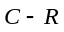) = maximum number of end-devices a ZigBee device may accept as children
D = max. Depth of a device in the ZigBee network, we may compute the function, 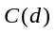 or 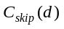, essentially the size of the address sub-block being distributed by each parent at depth to its router-capable child devices at depth 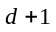:
Let 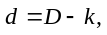where 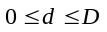and 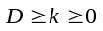
At 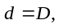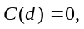(As no devices exist at depth )
At 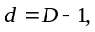 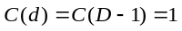 (A router-capable device at depth D gets an address for itself; it can have no child)
At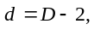
[a router-capable device at depth gets an address for itself, E addresses to assign to its E end-device children and 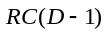to be assigned to its at most R router-capable children.]
In general,
C(D-k) =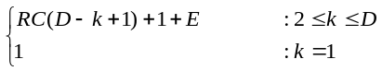
Solving this recurrence (by substitution),
Using the identity:
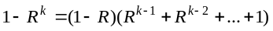 we get,
C(D-k)=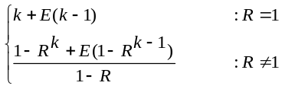

Now substituting D – k = d, E = C – R, we have:
C(D-k)=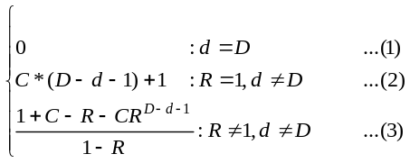
It may be noted that the specification [2] that we are working with mentions only formula (3) and is silent about the other cases. That formula definitely does not hold in the boundary regions. Our derivation explicitly tackles them.
  - Address Assignment
If a device has a C(d) value of zero, then it shall not be capable of accepting children and shall be treated as a ZigBee end device. A parent device that has a C(d) value greater than zero shall accept child devices and shall assign addresses to them differently depending on whether the child device is router-capable or not. Network addresses shall be assigned to router-capable child devices using the value of C(d) as an offset. A parent assigns an address that is one greater than its own to its first router-capable child device. Subsequently assigned addresses to router-capable child devices are separated from each other by C(d) . A maximum of nwkMaxRouters of such addresses shall be assigned.
A router-capable device having address A_{parent} at depth d assigns addresses to its n^{th} child A_{n} at depth d+1 in the following way:
END-DEVICE CHILD:
ROUTER-CAPABLE CHILD:
The first router-capable child gets address A_{parent} +1 and subsequent router-capable children get addresses separated by . This happens for all the R router-capable children of the device.
End-devices get addresses starting from A_{parent} + 1 + C(d)*R separated by 1.
An example follows:

[C(d) = 1, Addr = 23]
[C(d) = 1, Addr = 22]
[C(d) = 5, Addr = 43]
[C(d) = 1, Addr = 70]
[C(d) = 1, Addr = 65]
[C(d) = 1, Addr = 2]
ZigBee Coordinator [C(d) = 21, Addr = 0]
[C(d) = 5, Addr = 1]
[C(d) = 5, Addr = 64]
[C(d) = 0, Addr = 66]
[C(d) = 1, Addr = 28]
L = 3, C = 4
Address Block size = 85

    - Address assignment (an example)
  - Routing Mechanism In A Zigbee Network
The routing table maintained by a ZigBee router or ZigBee Coordinator has entries each of which is a three-tuple: (Destination address, Status, Next-hop address). Status indicates whether the route-discovery is underway or the route is active, etc. To accomplish mesh routing, devices also need to maintain route discovery tables. A device is said to have routing capacity if it has both “routing table capacity” and “route discovery table capacity”. 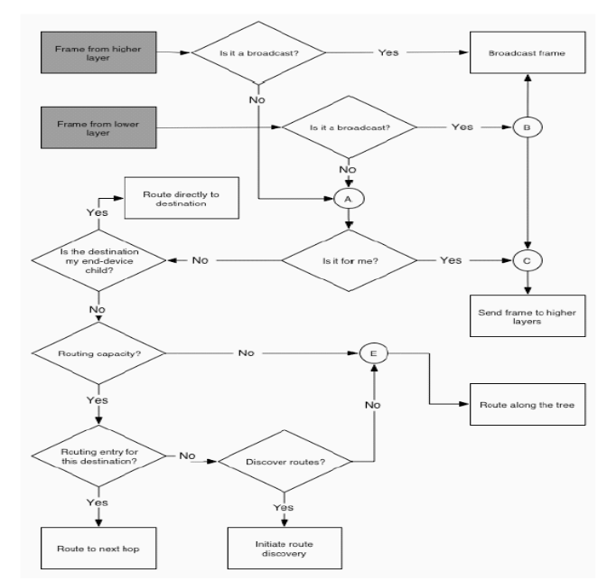
    - Basic routing algorithm

Field name | Size
Destination address | 2 bytes
Status | 3 bytes
Next hop address | 2 bytes

    - Routing table

Upon receipt of a data frame, the NWK layer starts its work of routing the frame to its appropriate destination. The algorithm followed by it is shown below:
Clearly, a ZigBee router that uses hierarchical tree routing (we call it ZTree) will route along the tree while one using mesh routing (we call it ZMesh) will proceed to discover routes.
  - Hierarchical Tree Routing
For hierarchical routing, if the destination is a descendant of the device, the device shall route the frame to the appropriate child. Trivially, every other device is a descendant of the ZigBee Coordinator and no device is a descendant of any ZigBee end-device.
For a ZigBee router with address A at depth d, if the following logical expression is true, then a destination device with address D is a descendant:

Data Packet Received /Route Along Tree
IDLE
FOWARDING PACKET
Packet Forwarded

    - State transition in ZTree (tree routing)

This follows because the parent(P) at depth (d-1) of the device(X) with address A gives X the address A and the “closest” router-capable-sibling of X that is also a child of P the address A+C(d-1). The address sub-block 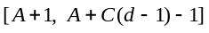is reserved for the descendants of X.
If the destination is a descendant of the receiving device, the address N of the next hop device is determined as:
N = 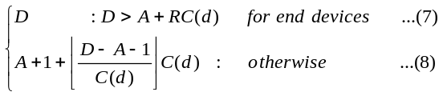
We look below at the derivation of formula (8):
The next-hop address is 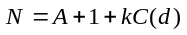, i.e. the packet is to be routed to the router-capable-child with address 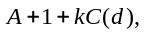if
Since the device with address 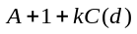 gets address sub-block 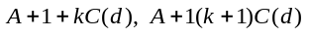
i.e. 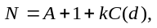where 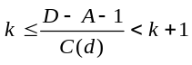
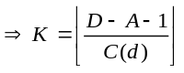
Formula (8) is incorrectly§ quoted in [2] as:
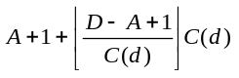[The ‘+’(plus) in D-A+1, above, is to be replaced by a ‘-‘(minus)].
  - Mesh Routing
A device that has routing capacity performs route discovery to route packets. A device that has routing capacity performs route discovery to route packets. It is a kind of source-initiated on-demand routing protocol. We call it mesh routing. In this protocol the source, upon receiving a packet meant for a destination to which it knows no route starts route-discovery. It is quite similar to AODV [11].
  - Initiation Of Route Discovery
Route discovery is the procedure whereby network devices cooperate to find and establish routes through the NWK and is always performed with regard to a particular source and destination device. A device having routing capacity shall establish both a routing table entry and a route discovery table entry and the Status field of that entry shall be set to DISCOVERY_UNDERWAY. However, if it already has a route to the destination, it shall be used. The device shall then construct a route-request command frame and broadcast it. The device shall then construct a route-request (RREQ) command frame and broadcast it. The RREQ frame is essentially a query directed to the devices of the network, asking to which device should it forward the data frame so that it may finally get to the destination.
Packet Forwarded

Discovery Done / Forward packet
Data Packet Received/ Discover Route
IDLE
DISCOVER ROUTE
FOWARDING PACKET

    - State transition in ZMesh (mesh routing)

The spec. [2] says that when a ZigBee device that does not have routing capacity receives a RREQ packet, it will first check if the packet arrived along a valid path. The definition of a valid path as given in specification [2] is incorrect. The specification defines it as: a path is valid if the frame was received from one of the device’s child devices and the source device is a descendant of that child device or if the frame was received from the device’s parent device and the source device is not a descendant of the device. The correct definition is: a path is valid if the frame was received from one of the device’s child devices and the source device is either that child device or a descendant of that child device or if the frame was received from the device’s parent device and the source device is neither the device itself nor a descendant of the device.
If the receiving device is the destination of the RREQ (in case of ZTree or ZMesh) or the destination is an end-device of the receiving device (for ZMesh only), it generates a RREP packet. This RREP packet generated propagates back to the originator of the RREQ along the reverse path constructed when the RREQ flew from the source.
- Experimental Results And Optimizations
We conduct a series of experiments to study the ZigBee routing protocol as implemented by us. The experimental setup is outlined below.

Bandwidth: 250 Kbps
Application traffic type: Poisson (The popular CBR traffic is too deterministic for stationary wireless networks.)
Application packet size: 70 bytes
Simulation time: 0 – 120 seconds with application traffic flowing from 10 to 90 seconds.

All experiments are carried out 10 times with random seeds and the average taken.

Topologies used:
Topology I: 21 nodes form a peer-to-peer topology [Fig 5.1].

Traffic flows:
- Peer-to-peer application sessions between the following nodes: 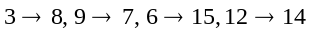
- Multiple-to-one© application traffic (sink-type application traffic) from nodes 3, 6, 9,12, 14, 15, 17, 18 to node 0.
9
13
19
0
2
1
3
12
11
7
4
6
16
10
5
8
20
18
17
14
15

    - Topology-I

Topology II: 101 nodes in peer-to-peer topology with each node reaching only its neighbors along diagonal direction [Figure 5.2].

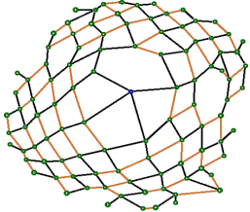

    - Topology-II

Traffic flows:
- Peer-to-peer application sessions between the following nodes:
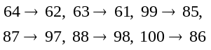
- Multiple-to-one application traffic (sink-type application traffic) from nodes 64, 62, 63, 61, 99, 85, 87, 97, 88, 98 and 100 to node 0.
  - Experiment 1–Amount of Routing packets generated
From the graph in Figure 5.3 (see the un-optimized [unopt] cases) it is clear that a huge volume of control packets is generated in the network due to the route discovery procedure. If a device blindly initiates route-discovery every time it gets a packet addressed to a device to which it does not have a routing table entry, the number of control packets quickly explodes to a large number. Moreover the specification says that an intermediate device receiving a route-request packet must install an entry corresponding to the sought for destination, in its routing table with status=DISCOVERY_UNDERWAY. But this invalidates any active route that the device might be having for this destination. This, in turn, fuels the broadcast storm problem [10].
We try to mitigate it by introducing two optimizations:
1. A device does not initiate route-discovery for a destination if it has already done so for the same destination in the recent past. Thus if it has initiated route-discovery for destination X and before it has got a route-reply, it gets another packet destined for X, it simply queues it instead of restarting a fresh route discovery.
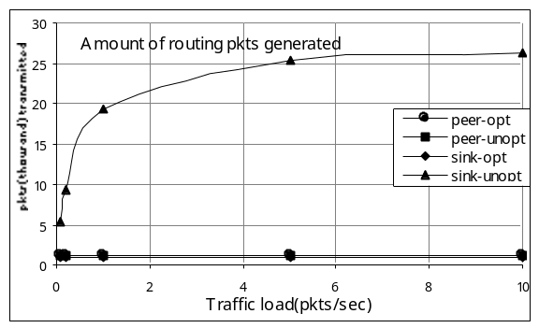
    - Amount of routing packets generated

2. An intermediate device receiving a route-request packet installs an entry corresponding to the sought for destination in its routing table with status = DISCOVERY_UNDERWAY if and only if it does not have an entry for that destination. The device, however, updates its route-discovery table as earlier. Thus any active route it has for the destination is not destroyed outright, yet the route-request packet propagates. When the route reply packet arrives, the device again behaves as earlier.
With these implementation tricks the number of routing packets transmitted has been brought down considerably (see the optimized cases).
  - Experiment 2–Packet Delivery Ratio
We perform this experiment for both peer-to-peer and sink-type traffic in topology II. The packet delivery ratio at the network layer, under ideal conditions, is high. This is because of the highly effective route-discovery procedures, and the robust tree-routing algorithm that successfully delivers packets as long as the source and destination nodes remain connected along the network tree. In mesh-routing based nodes, tree routing may be resorted to only if route-discovery is unsuccessful.

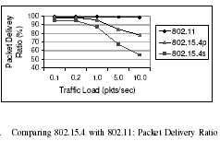

    - Packet delivery ratio at the MAC sublayer (from [5])

However, in practice the packet delivery ratio at the MAC sub-layer falls sharply with packet-rate due to increased number of collisions (which we do not model), as evidenced by the following curve (Figure. 5.4) from [11].
  - Experiment 3–Hop Count
In this experiment we look at the number of hops taken by data packets from source to destination. We use topology I (max. network depth = 3).
Its 3 variants are:
- All ZMesh: All 21 nodes use mesh routing.
- All ZTree: All 21 nodes use hierarchical tree routing.
- Mixed: 10 nodes (nodes 3, 4, 5, 7, 8, 9, 10, 13, 15,18, 20) use tree routing and 11 nodes use mesh routing.
Figure 5.7 shows the case for peer-to-peer application traffic while Figure 5.8 illustrates the hop count for sink-type traffic.
8 → 10 12
↓ ↓
6 7 → 9 ← 11 15
↓ ↓ ↓
5 → 1 → 0 ← 13 ← 14
↑ ↑ ↑
4 → 2 → 19 16 ← 17
↑ ↑ ↑
3 20 18

    - Topology I consisting of 21 nodes. Node 0 is the ZigBee (WPAN) Coordinator Only parent-child links have only been shown. Adjacent devices (e.g. devices 10 and 12) are connected by weak-links.

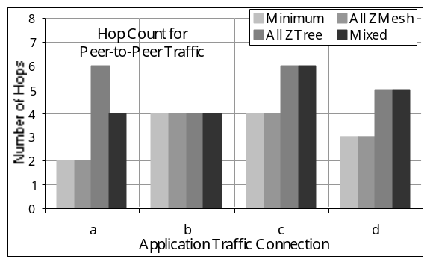

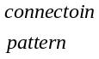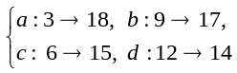

    - Hop count for peer-to-peer traffic

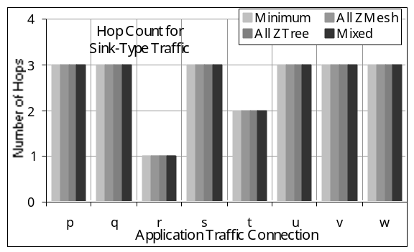

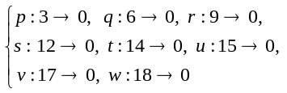

    - Hop count for sink-type traffic

Clearly, if all devices use mesh routing a shortest path between the source and the destination is discovered and taken for packet flows. It is easy to see that, in general, if, for a given application traffic connection, in any ZigBee network,
x = number of hops taken if all devices use mesh routing,
y = number of hops taken if all devices use tree routing,
z = number of hops taken if some devices use tree routing and the rest mesh routing,
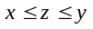
This advantage of mesh routing comes at a cost: the huge number of control packets generated for route discovery. Tree routing has no such overhead as next hop router is calculated from mathematical equations [equation no. 7 and 8].
Empirical evidences [Figure 5.8] indicate that both tree routing and mesh routing usually use the shortest number of hops in sink-type traffic. The same observations (not shown) were made with topology II although, obviously, this may not be the case always.
  - A few more optimizations/extensions:
We also suggest the following optimizations/extensions to the basic routing algorithm. These features are not currently included in our implementation.

(1) Expanding ring search: The burst of traffic generated by flooding (such as the case when RREQ’s are broadcast) chews up a lot of bandwidth. Moreover there is a lot of redundancy. We explore one way of reducing the broadcast radius for route request packets. Instead of broadcasting RREQ packets into the network with TTL set to NETWORK_DIAMETER, a node may send out RREQ packets with TTL = 1 and start a timer with expiration time << ROUTE_DISCOVERY_TIME. When the timer expires, the router shall check if RREP has come to it. If not, it can start route discovery again but with TTL set to, say, 3. If even this effort turns out to be futile, it may attempt route discovery with TTL = NETWORK_DIAMETER and set the timer to ROUTE_DISCOVERY_TIME. In practice, the TTL values may be tuned dynamically based on recent history or predefined based on data gathered from experiments over simulators and live networks. The latter method will reduce computational overhead in a ZigBee network. This method, per se, may not turn out to be very useful in large sensor networks where end devices are primarily responsible for event recording and data transmission to the sink. But here devices are almost always likely to send data to the sink. Hence once the hop-count to the sink is discovered by an end-device, it may flood the network with this value. This could be used by other end-devices as a rough estimate for the TTL value to be used by these nodes, in expanding ring search, for discovery of routes to the sink. Here, implementers must be careful not to flood the network frequently.
(2) Multipath routing: There is significant latency and overhead associated with route discovery, especially in large networks. In mission-critical operations, high reliability is often necessary. In that case it is desirable that nodes continue to communicate with minimal disruption even if some links fail. To ensure this, multiple paths – node disjoint or link disjoint – may be maintained from the source to the destination. It is possible to accommodate this within the framework of the ZigBee protocol: First, alternate loop-free reverse paths are formed at intermediate nodes and the destination by using the routing information obtained via duplicate route request copies. Second, the destination generates multiple route replies. These replies travel along multiple loop-free reverse paths to the source established during the route request propagation phase to yield multiple loop-free forward paths to the destination.
It is highly desirable that these multiple paths are link-disjoint or better still node-disjoint. Moreover, the lengths of these alternate paths should not differ by more than some small predefined number H. H = 3 may be a good choice.

(3) Location-aided routing: In large unattended sensor networks, route-discovery or tree based routing may not be suitable. While the former may produce explosively large number of control packets, the latter may produce very long paths especially if the tree is not well balanced. In such situations, geographic routing that uses the spatial coordinates of the nodes for routing packets may be more attractive options.

(4) Extension to inter-PAN routing: Presently the ZigBee routing protocol limits itself to packet propagation within a single PAN. But as the number of nodes grow larger, need to communicate across WPANs may be necessary. This is more so because the ZigBee protocol does not attempt to form balanced cluster trees. Nodes may not be able to associate successfully in large dense networks. Hence it is desirable that efforts be initiated to extend the protocol to inter-PAN routing.

Future Research direction: Future work will concentrate on investigating the other proposed improvements. Porting our work to the recent ns2 simulator for 802.15.4 developed in [11] may be considered later.
Another direction for future work is to perform real experiments to test the performance of 802.15.4/ZigBee when products become available.
- Conclusion
In this project we develop an ns2 simulator for ZigBee and study the routing protocol specified for ZigBee networks. The theoretical analysis of the protocol leads to refining the draft specification we have been working with. We also design and execute a set of experiments that show that packets are successfully routed even in large complex topologies. The paths taken are close to the shortest ones. The source-driven routing and tree routing methods achieve their objective with minimal resources and hence reinforce the fundamental design goals of energy conscious 802.15.4 standard for low-rate low-power low-cost wireless networks. But, as we have seen, careful implementation is needed to abate broadcast storm in the network during route discovery.
- Acknowledgements
This work is a part of the project done for the partial fulfillment of Bachelor of Information Technology, Jadavpur University, Kolkata.

References

- C. E. Perkins, E. Belding-Royer, and S. R. Das, “Ad hoc On-Demand Distance Vector (AODV) Routing”, http://www.ietf.org/rfc/rfc3561.txt, July 2003. RFC 3561.
- C. E. Perkins and P. Bhagwat, “Highly Dynamic Destination-Sequenced Distance-Vector Routing (DSDV) for Mobile Computers”, Proceedings of ACM SIGCOMM, 1994.
- C. E. Perkins and Elizabeth Royer, “Ad-hoc On-Demand Distance Vector Routing”, Proceedings of the 2nd IEEE Workshop on Mobile Computing Systems and Applications, New Orleans, LA, February 1999.
- D. B. Johnson, D. B. Maltz, “Dynamic Source Routing in Ad-hoc Wireless Networks”, Mobile Computing, T. Imielinski, H. Korth, Eds. Kluwer Academic Publishers, 1996, ch. 5, pp. 153-181.
- D. Ganeshan, B. Krishnamachari, “Complex Behavior at Scale: An Experimental Study of Low-Power Wireless Sensor Networks”, UCLA/CSD-TR 02-0013, UCLA Computer Science, 2002.
- Ed Callaway, Paul Gorday, Lance Hester, Jose A. Gutierrez, Marco Naeve, Bob Heile and Venkat Bahl. “Home Networking with IEEE 802.15.4: A Developing Standard for Low-Rate Wireless Personal Area Networks”,IEEE Communications Magazine August 2002.
- Elizabeth Royer and C-K Toh, “A Review of Current Routing Protocols for Ad-Hoc Mobile Wireless Networks”, IEEE Personal Communications Magazine, April 1999.
- Gang Lu, Bhaskar Krishnamachari, Cauligi S. Raghavendra, “Performance Evaluation of the IEEE 802.15.4 MAC for Low-Rate Low-Power Wireless Networks”, IEEE International Conference on Performance, Computing, and Communications, 2004.
- IEEE P802.15.4/D18, Draft Standard: ”Low rate Wireless Personal Area Networks, Feb. 2003”.
- J. Heidemann, W. Ye and D. Estrin.”An Energy-Efficient MAC Protocol for Wireless Sensor Networks”, Proceedings of the 21st International Conference of the IEEE Computer and Communications Societies (INFOCOM 2002), New York, NY, June 2002.
- Jianliang Zheng and Myung J. Lee. “A Comprehensive Performance Study of IEEE 802.15.4”, http://www-ee.ccny.edu/zheng/pub, 2004.
- Jianliang Zheng and Myung J. Lee, “Will IEEE 802.15.4 Make Ubiquitous Networking a Reality?: A Discussion on a Potential Low power, Low Bit Rate Standard”, IEEE Communications Magazine, June 2004.
- S. Ni, Y. Tseng, Y. Chen and J. Sheu, “The broadcast storm problem in a mobile ad hoc network”, Proceedings of the 5th Annual ACM/IEEE International Conference on Mobile Computing and Networking, ACM Press, 1999.
- Shree Murthy, J. J. Garcia-Luna-Aceves, “An Efficient Routing Protocol for Wireless Networks”, Mobile Networks and Applications, 1996.
- USC Information Sciences Institute, Marina del Rey, CA Network Simulator–NS2. (http://www.isi.edu/nsnam/ns).
- USC Information Sciences Institute, Marina del Rey, CA. Network Animator – Nam. (http://www.isi.edu/nsnam/nam).
- USC Information Sciences Institute, Marina del Rey, CA. The ns Manual. (http://www.isi.edu/nsnam/ns/ns-documentation)
- V. Raghunathan, C. Schurgers, S. Park and M. B. Srivastava, “Energy-Aware Wireless Microsensor Networks”, IEEE Signal Processing Magazine, Volume: 19, Issue: 2, March 2002.
- ZigBee Alliance (ZigBee Document 02130r7) Draft Version 0.90: Network Specification, July 2004.

§ The mistake may be trivial but it led to our ns2 simulations dropping packets and quite obviously may lead to disastrous results if not corrected before an actual implementation of the routing algorithm.
 This type of traffic targets the important application of ZigBee sensor networks, where traffic flows between multiple source nodes and a sink.

