Please find the project source from the below public GitHub repository

***https://github.com/royvantony/NumberToWords***

**Project Structure**

Project developed in Asp.Net core Web App Razor pages with two standard library projects. No file/Db connections used. Used Razor pages with .Net 6 framework. It is used because of the easiness and its page focused structure and it is the recemented model for developing applications from Microsoft.

I initially thought of creating a Web API for generating Numbers in words and consume that in the project but used the same solution by considering the easiness and speed for configuring and testing.

Below are the projects in the solution

**NumberToWords.TestClient** -> UI Project to test Number to Words conversion.

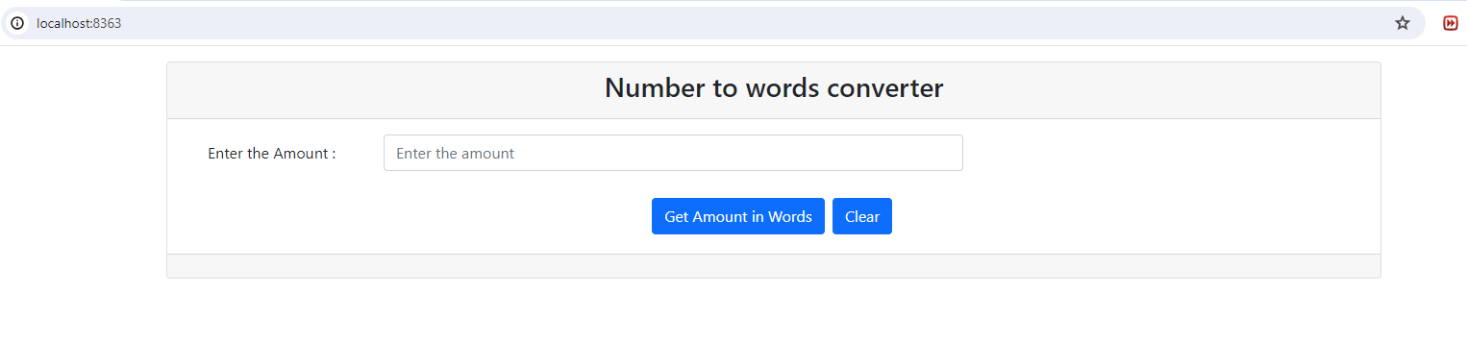

It is simple application where user can enter the amount and generate the equivalent amount in words by clicking on ‘GET AMOUNT IN WORDS’ button.

There are two library projects

**NumberToWords.Models** Project implemented the model class with the required entities and functionality to populate the number in words. Which is referred in both the other two projects.

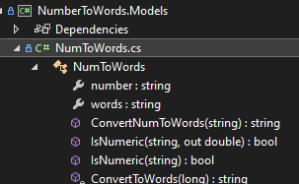

The logic for converting number to words is written in two methods

*ConvertNumToWords* and *ConvertToWords*

ConvertNumToWords is a public method which accepts the numeric value from the services class and do the necessary validations and initial jobs for creating the word equivalent then it use the private method *ConvertToWords* mainly to generate the string equivalent. It executes recursively if required. Which reduces the code required and provides better readability.

**NumberToWords.Services** contains the data access service which implemented the repository pattern for dependency Injection.

