Tomcat服务器布署详细步骤
小易生活共7台tomcat，由线上“YYJF-tomcat”模板克隆生成
ssh登录tomcat服务器
1，拷贝/opt目录下tomcat目录，并删除掉各tomcat下webapp里的内容
cp -ar /opt/tomcat* /data/
rm -rf /data/tomcat*/web*/*
2，更改主机名，vim /etc/sysconfig/network vim/etc/hosts
如：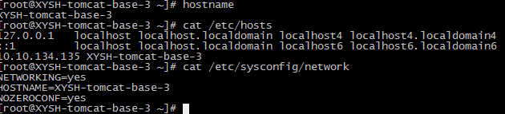
3，配置网关及dns服务器，主要是修改网关，和dns
例:[root@XYSH-tomcat-1 ~]# vim /etc/sysconfig/network-scripts/ifcfg-eth0
DEVICE=eth0
HWADDR=52:54:00:2B:F8:7F
IPADDR=10.10.146.48
NETMASK=255.255.0.0
GATEWAY=10.10.105.15
BOOTPROTO=none
PEERDNS=yes
USERCTL=no
NM_CONTROLLED=no
ONBOOT=yes
MTU=1454
DNS1=10.10.21.80
DNS2=10.10.132.103

4,检查/etc/profile 例：
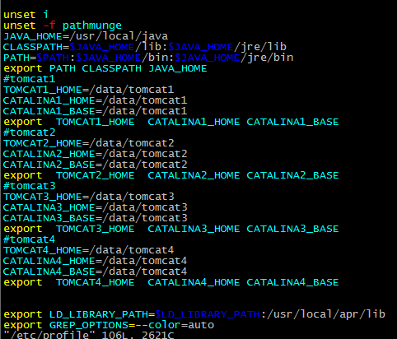
5检查：vim /etc/sysctl.conf
6检查：vim /etc/security/limits.conf
* soft nproc 51200
* hard nproc 51200
* hard nofile 1000000
* soft nofile 1000000
* soft core unlimited
* soft stack 10240
vim /etc/security/limits.d/90-nproc.conf
* soft nproc 102400
root soft nproc unlimited
7，修改启动项，tomcat开机启动 vim /etc/rc.local
for i in `seq 1 4`;do su - online /usr/local/bin/tomde $i start;done
8，重启系统reboot
9，安装saltstack客户端
yum install salt-minion -y
chkconfig salt-minion on
sed -i "s/#master: salt/ master: 10.10.109.47/" /etc/salt/minion
/etc/init.d/salt-minion start

