详细部署内容：
- 线上服务器详细
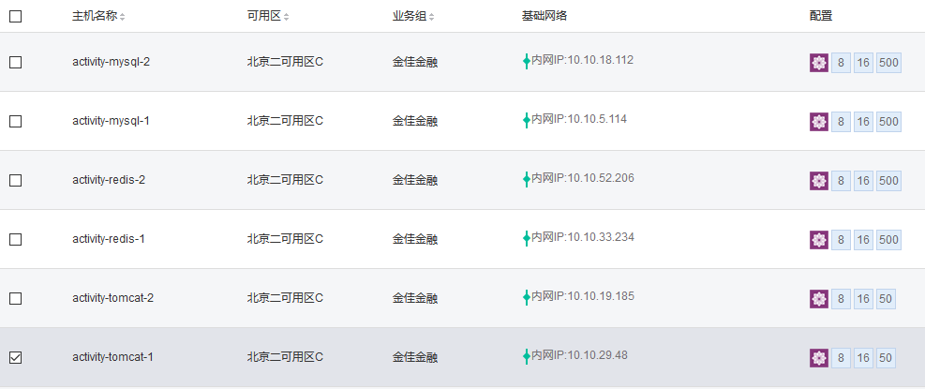

共6台服务器，由线上现有模板克隆生成
cp -ar /opt/tomcat* /data/
rm -rf /data/tomcat*/web*/*
更改主机名，vim /etc/sysconfig/network vim/etc/hosts
配置网关及dns服务器
[root@XYSH-tomcat-1 ~]# vim /etc/sysconfig/network-scripts/ifcfg-eth0
DEVICE=eth0
HWADDR=52:54:00:2B:F8:7F
IPADDR=10.10.146.48
NETMASK=255.255.0.0
GATEWAY=10.10.105.15
BOOTPROTO=none
PEERDNS=yes
USERCTL=no
NM_CONTROLLED=no
ONBOOT=yes
MTU=1454
DNS1=10.10.21.80
DNS2=10.10.132.103

检查启动项，及/etc/profile
检查：vim /etc/sysctl.conf
检查：vim /etc/security/limits.conf
* soft nproc 51200
* hard nproc 51200
* hard nofile 1000000
* soft nofile 1000000
* soft core unlimited
* soft stack 10240

vim /etc/security/limits.d/90-nproc.conf

* soft nproc 102400
root soft nproc unlimited

reboot

yum install salt-minion -y
chkconfig salt-minion on
sed -i "s/#master: salt/ master: 10.10.109.47/" /etc/salt/minion
/etc/init.d/salt-minion start

vim /etc/rc.local
for i in `seq 1 4`;do su - online /usr/local/bin/tomde $i start;done

Redis:
基本配置：
daemonize yes ##后台
port 6379 #端口

Redis1: 10.10.33.234
Redis2: 10.10.52.206从
VIP: 10.10.8.127

Redis启动脚本
[root@activity-redis-1 redis]# vim /etc/init.d/redis
#!/bin/sh
# chkconfig: 345 86 14
# description: Startup and shutdown script for Redis
REDIS_DIR=/usr/local
#export $REDIS_DIR

REDIS_CONF=/etc/redis/redis.conf
REDIS_PID=/data/redis/redis.pid

case $1 in
'start'|'s' )
if test -x $REDIS_DIR/bin/redis-server
then
echo "Starting Redis..."
if $REDIS_DIR/bin/redis-server $REDIS_CONF
then
echo "OK"
else
echo "failed"
fi
else
echo "Couldn't find Redis Server ($REDIS_DIR/bin/redis-server)"
fi
;;

'stop' )
echo "Stopping Redis..."
kill `cat $REDIS_PID`
;;

'restart'|'reload'|'r' )
${0} stop
${0} start
;;

'list'|'l' )
ps aux | egrep '(PID|redis-server)'
;;

*)
echo "usage: `basename $0` {start|restart|reload|stop|list}"
esac

安装keepalived,并设置开机启动
[root@activity-redis-1 redis]# vim /etc/keepalived/keepalived.conf
! Configuration File for keepalived

global_defs {
router_id LVS_DEVEL
}

vrrp_script chk_redis {
script "/etc/keepalived/scripts/redis_check.sh"
interval 2
}

vrrp_instance VI_1 {
state MASTER
interface eth0
unicast_peer {
10.10.52.206
}
nopreempt
virtual_router_id 51
priority 100
advert_int 5
authentication {
auth_type PASS
auth_pass jjjr@2015
}

track_script {
chk_redis
}

virtual_ipaddress {
10.10.8.127 dev eth0
}
notify_master /etc/keepalived/scripts/redis_master.sh
notify_backup /etc/keepalived/scripts/redis_backup.sh
notify_fault /etc/keepalived/scripts/redis_fault.sh
notify_stop /etc/keepalived/scripts/redis_stop.sh
}

Redis2亦配置：
[root@activity-redis-2 ~]# vim /etc/keepalived/keepalived.conf
! Configuration File for keepalived

global_defs {
router_id LVS_DEVEL
}

vrrp_script chk_redis {
script "/etc/keepalived/scripts/redis_check.sh"
interval 2
}

vrrp_instance VI_1 {
state BACKUP
interface eth0
unicast_peer {
10.10.33.234
}
nopreempt
virtual_router_id 51
priority 99
advert_int 5
authentication {
auth_type PASS
auth_pass jjjr@2015
}

track_script {
chk_redis
}

virtual_ipaddress {
10.10.8.127 dev eth0
}
notify_master /etc/keepalived/scripts/redis_master.sh
notify_backup /etc/keepalived/scripts/redis_backup.sh
notify_fault /etc/keepalived/scripts/redis_fault.sh
notify_stop /etc/keepalived/scripts/redis_stop.sh
}
当其中一台redis停掉时，主从切换成功

# Replication
role:master
connected_slaves:1
slave0:ip=10.10.52.206,port=6379,state=online,offset=469785,lag=1
master_repl_offset:469785
repl_backlog_active:1
repl_backlog_size:1048576
repl_backlog_first_byte_offset:2
repl_backlog_histlen:469784

# Replication
role:slave
master_host:10.10.33.234
master_port:6379
master_link_status:up
master_last_io_seconds_ago:9
master_sync_in_progress:0
slave_repl_offset:469799
slave_priority:100
slave_read_only:1
connected_slaves:0
master_repl_offset:0
repl_backlog_active:0
repl_backlog_size:1048576
repl_backlog_first_byte_offset:0
repl_backlog_histlen:0
主从连接正常

Mysql:
由于是由模板生成，两台mysql完全一样，
activity-mysql-1: 10.10.5.114
activity-mysql-2: 10.10.18.112
VIP: 10.10.54.166
首先配置主从：
root jjjr-op@2017

停掉两台mysql的从库，两台mysql都执行
stop slave;
reset master;
reset slave;

以mysql2为从库，
start slave;
change master to 。。。（如果没连重新配下）连主库mysql1
show slave status\G;

mysql 1 为主库
show master status\G;
注意mysql的my.cnf 配置中server-id 主从要设为不一样
从库显示如下：
mysql> show slave status\G;
*************************** 1. row ***************************
Slave_IO_State: Waiting for master to send event
Master_Host: 10.10.5.114
Master_User: slave
Master_Port: 3306
Connect_Retry: 60
Master_Log_File: mysql-bin.000001
Read_Master_Log_Pos: 2212
Relay_Log_File: activity-mysql-2-relay-bin.000003
Relay_Log_Pos: 2375
Relay_Master_Log_File: mysql-bin.000001
Slave_IO_Running: Yes
Slave_SQL_Running: Yes
Replicate_Do_DB:
Replicate_Ignore_DB:
Replicate_Do_Table:
Replicate_Ignore_Table:
Replicate_Wild_Do_Table:
Replicate_Wild_Ignore_Table:
Last_Errno: 0
Last_Error:
Skip_Counter: 0
Exec_Master_Log_Pos: 2212
Relay_Log_Space: 2559
Until_Condition: None
Until_Log_File:
Until_Log_Pos: 0
Master_SSL_Allowed: No
Master_SSL_CA_File:
Master_SSL_CA_Path:
Master_SSL_Cert:
Master_SSL_Cipher:
Master_SSL_Key:
Seconds_Behind_Master: 0
Master_SSL_Verify_Server_Cert: No
Last_IO_Errno: 0
Last_IO_Error:
Last_SQL_Errno: 0
Last_SQL_Error:
Replicate_Ignore_Server_Ids:
Master_Server_Id: 22
Master_UUID: de65f6e4-2923-11e5-99cb-525400f78d0b
Master_Info_File: /data/mysql/data/master.info
SQL_Delay: 0
SQL_Remaining_Delay: NULL
Slave_SQL_Running_State: Slave has read all relay log; waiting for the slave I/O thread to update it
Master_Retry_Count: 86400
Master_Bind:
Last_IO_Error_Timestamp:
Last_SQL_Error_Timestamp:
Master_SSL_Crl:
Master_SSL_Crlpath:
Retrieved_Gtid_Set:
Executed_Gtid_Set:
Auto_Position: 0
1 row in set (0.00 sec)

删掉主库上多余的库，从库完全同步，主从同步重置完成

配置keepalive

[root@activity-mysql-1 ~]# vim /etc/keepalived/keepalived.conf
! Configuration File for keepalived
global_defs {
router_id LVS_DEVEL
}

vrrp_script chk_mysql {
script "/etc/keepalived/scripts/check-mysql.sh"
interval 2
}

vrrp_instance VI_1 {
state MASTER
interface eth0
unicast_peer {
10.10.18.112
}
nopreempt
virtual_router_id 51
priority 100
advert_int 5
authentication {
auth_type PASS
auth_pass jjjr@2015
}

track_script {
chk_mysql
}

virtual_ipaddress {
10.10.54.166 dev eth0
}
notify_master /etc/keepalived/scripts/master.sh
notify_backup /etc/keepalived/scripts/backup.sh
# notify_fault /etc/keepalived/scripts/redis_fault.sh
notify_stop /etc/keepalived/scripts/stop.sh
}

测试：当停掉主库时，VIP自动连上从库

Tomcat:

activity-tomcat-1: 10.10.29.48
activity-tomcat-2: 10.10.19.185

设置tomcat 开机启动
oot@activity-tomcat-2 ~]# vim /etc/rc.local
#!/bin/sh
#
# This script will be executed *after* all the other init scripts.
# You can put your own initialization stuff in here if you don't
# want to do the full Sys V style init stuff.

touch /var/lock/subsys/local

bash /usr/local/bin/set_irq_affinity.sh
for i in `seq 1 4`;do su - online /usr/local/bin/tomde $i start;done

vim /etc/profile

加上：
JAVA_HOME=/usr/local/java
CLASSPATH=$JAVA_HOME/lib:$JAVA_HOME/jre/lib
PATH=$PATH:$JAVA_HOME/bin:$JAVA_HOME/jre/bin
export PATH CLASSPATH JAVA_HOME
#tomcat1
TOMCAT1_HOME=/data/tomcat1
CATALINA1_HOME=/data/tomcat1
CATALINA1_BASE=/data/tomcat1
export TOMCAT1_HOME CATALINA1_HOME CATALINA1_BASE
#tomcat2
TOMCAT2_HOME=/data/tomcat2
CATALINA2_HOME=/data/tomcat2
CATALINA2_BASE=/data/tomcat2
export TOMCAT2_HOME CATALINA2_HOME CATALINA2_BASE
#tomcat3
TOMCAT3_HOME=/data/tomcat3
CATALINA3_HOME=/data/tomcat3
CATALINA3_BASE=/data/tomcat3
export TOMCAT3_HOME CATALINA3_HOME CATALINA3_BASE
#tomcat4
TOMCAT4_HOME=/data/tomcat4
CATALINA4_HOME=/data/tomcat4
CATALINA4_BASE=/data/tomcat4
export TOMCAT4_HOME CATALINA4_HOME CATALINA4_BASE

export LD_LIBRARY_PATH=$LD_LIBRARY_PATH:/usr/local/apr/lib
export GREP_OPTIONS=--color=auto

清空原tomcat下各日志及内容，各tomcat启动正常

