**小易生活Tomcat服务器添加监控详细操作**

Nagios监控：

客户端：

安装nrpe 客户端略，文档已存在git\安装部署文档等\nagios\

配置：

vim /usr/local/nagios/etc/nrpe.cfg

添加：

command[check_users]=/usr/local/nagios/libexec/check_users -w 5 -c 10

command[check_load]=/usr/local/nagios/libexec/check_load -w 3,6,9 -c 6,12,18

command[check_vda]=/usr/local/nagios/libexec/check_disk -w 20% -c 10% -p /dev/vda

command[check_vdb]=/usr/local/nagios/libexec/check_disk -w 20% -c 10% -p /dev/vdb

command[check_zombie_procs]=/usr/local/nagios/libexec/check_procs -w 5 -c 10 -s Z

command[check_total_procs]=/usr/local/nagios/libexec/check_procs -w 1000 -c 1500

command[check_swap]=/usr/local/nagios/libexec/check_swap -w 20% -c 10%

command[check_ping]=/usr/local/nagios/libexec/check_ping -w 100.0,70% -c 200.0,90%

command[check_mem]=/usr/local/nagios/libexec/check_mem -fC -w 20 -c 10

command[check_vdaio]=/usr/local/nagios/libexec/check_io -d vda -w 2000 -c 3000

command[check_vdbio]=/usr/local/nagios/libexec/check_io -d vdb -w 2000 -c 3000

command[check_java]=/usr/local/nagios/libexec/check_java

command[tomcat1]=/usr/local/nagios/libexec/check_http -I 127.0.0.1 -p 8081 -u /xiaoyi-front-merchant/healthCheck

command[tomcat2]=/usr/local/nagios/libexec/check_http -I 127.0.0.1 -p 8082 -u /xiaoyi-front-mobile/healthCheck

/etc/init.d/nrpe start

添加监控脚本 vim /usr/local/nagios/libexec/check_java

#!/bin/bash

# Nagios java plugin

a=`ps -e|grep java|wc -l`

if [ -n $a ];then

echo "java is running."

exit 0

else

echo "java is NOT running."

exit 2

fi

chmod +x /usr/local/nagios/libexec/check_java

snmp安装配置

yum install -y net-snmp

vim /etc/snmp/snmpd.conf

41 com2sec notConfigUser default jjjr.com #修改public为jjjr.com

57 view all included .1 80 #增加这一行

63 access notConfigGroup "" any noauth exact all none none #修改systemview为all

chkconfig --add snmpd

chkconfig snmpd on

/etc/init.d/snmpd start

**服务端配置**：

1.增加主机

在/data/nagios/etc/service/下增加主机并增加主机名等信息，如XYSH-tomcat-1.cfg

define host{

use linux-server,host-pnp

host_name XYSH-tomcat-1

alias 10.10.146.48

address 10.10.146.48

}

加入tomcat组

vim Tomcat-2.cfg

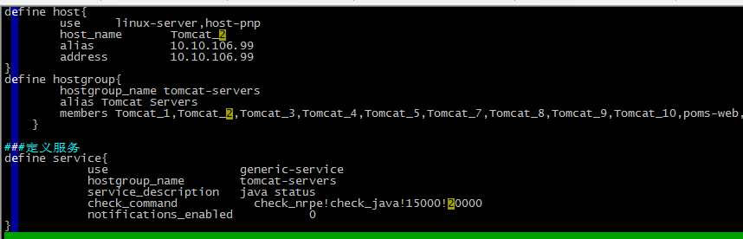

2.在/data/nagios/etc/objects/client.cfg中添加主机名

4.在/data/nagios/etc/objects/escalations.cfg中添加主机名

5.在html_tomcat.cfg中加入主机组及服务

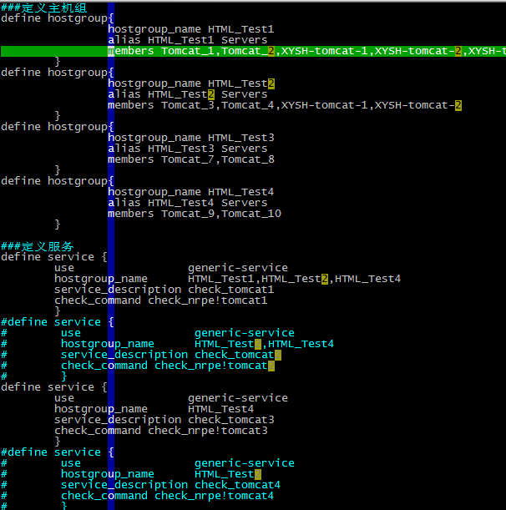

6.测试配置文件是否错误

nagios -v /data/nagios/etc/nagios.cfg

7.重启服务

/etc/init.d/nagios restart