SCORES AI ANALYTICS
Systemic-Criticality Auto-Escalation Platform

A knowledge-graph platform that reads every investor complaint, scores its systemic criticality, consolidates related cases, and auto-escalates the critical few to the right person at SEBI — with the evidence attached.

Product & Feature Specification
Prepared by OnFinance AI | Version 1.0
Builds on the Systemic-Criticality Auto-Escalation Framework v1.0

Contents
1. Purpose & Scope
2. Product Overview
3. How It Works — graph, ontology & pipeline
4. The Systemic-Criticality Score
5. The Platform in Action
6. Auto-Escalation & Notification Engine
7. Governance, Deployment & Roadmap
8. Annexure — Parameter Quick Reference
1. Purpose & Scope
SEBI's SCORES portal classifies complaints by entity and grievance — what kind of complaint it is. It does not answer the question senior management cares about: which complaints, today, could signal harm to many investors, a large sum, or market integrity — and cannot wait in the routine queue?
This platform operationalises the Systemic-Criticality Auto-Escalation Framework: it reads every complaint, scores its systemic criticality across 11 dimensions, consolidates related cases into single case-files, and auto-escalates the critical few to the right SEBI officer — with the evidence attached.
- A layer on top of SCORES — it surfaces, ranks and notifies; it does not replace SEBI's categories.
- Recommends, never decides. Every escalation is explainable and reversible; officers retain full control.
- Fully isolated. It reads SCORES data read-only and writes nothing back — no existing service is touched.
2. Product Overview
Pillar | What it does
Knowledge Graph | Every complaint, entity, typology, product and cluster becomes a connected node — so systemic patterns (one IPO hitting 60 people, a broker's recurring fraud, an issue across 8 states) become visible at a glance.
Criticality Scoring | Each complaint is scored across 11 dimensions into a single 0–100 SCS and a tier; any of nine hard triggers forces the top tier.
Auto-Escalation | When a case or cluster crosses a tier, it is routed to the designated SEBI officer by email + dashboard alert, with the breakdown, evidence and an SLA (§6).
Investigation surface | A live dashboard, one-line AI case summaries, and an Ask-the-Graph chatbot that answers plain-English questions.

Pilot snapshot | Value | Note
Complaints in the graph | 17,132 | Full Q4-2024 population (183k+ nodes / 230k+ relationships)
AI-enriched & scored | ~2,000 | Validation slice; full-population run is a background job
Consolidated clusters | 615 | 571 root-cause + 44 cross-RE product case-files
Tier distribution (scored) | 320 Critical 4 Priority 143 Watch | 320 critical complaints consolidate to ~21 Tier-3 case-files

3. How It Works — graph, ontology & pipeline
The platform turns messy complaint text into a connected graph of typed facts, then scores it. It is deliberately hybrid — a ruler where a fact is already a database field, an AI where the fact is buried in the story.
- Deterministic (no AI). Entity, category, state, workflow history are copied straight from the complaint — instant, exact, no guessing.
- AI-read (Claude Haiku 4.5). Fraud, amounts, vulnerability live only in the free text; the AI extracts them under strict instruction — report only what the text supports; never invent an amount or allegation.
Pipeline: complaints (read-only) → triples (deterministic + AI) → Neo4j graph → clustering → 11-dimension scoring → SCS → tier → escalate. The graph follows a fixed ontology — a controlled set of node types (Complaint, Entity, Typology, Product, Cluster, Investor…) and relationships (filed-against, alleges, member-of…).
WHY IT MATTERS — Pinning the AI's output to a fixed vocabulary is what makes every signal both AI-powered and countable — you can ask “how many misappropriation cases?” and get a real, auditable number.

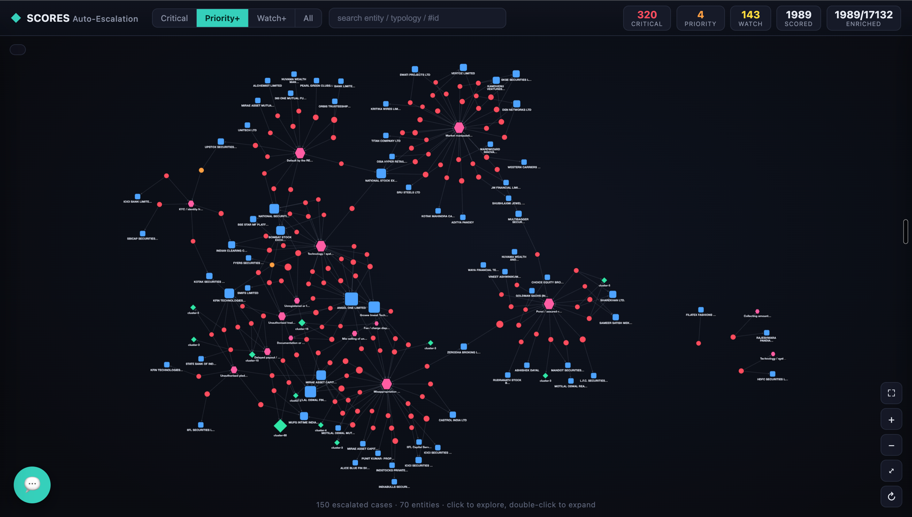
Figure 1 — The escalation knowledge graph. Complaints (red/blue) link to entities, typologies (pink) and consolidated clusters (green); systemic hubs emerge visually.
4. The Systemic-Criticality Score
Every complaint is scored 0–100 on eleven independent dimensions. Vulnerability is a capped amplifier; any single hard trigger forces the top tier regardless of the composite score.
Dim | Dimension | Wt | Core question
A | Scale / Mass-Population | 18% | How many investors, directly or by pattern?
B | Financial Magnitude | 16% | How much money — per case and in aggregate?
C | Fraud & Severity Typology | 16% | Is the alleged conduct inherently grave?
D | Entity Systemic Importance | 10% | Is the RE systemically important or under stress?
E | Velocity & Emergent Patterns | 10% | Is this surging or a brand-new typology?
G | Market-Integrity & Contagion | 10% | Could it threaten price discovery or trigger a run?
I | Process & Resolution Failure | 8% | Is the RE's response evasive or chronically failing?
J | Cross-Portal Correlation | 6% | Does it corroborate other intelligence? (data-dependent)
H | Distress & Escalation Signals | 3% | Fraud, coordination or acute distress in the language?
K | Legal & Reputational Sensitivity | 3% | Institutional / legal / reputational risk for SEBI?
F | Vulnerable-Investor Impact | ×mult | Amplifier (+0–30%), never a standalone gate

Tier | SCS | Routing & SLA
Tier 0 · Routine | 0–39 | Standard SCORES queue
Tier 1 · Watch | 40–59 | Analytics watch-list; weekly digest
Tier 2 · Priority | 60–79 | Division / Department Head within 48 hrs
Tier 3 · Critical | 80–100 or any hard trigger | Senior-management / WTM-level desk within 24 hrs

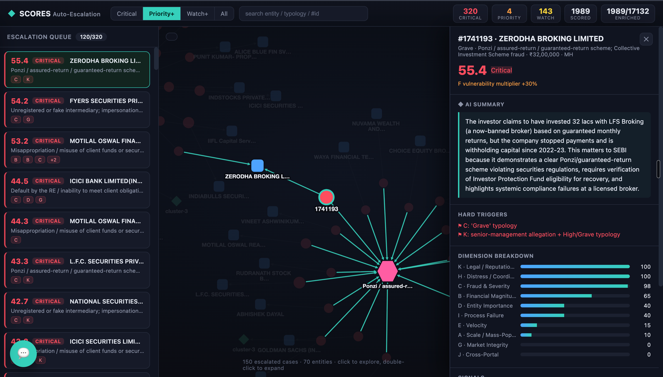
Figure 2 — Every case is fully explainable: AI summary, the hard triggers that fired, the 11-dimension breakdown, extracted signals and verbatim evidence.
5. The Platform in Action
- Dashboard — a ranked escalation queue, an interactive knowledge-graph explorer, and analytics tabs (clusters, drivers, entities).
- AI case summaries — a one-line, plain-English “what's the issue” on every case, generated once and cached.
- Ask-the-Graph chatbot — plain-English questions answered by a live, read-only query; abbreviation-aware (“Zerodha”, “NSE”); shows the query for full transparency.
AI SUMMARY EXAMPLE — “Investor invested ₹32 lakh with a now-banned broker on guaranteed monthly returns; payments stopped since 2022-23 — a clear Ponzi/guaranteed-return scheme; verify IPF eligibility.”

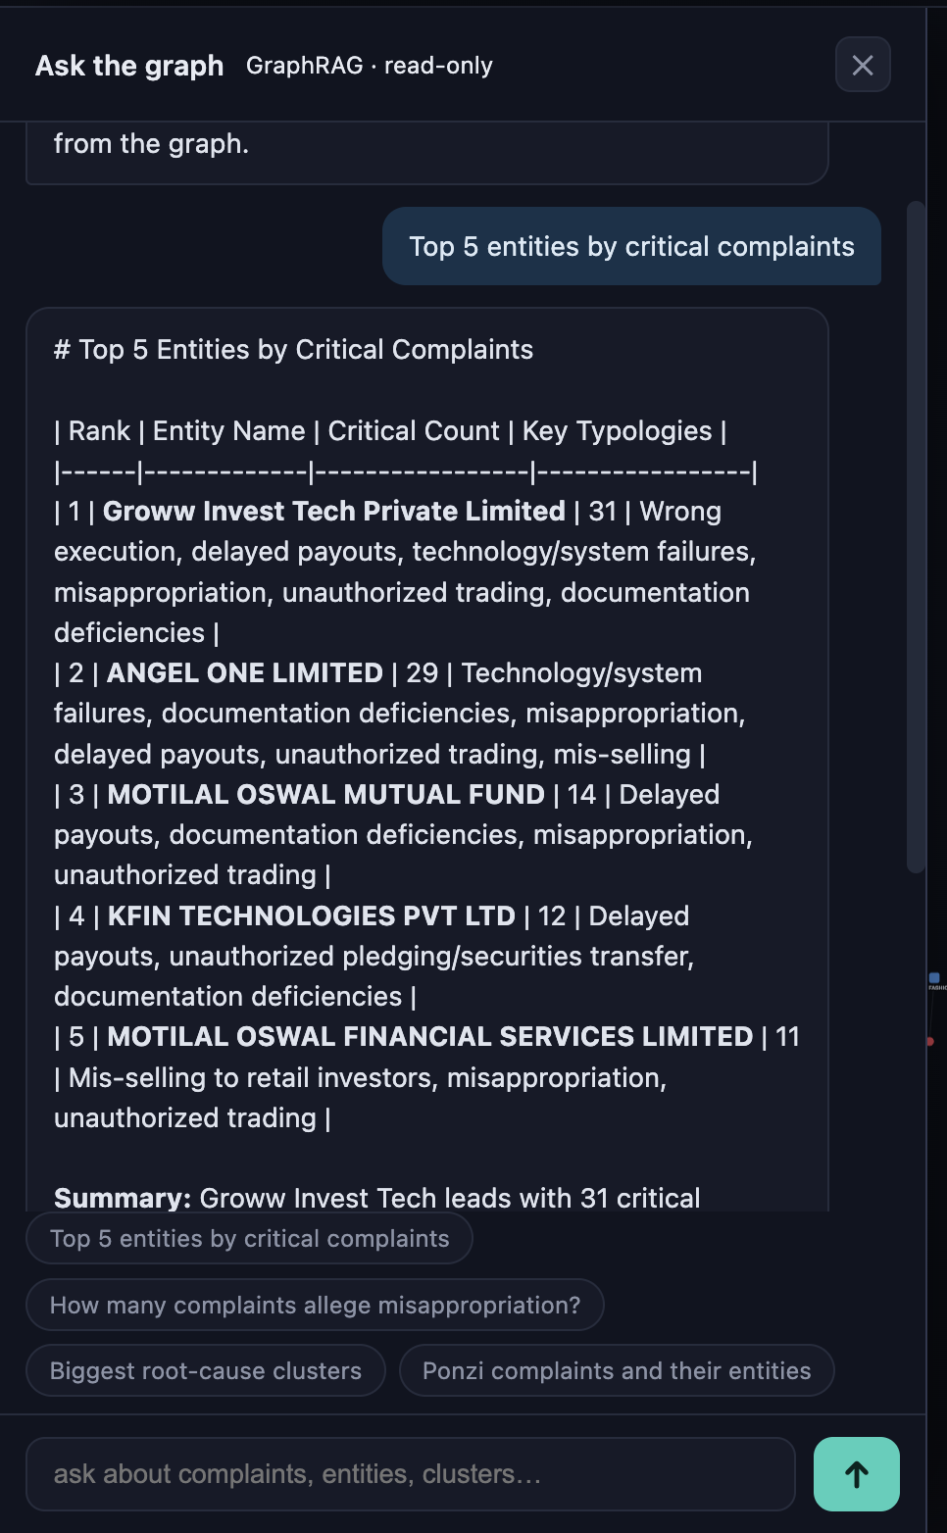
Figure 3 — “Top 5 entities by critical complaints”, answered from the live graph with the underlying query shown for transparency.
6. Auto-Escalation & Notification Engine
This is how a critical issue stops being a database row and becomes an alert on the right person's desk. When scoring assigns a tier or fires a hard trigger, the engine decides who is told, how, and how fast.
6.1 The cues — what causes an escalation
Cue | What fires it | Tier
Hard trigger (9) | Any single grave signal — Grave typology (misappropriation, Ponzi, manipulation, RE default, fake entity); ≥₹5 cr (or misappropriation ≥₹2 cr); mass cluster (≥100 complainants / ≥3 states / cross-RE); MII integrity failure; market-integrity signal; senior-management allegation + grave typology. | Critical
Composite score | The weighted 11-dimension SCS crosses a band (60 → Priority, 80 → Critical). | Priority / Critical
Emergent pattern | A velocity spike (≥4× baseline) or a newly-formed mass cluster. | Priority → Critical

HARD-TRIGGER OVERRIDE — any single hard trigger routes the case to Tier 3 regardless of the score. A one-victim Ponzi allegation escalates as forcefully as a thousand-victim cluster.

6.2 Routing — who is told, how, how fast
Escalation | Designated recipient | Channel | SLA
Tier 3 · Critical | Senior-management / WTM desk + department | Immediate email + dashboard | 24 hrs
Tier 2 · Priority | Division / Department Head | Daily digest + dashboard | 48 hrs
Tier 1 · Watch | Dealing officer / analytics desk | Weekly digest + watch-list | Best-effort
Special: MII implicated | MII supervision cell | Immediate email | 24 hrs
Special: price-sensitive | Restricted list; confidential flag; hidden on general dashboard | Email (restricted) | 24 hrs
Special: acute distress | Investor-services / duty-of-care desk | Immediate email | Prompt

Channels: email (primary, via SEBI's SMTP relay) · the always-on in-dashboard alert feed · daily/weekly digests for lower tiers · optional Slack / Teams webhook.
6.3 The escalation notice — what the officer receives
▲ SCORES Auto-Escalation — TIER 3 · CRITICAL — action within 24 hrs
Case: #1741193 · ZERODHA BROKING LIMITED · Maharashtra
SCS / Tier: 55.4 · Critical (+30% vulnerability multiplier)
Why: C: Grave typology (Ponzi/assured-return) · K: senior-management allegation + grave typology
AI summary: ₹32 lakh invested with a now-banned broker on guaranteed returns; payments stopped since 2022-23 — Ponzi; IPF-eligibility check needed.
Evidence: “…Being Banned for 5 yrs … for assuring fixed return monthly and the MD … is jailed.”
Exposure / confidence: ₹32,00,000 · high · Open case ▸ (deep-link to dashboard)

6.4 Noise control & implementation
- De-duplication — a mass event escalates as one case-file, not N alerts (320 critical → ~21 case-files).
- Confidence gating & coordinated-campaign flags — low-confidence marked “provisional”; templated filings flagged, not counted as mass harm. Cool-downs prevent re-alerting.
- Status — scoring already produces the full notice payload (tier, triggers, evidence, summary, exposure, confidence); the live dashboard is the always-on feed. Going live on email is a thin, config-driven step: SEBI supplies the SMTP relay and the recipient routing table (all tunable without code changes).
7. Governance, Deployment & Roadmap
- Explainable & human-in-the-loop. Every escalation carries its reasons, evidence and confidence; the engine recommends — officers confirm, de-escalate or re-route, and those decisions are logged.
- False-positive control. Cluster de-dup, precision-guarded triggers and per-RE baselines keep the critical queue meaningful (~16% of scored, consolidating to a handful of case-files).
- Private & isolated. Complainant identity is a one-way hash; the platform never writes to SCORES; price-sensitive cases get restricted visibility.
- Deployment. One standalone service + Neo4j; containerised; VM / air-gapped ready (on-prem LLM gateway supported); enrichment and scoring are resumable batch jobs.
Roadmap | Description
Full-population enrichment | Extend scoring from the ~2,000-case pilot to all 17,132 complaints.
Live notifications | Connect the escalation outbox to SEBI's SMTP / Slack / Teams and load the routing matrix.
SEBI control panel | UI to tune thresholds, weights, routing and recipients — with change history, no code changes.
Cross-portal (Dim J) | Wire in MI-portal / examination signals when access is granted (currently 0, never fabricated).

8. Annexure — Parameter Quick Reference
Weights: A 18 · B 16 · C 16 · D 10 · E 10 · G 10 · I 8 · J 6 · H 3 · K 3 (%, sum 100); F = ×(+0–30%). Tiers: 0–39 Routine · 40–59 Watch · 60–79 Priority · 80–100 (or hard trigger) Critical.
# | Dim | Hard trigger (default)
1 | A Scale | cluster ≥ 100 complainants, or ≥ 3 states, or cross-RE product ≥ 3 REs
2 | B Magnitude | single ≥ ₹5 cr; misappropriation ≥ ₹2 cr; cluster aggregate ≥ ₹50 cr
3 | C Typology | any “Grave” typology (misappropriation, manipulation, Ponzi, default, fake entity)
4–5 | D Entity | MII in integrity/operational failure; payout-delay cluster (solvency stress)
6 | G Integrity | credible manipulation / settlement / run-risk / price-sensitive signal
7 | I Process | cluster of second-level-review escalations against one RE
8 | J Correlation | corroborates an open MI-portal subject / examination (when data available)
9 | K Sensitivity | senior-management/promoter allegation + a High/Grave typology

All thresholds, weights, routing rules and recipients are configurable defaults, tunable by SEBI without code changes.

