ASSIGNMENT 5 (Dynamic Programming)
Name: Zannatul Hasan Roza
Id: 2024-3-60-246
Section:4
CSE 246

1. Number of Ways to Make Amount Using Exactly K Coins
Given coin denominations and a target amount, compute how many ways you can form the
amount using exactly K coins. Order does not matter.
Input Format:
• n — number of coin types
• coins[1..n]
• amount
• K
Output Format:
• Number of ways
Hint:
Extend the classical coin-change DP by adding a third-dimension tracking number of coins used.
#include<bits/stdc++.h>
using namespace std;
long long Num_Ways(int coins[],int n, int amount ,int k){
long long dp[n+1][amount+1][k+1];
for(int i=0;i<=n;i++){
for(int j=0;j<=amount;j++){
for(int K=0;K<=k;K++){
dp[i][j][K]=0;
}
}
}
for (int i = 0; i <= n; i++){
dp[i][0][0] = 1;
}
for(int i=1;i<=n;i++){
for(int j=0;j<=amount;j++){
for(int K=0;K<=k;K++){
dp[i][j][K]=dp[i-1][j][K];
if(coins[i-1]<=j&&K>0){
dp[i][j][K]+=dp[i][j-coins[i-1]][K-1];
}
}
}
}
return dp[n][amount][k];
}
int main(){
int n,amount,k;
cout<<"Enter num of coins:";
cin>>n;
cout<<"Enter amount:";
cin>>amount;
cout<<"Enter exact num of coins (k) :";
cin>>k;
int coins[n];
cout<<"Enter coins :";
for (int i = 0; i < n; i++){
cin>>coins[i];
}
long long ways=Num_Ways(coins, n,amount,k);
cout<<"Num of ways: "<<ways<<endl;
}
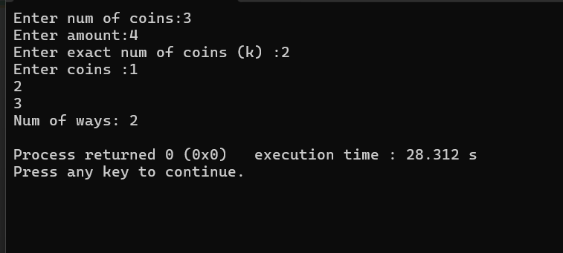
2. Number of Ways When You Can Use At Most K Coins
Compute the number of ways to make the amount using at most K coins.
Input Format:
Same as previous, except K is a limit.
Output Format:
Total number of ways.
Hint:
Use dp[i][a][k] and sum over all k ≤ K.
#include <bits/stdc++.h>
using namespace std;
long long Coin_Change_AtMostK(int coins[], int n, int amount, int K) {
long long dp[n+1][amount+1][K+1];
for(int i=0;i<=n;i++)
for(int j=0;j<=amount;j++)
for(int k=0;k<=K;k++)
dp[i][j][k] = 0;
for(int i=0;i<=n;i++)
dp[i][0][0] = 1;

for(int i=1;i<=n;i++){
for(int j=0;j<=amount;j++){
for(int k=0;k<=K;k++){
dp[i][j][k] = dp[i-1][j][k];
if(j >= coins[i-1] && k >= 1)
dp[i][j][k] += dp[i][j - coins[i-1]][k-1];
}
}
}
long long total = 0;
for(int k=0;k<=K;k++)
total += dp[n][amount][k];
return total;
}
int main() {
int n, amount, K;
cin >> n >> amount >> K;
int coins[n];
for(int i=0;i<n;i++) cin >> coins[i];
cout << Coin_Change_AtMostK(coins, n, amount, K) << endl;
return 0;
}
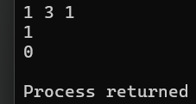
3. Minimum Coins With Mandatory Coin
Given coins and amount, find minimum coins needed but you must use coin C at least once.
Input Format:
• n
• coins
• amount
• C (mandatory coin value)
Hint:
Compute two DP: normal DP, and DP after forcing one use of coin C (reduce amount first).
#include <bits/stdc++.h>
using namespace std;
int MinCoinsMandatory(int coins[], int n, int amount, int C) {
int INF = 1e9;
if(C > amount) return -1;
int remaining = amount - C;
int dp[n+1][remaining+1];
for(int i=0;i<=n;i++)
for(int j=0;j<=remaining;j++)
dp[i][j] = INF;
for(int i=0;i<=n;i++)
dp[i][0] = 0;
for(int i=1;i<=n;i++){
for(int j=0;j<=remaining;j++){
dp[i][j] = dp[i-1][j];
if(j >= coins[i-1] && dp[i][j - coins[i-1]] != INF)
dp[i][j] = min(dp[i][j], dp[i][j - coins[i-1]] + 1);
}
}

if(dp[n][remaining] == INF) return -1;
return dp[n][remaining] + 1;
}
int main() {
int n, amount, C;
cout << "Enter number of coins and target amount: ";
cin >> n >> amount;
cout << "Enter mandatory coin value: ";
cin >> C;
int coins[n];
cout << "Enter the coin values: ";
for(int i=0;i<n;i++)
cin >> coins[i];
int ans = MinCoinsMandatory(coins, n, amount, C);
cout << "Minimum coins needed (or -1 if impossible): " << ans << endl;
return 0;
}
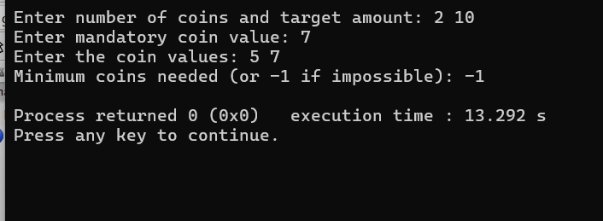
4 .Minimum Coins with Usage Limit = 2
Find the minimum number of coins to make amount if each coin type can be used at most twice.
Input Format:
n, coins, amount
Output: Minimum coins or -1.
Hint:
Convert each coin into two copies: effectively 0/1 knapsack on counts.

#include <bits/stdc++.h>
using namespace std;

int MinCoinsUsageLimit(int coins[], int n, int amount){
int INF = 1e9;
int expanded[2*n];
int m = 0;
for(int i=0;i<n;i++){
expanded[m++] = coins[i];
expanded[m++] = coins[i];
}
int dp[m+1][amount+1];
for(int i=0;i<=m;i++)
for(int j=0;j<=amount;j++)
dp[i][j] = INF;
for(int i=0;i<=m;i++) dp[i][0] = 0;
for(int i=1;i<=m;i++){
for(int j=0;j<=amount;j++){
dp[i][j] = dp[i-1][j];
if(j >= expanded[i-1] && dp[i-1][j - expanded[i-1]] != INF)
dp[i][j] = min(dp[i][j], dp[i-1][j - expanded[i-1]] + 1);
}
}
if(dp[m][amount] == INF) return -1;
return dp[m][amount];
}
int main(){
int n, amount;
cout << "Enter number of coins and target amount: ";
cin >> n >> amount;
int coins[n];
cout << "Enter coin values: ";
for(int i=0;i<n;i++) cin >> coins[i];
int ans = MinCoinsUsageLimit(coins, n, amount);
cout << "Minimum coins needed (or -1 if impossible): " << ans << endl;
return 0;
}
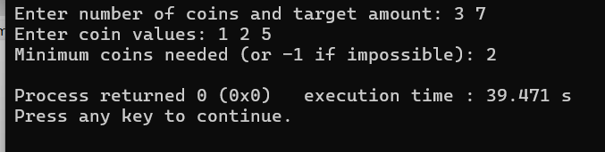
5. 0/1 Knapsack With Exactly K Items
Pick items to maximize value but choose exactly K items.
Input Format:
n
weights
values
capacity
K
Hint:
Add a dimension for selecting k items.

#include <bits/stdc++.h>
using namespace std;
int KnapsackExactlyK(int weights[], int values[], int n, int capacity, int K) {
int INF = -1e9;
int dp[n+1][capacity+1][K+1];
for(int i=0;i<=n;i++)
for(int w=0;w<=capacity;w++)
for(int k=0;k<=K;k++)
dp[i][w][k] = INF;

for(int i=0;i<=n;i++)
for(int w=0;w<=capacity;w++)
dp[i][w][0] = 0;

for(int i=1;i<=n;i++){
for(int w=0;w<=capacity;w++){
for(int k=0;k<=K;k++){

dp[i][w][k] = dp[i-1][w][k];

if(k >= 1 && w >= weights[i-1] && dp[i-1][w - weights[i-1]][k-1] != INF)
dp[i][w][k] = max(dp[i][w][k], dp[i-1][w - weights[i-1]][k-1] + values[i-1]);
}
}
}
if(dp[n][capacity][K] == INF) return -1;
return dp[n][capacity][K];
}
int main() {
int n, capacity, K;
cout << "Enter number of items, capacity and K: ";
cin >> n >> capacity >> K;

int weights[n], values[n];
cout << "Enter weights: ";
for(int i=0;i<n;i++) cin >> weights[i];

cout << "Enter values: ";
for(int i=0;i<n;i++) cin >> values[i];

int ans = KnapsackExactlyK(weights, values, n, capacity, K);
cout << "Maximum value with exactly K items: " << ans << endl;
return 0;
}
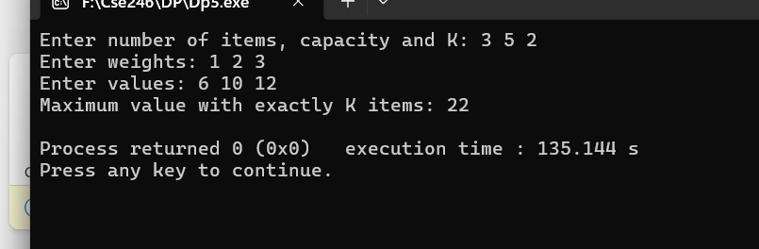
6. 0/1 Knapsack With Mandatory Heavy Item
Description:
Choose items to maximize value but you must pick at least one item whose weight ≥ H.
Input Format:
n, weights, values, cap, H
Hint:
Run DP twice: normal and forced to include each heavy item.

#include <bits/stdc++.h>
using namespace std;
int KnapsackMandatoryHeavy(int weights[], int values[], int n, int capacity, int H) {
int INF = -1e9;
bool hasHeavy = false;
for(int i=0;i<n;i++) if(weights[i] >= H) {
hasHeavy = true;
break;
}
if(!hasHeavy) return -1;
int dp[n+1][capacity+1];
for(int i=0;i<=n;i++)
for(int w=0;w<=capacity;w++)
dp[i][w] = 0;
for(int i=1;i<=n;i++){
for(int w=0;w<=capacity;w++){
dp[i][w] = dp[i-1][w];
if(w >= weights[i-1])
dp[i][w] = max(dp[i][w], dp[i-1][w - weights[i-1]] + values[i-1]);
}
}
int maxValue = -1;
for(int i=0;i<n;i++){
if(weights[i] >= H){
int remainingCap = capacity - weights[i];
if(remainingCap < 0) continue;
int dp2[n+1][remainingCap+1];
for(int x=0;x<=n;x++)
for(int y=0;y<=remainingCap;y++)
dp2[x][y] = 0;
for(int x=1;x<=n;x++){
for(int y=0;y<=remainingCap;y++){
dp2[x][y] = dp2[x-1][y];
if(x-1 != i && y >= weights[x-1])
dp2[x][y] = max(dp2[x][y], dp2[x-1][y - weights[x-1]] + values[x-1]);
}
}
int totalValue = values[i] + dp2[n][remainingCap];
maxValue = max(maxValue, totalValue);
}
}
return maxValue == -1 ? -1 : maxValue;
}
int main() {
int n, capacity, H;
cout << "Enter number of items, capacity and H (weight threshold for heavy item): ";
cin >> n >> capacity >> H;
int weights[n], values[n];
cout << "Enter weights: ";
for(int i=0;i<n;i++) cin >> weights[i];

cout << "Enter values: ";
for(int i=0;i<n;i++) cin >> values[i];
int ans = KnapsackMandatoryHeavy(weights, values, n, capacity, H);
cout << "Maximum value with at least one heavy item: " << ans << endl;
return 0;
}

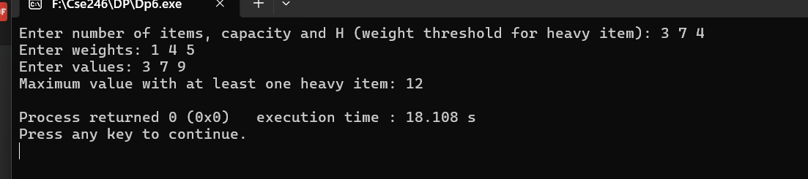
7. Count Distinct LCS
Find the number of distinct longest common subsequences of two strings.
Input Format:
X, Y
Output Format:
Count of distinct LCS.
Hint:
Modify LCS dp to track count; when dp[i-1][j] and dp[i][j-1] tie, subtract dp[i-1][j-1].
#include <bits/stdc++.h>
using namespace std;
int CountDistinctLCS(string X, string Y) {
int m = X.size();
int n = Y.size();
int dpLen[m+1][n+1];
int dpCount[m+1][n+1];

for(int i=0;i<=m;i++){
for(int j=0;j<=n;j++){
if(i==0 || j==0){
dpLen[i][j] = 0;
dpCount[i][j] = 1;
}
}
}
for(int i=1;i<=m;i++){
for(int j=1;j<=n;j++){
if(X[i-1] == Y[j-1]){
dpLen[i][j] = dpLen[i-1][j-1] + 1;
dpCount[i][j] = dpCount[i-1][j-1];
} else {
if(dpLen[i-1][j] > dpLen[i][j-1]){
dpLen[i][j] = dpLen[i-1][j];
dpCount[i][j] = dpCount[i-1][j];
} else if(dpLen[i-1][j] < dpLen[i][j-1]){
dpLen[i][j] = dpLen[i][j-1];
dpCount[i][j] = dpCount[i][j-1];
} else {
dpLen[i][j] = dpLen[i-1][j];
dpCount[i][j] = dpCount[i-1][j] + dpCount[i][j-1];
if(dpLen[i-1][j-1] == dpLen[i][j])
dpCount[i][j] -= dpCount[i-1][j-1];
}
}
}
}

return dpCount[m][n];
}
int main() {
string X, Y;
cout << "Enter first string: ";
cin >> X;
cout << "Enter second string: ";
cin >> Y;
int ans = CountDistinctLCS(X, Y);
cout << "Number of distinct LCS: " << ans << endl;
}
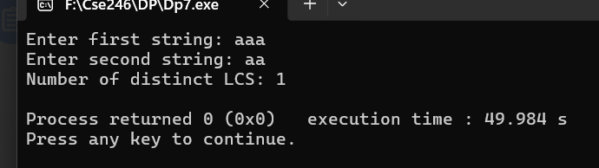
8. LCS With Mandatory Character
Compute LCS of X and Y, but only consider subsequences that contain at least one character C.
Input:
X, Y, C
Hint:
Compute two LCS:
1. Normal
2. LCS after removing all prefixes before first C match.
#include <bits/stdc++.h>
using namespace std;
int LCSWithMandatoryChar(string X, string Y, char C) {
int m = X.size();
int n = Y.size();
bool hasC_X = false, hasC_Y = false;
for(char ch : X) if(ch == C) {
hasC_X = true;
break;
}
for(char ch : Y) if(ch == C) {
hasC_Y = true;
break;
}
if(!hasC_X || !hasC_Y)
return 0;
int dp[m+1][n+1];
for(int i=0;i<=m;i++)
for(int j=0;j<=n;j++)
dp[i][j] = 0;
for(int i=1;i<=m;i++){
for(int j=1;j<=n;j++){
if(X[i-1] == Y[j-1])
dp[i][j] = dp[i-1][j-1] + 1;
else
dp[i][j] = max(dp[i-1][j], dp[i][j-1]);
}
}

int normalLCS = dp[m][n];

int firstC_X = -1, firstC_Y = -1;
for(int i=0;i<m;i++) if(X[i] == C) { firstC_X = i; break; }
for(int j=0;j<n;j++) if(Y[j] == C) { firstC_Y = j; break; }
int dp2[m+1][n+1];
for(int i=0;i<=m;i++)
for(int j=0;j<=n;j++)
dp2[i][j] = 0;
for(int i=firstC_X+1;i<=m;i++){
for(int j=firstC_Y+1;j<=n;j++){
if(X[i-1] == Y[j-1])
dp2[i][j] = dp2[i-1][j-1] + 1;
else
dp2[i][j] = max(dp2[i-1][j], dp2[i][j-1]);
}
}

return dp2[m][n];
}
int main() {
string X, Y;
char C;
cout << "Enter first string: ";
cin >> X;
cout << "Enter second string: ";
cin >> Y;
cout << "Enter mandatory character: ";
cin >> C;
int ans = LCSWithMandatoryChar(X, Y, C);
cout << "Length of LCS containing character " << C << ": " << ans << endl;
return 0;
}

