#include <bits/stdc++.h>
using namespace std;

vector<int> adj[100]; // graph store
bool visited[100]; // visited track

void dfs(int node) {
visited[node] = true; // Step 1: mark visited
cout << node << " "; // Step 2: print

for(int i = 0; i < adj[node].size(); i++) {
int neighbor = adj[node][i];

if(visited[neighbor] == false) {
dfs(neighbor); // Step 3: recursive call
}
}
}

int main() {
int n = 4; // total node

// graph build (undirected)
adj[1].push_back(2);
adj[2].push_back(1);

adj[1].push_back(3);
adj[3].push_back(1);

adj[2].push_back(4);
adj[4].push_back(2);

adj[3].push_back(4);
adj[4].push_back(3);

dfs(1); // start from node 1

return 0;
}
1.
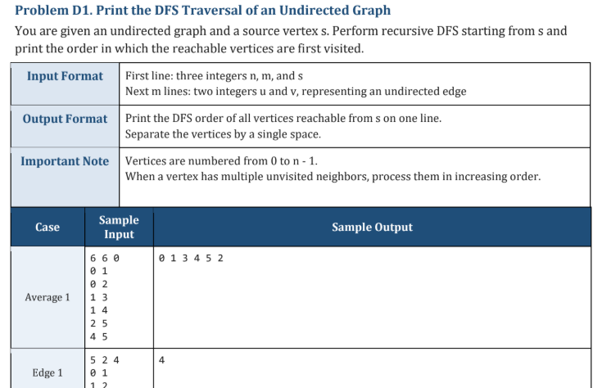
#include <bits/stdc++.h>
using namespace std;
void dfs(vector<vector<int>> &adj, vector<bool> &visited, int node) {
visited[node] = true;
cout << node << " ";
for(int neighbor : adj[node]) {
if(!visited[neighbor]) {
dfs(adj, visited, neighbor);
}
}
}
int main() {
int n, m, s;
cin >> n >> m >> s;
vector<vector<int>> adj(n);
for(int i = 0; i < m; i++) {
int u, v;
cin >> u >> v;
adj[u].push_back(v);
adj[v].push_back(u);
}
for(int i = 0; i < n; i++) {
sort(adj[i].begin(), adj[i].end());
}
vector<bool> visited(n, false);
dfs(adj, visited, s);
return 0;
}
2.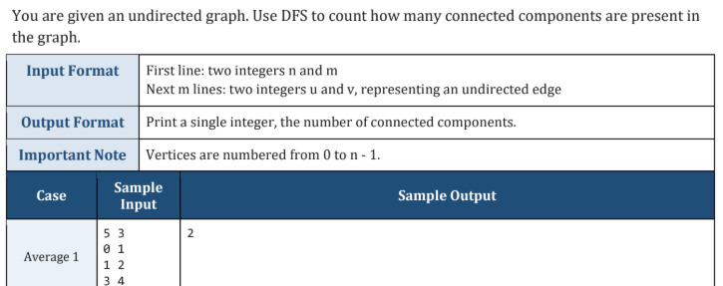

#include <bits/stdc++.h>
using namespace std;

void dfs(vector<vector<int>> &adj, vector<bool> &visited, int node) {
visited[node] = true;

for(int neighbor : adj[node]) {
if(!visited[neighbor]) {
dfs(adj, visited, neighbor);
}
}
}

int main() {
int n, m;
cin >> n >> m;

vector<vector<int>> adj(n);

// input edges (undirected)
for(int i = 0; i < m; i++) {
int u, v;
cin >> u >> v;

adj[u].push_back(v);
adj[v].push_back(u);
}

vector<bool> visited(n, false);

int components = 0;

// check all nodes
for(int i = 0; i < n; i++) {
if(!visited[i]) {
dfs(adj, visited, i); // explore full component
components++; // one component found
}
}

cout << components << endl;

return 0;
}

#include <bits/stdc++.h>
using namespace std;

void dfs(vector<vector<int>> &adj, vector<bool> &visited, int node) {
visited[node] = true;
cout << node << " ";

for(int neighbor : adj[node]) {
if(!visited[neighbor]) {
dfs(adj, visited, neighbor);
}
}
}

int main() {
int n = 6;
vector<vector<int>> adj(n);

adj[0] = {1,2};
adj[1] = {3};
adj[2] = {3};
adj[3] = {4};
adj[4] = {5};
adj[5] = {3}; // cycle

vector<bool> visited(n,false);

dfs(adj, visited, 0);
}

