PostAd
PostAd is intended to be a public platform for users to post advertisements
Below is what the website looks like.
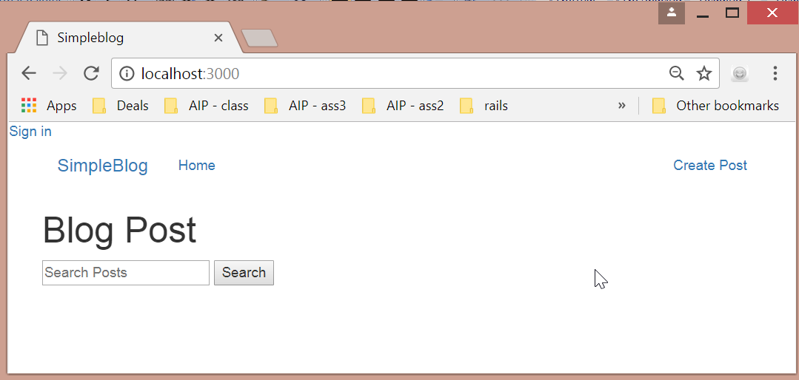

Installation
To have PostAd up and running on your PC, you will require a copy of:
- Rails 5.1, which can be downloaded under http://railsinstaller.org/en.
Download "railsinstaller-3.4.0.exe" from the link above and install on your computer
The above package includes:
  - Ruby 2.3.3
  - Rails 5.1
  - Bundler
  - Git
  - Sqlite
  - TinyTDS
  - SQL Server Support
  - DevKit
- Once installed, open Git Bash.
- Go to C:\Sites
cd C:\Sites
- Download a copy of this project
git clone https://github.com/ZhiruiWang1/PostAd.git
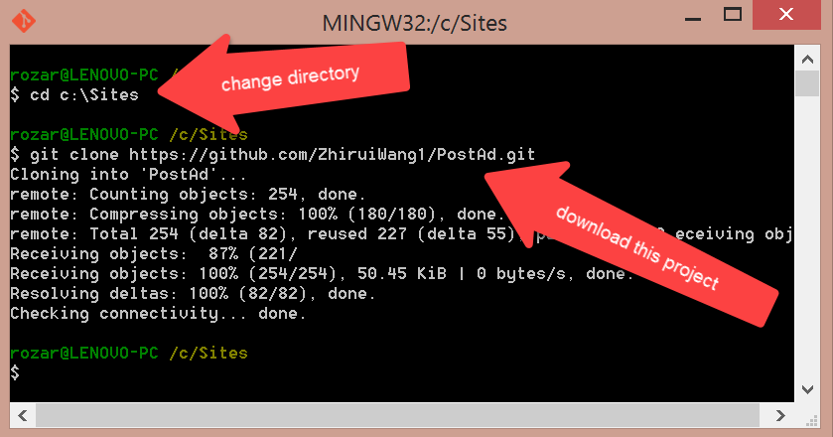
- Change directory
cd PostAd
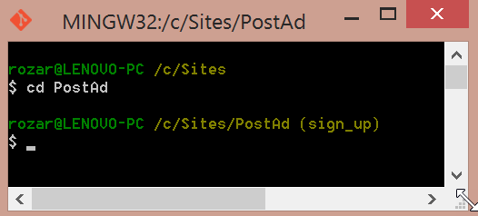

- Run bundle install
bundle install
- Run rails db:migrate
rails db:migrate
- Next run rails server (or "s" for server) as per the image below.
rails s
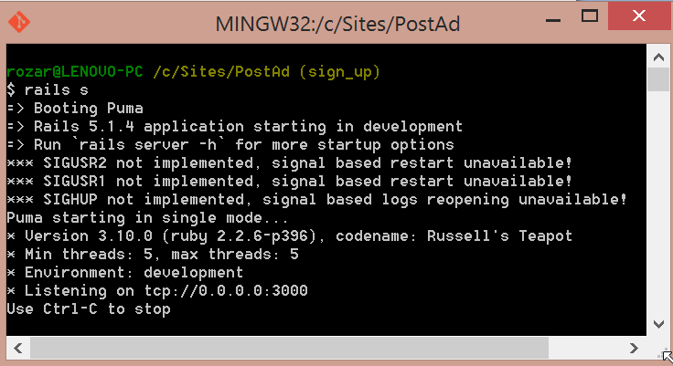
- Once the server is up and running, open a browser and type "http://localhost:3000/" as per the image below.
http://localhost:3000/

Versioning
We use gitHub for versioning.

Authors
- Zhirui Wang
- Chris
- Rosa Rodriguez

Acknowledgments

