**BIRD SPECIES CLASSIFICATION USING EFFICIENTNET ARCHITECTURE**

***Omi Evance Rozario  
Email : neelrozario@gmail.com***

**Abstract** - The Aves class includes warm-blooded vertebrates such as birds. There are around 10,000 living bird species worldwide, with a diverse range of characteristics and appearances. Bird watching is a popular hobby among people who live in the natural environment. Human knowledge of a species is insufficient to correctly identify a bird species, as ornithology requires a high level of expertise. An EfficietNet architectural model is presented in this paper for automatically recognizing the species of a bird supplied as the test data set. The model was trained and validated for 325 bird species using 47332, 1625, and 1625 images for the train, test, and validation datasets, respectively, and when tested with the test datasets, the model exhibited a promising accuracy of 99.14 percent.

***Key Words: Convolution neural network, Artificial Intelligence, Machine Learning, Image Classification.***

**1. Introduction**

People rarely have knowledge about the various species and thus cannot easily distinguish the characteristics and the species name without expertise in the field of ornithology. Many people visit bird sanctuaries to see various birds and to enjoy the beautiful variations of colors and characteristics of the birds. Bird watching is often seen as a good recreational activity that most people engage in in addition to their regular routine. The creation of the suggested model is motivated by the automatic recognition and classification of birds using modern artificial intelligence and machine learning. Deep Learning is a subset of machine learning that consists of numerous algorithms inspired by human neural networks. The algorithms emulate the workings of human brains in data processing and provide a data pattern for decision making. This research describes a method for recognizing bird species using a convolutional neural network model.

CNN is a popular tool for analyzing visual imagery and images. We have proposed a CNN-based classification model that classifies the bird species given a bird image as input in this paper. The convolution neural network model is capable of extracting variation information from images based on size, shape, and color, and hence of successful categorization.

**2. Related Works**

In April 2020, the IRJET published a paper titled "BIRD SPECIES CLASSIFICATION USING DEEP LEARNING APPROACH." The goal of this project was to develop an automated model that could identify bird species using a test image from the dataset as a test image. The main objectives are to develop an automated model that can detect and categorize bird species using colored images of birds as training and testing data. The focus of this thesis was to develop a platform for identifying bird species from digital images uploaded by users using deep learning for image processing. The proposed approach can detect and distinguish uploaded images that are of birds. The CNN model's overall accuracy on the training dataset is high. The purpose of this research was to develop an automatic method for identifying bird photographs that shared basic characteristics but differed somewhat in appearance. Images of 20 different bird species were collected from various web sources and used in the Deep neural network model's training and testing [1].

JOHN MARTINSSON of the University of Gothenburg published a paper in 2017 named "BIRD SPECIES IDENTIFICATION USING CONVOLUTIONAL NEURAL NETWORKS." This research aims to enhance on the present state-of-the-art bird species classifier, which has been implemented and is being used as a benchmark. The questions are as follows: Deep residual neural networks can learn to distinguish bird species based on their song, but how well can they do so? Is it possible to improve the model's accuracy by employing data augmentation or meta-data fusion with multiple-width frequency-delta data? The difficulties are solved by training a deep residual neural network with and without multiple width frequency-delta data augmentation and meta-data fusion on one of the world's largest bird song data sets and comparing the outcomes to the baseline. Deep residual neural networks can learn to classify bird species based on their song, according to the study, and the classifier's mean average precision is nearly as excellent as the best in the field. We then develop a proof of concept for meta-data fusion, demonstrating that incorporating elevation data can improve model performance and, especially, reduce coverage error. Next steps could include good the hyper parameters of the deep residual neural network, incorporating time of recording and geological location data into the model, or switching to the more realistic, but less studied, open set problem of continuous classification rather than the N-class problem studied in this thesis [2].

**3. Proposed Model**

The purpose of this project is to develop a platform for identifying bird species from digital images submitted by users using deep learning for image processing. EfficientNet was the architecture that we used. EfficientNet is a convolutional neural network design and scaling method that properly adjusts all depth/width/resolution dimensions using a compound coefficient. EfficientNet grows network breadth, depth, and resolution evenly and reliably using a compound coefficient. This notebook includes a custom callback. Reduce Learning Rate on Plateau, Early Stopping, and Model Checkpoint are combined in this Keras callback, but some of their drawbacks are removed. It also provides an easier-to-read overview of the model's performance at the end of each periodIt also has a handy feature that allows anyone to define the number of epochs to train for until a message appears asking if they want to stop training on the current epoch by typing H or an integer to specify how many more epochs to run before the message appears again. This is particularly useful if you're training a model and find that the metrics are enough and you want to stop training the model early. The callback always delivers someone's model with the weights set to those of the epoch with the best performance on the metric in question (accuracy or validation accuracy).

At first, the callback will check training accuracy and modify the learning rate accordingly until the accuracy meets a user-defined threshold. Once that level of training accuracy is achieved, the callback switches to monitoring validation loss and changing the learning rate accordingly. The proposed method is capable of recognizing and distinguishing uploaded photos as being of birds. The CNN model's total accuracy on the training dataset is 99.14 percent. The purpose of this study is to develop an automatic system that can discriminate between bird images that have similar key characteristics but differ slightly in appearance. Callbacks=[LRA(model, base model, patience, stop patience, threshold, factor, dwell, batches, initial epoch, epochs, ask epoch)] is the form of the callback.

**4. Results and Discussion**

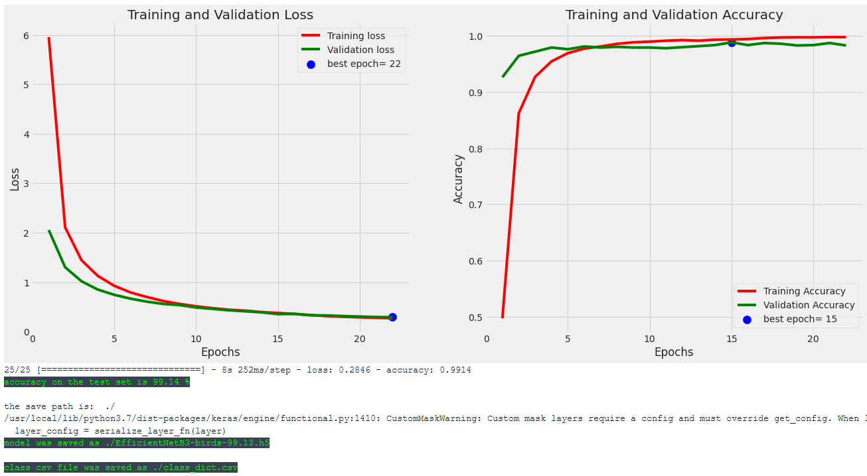

The developed model was successfully tested using the datasets and the accuracy of the model built was found to be 99.14% overall.

**5. Conclusion**

This model helps in the creation of applications that help visitors to bird sanctuaries identify bird species by simply taking a picture of a bird and sending it to the model as an input. Many people are unaware of unusual bird species because many have become endangered or are on the verge of extinction. As a result, a model-based application could be effective in identifying endangered species and increasing awareness about the relevance of all species in maintaining natural balance. Because the model assumes knowledge of Deep Convolution neural networks, we can assume that the CNN is the best algorithm for analyzing visual imagery and image classification.

**References**

[1] BIRD SPECIES CLASSIFICATION USING DEEP LEARNING APPROACH SHRIHARSHA1, TUSHARA2, VIJETH3, SURAJ4, Dr. HEMAVATHI P5

[2] BIRD SPECIES IDENTIFICATION USING CONVOLUTIONAL NEURAL NETWORKS MASTER’S THESIS IN COMPUTER SCIENCE - ALGORITHMS, LANGUAGES AND LOGIC JOHN MARTINSSON

**4. VISUALIZATION OF LAYERS**

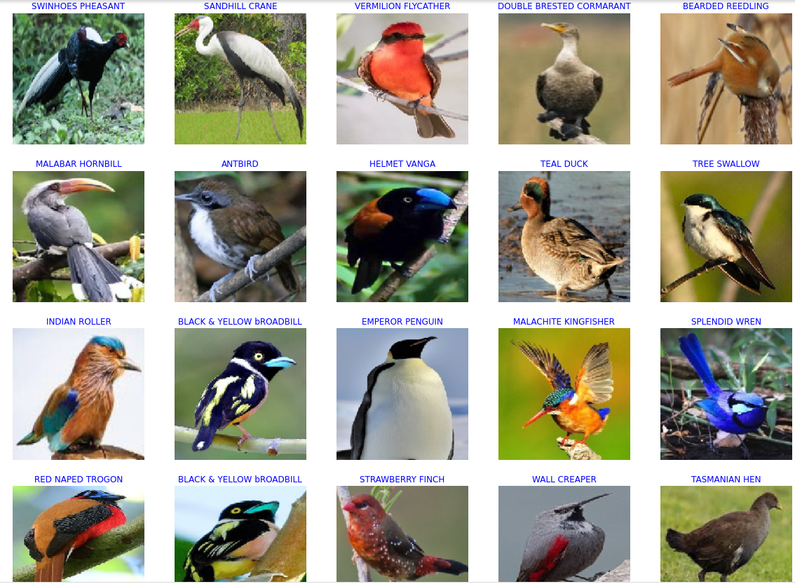

The model was trained and tested for 325 bird species using 47332, 1625, and 1625 images for the train, test, and validation datasets, respectively, and when tested with the test datasets, the model exhibited a promising accuracy of 99.14 percent. EfficientNet was the architecture that we used. EfficientNet is a convolutional neural network design and scaling method that uniformly scales all depth/width/resolution dimensions using a compound coefficient. EfficientNet scales network breadth, depth, and resolution evenly and reliably using a compound coefficient.

Because EfficientNet is scaled in a more principled way and everything is gradually enhanced, our method is superior. The model is efficient and produces better results with a less number of parameters. Input layer, rescaling, normalization, zero padding, Conv2D, batch normalization, and Activation are the blocks of EfficientNet. These blocks also have a different number of sub-blocks, with the number of sub-blocks increasing with the number of sub-blocks. In this project, we used EfficientNet-B3, which comprises a total of seven blocks and fourteen modules. The model then adds a new layer, which has 5 modules as well, making it more efficient.

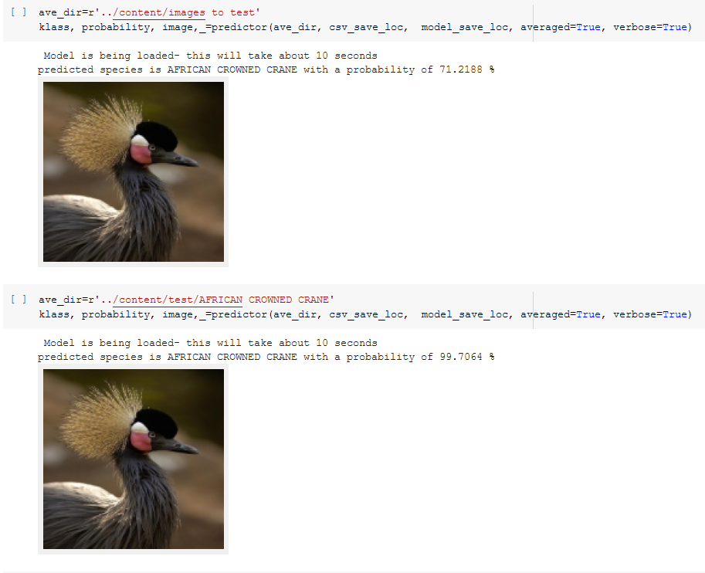

Here, we can see our model has a probability of 99.7% in predicting AFRICAN CROWNED CRANE. This is how our model can predict 325 bird species that have been trained using EfficientNet architecture.