Width between two nodes : last – first +1

If we can get index of each node then it would be vary easy for us to calculate index.

How to calculate Index

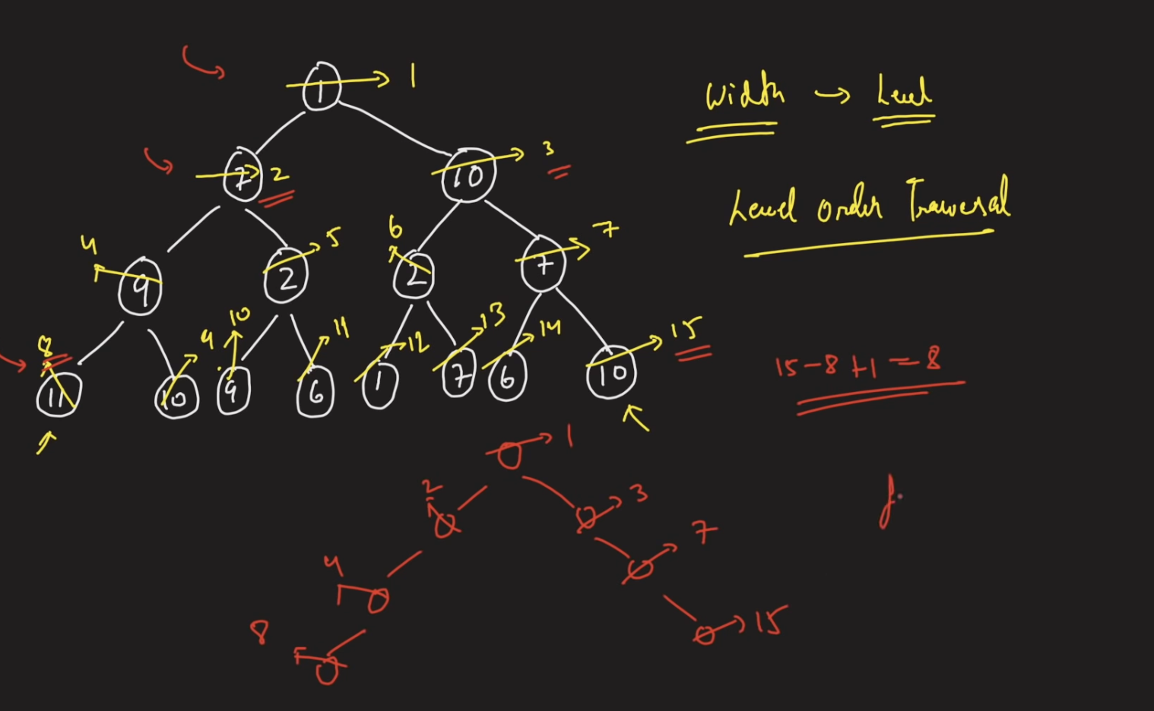

Intution : Segment tree

Left Node : ((2\*i)+1)

Right Node : ((2\*i)+2)

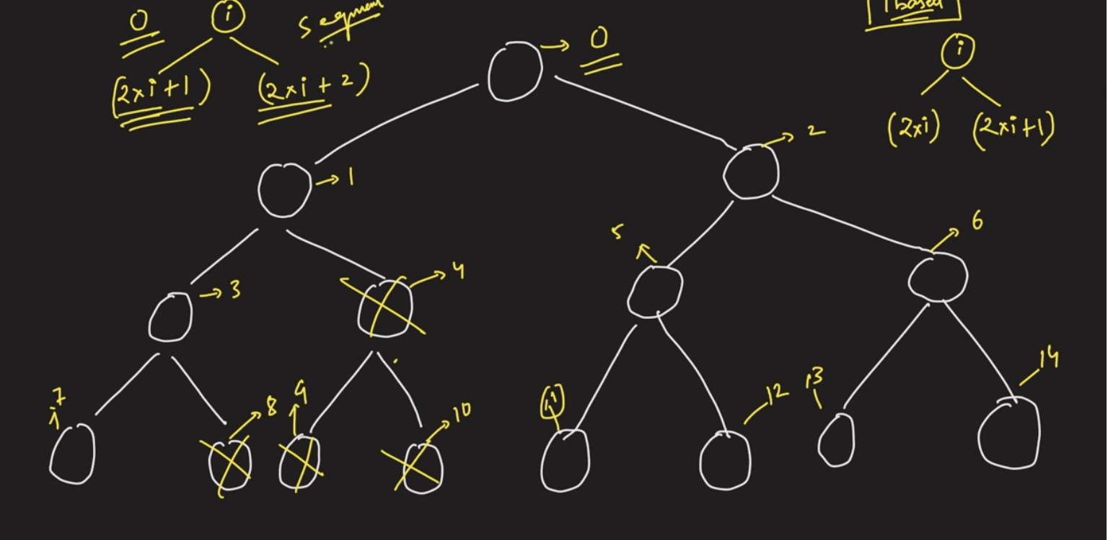

Width = right -left+1 => 14 - 7 +1 => 8

Above approach does not work in case of skew tree and it would cause overflow

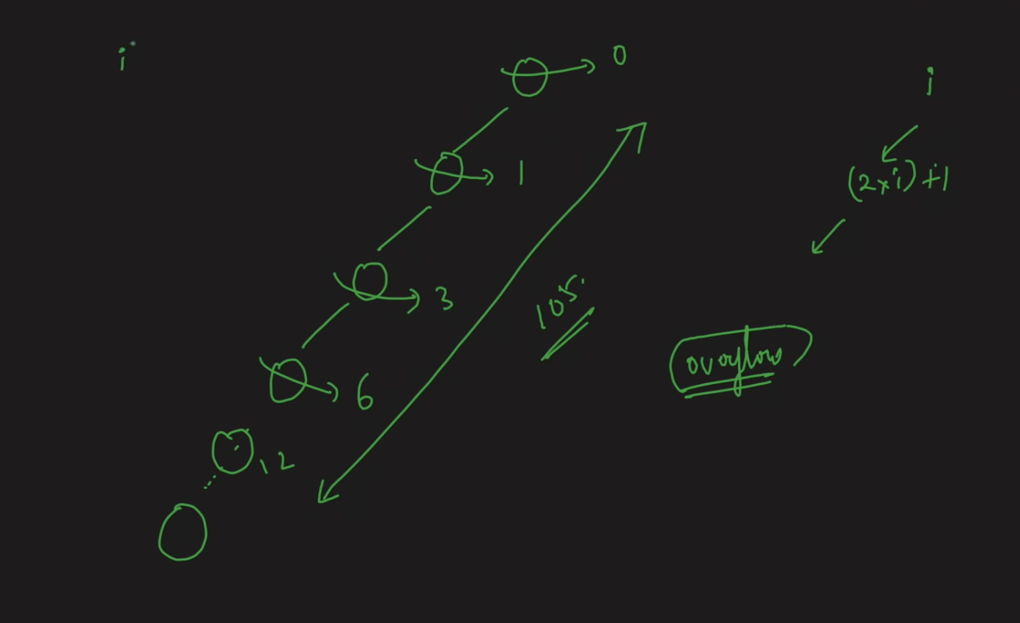

So instead of starting 2\*i+1 for left node of each lavel, if we start from 1 then there wont be overflow.To do this apply formula

Left Node : 2i

Right Node : 2i+1

