Gamma presentation content (English, brief)
Comparative Genomics
K-mer Analysis & GC Content across Five Genomes
Python · Biopython · SciPy · scikit-learn · Matplotlib/Seaborn
Upload this file to Gamma, or turn each heading + figure into one card.

1. Introduction
- NGS produces huge genomic datasets that need computational analysis.
- Two core signals: GC content (composition/stability proxies) and K-mers (alignment-free comparison).
- Goal: compare five assemblies using GC, k-mers, similarity, stats, and visualization.

2. Project goals
- Obtain genomes from a trusted source (NCBI)
- Compute and compare GC content
- Extract k-mer frequencies and Shannon entropy
- Relate species with statistics and ML (PCA / clustering)
- Visualize results and interpret biology carefully

3. Organisms we analyzed
The brief listed example species. Our working set is the five assemblies actually present in the repo (identified from FASTA headers / NCBI summaries):
Species | What it is | Why it matters here
C. elegans | Model nematode | Only brief match · largest genome (~100 Mb)
N. crassa | Filamentous fungus | Highest entropy · close to Y. lipolytica
Y. lipolytica | Industrial oleaginous yeast | Highest GC (~49%)
D. discoideum | Social amoeba (AT-rich) | Lowest GC/entropy · PCA outlier
E. coryli | Compact yeast/fungus | Smallest assembly (~9 Mb, scaffolds)

Data note: four files differed from the brief examples; we did not silently replace them.

4. Code pipeline (brief)
- Member 1: streaming GC + stats → member1_gc_analysis/
- Member 2: k-mer → entropy → similarity → PCA/Ward → TATA → plots
# GC
python scripts/student1_gc_analysis.py --input-dir data/raw --output-dir results
# K-mer pipeline (default k=4)
python scripts/kmer_analysis.py && python scripts/entropy.py && python scripts/similarity.py && python scripts/clustering.py && python scripts/tata_box.py && python scripts/visualization.py
GC% = 100 × (G+C) / (A+T+G+C) # N/ambiguous excluded from primary metric

5. Part 1 — Data collection
Species | Source | Accession | Assembly | Records | Size | File
C. elegans | NCBI | GCA_000002985.3 | WBcel235 | 6 chr | 100.27 Mb | 101.5 MB
N. crassa | NCBI | GCA_000182925.2 | NC12 | 7+extra | 41.10 Mb | 41.6 MB
Y. lipolytica | NCBI | GCA_001761485.1 | ASM176148v1 | 6+mt | 20.55 Mb | 20.8 MB
D. discoideum | NCBI | GCA_000004695.1 | dicty_2.7 | 6+unplaced | 34.13 Mb | 34.6 MB
E. coryli | NCBI | GCA_000710315.1 | E. coryli | 19 scaffolds | 9.09 Mb | 9.2 MB

- Source: NCBI Datasets FASTA
- Assembly labels and sizes extracted programmatically from headers/files

Genome size
C. elegans largest · E. coryli smallest
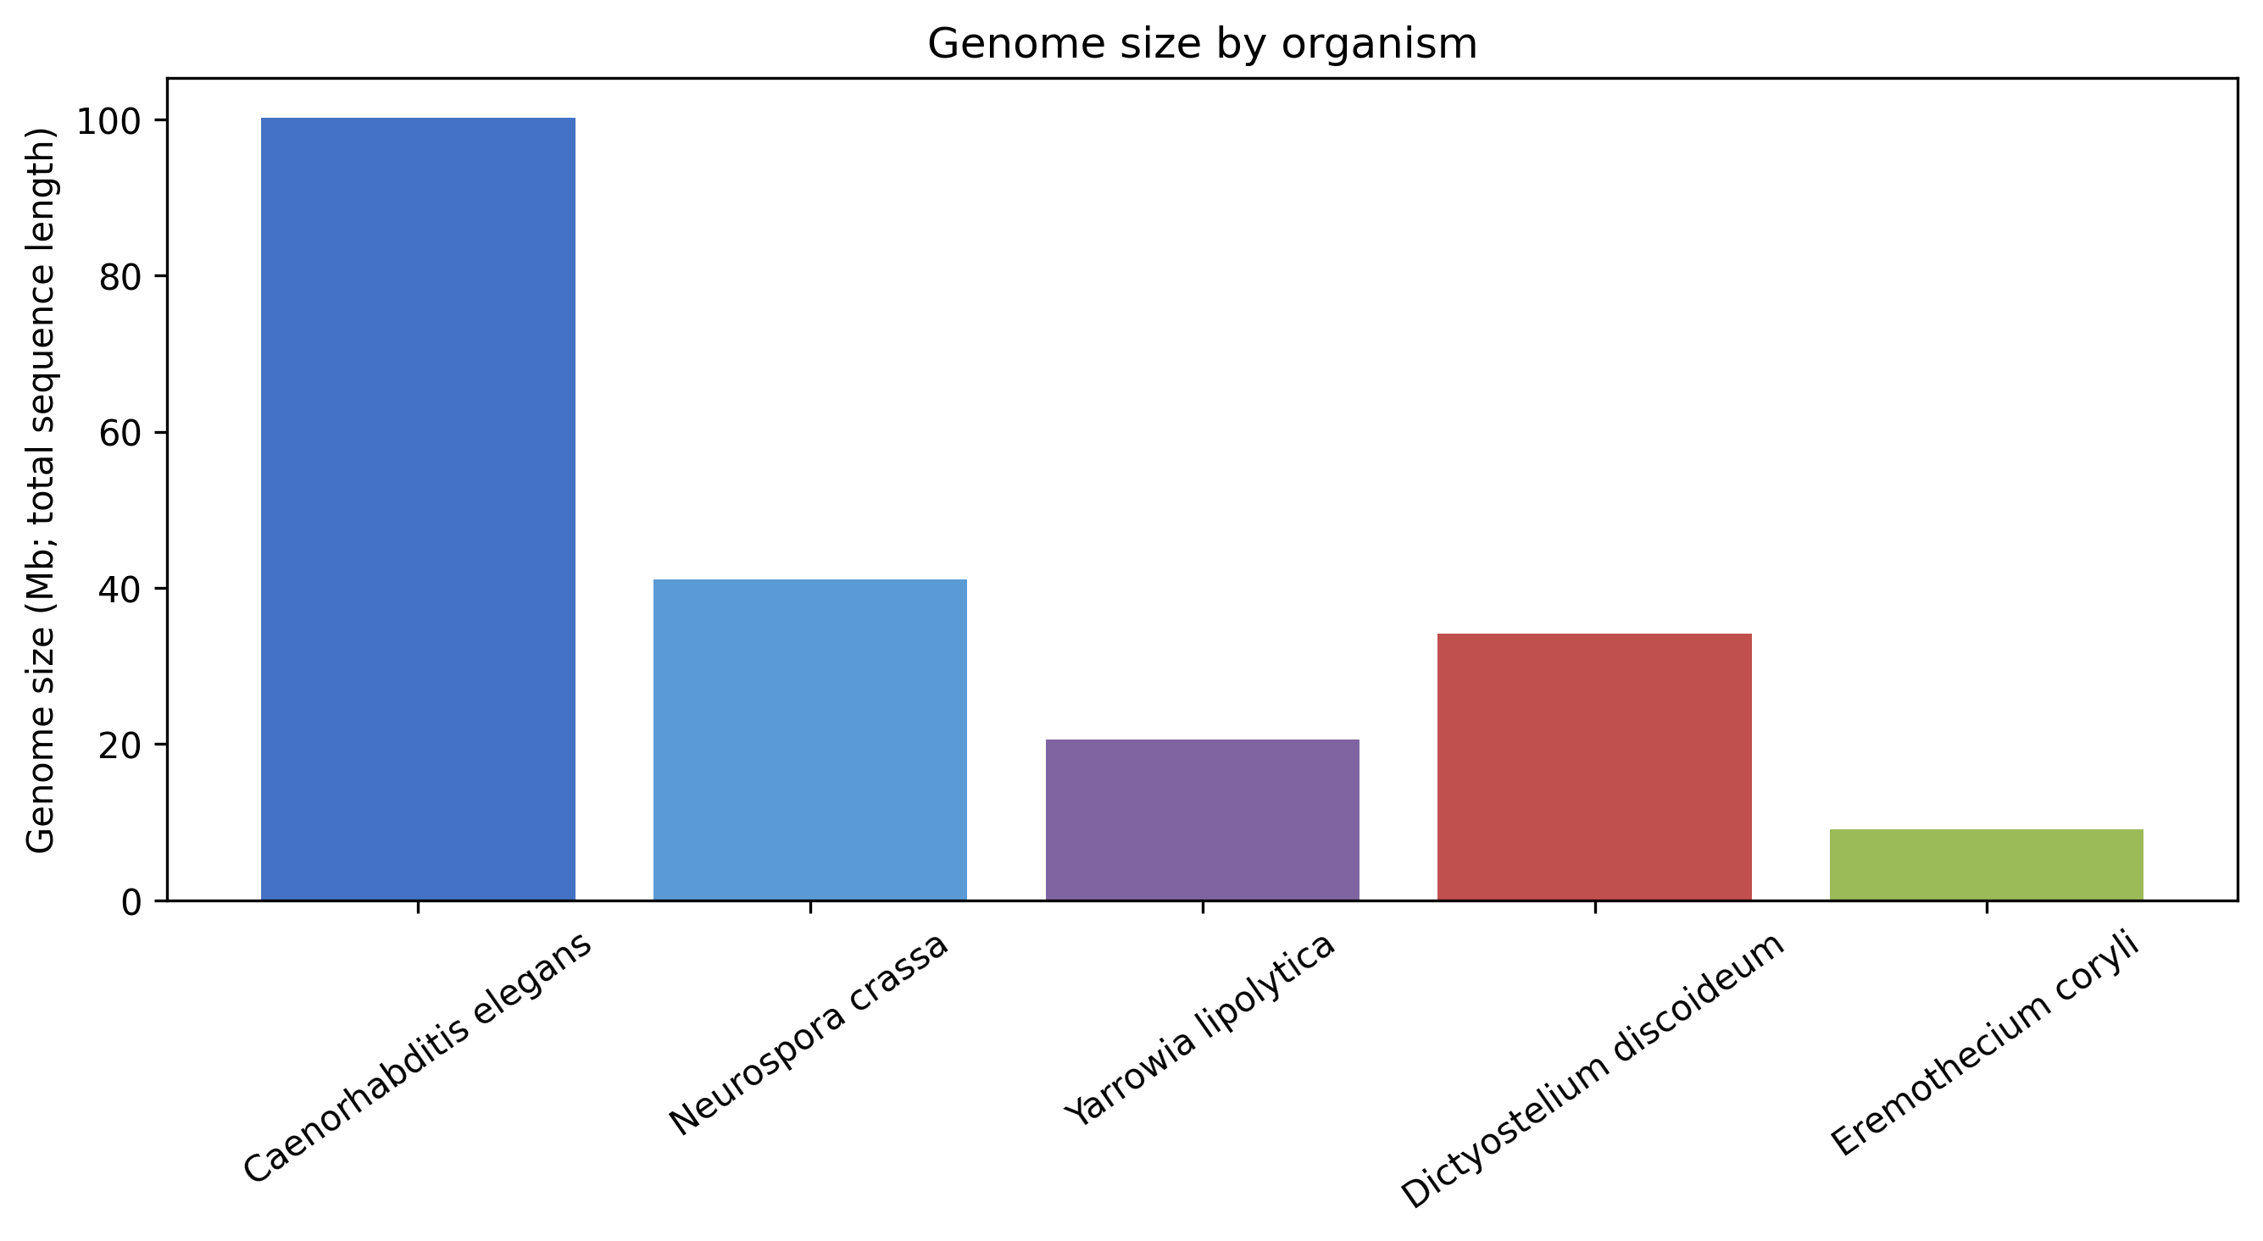

Major record lengths
Chromosomes/scaffolds vary widely in length
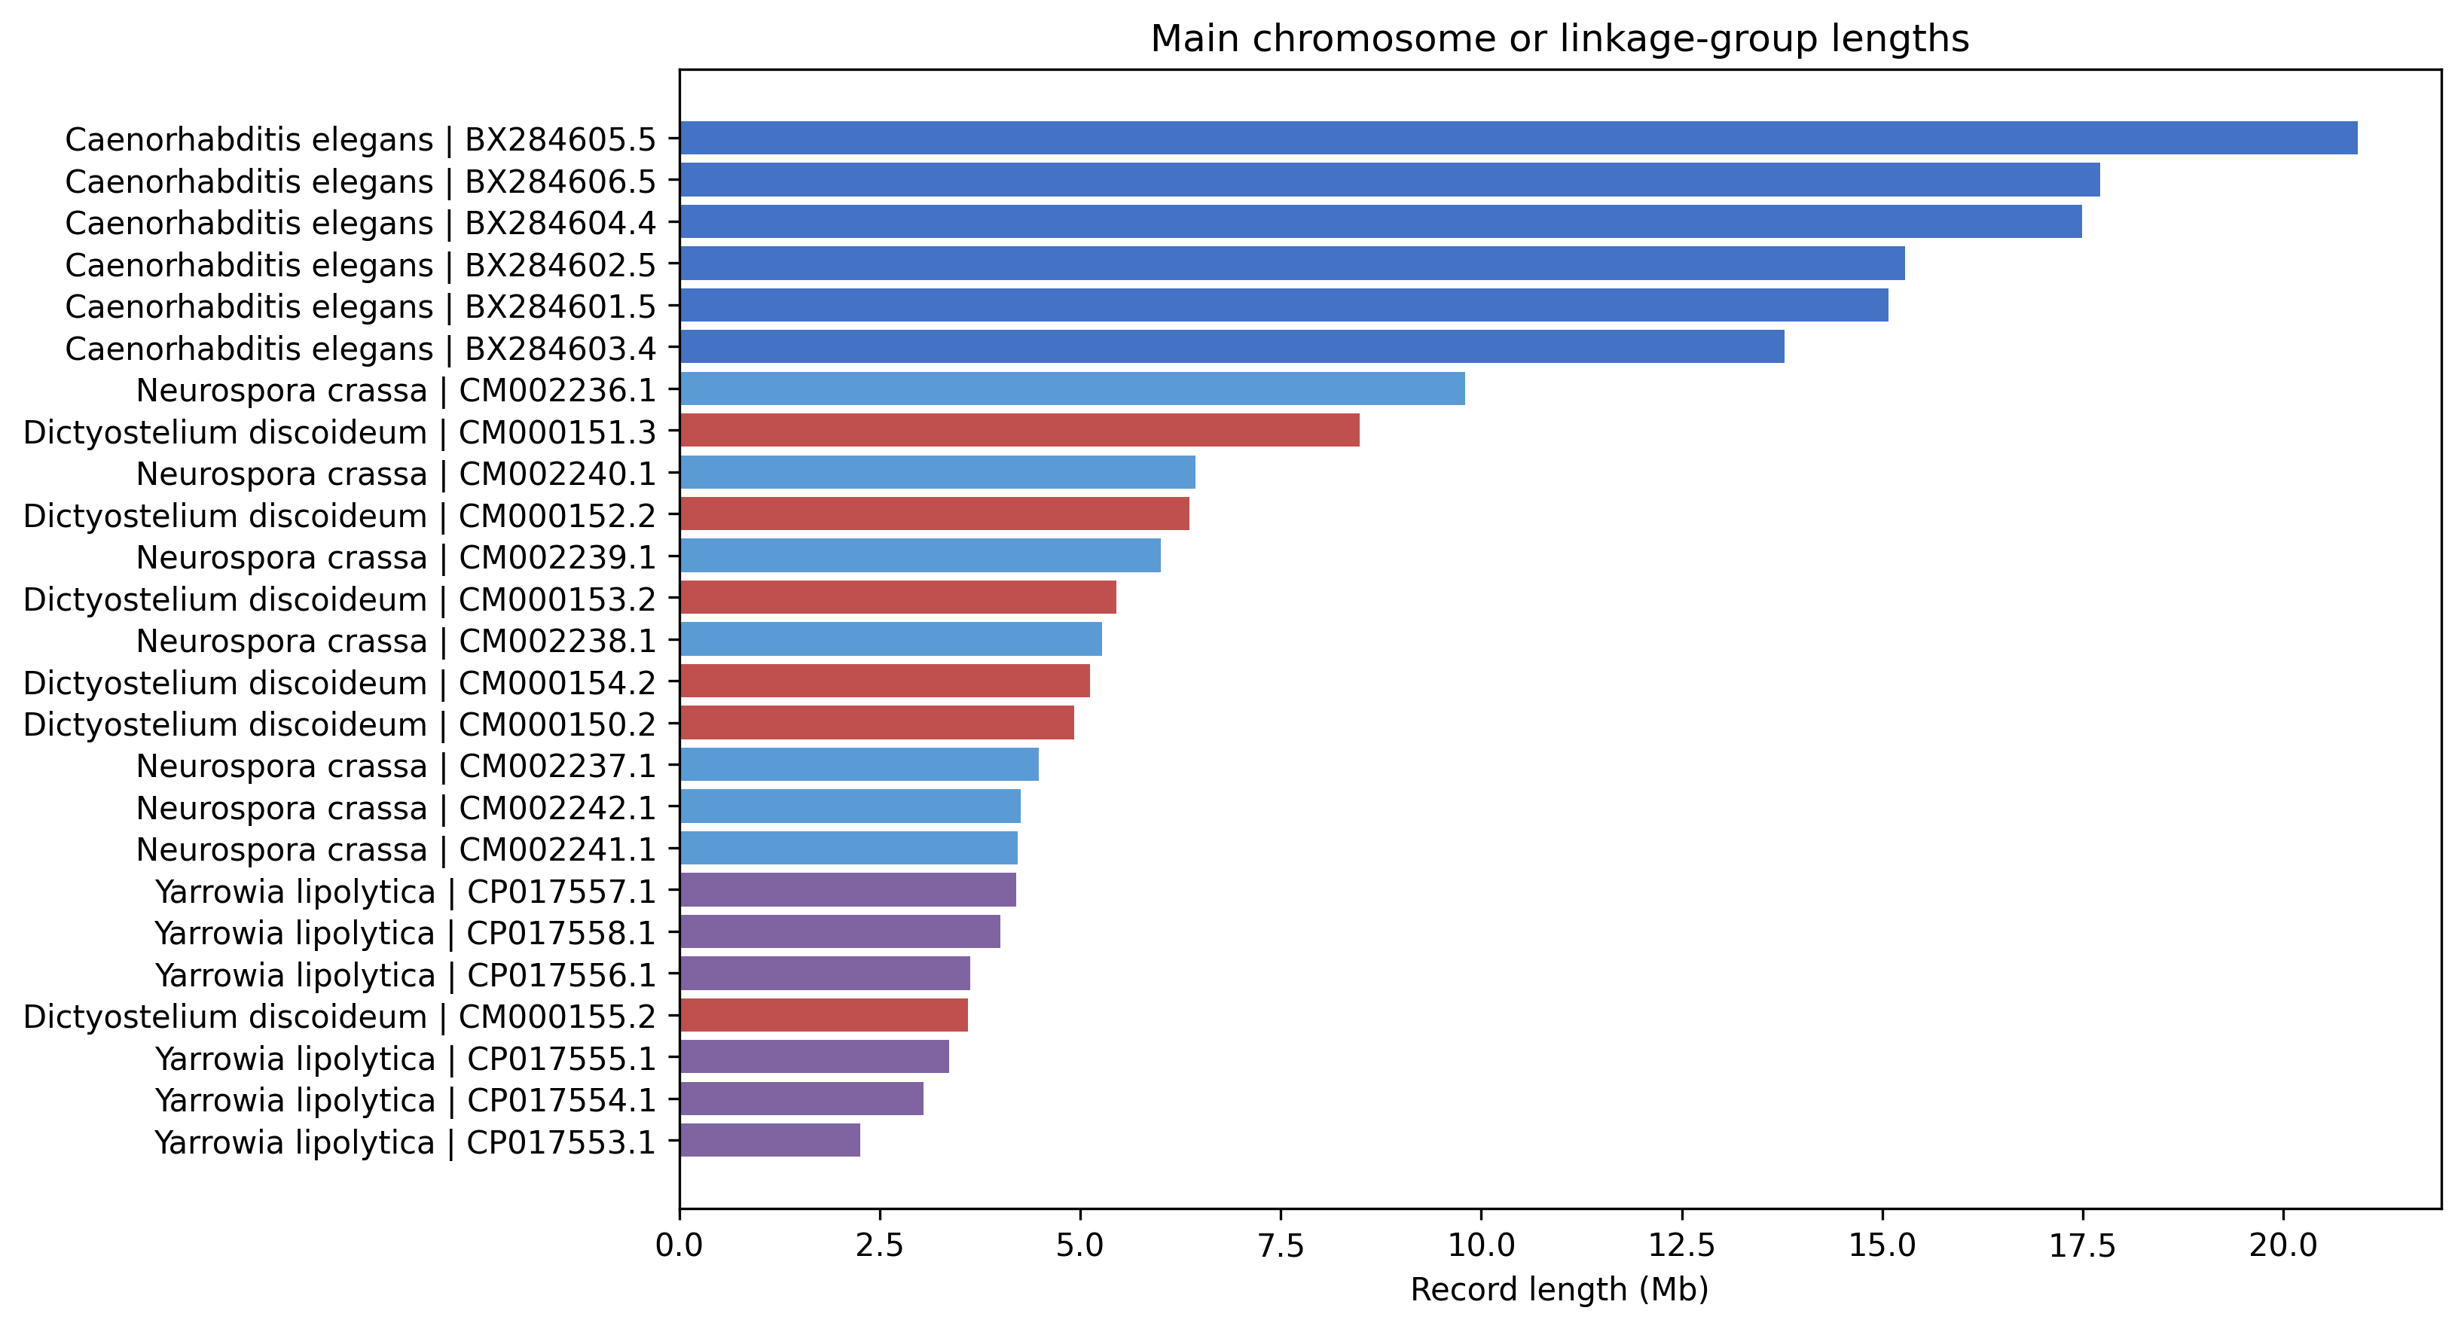

6. Part 2 — GC content
- GC: C. elegans 35.4% · N. crassa 48.2% · Y. lipolytica 49.0% · D. discoideum 22.4% · E. coryli 41.6%
- Highest: Y. lipolytica · Lowest: D. discoideum
- Size vs GC: Pearson r≈−0.25 (p≈0.69) · Spearman ρ≈−0.30 (p≈0.62) → no clear link at n=5
- Records within a species do not share one GC value

Whole-genome GC%
Highest yeast · lowest amoeba
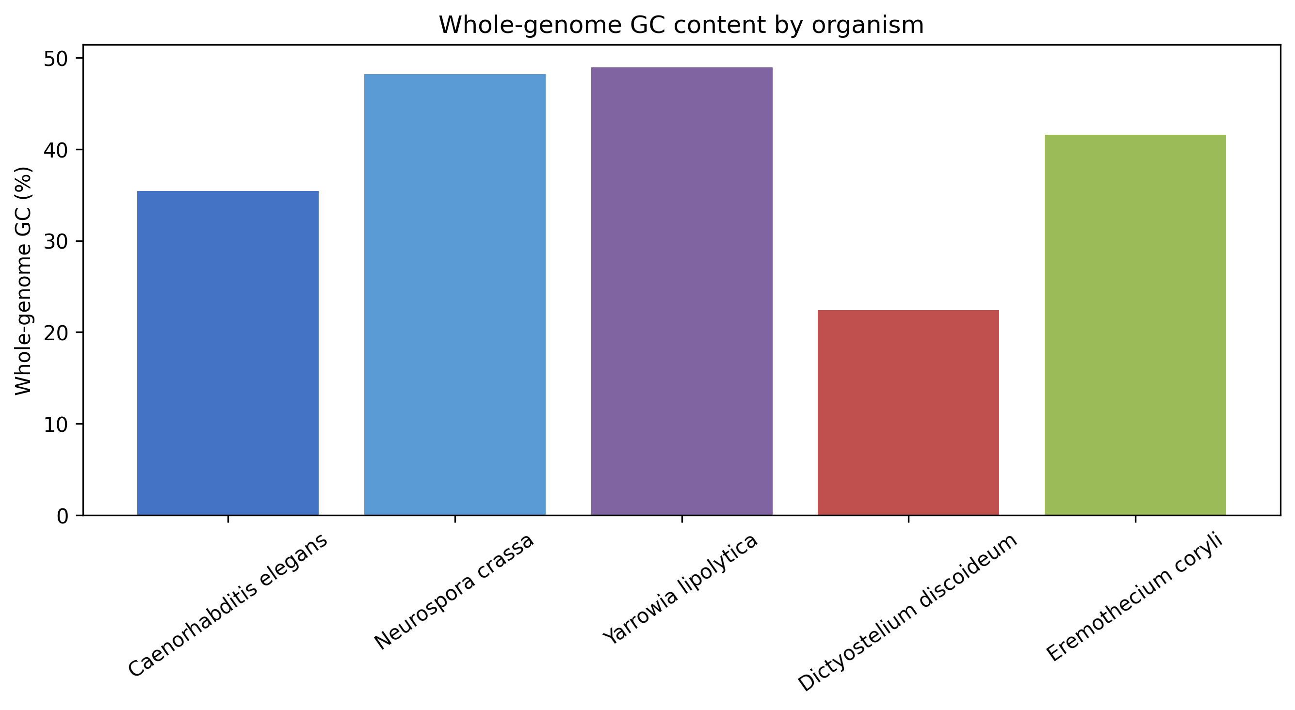

Size vs GC
Weak / non-significant at n=5
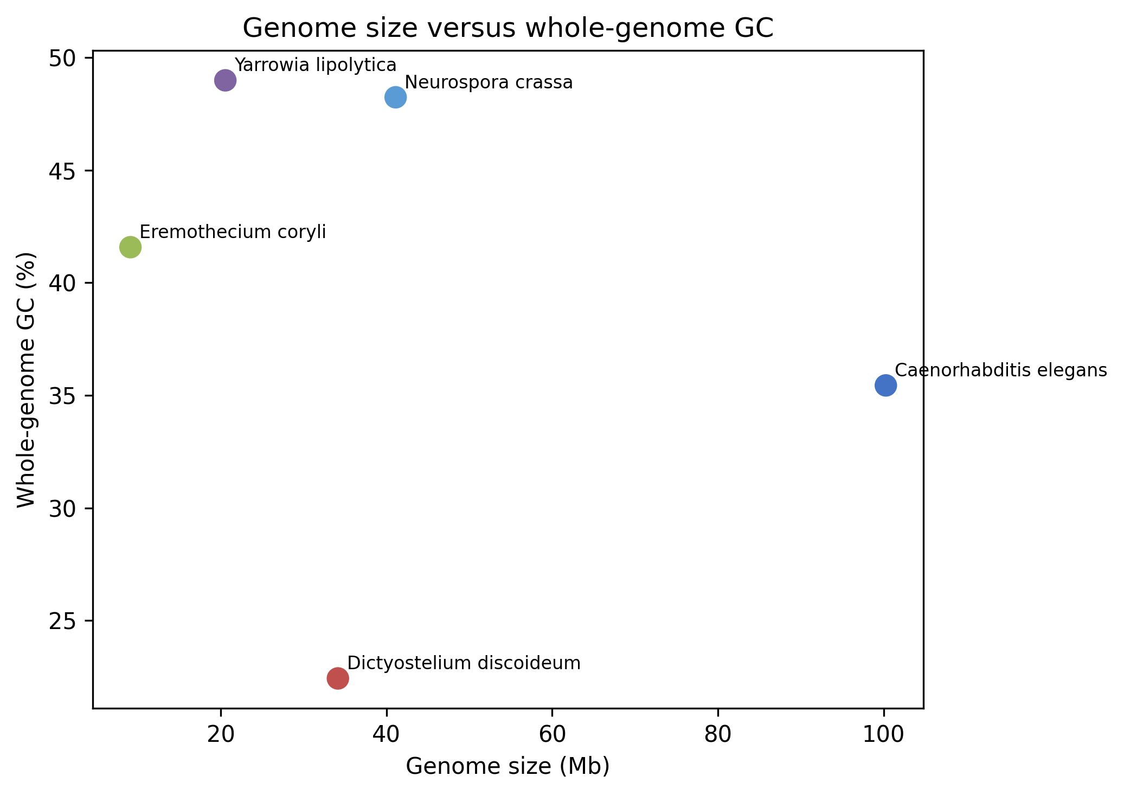

Trend line (descriptive)
Not a causal model
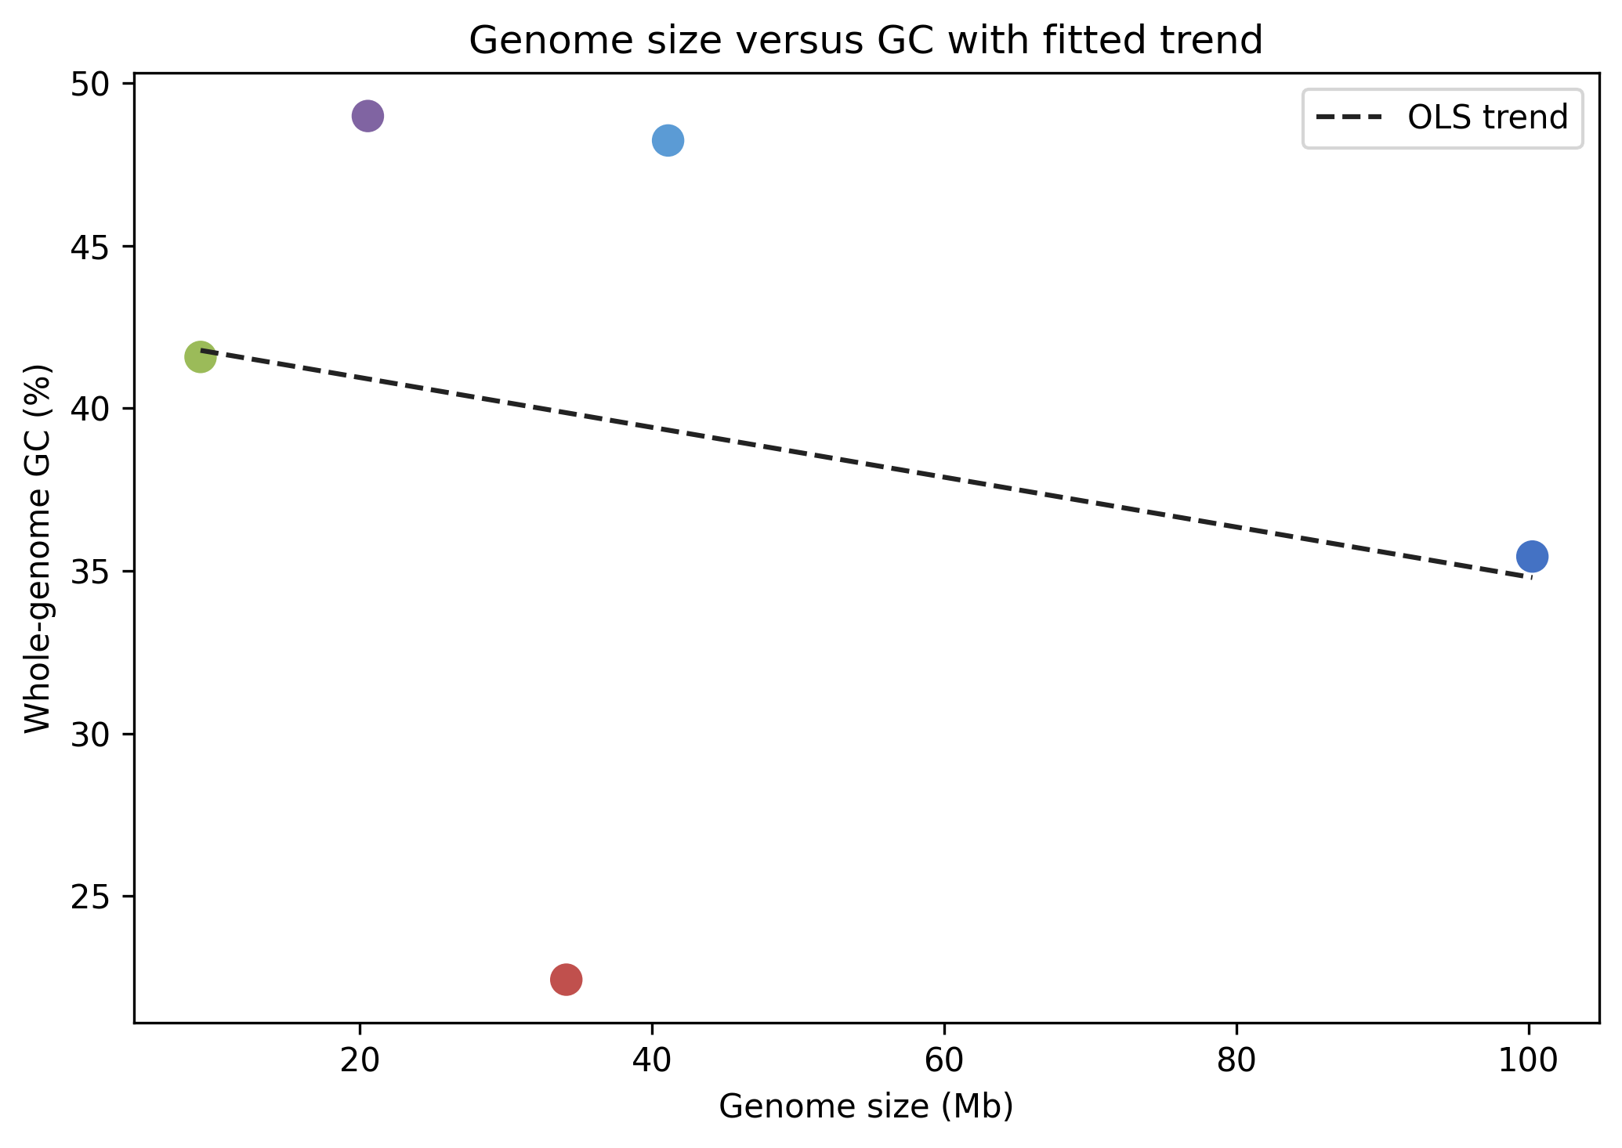

Record-level GC spread
Chromosomes are not identical
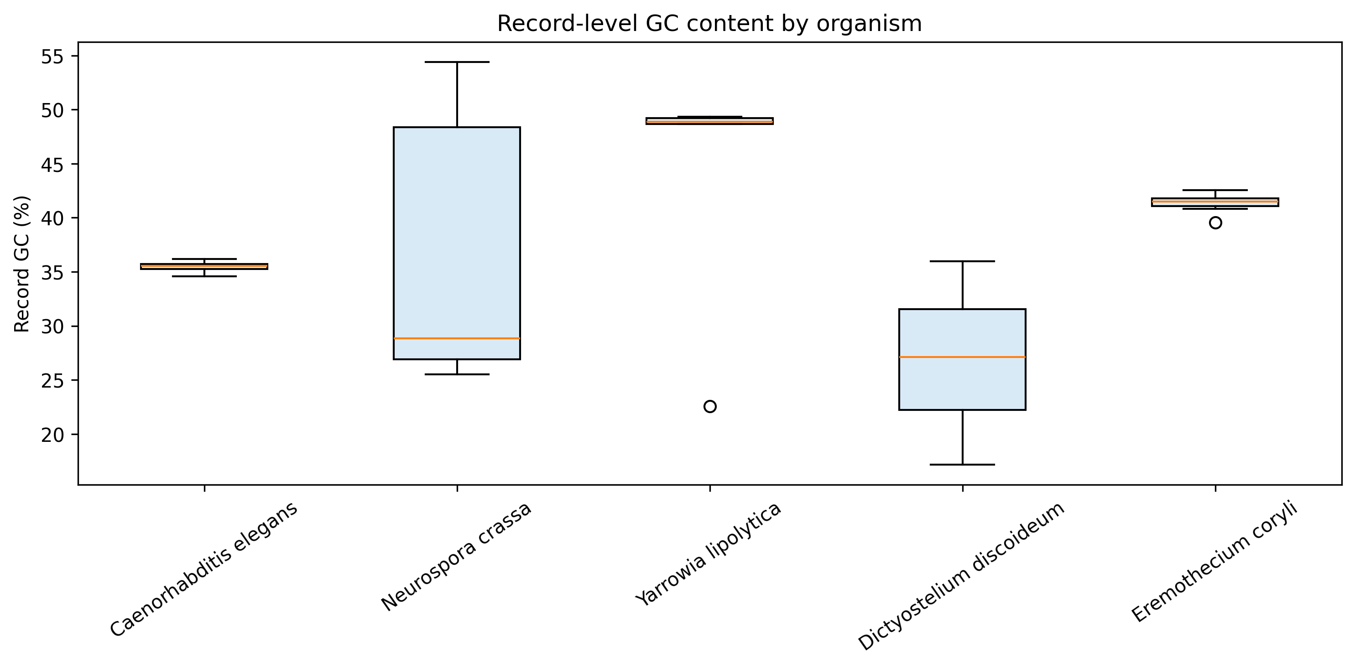

GC distributions
Shape differs by species
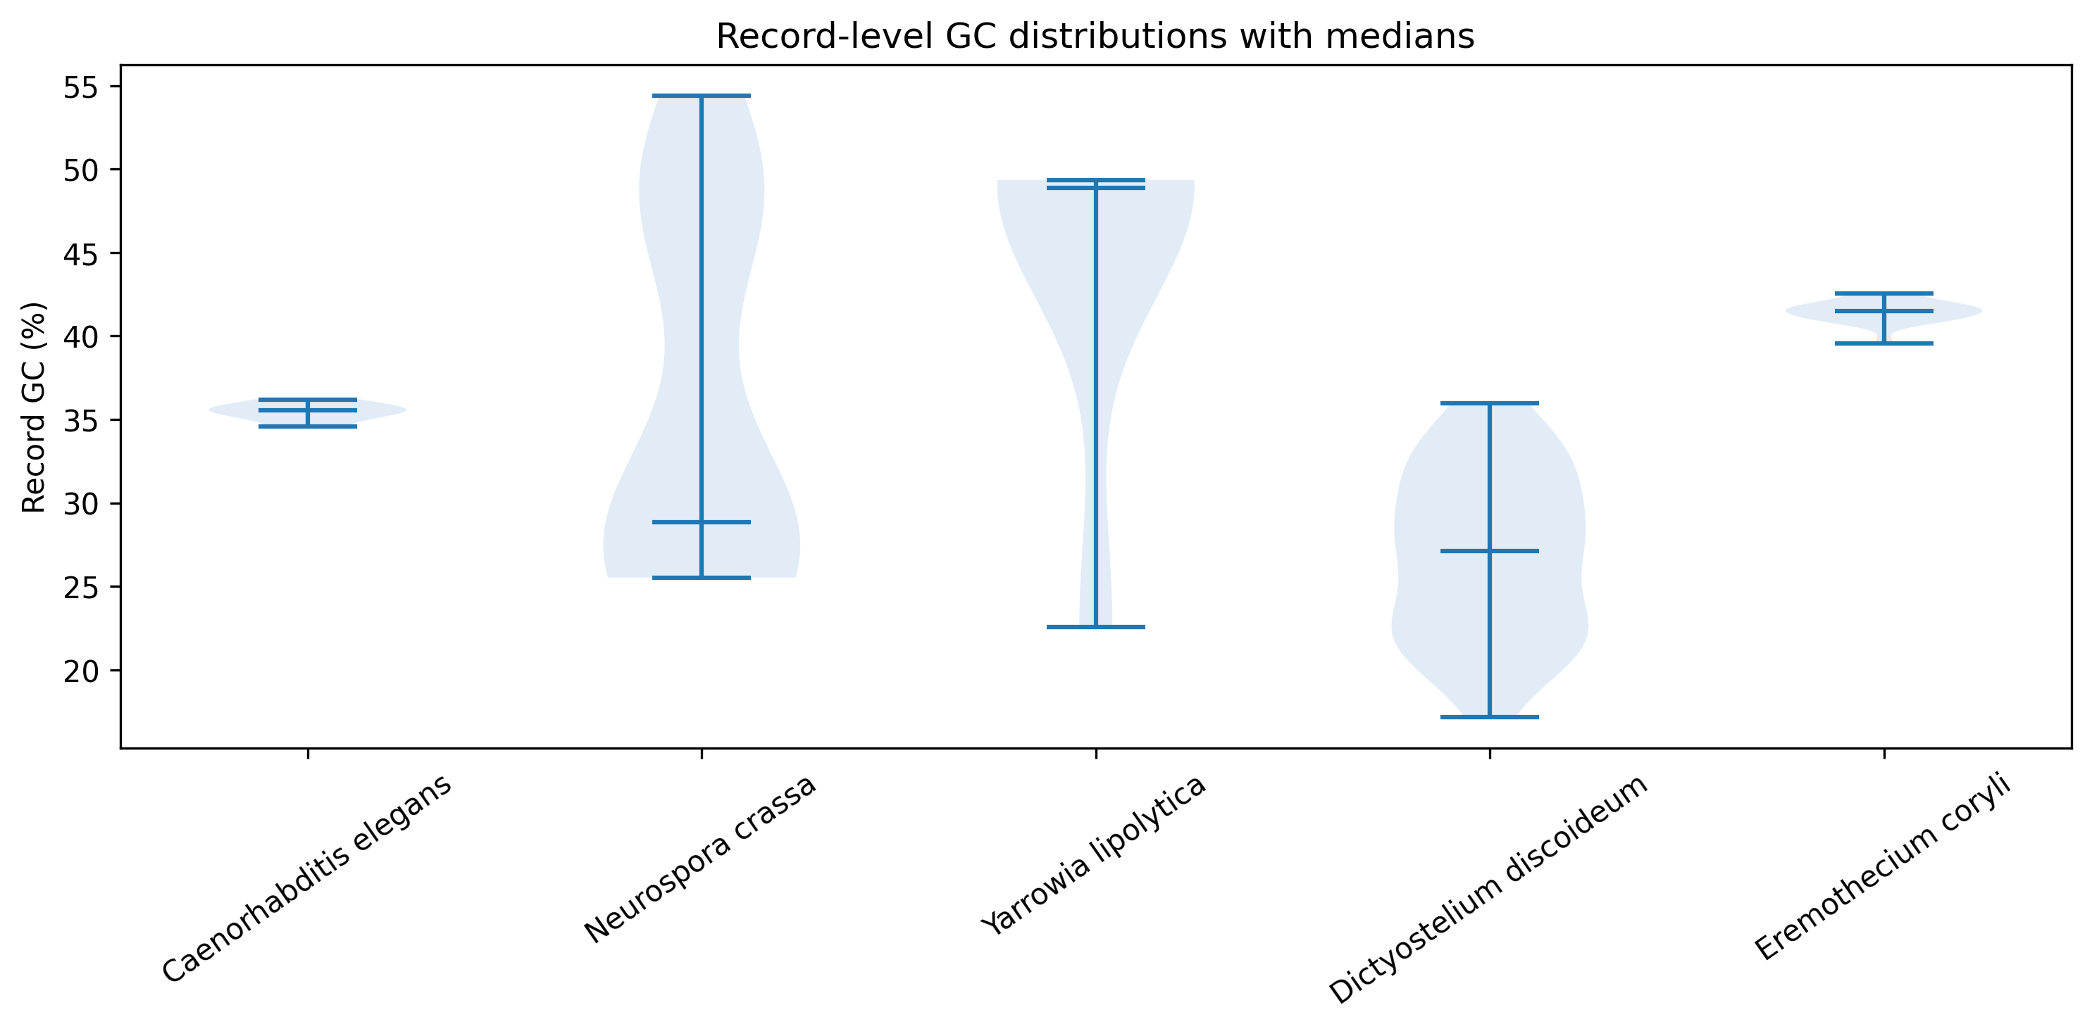

GC vs record length
Short vs long records differ
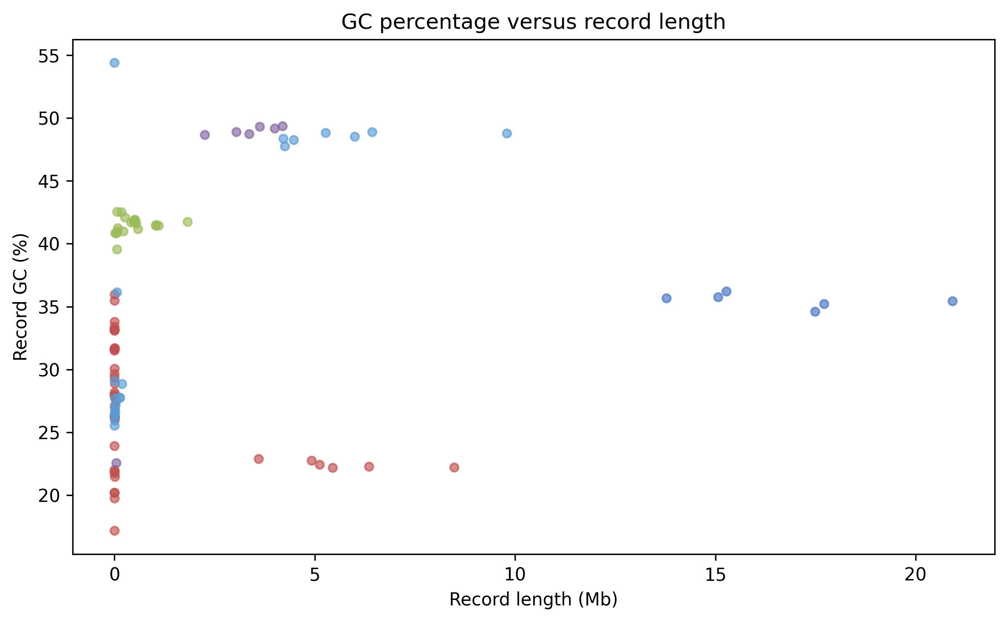

Main-chromosome GC
Sensitivity without scaffolds
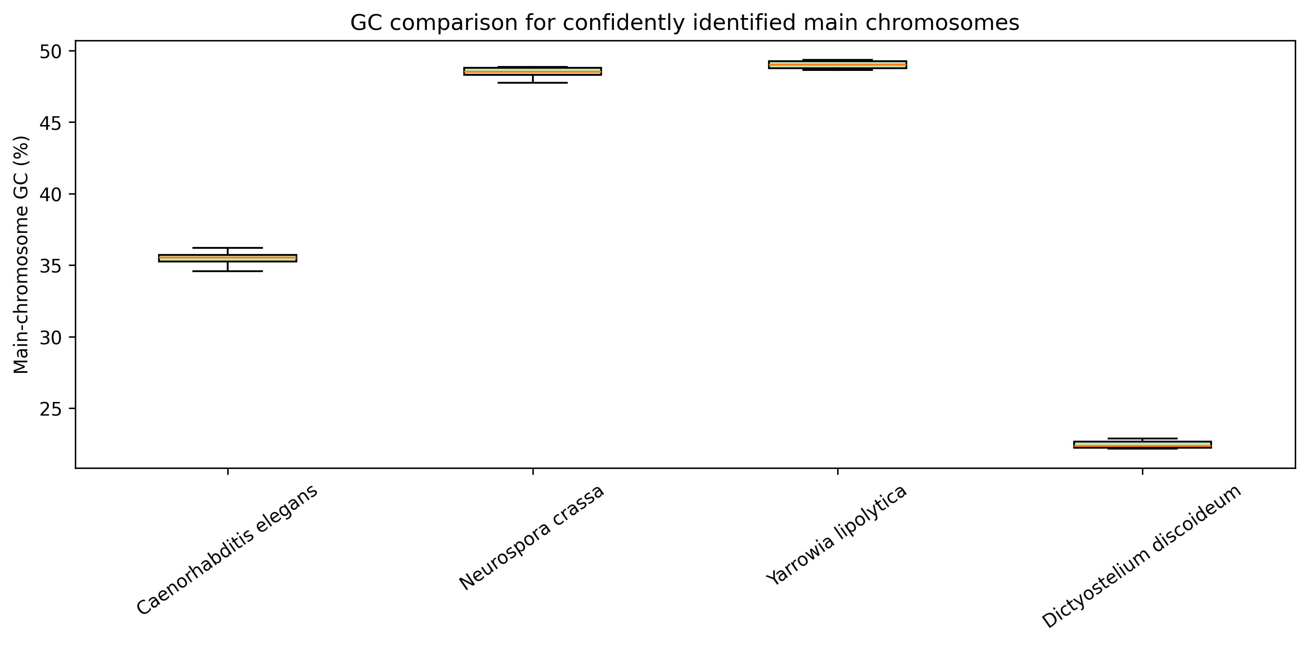

Nuclear vs organellar GC
Only where headers label organelles
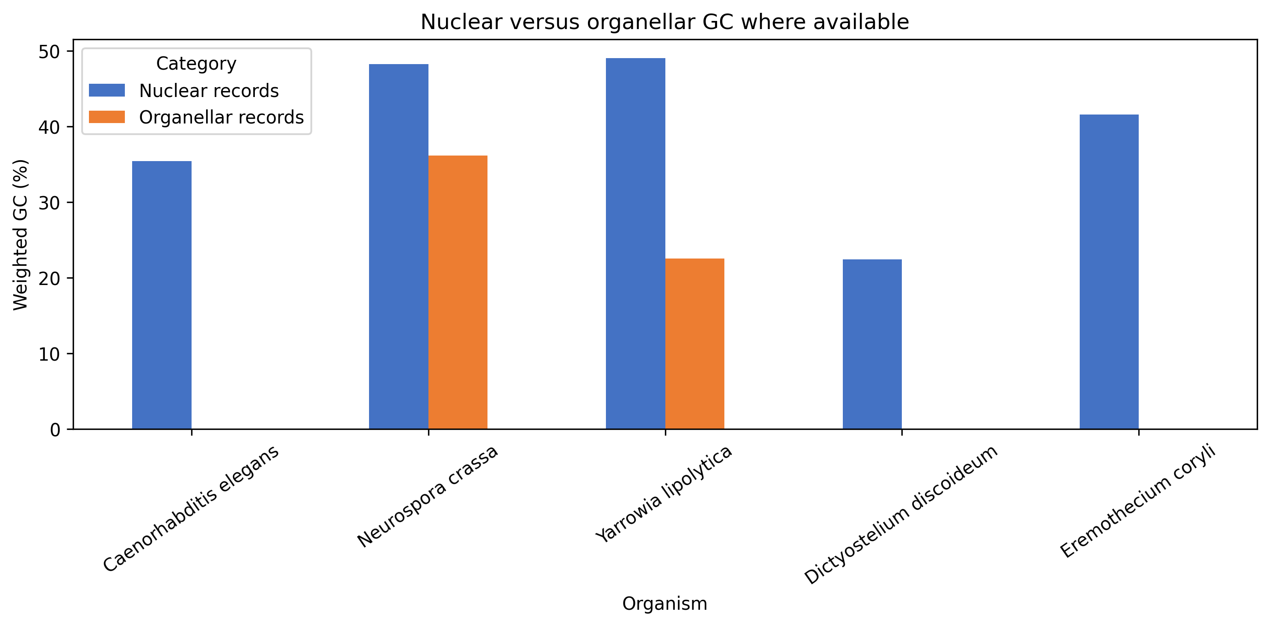

Ambiguous bases (N%)
Highest in E. coryli
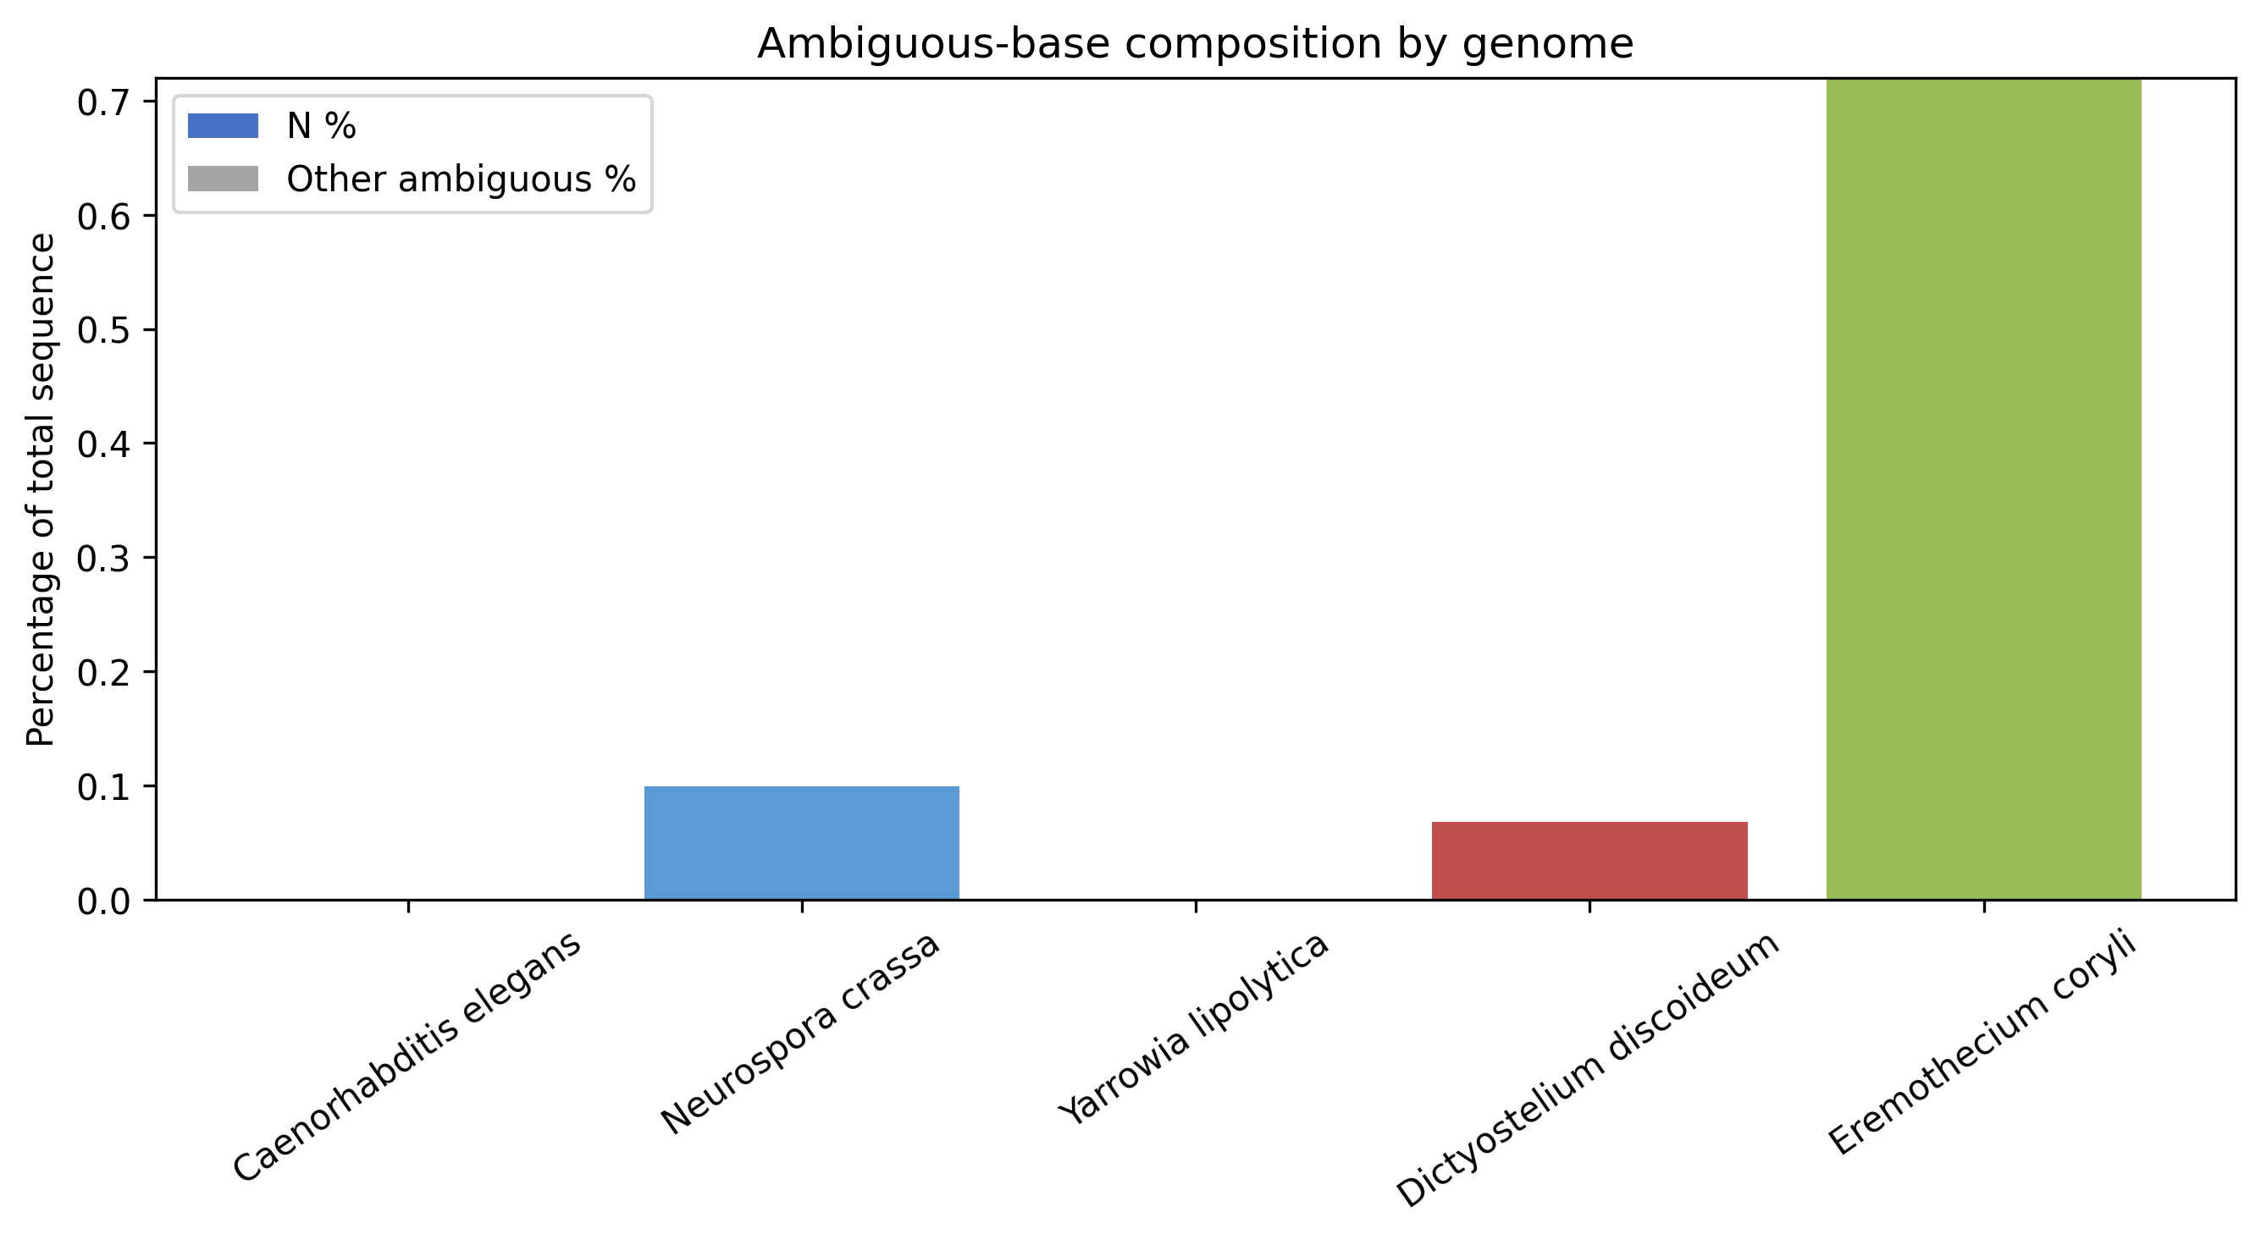

7. Part 3 — K-mers
- Primary analysis: k=4 (256 possible 4-mers); pipeline supports -k 3 / -k 5
- All species use all 256 4-mers → no species-exclusive 4-mer
- Most common 4-mer: AAAA (C. elegans, Dicty, E. coryli) or TTTT (fungi)
- Highest Shannon entropy: N. crassa (~7.97 bits) · lowest: D. discoideum (~6.92)
- Similar k-mer profiles suggest compositional closeness, not a formal phylogeny
Species | Unique 4-mers | Top 4-mer | Entropy (bits)
C. elegans | 256/256 | AAAA | 7.64
N. crassa | 256/256 | TTTT | 7.97
Y. lipolytica | 256/256 | TTTT | 7.95
D. discoideum | 256/256 | AAAA | 6.92
E. coryli | 256/256 | AAAA | 7.89

Shannon entropy
N. crassa highest · Dicty lowest
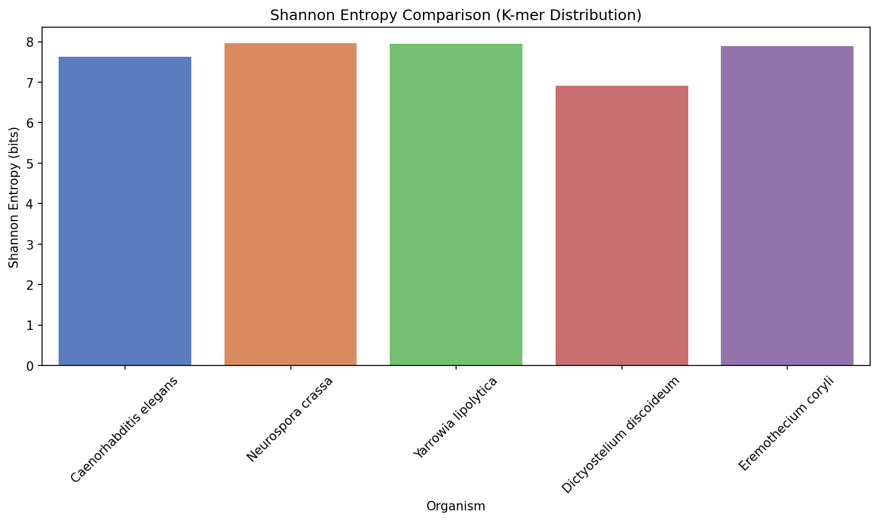

8. Part 4 — Similarity
- Closest pair: N. crassa–Y. lipolytica (distance≈0.015 · cosine≈0.97)
- Farthest from the fungi: D. discoideum
- Brief “animals vs plant” clustering not directly testable (those taxa were not in our files)
- Broad pattern fits biology: fungi cluster · amoeba separates — still not a formal tree

Euclidean distance heatmap
Fungal pair closest
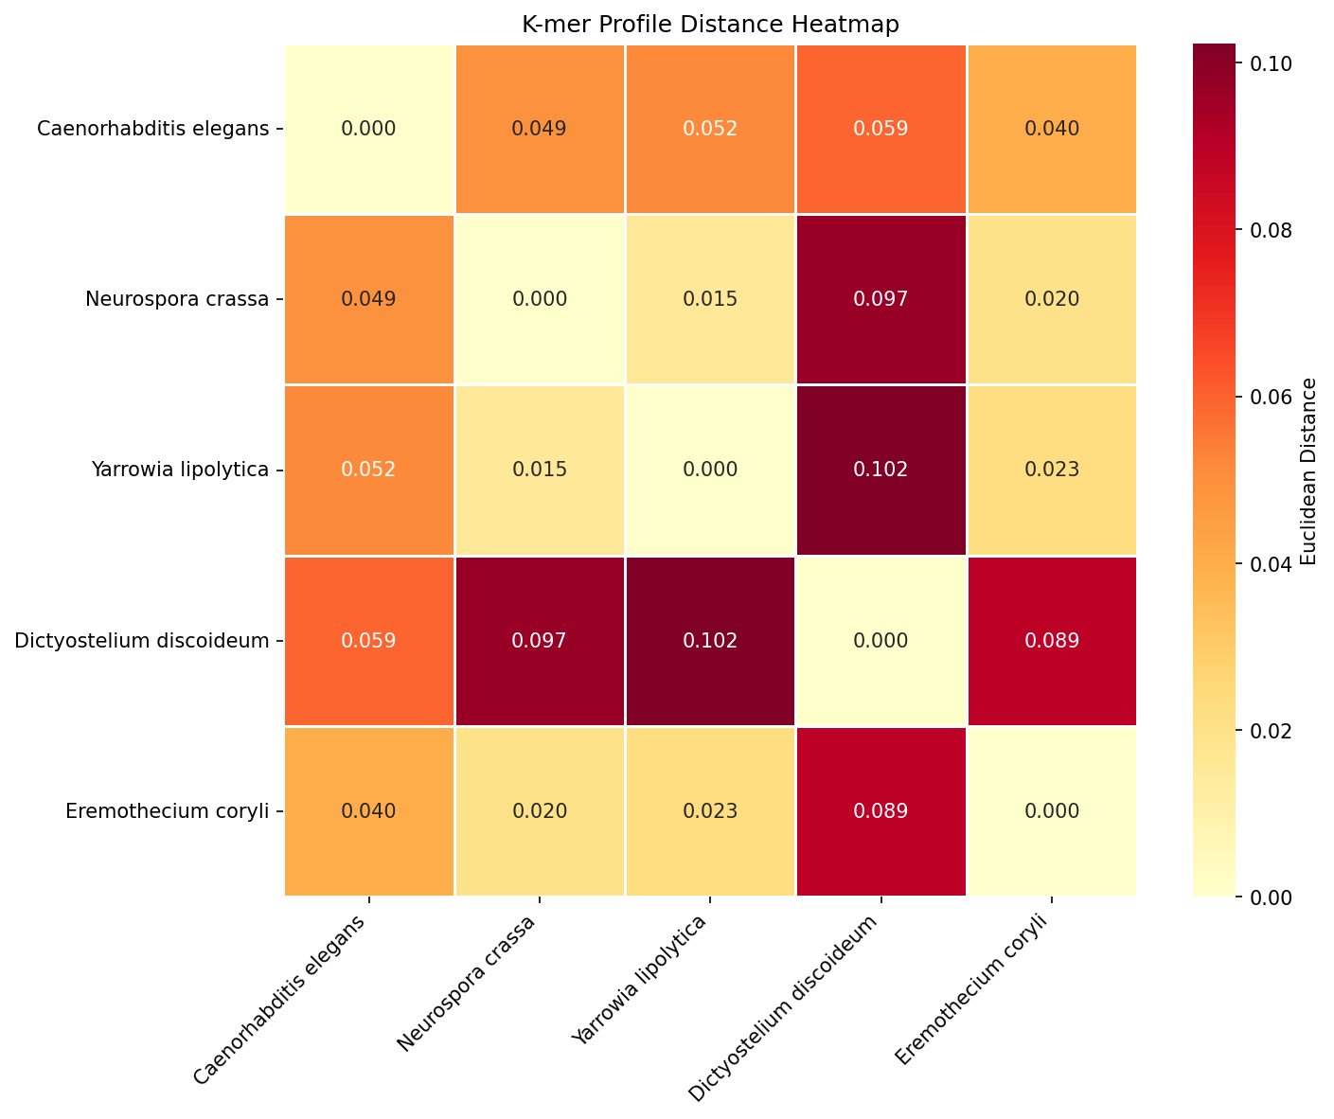

Cosine similarity
Fungal cosine ≈ 0.97
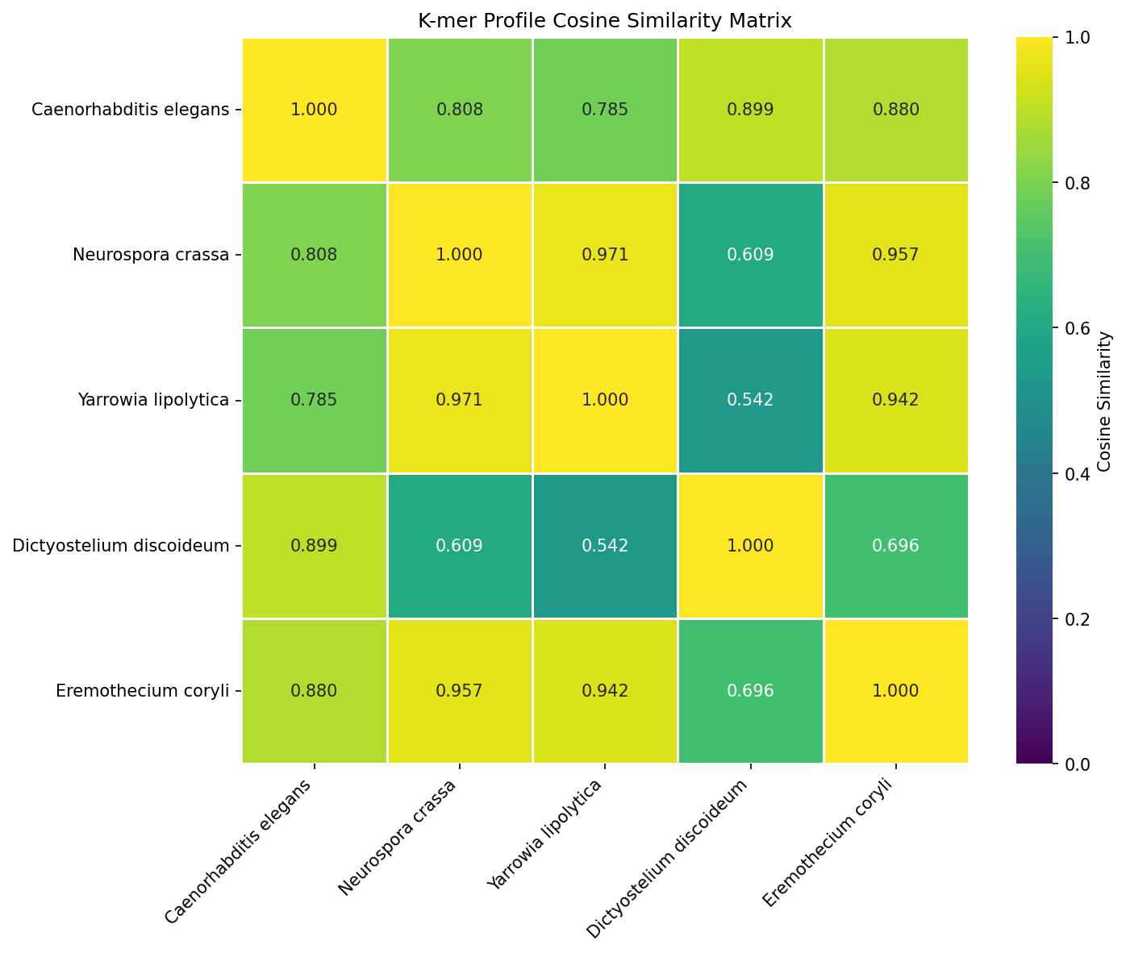

PCA of k-mer profiles
PC1≈70% · Dicty outlier
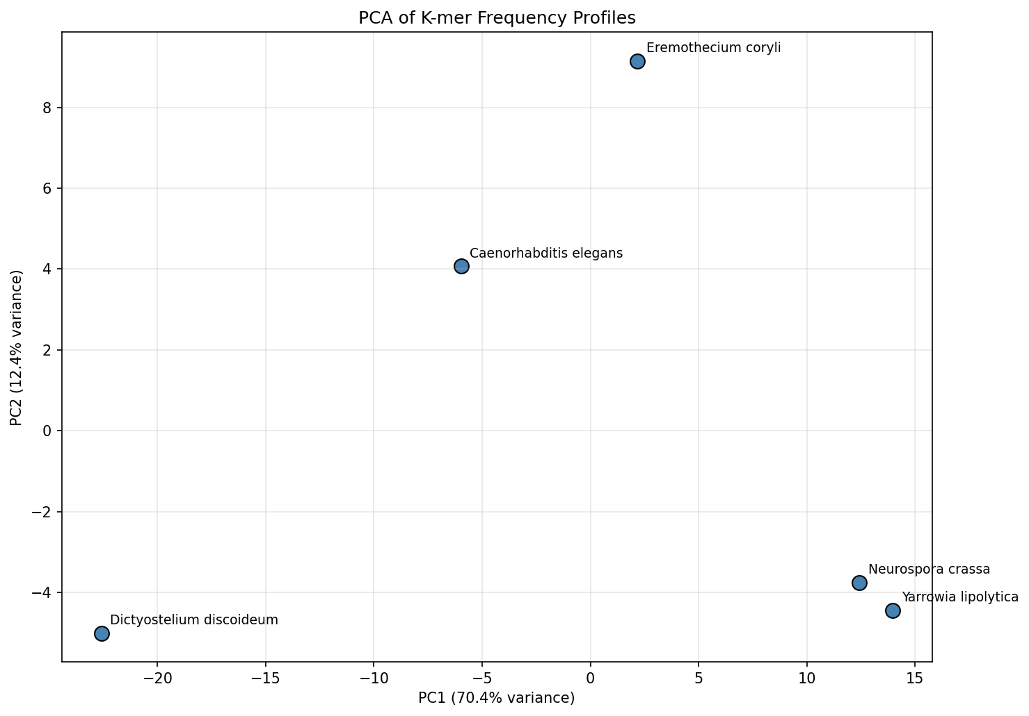

Ward dendrogram
Fungal cluster confirmed
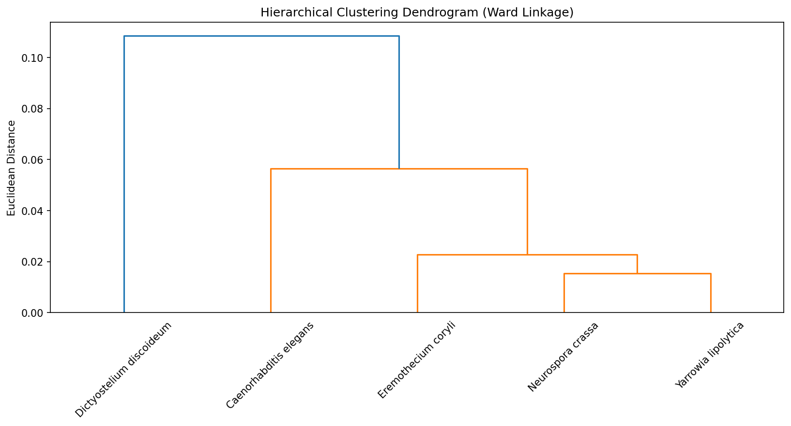

9. Part 5 — Statistics
- Record-level GC differs among species (Kruskal–Wallis / ANOVA) — interpret with nested-record caution
- Entropy differs descriptively across species
- At k=4, unique-count diversity is saturated (256/256); entropy is the better complexity signal
- Low GC in Dicty aligns with low entropy and AAAA dominance

Feature correlation matrix
Organism-level relationships
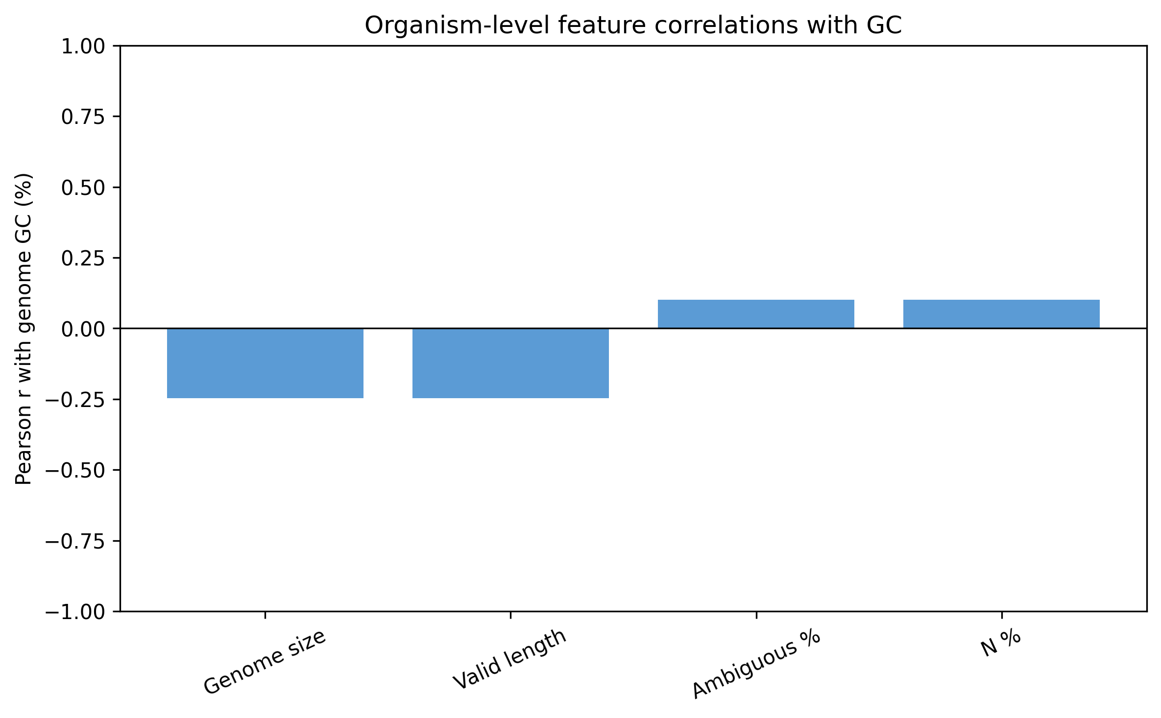

Q-Q diagnostics
Assumption checks before ANOVA
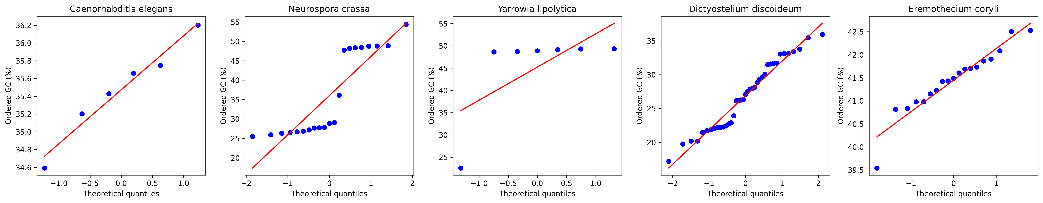

10. Part 6 — TATA box
- Scan: first 500 bp of concatenated assembly for TATAAA (+ variants)
- Hits: N. crassa 5 · D. discoideum 2 · others 0 canonical in-window
- Cannot report % of genes with TATA (no full gene/TSS annotation used)
- Expression questions need RNA-seq — out of scope
- Absence in a 500 bp window ≠ absence genome-wide

11. Takeaways
- GC extremes: Y. lipolytica high · D. discoideum low
- K-mer space: fungi closest · Dicty separates in PCA/dendrogram
- Stats support GC differences but n=5 limits Size–GC claims
- Transparent about data identity and method limits
Thank you — questions?

