Hive Activity1:

Dialogue iv:

Total MapReduce CPU Time Spent: 18 seconds 70 msec

OK

LUKE 253

HAN 152

THREEPIO 119

BEN 76

LEIA 57

VADER 41

RED LEADER 36

BIGGS 34

TARKIN 28

OWEN 25

TROOPER 19

WEDGE 14

GOLD LEADER 14

OFFICER 11

GOLD FIVE 7

RED TEN 7

AUNT BERU 6

INTERCOM VOICE 6

JABBA 6

FIRST TROOPER 6

DODONNA 6

DEATH STAR INTERCOM VOICE 6

BEN'S VOICE 6

GREEDO 6

TAGGE 4

HUMAN 4

MOTTI 4

VOICE 3

COMMANDER 3

SECOND TROOPER 3

BARTENDER 3

MASSASSI INTERCOM VOICE 3

CAMIE 2

CHIEF 2

WILLARD 2

FIXER 2

GANTRY OFFICER 2

GOLD TWO 2

IMPERIAL OFFICER 2

WOMAN 1

WINGMAN'S VOICE 1

WINGMAN 1

VOICE OVER DEATH STAR INTERCOM 1

TROOPER VOICE 1

TECHNICIAN 1

STAR WARS - EPISODE 4: STAR WARS 1

SECOND OFFICER 1

RED TEN'S VOICE 1

RED SEVEN 1

RED NINE'S VOICE 1

RED NINE 1

RED LEADER'S VOICE 1

RED ELEVEN 1

REBEL OFFICER 1

PORKINS 1

OFFICER CASS 1

MAN'S VOICE 1

LUKE'S VOICE 1

HAN'S VOICE 1

FIRST OFFICER 1

DEAK 1

CREATURE 1

CONTROL OFFICER 1

CHIEF PILOT 1

CAPTAIN 1

BERU 1

BASE VOICE 1

ASTRO-OFFICER 1

1

Time taken: 60.494 seconds, Fetched: 69 row(s)

Dialogue v:

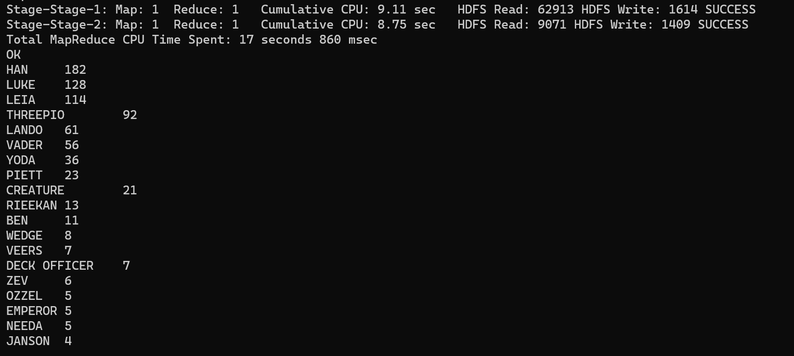

Total MapReduce CPU Time Spent: 17 seconds 860 msec

OK

HAN 182

LUKE 128

LEIA 114

THREEPIO 92

LANDO 61

VADER 56

YODA 36

PIETT 23

CREATURE 21

RIEEKAN 13

BEN 11

WEDGE 8

VEERS 7

DECK OFFICER 7

ZEV 6

OZZEL 5

EMPEROR 5

NEEDA 5

JANSON 4

DACK 4

BEN'S VOICE 4

BOBA FETT 4

ANNOUNCER 3

DERLIN 3

TRENCH OFFICER 3

CONTROLLER 3

COMMUNICATIONS OFFICER 2

TRACKING OFFICER 2

MEDICAL DROID 2

SENIOR CONTROLLER 2

INTERCOM VOICE 2

LIEUTENANT 2

IMPERIAL OFFICER 2

SECOND CONTROLLER 1

REBEL FIGHTER 1

REBEL CAPTAIN 1

PILOTS 1

PILOT 1

SECOND OFFICER 1

OFFICER 1

MAN'S VOICE 1

SECOND THREEPIO 1

STAR WARS - EPISODE 5: THE EMPIRE STRIKES BACK 1

IMPERIAL SOLDIER 1

HOBBIE 1

HEAD CONTROLLER 1

STRANGE VOICE 1

FIRST CONTROLLER 1

CAPTAIN 1

WOMAN CONTROLLER 1

ASSISTANT OFFICER 1

1

Time taken: 60.788 seconds, Fetched: 52 row(s)

Dialogue:VI

Total MapReduce CPU Time Spent: 19 seconds 300 msec

OK

HAN 104

LUKE 100

THREEPIO 84

LEIA 51

VADER 37

LANDO 35

EMPEROR 31

JABBA (in Huttese subtitled) 15

BEN 14

ACKBAR 11

WEDGE 10

YODA 10

COMMANDER 7

JERJERROD 6

PIETT 6

BOUSHH 5

BIB 5

NINEDENINE 5

STORMTROOPER 5

JABBA 4

REBEL PILOT 3

HAN (cont) 3

MON MOTHMA 2

BOUSHH (in Ubese subtitled) 2

GENERAL MADINE 2

ACKBAR (VO) 2

CONTROLLER (over radio) 2

GUARD 2

CONTROLLER 2

SHUTTLE CAPTAIN 2

SCOUT #1 2

YODA (tickled, chuckles) 1

YODA (shakes his head) 1

YODA (gathering all his strength) 1

Y-WING PILOT 1

WEDGE (VO) 1

WALKER PILOT #1 1

VOICE (OS) 1

VADER (turning to face him) 1

VADER (skeptical) 1

VADER (indicating lightsaber) 1

VADER (bows) 1

VADER (after a beat) 1

VADER (a whisper) 1

THREEPIO (to Wicket) 1

THREEPIO (to Artoo) 1

THREEPIO (still shaken) 1

THREEPIO (instantly) 1

THREEPIO (disappearing) 1

THREEPIO (cont) 1

STRANGE VOICE 1

STORMTROOPER (OS) 1

STAR WARS - EPISODE 6: RETURN OF THE JEDI 1

SECOND COMMANDER 1

SCOUT #l 1

SCOUT #2 1

SCOUT 1

RED TWO 1

RED THREE 1

RED LEADER (VO) 1

PILOT VOICE (HAN)(filtered) 1

PILOT #2 1

PILOT 1

PIETT (surprised) 1

PIETT (into comlink) 1

OPERATOR 1

OOLA 1

OFFICER 1

NINEDENINE (to a Gamorrean guard) 1

NAVIGATOR 1

MON MOTHMA (cont) 1

LURE 1

LUKE (with sadness) 1

LUKE (turning away, derisive) 1

LUKE (to Leia) 1

LUKE (shrugging it off) 1

LUKE (sarcastic) 1

LUKE (pointing to the controls) 1

LUKE (moving to his ship) 1

LUKE (indicating the one ahead) 1

LUKE (hesitant) 1

LUKE (groans) 1

LUKE (cont) 1

LUKE (concerned) 1

LEIA (to Han) 1

LEIA (softly) 1

LEIA (over comlink) 1

LEIA (into comlink) 1

LEIA (alarmed) 1

LANDO (to himself) 1

LANDO (smiling) 1

LANDO (over comlink) 1

LANDO (into comlink) 1

LANDO (desperately) 1

JERJERROD (aghast) 1

JABBA (cont Huttese subtitled) 1

HAN/PILOT (VO) 1

HAN and LUKE 1

HAN (with self-confident grin) 1

HAN (whispering to himself) 1

HAN (turning to Luke) 1

HAN (to Luke) 1

HAN (to Leia) 1

HAN (smiles) 1

HAN (sighs) 1

HAN (sarcastic) 1

HAN (over comlink) 1

HAN (loses his temper) 1

HAN (looks at him warmly) 1

HAN (grins) 1

HAN (gravely) 1

HAN (chuckles) 1

HAN (blinking) 1

HAN (angry) 1

HAN (OS) 1

GREEN LEADER 1

GRAY LEADER 1

EMPEROR (very cool) 1

EMPEROR (to Vader) 1

EMPEROR (to Luke) 1

EMPEROR (no surprise) 1

EMPEROR (laughs) 1

EMPEROR (laughing) 1

EMPEROR (cont) 1

EMPEROR (angry) 1

DEATH STAR CONTROLLER(filtered VO) 1

CONTROLLER (filtered) 1

CONTROL ROOM COMMANDER 1

BUNKER COMMANDER 1

BIB (in Huttese subtitled) 1

BEN (grinning at Luke's indignation) 1

BEN (continuing his narrative) 1

BEN (attempting to give solace with his words) 1

BEN (OS) 1

ANAKIN (very weak) 1

ANAKIN 1

ACKBAR (cont) 1

1

Time taken: 62.679 seconds, Fetched: 138 row(s)

Hive Activity2:

