|  |
| --- |
|  |
| Micro Finance Management System |
| Synopsis |
|  |
| **Shovan Saha** |
|  |

|  |
| --- |
|  |

Table of Contents

1. Introduction And Objective 3

1.1 Introduction 3

1.2 Objective 3

2. Project Category 3

3. Hardware And Software Specification 4

3.1 Hardware Requirement 4

3.2 Software Requirement 4

4. Requirements And Analysis 4

4.1 Problem Definition 4

4.1.1 Existing System 4

4.1.2 WORK To Be Done 5

4.2 Requirements Specification 5

Functional Requirements 5

4.3 Technical specification 8

4.4 Planning and Scheduling 8

4.4.1 Gantt chart 8

4.4.2 Tracking Gantt 8

4.4.3 Pert chart (Network Diagram) 9

5. Scope Of The Solution 9

6. Analysis 9

6.1 Context Diagram 9

6.2 Data Flow Diagram 9

6.2.1 Level 0 DFD 9

6.2.2 Level 1 DFD 10

6.2.3 Level 2 DFD 10

6.3 E-R Diagram 11

6.3.1 Relationship between Entities: 11

6.4 Class Diagram 13

7. Database And Table Details 14

8. Complete Data Structure 14

8.1 Module Description 14

Micro Finance Management Server 14

Micro Finance Management Client 14

Micro Finance Management Database 14

8.2 Estimation 15

8.3 Data Structure 15

8.4 Implementation Methodology 15

8.5 List of Reports 15

9. Security Mechanism 15

10. Future Scope And Further Requirements 16

11. Bibliography 16

# Introduction And Objective

## Introduction

Microfinance is considered to be effective tool in alleviating poverty by increasing income of poor households and reducing their vulnerabilities. Today, when the majority of the world’s population is living below subsistence level, many organizations are providing microfinance services to millions of the-world’s poor. Yet most of the poor still have little or no access to financial services. Microfinance institutions (MFIs) have reached a lot of poor people. The task of reaching such a big number is a major challenge. The microfinance posed a big challenge as the existing MFI did not have any functionality related to deposits, remittances and insurance that the organization envisaged to Offer. The challenge will be removed through the following strategy:

* Establishment of a strong IT department
* Short-term solution that involved integration of an off the-shelf application with its existing portfolio management system.
* Long-term plan to build an enterprise MIS with the functionality to deliver all banking and microfinance services, and flexible enough to meet the current and future technology requirements of the bank.

As a result of its strong and flexible computerized system MFI will be able to introduce a wide range of products and services, including loans, deposits, remittances and insurance. The system is used to obtain maximum information to support timely decisions.

## Objective

Micro Finance Management System is versatile and complete end-to-end Micro Finance Management software .Micro Finance Management System is used to enhance the administrative efficiency of educational institutions. It is an interactive platform for all entities viz. Students, Teachers, Management, Parents. It is a simple yet powerful one point integrated platform that connects all the departments of an institution namely office, fee counter, library, hostel, stores, academics, activity center and so on.

# Project Category

This software will follow Object Oriented Programming Paradigm and use below mentioned areas:

* OOP Language: Java
* RDBMS: MySQL 5.5.15
* Networking: TCP/IP
* Applications: Expert Systems

-

# Hardware And Software Specification

## Hardware Requirement

* **Disc capacity :** 10 MB of available hard disk space
* **RAM :** 1 GB (32 Bit) or 2 GB (64 Bit)
* **Processor :** 1.6GHz or faster
* DVD-ROM Drive / USB **Port**

## Software Requirement

* Windows XP (x86) with Service Pack 3 / Windows Vista (x86 & x64) with
* Service Pack 2 / Windows 7 (x86 & x64)
* Microsoft .NET 4.0

# Requirements And Analysis

## Problem Definition

### Existing System

The microfinance sector is also quite diverse in its use of information systems. Generally there are the following two types:

1. **Manual System:**

Some MFIs still rely on manual systems, which involve maintenance of records in forms and ledgers. Organizations having manual systems are either small micro-credit programs or NGOs.

1. **Semi-automated System:**

More than 50% of MFIs are operating in a semi automated mode. Within this category, the spreadsheet is the common tool being used either in conjunction with a manual system or with an MIS application that does not fulfill the information requirements of the MFI. The majority of non-regulated MFIs have semi automated systems.

**Disadvantage of manual systems:**

Some of the disadvantages of manual Information Systems are:

* Too laborious and time consuming.
* Prone to Errors.
* Data manipulation and analysis is very difficult.
* Maintenance of large amount of data is almost impossible.
* Data and information is not secured.
* Loosely controlled.
* Highly inflexible (addition of new products and change in business processes cannot be made).
* Business continuity is at risk in case of damage to information due to fire, water or any other disaster.
* Reporting is very cumbersome, time consuming and difficult.

### WORK To Be Done

The primary roles of the MFMS are to capture information, create new information, store information, and convey information to the user. MFMS can add substantial value in achieving all the objectives of MFI:

* A major advantage of MIS is that it provides easy access to accurate and up-to-date information.
* Detailed information is captured on customers and their activities that can then be used to assess client business to assess impact. It is also useful in tracking historical information of clients.
* Activities, such as disbursements, repayments, deposits, withdrawals and money transfers are completed faster, better controlled and with minimum opportunity for errors.
* Information is produced in user-required formats, which facilitates better understanding, setting priorities, objectives and strategy.
* Key performance indicators provide an overview of the organization’s performance, efficiency and effectiveness of business procedures so that timely adjustments can be made.
* Use of ICT helps make MFI services more interactive, accessible and transparent.
* In terms of innovation, ICT provides full flexibility to structure products and services to the needs of its target group.
* Efficiency and productivity of staff is increased, as they are able to manage more products, customers, and transactions in less time.
* To meet target market needs, introduction of new products and setting procedures is easy and can be quickly applied throughout the branch network.
* It can also provide the flexibility to integrate with other applications and delivery mechanisms
* MFMS will provide low transaction cost, increases productivity, reduces risk of failure, and pushes the boundaries beyond bricks and mortar infrastructure to carryout business.

## Requirements Specification

### Functional Requirements

#### View and Enter new Student and Employee information

**Introduction**

The details of a new student are stored into a student profile. Only School administration department can enter that details of new student but and teachers can only updated the existing student status. Details of employee are also kept into individual employee profile and it will also be updated by School Administration System.

**Input**

Relevant student and employee data like name, address, contact no., applying for which class.

**Processing**

Employee will enter data in SMS and create a new Student enrolment no, as well as a new code number for Employee.

**Output**

SMS will generate Enrolment no. for Student and Code no. for Employee .Details can be viewed later on whenever required.

#### View and Enter new timetable information

**Introduction**

Employee can view the time table and can also update the timetable information.

**Input**

Employee number, department number and Week range

**Processing**

Employee number and department number must be unique, and when entering timetable of any employee or teacher both values must be valid references. Week range must be between 1to 52.

**Output**

Teacher and Student both can see the time table.

#### Security

**Introduction**

Only the high level members of the School and Network manager will have access to the system for securing their important data from others.

**Input**

System username and password

**Processing**

The network operating system in the department will be used to enforce security. Another security level should also be incorporated to make the system more secure.

**Output**

All data are secured and that can be used in future.

#### Changing Password and Username

**Introduction**

Change existing username and password

**Input**

New username and password

**Processing**

Old username and password will be replaced by user provided new username and password after authenticating.

**Output**

Password and Username can be changed according to the Employee requirement whenever they want to change for better security of the System.

#### Mail Notification

**Introduction**

If holiday is declared suddenly, all students, teachers and employees are informed by sending them a mail.

**Input**

Student and Teacher’s name and email id.

**Processing**

Employee will enter the name, email id and reason of holidays in the SMS and it will generate a message.

**Output**

Employee and Students get a message from SMS.

#### Exam Grade Details

**Introduction**

Data sheets are prepared for individual class. And each datasheet is given via email to the student of the corresponding class.

**Input**

Student name, marks in individual subject, attendance, class performance**.**

**Processing**

Grade card can be generated for individual students. Exam administrators would need to be able to view, update, delete, print and add grade details.

**Output**

A printed Grade card can be given to the student as well as an email can be received by the student with Grade card.

#### Fees Details

**Introduction**

Fees details of all Students are kept and they are reminded after every 4 days after last date. Late Fee is also charged after last date.

**Input**

Student name, enrolment no, remaining fees, last date of deposit amount.

**Processing**

SMS automatically generates a message and send it to the student email id.

**Output**

Students are reminded after every 4 days after last date.

## Technical specification

* **Front End/ GUI Tools:** Windows Presentation Framework (WPF)
* **IDE:** Visual Studio 2010
* **Framework:** Microsoft .NET 4.0
* **Database:** MySQL
* **Database Tool:** MySQL workbench CE
* **Operating Systems**: Windows XP, Windows 7
* **Cloud Technology**: Google Drive, Google forms

## Planning and Scheduling

### Gantt chart

### Tracking Gantt

### Pert chart (Network Diagram)

# Scope Of The Solution

Currently this software is aimed for a single Micro Finance Management. It can be extended to support networked multiple branches and have a centralized database and to serve wider range of clients of different branches of same organization around the country.

We have developed this for Desktop Computers running on Windows Operating System. It can be enhanced to support UNIX / Linux, MAC OSX Operating systems.

Our software will not be integrated with Mobile Application right now. But in future we can easily extend to support that.

# Analysis

## Context Diagram

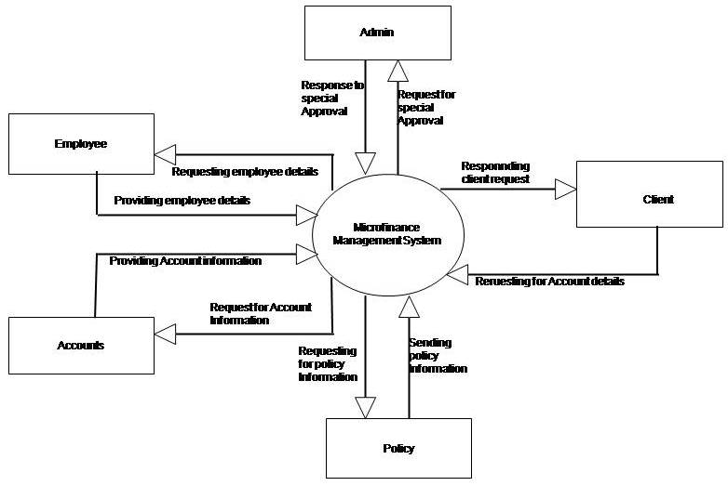

## Data Flow Diagram

### Level 0 DFD

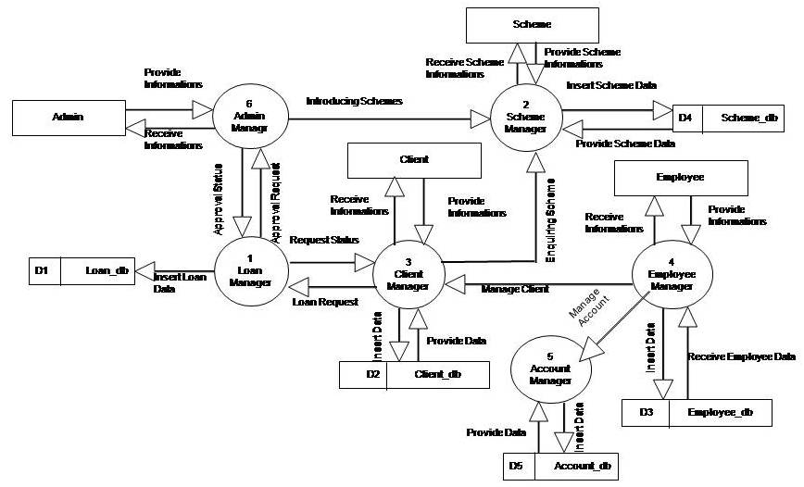

### Level 1 DFD

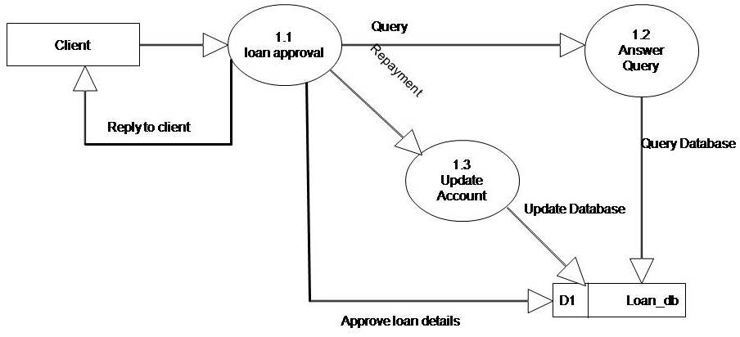

### Level 2 DFD

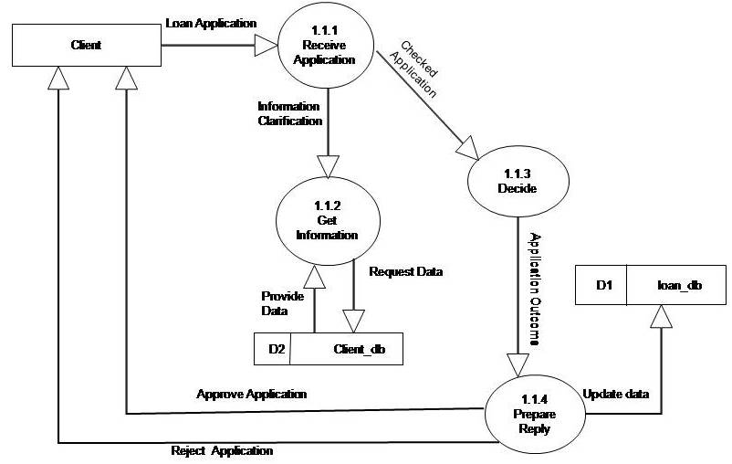

## E-R Diagram

We will design a RDBMS for Micro Finance Management System. The entities and their attributes are listed below. Attributes in Bold letter is the unique key.

|  |  |
| --- | --- |
| **Entities** | **Attributes** |
| Employees | **employeeId**, employeeName, employeeAddress, employeeJoinDate, employeeQualification, employeeContactDetails, employeeContactNumber, employeeEmail, employeeDOB |
| Clients | **clientId**, clientName, clientEmail, clientContactNumber, clientAddress, clientType, businessDetails |
| Accounts | **AmountId,** amountDescription**,** amountType, amountValue, accountBalance |
| Schemes | **schemeId,** schemeName, schemeDescription, schemeType, schemeDuration |
| Loans | **loanId,** loanName, loanDescription, loanType, loanDuration |

### Relationship between Entities:

* Micro Finance Management System has employees 1 : N
* Micro Finance Management System has clients 1 : N
* Micro Finance Management System manages accounts 1 : 1
* Micro Finance Management System has schemes 1 : N
* Micro Finance Management provides loans 1 : N
* employees receive from accounts N:1
* clients pay to accounts N:1
* clients take loans N:N
* clients take schemes N:N

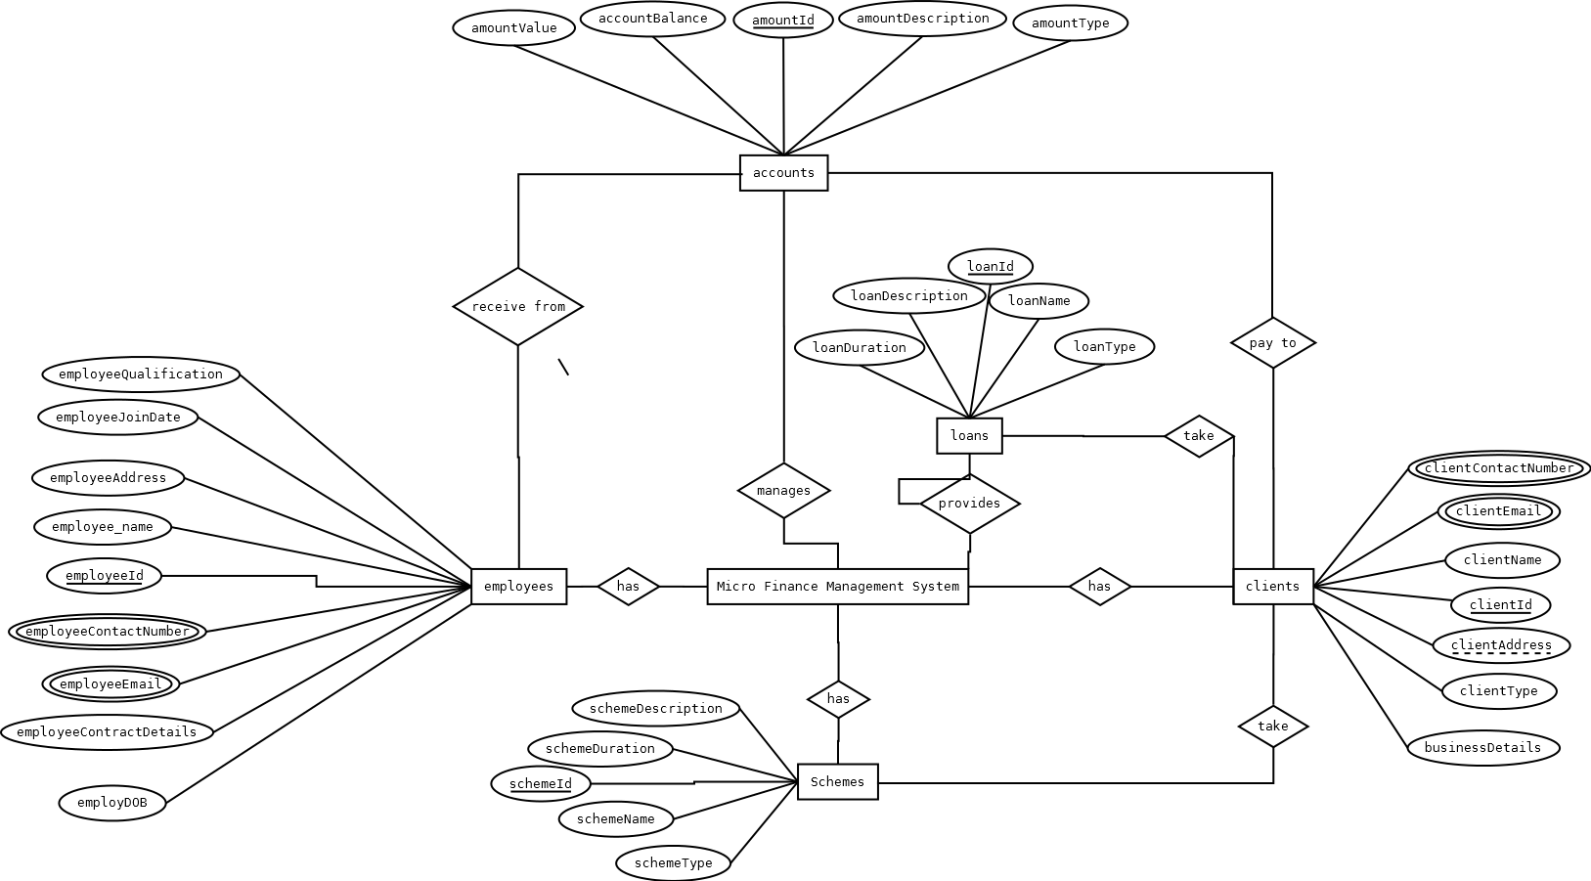

## Class Diagram

# Database And Table Details

The database used for this software is called **smsdb**. A screenshot from the MySQl workbench is given below. It shows the tables and its columns. The first row is the primary key.

# Complete Data Structure

## Module Description

Micro Finance Management System is divided three main modules such as:

1. Micro Finance Management Server
2. Micro Finance Management Client
3. Micro Finance Management Database

### Micro Finance Management Server

Micro Finance Management server is a singleton server designed provide services for Micro Finance Management system. It controls various activities required for the Micro Finance Management system. To manage these activities it has several sub modules such as:

1. Admission Management
2. Student Management
3. Faculty Management
4. Course Management
5. Attendance & Leave Management
6. Library Management
7. Accounts Management
8. Administration Management

### Micro Finance Management Client

Micro Finance Management System will provide two different clients for the convenience of the user. Desktop client is for doing bulk activities and faster tasks. Web client will allow instant access from anywhere and anytime.

### Micro Finance Management Database

Micro Finance Management System will have a unified database for storing all the information. It can be a networked database or a database situated in the server machine.

## Estimation

## Data Structure

## Implementation Methodology

* Object Oriented Programming methodology will be adopted
* User interface development will be done in MVC architecture using Windows Presentation Framework.
* Relational DBMS MySQL will be used to implement & execute SQL query to database.
* Agile Software Development model will be used while developing this software.

## List of Reports

List of reports that are likely to be generated in this software are given below:

* Annual client’s saving report can be generated
* Hierarchical relationship of client’s report can be generated
* Loan statements of borrower can be generated
* Annual turnover report can be generated
* Updated balance sheet can be generated
* Scheme details can be generated
* Fund details can be generated
* Salary slips can be created

# Security Mechanism

* Micro Finance Management System is password protected software. It will be developed such a way that the admin will have complete control on the client’s data.
* Admin can create account with various permission levels, like employee, clients, customer, admin etc. so that the users can see relevant data only.
* The data of the Microfinance will be stored in the database with an encrypted format so even if someone hacks the database somehow still he can make no real harm.
* The software will provide a backup and restore feature in case of loss of data.

# Future Scope And Further Requirements

* Mobile application could be developed for students’ guardians for querying about various details.
* Support for Linux operating system could be added.
* Online result checking and fees payment feature could be added.

# Bibliography

* <http://en.wikipedia.org>
* <http://msdn.microsoft.com/en-us/>
* <http://www.microsoft.com/en-us/default.aspx>
* <http://www.codeplex.com/>
* <http://stackoverflow.com/>
* <http://www.codeguru.com/>
* [http://www.w3schools.com](http://www.w3schools.com/)
* [www.mysql.org](http://www.mysql.org)
* School Professionals
* **Programming Java** - E. R. Balaguruswamy