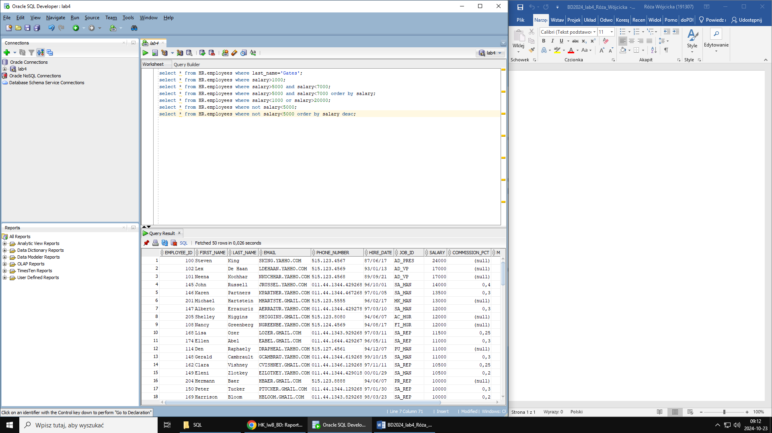order by … – rosnąco

order by ... desc – malejąco

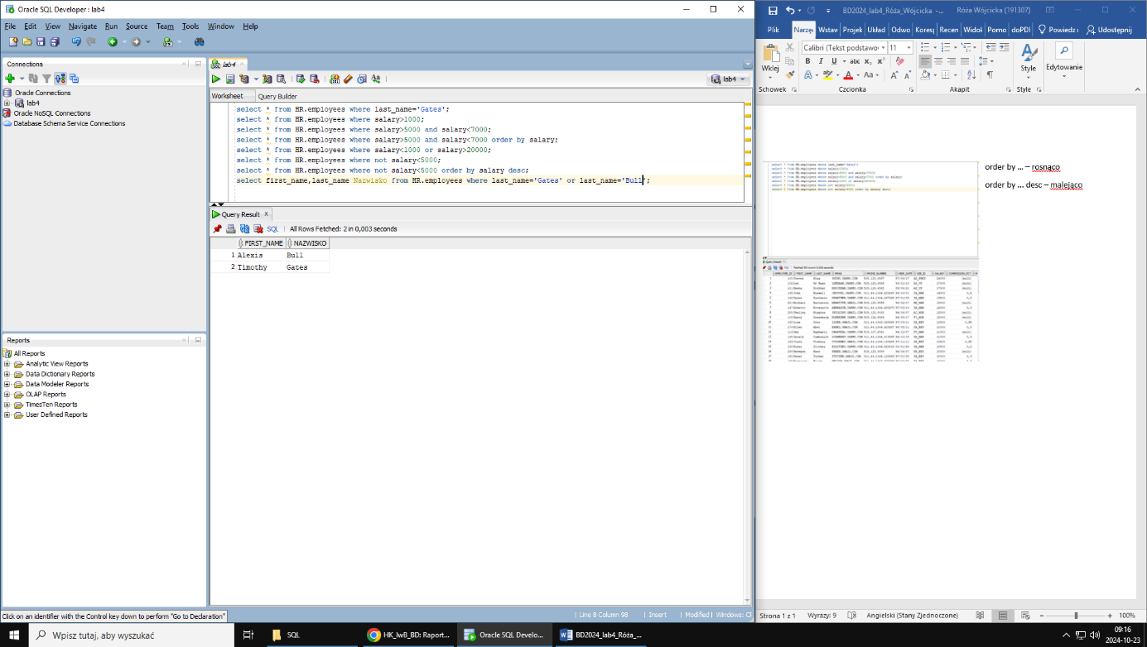

like ‘C%’ - % obojętnie ile znaków

like ‘C____’ – każdy _ to jeden znak

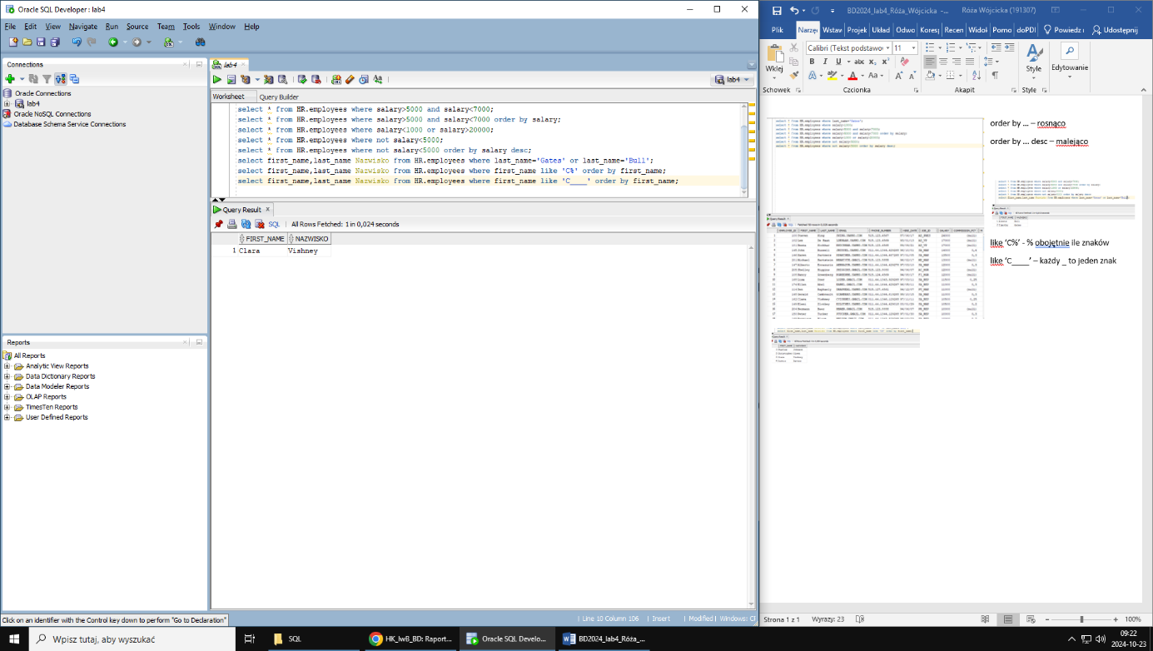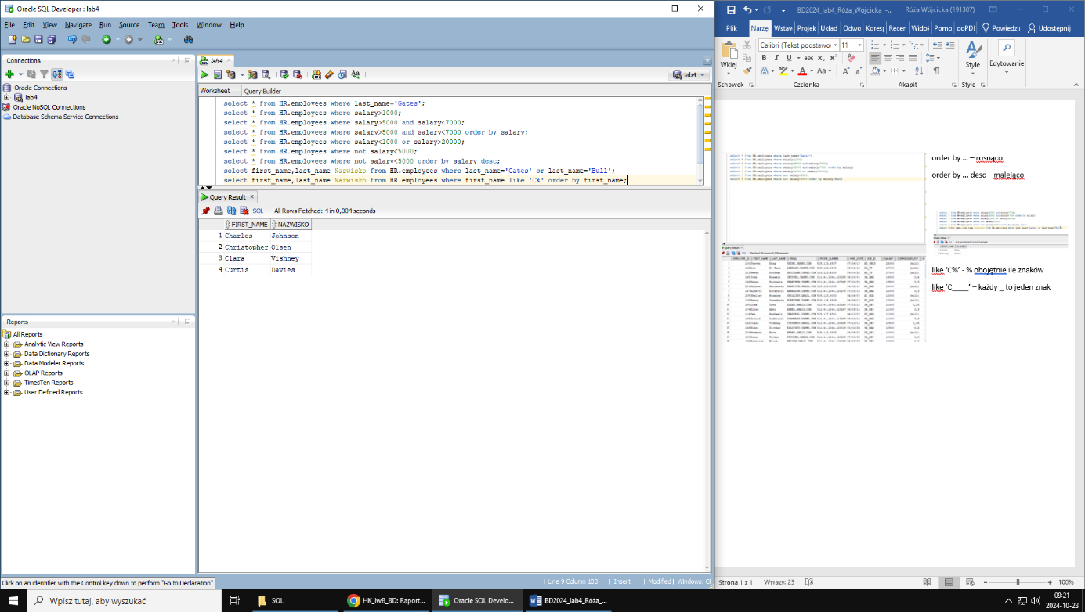

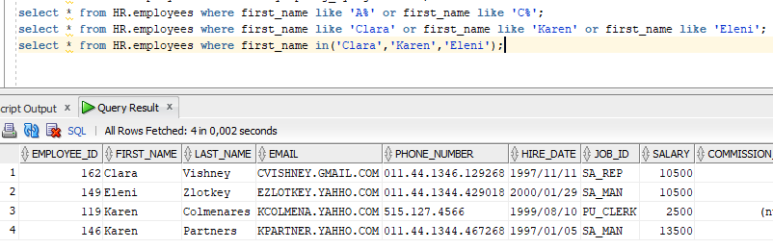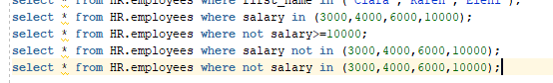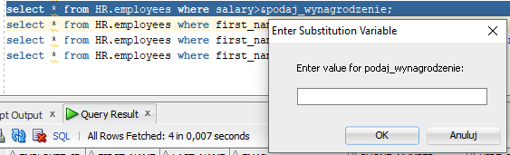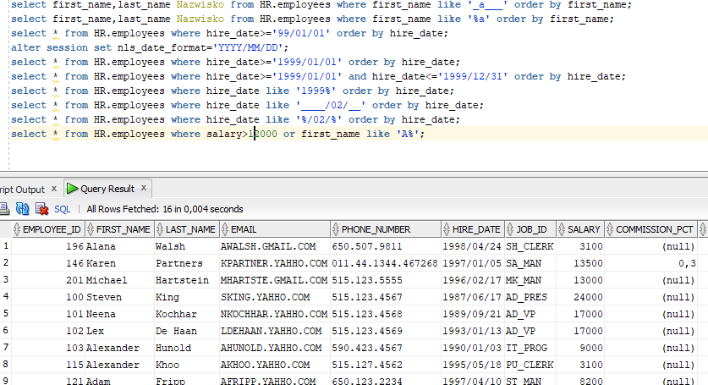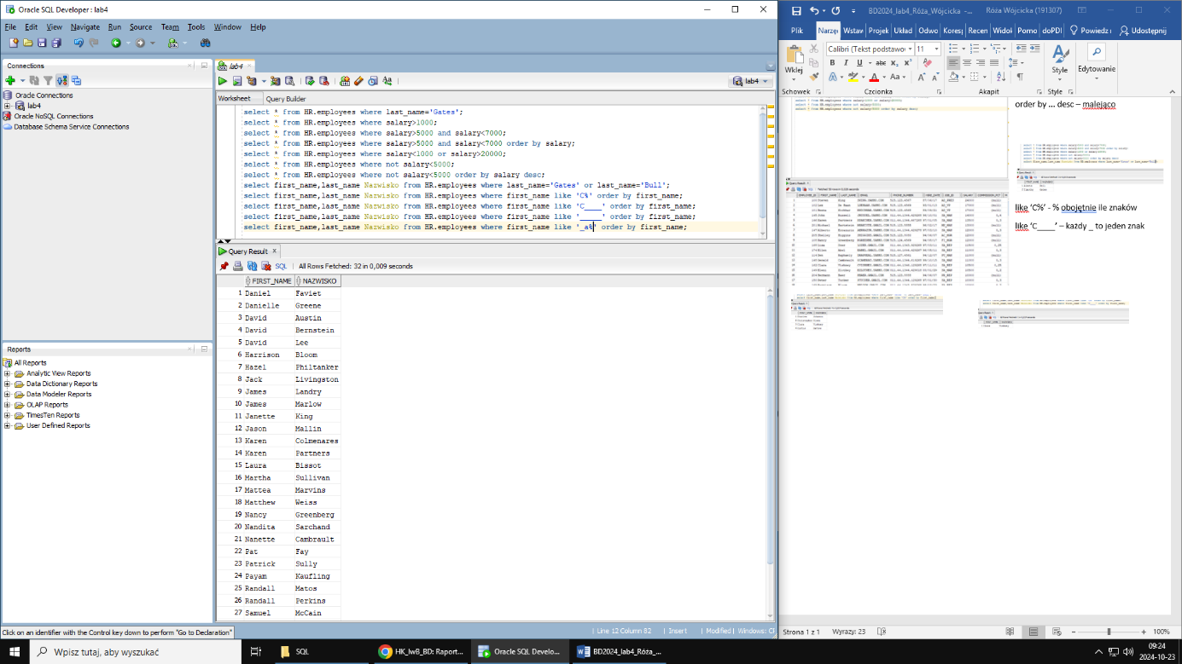

salary between 5000 and 7000

-> >=5000 and <=7000