ONDOKUZMAYIS ÜNİVERSİTESİ
Bilgisayar Mühendisliği Bölümü

Veri Tabanı Lab. Dersi Deney Föyü-1

M. Emin Eker
09060257

postgresql

1 - select books.id as id, books.name as name from "books" inner join "publishers" on "publishers"."id" = "books"."publisher_id" where (publishers.name = 'Pusula Yayıncılık') order by year;

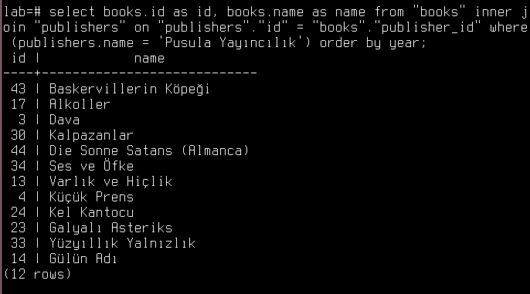
2 - select publishers.name as publisher, books.name as book_name, books.year from "books" inner join "publishers" on "publishers"."id" = "books"."publisher_id" order by publishers.name, year;

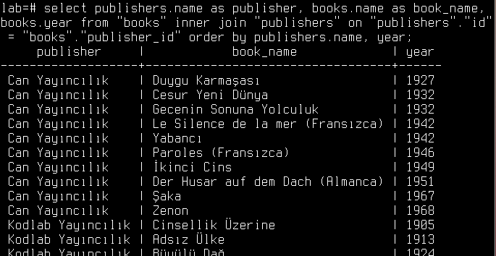

3 - select publishers.name as publisher, count(*) as book_count from "books" inner join "publishers" on "publishers"."id" = "books"."publisher_id" group by publishers.name;

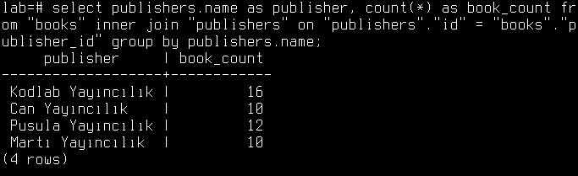
4 - select publishers.name as publisher, count(*) as book_count from "books" inner join "publishers" on "publishers"."id" = "books"."publisher_id" where(books.year between 1900 and 2002) group by publishers.name having count(*) = 10;

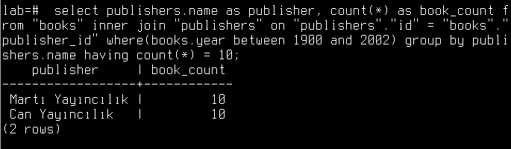
5 - select name from books order by price, desc limit 10;
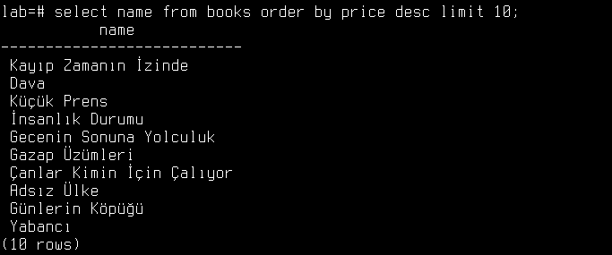

6 - select publishers.name as publisher from "books" inner join "publishers" on "publishers"."id" = "books"."publisher_id" where((books.year between 1900 and 2002)) GROUP by publishers.name;

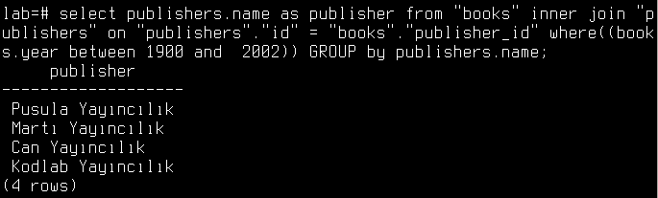

7 - select publishers.name, count(*) as book_count from "books" inner join "publishers" on "publishers"."id" = "books"."publisher_id" where (year > 2007) GROUP by publishers.name;

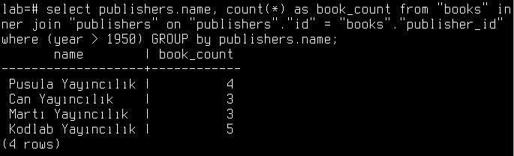

8 - select name from books where first_author = (select first_author from books group by books.first_author order by count(*) desc limit 1);

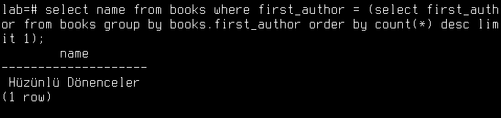

9 - select name from books where price > (select avg(price) as price from books);

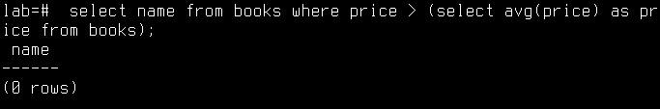

10 - select students.name from "subjects" inner join "studies" on "studies"."subject_id" = "subjects"."id" inner join "students" on "students"."id" = "studies"."student_id" inner join "departments" on "departments"."id" = "students"."department_id" WHERE "subjects"."stitle" = 'Veritabanı' and "departments"."name" = 'Bilgisayar Mühendisliği';

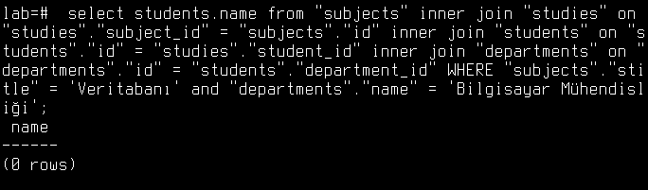

11 - select students.name as student, departments.name department from "subjects" inner join "studies" on "studies"."subject_id" = "subjects"."id" inner join "students" on "students"."id" = "studies"."student_id" inner join "departments" on "departments"."id" = "students"."department_id" inner join "buys" on "buys"."student_id" = "students"."id" inner join "books" on "books"."id" = "buys"."book_id" where "subjects"."stitle" = 'Ağlar' and (subjects.stitle = 'Ağlar' and subjects.id = books.subject_id and departments.name != 'Bilgisyaar Mühendisliği');

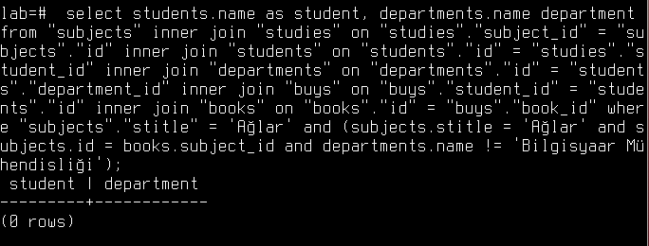
12 - select students.name from "students" inner join "studies" on "studies"."student_id" = "students"."id" inner join "buys" on "buys"."student_id" = "students"."id" inner join "books" on "books"."id" = "buys"."book_id" where (studies.student_id = buys.student_id);

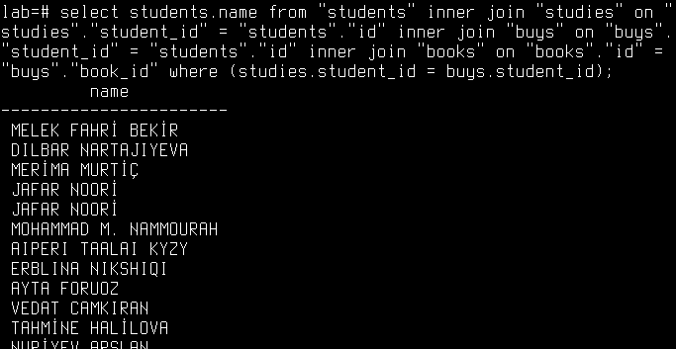
13 - select books.name from "subjects" inner join "covers" on "covers"."subject_id" = "subjects"."id" inner join "books" on "books"."id" = "covers"."book_id" where (books.name = 'Veritabanı') order by books.id desc limit 1;


14 - select buys.student_id, sum(price) as price from "books" inner join "buys" on "buys"."book_id" = "books"."id" where price > 40 group by buys.student_id having sum(price) > 200;

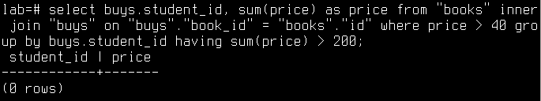

15 - select "books".* from "books" limit 10 ofset 10;

