1. Command for searching pattern line by line in any document with an example.

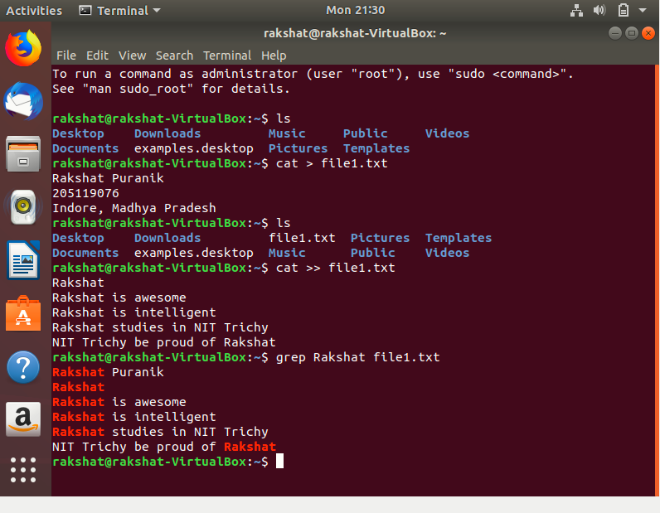

1. What all permissions are there in Linux? State all permissions and different way of changing permissions with example.

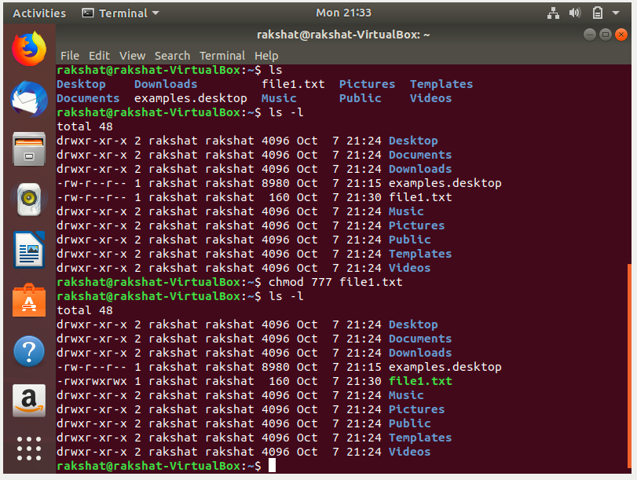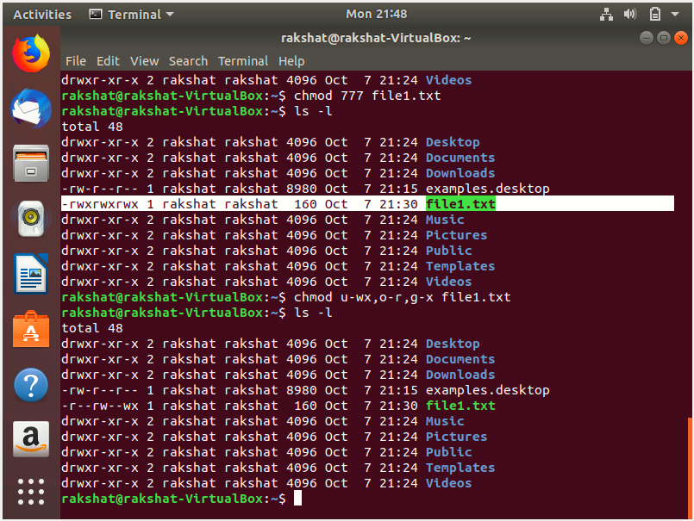

1. Create a folder ***OSOC*** and inside that another folder ***Inductions*** and now create a file ***task.txt*** inside ***Inductions*** with some content now copy this file into another folder ***Workshop*** in ***OSOC.***

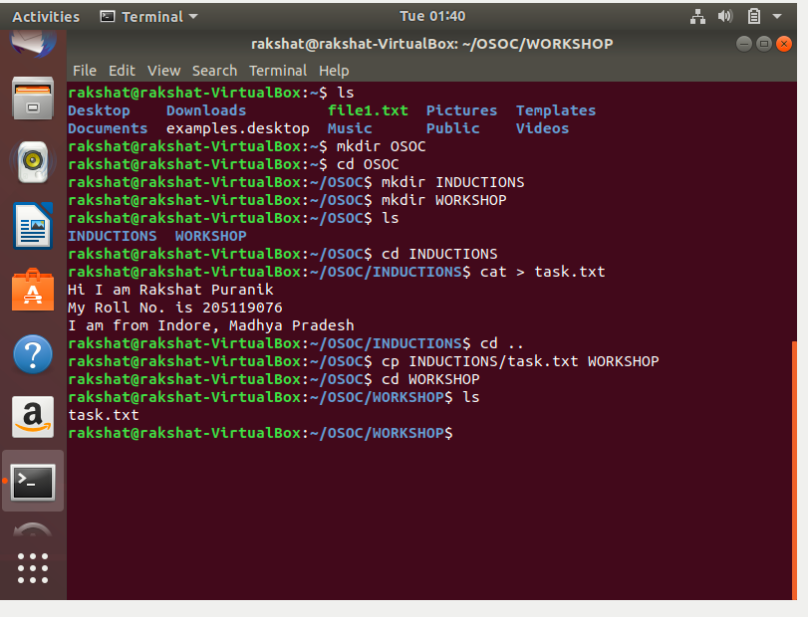

1. I want to check whether my system is connected to any network or not, please suggest appropriate command for this.

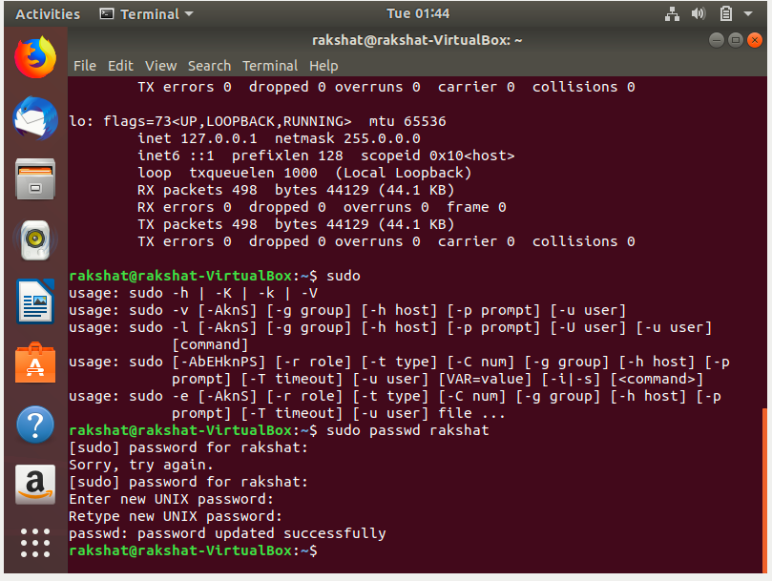

1. I want to change password of another user how will I do that?



1. Using shell scripting write program for sort an Array. Input should be taken from user.

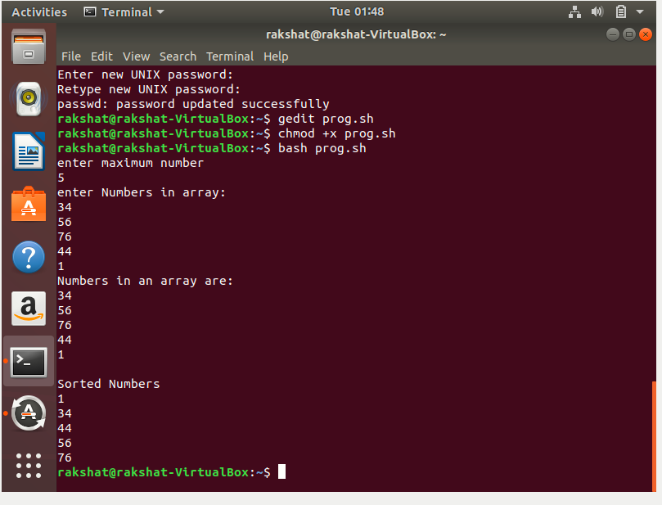

1. Using Shell scripting write a program to reverse a string. Input should be taken from user.

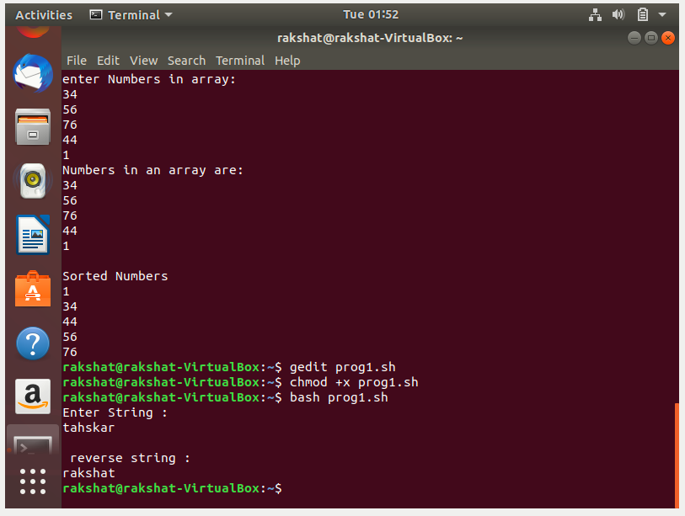gedit