Google-Search companies
SOLUTION DESIGN DOCUMENT (SDD)

VERSION HISTORY

Version  # | Implemented  By | Revision  Date | Approved  By | Approval  Date
1 | Ravindra Prasad | 31-10-2022

Table of Contents
1 Objective
1.1 Current State Overview
1.2 IA Solution Overview
2 Architectural Diagram of UiPath
3 Scope
4 Anchor Applications (include System Availability)
5 Process Performance Detail (include Operating Windows)
6 As Is Pre-process Steps
7 AS IS Common Steps
8 AS-IS- Detail Process Steps
9 As Is Post Process Steps
10 Proposed IA Solution Input
11 Configuration Detail
12 Proposed Detailed RPA Automation Flow Process Map
12.1 Proposed To Be Pre-process Steps
12.2 Proposed To Be Common Steps
12.3 Proposed To Be Process steps
13 Logging and Report
14 Exceptions
14.1 Business Exception
14.2 System Exception
15 Assumptions for Success to Automate
16 Success Criteria
17 Process Continuity
17.1 System Unavailability
17.2 Alerts
17.3 Manual Intervention
17.4 Case of High Volumes of alarms
18 Schedule and Operating Hours
19 Data Policies
20 IT Security
21 Reference/Acronym Lookup

1 Objectives

Current State Overview
Operation team have to Search the companies in Google and get the first four URL related to the companies from the google search engine, Operation team read the companies name from the text file that exist in the shared folder shared by the team in sequential manner and search the company name in the Google search engine. Copy first four URL and write in the excel sheet, Operation team repeated the same task till all the companies first four URL completed.
Once above task finished Operation team prepare the report and send the Excel file to the stakeholders via email.
Excel file Report must have Information like Company Name, URL1, URL2, URL3, URL4 in tabular structured format.

IA Solution Overview
After proposed Intelligent Automation Solution. Dispatcher robot will read the companies name from the text file and add all the company’s name to the cloud orchestrator queue (GoogleSearchQueue). Performer robot will read the companies name from the Orchestrator queue (GoogleSearchQueue) and search that companies name in the Google Search engine, robot will read the first four url from the google search engine and add company Name and all URL to the Data Table and mark the status as successful in the orchestrator queue also add four URL to orchestrator queue in Output columns. So in future we can generate the reports from the orchestrator queues. If any system exception robot will retry the transaction item from the queue till configurable limit. Business exception will fail marked as Business rule exception and robot will continue with next transaction from the queue. At the end of all the transaction robot will prepared the report in excel format and send to the IT-Stakeholders via email.
Process must be designed in Robotic Enterprise framework that followed the state machine design, In this development I will combine the dispatcher and performer subprocess in the same RE-framework.
Process design must support the multi bot architecture so in future if volume is heavy so we can scale up to the Multirobot.

Architectural Diagram of UiPath
- Orchestrator UiPath Cloud(https://cloud.uipath.com/wiproqjaiiqv/portal_/admin)
- UiPath Studio 2022.4.4
- UiPath Assistant

Scope
In Scope
Google Search-Companies four URL
- Company Search in google.
- Fetch the first four url related to the companies.
- Prepare Excel Report.
- Send Company Search Report to the team by email.

ANCHOR APPLICATIONS (INCLUDE SYSTEM AVAILABILITY)

Application Name | URL | External/Internal | Application Type | Credential Required for IA
Google Search Engine | https://www.google.com | External | Web | No
Microsoft office -Excel |  | Internal | Windows
Microsoft-outlook |  | Internal | Windows

PROCESS PERFORMANCE DETAIL (INCLUDE OPERATING WINDOWS)
Volume | Average Handling Time | Frequency | SLA | Operating windows
1 | 5-sec | Daily

AS-IS Pre-Process Steps
- Excel should be installed
- Microsoft office

7 Common Step (N/A)

8 AS-IS Detail Process Steps
Google Search-Company Name- Process Map- AS-IS

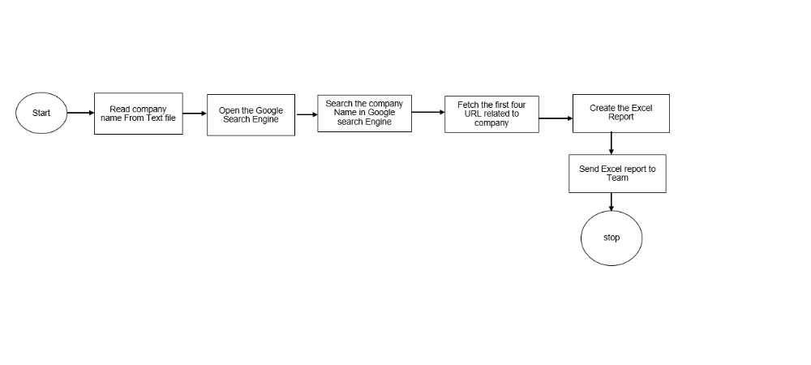

S.no | Process Steps | Detail | Screenshot
1 | Agent will open Text file share by team that have the list of company Name | Manually open the Text file from shared folder
2 | Agent will open the Google Search Engine | Manually
3 | Agent will read the company Name from the text file and search that company name in google search engine | Manually
4 | Agent will get first four URL from the related companies that display in google search engine | Manually
5 | Agent will open the excel file and write the company name and first four URL in the excel sheet and | Manually
6 | Agent will repeat the same above activity till all the companies search finished | manually
6 | Agent will save the report Excel file and send that report to the IT stake holder | manually

9 AS-IS Post Process Steps
N/A

10 Proposed IA Solution Input
List of the companies must be available in Text File and that file exist in the Shared path.
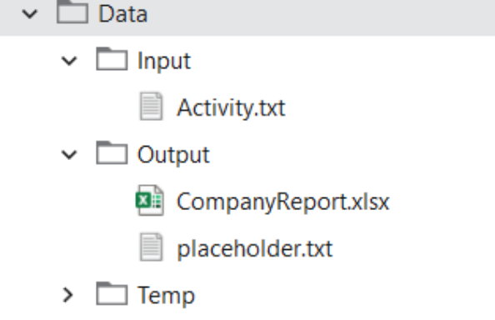

11 Configuration Detail (Queue/Config.xlsx)
Config.xlsx is configuration file that will be used to store all the information/data that will be used in the automation workflow to avoid the hardcode value in workflow.
Queue: - GoogleSearchQueue

12 Proposed To-Be Detailed Google Search-Company Name RPA Automation Flow (Process Map)

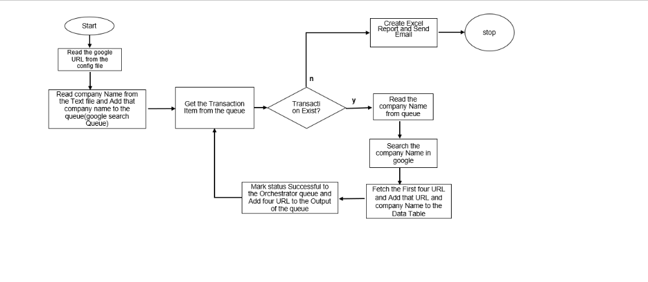

12.1 Proposed To-Be Pre-process Steps
N/A

12.2 Proposed To-Be Common steps
N/A

12.3 Proposed To-Be Process Steps (Dispatcher/Performer)

Process Name: Google Search Companies Name
S.no | Process Steps | Detail | Screenshot
1 | Read the google URL and other configuration details from config file. | Robot will read the configuration information from the Initialization state
2 | Read the Companies Name from the Text file shared by the operation team and add all companies Name to the Orchestrator queue (GoogleSearchQueue) | Robot extract all the companies name from the File and Add to orchestrators queue that is dispatcher code must be written in the Initialization State in RE-Framework (First Run).
3 | Robot will get the Transaction from the queue and read the company name from the queue. | If Robot got the transaction from the queue, then it read if not then will end the process.
4 | Robot will open the Google Search engine and search the company name and read the first four URL display by google related to the respective company Name
5 | Robot will fetch the four url from the google and Add that four url and company name to the data table. And mark the status successful to the orchestrator queue. And add fetched four url to the output column in orchestrator queue(googleSearchQueue), after successful completion of the transaction, robot will pick up the next transaction from queue and repeat till it finished all queue transaction in new state.
6 | Robot will retry the transaction from the queue till configurable limit in case of System exception, In Business exception will mark the queue status as failed due to business rule exception and robot will pick up the next transaction from the queue.
7 | At the end of all the transaction robot will prepared the Report in excel and Send to IT stake holder by email. | This code must he written in End state of Reframe work

13 Logging and MIS Reports
Robot will log all the necessary information to orchestrators, Log will be very useful to investigate any production Issues. At end Robot will generate the report of successful/Failed and send the report to the ops team by email.

14 Exceptions

14.1 Business Exception

S.no | Exception Name | Robot Action
1 | Company Name not found in Search engine | Robot will throw the business rule exception (BRE). And send an email to operation team, and that company Name not available in the Google system
2 | If not get URL from the respective companies | Robot will throw the BRE if Not get URL or less than 4 URL to the Selected companies, robot will mark as business exception to the orchestrator queue and marked as Failed status

14.2 System Exception (TBD)
S.no | Exception Name | Robot Action
1 | If Google Search Engine is down | Robot will mark as system exception and reason will be google search engine not opened , retry it with in limit if failed then mark transaction as an system exception. Log the information to the orchestrator. If consecutive system exception occurred then Robot will automatically stop, consecutive system exception must be configured in config file
2 | Any unknown system exception like unable to launch the URL and selector not able to find due to application changes | Robot will retry from with in configured retry limit and after that throw the system exception, if configured maximum consecutive system exception reached then robot will stop and it transit to End state. And send an email to the respective team. . Log the information to the orchestrator

15 Assumptions for Success to Automate

16 Success Criteria

17 Process Continuity

17.1 System Unavailability
System unavailability is likely to manifest itself in one of two ways:
- Either the UiPath process will be unable to access or login to the below application:
- Google Search Engine
- Microsoft Outlook
- Microsoft Excel
- The system will exhibit unfamiliar behaviour while navigating through the applications or systems.

In case when UiPath is working but not able to log in to the application then it will show an exception alert on the screen and also add the failure entry in the log file. But, if UiPath itself is not able to start on the system then it needs to be handled manually by support (user or admin). It cannot be handled by the IA(Intelligent Automation)

17.2 Alert
- Where the process is unable to log in to any of the systems, an alert will be raised.
- Where a system exhibits unfamiliar behaviour, the UiPath process will most likely encounter a repeating pattern of System Exceptions. Where three consecutive system exceptions are encountered, the process will stop under the presumption that the system has a problem. Automation will log the alert in logs and restart all activities from start.
- When the automation failed on unknown/unhandled exception and not able to understand next step. Automation will log the alert in logs and restart all activities from start to resume the work from next line item.
- When automation fails to even restart again from next line item, an alert will be raised detailing the requirement of manually restarting the automation.

17.3 Manual Intervention
Manual Intervention is needed when system or applications are not available. During processing, manual intervention is required when automation fails to restart due to unknown/unhandled exception.

18 Schedule and Operating Hours
TBD(To be determined)

19 Data Policies

Data Privacy
The UiPath Automation cloud provides a secure and auditable record of the activity undertaken by the automated process. Access to the UiPath environment is security controlled. It is important that a record be made available of the activity undertaken against each account and for this reason the process will log its actions.

System Assumptions
UiPath allows for the business to grant varying degrees of access to users. It is noted that this includes access to Development, SIT, and UAT. To mitigate any risks associated with system being compromised, the business should grant access to users based on need.

20 IT Security and Credential Management

This section captures credential details for the applications that the processes will depend on.
The credentials will be stored within the UIPATH orchestrator Asset and will be encrypted securely (UiPath natively encrypts the credentials using the configured encryption schemes).
Credential Management
Credentials are managed by selecting the Assets UiPath Orchestrator. User name, password, can be added and managed here.
Outlined below is the format for how these credentials should be provisioned. Resource and Role to be determined as part of deployment activities.

Credential Name | Description |  | Expiry
n/a

21 Reference/Acronym Lookup

