Attendance Record
SOLUTION DESIGN DOCUMENT (SDD)

VERSION HISTORY

Version  # | Implemented  By | Revision  Date | Approved  By | Approval  Date
1 | Ravindra Prasad | 03-11-2022

Table of Contents
1 Objective
1.1 Current State Overview
1.2 IA Solution Overview
2 Architectural Diagram of UiPath
3 Scope
4 Anchor Applications (include System Availability)
5 Process Performance Detail (include Operating Windows)
6 As Is Pre-process Steps
7 AS IS Common Steps
8 AS-IS- Detail Process Steps
9 As Is Post Process Steps
10 Proposed IA Solution Input
11 Configuration Detail
12 Proposed Detailed RPA Automation Flow Process Map
12.1 Proposed To Be Pre-process Steps
12.2 Proposed To Be Common Steps
12.3 Proposed To Be Process steps
13 Logging and Report
14 Exceptions
14.1 Business Exception
14.2 System Exception
15 Assumptions for Success to Automate
16 Success Criteria
17 Process Continuity
17.1 System Unavailability
17.2 Alerts
17.3 Manual Intervention
17.4 Case of High Volumes of alarms
18 Schedule and Operating Hours
19 Data Policies
20 IT Security
21 Reference/Acronym Lookup

1 Objectives

Current State Overview
Operation team have to login to Wipro portal with employee/admin credential and Navigate to Timesheet page and Capture the attendance record of last 14 days from the timesheet and Prepare the Excel report that contains last 14 days attendance of the employee and Send the Report to IT-stakeholder via email

IA Solution Overview
After proposed Intelligent Automation Solution. Robot will login to Wipro portal with employee credential and Navigate to Timesheet page, Robot will calculate 14 days from today and Navigate back to 14 days in timesheet and start capture the Attendance from last 14 days to current date, after capturing the last 14 days attendance data, Robot will prepare the attendance report in the excelsheet and send that excelsheet to the IT-stake holder, it’s a Linear process and currently design in Robotic Enterprise framework.

Architectural Diagram of UiPath
- Orchestrator UiPath Cloud(https://cloud.uipath.com/wiproqjaiiqv/portal_/admin)
- UiPath Studio 2022.4.4
- UiPath Assistant

Scope
In Scope
Attendance Record
- Login to Wipro Portal and Navigate to Timesheet
- Fetch the Last 14 days attendance Record from the timesheet
- Prepare Excel Report that contains 14 days attendance Record
- Send the Excel report to the team by email.

ANCHOR APPLICATIONS (INCLUDE SYSTEM AVAILABILITY)

Application Name | URL | External/Internal | Application Type | Credential Required for IA
Wipro Portal | https://www.wipro.com | Internal | Web | No
Microsoft office -Excel |  | Internal | Windows
Microsoft-outlook |  | Internal | Windows

PROCESS PERFORMANCE DETAIL (INCLUDE OPERATING WINDOWS)
Volume | Average Handling Time | Frequency | SLA | Operating windows
1 | 30-sec | Daily

AS-IS Pre-Process Steps
- Excel should be installed
- Microsoft office

7 Common Step (N/A)

8 AS-IS Detail Process Steps
Attendance Record- Process Map- AS-IS

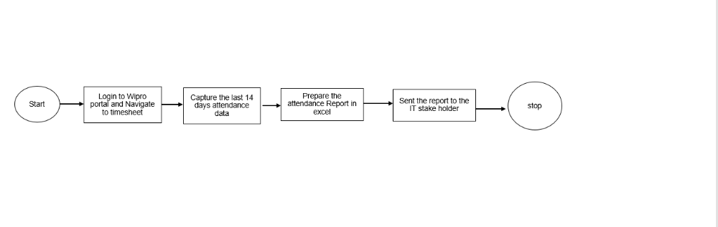

S.no | Process Steps | Detail | Screenshot
1 | Employee will login to wipro portal and navigate to Timesheet
2 | Employee will capture the last 14 days attendance data from the Timesheet. | Manually
3 | Employee will prepare the report in excel that contains last 14 days attendance data | Manually
4 | Employee will send the report to the Stakeholder | Manually

9 AS-IS Post Process Steps
N/A

10 Proposed IA Solution Input
Wipro Timesheet

11 Configuration Detail (Queue/Config.xlsx)
Config.xlsx is configuration file that will be used to store all the information/data that will be used in the automation workflow to avoid the hardcode value in workflow.

12 Proposed To-Be Detailed Attendance Records (Process Map)

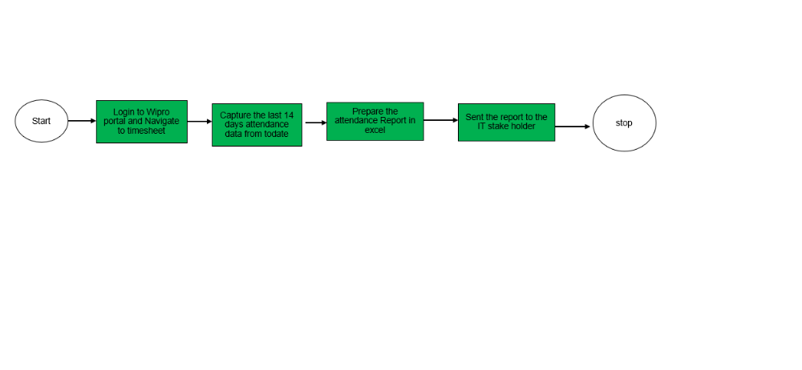

12.1 Proposed To-Be Pre-process Steps
N/A

12.2 Proposed To-Be Common steps
N/A

12.3 Proposed To-Be Process Steps (Dispatcher/Performer)

Process Name: Google Search Companies Name
S.no | Process Steps | Detail | Screenshot
1 | Read the google URL and other configuration details from config file. | Robot will read the configuration information from the Initialization state
2 | Robot will login to Wipro portal and Navigate to Timesheet
3 | Robot will Navigate back in timesheet and calculate 14 days and capture 14 days attendance data. | If Robot got the transaction from the queue, then it read if not then will end the process.
4 | Robot Prepare the attendance report in and send to the stakeholder via email

13 Logging and MIS Reports
Robot will log all the necessary information to orchestrators, Log will be very useful to investigate any production Issues. At end Robot will generate the report of successful/Failed and send the report to the ops team by email.

14 Exceptions

14.1 Business Exception

S.no | Exception Name | Robot Action
1 | Not able to Login with Employee credential | Robot will stop may be password Expire and wrong credential provided.
2

14.2 System Exception (TBD)
S.no | Exception Name | Robot Action
1 | If Wipro portal is down and timesheet not working | Robot will mark as system exception and reason will be wipro Portal down and retry it with in limit if failed then mark transaction as an system exception. Log the information to the orchestrator. If consecutive system exception occurred then Robot will automatically stop, consecutive system exception must be configured in config file
2 | Any unknown system exception like unable to launch the URL and selector not able to find due to application changes | Robot will retry from with in configured retry limit and after that throw the system exception, if configured maximum consecutive system exception reached then robot will stop and it transit to End state. And send an email to the respective team. . Log the information to the orchestrator

15 Assumptions for Success to Automate

16 Success Criteria

17 Process Continuity

17.1 System Unavailability
System unavailability is likely to manifest itself in one of two ways:
- Either the UiPath process will be unable to access or login to the below application:
- Wipro Portal
- Microsoft Outlook
- Microsoft Excel
- The system will exhibit unfamiliar behaviour while navigating through the applications or systems.

In case when UiPath is working but not able to log in to the application then it will show an exception alert on the screen and also add the failure entry in the log file. But, if UiPath itself is not able to start on the system then it needs to be handled manually by support (user or admin). It cannot be handled by the IA(Intelligent Automation)

17.2 Alert
- Where the process is unable to log in to any of the systems, an alert will be raised.
- Where a system exhibits unfamiliar behaviour, the UiPath process will most likely encounter a repeating pattern of System Exceptions. Where three consecutive system exceptions are encountered, the process will stop under the presumption that the system has a problem. Automation will log the alert in logs and restart all activities from start.
- When the automation failed on unknown/unhandled exception and not able to understand next step. Automation will log the alert in logs and restart all activities from start to resume the work from next line item.
- When automation fails to even restart again from next line item, an alert will be raised detailing the requirement of manually restarting the automation.

17.3 Manual Intervention
Manual Intervention is needed when system or applications are not available. During processing, manual intervention is required when automation fails to restart due to unknown/unhandled exception.

18 Schedule and Operating Hours
TBD(To be determined)

19 Data Policies

Data Privacy
The UiPath Automation cloud provides a secure and auditable record of the activity undertaken by the automated process. Access to the UiPath environment is security controlled. It is important that a record be made available of the activity undertaken against each account and for this reason the process will log its actions.

System Assumptions
UiPath allows for the business to grant varying degrees of access to users. It is noted that this includes access to Development, SIT, and UAT. To mitigate any risks associated with system being compromised, the business should grant access to users based on need.

20 IT Security and Credential Management

This section captures credential details for the applications that the processes will depend on.
The credentials will be stored within the UIPATH orchestrator Asset and will be encrypted securely (UiPath natively encrypts the credentials using the configured encryption schemes).
Credential Management
Credentials are managed by selecting the Assets UiPath Orchestrator. User name, password, can be added and managed here.
Outlined below is the format for how these credentials should be provisioned. Resource and Role to be determined as part of deployment activities.
ModernFolderName:-GoogleSearch

Credential Name | Description |  | Expiry
LoginCred

21 Reference/Acronym Lookup

