VLSI Special Assignment Topic:

F = (AB’+CD’A)

Using CMOS
Course Code:

2EC601CC24

Submitted by:

23BEC160,23BEC161
Parth Rathod,Patel Ravi

Submitted to:

Prof. Vijay Savani

Prof. Purvi Patel



Department of Electronics and Communication, Institute of Technology
Nirma University

Design Problem:
Make CMOS circuit for AB’+CD’A

- Introduction

In this project, I have implemented the logic function: Y=AB′+CD’A
The design started from the Boolean expression and was broken down into logic gates to understand how the function behaves. From there, I created the truth table, drew the circuit diagram, and then developed the stick diagram and layout using CMOS design rules. The layout shows how the transistors are connected.
I also studied the CMOS inverter, By analysing its voltage transfer characteristics, I could measure important values like VOH, VOL, VIH, and VIL, which tell us about the performance and noise margins of the circuit.
Overall, this project helped me understand the complete flow of VLSI design—from a simple Boolean expression to the final CMOS layout—while also learning how the inverter characteristics define the reliability of digital circuits.

- Find out the optimized Boolean Equation.

Y = AB’+CD’A
Y = A(B’+CD’)
Y’ = (A’+B(C’+D))’

- Draw the optimized gate level circuit diagram.
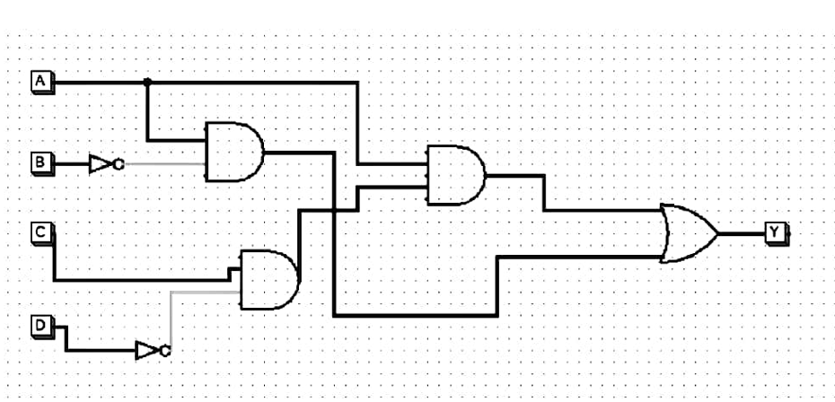

- Draw the transistor level schematic for CMOS/MOS implementation.

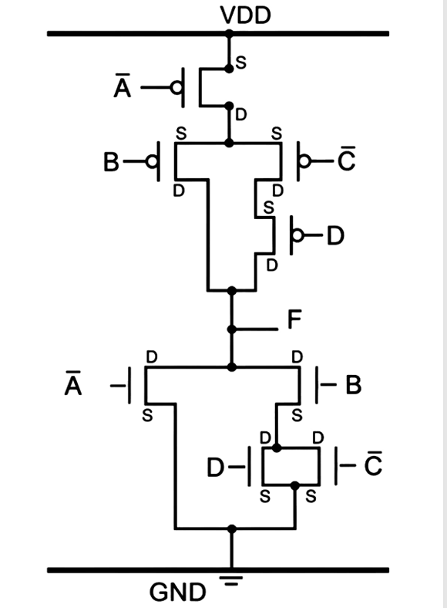
- Draw stick diagram for above implementation level using proper colour code.

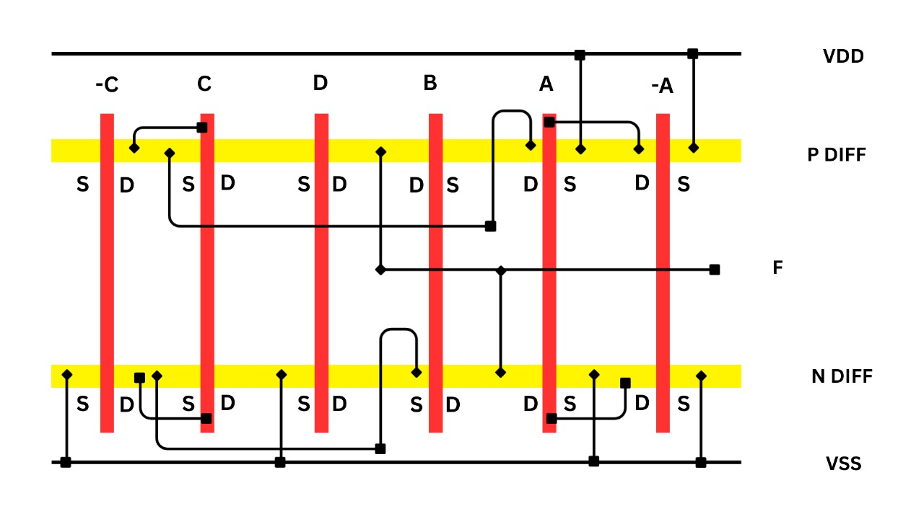

- Draw an equivalent CMOS inverter circuit.

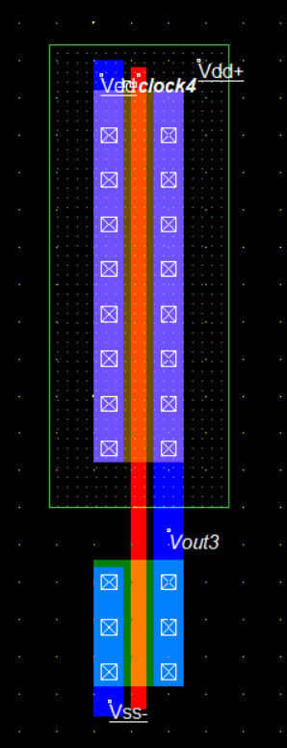
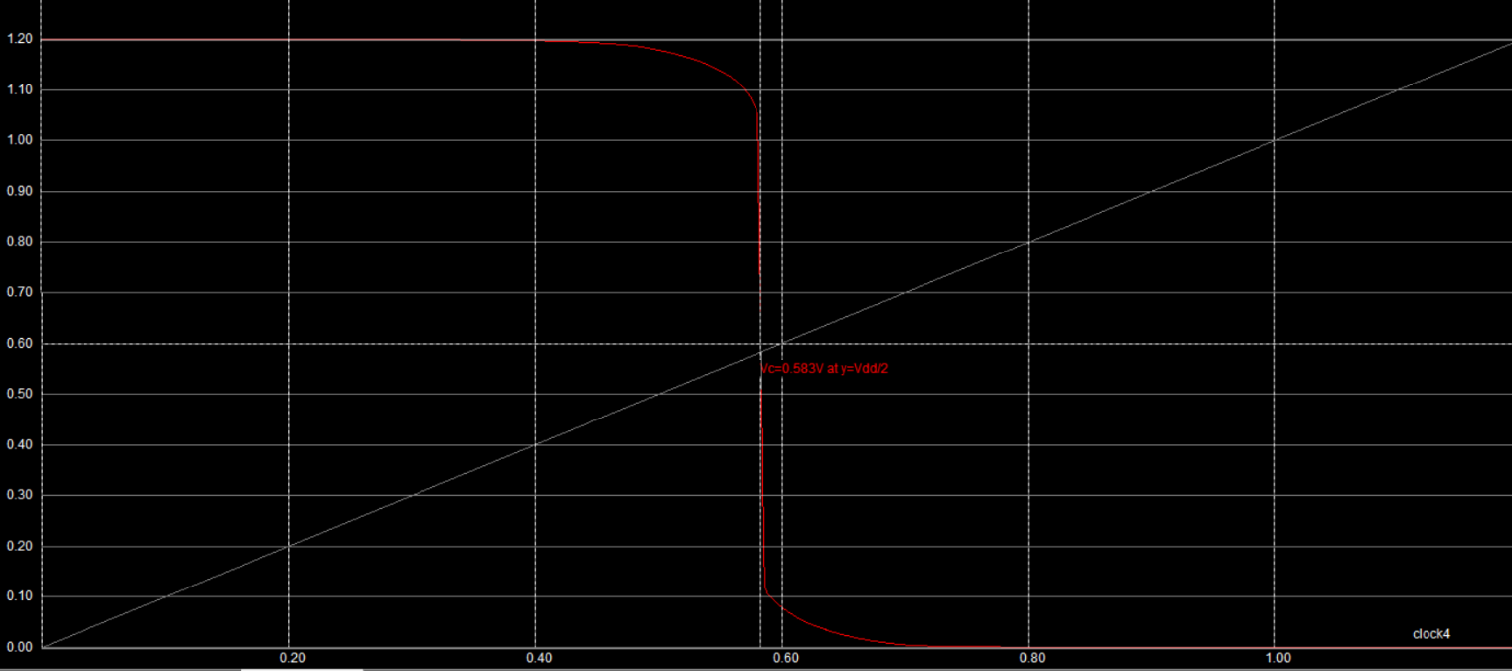

Vth = 0.583 v
VOH = 1.2 v
VOL = 0 v
VIH = 0.47 v
VIL = 0.68 v

- Equivalent W/L Ratio :

For PMOS:

W/L Ratio for all PMOS are 12.5. Equivalent W/L Ratio is 7.46.

For NMOS:

W/L Ratio for all NMOS are 5. Equivalent W/L Ratio is 8.34. For an Ideal CMOS Inverter, W of PMOS should be 2.5 times of W of NMOS by taking L = 0.12 um.

- Area of layout :

W = 144 lamda = 144 *0.06um = 8.64um
L = 86 lamda = 86*0.06um = 5.16 um

Area = 44.58 um^2
- Prepare the layout using Microwind tool.
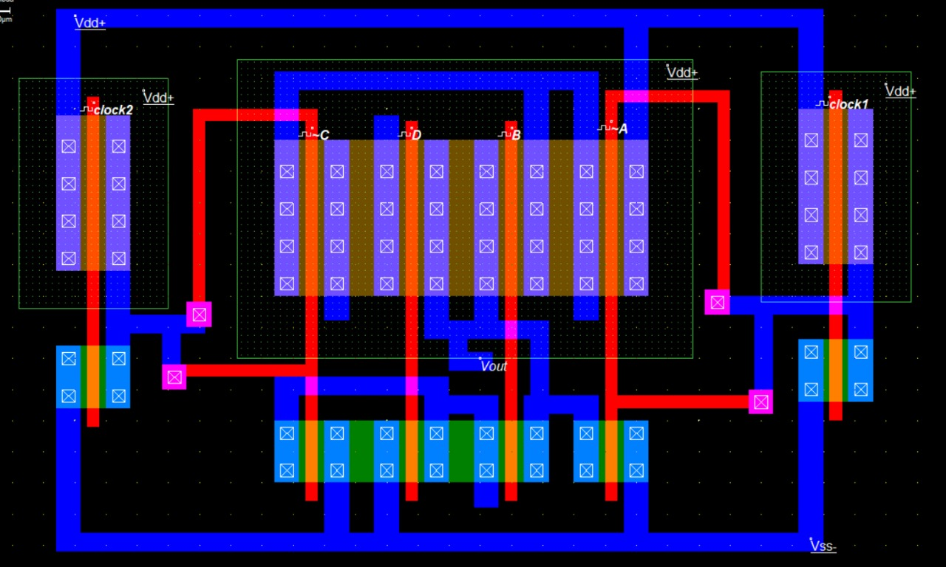
- Measure the rise time, fall time, propagation delay and other parameters.
Rise Time = 80 ps, Fall time = 20 ps, Propagation delay = 30 ps
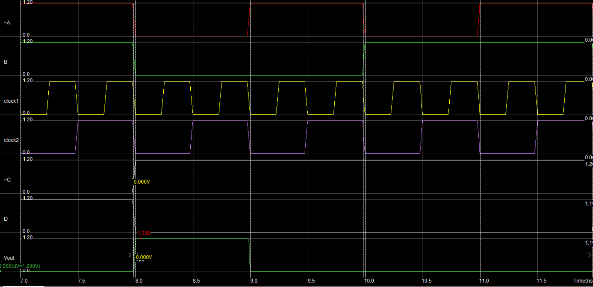

- Simulate it for various combinations of inputs.

A | B | C | D | A' | C' | F | F'
0 | 0 | 0 | 0 | 1 | 1 | 0 | 1
0 | 0 | 0 | 1 | 1 | 1 | 0 | 1
0 | 0 | 1 | 0 | 1 | 0 | 0 | 1
0 | 0 | 1 | 1 | 1 | 0 | 0 | 1
0 | 1 | 0 | 0 | 1 | 1 | 0 | 1
0 | 1 | 0 | 1 | 1 | 1 | 0 | 1
0 | 1 | 1 | 0 | 1 | 0 | 0 | 1
0 | 1 | 1 | 1 | 1 | 0 | 0 | 1
1 | 0 | 0 | 0 | 0 | 1 | 1 | 0
1 | 0 | 0 | 1 | 0 | 1 | 1 | 0
1 | 0 | 1 | 0 | 0 | 0 | 1 | 0
1 | 0 | 1 | 1 | 0 | 0 | 1 | 0
1 | 1 | 0 | 0 | 0 | 1 | 0 | 1
1 | 1 | 0 | 1 | 0 | 1 | 0 | 1
1 | 1 | 1 | 0 | 0 | 0 | 1 | 0
1 | 1 | 1 | 1 | 0 | 0 | 0 | 1

Conclusion:
Working on this project gave me a complete picture of how a digital logic expression can be transformed step by step into an actual CMOS layout. Starting from the Boolean function Y=AB′+CD′A, I was able to design the circuit, prepare the truth table, draw the stick diagram, and finally implement the layout in static CMOS technology.
By analysing the CMOS inverter characteristics, I also learned how to determine important parameters like VOH, VOL, VIH, and VIL, which are crucial for defining the noise margins and overall reliability of the circuit. These observations confirmed that the designed logic circuit behaves as expected and produces correct output levels.

