Executive Summary
- Introduction
Organisations increasingly rely on data-driven insights to inform decision-making. However, the availability of big data does not inherently lead to effective decision-making, and data quality validation is essential for producing valuable results (Huxley, 2020). This project applied AI-assisted analysis to race-level data to develop an interactive dashboard supporting evidence-informed event optimisation.
- Project Overview
The project was designed for a fictitious running events company. This organisation was selected due to the growing popularity of recreational and competitive running, which is attributed to its accessibility, simplicity, and health benefits (Abrahamson et al., 2025, p. 1). Research has suggested that race completion may contribute to positive participant experiences and repeat participation (Nikolaidis et al., 2019). Therefore, identifying factors associated with Did Not Finish (DNF) outcomes may help inform strategies to improve race completion and potentially encourage repeat participation. This project analyses factors associated with race outcomes and translates these findings into an interactive dashboard, providing accessible insights to support data-driven decision-making.
- Project Objectives
Chatterjee et al. (2023) demonstrated how big data analytics can support organisational decision-making by identifying trends, predicting outcomes, and spotting opportunities. Although their study focused on consumer purchasing behaviour, the findings illustrate the broader value of data analytics for evidence-based decision-making, with increasing relevance to sports science as data analytics and information systems enable the generation of actionable insights (Morgulev, Azar and Lidor, 2018, p. 214). For running events, interactive dashboards can translate data insights into accessible information to support event planning and participant outcomes. The project aimed to move beyond reporting historical Did Not Finish (DNF) results by examining associations between DNF proportions and race distance, elevation gain, participation totals and geographical characteristics. An interactive dashboard enabled users to explore these patterns to support evidence-informed event planning.
- AI Assistance in Project Development
A data pipeline encompasses processes including data acquisition, storage, preparation, retrieval, and analysis (Mahato et al., 2024). ChatGPT was utilised throughout the data pipeline for this project, as it allows for code generation, technical problem-solving and methodological enquiry (Hao et al., 2024). However, to ensure quality and accuracy, the project implemented a human-AI-human approach (Giray, 2026), with AI-generated outputs being reviewed, tested and adapted before implementation, ensuring that analytical decisions remained subject to human judgement.
- Data Selection
Data selection was guided by the project objectives, with ChatGPT supporting the initial assessment of suitable dataset characteristics. ChatGPT recommended a structured dataset containing numerical, categorical, temporal, and potentially text data, with CSV suggested as the preferred starting format and Parquet for larger datasets (ChatGPT, 2026, personal communication, 21 September). These recommendations were critically evaluated against Gorale (2025), who argues that dataset suitability depends on structure, scale and analytical requirements rather than file format alone. The CSV version of the UTMB World Race Data dataset (Poirot, 2024) was selected because its numerical, categorical and temporal variables aligned with the project objectives
- Data Ingestion
Given the dataset's size and public availability, local storage provided a proportionate solution without unnecessary infrastructure. However, this approach offered limited scalability and resilience, which would need reconsideration for larger or more frequently updated datasets (Cilia and Buttigieg, 2025).
- Data Processing
The dataset was cleaned and transformed in Python using pandas, following tidy data principles to support consistent analysis (Wickham, 2014; McKinney, 2022). AI-assisted validation code was manually reviewed and tested before implementation.
  - Data Structure
Python was used to examine the dataset's dimensions, column names and data types (Figure 1). This confirmed that the dataset had been imported correctly and identified whether variables were appropriately formatted for subsequent analysis. No structural inconsistencies requiring correction were identified.
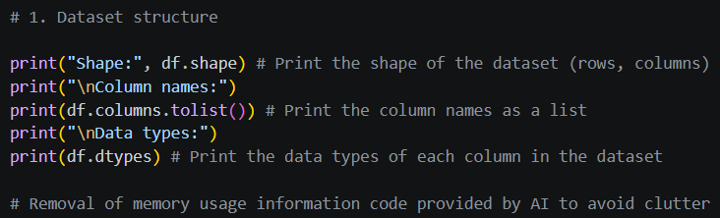
Figure 1
  - Missing Data
Missing values were examined across all variables to assess their extent and potential impact on the analysis (Figure 2). Most variables contained no missing values, while the remaining variables contained less than 1% missingness. One variable contained 14.6% missing values but was excluded from the subsequent analysis. No imputation or removal of observations was therefore required. Appropriate identification and handling of missing values is important because inappropriate treatment can affect subsequent analysis (Huxley, 2020).
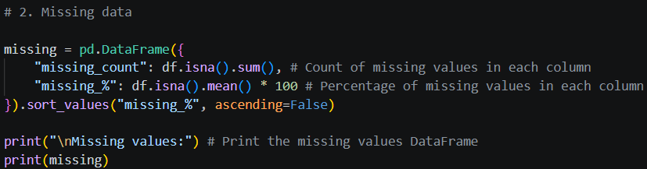
Figure 2
  - Unique Values
The number of unique values within each variable was examined to identify unexpected entries, inconsistent categories or unusual cardinality (Figure 3). Categorical variables were reviewed for naming consistency, while numerical variables were assessed against their expected characteristics. No unexpected values requiring correction were identified.
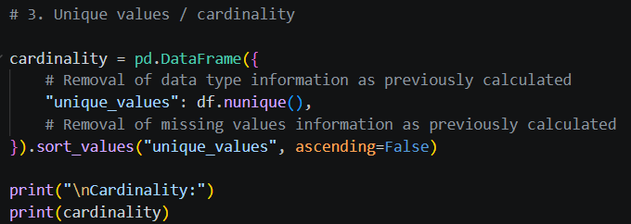
Figure 3
  - Duplicate Records
Duplicate records were examined to determine whether observations had been inadvertently repeated (Figure 4). Duplicate cases can introduce redundancy and affect subsequent analysis (Huxley, 2020). No duplicate observations were identified and therefore no records required removal.
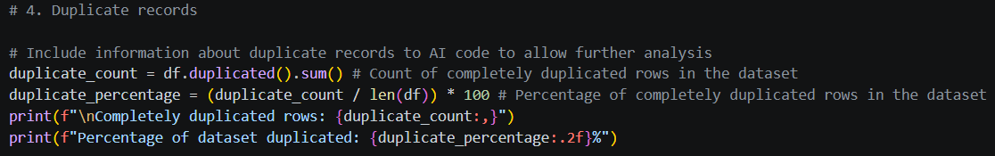
Figure 4
  - Numerical Summary
Descriptive statistics, including minimum, maximum, mean, median and standard deviation, were generated for numerical variables (Figure 5). These were reviewed to identify implausible values or substantial differences between measures of central tendency. No values requiring corrective action were identified.
Figure 5
  - Categorical Variables
Categorical variables were examined for unexpected categories, inconsistent labels, and low-frequency categories (Figure 6). The results indicated that the categorical variables were appropriate for the intended analysis.
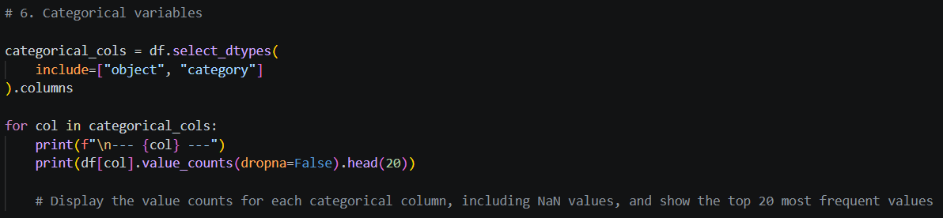
Figure 6
  - Outliers and Extreme Values
Potential outliers were assessed using numerical summaries and Interquartile Range (IQR) based detection (Figure 7). Outliers were not automatically treated as errors because extreme observations may represent legitimate characteristics of the dataset (Sullivan, Warkentin and Wallace, 2021). ChatGPT was used to assist with contextualising flagged values and prompted further consideration of whether the IQR method was equally appropriate across all variables (ChatGPT, 2026, personal communication, 27 September). However, final decisions were based on the characteristics and analytical relevance of each variable. This process highlighted the importance of selecting outlier detection methods according to the nature of the variable rather than applying a uniform approach. No observations were identified as sufficiently implausible to warrant removal.
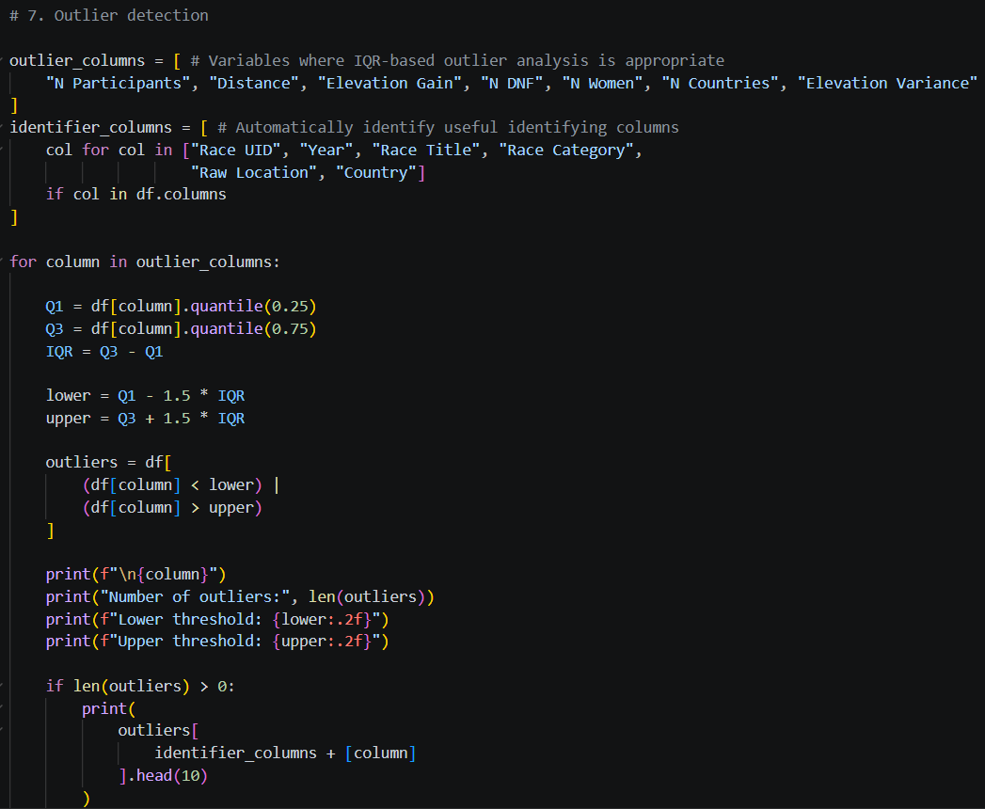
Figure 7
  - Logical Consistency
Logical consistency checks were conducted to assess whether variables were plausible independently and in relation to one another (Figure 8). Participant counts, DNF counts, DNF proportions, and geographical coordinates were assessed against their expected ranges. Logical consistency checks enable the identification of suspected abnormalities, which can then be investigated, as it is not always immediately possible to establish whether flagged data points are erroneous (Van den Broeck et al., 2005). One observation had a non-positive race distance, and six had negative elevation gain. These observations were reviewed against the relevant race information. The non-positive race distance was confirmed to be erroneous and was therefore removed, while the observations with negative elevation gain were not considered sufficiently problematic to warrant modification or removal.
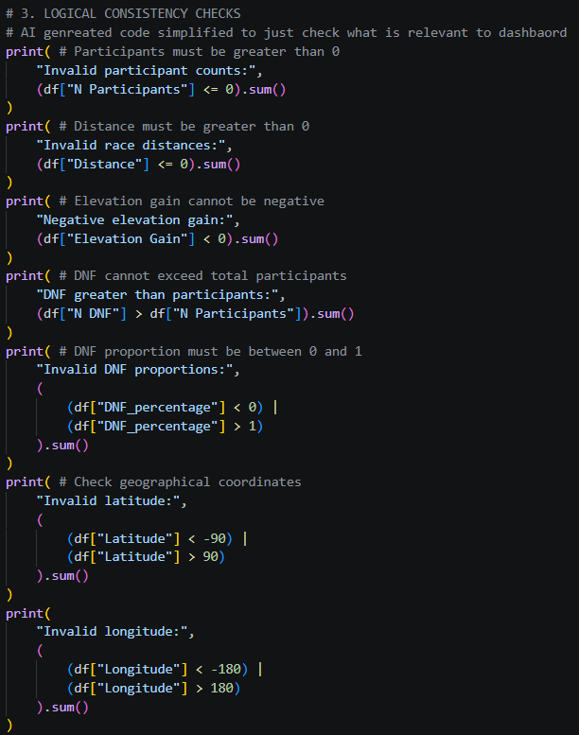
Figure 8
- Data Storage, Normalisation and Validation
ChatGPT was used to support the database design and evaluation process by assisting with SQL scripting for data profiling, validating and testing relationships, and providing guidance on potential normalisation approaches. All suggestions were critically evaluated and tested against the dataset, then accepted, modified, or rejected based on human judgement.
The UTMB dataset comprised 38,460 records and 23 attributes, initially stored in a flat spreadsheet. PostgreSQL is an open-source object-relational database management system (DBMS) that supports persistent data storage, SQL-based querying, relational data modelling, and the enforcement of data integrity and transactional consistency (PostgreSQL Global Development Group, 2026). These capabilities made PostgreSQL an appropriate choice for this project, as it enabled the dataset to be structured, stored, queried, and prepared for subsequent regression analysis. The original data was first imported into a UTMB_RAW staging table, preserving the source data before transformation. Data profiling and analysis of attribute relationships were then used to examine the structure, quality, and relationships within the dataset, informing the relational design and resulting in four tables: UTMB_RAW, COUNTRY, RACE, and RACE_EDITION. The resulting structure is shown in Figure 9. The COUNTRY table stores geographical information, RACE represents the underlying race, and RACE_EDITION represents a specific occurrence of a race each year. The distribution of records across the four tables is presented in Table 1.
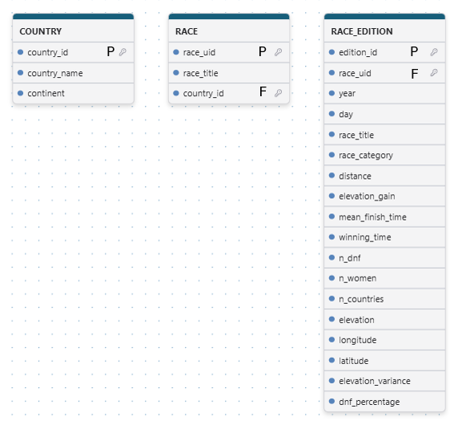
Figure 9
Table | Purpose | Records
UTMB_RAW | Original/staging data | 38,460
COUNTRY | Unique countries | 127
RACE | Unique races | 15,679
RACE_EDITION | Individual race occurrences | 38,460
Table 1
Database normalisation organises relational data to reduce redundancy and prevent data anomalies. The main normal forms are 1NF, which requires atomic values; 2NF, which removes partial dependencies; and 3NF, which removes transitive dependencies (Chen, 2023). The design applies 1NF, 2NF and 3NF. The dataset already satisfied 1NF, as each attribute contained a single atomic value with no repeating groups. Separating race-level and edition-level attributes supports 2NF, while isolating country information supports 3NF by ensuring attributes depend on the appropriate identifier. This reduces redundancy and potential update anomalies.
Validation was necessary to ensure that the relational structure accurately represented the source data and that the relationships between tables did not introduce inconsistencies (The Open University, n.d). Table 2 records 0 duplicate Race UID + Year combinations, 0 orphaned Race Editions, and 0 orphaned Races, providing evidence of uniqueness and referential integrity. Further investigation showed that Race UID could occur across multiple years with changing race titles, confirming that it identifies the underlying race rather than an individual edition. Missing values were retained as NULL where unavailable rather than imputed, as this preserved the integrity of the source data (PostgreSQL Global Development Group, 2026).
Validation | Result
Raw records | 38,460
Countries | 127
Unique races | 15,679
Race editions | 38,460
Duplicate Race UID + Year combinations | 0
Orphaned Race Editions | 0
Orphaned Races | 0
Table 2: Validation evidence
The resulting database provided a normalised and validated foundation for Power BI visualisation and regression analysis.
- Dashboard Development, Findings and Critical Evaluation
The final stage involved developing an interactive Microsoft Power BI dashboard to examine relationships between race characteristics and DNF outcomes. ChatGPT supported visualisation selection and Power BI functionality. The dashboard incorporates total participants, DNFs, and average DNF percentages, alongside graphs examining distance, elevation gain, participant numbers and geographical variation. Interactive slicers enable comparisons across years, countries, continents and race categories (Figure 10).
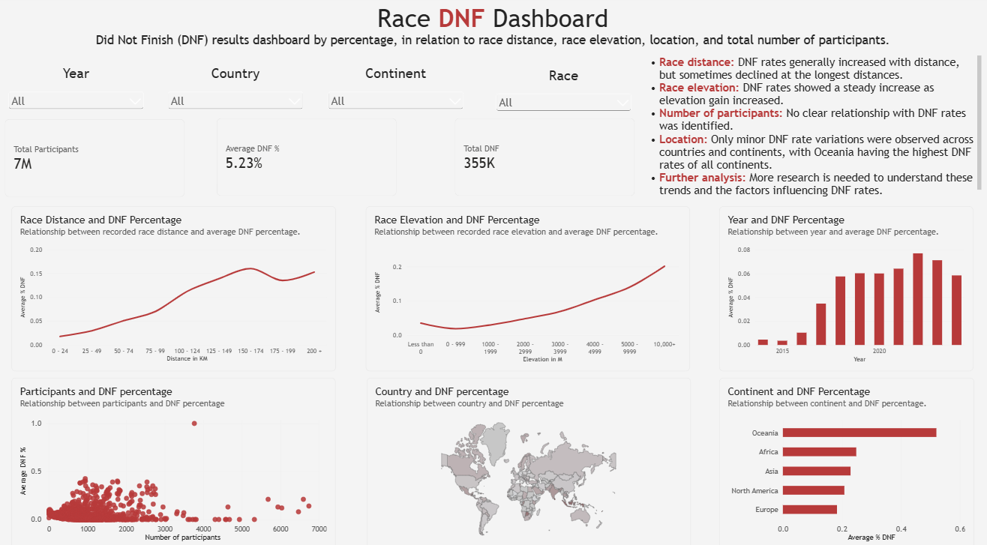
Figure 10
DNF percentages generally increased with race distance, although occasional declines at the longest distances challenges the assumption of a linear relationship. These declines may reflect differences in participant experience or sample composition rather than reduced course difficulty, as previous research identifies limited race experience and lower training volumes as risk factors for ultramarathon non-completion (Sewry et al., 2022).
Elevation gain showed a more consistent positive association with DNF percentages, suggesting that climbing demands warrant investigation. However, this relationship does not establish causality, as other physiological and environmental factors, like running injuries and competing commitments, may influence completion (Hoffman and Krishnan, 2013). Participant numbers showed no clear relationship with DNF percentages, indicating that event size alone is not a reliable indicator of non-completion. Geographical differences were relatively minor, although Oceania recorded the highest continental DNF percentages. This finding warrants further investigation rather than attributing risk to location, as climate, course design and participant characteristics may explain the variation (Sewry et al., 2022).
From an event-management perspective, these findings can inform targeted investigation rather than justify immediate interventions. Organisers could review course difficulty, pacing guidance, checkpoint provision and medical support at events with substantial elevation gain or high DNF percentages. However, regional and distance-related patterns should be validated against individual event characteristics before resources are allocated. The dashboard therefore functions primarily as a decision-support tool, identifying potential areas of concern rather than demonstrating which interventions will improve completion rates.
Methodologically, the dashboard provides descriptive rather than predictive or causal evidence. Aggregated race-level data cannot explain individual outcomes, highlighting need for further investigation into both participant characteristics and geographical factors. Future analysis should incorporate relevant personal, environmental and race-specific variables. Multivariable modelling could then assess whether distance and elevation remain associated with DNF outcomes after adjustment for potential confounding factors.
Ethically, using race-level rather than identifiable runner data supports data minimisation by limiting the personal information required for analysis (ICO, n.d.-a). Genuinely anonymised information falls outside the scope of UK GDPR where individuals are no longer identifiable by means reasonably likely to be used; however, aggregation alone does not guarantee anonymity (ICO, n.d.-b). Integrating identifiable participant or health data would require an appropriate lawful basis, transparency, and adequate security measures, with additional legal conditions applying to special-category health data (ICO, n.d.-c). Therefore, the dashboard's use of race-level data reduces the need to process personal information. Incorporating identifiable personal details to deepen understanding of non-completion (DNF) would increase data protection obligations and require stronger safeguards and appropriate controls over data access and analysis.
- Conclusion
Overall, the project integrates AI-assisted data preparation, PostgreSQL and Power BI to transform race-level data into actionable insights. The dashboard highlights variation in DNF percentages across race distances, elevation-gain intervals and geographical locations, suggesting that course characteristics may influence race completion. These findings can help event organisers identify demanding race formats and review training guidance, pacing strategies and course support. However, aggregated historical data cannot establish causation, and factors such as runner fitness and weather remain unaccounted for. Future development should improve data quality, incorporate additional variables and strengthen analytical validation. Any future processing of personal data must also consider applicable data protection legislation, including UK GDPR. Ultimately, the project demonstrates how validated, AI-assisted analysis can support evidence-based race development while recognising the limitations of the available data.

References
Abrahamson, J. et al. (2025) ‘Using self-reported training characteristics to better understand who is more likely to sustain running-related injuries than others: The Garmin-RUNSAFE Running Health Study’, Scandinavian Journal of Medicine & Science Sports, 35(1), pp 1 - 8. Available at: https://doi.org/10.1111/sms.70004.
ChatGPT (2026). Personal communication with Rebekah Pollington. 21 September.
ChatGPT (2026). Personal communication with Rebekah Pollington. 27 September.
Chen, W. (2023) Database Design and Implementation. Arkansas Tech University. Available at: https://orc.library.atu.edu/cgi/viewcontent.cgi?article=1002&context=atu_oer (Accessed: 5 October 2026).
Chatterjee, S. et al. (2023) ‘Assessing the impact of big data analytics on decision-making processes, forecasting, and performance of a firm’, Technological Forecasting & Social Change, 196, pp 1 – 10. Available at: https://doi.org/10.1016/j.techfore.2023.122824.
Cilia, M. and Buttigieg, S. (2025) ‘Health Data Pipelines: Moving Away from Excel to Scalable, Sustainable, Insightful, and Future-Proof Infostructure’, in Zeeb, H. et al. (eds) Digital Public Health. Cham: Springer Nature. Available at: https://doi.org/10.1007/978-3-031-90154-6_30.
Giray, L. (2026) ‘When Using AI in Scientific Research: Start with Human, End with Human’, TechTrends, 70, pp 265 – 272. Available at: https://doi.org/10.1007/s11528-025-01132-7.
Gorale, C. (2025) CSV vs Excel vs Parquet vs Binary: Which Data Format Should You Use in Data Science & ML? Available at: https://cgorale111.medium.com/csv-vs-excel-vs-parquet-vs-binary-which-data-format-should-you-use-in-data-science-ml-81d435442376 (Accessed: 21 September 2026).
Hao, H. et al. (2024) ‘An empirical study on developers’ shared conversations with ChatGPT in GitHub pull requests and issues’, Empirical Software Engineering, 29, pp.1-43. Available at: https://doi.org/10.1007/s10664-024-10540-x.
Hoffman, M., and Krishnan, E. (2013). ‘Exercise Behavior of Ultramarathon Runners: Baseline Findings From the ULTRA Study’, Journal of Strength & Conditioning Research, 27(11), 2939–2945. Available at: https://doi.org/10.1519/JSC.0b013e3182a1f261
Huxley, K. (2020) 'Data cleaning', in Atkinson, P. et al. (eds) SAGE Research Methods Foundations. London: SAGE Publications Ltd. Available at: https://doi.org/10.4135/9781526421036842861.
Information Commissioner's Office (ICO) (n.d.-a) Principle (c): Data minimisation. Available at: https://ico.org.uk/for-organisations/uk-gdpr-guidance-and-resources/data-protection-principles/a-guide-to-the-data-protection-principles/data-minimisation/ (Accessed: 10 October 2026).
Information Commissioner's Office (ICO) (n.d.-b) What is personal data? Available at: https://ico.org.uk/for-organisations/uk-gdpr-guidance-and-resources/personal-information-what-is-it/what-is-personal-data/what-is-personal-data/ (Accessed: 10 October 2026).
Information Commissioner's Office (ICO) (n.d.-c) Principle (a): Lawfulness, fairness and transparency. Available at: https://ico.org.uk/for-organisations/uk-gdpr-guidance-and-resources/data-protection-principles/a-guide-to-the-data-protection-principles/lawfulness-fairness-and-transparency/ (Accessed: 10 October 2026).
Mahato, M. et al. (2024) 'Leveraging Big Data Analytics and Conversational AI for Agriculture' in Sardar, T.H. and Pandey, B.K. (eds) Big Data Computing: Advances in Technologies, Methodologies, and Applications. Boca Raton: CRC Press. Available at: https://doi.org/10.1201/9781032634050.
McKinney, W. (2022) Python for Data Analysis: Data Wrangling with Pandas, NumPy, and Jupyter. 3rd edn. Sebastopol, CA: O'Reilly Media. Available at: https://learning.oreilly.com/library/view/python-for-data/9781098104023/ (Accessed: 23 September 2026).
Morgulev, E., Azar, O.H. and Lidor, R. (2018) ‘Sports analytics and the big-data era’, International Journal of Data Science and Analytics, 5(4), pp. 213-222. Available at: https://doi.org/10.1007/s41060-017-0093-7.
Nikolaidis, P.T. et al. (2019) ‘Motivation in the Athens Classic Marathon: The role of sex, age, and performance level in Greek recreational marathon runners’, International Journal of Environmental Research and Public Health, 16(14), pp. 1-9. Available at: https://doi.org/10.3390/ijerph16142549.
Poirot, M.G. (2024) UTMB world race data. Kaggle. Available at: https://www.kaggle.com/datasets/mgpoirot/utmb-world-race-daa/ (Accessed: 04 October 2026).
PostgreSQL Global Development Group (2026) What is PostgreSQL? PostgreSQL 18 documentation. Available at: https://www.postgresql.org/docs/18/intro-whatis.html (Accessed: 5 October 2026).
Sullivan, J.H., Warkentin, M. and Wallace, L. (2021) ‘So many ways for assessing outliers: What really works and does it matter?’, Journal of Business Research, 132, pp. 530-543. Available at: https://doi.org/10.1016/j.jbusres.2021.03.066.
Sewry, N. et al. (2022) ‘Risk factors for not finishing an ultramarathon: 4-year study in 23,996 race starters, SAFER XXI’, The Journal of Sports Medicine and Physical Fitness, 62(5), pp. 710–715. Available at: https://doi.org/10.23736/S0022-4707.21.12252-2
The Open University (n.d.) 1.7 Testing. OpenLearn: The database development life cycle. Available at: https://www.open.edu/openlearn/science-maths-technology/the-database-development-life-cycle/content-section-1.7 (Accessed: 05 October 2026).
Van den Broeck, J. et al. (2005) ‘Data Cleaning: Detecting, Diagnosing, and Editing Data Abnormalities’, PLoS Medicine, 2(10), pp. 966-970. Available at: https://doi.org/10.1371/journal.pmed.0020267.
Wickham, H. (2014) ‘Tidy Data’, Journal of Statistical Software, 59(10), pp. 1-23. Available at: https://doi.org/10.18637/jss.v059.i10.

