Data Build Task
The aim of this task was to build a relational database system, with linked tables and develop knowledge of and demonstrate primary and secondary keys. To complete this task, I utilised PostgreSQL. The database was designed to reduce data duplication, link related information and maintain data accuracy.
Database Design and Implementation
As shown in Figure 1, the database contains three tables: student, course and student_course. The student table stores student details, while the course table stores course names, exam boards and teachers. The student_course table links students to the courses they study.
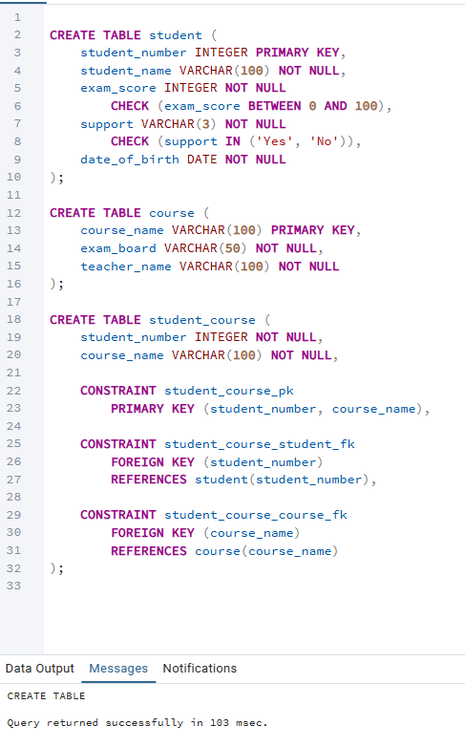
Figure 1
Primary keys uniquely identify records. The student_number field is the primary key in the student table, and course_name is the primary key in the course table. The student_course table uses a composite primary key consisting of student_number and course_name, preventing duplicate student-course combinations. Foreign keys connect this table to the student and course tables, maintaining referential integrity (PostgreSQL Global Development Group, n.d.).
Figure 2 shows the database implementation and populated tables. The database contained five student records, five course records and fifteen student-course relationships. Separating the information into three tables reduces unnecessary repetition and supports a more organised database structure.
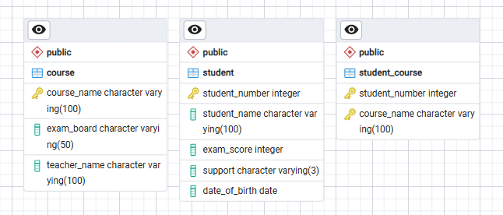
Figure 2
Testin and Results
The database was tested using an SQL JOIN query, shown in Figure 3. This query combines information from all three tables using their related key fields. The results demonstrate that student details can be retrieved alongside their course information, exam board and teacher. The query returned fifteen rows, corresponding to the fifteen student-course relationships.
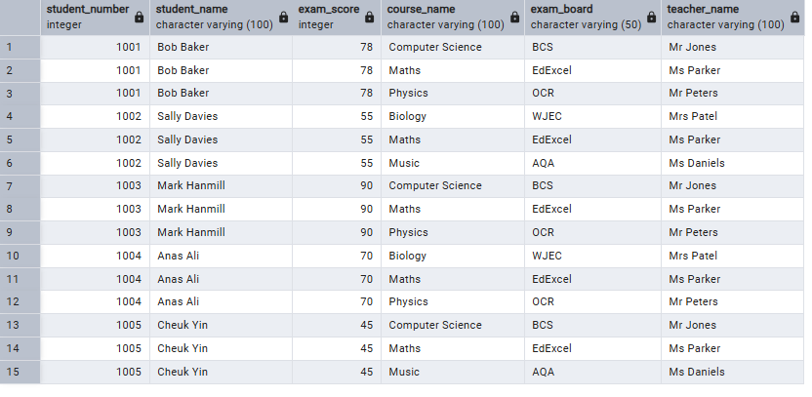
Figure 3
Referential integrity was tested by attempting to insert a student-course record containing a student number that did not exist, as shown in Figure 4. PostgreSQL rejected the insertion because the foreign key requirement was not met. This confirms that the database prevents links to non-existent student records. A similar test was performed using a course name that is not present in the course table, as shown in Figure 5.
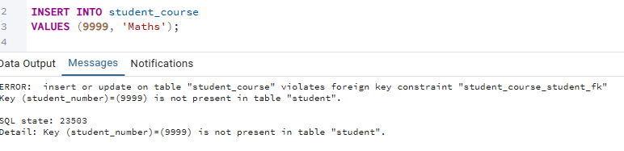
Figure 4
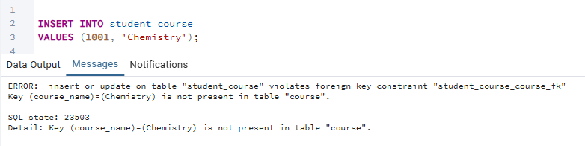
Figure 5
Conclusion
The database successfully organises student and course information into linked tables. Primary keys identify records, while foreign keys maintain valid relationships. The JOIN query demonstrated that related information could be retrieved successfully, and the failed insertion demonstrated that referential integrity was enforced. Overall, the design provides a structured and reliable way to store and retrieve the supplied data.
References
PostgreSQL Global Development Group (n.d.) Constraints. PostgreSQL Documentation. Available at: https://www.postgresql.org/docs/current/ddl-constraints.html (Accessed: 06 September 2026).

