Simple document

library(tidyverse)

## ── Attaching packages ─────────────────────────────────────── tidyverse 1.3.2 ──  
## ✔ ggplot2 3.3.6 ✔ purrr 0.3.4   
## ✔ tibble 3.1.8 ✔ dplyr 1.0.10  
## ✔ tidyr 1.2.0 ✔ stringr 1.4.1   
## ✔ readr 2.1.2 ✔ forcats 0.5.2   
## ── Conflicts ────────────────────────────────────────── tidyverse_conflicts() ──  
## ✖ dplyr::filter() masks stats::filter()  
## ✖ dplyr::lag() masks stats::lag()

I’m an R Markdown document!

# Section 1

Here’s a **code chunk** that samples from a *normal distribution*:

samp = rnorm(100)  
length(samp)

## [1] 100

# Section 2

I can take the mean of the sample, too! The mean is -0.1167125 round(mean(samp),2)

#section 3 This is going to make a plot. First load the dataframe, then use ggplot to make a scatterplot

example_df =  
 tibble (  
 var_numeric = 5:8,  
 var_char = c("my", "name", "is", "rhea"),  
 var_logic = c(TRUE, TRUE, FALSE, TRUE),  
 var_factor= factor(c("male", "female", "male", "male"))  
 )  
  
plot_df =  
 tibble(  
 x= rnorm(n=1000),  
 y=1+2*x+rnorm(n=1000)  
 )  
   
  
  
ggplot (plot_df, aes(x=x, y=y))+geom_point()

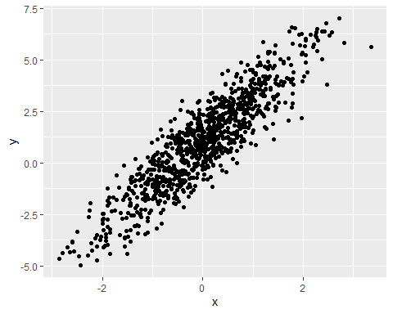

ggsave ("scatter_plot.pdf", height=4, width=6)

#Section 4

la_df=  
 tibble(  
 norm = rnorm(n=500, mean=1),  
 logical =norm >0,  
 abs_norm=abs(norm)  
   
 )  
  
ggplot(la_df, aes(x= abs_norm))+geom_histogram()

## `stat_bin()` using `bins = 30`. Pick better value with `binwidth`.

