Product Introduction
We know that the displayers such as LCD and nixie tubes, although they greatly enrich the man-machine interactive, they also have a common feature, connecting the controllers need to occupy major IO lines. It is a big problem for those controllers that peripheral interfaces are not enough, also it limits the other functions of the controller. Aiming at this point, our product LCD2004 with I2C interface can solve this problem commendably, and it is very simple to use.

Product Features
Interface: I2C Interface
I2C address：0x27
Pin Connections: VCC、GND、SDA、SCL
Operating Voltage: +5V
Size: 27.7mm×42.6mm
contrast control: through the potentiometer
Use 0nly two IO interfaces

Directions For Use
As this is the I2C interface module, we should follow the I2C protocol when we use.
Now let's look at how it is connected with the Arduino control board firstly.
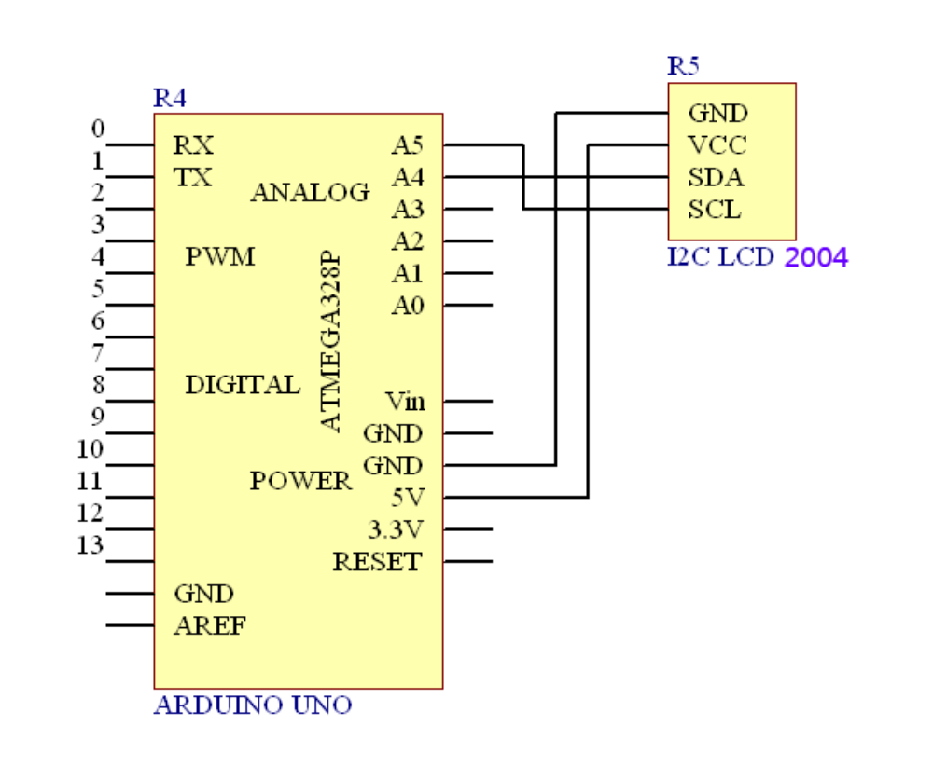

Module Testing
Hardware Requirement
1、Arduino controller× 1
2、USB Data Cable× 1
3、I2C LCD 2004 module× 1

Here we do a simple test, show a line of characters “www.funduino.com” on the LCD.
Look at the test code firstly.

#include <Wire.h>
#include <LiquidCrystal_I2C.h>
LiquidCrystal_I2C lcd(0x27,20,4 ); // set the LCD address to 0x27 for a 20 chars and 4 line display
void setup()
{
lcd.init(); // initialize the lcd
// Print a message to the LCD.
lcd.backlight();
lcd.print("www.funduino.com");
}
void loop()
{
}

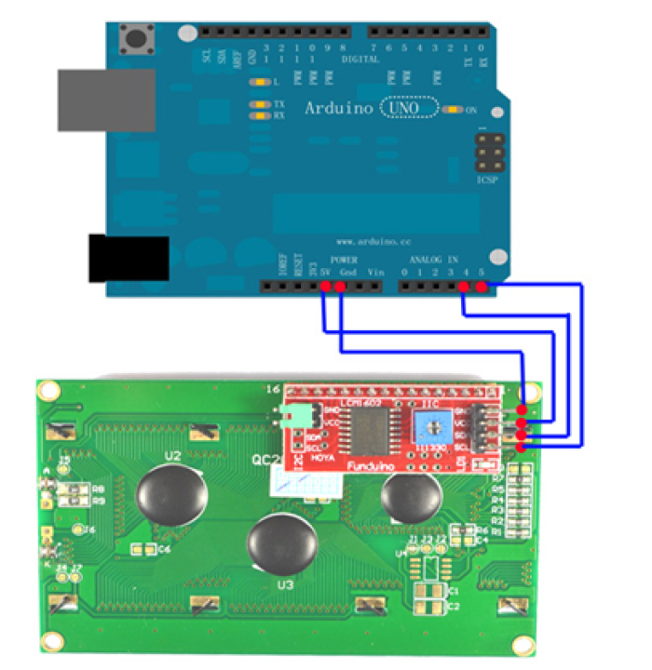

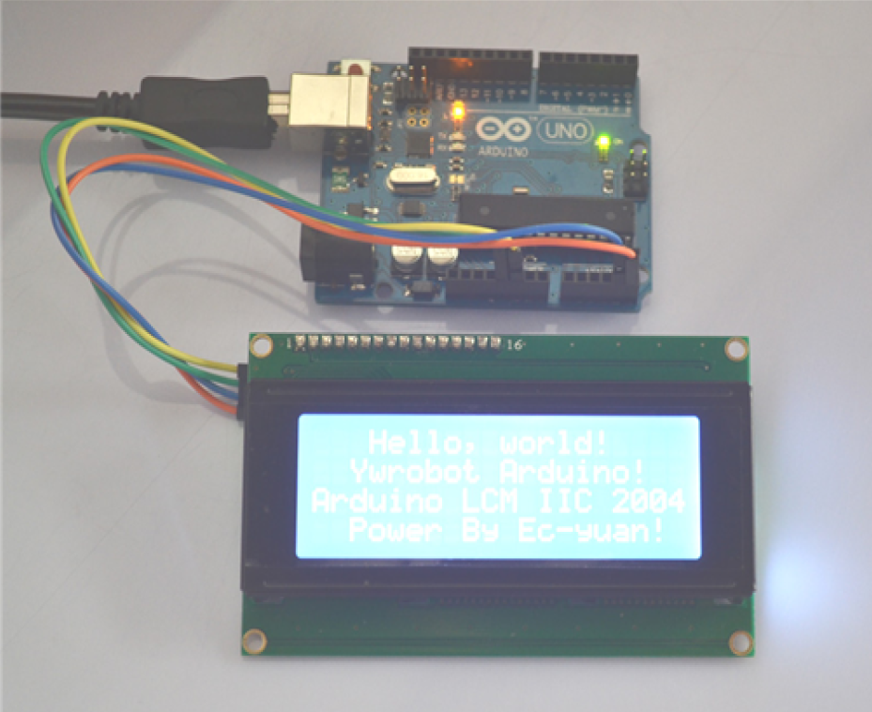

Reference code：

//YWROBOT
//Compatible with the Arduino IDE 1.0
//Library version:1.1
#include <Wire.h>
#include <LiquidCrystal_I2C.h>
LiquidCrystal_I2C lcd(0x27,20,4); // set the LCD address to 0x27 for a 16 chars and 2 line
display
void setup()
{
lcd.init(); // initialize the lcd
lcd.init();
// Print a message to the LCD.
lcd.backlight();
lcd.setCursor(3,0);
lcd.print("Hello, world!");
lcd.setCursor(2,1);
lcd.print("Ywrobot Arduino!");
lcd.setCursor(0,2);
lcd.print("Arduino LCM IIC 2004");
lcd.setCursor(2,3);
lcd.print("Power By Ec-yuan!");
}
void loop()
{
}

