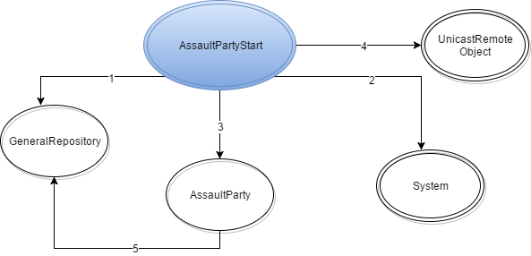

1. getGeneralRepository
2. getSecurityManager, setSecurityManager
3. Instanciação
4. exportObject
5. updateThiefPosition, setRoomIdAP