1. getGeneralRepository
2. getSecurityManager, setSecurityManager

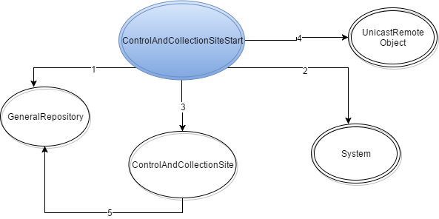

1. Instanciação
2. exportObject
3. clearParty, setCollectedCanvas