1. Instanciação

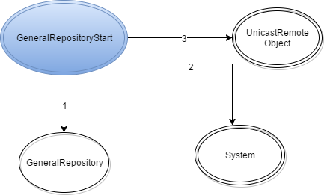

1. getSecurityManager, setSecurityManager
2. exportObject