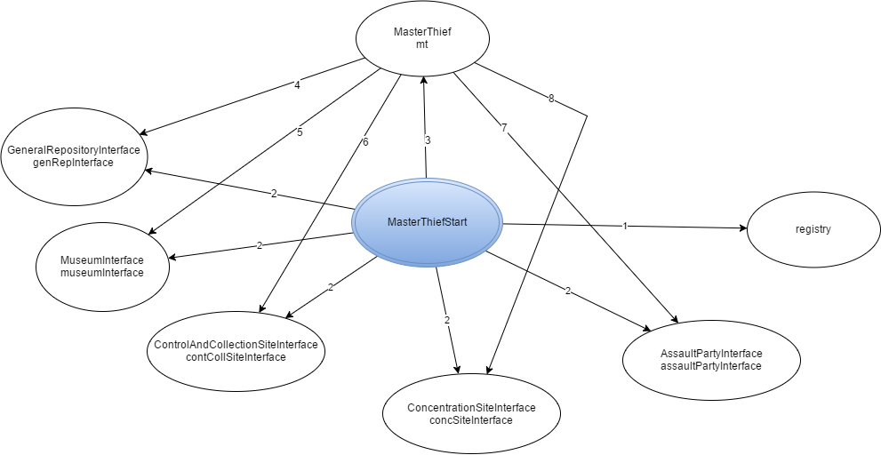

1. Instanciação, lookup
2. Instanciação
3. Instanciação, join, start
4. updateMThiefState, FinalizeLog
5. getRoomDistance
6. getTargetRoom, getPartyToDeploy, takeARest, collectCanvas, isHeistCompleted, waitingNedded
7. setRoom, sendAssaultParty
8. startOperations, prepareAssaultParty, sumUpResults, appraiseSit